5. PROJECT DEVELOPMENT PHASE
EduGenie: Google Gemini Powered Learning Assistant
The development phase implements the EduGenie modules, FastAPI backend, frontend, and live integration described in the project documentation.
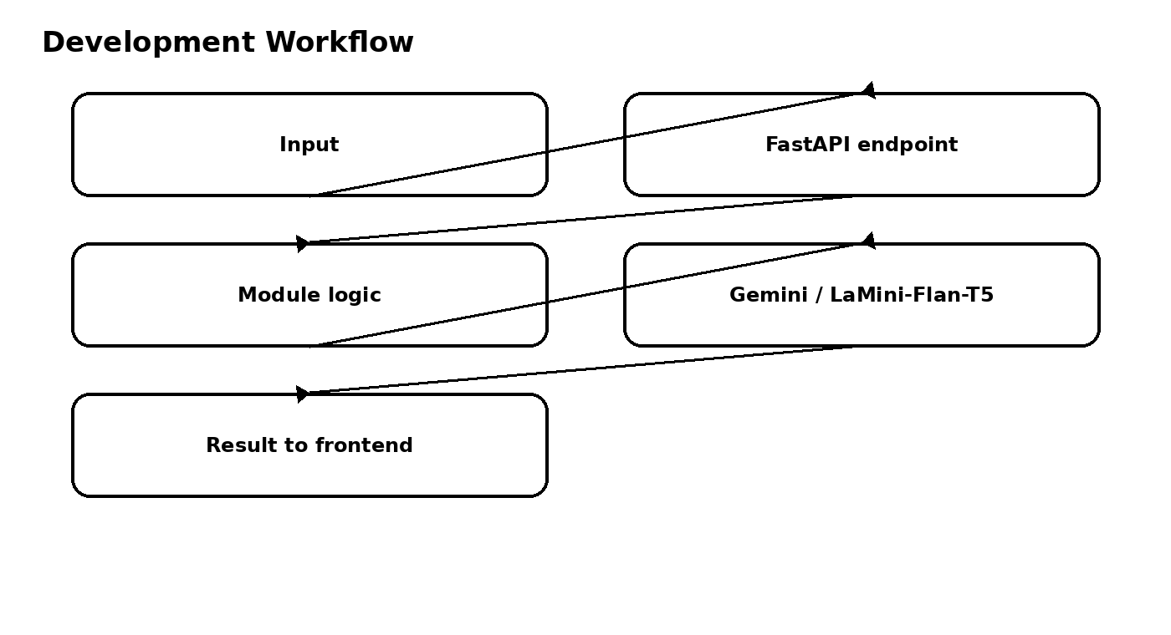

5.1 Explanation Module
LaMini-Flan-T5-783M is used to provide concise, context-aware explanations that break complex topics into understandable language.

5.2 QnA Module
Gemini 1.5 Pro handles general knowledge and academic question-answering tasks.

5.3 Quiz Module
The quiz module generates three MCQs from a passage, with four options for each question. The response is structured as JSON for integration. Markdown code blocks are cleaned before parsing.

5.4 Summary Module
Gemini summarizes long paragraphs into concise versions while retaining core information and removing redundancy.

5.5 Learning Path Module
Gemini generates a structured learning path from beginner to advanced concepts and can include resources such as videos, articles, or books.

5.6 Backend API
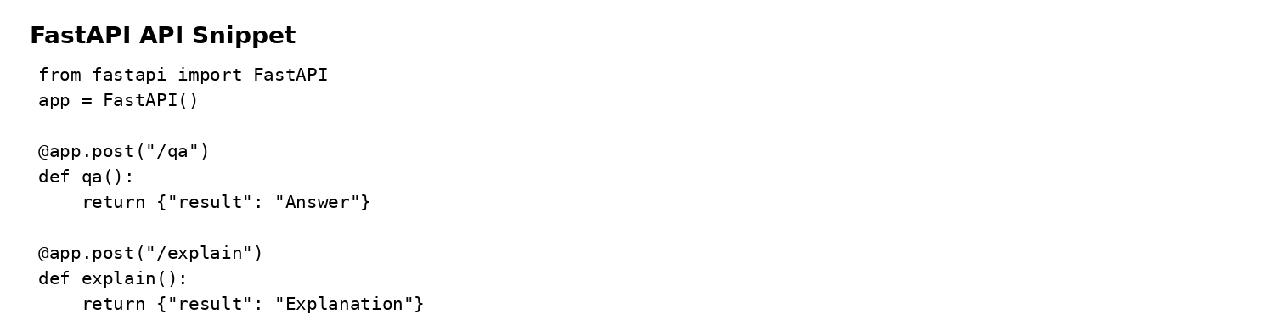

5.7 Frontend Development
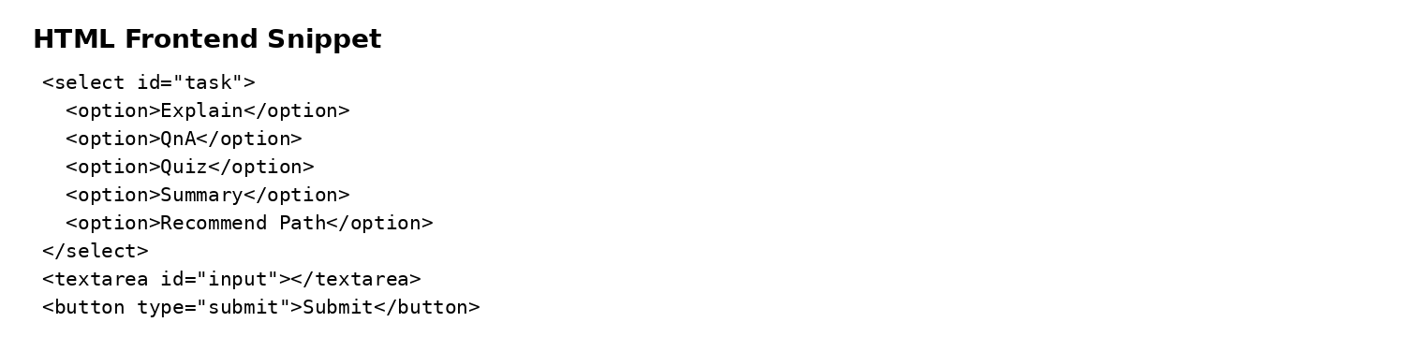

5.8 Live Integration
Form submission sends a POST request to the FastAPI backend, and the result appears below the input box in real time.

