6. PROJECT TESTING PHASE
EduGenie: Google Gemini Powered Learning Assistant
Testing verifies that the EduGenie functions respond correctly and that the frontend and backend integration works as described in the project document.
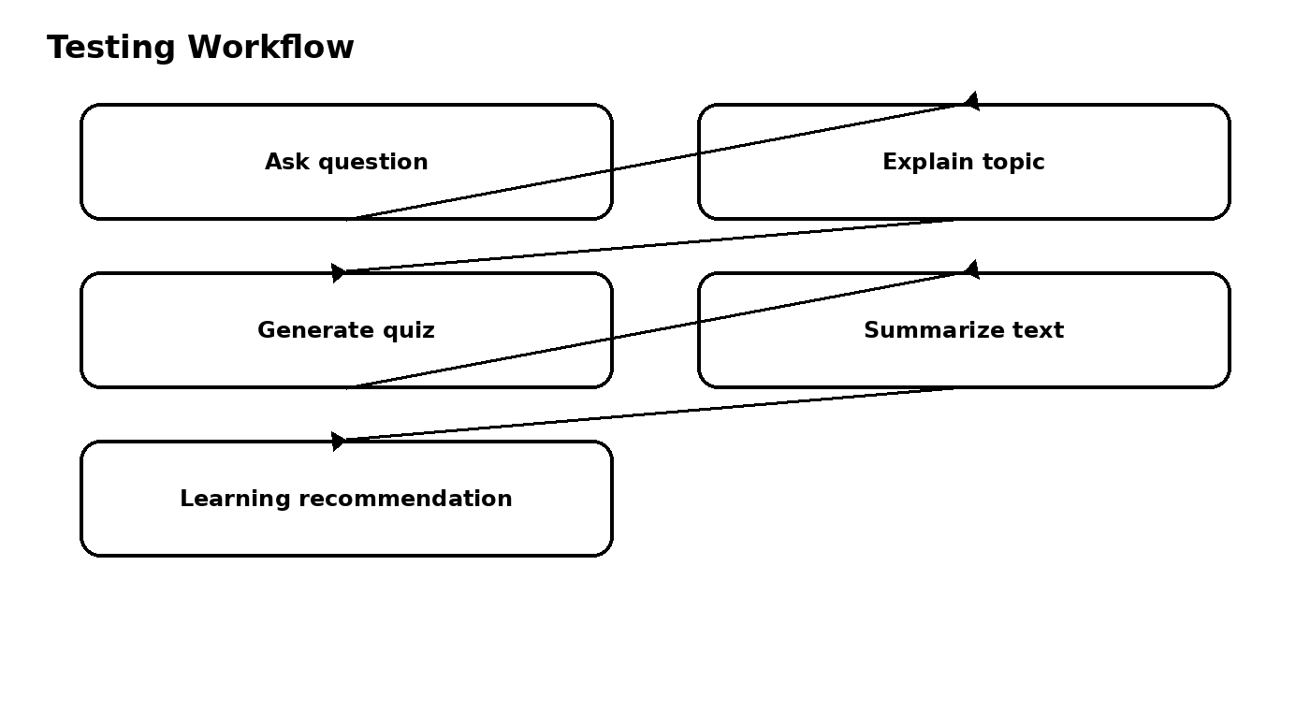

6.1 Functional Test Cases
Test Case | Input / Action | Expected Result | Status
Question Answering | Enter an academic question | Answer is displayed | To be tested
Explanation | Enter a complex topic | Simplified explanation is displayed | To be tested
Quiz | Provide a passage and generate quiz | 3 MCQs with 4 options each | To be tested
Summary | Enter a long paragraph | Concise summary is displayed | To be tested
Learning Path | Enter a topic | Beginner-to-advanced learning plan is displayed | To be tested

6.2 Error Handling
- Quiz generation cleans Markdown code blocks before JSON parsing.
- If generation or parsing fails, a detailed error message is returned.
- Learning path generation handles invalid or incomplete API responses with a helpful error message.

6.3 Local Application Test
Run the application using Uvicorn and access it through the local browser address http://127.0.0.1:8000.
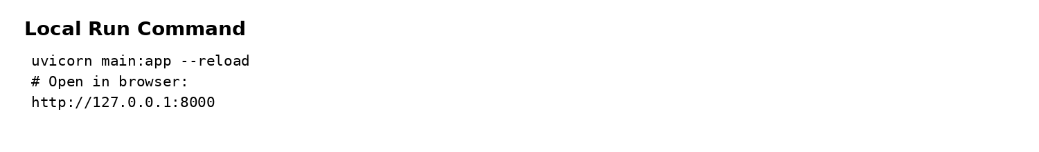

6.4 Testing Outcome
The testing phase checks the five main educational functions and their integration with the FastAPI backend. The source document also identifies accuracy, device performance, personalization, prompt tuning, and data privacy as development challenges requiring continuous testing and improvement.

