7. PROJECT DOCUMENTATION PHASE
EduGenie: Google Gemini Powered Learning Assistant
Documentation records the EduGenie project description, prerequisites, architecture, workflow, modules, API endpoints, frontend integration, deployment, testing, results, challenges, and future enhancements.
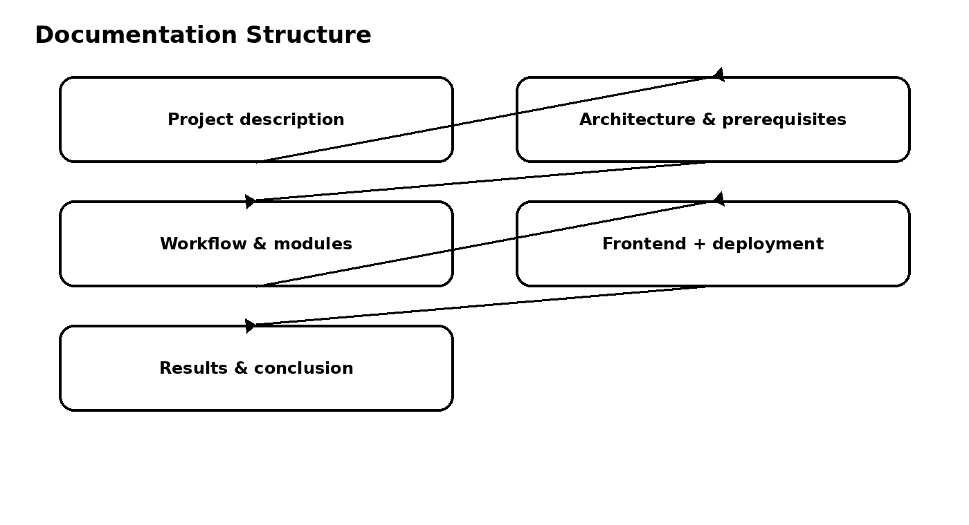

7.1 Project Description
EduGenie is a lightweight AI-powered educational assistant that supports question answering, concept explanation, quiz generation, summarization, and personalized learning recommendations.

7.2 Prerequisites to Document
- Python 3.10+
- FastAPI
- HTML & CSS
- Google Gemini API key
- Uvicorn
- Jinja2

7.3 Technical Documentation
- Folder architecture and purpose of each file.
- AI model selection and module responsibilities.
- FastAPI REST endpoints.
- Frontend task selection and result display.
- Local deployment command and application address.

7.4 User-Facing Features to Document
- Asking questions.
- Explaining topics.
- Summarizing long paragraphs.
- Generating quizzes.
- Guiding learners with recommendations from beginner to advanced levels.

7.5 Challenges and Learning Outcomes
- Accuracy of AI-generated responses.
- Performance across devices.
- Balancing personalization with general usability.
- Prompt engineering and cloud integration.
- User-centric design and data privacy.

7.6 Future Enhancements
- Voice-based interaction.
- Multilingual support.
- Mobile application and offline features.
- Progress tracking dashboards.
- Gamification such as badges and learning streaks.
- Adaptive learning paths.
- Group study and teacher/parent dashboards.
- LMS integration such as Moodle or Google Classroom.
- Image and PDF input recognition.
- Smart notifications and real-time synchronization.

