8. PROJECT DEMONSTRATION PHASE
EduGenie: Google Gemini Powered Learning Assistant
The demonstration phase presents the working EduGenie application through its main learner scenarios. The project document demonstrates question answering, explanation, summarization, quiz generation, and learning recommendations.
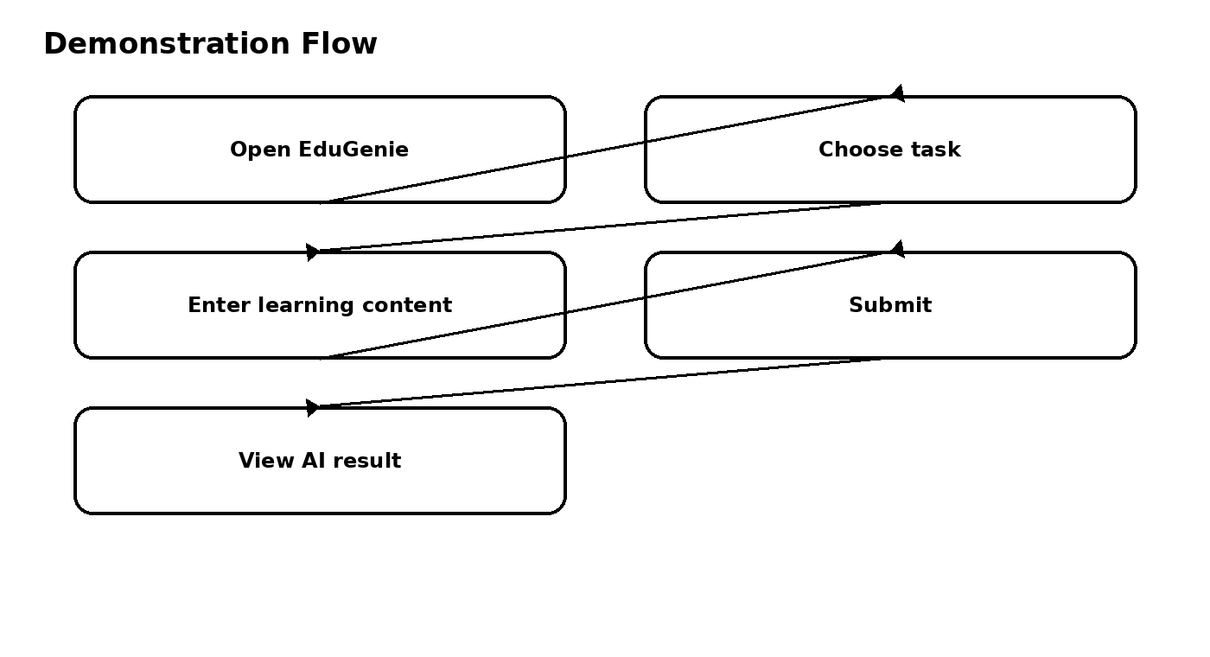

8.1 Demonstration Setup
- Start the FastAPI application with Uvicorn.
- Open http://127.0.0.1:8000 in a browser.
- Select the required task from the task dropdown.
- Enter a question, topic, passage, or learning topic.
- Submit the request and observe the result below the input box.

8.2 Demonstration 1 – Asking Questions
Enter an academic question such as “Which is the largest ocean?” and demonstrate the question-answering function.

8.3 Demonstration 2 – Explanation
Enter a complex topic and show how EduGenie provides a simplified explanation.

8.4 Demonstration 3 – Summarization
Enter a long educational paragraph and demonstrate how the system produces a concise summary while retaining core information.

8.5 Demonstration 4 – Quiz Generation
Provide educational content and select Quiz. The project generates three questions with four options each and identifies the correct answer.

8.6 Demonstration 5 – Learning Recommendations
Enter a topic such as SQL and demonstrate the structured beginner-to-advanced learning path with suggested resources.

8.7 Demonstration Conclusion
The demonstration shows how the separate EduGenie modules combine into a single learning assistant interface and provide interactive educational support.

