Microsoft recommends using

[zone-redundant storage](https://docs.microsoft.com/en-us/azure/storage/common/storage-redundancy#zone-redundant-storage) (ZRS),

[geo-redundant storage](https://docs.microsoft.com/en-us/azure/storage/common/storage-redundancy#geo-redundant-storage) (GRS), or [geo-zone-redundant storage](https://docs.microsoft.com/en-us/azure/storage/common/storage-redundancy#geo-zone-redundant-storage) (GZRS).

**Zone-redundant storage**

replicates your storage account synchronously across three Azure availability zones in the primary region. Each availability zone is a separate physical location with independent power, cooling, and networking. ZRS offers durability for storage resources of at least 99.9999999999% (12 9's) over a given year.

With ZRS, your data is still accessible for both read and write operations even if a zone becomes unavailable. If a zone becomes unavailable, Azure undertakes networking updates, such as DNS repointing. These updates may affect your application if you access data before the updates have completed.

Microsoft recommends using ZRS for Azure Files workloads. If a zone becomes unavailable, no

remounting of Azure file shares from the connected clients is required.

ZRS provides excellent performance, low latency, and resiliency for your data if it becomes temporarily unavailable. However, ZRS by itself may not protect your data against a regional disaster where multiple zones are permanently affected.

### Geo-zone-redundant storage

For protection against regional disasters, Microsoft recommends using [geo-zone-redundant storage](https://docs.microsoft.com/en-us/azure/storage/common/storage-redundancy#geo-zone-redundant-storage) (GZRS), combines the high availability provided by redundancy across availability zones with protection from regional outages provided by geo-replication. Data in a GZRS storage account is copied across three [Azure availability zones](https://docs.microsoft.com/en-us/azure/availability-zones/az-overview) in the primary region and is also replicated to a secondary geographic region for protection from regional disasters. Microsoft recommends using GZRS for applications requiring maximum consistency, durability, and availability, excellent performance, and resilience for disaster recovery.

With a GZRS storage account, you can continue to read and write data if an availability zone becomes unavailable or is unrecoverable. Additionally, your data is also durable in the case of a complete regional outage or a disaster in which the primary region isn't recoverable. GZRS is designed to provide at least 99.99999999999999% (16 9's) durability of objects over a given year.

The following diagram shows how your data is replicated with GZRS or RA-GZRS:

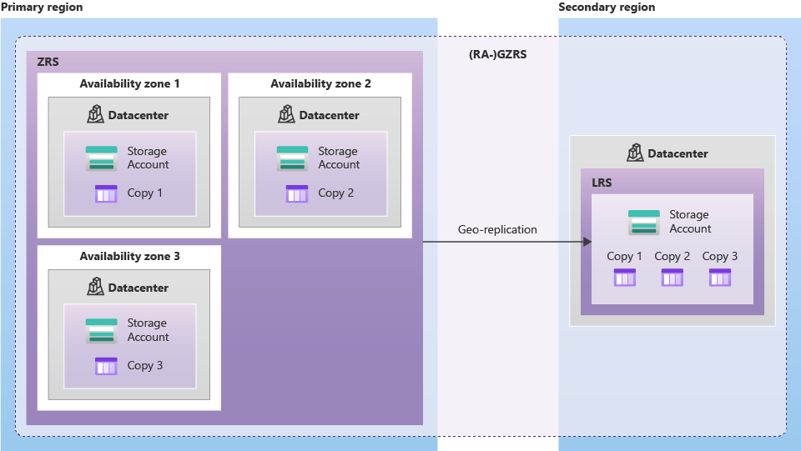

Only standard general-purpose v2 storage accounts support GZRS. GZRS is supported by all of the Azure Storage services, including:

* Azure Blob storage (hot and cool block blobs, non-disk page blobs)
* Azure Files (all standard tiers: transaction optimized, hot, and cool)
* Azure Table storage
* Azure Queue storage

**The primary difference between GRS and GZRS is how data is replicated in the primary region. Within the secondary region, data is always replicated synchronously three times using LRS. LRS in the secondary region protects your data against hardware failures.**

**Because data is replicated to the secondary region asynchronously, a failure that affects the primary region may result in data loss if the primary region cannot be recovered. The interval between the most recent writes to the primary region and the last write to the secondary region is known as the recovery point objective (RPO). The RPO indicates the point in time to which data can be recovered. The Azure Storage platform typically has an RPO of less than 15 minutes, although there's currently no SLA on how long it takes to replicate data to the secondary region.**

Because data is replicated asynchronously from the primary to the secondary region, the secondary region is typically behind the primary region in terms of write operations. If a disaster were to strike the primary region, it's likely that some data would be lost. For more information about how to plan for potential data loss.

Azure Files does not support read-access geo-redundant storage (RA-GRS) or read-access geo-zone-redundant storage (RA-GZRS).