STRING CODING CHALLENGE

NAME:L.SANKARI BHARATHI PRIYA

BATCH:FEBURARY 2023

1.Display the only digit in alpha numeric

public class DisplayDigits {

public static void main(String[] args) {

String input = "75#41";

String output = displayDigits(input);

System.out.println("Output: " + output);

}

public static String displayDigits(String input) {

StringBuilder digits = new StringBuilder();

for (int i = 0; i < input.length(); i++) {

char c = input.charAt(i);

if (Character.isDigit(c)) {

digits.append(c);

}

}

return digits.toString();

}

}

OUTPUT:

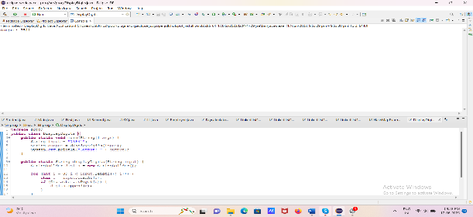

2.CONVERT CASE:

public class ConvertCase {

public static void main(String[] args) {

String input = "Hello, World!";

String uppercase = convertToUppercase(input);

String lowercase = convertToLowercase(input);

System.out.println("Uppercase: " + uppercase);

System.out.println("Lowercase: " + lowercase);

}

public static String convertToUppercase(String input) {

char[] chars = input.toCharArray();

for (int i = 0; i < chars.length; i++) {

if (chars[i] >= 'a' && chars[i] <= 'z') {

chars[i] = (char) (chars[i] - 32);

}

}

return new String(chars);

}

public static String convertToLowercase(String input) {

char[] chars = input.toCharArray();

for (int i = 0; i < chars.length; i++) {

if (chars[i] >= 'A' && chars[i] <= 'Z') {

chars[i] = (char) (chars[i] + 32);

}

}

return new String(chars);

}

}

OUTPUT:

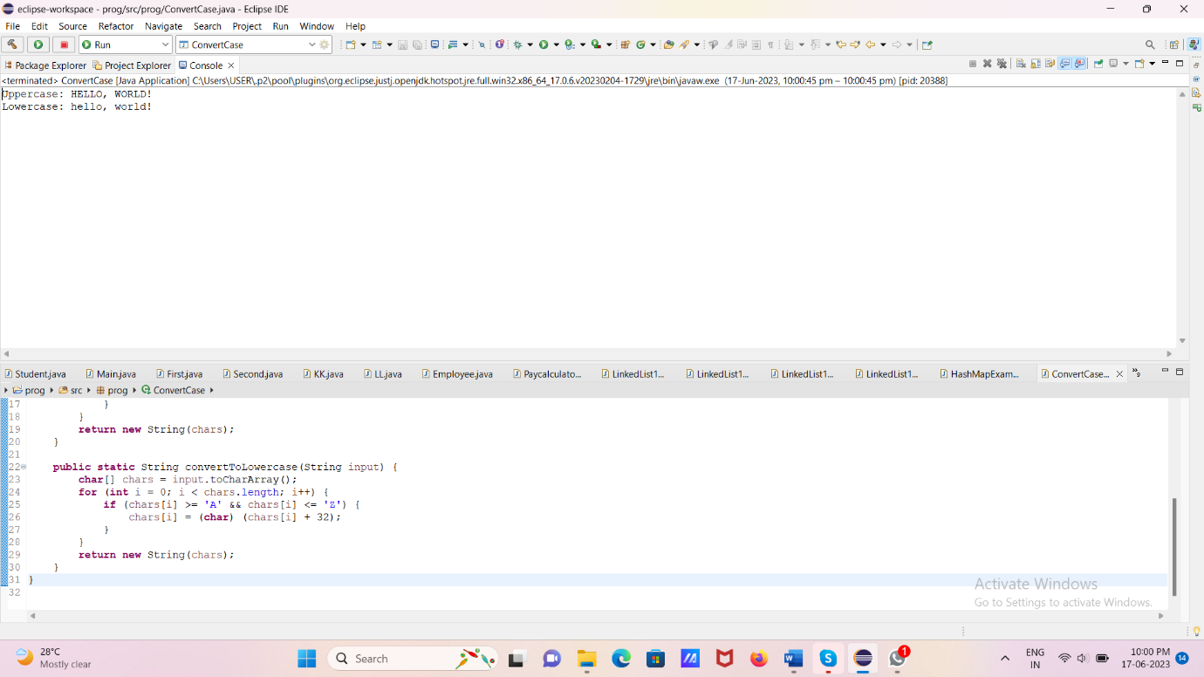

3.Reverse a String:

public class ReverseString {

public static void main(String[] args) {

String input = "am a developer";

String reversed = reverseString(input);

System.out.println(reversed);

}

public static String reverseString(String input) {

String[] words = input.split(" ");

StringBuilder reversed = new StringBuilder();

for (int i = words.length - 1; i >= 0; i--) {

reversed.append(words[i]).append(" ");

}

return reversed.toString().trim();

}

}

OUTPUT:

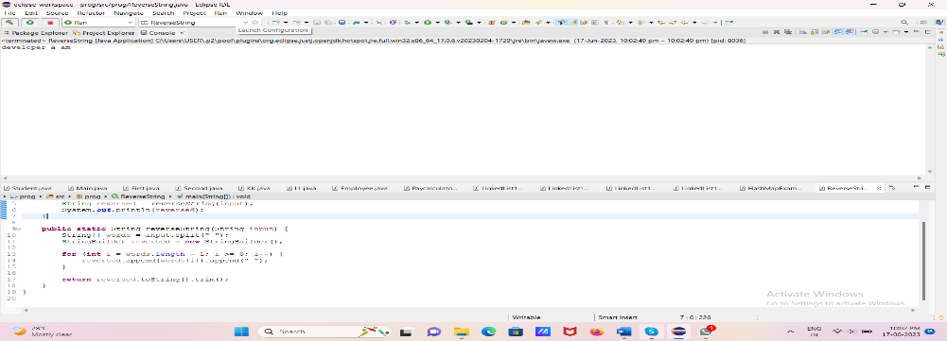

4.Repeated Characters:

import java.util.HashMap;

import java.util.Map;

public class RepeatedCharacters {

public static void main(String[] args) {

String input = "Hello, World!";

printRepeatedCharacters(input);

}

public static void printRepeatedCharacters(String input) {

Map<Character, Integer> charCountMap = new HashMap<>();

for (char c : input.toCharArray()) {

if (Character.isLetter(c)) {

charCountMap.put(c, charCountMap.getOrDefault(c, 0) + 1);

}

}

for (Map.Entry<Character, Integer> entry : charCountMap.entrySet()) {

if (entry.getValue() > 1) {

System.out.println(entry.getKey());

}

}

}

}

OUTPUT:

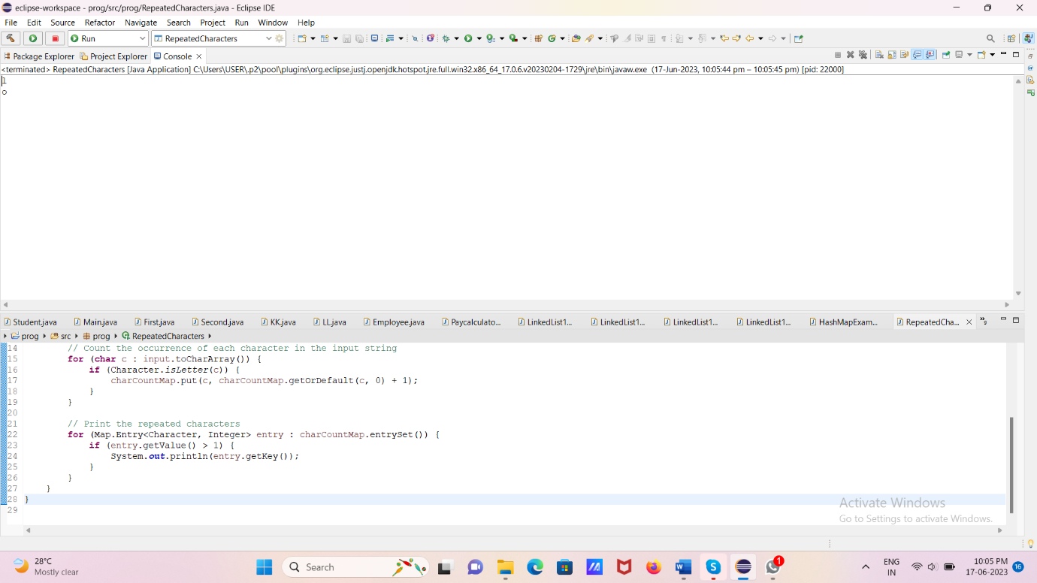

5.Count Vowels:

public class CountVowels {

public static void main(String[] args) {

String input = "Hello, World!";

int vowelCount = countVowels(input);

System.out.println("Number of vowels: " + vowelCount);

}

public static int countVowels(String input) {

int count = 0;

String lowercaseInput = input.toLowerCase();

for (int i = 0; i < lowercaseInput.length(); i++) {

char c = lowercaseInput.charAt(i);

if (isVowel(c)) {

count++;

}

}

return count;

}

public static boolean isVowel(char c) {

return c == 'a' || c == 'e' || c == 'i' || c == 'o' || c == 'u';

}

}

OUTPUT:

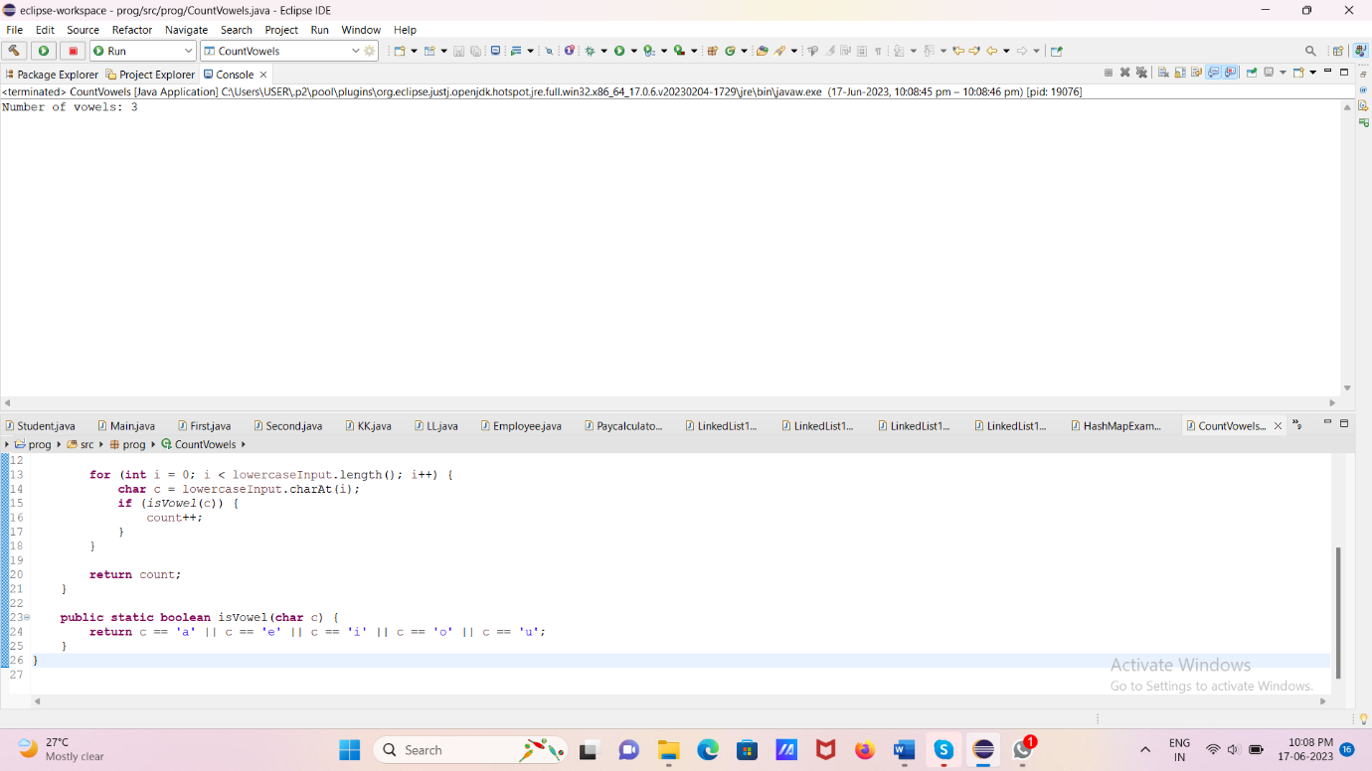

6.Remove Word From String:

public class RemoveWordFromString {

public static void main(String[] args) {

String input = "The quick brown fox jumps over the lazy dog";

String wordToRemove = "fox";

String result = removeWordFromString(input, wordToRemove);

System.out.println("Result: " + result);

}

public static String removeWordFromString(String input, String wordToRemove) {

String[] words = input.split(" ");

StringBuilder modifiedString = new StringBuilder();

for (String word : words) {

if (!word.equals(wordToRemove)) {

modifiedString.append(word).append(" ");

}

}

return modifiedString.toString().trim();

}

}

OUTPUT:

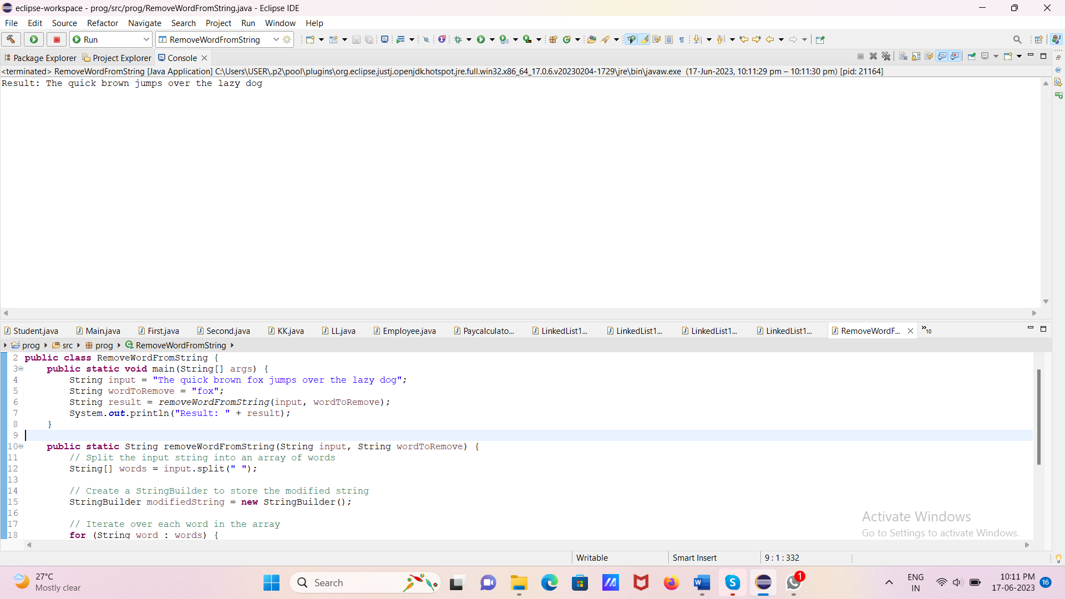

7.RemovefirstAndLastCharacter:

public class RemoveFirstAndLastCharacter {

public static void main(String[] args) {

String input = "Hello, World!";

String result = removeFirstAndLastCharacter(input);

System.out.println("Result: " + result);

}

public static String removeFirstAndLastCharacter(String input) {

if (input.length() <= 2) {

return "";

} else {

return input.substring(1, input.length() - 1);

}

}

}

OUTPUT:

