1.What is the difference between Selenium IDE, Selenium RC and WebDriver?

Selenium IDE | Selenium RC | Selenium WebDriver
It only works in Mozilla browser. | It supports with all browsers like Firefox, IE, Chrome, Safari, Opera etc. | It supports with all browsers like Firefox, IE, Chrome, Safari, Opera etc.
It supports Record and playback | It doesn’t supports Record and playback | It doesn’t supports Record and playback
Doesn’t required to start server before executing the test script. | Required to start server before executing the test script. | Doesn’t required to start server before executing the test script.

The difference between Selenium IDE vs WebDriver is pretty simple. IDE is a tool for recording test cases and for playback of those tests. WebDriver is a tool for writing test cases in programmatic fashion. That is what you need to know on a higher level.
Definition: Selenium WebDriver is a collection of open source APIs which are used to automate the testing of a web application. Description: Selenium WebDriver tool is used to automate web application testing to verify that it works as expected. It supports many browsers such as Firefox, Chrome, IE, and Safari.

2.Difference between css and xpath?

While CSS selector and XPath are popular among Selenium users, CSS selector is highly recommended over XPath due to its simplicity, speed, and performance.
One of the important differences between XPath and CSS is, with XPath we can search elements backward or forward in the DOM hierarchy while CSS works only in a forward direction. This means that with XPath we can locate a parent element using a child element.

Featured snippet from the web
3.Can we enter text without using 'sendKeys()'?
Yes using java executor and robotclasss and keyboard class
4.How can you find if an element in displayed on the screen?
IsDisplayed

5.Explain what is assertion in Selenium and what are the types of assertion?
To validate whther the expected and actual are sam e
Selenium Assertions can be of three types: “assert”, “verify”, and ” waitFor”. When an “assert” fails, the test is aborted. When a “verify” fails, the test will continue execution, logging the failure. A “waitFor” command waits for some condition to become true
Assertions verify that the state of the application is same to what we are expecting. Selenium Assertions can be of three types: “assert”, “verify”, and ” waitFor”. When an “assert” fails, the test is aborted. When a “verify” fails, the test will continue execution, logging the failure

6.How do you use AutoIt?
Selenium is an open source tool that is designed to automate web-based applications on different browsers but to handle window GUI and non HTML popups in application. AutoIT is required as these window based activity are not handled by Selenium.
7.How do we handle frame related issues in selenium?
When the testcase fail...then we check for th correct iframe and then use iit
.How you will handle dynamic elements in selenium?

Writing userdefined xxpath

.How to add/upload Images or files from System?
ploading files in WebDriver is done by simply using the sendKeys() method on the file-select input field to enter the path to the file to be uploaded. ...
Sendkeys

How do we use a date picker in selenium ?
Go to http://www.turkishairlines.com/tr-tr/ website
- Maximize browser
- Get Current Day as a number
- Get “from date“‘s date-picker. It comprises of all weeks as TR and all days as TD. It is shown as below.
- Get all TDs because TDs are the days of the month and hold them into a WebElements list.
- Do a for loop over all TDs and when a TD’s text is equal to current day’s number then click that element.
(If you want you can click any day. You need to change if condition’s comparison. I gave an example into code as 18th day of the month but it is commented.)

and locate

To handle this type of control first we will fill date without separating with delimiter, i.e. if date is 09/25/2013, then we will pass 09252013 to the input box.

1.How do we perform scroll down operation?
Javaexecutor
12.What are the different types locators in selenium?
By id
by name NAM

by Class Naame
CSS selector
Xpath
linked Text
partial linked text
TagName

3.How do you get all elements with same tag name?

links= driver.findElements(By.tagName("a")); //storing the size of the links
int i= links.size(); //Printing the size of the string System.out.println(i);

for(int j=0; j<i; j++) {

//Printing the links

System.out.println(links.get(j).getText()); } //Closing the browser driver.close(); } }

Search Results

4.What is selenium GRID?
Selenium Grid is a smart proxy server that makes it easy to run tests in parallel on multiple machines. ... Hub conducts a concurrent execution of tests on multiple machines, managing different browsers centrally, instead of conducting different tests for each of them
5.How can you automate windows pop-up in selenium?
Robot class
autoit
sukoli
6.How do you validate an option is in a dropdown as default option?

<!DOCTYPE html>
<html>

<head>
<title>
set the default value for <select> element
</title>
</head>

<body>
<h1 style="color: green">GeeksforGeeks</h1>
<b>
How to set the default
value for an HTML <select> element?
</b>
<p>The Starter option will be selected by default</p>
<p>Choose your plan below:</p>

<select name="plan" id="plan">
<option value="free">Free</option>
<option value="starter" selected>Starter </option>
<option value="professional">Professional</option>
<option value="corporate">Corporate</option>
</select>
</body>

</html>
<option value="value" selected>Option Name</option>

The select tag in HTML is used to create a dropdown list of options which can be selected. The option tag contains the value that would be used when selected.
The default value of the select element can be set by using the ‘selected’ attribute on the required option. This is a boolean attribute.
The option that is having the ‘selected’ attribute will be displayed by default on the dropdown list.
String foo =
Selenium.getText("//select[@id='bar']/option[@selected='selected']");
Regards
What is the difference between '/' and '//'?
// parent
/ child
What is the difference between '/' and '//'?

18.How do you handle alert windows?
Driver.switch.alert.accept
.senkeys
.dismisas

9.How do we handle switching between windows in selenium?
Driver.getWindowHAndles
0.Difference b/w verify and assert? When assert fails the execution why do you need to use it?

Wil

0.Difference b/w verify and assert? When assert fails the execution why do you need to use it?

validation fails execeution partivular method fails

1.How you can perform parallel execution in selenium?
GRID
Selenium Grid is a smart proxy server that makes it easy to run tests in parallel on multiple machines. ... Hub conducts a concurrent execution of tests on multiple machines, managing different browsers centrally, instead of conducting different tests for each of them

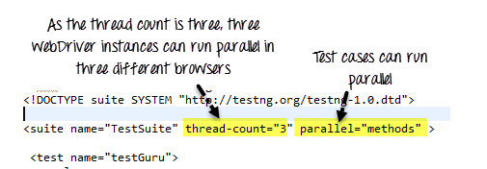

.How will you automate web table?
Create a list for finding the rows
and the from rows we put in for loop to print th and td valuess
23.How do you perform cross browser testing?

Your testing.xml will look like that,
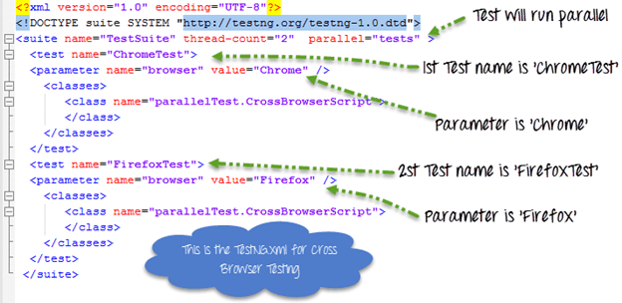
This testing.xml will map with the Test Case which will look like that
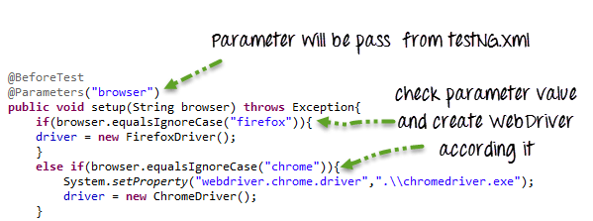
Here because the testing.xml has two Test tags ('ChromeTest','FirefoxTest'),this test case will execute two times for 2 different browsers.
First Test 'ChromeTest' will pass the value of parameter 'browser' as 'chrome' so ChromeDriver will be executed. This test case will run on Chrome browser.
Second Test 'FirefoxTest' will pass the value of parameter 'browser' as 'Firefox' so FirefoxDriver will be executed. This test case will run on FireFox browser.
24.When do we use findElement() and findElements()?
To find singk=le element
dropdown -findeleemnts
findElement: This command is used to uniquely identify a web element within the web page.
- findElements: This command is used to uniquely identify the list of web elements within the web page.

25.How do we select drop down content in Selenium?
Select class
26.What are the different types of waits available in WebDriver? Differences

Once you define implicit wait then it will wait for all findElement() and findElements(). Webdriver tries to find element in DOM after every polling time, if element is not found then it wait for polling time(0.5 Seconds) and again try to find the element until maximum time defined is over. If element is not found then it will throw NoSuchElementException.
Polling time can be changed using

1 | <span style="font-size: 16px;">wait.pollingEvery(1, TimeUnit.SECONDS);</span>

Usage:

1  2 | <span style="font-size: 16px;">WebDriver driver = new ChromeDriver();  driver.manage().timeouts().implicitlyWait(10, TimeUnit.SECONDS);</span>

In above code it will wait for maximum 10 seconds if element is not found within 10
Explicit wait:
Explicit wait would be defined to particular web element. It will wait for single web element. For example if one of the web element takes more time than implicit wait then instead of changing implicit wait time it is better to define explicit wait.
Usage:

1  2  3 | <span style="font-size: 16px;">WebDriver driver = new ChromeDriver();  WebDriverWait wait = new WebDriverWait(driver, 20);  WebElement element = wait.until(ExpectedConditions.elementToBeClickable(By.id(“username”)));</span>

Fluent wait:
Fluent wait is similar to explicit wait the difference is in fluent wait we can define polling time. And we can ignore the exception.
Usage:

1  2  3  4  5  6  7  8  9  10  11 | <span style="font-size: 16px;">Wait<WebDriver> wait = new FluentWait<WebDriver>(driver)  .withTimeout(50, SECONDS)  .pollingEvery(10, SECONDS)  .ignoring(NoSuchElementException.class);  WebElement Element = wait.until(new Function<WebDriver, WebElement>()  {  public WebElement apply(WebDriver driver) {  return driver.findElement(By.xpath("//button[text()='Login']"));  }  });</span>

7.How to capture screenshot in WebDriver?
//Convert web driver object to TakeScreenshot

TakesScreenshot scrShot =((TakesScreenshot)webdriver);

//Call getScreenshotAs method to create image file

File SrcFile=scrShot.getScreenshotAs(OutputType.FILE);

//Move image file to new destination

File DestFile=new File(fileWithPath);

//Copy file at destination

FileUtils.copyFile(SrcFile, DestFile);

