1. INTRODUCTION
   1. Overview

Social media refers to the means of interactions among people in

Which thry create,share,and /or exchange information and ideas

In virtual communities and networks.

* 1. Purpose

You can share information and ideas in a variety of ways .different

Outlets allow you to publish your own ideas in writing ,with pictures

,or through videos and voice recordings.

1. 2.1 Empathy map

Paste the empathy map screenshot

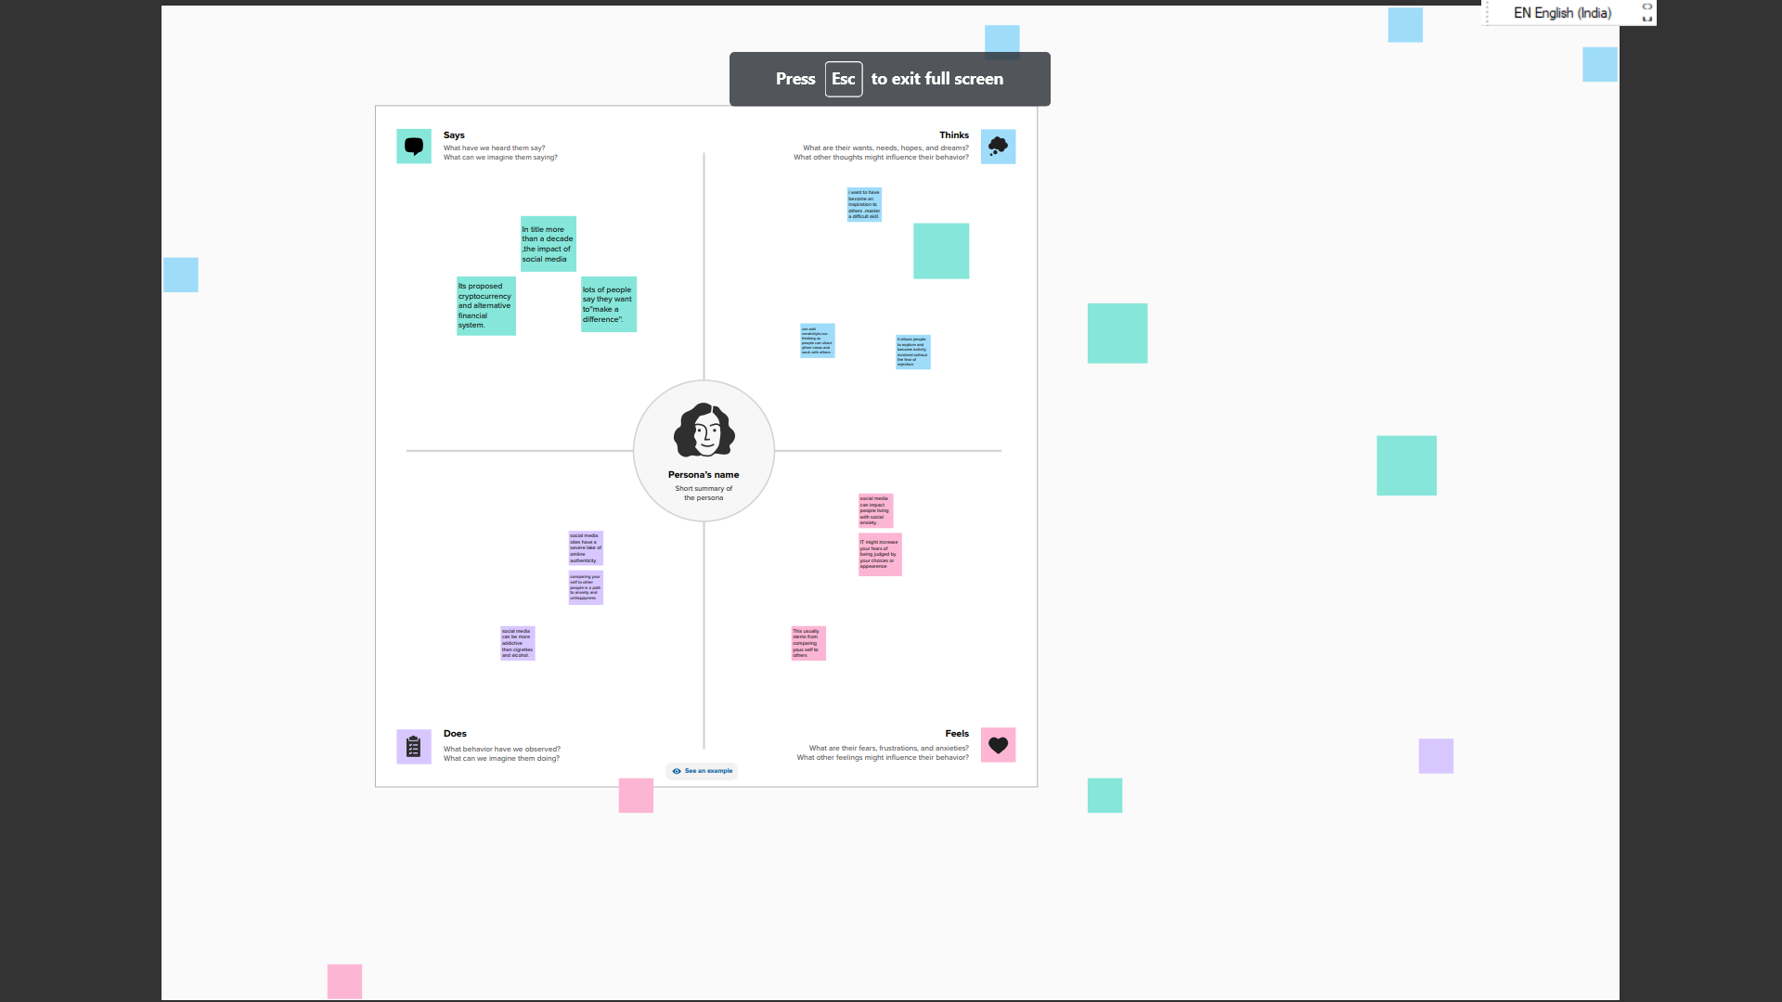

2.2 Ideation &Brainstorming map

Paste the ideation&brainstorming map screenshot.

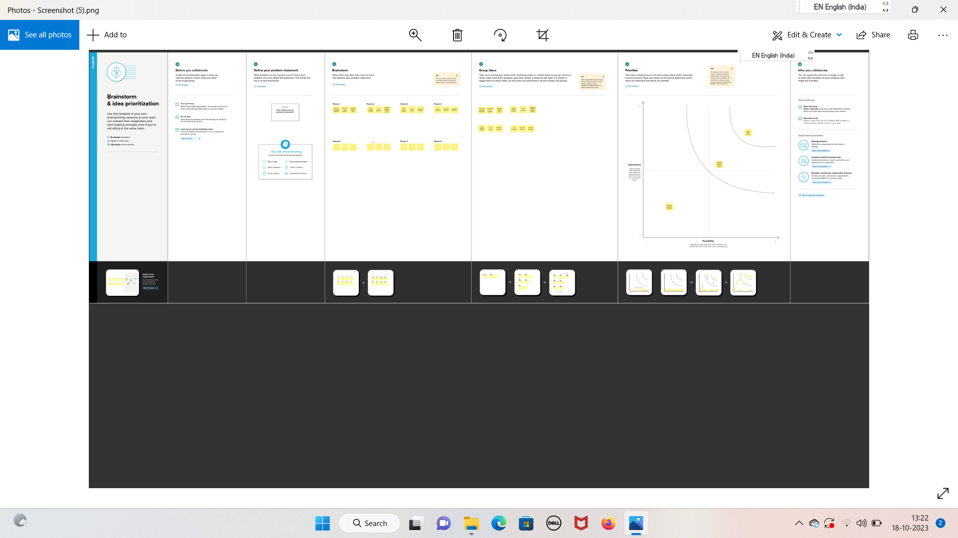

1. RESULT

Final flindings (out put) of the project along with screenshots

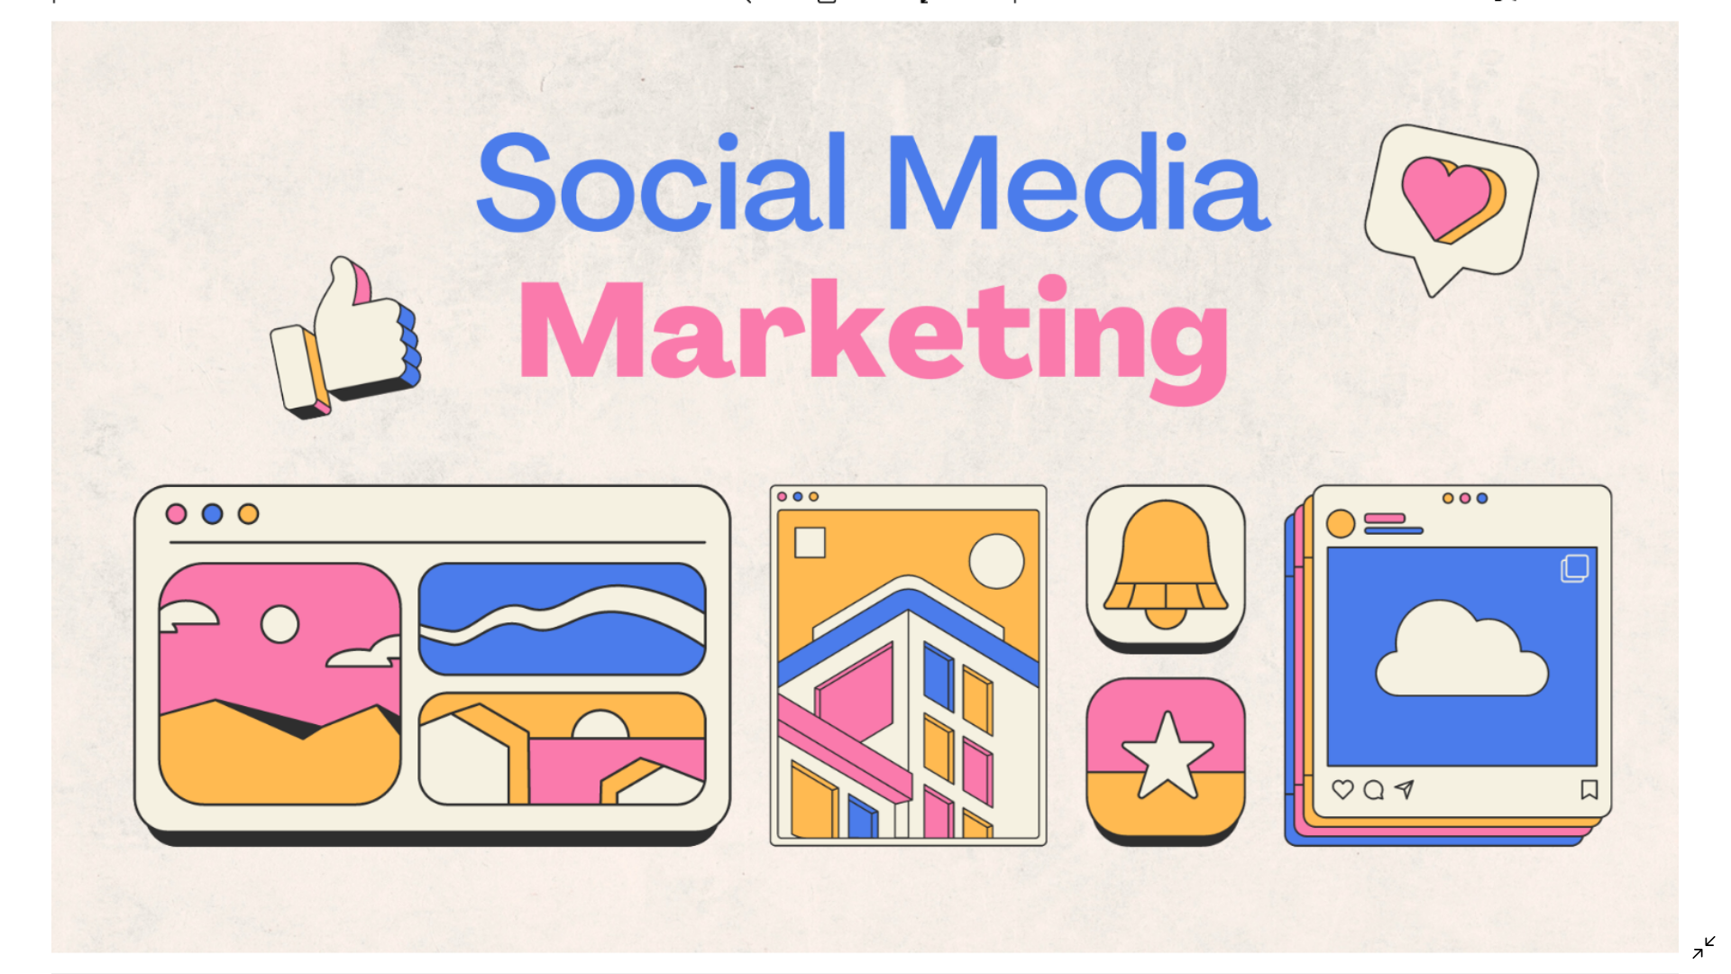

1. ADVANTAGES & DISADVANTAGES
2. Informations spreads fast
3. Lakhs emotional connection
4. Privacy problems
5. It helps you to achieve your goals
6. Online marketing
7. It changes life style habbits and it is

Sleep disruption.

5 APPLICATIONS

If you are looking ,opt for Instagram ,tiktok ,and snapchat.

For entertainment specializing in video format -choose you tube.

1. CONCLUSION

The excessive use of social media and internet has negative

Impacts on the lives of people.