
END-SEMESTER PROJECT REPORT
ON

MAT339 - TRANSFORMER MODELS AND SEQUENCE LEARNING

Submitted By
Student Name | : | HARINI S
Register Number | : | XXXXXXXXX
Programme | : | MSc - Data Science
Academic Year | : | 2026 – 2027
School | : | School of Arts, Sciences, Humanities & Education
Project Title | : | Comparative Analysis of BiLSTM, DistilBERT and BERT-base for Patient Sentiment Classification Using Drug Reviews

Internal Faculty Signature External Faculty Signature(s)
Contents
Abstract 5
1 Introduction 6
2 Problem Statement 8
3 Objectives 9
4 Dataset Description 10
5 Methodology 13
6 Experimental Setup 17
7 Evaluation Metrics 19
8 Results and Analysis 20
9 Sample Predictions 27
10 Discussion 29
11 Limitations 31
12 Future Enhancements 32
Bibliography 33
A Source Code 35
List of Figures
4.1 Binary class distribution (left) and review length in words (right) 11
5.1 Overall pipeline of the comparative study 13
8.1 Row-normalised confusion matrices on the three-class test set 21
8.2 BERT-base learning curves in the three-class experiment (loss, accuracy, validation macro-F1) 22
8.3 Row-normalised confusion matrices with counts on the binary test set 23
8.4 ROC curves of the three models on the binary test set 23
8.5 Binary test accuracy with 95% CI, test macro-F1, train–validation gap and per-class F1 24
8.6 Test macro-F1 and accuracy in the three-class and binary experiments 24
8.7 BERT-base learning curves in the binary experiment (loss, macro-F1, accuracy) 25
List of Tables
3.1 Overview of the two experiments 9
4.1 Columns of the Drugs.com dataset 10
4.2 Rating distribution and binary labels (after de-duplication) 11
4.3 Stratified data splits used in the two experiments 11
5.1 Architectural comparison of the models 15
6.1 Hyperparameters in Experiment 2 (binary) 17
7.1 Evaluation metrics 19
8.1 Three-class test results (E1, n = 3,422) 20
8.2 Per-class precision / recall / F1 in the three-class experiment 20
8.3 Paired McNemar tests on the three-class test set (α = 0.0167) 21
8.4 Binary test results (E2, n = 12,811) 22
8.5 Per-class precision / recall / F1 in the binary experiment 22
8.6 Paired McNemar tests on the binary test set (α = 0.0167) 23
8.7 Train–validation gap at the best epoch 25
8.8 Model size and training cost in E2 (Tesla T4) 25
8.9 Summary of findings 26
9.1 Sample BERT-base errors on the binary test set 27
10.1 Recommended model by use case 30

Abstract
Online drug reviews describe how patients actually experience a medicine: whether it worked, which side effects appeared and whether they would take it again. Reading tens of thousands of such reviews by hand is slow, so automatic sentiment classification is useful for pharmacovigilance teams, pharmacies and health platforms. This project compares a sequence-learning model, the Bidirectional Long Short-Term Memory network (BiLSTM), with two Transformer language models, DistilBERT and BERT-base, for classifying patient sentiment in the Drugs.com review dataset (215,063 reviews; 128,108 after cleaning and de-duplication).
Two labelling schemes derived from the 1–10 star rating were studied. In Experiment 1 the reviews were split into three classes (Negative 1–4, Neutral 5–6, Positive 7–10) and each class was down-sampled to 11,407 reviews. In Experiment 2 the Neutral class was removed by dividing the ten rating levels evenly into Negative (1–5) and Positive (6–10), and all reviews were used with a class-weighted loss. Models were evaluated on held-out test sets with accuracy, macro precision, macro recall, macro-F1, confusion matrices, ROC-AUC and paired McNemar tests.
BERT-base was the strongest model in both experiments. In the three-class task it reached a macro-F1 of 0.721 against 0.696 for DistilBERT and 0.612 for BiLSTM; Neutral was the hardest class for every model (F1 0.49–0.62). In the binary task the scores rose to 0.882 (BERT-base), 0.880 (DistilBERT) and 0.846 (BiLSTM), with test accuracy of 90.1%, 90.0% and 86.9%. Both Transformers were significantly better than BiLSTM (p < 10⁻²⁸), but the 0.2-point gap between BERT-base and DistilBERT was not significant (p = 0.455), even though DistilBERT has 39% fewer parameters and trained in half the time. With more training data and stronger regularisation, the train–validation macro-F1 gap stayed at or below 0.076 for all models. For binary patient-sentiment screening, DistilBERT therefore offers the best balance of accuracy and cost.
Keywords: sentiment analysis, drug reviews, BiLSTM, BERT, DistilBERT, Transformers, self-attention, sequence learning, class imbalance, macro-F1, McNemar test
Chapter 1

Introduction
Patients increasingly share their experiences with medicines on public websites such as Drugs.com and WebMD. A single review may mention the condition being treated, how quickly the drug worked, the side effects that appeared and whether the patient would recommend it. Taken together, these reviews are a large and freely available record of real-world treatment experience that complements clinical trials, which are run on small and carefully selected groups of people.
The volume of this text makes manual analysis impractical. The Drugs.com dataset used here alone contains more than 200,000 reviews covering thousands of drugs and conditions. Sentiment classification, the task of deciding whether a piece of text expresses a positive, neutral or negative opinion, offers a way to summarise this information automatically. A reliable classifier can flag drugs that attract unusually negative feedback, track how opinion changes after a new side effect is reported, or help a health platform surface the most informative reviews.
Patient reviews are harder to classify than film or product reviews. They mix medical vocabulary with everyday language, describe side effects in detail even when the overall experience is positive, and often contrast an early bad period with later improvement ("the first two weeks were awful but now I feel great"). The meaning of a review therefore depends on word order and long-range context, which is exactly what sequence models and Transformer models are designed to capture.
This project compares the two main families of models studied in the course. The BiLSTM reads a review word by word in both directions and is trained from scratch. DistilBERT and BERT-base are pre-trained Transformer encoders that use self-attention to relate every word to every other word and are fine-tuned on the reviews. Comparing them on the same data, with the same metrics, shows how much pre-training and attention add, and at what computational cost.

1.1 Contributions
- A cleaned, de-duplicated and leakage-checked version of the Drugs.com review dataset with two rating-based labelling schemes.
- A controlled comparison of BiLSTM, DistilBERT and BERT-base on a three-class task (Negative / Neutral / Positive) and a binary task (Negative / Positive).
- An improved training recipe for imbalanced data: class-weighted loss, label smoothing, warm-up scheduling, early stopping on validation macro-F1 and decision thresholds tuned on the validation set only.
- A statistical comparison using 95% confidence intervals and paired McNemar tests, together with model size and training-time measurements.
- An error analysis of the reviews that all models find difficult.

1.2 Organisation of the Report
Chapter 2 states the problem and the research questions, and Chapter 3 lists the objectives. Chapter 4 describes the dataset and the two labelling schemes. Chapter 5 explains the three models and the training recipe, Chapter 6 the experimental set-up and Chapter 7 the evaluation metrics. Chapter 8 presents the results, Chapter 9 analyses sample predictions and errors, and Chapters 10 to 12 discuss the findings, the limitations and future work. The complete source code is given in Appendix A.
Chapter 2

Problem Statement
Given the free text of a patient’s drug review, the goal is to predict the patient’s overall sentiment towards the drug. The Drugs.com dataset does not contain sentiment labels written by annotators. It does, however, contain the star rating (1–10) that the patient gave together with the review, so the rating can be used as a weak but objective label.
Two questions make the problem non-trivial. First, it is not obvious how ratings should be mapped to classes: a 5 or a 6 may express mixed feelings, and a separate Neutral class may be too vague to learn. Second, the dataset is heavily skewed towards positive reviews, so a model can reach high accuracy while largely ignoring negative or neutral ones. The comparison must therefore use metrics that treat every class equally.

2.1 Formal Statement
Let a review be a sequence of tokens x = (w₁, w₂, …, w_n) with rating r ∈ {1, …, 10}. A labelling function g maps the rating to a class y = g(r). In the three-class task y ∈ {Negative, Neutral, Positive}; in the binary task y ∈ {Negative, Positive}. Each model f learns a probability distribution over classes, and the predicted class is the one with the highest (threshold-adjusted) probability:
ŷ = argmax_c P(y = c | x) , chosen to maximise macro-F1 on unseen reviews

2.2 Research Questions
- RQ1. Do pre-trained Transformer models (DistilBERT, BERT-base) classify patient sentiment better than a BiLSTM trained from scratch?
- RQ2. Is the full BERT-base model significantly better than the smaller DistilBERT, and is the extra cost worth it?
- RQ3. How does removing the Neutral class (three classes versus two) change the performance of each model?
- RQ4. Can overfitting be kept under control when fine-tuning large Transformers on this dataset?
Chapter 3

Objectives
The project has the following objectives:
- Prepare the Drugs.com review dataset: decode HTML entities, remove very short and duplicate reviews, and check that no review appears in more than one data split.
- Derive sentiment labels from the patient rating using a three-class scheme and a balanced binary scheme (five rating levels per class).
- Implement and train a BiLSTM sequence-learning model as a strong non-Transformer baseline.
- Fine-tune two Transformer models, DistilBERT and BERT-base, under one shared training recipe.
- Evaluate all models with accuracy, macro precision, macro recall, macro-F1 and confusion matrices, and test whether the differences are statistically significant.
- Analyse overfitting, model size and training time, and identify the strengths and limitations of sequence-learning and Transformer approaches.
Table 3.1 summarises how the two experiments relate to these objectives.
Table 3.1: Overview of the two experiments
Experiment | Classes | Rating mapping | Training data
E1 – three-class | Negative, Neutral, Positive | 1–4 / 5–6 / 7–10 | Balanced, 23,954 reviews
E2 – binary | Negative, Positive | 1–5 / 6–10 | Full, 102,486 reviews (class-weighted)

Chapter 4

Dataset Description
The study uses the Drug Review Dataset (Drugs.com) collected by Gräßer et al. (2018) and distributed on the UCI Machine Learning Repository and on Kaggle (“UCI ML Drug Review dataset”, jessicali9530/kuc-hackathon-winter-2018). It is supplied as a training file and a test file, which were merged and re-split for this study. Table 4.1 lists the columns.
Table 4.1: Columns of the Drugs.com dataset
Column | Description | Used
uniqueID | Identifier of the review | No
drugName | Name of the drug reviewed | No (error analysis only)
condition | Condition the drug was taken for | No
review | Free-text patient review | Yes – model input
rating | Patient rating from 1 (worst) to 10 (best) | Yes – label source
date | Date the review was posted | No
usefulCount | Number of users who found the review useful | No

4.1 Cleaning and De-duplication
The raw files contain 215,063 reviews. HTML entities such as &#039; were decoded, repeated whitespace and surrounding quotes were removed, and reviews with fewer than three words were dropped. Many reviews are listed several times because the same text is attached to different brand and generic names of a drug. If such copies fell into both the training and the test set, the test score would be inflated, so exact duplicates were removed. This left 128,114 unique reviews in Experiment 1 and 128,108 in Experiment 2 (the second pipeline strips one extra layer of surrounding whitespace, which merges six more duplicates). After splitting, the code asserts that no review text occurs in more than one split.

4.2 Labelling Schemes
Table 4.2 shows how each rating level was mapped to a class in the binary scheme, together with the number of unique reviews. The distribution is strongly skewed: rating 10 alone accounts for 31.6% of all reviews, and rating 1 is the second most common value. Patients therefore tend to write when they are either very satisfied or very dissatisfied.
Table 4.2: Rating distribution and binary labels (after de-duplication)
Rating | 1 | 2 | 3 | 4 | 5 | 6 | 7 | 8 | 9 | 10
Reviews | 17,390 | 5,410 | 5,073 | 3,897 | 6,376 | 5,034 | 7,546 | 15,035 | 21,853 | 40,494
Binary label | Neg | Neg | Neg | Neg | Neg | Pos | Pos | Pos | Pos | Pos
Three-class label | Neg | Neg | Neg | Neg | Neu | Neu | Pos | Pos | Pos | Pos

Three-class scheme (E1). Ratings 1–4 are Negative (31,772 reviews), 5–6 Neutral (11,407) and 7–10 Positive (84,935). Neutral is the smallest class. To give every class equal weight, each class was randomly down-sampled to 11,407 reviews (34,221 in total).
Binary scheme (E2). The ten rating levels are divided evenly: ratings 1–5 are Negative (38,146 reviews, 29.8%) and ratings 6–10 are Positive (89,962 reviews, 70.2%). No reviews are discarded; the imbalance is handled in the loss function instead (Section 5.4).
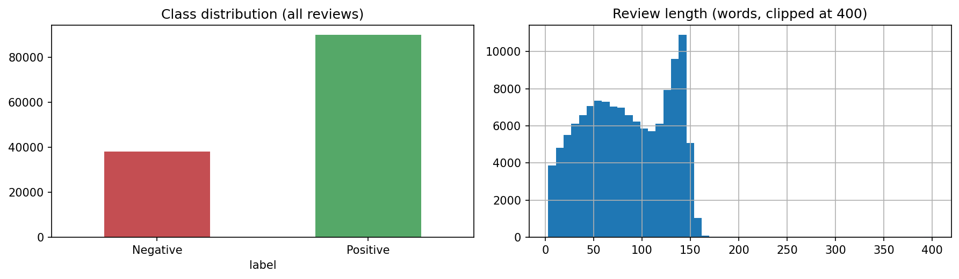
Figure 4.1: Binary class distribution (left) and review length in words (right)
Figure 4.1 also shows that most reviews are between 20 and 160 words long, with a sharp drop after about 150 words, which suggests a length limit on the website. A maximum input length of 256 tokens therefore covers nearly every review in full.

4.3 Data Split and Leakage Control
Table 4.3: Stratified data splits used in the two experiments
Split | E1 three-class (Neg / Neu / Pos) | E2 binary (Neg / Pos)
Train | 23,954 (7,985 / 7,985 / 7,984) | 102,486 (30,517 / 71,969)
Validation | 3,422 (1,140 / 1,141 / 1,141) | 12,811 (3,814 / 8,997)
Test | 3,422 (1,141 / 1,140 / 1,141) | 12,811 (3,815 / 8,996)
Reserve (unused) | 3,423 | –
Proportions | 70 / 10 / 10 / 10 | 80 / 10 / 10

All splits were stratified by class with a fixed random seed (42). The validation set was used for early stopping and threshold tuning, and the test set was used only once, for the final evaluation. In Experiment 1 an extra 10% reserve split was held back for a separate downstream study and is not used in this report. Because Experiment 1 uses a balanced test set and Experiment 2 the natural class distribution, absolute scores across the two experiments are compared with care in Chapter 8.
Chapter 5

Methodology
Figure 5.1 shows the overall pipeline. The same cleaned reviews and the same splits are given to all three models, and all predictions are evaluated by the same code, so that differences in the results come from the models and not from the data.
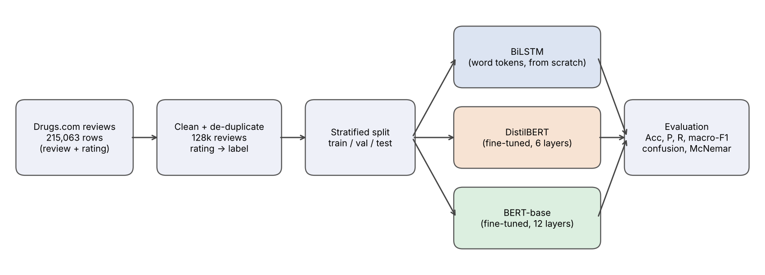
Figure 5.1: Overall pipeline of the comparative study

5.1 BiLSTM (Sequence Learning)
A recurrent neural network reads a sequence one token at a time and keeps a hidden state that summarises what it has read so far. The Long Short-Term Memory (LSTM) cell (Hochreiter and Schmidhuber, 1997) adds a memory cell and three gates, so that information can be kept over long distances without the gradient vanishing:
- Forget gate – decides which part of the previous memory to discard.
- Input gate – decides which new information to write into the memory.
- Output gate – decides which part of the memory to expose as the hidden state.
A bidirectional LSTM (Schuster and Paliwal, 1997) runs one LSTM from left to right and a second one from right to left and concatenates their hidden states, so that the representation of each word sees both its left and its right context. This matters for reviews such as “not bad at all”, where the meaning of “bad” depends on the words around it.
Architecture (E2). Reviews are lower-cased and split into word tokens; a vocabulary of the 27,667 words that occur at least twice in the training set is built (unknown words map to <unk>). Each word is mapped to a 200-dimensional embedding learned from scratch, followed by a two-layer BiLSTM with 128 hidden units per direction. The output sequence is summarised by concatenating max-pooling and mean-pooling over time (ignoring padding), and a linear layer produces the class scores. Dropout is applied to the embeddings (0.3), between LSTM layers (0.3) and before the output layer (0.4). The model has 6.27 million parameters, most of them in the embedding table. In E1 a smaller single-layer version (128-dimensional embeddings, max-pooling only, dropout 0.5, vocabulary 13,700) was used.

5.2 Transformer Encoder and Self-Attention
The Transformer (Vaswani et al., 2017) replaces recurrence with self-attention. Every token is projected to a query, a key and a value vector. The attention weight between two tokens is the similarity of the first token’s query with the second token’s key, and each token’s new representation is the attention-weighted average of all value vectors:
Attention(Q, K, V) = softmax( Q Kᵀ / √d_k ) V
Because every token attends to every other token in one step, a word at the end of a review can directly use information from the beginning, and the computation runs in parallel over the whole sequence. Multi-head attention repeats this with several independent sets of projections, and each layer adds a feed-forward network, residual connections and layer normalisation. Position embeddings tell the model where each token is in the sequence.

BERT-base
BERT (Devlin et al., 2019) is a stack of 12 Transformer encoder layers with a hidden size of 768 and 12 attention heads (about 110 million parameters). It is pre-trained on BooksCorpus and English Wikipedia with masked-language modelling, predicting randomly hidden words from both sides, and next-sentence prediction. Text is split into WordPiece sub-words, so rare drug names are broken into known pieces instead of becoming unknown tokens. For classification, the final hidden state of the special [CLS] token is passed to a linear output layer, and the whole network is fine-tuned on the reviews.

DistilBERT
DistilBERT (Sanh et al., 2019) is a compressed version of BERT obtained by knowledge distillation: a 6-layer student network is trained to reproduce the outputs of the 12-layer BERT teacher. The original authors report that it keeps about 97% of BERT’s language-understanding performance while being 40% smaller and 60% faster. It uses the same WordPiece vocabulary, and its classification head adds one extra hidden layer before the output layer.

5.3 Comparison of the Three Models
Table 5.1: Architectural comparison of the models
Property | BiLSTM | DistilBERT | BERT-base
Family | Recurrent (sequence learning) | Transformer encoder | Transformer encoder
Layers | 2 BiLSTM layers | 6 | 12
Context handling | Sequential, both directions | Self-attention, all tokens | Self-attention, all tokens
Tokenisation | Words (27.7k vocabulary) | WordPiece (30.5k) | WordPiece (30.5k)
Pre-training | None (trained from scratch) | Distilled from BERT | Masked LM + next sentence
Parameters (binary) | 6.27 M | 66.96 M | 109.48 M

5.4 Handling Class Imbalance and Overfitting
The first version of the notebook (used for E1) showed a clear overfitting pattern for the Transformers: training accuracy kept rising while validation loss increased after the first epoch, and the train–validation accuracy gap reached 0.145 for DistilBERT. The second pipeline (E2) therefore combines several remedies in one weighted, label-smoothed loss and a careful training schedule:
L = − w_y · Σ_c q_c log p_c , with q_c = (1 − ε) · [c = y] + ε / C
Here w_y is the class weight, ε the label-smoothing factor and C the number of classes. The individual remedies are:
- More data. All 102,486 training reviews are used instead of a down-sampled subset; more data is the most effective protection against memorisation.
- Class-weighted cross-entropy. Each class is weighted by the square root of its inverse frequency (Negative 1.211, Positive 0.789), so that errors on the smaller class cost more.
- Label smoothing. Targets are softened (ε = 0.1 for Transformers, 0.05 for BiLSTM) to discourage over-confident predictions.
- Regularisation. Weight decay (AdamW), dropout in the classification heads and gradient clipping at norm 1.0.
- Learning-rate schedule. Linear warm-up over the first 10% of steps followed by linear decay for the Transformers; reduce-on-plateau for the BiLSTM.
- Early stopping. Training stops when validation macro-F1 stops improving, and the weights of the best validation epoch are restored.
- Threshold tuning. A bias added to the Negative log-probability is chosen on the validation set to maximise macro-F1 and then applied unchanged to the test set.
Chapter 6

Experimental Setup

6.1 Environment
All experiments were run in Google Colab on a single NVIDIA Tesla T4 GPU (16 GB) with Python, PyTorch, Hugging Face Transformers and scikit-learn. Transformer training used automatic mixed precision (float16) to reduce memory and time. The random seed was fixed to 42 for Python, NumPy and PyTorch, and cuDNN was set to deterministic mode in E2.

6.2 Hyperparameters
Table 6.1: Hyperparameters in Experiment 2 (binary)
Setting | BiLSTM | DistilBERT | BERT-base
Max input length | 256 words | 256 tokens | 256 tokens
Batch size | 128 | 32 | 32
Optimiser | AdamW | AdamW | AdamW
Learning rate | 2e-3 | 3e-5 | 2e-5
Weight decay | 1e-4 | 0.01 | 0.01
Schedule | Reduce on plateau (×0.5) | 10% warm-up, linear decay | 10% warm-up, linear decay
Max epochs / patience | 15 / 3 | 3 / 1 | 3 / 1
Dropout | 0.3 / 0.3 / 0.4 | 0.1 + head 0.2 | 0.1 + head 0.2
Label smoothing | 0.05 | 0.1 | 0.1
Class weights | Yes | Yes | Yes
Gradient clipping | 1.0 | 1.0 | 1.0

Experiment 1 used the earlier recipe: BiLSTM with Adam (lr 1e-3, weight decay 1e-5), max length 200 and up to 15 epochs; DistilBERT and BERT-base with AdamW (lr 2e-5), 6% warm-up, max length 200, head dropout 0.3, up to 4 epochs with patience 1, unweighted cross-entropy and no label smoothing. Because its classes were balanced by down-sampling, class weights were not needed.

6.3 Experiments
- E1 – Three-class comparison: BiLSTM, DistilBERT and BERT-base on the balanced Negative / Neutral / Positive task.
- E2 – Binary comparison: the same three models on the full Negative (1–5) / Positive (6–10) task with the improved training recipe.
- E3 – Cross-experiment analysis: the effect of removing the Neutral class, overfitting behaviour, and the accuracy–cost trade-off.

6.4 Evaluation Protocol
After every epoch, each model was evaluated in inference mode on the validation set and on a fixed random subset of the training set (6,000 reviews in E1, 8,000 in E2). Comparing the two shows how far the model fits the training data beyond what generalises. The checkpoint with the best validation macro-F1 was kept. Final metrics were computed once on the test set.
Chapter 7

Evaluation Metrics
Because the classes are not equally frequent, accuracy alone can hide poor performance on the smaller class. Several complementary metrics were therefore reported (Table 7.1). TP, FP and FN denote true positives, false positives and false negatives for one class treated as the positive class.
Table 7.1: Evaluation metrics
Metric | Definition | What it shows
Accuracy | Correct predictions / all predictions | Overall correctness
Precision | TP / (TP + FP) | How trustworthy a predicted label is
Recall | TP / (TP + FN) | How many reviews of a class are found
F1-score | 2 · P · R / (P + R) | Balance of precision and recall
Macro-F1 | Unweighted mean of the per-class F1 | Main metric; every class counts equally
Weighted F1 | Per-class F1 weighted by class size | Performance on the natural mix
ROC-AUC | Area under the ROC curve (binary only) | Ranking quality, independent of threshold
Confusion matrix | Counts of true versus predicted class | Which classes are confused

7.1 Confidence Interval for Accuracy
For a test set of n reviews and accuracy a, the 95% confidence interval was approximated with the normal approximation to the binomial distribution:
a ± 1.96 × √( a (1 − a) / n )

7.2 McNemar Test
Two models evaluated on the same test reviews are not independent, so their accuracies cannot be compared with an ordinary two-sample test. The McNemar test (McNemar, 1947; Dietterich, 1998) uses only the reviews on which the models disagree: b reviews that only model A classifies correctly and c reviews that only model B classifies correctly. Under the null hypothesis that both models are equally accurate, b follows a Binomial(b + c, 0.5) distribution, and an exact two-sided binomial test gives the p-value. With three pairwise comparisons, a Bonferroni-corrected significance level of 0.05 / 3 = 0.0167 was used.
Chapter 8

Results and Analysis

8.1 Experiment 1: Three-Class Sentiment
Table 8.1 reports the test results of the three-class experiment. The test set is balanced, with about 1,140 reviews per class.
Table 8.1: Three-class test results (E1, n = 3,422)
Model | Accuracy (95% CI) | Macro P | Macro R | Macro-F1 | Val. macro-F1
BiLSTM | 0.616 ± 0.016 | 0.611 | 0.616 | 0.612 | 0.624
DistilBERT | 0.695 ± 0.015 | 0.697 | 0.695 | 0.696 | 0.708
BERT-base | 0.718 ± 0.015 | 0.728 | 0.718 | 0.721 | 0.726

BERT-base is best on every metric, followed by DistilBERT and then BiLSTM. The Transformers improve macro-F1 by 8.4 (DistilBERT) and 10.9 (BERT-base) points over the BiLSTM. Table 8.2 breaks the F1-score down by class.
Table 8.2: Per-class precision / recall / F1 in the three-class experiment
Class | BiLSTM | DistilBERT | BERT-base
Negative | 0.663 / 0.630 / 0.646 | 0.716 / 0.743 / 0.729 | 0.743 / 0.734 / 0.738
Neutral | 0.516 / 0.458 / 0.485 | 0.573 / 0.583 / 0.578 | 0.590 / 0.661 / 0.623
Positive | 0.655 / 0.761 / 0.704 | 0.802 / 0.758 / 0.780 | 0.851 / 0.758 / 0.802

Neutral is clearly the hardest class for all three models: the best Neutral F1 (0.623) is 18 points below the best Positive F1. The confusion matrices in Figure 8.1 show why. About a quarter of Negative reviews and a fifth of Positive reviews are predicted as Neutral, and Neutral reviews are spread over all three columns. Very few Negative reviews are predicted as Positive (2–3% for the Transformers), so the models clearly separate the two ends of the scale but struggle with the middle.
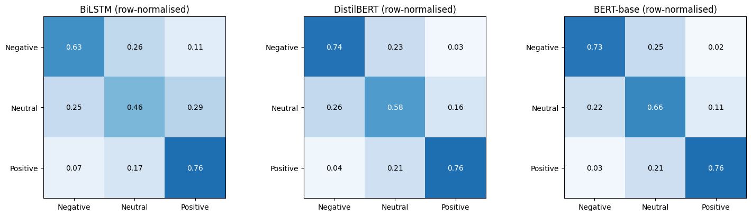
Figure 8.1: Row-normalised confusion matrices on the three-class test set
Table 8.3: Paired McNemar tests on the three-class test set (α = 0.0167)
Comparison | Only A correct | Only B correct | p-value | Result
BiLSTM (A) vs DistilBERT (B) | 306 | 575 | < 0.0001 | Significant
BiLSTM (A) vs BERT-base (B) | 282 | 629 | < 0.0001 | Significant
DistilBERT (A) vs BERT-base (B) | 177 | 255 | 0.0002 | Significant

All three differences are statistically significant. In the three-class task the larger BERT-base model therefore gives a real gain over DistilBERT, mainly through better Neutral recall (0.661 versus 0.583).

Training behaviour in E1
Figure 8.2 shows the learning curves of BERT-base in E1. Validation loss is lowest after the first epoch and rises afterwards, while training accuracy keeps climbing to 0.90. Early stopping kept the epoch-2 weights, where the train–validation accuracy gap was 0.115 (0.145 for DistilBERT at its best epoch 3, and 0.031 for BiLSTM). With only 23,954 training reviews, the large pre-trained models begin to memorise the training set within two or three epochs.
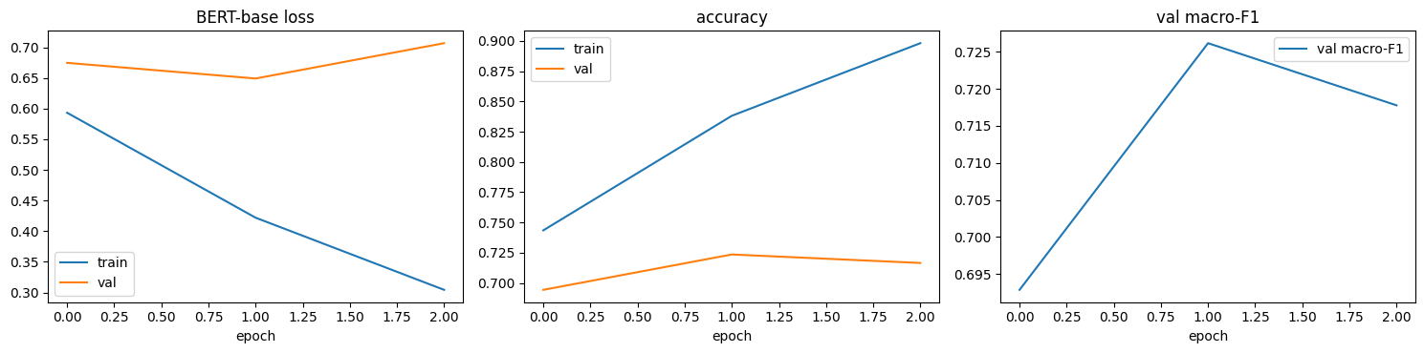
Figure 8.2: BERT-base learning curves in the three-class experiment (loss, accuracy, validation macro-F1)

8.2 Experiment 2: Binary Sentiment
Table 8.4: Binary test results (E2, n = 12,811)
Model | Accuracy (95% CI) | Macro P | Macro R | Macro-F1 | Weighted F1 | ROC-AUC
BiLSTM | 0.869 ± 0.006 | 0.841 | 0.851 | 0.846 | 0.870 | 0.934
DistilBERT | 0.900 ± 0.005 | 0.880 | 0.880 | 0.880 | 0.900 | 0.957
BERT-base | 0.901 ± 0.005 | 0.881 | 0.884 | 0.882 | 0.901 | 0.961

Table 8.4 shows that all three models perform much better on the binary task. BERT-base again leads on every metric, but only by a small margin over DistilBERT (0.882 versus 0.880 macro-F1). The BiLSTM is about 3.5 points behind in macro-F1 and 3 points behind in accuracy. The macro-F1 values are reported after threshold tuning on the validation set; with a plain argmax decision the values are almost identical (0.846, 0.880 and 0.884), so the ranking does not depend on this step.
Table 8.5: Per-class precision / recall / F1 in the binary experiment
Class (support) | BiLSTM | DistilBERT | BERT-base
Negative (3,815) | 0.767 / 0.804 / 0.785 | 0.830 / 0.833 / 0.832 | 0.829 / 0.842 / 0.835
Positive (8,996) | 0.915 / 0.897 / 0.906 | 0.929 / 0.928 / 0.928 | 0.932 / 0.926 / 0.929

The class-weighted loss keeps the smaller Negative class well recognised: Negative recall is 0.80–0.84 for every model, close to its precision, so the models are not biased towards the majority class. The main advantage of the Transformers lies in Negative precision (0.83 versus 0.77): the BiLSTM labels many more positive reviews as negative, typically reviews that describe side effects but end positively.
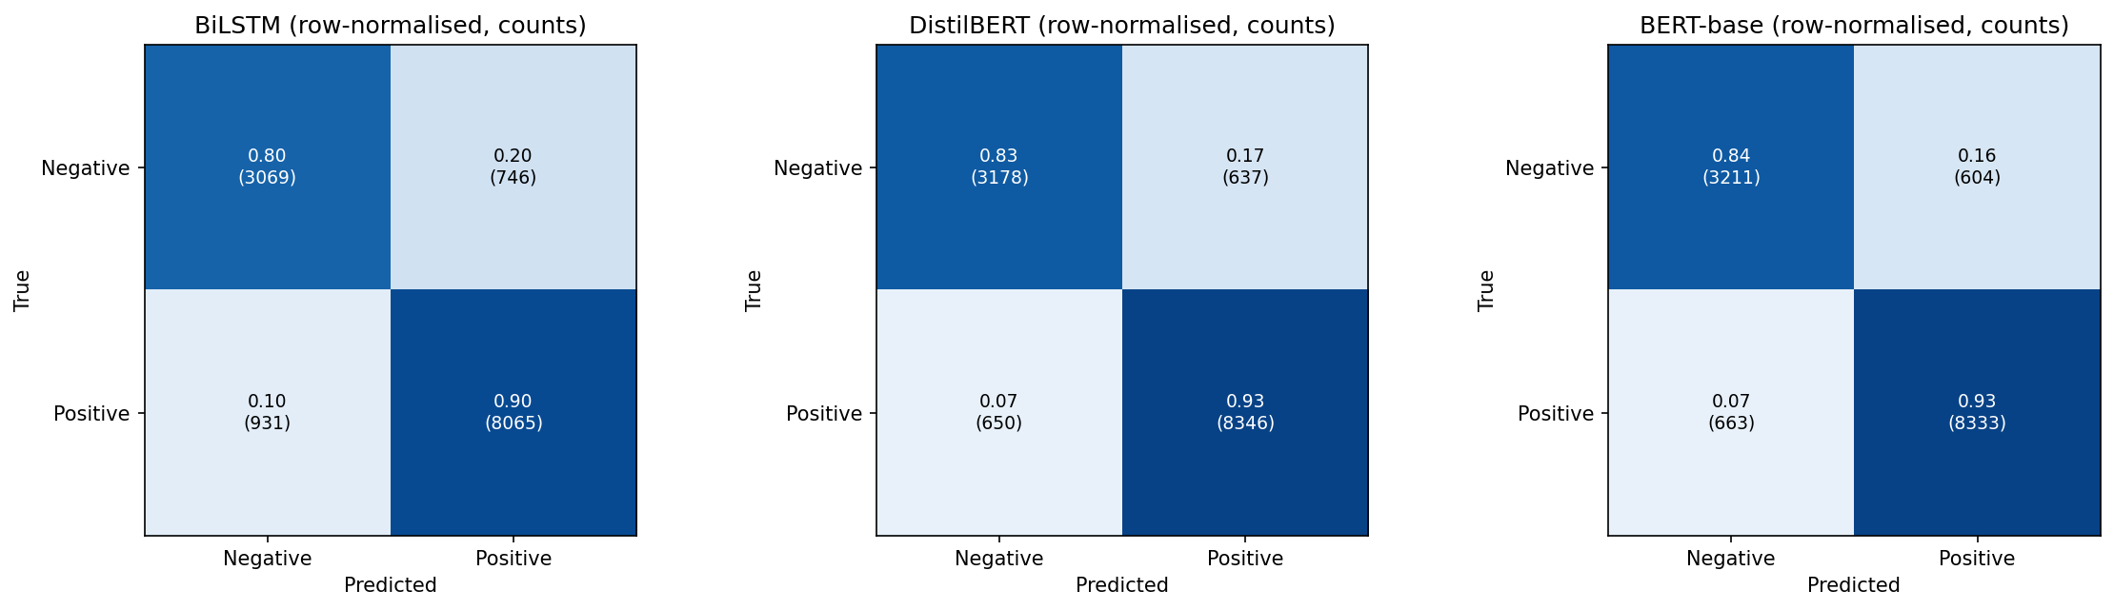
Figure 8.3: Row-normalised confusion matrices with counts on the binary test set
Figure 8.3 shows that the Transformers make about 1,270–1,290 errors each, split almost evenly between the two directions (BERT-base: 604 Negative reviews predicted as Positive and 663 Positive reviews predicted as Negative). The BiLSTM makes 1,677 errors, 931 of which are Positive reviews predicted as Negative.
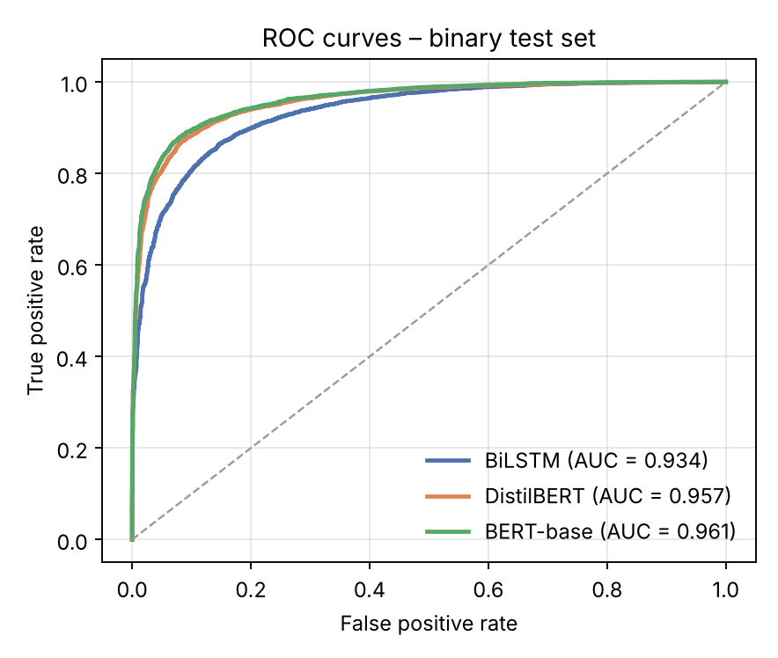
Figure 8.4: ROC curves of the three models on the binary test set
The ROC curves in Figure 8.4 confirm the ranking independently of any threshold. The two Transformer curves lie almost on top of each other (AUC 0.957 and 0.961), while the BiLSTM curve is visibly lower (0.934), especially at low false-positive rates.
Table 8.6: Paired McNemar tests on the binary test set (α = 0.0167)
Comparison | Only A correct | Only B correct | p-value | Result
BiLSTM (A) vs DistilBERT (B) | 427 | 817 | 9.9 × 10⁻²⁹ | Significant
BiLSTM (A) vs BERT-base (B) | 385 | 795 | 2.5 × 10⁻³³ | Significant
DistilBERT (A) vs BERT-base (B) | 313 | 333 | 0.455 | Not significant

Both Transformers are significantly better than the BiLSTM, roughly doubling the number of reviews that only they classify correctly. Between DistilBERT and BERT-base, however, the disagreements are almost balanced (313 versus 333), and the difference is not statistically significant. On the binary task the two Transformers should therefore be regarded as equally accurate.
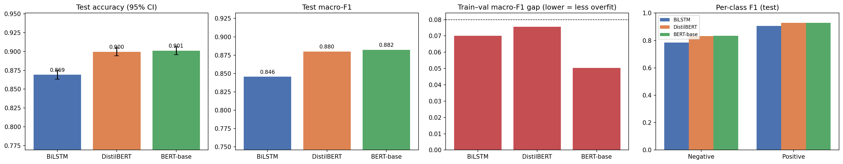
Figure 8.5: Binary test accuracy with 95% CI, test macro-F1, train–validation gap and per-class F1

8.3 Effect of Removing the Neutral Class
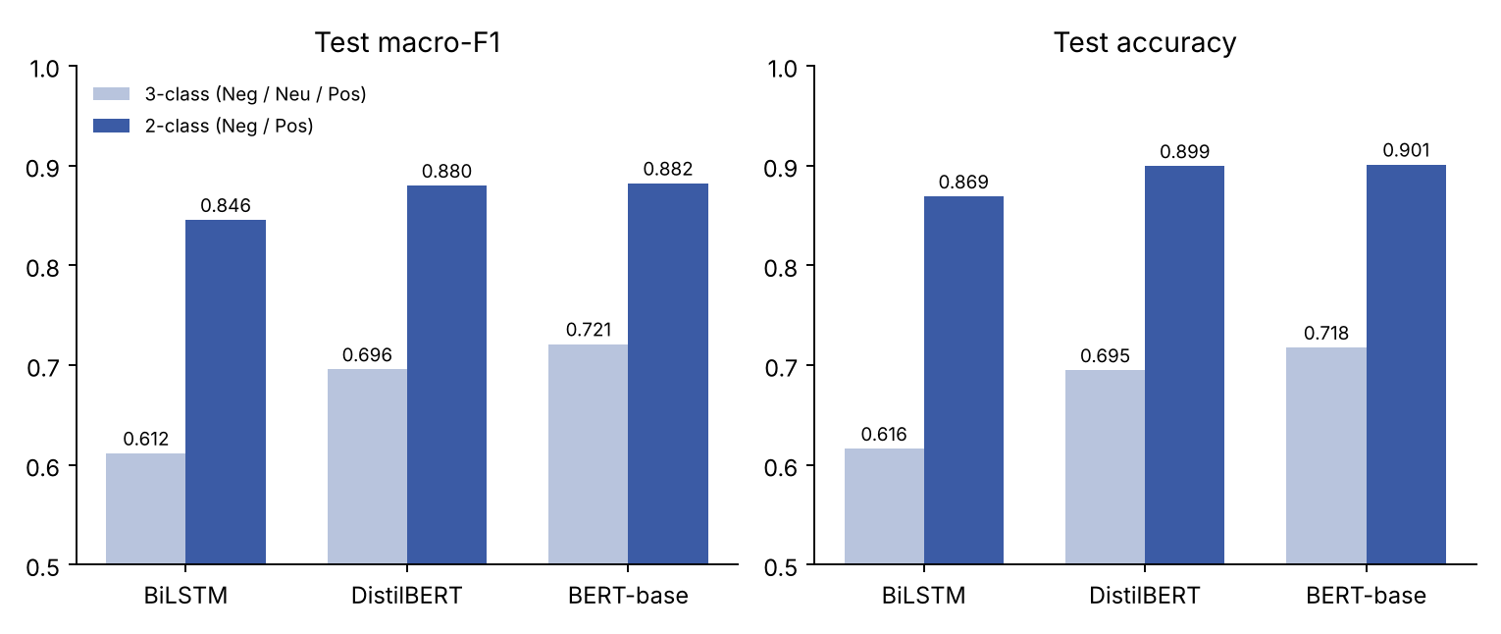
Figure 8.6: Test macro-F1 and accuracy in the three-class and binary experiments
Figure 8.6 compares the two experiments. Moving from three classes to two raises macro-F1 by 23.4 points for BiLSTM, 18.4 for DistilBERT and 16.1 for BERT-base. Two factors contribute: the binary task is easier because the ambiguous middle ratings no longer form a separate class, and the E2 pipeline trains on about four times more reviews with a better recipe. The test sets also differ (balanced in E1, natural distribution in E2), so the size of the jump should be read as indicative rather than exact. Two observations are robust, however. First, the ranking BERT-base > DistilBERT > BiLSTM is the same in both experiments. Second, the gap between the models shrinks on the easier task: BERT-base leads BiLSTM by 10.9 points in E1 but by only 3.7 points in E2, and its lead over DistilBERT falls from 2.5 points to 0.2. The extra capacity of the larger models is most useful when the decision boundary is subtle, as with Neutral reviews.

8.4 Overfitting Analysis
Table 8.7: Train–validation gap at the best epoch
Model | E1 best epoch | E1 gap (accuracy) | E2 best epoch | E2 gap (macro-F1) | E2 val. macro-F1
BiLSTM | 7 of 10 | 0.031 | 4 of 7 | 0.070 | 0.850
DistilBERT | 3 of 4 | 0.145 | 3 of 3 | 0.076 | 0.881
BERT-base | 2 of 3 | 0.115 | 2 of 3 | 0.051 | 0.890

Table 8.7 shows that the improved recipe roughly halved the generalisation gap of the Transformers, from 0.145 to 0.076 for DistilBERT and from 0.115 to 0.051 for BERT-base, which is below the 0.08 threshold used in the notebook as a warning level. The gaps are measured with slightly different metrics (accuracy in E1, macro-F1 in E2), but both are computed in the same way on a fixed training subset. The learning curves in Figure 8.7 show that BERT-base’s validation loss is lowest at epoch 2, which is the checkpoint that early stopping kept. The BiLSTM’s gap grew slightly because the larger two-layer model fits the training data more closely; early stopping again selected the epoch with the best validation score.
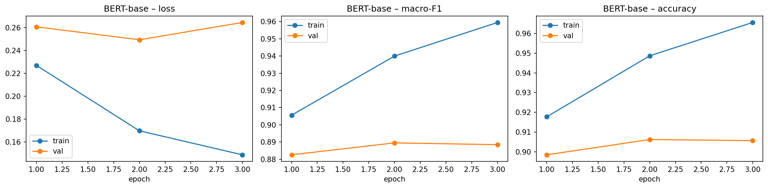
Figure 8.7: BERT-base learning curves in the binary experiment (loss, macro-F1, accuracy)

8.5 Accuracy versus Cost
Table 8.8: Model size and training cost in E2 (Tesla T4)
Model | Parameters | Training time | Time per epoch | Macro-F1
BiLSTM | 6.27 M | 7.3 min (7 epochs) | ≈ 1.0 min | 0.846
DistilBERT | 66.96 M | 28.9 min (3 epochs) | ≈ 9.6 min | 0.880
BERT-base | 109.48 M | 57.4 min (3 epochs) | ≈ 19.1 min | 0.882

BERT-base needs 1.6 times more parameters and twice the training time of DistilBERT for a non-significant 0.2-point gain in macro-F1. The BiLSTM is about nine times faster per epoch than DistilBERT and seventeen times smaller than BERT-base, which makes it attractive when computing resources are very limited, at the cost of about 3.4 points of macro-F1.

8.6 Answers to the Research Questions
Table 8.9: Summary of findings
Question | Finding
RQ1: Transformers vs BiLSTM | Yes. Both Transformers beat BiLSTM significantly in both experiments (macro-F1 +8.4 to +10.9 points in E1, +3.4 to +3.7 in E2; p < 10⁻²⁸ in E2).
RQ2: BERT-base vs DistilBERT | Only in the three-class task (+2.5 points, p = 0.0002). On the binary task the difference is 0.2 points and not significant (p = 0.455), so DistilBERT is preferred for its lower cost.
RQ3: Removing Neutral | Macro-F1 rises to 0.85–0.88. Neutral was the main source of confusion; without it, the gap between models also becomes smaller.
RQ4: Overfitting | Yes. More data, class weighting, label smoothing and early stopping reduced the Transformers’ train–val gap to 0.05–0.08.

Chapter 9

Sample Predictions

9.1 Agreement Between the Models
On the binary test set, all three models classify 10,560 reviews (82.4%) correctly, and all three misclassify the same 733 reviews (5.7%). BERT-base corrects 795 of the BiLSTM’s 1,677 errors (47.4%). The 733 reviews that no model gets right are a useful indicator of how much of the remaining error comes from the labels themselves rather than from the models.

9.2 Examples of Errors
Table 9.1 lists misclassified test reviews from BERT-base, the best model, taken from the notebook’s random sample of errors (text shortened).
Table 9.1: Sample BERT-base errors on the binary test set
Rating | True | Predicted | Review (beginning)
5 | Negative | Positive | “I suffer from anxiety and have tried several medications in the past. I just started using Buspar 5mg twice daily. I notice in the morning, I am dizzy and have vision problems …”
2 | Negative | Positive | “I was taking Lisinopril for about 6 months for my blood pressure which was 150/103 … it went down to about 115/70 which is good. But I developed the ACE cough …”
6 | Positive | Negative | “I am experiencing side effect of diarrhea after 5 day. Still having pain. Don’t know if it’s going to be worth all the diarrhea …”
7 | Positive | Negative | “I have been using Zetia for two years. I am also having extreme muscle pain with profuse sweating when I get too hot …”
8 | Positive | Negative | “Medicare does not cover this product so I had to pay $130.00 at the pharmacy for 2 paks of laxative powder. Very over priced …”
8 | Positive | Negative | “My dose was increased to 500mg. I started out great on the 250mg. I think the 500 is too much for me. I gained 13lbs again, irritable a lot …”

9.3 Error Patterns
- Text and rating disagree. Several “Positive” reviews (ratings 6–8) contain only complaints about side effects, cost or dosage. The text alone gives no evidence of satisfaction, so the model’s Negative prediction is reasonable; the error lies in using the rating as the label.
- Mixed reviews. Reviews such as the Lisinopril example describe a clear benefit followed by a serious side effect. The model must decide which part dominates, and the patient’s rating does not always follow the final sentence.
- Boundary ratings. Ratings of 5 and 6 sit on the class boundary. A patient who rates a drug 5 (Negative) and one who rates it 6 (Positive) may write almost the same review.
- Medical side-effect vocabulary. Words such as “pain”, “dizzy” or “diarrhea” are strongly linked with negative reviews, yet they also appear in positive reviews that report tolerable side effects. The BiLSTM is more affected by these words than the Transformers, which use the surrounding context.
Chapter 10

Discussion

10.1 Why the Transformers Win
The Transformers start from language knowledge learned on billions of words, whereas the BiLSTM must learn word meanings from the drug reviews alone. Pre-training helps most with expressions that are rare in the training set, with negation and contrast (“not as bad as”, “but now”), and with drug names that WordPiece breaks into known sub-words. Self-attention lets the final verdict of a review be linked directly to an early description of symptoms, whereas the BiLSTM has to carry this information through every intermediate step.

10.2 Why DistilBERT Is Nearly as Good as BERT-base
On the binary task DistilBERT matched BERT-base within 0.2 points of macro-F1. Distinguishing clearly satisfied patients from clearly dissatisfied ones does not require the full depth of BERT, and knowledge distillation preserves most of the teacher’s useful representations. BERT-base kept a significant advantage only in the three-class task, where the subtle Neutral category benefits from the extra layers. This matches the general observation that larger models pay off mainly on harder, more nuanced decisions.

10.3 The Strength of the BiLSTM
The BiLSTM reached 86.9% accuracy and 0.934 ROC-AUC on the binary task without any pre-training, with only 6.3 million parameters and seven minutes of training. Its gap to the Transformers (3.4 points of macro-F1) is much smaller than in the three-class task. For a hospital or pharmacy without a GPU, a BiLSTM may still be a practical choice, especially if its predictions are used to rank reviews for human reading rather than to make automatic decisions.

10.4 Three Classes or Two?
The Neutral class was the weakest point of every model, and its errors came from both directions. Ratings of 5 and 6 seem to represent mixed or lukewarm experiences rather than a distinct sentiment, which makes them hard to separate from mildly positive or mildly negative reviews. For screening purposes, such as finding drugs with many dissatisfied users, the binary scheme is more reliable. When the middle ground matters, a regression model that predicts the rating directly, or an ordinal classifier, may be more suitable than a Neutral class.

10.5 Recommended Model by Scenario
Table 10.1: Recommended model by use case
Scenario | Recommended model | Reason
Binary screening with a GPU | DistilBERT | Same accuracy as BERT-base, half the training time
Three-class or fine-grained sentiment | BERT-base | Significantly better on the Neutral class
No GPU / very limited resources | BiLSTM | ≈ 9× faster per epoch, 0.934 AUC, small model
Highest possible accuracy | BERT-base | Best on every metric, if cost is acceptable

Chapter 11

Limitations
- Ratings as labels. Sentiment labels are derived from star ratings, not annotated by people. Some reviews describe only complaints yet carry a high rating, which places a ceiling on any text-based model.
- Different set-ups in E1 and E2. The two experiments differ in data size, test distribution and training recipe, so the improvement from three to two classes cannot be attributed to the task change alone.
- Single run per model. Each model was trained once with seed 42. Repeating training with several seeds would show how much the results vary between runs.
- Limited hyperparameter search. Learning rates and epochs were set from common practice rather than by a systematic search, which may slightly disadvantage one of the models.
- Truncation. Inputs longer than 256 tokens are truncated, so the end of a very long review, which often contains the verdict, can be lost.
- One source and one language. All reviews come from one English-language website, so the results may not transfer to other platforms, languages or clinical notes.
- Uncased models only. Capitalisation and emoji, which can carry emotion, are discarded by the uncased tokenisers.
Chapter 12

Future Enhancements
- Domain-specific language models: fine-tune BioBERT, ClinicalBERT or BioMed-RoBERTa, which are pre-trained on biomedical text.
- Stronger general models: compare RoBERTa and DeBERTa, which usually outperform BERT-base on sentiment tasks.
- Pre-trained word vectors for the BiLSTM: initialise the embeddings with GloVe or fastText to narrow the gap with the Transformers.
- Rating regression or ordinal classification: predict the 1–10 rating directly to handle the middle of the scale better than a Neutral class.
- Aspect-based sentiment: separate sentiment about effectiveness, side effects and cost, which are often mixed in one review.
- Head-and-tail truncation and longer models: keep the beginning and the end of long reviews, or use Longformer-style models.
- Explainability: visualise attention or use SHAP / integrated gradients to show which words drive each prediction.
- Robustness and fairness: test on other review sites and check whether performance differs across conditions and drug classes.

Bibliography
- Vaswani, A., Shazeer, N., Parmar, N., Uszkoreit, J., Jones, L., Gomez, A.N., Kaiser, Ł. and Polosukhin, I., 2017. Attention is all you need. Advances in Neural Information Processing Systems, 30.
- Devlin, J., Chang, M.W., Lee, K. and Toutanova, K., 2019. BERT: Pre-training of deep bidirectional transformers for language understanding. In Proceedings of NAACL-HLT 2019, pp. 4171–4186.
- Sanh, V., Debut, L., Chaumond, J. and Wolf, T., 2019. DistilBERT, a distilled version of BERT: smaller, faster, cheaper and lighter. arXiv preprint arXiv:1910.01108.
- Hochreiter, S. and Schmidhuber, J., 1997. Long short-term memory. Neural Computation, 9(8), pp. 1735–1780.
- Schuster, M. and Paliwal, K.K., 1997. Bidirectional recurrent neural networks. IEEE Transactions on Signal Processing, 45(11), pp. 2673–2681.
- Gräßer, F., Kallumadi, S., Malberg, H. and Zaunseder, S., 2018. Aspect-based sentiment analysis of drug reviews applying cross-domain and cross-data learning. In Proceedings of the 2018 International Conference on Digital Health, pp. 121–125.
- Kallumadi, S. and Gräßer, F., 2018. Drug Review Dataset (Drugs.com). UCI Machine Learning Repository. https://www.kaggle.com/datasets/jessicali9530/kuc-hackathon-winter-2018
- Wolf, T. et al., 2020. Transformers: State-of-the-art natural language processing. In Proceedings of EMNLP 2020: System Demonstrations, pp. 38–45.
- Paszke, A. et al., 2019. PyTorch: An imperative style, high-performance deep learning library. Advances in Neural Information Processing Systems, 32.
- Loshchilov, I. and Hutter, F., 2019. Decoupled weight decay regularization. In International Conference on Learning Representations (ICLR).
- Szegedy, C., Vanhoucke, V., Ioffe, S., Shlens, J. and Wojna, Z., 2016. Rethinking the Inception architecture for computer vision. In Proceedings of CVPR, pp. 2818–2826.
- McNemar, Q., 1947. Note on the sampling error of the difference between correlated proportions or percentages. Psychometrika, 12(2), pp. 153–157.
- Dietterich, T.G., 1998. Approximate statistical tests for comparing supervised classification learning algorithms. Neural Computation, 10(7), pp. 1895–1923.
- Pedregosa, F. et al., 2011. Scikit-learn: Machine learning in Python. Journal of Machine Learning Research, 12, pp. 2825–2830.
Appendix A

Source Code
Sections A.1 to A.12 contain the complete Google Colab notebook for Experiment 2 (Drug_Review_Sentiment_Binary_BiLSTM_DistilBERT_BERT.ipynb). Sections A.13 to A.16 contain the cells of the Experiment 1 notebook that differ: the three-class labelling and balancing, and the original BiLSTM, DistilBERT and BERT-base training code.

A.1 Install packages
!pip -q install transformers kaggle

A.2 Setup, imports and configuration
import os, re, glob, html, copy, random, time, gc, shutil
from collections import Counter
import numpy as np, pandas as pd
import torch, torch.nn as nn, torch.nn.functional as F
from torch.utils.data import Dataset, DataLoader, Subset
from torch.nn.utils.rnn import pack_padded_sequence, pad_packed_sequence
from sklearn.model_selection import train_test_split
from sklearn.metrics import (accuracy_score, precision_recall_fscore_support, f1_score,
confusion_matrix, classification_report)
from scipy.stats import binomtest
import matplotlib.pyplot as plt
import warnings; warnings.filterwarnings('ignore', category=FutureWarning)

SEED = 42
def set_seed(s=SEED):
random.seed(s); np.random.seed(s); torch.manual_seed(s); torch.cuda.manual_seed_all(s)
torch.backends.cudnn.deterministic = True; torch.backends.cudnn.benchmark = False
set_seed()
DEVICE = torch.device('cuda' if torch.cuda.is_available() else 'cpu')
USE_AMP = DEVICE.type == 'cuda'
print('Device:', DEVICE, '| GPU:', torch.cuda.get_device_name(0) if USE_AMP else '-')
LABELS = ['Negative', 'Positive'] # 0 = rating 1-5, 1 = rating 6-10
NC = len(LABELS)

# ---------------- configuration ----------------
MAX_TRAIN = None # e.g. 50000 to finish faster on a slow GPU; None = use the full training split
RUN_BERT_BASE = True # BERT-base is the slowest model (~2x DistilBERT)
DISTIL_NAME = 'distilbert-base-uncased'
BERT_NAME = 'bert-base-uncased'
TF_MAX_LEN = 256 # transformer max tokens (covers ~95% of reviews)
LSTM_MAX_LEN = 256 # BiLSTM max words

OUT = '/content/outputs' if os.path.isdir('/content') else './outputs'
os.makedirs(OUT, exist_ok=True)
_fig_n = [0]
def savefig_auto():
_fig_n[0] += 1
plt.savefig(f'{OUT}/fig_{_fig_n[0]:02d}.png', dpi=150, bbox_inches='tight')

A.3 Download the dataset
try:
from google.colab import files
IN_COLAB = True
except ImportError:
IN_COLAB = False

def find_paths(): return sorted(glob.glob('data/**/drugsCom*_raw.*', recursive=True))
if not find_paths():
rc = os.system('kaggle datasets download -d jessicali9530/kuc-hackathon-winter-2018 -p data --unzip')
if (rc != 0 or not find_paths()) and IN_COLAB:
print('Kaggle login needed: upload kaggle.json (Kaggle > Settings > API > Create New Token)')
up = files.upload()
os.makedirs(os.path.expanduser('~/.kaggle'), exist_ok=True)
if 'kaggle.json' in up:
os.system('cp kaggle.json ~/.kaggle/ && chmod 600 ~/.kaggle/kaggle.json')
os.system('kaggle datasets download -d jessicali9530/kuc-hackathon-winter-2018 -p data --unzip')
paths = find_paths()
assert paths, 'Dataset not found. Upload a valid kaggle.json (or put the CSVs in ./data) and run this cell again.'
print(paths)

A.4 Cleaning, labelling (1–5 / 6–10) and stratified split
frames = [pd.read_csv(p, sep='\t' if p.endswith('.tsv') else ',') for p in paths]
df = pd.concat(frames, ignore_index=True)
print('raw rows:', len(df))

df = df.dropna(subset=['review', 'rating']).copy()
df['review'] = (df['review'].astype(str).map(html.unescape)
.str.replace(r'\s+', ' ', regex=True).str.strip().str.strip('"').str.strip())
df = df[df['review'].str.split().str.len() >= 3]
df = df.drop_duplicates(subset='review').reset_index(drop=True) # same review is listed many times -> leakage
print('after cleaning / de-duplication:', len(df))

df['label'] = (df['rating'] >= 6).astype(int) # 1-5 -> Negative (0), 6-10 -> Positive (1)
print(pd.crosstab(df['rating'].astype(int), df['label'].map(dict(enumerate(LABELS)))))
print(df['label'].value_counts().sort_index().rename(index=dict(enumerate(LABELS))))

train_df, rest = train_test_split(df, test_size=0.20, stratify=df['label'], random_state=SEED)
val_df, test_df = train_test_split(rest, test_size=0.50, stratify=rest['label'], random_state=SEED)
if MAX_TRAIN and len(train_df) > MAX_TRAIN:
train_df, _ = train_test_split(train_df, train_size=MAX_TRAIN, stratify=train_df['label'], random_state=SEED)
SPLITS = {'train': train_df.reset_index(drop=True), 'val': val_df.reset_index(drop=True),
'test': test_df.reset_index(drop=True)}
for k, v in SPLITS.items():
print(f'{k:5s} {len(v):6d}', v['label'].value_counts().sort_index().to_dict())

names = list(SPLITS)
for i in range(len(names)):
for j in range(i + 1, len(names)):
assert not set(SPLITS[names[i]]['review']) & set(SPLITS[names[j]]['review'])
print('No text overlap between splits')

# class weights (sqrt of inverse frequency, train split only) -> helps the smaller Negative class
cnt = np.bincount(SPLITS['train']['label'], minlength=NC)
CLASS_W = torch.tensor(np.sqrt(cnt.sum() / (NC * cnt)), dtype=torch.float32)
CLASS_W = CLASS_W / CLASS_W.mean()
print('class weights:', dict(zip(LABELS, CLASS_W.numpy().round(3))))

y_train, y_val, y_test = (SPLITS[k]['label'].values for k in ['train', 'val', 'test'])
for k, v in SPLITS.items():
np.save(f'{OUT}/labels_{k}.npy', v['label'].values)

# quick EDA
fig, ax = plt.subplots(1, 2, figsize=(12, 3.6))
df['label'].map(dict(enumerate(LABELS))).value_counts().reindex(LABELS).plot.bar(ax=ax[0], color=['#C44E52', '#55A868'])
ax[0].set_title('Class distribution (all reviews)'); ax[0].tick_params(axis='x', rotation=0)
df['review'].str.split().str.len().clip(upper=400).hist(bins=50, ax=ax[1])
ax[1].set_title('Review length (words, clipped at 400)')
plt.tight_layout(); savefig_auto(); plt.show()

A.5 Shared helpers: metrics, curves, threshold tuning
def metrics_from(y, probs, bias=None):
logp = np.log(np.clip(probs, 1e-9, 1))
pred = (logp + (0 if bias is None else bias)).argmax(1)
p, r, f, _ = precision_recall_fscore_support(y, pred, average='macro', zero_division=0)
return dict(acc=accuracy_score(y, pred), macro_p=p, macro_r=r, macro_f1=f, pred=pred)

def tune_bias(y, probs, grid=np.arange(-1.0, 1.01, 0.05)):
# additive log-prob bias for Negative (Positive fixed at 0) = decision threshold; tuned on VALIDATION only
best = (metrics_from(y, probs)['macro_f1'], np.zeros(NC))
for b0 in grid:
b = np.array([b0, 0.0])
f = metrics_from(y, probs, b)['macro_f1']
if f > best[0] + 1e-6: best = (f, b)
return best[1]

def plot_curves(hist, title):
fig, ax = plt.subplots(1, 3, figsize=(15, 3.8))
ep = range(1, len(hist['val_f1']) + 1)
ax[0].plot(ep, hist['train_loss'], 'o-', label='train'); ax[0].plot(ep, hist['val_loss'], 'o-', label='val'); ax[0].set_title(title + ' – loss')
ax[1].plot(ep, hist['train_f1'], 'o-', label='train'); ax[1].plot(ep, hist['val_f1'], 'o-', label='val'); ax[1].set_title(title + ' – macro-F1')
ax[2].plot(ep, hist['train_acc'], 'o-', label='train'); ax[2].plot(ep, hist['val_acc'], 'o-', label='val'); ax[2].set_title(title + ' – accuracy')
for a in ax: a.legend(); a.set_xlabel('epoch')
plt.tight_layout(); savefig_auto(); plt.show()

def overfit_report(hist, name):
b = int(np.argmax(hist['val_f1']))
gap = hist['train_f1'][b] - hist['val_f1'][b]
print(f'[{name}] best epoch = {b+1}/{len(hist["val_f1"])} | val macro-F1 = {hist["val_f1"][b]:.4f} | '
f'train-val macro-F1 gap = {gap:.3f}')
print(' -> OK: no meaningful overfitting' if gap < 0.08 else
' -> NOTE: noticeable gap; early stopping keeps the best-validation checkpoint')
return gap

def new_hist(): return {k: [] for k in ['train_loss', 'val_loss', 'train_acc', 'val_acc', 'train_f1', 'val_f1']}

# fixed random subset of the training set, evaluated in eval-mode -> fair train vs val comparison
SUB_IDX = np.random.RandomState(0).choice(len(SPLITS['train']), min(8000, len(SPLITS['train'])), replace=False)
n_params = lambda m: sum(p.numel() for p in m.parameters())
RESULTS = {} # name -> dict(probs per split, hist, params, train_time)

A.6 BiLSTM model and training
def tokenize(t):
return re.findall(r"[a-z0-9']+|[!?]", t.lower())

MAX_VOCAB = 40000
counter = Counter(tok for t in SPLITS['train']['review'] for tok in tokenize(t)) # TRAIN only
vocab = {'<pad>': 0, '<unk>': 1}
for w, c in counter.most_common(MAX_VOCAB - 2):
if c >= 2: vocab[w] = len(vocab)
print('vocab size:', len(vocab))

def encode(t):
ids = [vocab.get(w, 1) for w in tokenize(t)][:LSTM_MAX_LEN]
return ids if ids else [1]

class LSTMData(Dataset):
def __init__(self, df): self.x = [encode(t) for t in df['review']]; self.y = df['label'].values
def __len__(self): return len(self.y)
def __getitem__(self, i): return self.x[i], int(self.y[i])

def lstm_collate(batch):
lens = torch.tensor([len(x) for x, _ in batch])
X = torch.zeros(len(batch), int(lens.max()), dtype=torch.long)
for i, (x, _) in enumerate(batch): X[i, :len(x)] = torch.tensor(x)
return X, lens, torch.tensor([y for _, y in batch])

class BiLSTM(nn.Module):
def __init__(self, V, emb=200, hid=128, layers=2, nc=NC, emb_drop=0.3, drop=0.4):
super().__init__()
self.emb = nn.Embedding(V, emb, padding_idx=0)
self.emb_drop = nn.Dropout(emb_drop)
self.lstm = nn.LSTM(emb, hid, num_layers=layers, batch_first=True, bidirectional=True, dropout=0.3)
self.drop = nn.Dropout(drop)
self.fc = nn.Linear(hid * 4, nc) # [max-pool ; mean-pool] of 2*hid each
def forward(self, x, lens):
e = self.emb_drop(self.emb(x))
packed = pack_padded_sequence(e, lens.cpu(), batch_first=True, enforce_sorted=False)
out, _ = self.lstm(packed)
out, _ = pad_packed_sequence(out, batch_first=True, total_length=x.size(1))
mask = (x != 0).unsqueeze(-1)
mx = out.masked_fill(~mask, -1e4).max(1).values
mean = (out * mask).sum(1) / mask.sum(1).clamp(min=1)
return self.fc(self.drop(torch.cat([mx, mean], 1)))

lstm_sets = {k: LSTMData(v) for k, v in SPLITS.items()}
mk = lambda ds, shuffle, bs=128: DataLoader(ds, batch_size=bs, shuffle=shuffle, collate_fn=lstm_collate)
lstm_loaders = {k: mk(ds, k == 'train') for k, ds in lstm_sets.items()}
lstm_eval = {k: mk(ds, False, 512) for k, ds in lstm_sets.items()}
lstm_train_sub = mk(Subset(lstm_sets['train'], SUB_IDX), False, 512)

@torch.no_grad()
def lstm_predict(model, loader):
model.eval(); P, Y, L = [], [], 0.0
for X, lens, y in loader:
logits = model(X.to(DEVICE), lens)
L += F.cross_entropy(logits, y.to(DEVICE), reduction='sum').item()
P.append(F.softmax(logits, -1).cpu().numpy()); Y.append(y.numpy())
P, Y = np.concatenate(P), np.concatenate(Y)
return L / len(Y), P, Y

set_seed()
lstm = BiLSTM(len(vocab)).to(DEVICE)
opt = torch.optim.AdamW(lstm.parameters(), lr=2e-3, weight_decay=1e-4)
sched = torch.optim.lr_scheduler.ReduceLROnPlateau(opt, mode='max', factor=0.5, patience=1)
EPOCHS, PATIENCE = 15, 3
w_dev = CLASS_W.to(DEVICE)
hist = new_hist(); best_f1, best_state, bad = -1, None, 0
t0 = time.time()
for ep in range(1, EPOCHS + 1):
lstm.train()
for X, lens, y in lstm_loaders['train']:
opt.zero_grad()
loss = F.cross_entropy(lstm(X.to(DEVICE), lens), y.to(DEVICE), weight=w_dev, label_smoothing=0.05)
loss.backward(); nn.utils.clip_grad_norm_(lstm.parameters(), 1.0); opt.step()
tl, tp, ty = lstm_predict(lstm, lstm_train_sub)
vl, vp, vy = lstm_predict(lstm, lstm_eval['val'])
tm, vm = metrics_from(ty, tp), metrics_from(vy, vp)
for k, v in zip(hist, [tl, vl, tm['acc'], vm['acc'], tm['macro_f1'], vm['macro_f1']]): hist[k].append(v)
sched.step(vm['macro_f1'])
print(f"ep{ep:02d} train_loss {tl:.3f} val_loss {vl:.3f} | train_F1 {tm['macro_f1']:.3f} val_F1 {vm['macro_f1']:.3f} "
f"val_acc {vm['acc']:.3f} | lr {opt.param_groups[0]['lr']:.1e}")
if vm['macro_f1'] > best_f1:
best_f1, bad = vm['macro_f1'], 0
best_state = copy.deepcopy(lstm.state_dict())
else:
bad += 1
if bad >= PATIENCE: print('Early stopping'); break
lstm_time = time.time() - t0
lstm.load_state_dict(best_state)
overfit_report(hist, 'BiLSTM'); plot_curves(hist, 'BiLSTM')

RESULTS['BiLSTM'] = dict(hist=hist, params=n_params(lstm), train_time=lstm_time,
probs={k: lstm_predict(lstm, lstm_eval[k])[1] for k in ['val', 'test']})

A.7 Shared fine-tuning recipe for Transformers
from transformers import AutoTokenizer, AutoModelForSequenceClassification, DataCollatorWithPadding, get_linear_schedule_with_warmup

class TFData(Dataset):
def __init__(self, df, tok):
enc = tok(df['review'].tolist(), truncation=True, max_length=TF_MAX_LEN)
self.ids, self.att, self.y = enc['input_ids'], enc['attention_mask'], df['label'].values
def __len__(self): return len(self.y)
def __getitem__(self, i): return {'input_ids': self.ids[i], 'attention_mask': self.att[i], 'labels': int(self.y[i])}

@torch.no_grad()
def tf_predict(model, loader):
model.eval(); P, Y, L = [], [], 0.0
for b in loader:
b = {k: v.to(DEVICE) for k, v in b.items()}
with torch.autocast(device_type=DEVICE.type, dtype=torch.float16, enabled=USE_AMP):
logits = model(input_ids=b['input_ids'], attention_mask=b['attention_mask']).logits
logits = logits.float()
L += F.cross_entropy(logits, b['labels'], reduction='sum').item()
P.append(F.softmax(logits, -1).cpu().numpy()); Y.append(b['labels'].cpu().numpy())
P, Y = np.concatenate(P), np.concatenate(Y)
return L / len(Y), P, Y

def finetune_transformer(model_name, epochs=3, patience=1, lr=2e-5, bs=32, warmup=0.1,
weight_decay=0.01, label_smoothing=0.1, cls_dropout=0.2):
set_seed()
tok = AutoTokenizer.from_pretrained(model_name)
sets = {k: TFData(v, tok) for k, v in SPLITS.items()}
col = DataCollatorWithPadding(tok)
train_loader = DataLoader(sets['train'], batch_size=bs, shuffle=True, collate_fn=col, num_workers=2, pin_memory=USE_AMP)
ev = lambda ds: DataLoader(ds, batch_size=128, shuffle=False, collate_fn=col, num_workers=2, pin_memory=USE_AMP)
eval_loaders = {k: ev(sets[k]) for k in ['val', 'test']}
train_sub = ev(Subset(sets['train'], SUB_IDX))

extra = {'seq_classif_dropout': cls_dropout} if 'distilbert' in model_name else {'classifier_dropout': cls_dropout}
model = AutoModelForSequenceClassification.from_pretrained(model_name, num_labels=NC, **extra).to(DEVICE)
no_decay = ['bias', 'LayerNorm.weight', 'layer_norm.weight']
groups = [{'params': [p for n, p in model.named_parameters() if not any(nd in n for nd in no_decay)], 'weight_decay': weight_decay},
{'params': [p for n, p in model.named_parameters() if any(nd in n for nd in no_decay)], 'weight_decay': 0.0}]
opt = torch.optim.AdamW(groups, lr=lr)
total = epochs * len(train_loader)
sched = get_linear_schedule_with_warmup(opt, int(warmup * total), total)
scaler = torch.amp.GradScaler('cuda', enabled=USE_AMP)
w = CLASS_W.to(DEVICE)

h = new_hist(); best_f1, best_state, bad = -1, None, 0
t0 = time.time()
for ep in range(1, epochs + 1):
model.train()
for step, b in enumerate(train_loader):
b = {k: v.to(DEVICE) for k, v in b.items()}
opt.zero_grad(set_to_none=True)
with torch.autocast(device_type=DEVICE.type, dtype=torch.float16, enabled=USE_AMP):
logits = model(input_ids=b['input_ids'], attention_mask=b['attention_mask']).logits
loss = F.cross_entropy(logits.float(), b['labels'], weight=w, label_smoothing=label_smoothing)
scaler.scale(loss).backward(); scaler.unscale_(opt)
nn.utils.clip_grad_norm_(model.parameters(), 1.0)
scaler.step(opt); scaler.update(); sched.step()
if step % 500 == 0: print(f' ep{ep} step {step}/{len(train_loader)} loss {loss.item():.3f}')
tl, tp, ty = tf_predict(model, train_sub)
vl, vp, vy = tf_predict(model, eval_loaders['val'])
tm, vm = metrics_from(ty, tp), metrics_from(vy, vp)
for k, v in zip(h, [tl, vl, tm['acc'], vm['acc'], tm['macro_f1'], vm['macro_f1']]): h[k].append(v)
print(f"ep{ep} train_loss {tl:.3f} val_loss {vl:.3f} | train_F1 {tm['macro_f1']:.3f} val_F1 {vm['macro_f1']:.3f} val_acc {vm['acc']:.3f}")
if vm['macro_f1'] > best_f1:
best_f1, bad = vm['macro_f1'], 0
best_state = {k: v.detach().cpu().clone() for k, v in model.state_dict().items()}
else:
bad += 1
if bad >= patience: print('Early stopping'); break
train_time = time.time() - t0
model.load_state_dict(best_state)
probs = {k: tf_predict(model, eval_loaders[k])[1] for k in ['val', 'test']}
res = dict(hist=h, params=n_params(model), train_time=train_time, probs=probs)
del model, opt, best_state; gc.collect()
if USE_AMP: torch.cuda.empty_cache()
return res

A.8 DistilBERT
RESULTS['DistilBERT'] = finetune_transformer(DISTIL_NAME, epochs=3, lr=3e-5)
overfit_report(RESULTS['DistilBERT']['hist'], 'DistilBERT'); plot_curves(RESULTS['DistilBERT']['hist'], 'DistilBERT')

A.9 BERT-base
if RUN_BERT_BASE:
RESULTS['BERT-base'] = finetune_transformer(BERT_NAME, epochs=3, lr=2e-5)
overfit_report(RESULTS['BERT-base']['hist'], 'BERT-base'); plot_curves(RESULTS['BERT-base']['hist'], 'BERT-base')
else:
print('BERT-base skipped (RUN_BERT_BASE = False)')

A.10 Final comparison and McNemar tests
MODELS = list(RESULTS); N = len(MODELS)
rows, preds = [], {}
for name in MODELS:
r = RESULTS[name]
for k in ['val', 'test']: np.save(f'{OUT}/probs_{name}_{k}.npy', r['probs'][k])
bias = tune_bias(y_val, r['probs']['val']) # decided on validation only
raw = metrics_from(y_test, r['probs']['test'])
tm = metrics_from(y_test, r['probs']['test'], bias)
preds[name] = tm['pred']
b = int(np.argmax(r['hist']['val_f1']))
rows.append({'model': name,
'test_acc': tm['acc'],
'acc_95%CI(+-)': 1.96 * np.sqrt(tm['acc'] * (1 - tm['acc']) / len(y_test)),
'macro_precision': tm['macro_p'], 'macro_recall': tm['macro_r'], 'macro_F1': tm['macro_f1'],
'macro_F1(argmax)': raw['macro_f1'],
'weighted_F1': f1_score(y_test, tm['pred'], average='weighted'),
'train-val F1 gap': r['hist']['train_f1'][b] - r['hist']['val_f1'][b],
'params(M)': r['params'] / 1e6, 'train_min': r['train_time'] / 60})
tab = pd.DataFrame(rows)
pd.set_option('display.width', 200)
print(tab.round(4).to_string(index=False))
tab.round(4).to_csv(f'{OUT}/model_comparison.csv', index=False)

# paired McNemar (exact binomial), Bonferroni-corrected
alpha = 0.05 / max(1, N * (N - 1) // 2); pvals = {}
print(f'\nPaired McNemar test on the test set (significant if p < {alpha:.4f}):')
for i in range(N):
for j in range(i + 1, N):
a, c = preds[MODELS[i]] == y_test, preds[MODELS[j]] == y_test
only_a, only_c = int((a & ~c).sum()), int((~a & c).sum())
p = binomtest(only_a, only_a + only_c, 0.5).pvalue if only_a + only_c > 0 else 1.0
pvals[frozenset({MODELS[i], MODELS[j]})] = p
print(f' {MODELS[i]:10s} vs {MODELS[j]:10s}: only-{MODELS[i]} right={only_a:5d}, '
f'only-{MODELS[j]} right={only_c:5d}, p={p:.2e} -> ' + ('significant' if p < alpha else 'NOT significant'))

val_rank = sorted(MODELS, key=lambda m: -metrics_from(y_val, RESULTS[m]['probs']['val'])['macro_f1'])
top, second = val_rank[0], val_rank[1]
print(f'\nBEST by validation macro-F1: {top} (runner-up: {second})')
if pvals[frozenset({top, second})] < alpha:
print(f'VERDICT: {top} is significantly better than {second} on the test set.')
else:
print(f'VERDICT: {top} and {second} are not significantly different -> prefer the cheaper/faster model.')

A.11 Comparison charts and confusion matrices
cols = ['#4C72B0', '#DD8452', '#55A868'][:N]; x = np.arange(N)
fig, ax = plt.subplots(1, 4, figsize=(20, 4))
ax[0].bar(x, tab['test_acc'], yerr=tab['acc_95%CI(+-)'], capsize=4, color=cols); ax[0].set_title('Test accuracy (95% CI)')
ax[1].bar(x, tab['macro_F1'], color=cols); ax[1].set_title('Test macro-F1')
for a_, v in zip(ax[:2], [tab['test_acc'], tab['macro_F1']]):
a_.set_xticks(x); a_.set_xticklabels(MODELS); a_.set_ylim(max(0, v.min() - .1), min(1, v.max() + .05))
for xi, vi in zip(x, v): a_.text(xi, vi + .004, f'{vi:.3f}', ha='center', fontsize=9)
ax[2].bar(x, tab['train-val F1 gap'], color='#C44E52'); ax[2].set_xticks(x); ax[2].set_xticklabels(MODELS)
ax[2].axhline(.08, ls='--', color='k', lw=.8); ax[2].set_title('Train–val macro-F1 gap (lower = less overfit)')
w = .8 / N
for k_, nm in enumerate(MODELS):
ax[3].bar(np.arange(NC) + (k_ - (N - 1) / 2) * w, f1_score(y_test, preds[nm], average=None), w, label=nm, color=cols[k_])
ax[3].set_xticks(range(NC)); ax[3].set_xticklabels(LABELS); ax[3].set_ylim(0, 1); ax[3].legend(fontsize=8); ax[3].set_title('Per-class F1 (test)')
plt.tight_layout(); savefig_auto(); plt.show()

fig, ax = plt.subplots(1, N, figsize=(5.2 * N, 4.4), squeeze=False); ax = ax[0]
for a_, nm in zip(ax, MODELS):
cmc = confusion_matrix(y_test, preds[nm]); cm = cmc / cmc.sum(1, keepdims=True)
a_.imshow(cm, cmap='Blues', vmin=0, vmax=1); a_.set_title(nm + ' (row-normalised, counts)')
a_.set_xticks(range(NC)); a_.set_xticklabels(LABELS); a_.set_yticks(range(NC)); a_.set_yticklabels(LABELS)
a_.set_xlabel('Predicted'); a_.set_ylabel('True')
for i in range(NC):
for j in range(NC):
a_.text(j, i, f'{cm[i, j]:.2f}\n({cmc[i, j]})', ha='center', va='center', fontsize=9,
color='white' if cm[i, j] > .5 else 'black')
plt.tight_layout(); savefig_auto(); plt.show()

for nm in MODELS:
print(f'\n=== {nm} ===')
print(classification_report(y_test, preds[nm], target_names=LABELS, digits=3))

A.12 Error analysis
best = top
err = SPLITS['test'].assign(pred=preds[best])
err = err[err['label'] != err['pred']]
print(f'{best}: {len(err)} test errors. Most common confusions:')
print(err.groupby(['label', 'pred']).size().rename(lambda i: LABELS[i], level=0)
.rename(lambda i: LABELS[i], level=1).sort_values(ascending=False).to_string())
print('\nSample errors:')
for _, r_ in err.sample(min(6, len(err)), random_state=SEED).iterrows():
print(f"- rating {r_['rating']:.0f} | true {LABELS[r_['label']]:8s} | pred {LABELS[r_['pred']]:8s} | {r_['review'][:180]}...")

if 'BiLSTM' in preds and best != 'BiLSTM':
fixed = ((preds['BiLSTM'] != y_test) & (preds[best] == y_test)).sum()
print(f'\n{best} corrects {fixed} reviews that BiLSTM gets wrong '
f'({fixed / max(1, (preds["BiLSTM"] != y_test).sum()):.1%} of BiLSTM errors).')

A.13 E1: three-class labelling, balancing and split
frames = []
for p in paths:
sep = '\t' if p.endswith('.tsv') else ','
frames.append(pd.read_csv(p, sep=sep))
df = pd.concat(frames, ignore_index=True)
print("raw rows:", len(df))

df = df.dropna(subset=['review', 'rating']).copy()
df['review'] = (df['review'].astype(str).map(html.unescape)
.str.replace(r'\s+', ' ', regex=True).str.strip().str.strip('"'))
df = df[df['review'].str.split().str.len() >= 3]
df = df.drop_duplicates(subset='review') # prevents leakage across splits
print("after cleaning/dedupe:", len(df))

def rating_to_label(r):
return 0 if r <= 4 else (1 if r <= 6 else 2)
df['label'] = df['rating'].map(rating_to_label)
print(df['label'].value_counts().sort_index())

PER_CLASS = int(df['label'].value_counts().min()) # smallest class (Neutral) decides the size
df = (df.groupby('label', group_keys=False)
.apply(lambda g: g.sample(PER_CLASS, random_state=SEED))
.reset_index(drop=True))
print("balanced:", df['label'].value_counts().sort_index().to_dict())

# 70 / 10 / 10 / 10 stratified
train_df, rest = train_test_split(df, test_size=0.30, stratify=df['label'], random_state=SEED)
val_df, rest = train_test_split(rest, test_size=2/3, stratify=rest['label'], random_state=SEED)
test_df, rl_df = train_test_split(rest, test_size=0.5, stratify=rest['label'], random_state=SEED)
SPLITS = {'train': train_df.reset_index(drop=True), 'val': val_df.reset_index(drop=True),
'test': test_df.reset_index(drop=True), 'rl': rl_df.reset_index(drop=True)}
for k, v in SPLITS.items():
print(k, len(v), v['label'].value_counts().sort_index().to_dict())

# leakage check
names = list(SPLITS)
for i in range(len(names)):
for j in range(i + 1, len(names)):
assert len(set(SPLITS[names[i]]['review']) & set(SPLITS[names[j]]['review'])) == 0
print("No text overlap between splits")

for k, v in SPLITS.items():
np.save(f'{OUT}/labels_{k}.npy', v['label'].values)
np.save(f'{OUT}/ratings_{k}.npy', v['rating'].values)

A.14 E1: BiLSTM
def tokenize(t):
return re.findall(r"[a-z']+|[!?]", t.lower())

MAX_VOCAB, MAX_LEN = 30000, 200
counter = Counter(tok for t in SPLITS['train']['review'] for tok in tokenize(t)) # TRAIN only
vocab = {'<pad>': 0, '<unk>': 1}
for w, c in counter.most_common(MAX_VOCAB - 2):
if c >= 2: vocab[w] = len(vocab)
print("vocab size:", len(vocab))

def encode(t):
ids = [vocab.get(w, 1) for w in tokenize(t)][:MAX_LEN]
return ids if ids else [1]

class LSTMData(Dataset):
def __init__(self, df): self.x = [encode(t) for t in df['review']]; self.y = df['label'].values
def __len__(self): return len(self.y)
def __getitem__(self, i): return self.x[i], self.y[i]

def lstm_collate(batch):
lens = torch.tensor([len(x) for x, _ in batch])
X = torch.zeros(len(batch), lens.max(), dtype=torch.long)
for i, (x, _) in enumerate(batch): X[i, :len(x)] = torch.tensor(x)
return X, lens, torch.tensor([y for _, y in batch])

class BiLSTM(nn.Module):
def __init__(self, V, emb=128, hid=128, nc=3, drop=0.5):
super().__init__()
self.emb = nn.Embedding(V, emb, padding_idx=0)
self.lstm = nn.LSTM(emb, hid, batch_first=True, bidirectional=True)
self.drop = nn.Dropout(drop)
self.fc = nn.Linear(hid * 2, nc)
def forward(self, x, lens):
e = self.drop(self.emb(x))
packed = pack_padded_sequence(e, lens.cpu(), batch_first=True, enforce_sorted=False)
out, _ = self.lstm(packed)
out, _ = pad_packed_sequence(out, batch_first=True, total_length=x.size(1))
mask = (x != 0).unsqueeze(-1)
pooled = out.masked_fill(~mask, -1e9).max(1).values # max-pool over time
return self.fc(self.drop(pooled))

lstm_sets = {k: LSTMData(v) for k, v in SPLITS.items()}
mk = lambda ds, shuffle: DataLoader(ds, batch_size=128, shuffle=shuffle, collate_fn=lstm_collate)
lstm_loaders = {k: mk(ds, k == 'train') for k, ds in lstm_sets.items()}
# fixed 6k subset of train in eval mode -> fair train-vs-val comparison
sub_idx = np.random.RandomState(0).choice(len(lstm_sets['train']), 6000, replace=False)
train_sub_loader = mk(torch.utils.data.Subset(lstm_sets['train'], sub_idx), False)

@torch.no_grad()
def lstm_predict(model, loader):
model.eval(); P, Y, L = [], [], 0.0
for X, lens, y in loader:
logits = model(X.to(DEVICE), lens)
L += F.cross_entropy(logits, y.to(DEVICE), reduction='sum').item()
P.append(F.softmax(logits, -1).cpu().numpy()); Y.append(y.numpy())
P, Y = np.concatenate(P), np.concatenate(Y)
return L / len(Y), P, Y

set_seed()
lstm = BiLSTM(len(vocab)).to(DEVICE)
opt = torch.optim.Adam(lstm.parameters(), lr=1e-3, weight_decay=1e-5)
EPOCHS, PATIENCE = 15, 3
hist = {k: [] for k in ['train_loss', 'val_loss', 'train_acc', 'val_acc', 'val_f1']}
best_f1, best_state, bad = -1, None, 0
for ep in range(1, EPOCHS + 1):
lstm.train()
for X, lens, y in lstm_loaders['train']:
opt.zero_grad()
loss = F.cross_entropy(lstm(X.to(DEVICE), lens), y.to(DEVICE))
loss.backward(); nn.utils.clip_grad_norm_(lstm.parameters(), 1.0); opt.step()
tl, tp, ty = lstm_predict(lstm, train_sub_loader)
vl, vp, vy = lstm_predict(lstm, lstm_loaders['val'])
tm, vm = metrics_from(ty, tp), metrics_from(vy, vp)
for k, v in zip(hist, [tl, vl, tm['acc'], vm['acc'], vm['macro_f1']]): hist[k].append(v)
print(f"ep{ep:02d} train_loss {tl:.3f} val_loss {vl:.3f} | train_acc {tm['acc']:.3f} val_acc {vm['acc']:.3f} val_F1 {vm['macro_f1']:.3f}")
if vm['macro_f1'] > best_f1:
best_f1, bad = vm['macro_f1'], 0
best_state = copy.deepcopy(lstm.state_dict())
else:
bad += 1
if bad >= PATIENCE: print("Early stopping"); break
lstm.load_state_dict(best_state)
overfit_report(hist, 'BiLSTM'); plot_curves(hist, 'BiLSTM')

A.15 E1: DistilBERT and test evaluation
from transformers import AutoTokenizer, AutoModelForSequenceClassification, DataCollatorWithPadding, get_linear_schedule_with_warmup

MODEL_NAME, BERT_LEN = 'distilbert-base-uncased', 200
tok = AutoTokenizer.from_pretrained(MODEL_NAME)

class BertData(Dataset):
def __init__(self, df):
enc = tok(df['review'].tolist(), truncation=True, max_length=BERT_LEN)
self.ids, self.att, self.y = enc['input_ids'], enc['attention_mask'], df['label'].values
def __len__(self): return len(self.y)
def __getitem__(self, i): return {'input_ids': self.ids[i], 'attention_mask': self.att[i], 'labels': int(self.y[i])}

bert_sets = {k: BertData(v) for k, v in SPLITS.items()}
collator = DataCollatorWithPadding(tok)
mkb = lambda ds, bs, shuffle: DataLoader(ds, batch_size=bs, shuffle=shuffle, collate_fn=collator)
bert_loaders = {k: mkb(ds, 32 if k == 'train' else 128, k == 'train') for k, ds in bert_sets.items()}
bert_train_sub = mkb(torch.utils.data.Subset(bert_sets['train'], sub_idx), 128, False)

@torch.no_grad()
def bert_predict(model, loader):
model.eval(); P, Y, L = [], [], 0.0
for b in loader:
b = {k: v.to(DEVICE) for k, v in b.items()}
with torch.autocast('cuda', dtype=torch.float16, enabled=DEVICE.type == 'cuda'):
logits = model(input_ids=b['input_ids'], attention_mask=b['attention_mask']).logits
logits = logits.float()
L += F.cross_entropy(logits, b['labels'], reduction='sum').item()
P.append(F.softmax(logits, -1).cpu().numpy()); Y.append(b['labels'].cpu().numpy())
P, Y = np.concatenate(P), np.concatenate(Y)
return L / len(Y), P, Y

set_seed()
bert = AutoModelForSequenceClassification.from_pretrained(
MODEL_NAME, num_labels=3, dropout=0.1, seq_classif_dropout=0.3).to(DEVICE)
B_EPOCHS, B_PATIENCE = 4, 1
no_decay = ['bias', 'LayerNorm.weight']
groups = [{'params': [p for n, p in bert.named_parameters() if not any(nd in n for nd in no_decay)], 'weight_decay': 0.01},
{'params': [p for n, p in bert.named_parameters() if any(nd in n for nd in no_decay)], 'weight_decay': 0.0}]
opt = torch.optim.AdamW(groups, lr=2e-5)
total = B_EPOCHS * len(bert_loaders['train'])
sched = get_linear_schedule_with_warmup(opt, int(0.06 * total), total)
scaler = torch.amp.GradScaler('cuda', enabled=DEVICE.type == 'cuda')

bhist = {k: [] for k in ['train_loss', 'val_loss', 'train_acc', 'val_acc', 'val_f1']}
best_f1, best_state, bad = -1, None, 0
for ep in range(1, B_EPOCHS + 1):
bert.train()
for b in bert_loaders['train']:
b = {k: v.to(DEVICE) for k, v in b.items()}
opt.zero_grad()
with torch.autocast('cuda', dtype=torch.float16, enabled=DEVICE.type == 'cuda'):
loss = bert(**b).loss
scaler.scale(loss).backward(); scaler.unscale_(opt)
nn.utils.clip_grad_norm_(bert.parameters(), 1.0)
scaler.step(opt); scaler.update(); sched.step()
tl, tp, ty = bert_predict(bert, bert_train_sub)
vl, vp, vy = bert_predict(bert, bert_loaders['val'])
tm, vm = metrics_from(ty, tp), metrics_from(vy, vp)
for k, v in zip(bhist, [tl, vl, tm['acc'], vm['acc'], vm['macro_f1']]): bhist[k].append(v)
print(f"ep{ep} train_loss {tl:.3f} val_loss {vl:.3f} | train_acc {tm['acc']:.3f} val_acc {vm['acc']:.3f} val_F1 {vm['macro_f1']:.3f}")
if vm['macro_f1'] > best_f1:
best_f1, bad = vm['macro_f1'], 0
best_state = {k: v.detach().cpu().clone() for k, v in bert.state_dict().items()}
else:
bad += 1
if bad >= B_PATIENCE: print("Early stopping"); break
bert.load_state_dict(best_state)
overfit_report(bhist, 'DistilBERT'); plot_curves(bhist, 'DistilBERT')

A.16 E1: BERT-base
import gc
from transformers import AutoModelForSequenceClassification, get_linear_schedule_with_warmup

def finetune_transformer(model_name, config_kwargs, epochs=4, patience=1, lr=2e-5, bs=32):
set_seed()
train_loader = DataLoader(bert_sets['train'], batch_size=bs, shuffle=True, collate_fn=collator)
model = AutoModelForSequenceClassification.from_pretrained(model_name, num_labels=3, **config_kwargs).to(DEVICE)
no_decay = ['bias', 'LayerNorm.weight']
groups = [{'params': [p for n, p in model.named_parameters() if not any(nd in n for nd in no_decay)], 'weight_decay': 0.01},
{'params': [p for n, p in model.named_parameters() if any(nd in n for nd in no_decay)], 'weight_decay': 0.0}]
opt = torch.optim.AdamW(groups, lr=lr)
total = epochs * len(train_loader)
sched = get_linear_schedule_with_warmup(opt, int(0.06 * total), total)
scaler = torch.amp.GradScaler('cuda', enabled=DEVICE.type == 'cuda')
h = {k: [] for k in ['train_loss', 'val_loss', 'train_acc', 'val_acc', 'val_f1']}
best_f1, best_state, bad = -1, None, 0
for ep in range(1, epochs + 1):
model.train()
for b in train_loader:
b = {k: v.to(DEVICE) for k, v in b.items()}
opt.zero_grad()
with torch.autocast('cuda', dtype=torch.float16, enabled=DEVICE.type == 'cuda'):
loss = model(**b).loss
scaler.scale(loss).backward(); scaler.unscale_(opt)
nn.utils.clip_grad_norm_(model.parameters(), 1.0)
scaler.step(opt); scaler.update(); sched.step()
tl, tp, ty = bert_predict(model, bert_train_sub)
vl, vp, vy = bert_predict(model, bert_loaders['val'])
tm, vm = metrics_from(ty, tp), metrics_from(vy, vp)
for k, v in zip(h, [tl, vl, tm['acc'], vm['acc'], vm['macro_f1']]): h[k].append(v)
print(f"ep{ep} train_loss {tl:.3f} val_loss {vl:.3f} | train_acc {tm['acc']:.3f} val_acc {vm['acc']:.3f} val_F1 {vm['macro_f1']:.3f}")
if vm['macro_f1'] > best_f1:
best_f1, bad = vm['macro_f1'], 0
best_state = {k: v.detach().cpu().clone() for k, v in model.state_dict().items()}
else:
bad += 1
if bad >= patience: print("Early stopping"); break
model.load_state_dict(best_state)
return model, h

RUN_BERT_BASE = True # set to False to skip BERT-base (saves a lot of time)
if RUN_BERT_BASE:
BS = 32
bert_base, bbhist = finetune_transformer('bert-base-uncased',
dict(hidden_dropout_prob=0.1, classifier_dropout=0.3), bs=BS)
overfit_report(bbhist, 'BERT-base'); plot_curves(bbhist, 'BERT-base')

probs['bert'] = {}
for sp in ['val', 'test', 'rl']:
_, probs['bert'][sp], _ = bert_predict(bert_base, bert_loaders[sp])
np.save(f'{OUT}/probs_bert_{sp}.npy', probs['bert'][sp])
del bert_base; gc.collect(); torch.cuda.empty_cache()
print("BERT-base done")

