
END-SEMESTER PROJECT REPORT
ON

MAT340 - REINFORCEMENT LEARNING AND DECISION MAKING

Submitted By
Student Name | : | PRIYADHARSHINI S
Register Number | : | XXXXXXXXX
Programme | : | MSc - Data Science
Academic Year | : | 2026 – 2027
School | : | School of Arts, Sciences, Humanities & Education
Project Title | : | Learning When to Act: A Comparative Case Study of SARSA, Q-Learning, Expected SARSA and Bandit Policies under Different Exploration Strategies for Adaptive Toxic Content Moderation

Internal Faculty Signature External Faculty Signature(s)

Contents
Abstract 5
1 Introduction 6
2 Problem Statement 8
3 Objectives 10
4 Dataset Description 11
5 Methodology 13
6 Experimental Setup 17
7 Evaluation Metrics 19
8 Results and Analysis 20
9 Sample Predictions 26
10 Discussion 28
11 Limitations 30
12 Future Enhancements 31
Bibliography 32
A Source Code 34

List of Figures
4.1 Distribution of classifier toxicity scores for clean and toxic comments in the
held-out RL test pool 12
5.1 Moderation pipeline: classifier score and budget form the state, the agent
chooses an action and learns from the reward 13
8.1 Greedy evaluation after drift for all policies (grey = fixed, orange = bandit,
blue = SARSA, green = Q-Learning, pink = Expected SARSA) 21
8.2 Training reward of the learning rules with decaying-ε exploration (mean ±
95% CI over 20 seeds) 21
8.3 Training reward of Q-Learning under the five exploration strategies 22
8.4 Training reward of contextual bandits under the five exploration strategies 22
8.5 Sensitivity analysis: reward (left) and missed toxic comments (right) as the
miss penalty changes 24
8.6 Reward of the two-threshold rule and Q-Learning with the original and the
degraded classifier 25
9.1 Decision maps of the learned policies (seed 0) by toxicity score and
remaining review budget, second quarter of the shift 26
List of Tables
3.1 | Position of this study in the moderation pipeline | 10
4.1 | Label columns in the Jigsaw dataset | 11
4.2 | Stratified data split | 11
5.1 | Reward design (per comment) | 14
5.2 | Exploration strategies compared | 15
5.3 | Policies compared in the study | 16
6.1 | Hyperparameters and simulation settings | 17
6.2 | Quality of the two toxicity classifiers on the held-out test pool | 18
7.1 | Evaluation metrics | 19
8.1 | Evaluation after drift (mean ± 95% CI over 20 seeds, per shift of 100
 | comments) | 20
8.2 | Mean training reward before and after the drift (selected policies) | 22
8.3 | Reward per shift (missed toxic in brackets) for different miss penalties, no
 | drift | 23
8.4 | Policy performance with a strong and a degraded classifier (no drift, 10
 | seeds) | 24
8.5 | Summary of findings | 25
9.1 | Decision patterns read from the learned maps | 26
9.2 | Sample decisions from the interface (Q-Learning · UCB, 7 reviews left,
 | comment 50 of 100) | 27
10.1 | Recommended policy by moderation scenario | 29

Abstract
Online platforms must decide what to do with every user comment: publish it, send it to a human moderator, or remove it. Toxicity classifiers, including the transformer and sequence models studied in this course, return a probability, but turning that probability into an action with a fixed threshold ignores the unequal costs of mistakes and the limited capacity of human reviewers. This case study treats moderation as a sequential decision problem and asks whether a reinforcement learning (RL) agent can learn when to act.
A simulated moderation environment was built from the Jigsaw Toxic Comment Classification dataset (159,571 comments). A TF-IDF and logistic regression classifier (held-out AUC 0.972) supplies the toxicity score. The agent observes the score, the remaining review budget and its position in a 100-comment shift, and chooses to approve, escalate or remove. Sixteen policies were compared over 20 random seeds: two fixedthreshold baselines, contextual bandits, SARSA, Q-Learning and Expected SARSA, each under greedy, ε-greedy, decaying-ε, Upper Confidence Bound (UCB) and Thompson Sampling exploration. Halfway through training the toxic share rises from 10% to 25% and the review cost doubles.
Under these changing conditions the best learned policy, Q-Learning with UCB exploration, earned 62.0 ± 1.2 reward per shift against 57.3 ± 0.9 for the best fixed rule, and missed 3.3 toxic comments per shift instead of 5.9. The choice of exploration strategy changed reward by 15.7 points, nearly three times the 5.9-point spread across learning algorithms. On-policy SARSA recovered faster than off-policy Q-Learning after the change and made fewer false removals. When conditions stay fixed, however, a welltuned two-threshold rule remains highly competitive, so learned policies pay off mainly when costs or content mix change.
Keywords: reinforcement learning, content moderation, SARSA, Q-Learning, Expected SARSA, multi-armed bandits, exploration strategies, toxic comment classification, Jigsaw dataset
Chapter 1

Introduction
Social media sites, news portals and community forums receive millions of comments every day. A share of them are toxic: insults, threats, obscenity or identity-based hate. Leaving such content online harms users and drives people away from discussions, while removing harmless content limits free expression and erodes trust in the platform. Fully manual moderation does not scale, so platforms combine automatic classifiers with a limited team of human moderators.
Modern toxicity classifiers are sequence models. In the companion transformer case study, BiLSTM, DistilBERT, BERT and RoBERTa models were compared for detecting toxic comments, and each of them outputs a probability that a comment is toxic. A probability alone is not a decision. Someone still has to choose a rule such as "remove anything above 0.5". That rule treats a missed threat and a wrongly deleted opinion as equally bad, ignores whether moderators are free, and stays the same even when the volume of toxic content suddenly increases, for example during an election or a viral controversy.
Reinforcement learning offers a different view. An agent interacts with an environment, takes actions, receives rewards and gradually learns which action is best in each situation. In moderation, the situation is the classifier score together with the remaining human review capacity, the actions are approve, escalate or remove, and the reward reflects the real cost of each outcome. Because the agent must try actions to discover their value, the way it explores is as important as the rule it uses to learn.
This case study builds such an agent and compares the classic tabular RL algorithms taught in the course of sequence learning: the on-policy SARSA method, the off-policy QLearning method, Expected SARSA, and simpler contextual bandits. Each is combined with several exploration strategies and evaluated against fixed-threshold rules in a simulation built from real Jigsaw comments.

1.1 Contributions
- A Markov decision process (MDP) formulation of comment moderation with asymmetric costs and a limited human review budget.
- A controlled comparison of 16 policies (3 TD algorithms, bandits and fixed rules × 5 exploration strategies) over 20 random seeds with 95% confidence intervals.
- A robustness test in which the share of toxic comments and the cost of review change mid-training.
- A sensitivity analysis over the cost of a missed toxic comment and an analysis of how classifier quality limits the agent.
- An interactive Gradio interface for moderating single comments, simulating a full moderation shift and inspecting learned policies.

1.2 Organisation of the Report
Chapter 2 states the problem and the research questions, and Chapter 3 lists the objectives. Chapter 4 describes the dataset. Chapter 5 explains the classifier, the MDP, the learning algorithms and the exploration strategies. Chapters 6 and 7 give the experimental setup and the evaluation metrics. Chapter 8 presents the results, Chapter 9 shows sample decisions and the interface, and Chapters 10 to 12 discuss the findings, limitations and future work. The full source code is in Appendix A.
Chapter 2

Problem Statement
Online platforms must decide what to do with every comment: allow it, send it to a human moderator, or remove it. A toxicity classifier gives a probability, but converting that probability into an action with a fixed threshold ignores the real costs. Missing a toxic comment harms users, wrongly removing a clean comment harms free expression, and escalating too many comments overloads limited human reviewers. These costs and the share of toxic content can also change over time.
This case study formulates moderation as a sequential decision problem. An agent observes the classifier's toxicity score and the remaining human review capacity, then chooses to approve, escalate or remove each comment. It learns from rewards that reflect the cost of each outcome. Since the agent must try actions to learn their value, the exploration strategy (pure greedy, ε-greedy, decaying ε, UCB, Thompson Sampling) is as important as the learning rule.
The study compares fixed-threshold baselines, bandit strategies and temporal-difference algorithms (SARSA, Q-Learning, Expected SARSA) in a simulated environment built from the Jigsaw Toxic Comment dataset. It measures cumulative reward, missed toxic comments, false removals, human review load and adaptation to changing conditions, to determine which policy suits which moderation scenario.

2.1 Formal Statement
A moderation shift is a stream of T = 100 comments. For each comment t the classifier gives a score p between 0 and 1. The platform has B = 15 human reviews per shift. Atₜ every step the agent chooses an action a {Approve, Escalate, Remove} and receives aₜ ∈ reward r that depends on the action and on the true label of the comment. The goal is toₜ find a policy π that maximises the expected total reward of a shift:
maximise E [ r₁ + r₂ + … + r_T ] subject to at most B escalations per shift

2.2 Research Questions
- RQ1. Can a learned policy outperform fixed-threshold moderation under asymmetric costs?
- RQ2. Do on-policy (SARSA) and off-policy (Q-Learning) methods behave differently when review capacity is limited?
- RQ3. How much does the exploration strategy matter compared with the learning algorithm?
- RQ4. How does the quality of the underlying toxicity classifier change what the agent can achieve?
Chapter 3

Objectives
The case study has the following objectives:
- Formulate toxic content moderation as a Markov decision process with clearly defined states, actions and rewards.
- Compare SARSA, Q-Learning and Expected SARSA, and relate the on-policy versus off-policy distinction to moderation behaviour.
- Compare exploration strategies: pure greedy, ε-greedy, decaying ε, Upper Confidence Bound (UCB) and Thompson Sampling.
- Evaluate learned policies against fixed-threshold baselines on reward, missed toxic comments, false removals and human review workload.
- Test robustness when the toxic-comment rate and the review cost change in the middle of training.
- Analyse how the quality of the toxicity classifier affects the decisions the agent can make.
Together these objectives connect the two halves of a moderation pipeline. The transformer case study answers "is this comment toxic?", while this study answers "what should the platform do with it?".
Table 3.1: Position of this study in the moderation pipeline
Case study | Question answered | Output
Transformer models (BiLSTM, DistilBERT, BERT, RoBERTa) | Is this comment toxic? | Toxicity probability
Reinforcement learning (this study) | What should the platform do with it? | Approve, escalate or remove
Chapter 4

Dataset Description
The study uses the training set of the Jigsaw Toxic Comment Classification Challenge, released on Kaggle by Jigsaw and Google's Conversation AI team. It contains comments from Wikipedia talk pages, the discussion pages where editors debate changes to articles. Each comment was labelled by human raters for six types of toxicity.
Table 4.1: Label columns in the Jigsaw dataset
Label | Meaning
toxic | Rude, disrespectful or unreasonable comment
severe_toxic | Very hateful, aggressive or disrespectful comment
obscene | Contains obscene or vulgar language
threat | Expresses an intention to harm someone
insult | Insulting or abusive towards a person
identity_hate | Hateful towards a group identity (religion, race, gender, etc.)
For moderation the six labels were merged into one binary label: a comment is toxic if any of the six columns is 1, and clean otherwise. Of the 159,571 comments, 10.2% are toxic, so the data is strongly imbalanced, which is realistic for a live platform.

4.1 Data Split and Leakage Control
If the RL agent were trained on scores for comments the classifier had already memorised, the scores would look unrealistically confident. To avoid this data leakage the data was split with stratification on the label:
Table 4.2: Stratified data split
Subset | Share | Comments | Used for
Classifier training set | 60% | 95,742 | Training the TF-IDF + logistic regression classifier
RL training pool | 20% | 31,914 | Training the RL agents (classifier never saw these)
RL test pool | 20% | 31,915 | Final evaluation of all policies
Total | 100% | 159,571 | Toxic share 10.2% in every subset
Figure 4.1 shows the classifier scores on the held-out test pool. Most clean comments receive scores close to 0 and many toxic comments receive scores close to 1, but a large group of toxic comments falls in the middle range. These uncertain comments are exactly where the choice between approving, escalating and removing matters.
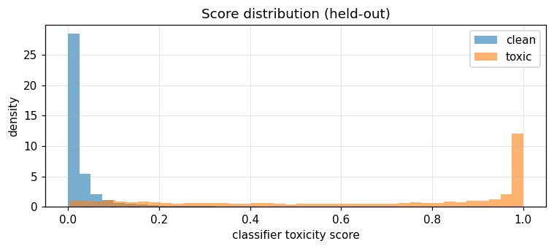
Figure 4.1: Distribution of classifier toxicity scores for clean and toxic comments in the heldout RL test pool

4.2 Ethical Handling
The dataset contains offensive language. In this report and in the interface, offensive words in displayed comments are masked (for example, i****), and no raw toxic examples are reproduced.
Chapter 5

Methodology
The system has two stages. A toxicity classifier converts each comment into a probability, and a reinforcement learning agent converts that probability, together with the current review budget, into an action. Figure 5.1 shows the pipeline.
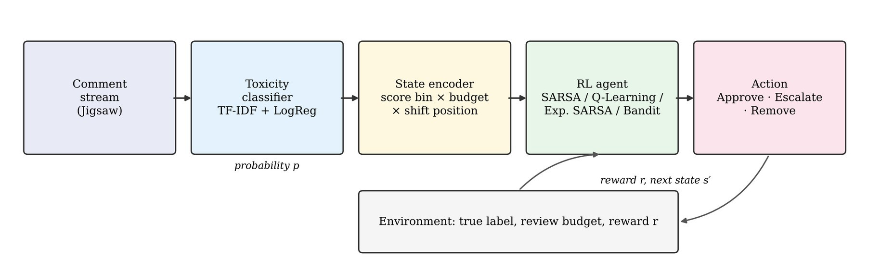
Figure 5.1: Moderation pipeline: classifier score and budget form the state, the agent chooses an action and learns from the reward

5.1 Toxicity Classifier
Each comment is converted into a TF-IDF vector of word unigrams and bigrams (50,000 features, sub-linear term frequency). A logistic regression model trained on the 60% classifier set maps this vector to a toxicity probability. This classifier was chosen because it is fast, well calibrated and strong on this dataset (held-out AUC 0.972). Scores from the transformer case study can be plugged in instead without changing the RL part, and the notebook includes an optional pretrained transformer for this purpose.
To study the effect of classifier quality, a second, degraded classifier was simulated by adding random noise to the logit of each score. Its AUC drops to 0.891, which approximates a weaker sequence model such as a small BiLSTM.

5.2 MDP Formulation

State
The state combines three pieces of information, each discretised so that a simple lookup table (Q-table) can be used:
- Toxicity score bin: the score is split into 10 equal bins (0.0–0.1, 0.1–0.2, …, 0.9–
1.0).
- Review budget level: remaining human reviews out of 15, grouped into 5 levels (none, low, medium, high, full).
- Shift position: which quarter of the 100-comment shift the agent is in (4 levels).
This gives 10 × 5 × 4 = 200 states. The shift position matters because spending a review early leaves less capacity for the rest of the shift.

Actions
Three actions are available: Approve (publish), Escalate (send to a human moderator, who is assumed to decide correctly) and Remove (delete). An escalation uses one unit of budget. If the budget is empty, an escalation fails and the comment is published automatically.

Reward
The rewards encode the cost of each outcome. Missing toxic content is treated as worse than a false removal, and human review has a cost.
Table 5.1: Reward design (per comment)
Outcome | Reward | Reason
Correct approve or correct remove | +1.0 | Right decision
Toxic comment approved (miss) | −5.0 | Harm to users
Clean comment removed (false removal) | −3.0 | Harm to free expression
Escalated to a human | +1.0 − review cost | Correct decision, but costs moderator time (cost 0.5, later 1.0)
Escalated with no budget left | outcome of approve − 1.0 | Overloaded review queue

Episodes and drift
One episode is a shift of 100 comments drawn from the RL pool, with 10% toxic comments. Each agent is trained for 500 episodes. At episode 250 the conditions change: the toxic share rises to 25% and the review cost rises from 0.5 to 1.0. This drift represents a sudden wave of abuse and a moderation team under pressure.

5.3 Learning Algorithms
All learning agents keep a table Q(s, a), which estimates the total future reward of taking action a in state s. After each step the estimate is moved a small amount α towards a target value. The algorithms differ only in the target they use.

Contextual bandit
The bandit only looks at the immediate reward and ignores the future (discount γ = 0). It learns which action is best for each state on its own, without considering that an escalation now leaves less budget later.
Q(s, a) ← Q(s, a) + α [ r − Q(s, a) ]

SARSA (on-policy)
SARSA uses the action a′ that the agent actually takes next, including exploratory actions. It therefore learns the value of the policy it is really following.
Q(s, a) ← Q(s, a) + α [ r + γ Q(s′, a′) − Q(s, a) ]

Q-Learning (off-policy)
Q-Learning uses the best possible next action, whatever the agent actually does. It learns the value of the ideal greedy policy while still exploring.
Q(s, a) ← Q(s, a) + α [ r + γ max Q(s′, ·) − Q(s, a) ]

Expected SARSA
Expected SARSA averages over all next actions, weighted by how likely the current policy is to choose them. This removes the randomness of the sampled next action and usually gives smoother learning.
Q(s, a) ← Q(s, a) + α [ r + γ Σ π(a′ | s′) Q(s′, a′) − Q(s, a) ]

5.4 Exploration Strategies
Table 5.2: Exploration strategies compared
Strategy | How it chooses an action | Idea
Greedy | Always the action with the highest Q value | No exploration; can get stuck on a poor early choice
ε-greedy | Random action with probability ε = 0.1, otherwise greedy | Simple, constant exploration
Decaying ε | ε starts at 1.0 and shrinks to 0.02 over 300 episodes | Explore a lot early, exploit later
UCB | Q(s, a) + c √( ln N(s) / N(s, a) ), c = 1 | Bonus for actions tried less often in that state
Thompson Sampling | Add Gaussian noise that shrinks as an action is tried more | Randomly sample plausible values; explore where uncertain

5.5 Fixed-Threshold Baselines
- Threshold 0.5: remove if the score is at least 0.5, otherwise approve. It never uses human review.
- Two-threshold 0.3/0.7: approve below 0.3, remove at or above 0.7, and escalate scores in between while budget remains (falling back to the 0.5 rule when the budget is empty).
Table 5.3 summarises the 16 policies compared.
Table 5.3: Policies compared in the study
Family | Discount γ | Exploration variants | Count
Fixed thresholds | – | Threshold 0.5, Two-threshold 0.3/0.7 | 2
Contextual bandit | 0 | Greedy, ε-greedy, decaying ε, UCB, Thompson | 5
SARSA | 0.95 | ε-greedy, decaying ε | 2
Q-Learning | 0.95 | Greedy, ε-greedy, decaying ε, UCB, Thompson | 5
Expected SARSA | 0.95 | ε-greedy, decaying ε | 2

Chapter 6

Experimental Setup

6.1 Environment
All experiments were run in Google Colab on a standard CPU runtime with Python 3, NumPy, pandas, scikit-learn and Matplotlib. The interface uses Gradio. The full main experiment (16 policies × 20 seeds × 500 episodes) took 2.8 minutes, and the classifier trained in 27 seconds.

6.2 Hyperparameters
Table 6.1: Hyperparameters and simulation settings
Parameter | Value | Parameter | Value
Random seeds (main) | 20 | Learning rate α | 0.1 (constant)
Seeds (sensitivity, classifier) | 10 | Discount γ (TD methods) | 0.95
Training episodes | 500 | ε (fixed) | 0.1
Comments per episode | 100 | Decaying ε | 1.0 → 0.02 over 300 episodes
Review budget per episode | 15 | UCB constant c | 1.0
Score bins | 10 | Thompson prior scale σ | 2.0
Toxic share before / after drift | 10% / 25% | Review cost before / after drift | 0.5 / 1.0
Drift episode | 250 | Evaluation episodes | 100
A constant learning rate was used instead of a decreasing one so that agents can keep adapting after the drift. Q-tables start with tiny random values to break ties.

6.3 Experiments
- E1 – Main comparison with drift: all 16 policies, 20 seeds each, drift at episode 250.
- E2 – Sensitivity analysis: the miss penalty is set to −2, −5, −10 and −20 for four representative policies, without drift, 10 seeds each.
- E3 – Classifier quality: the two-threshold rule and Q-Learning with decaying ε are run on scores from the original and the degraded classifier, without drift, 10 seeds each.

6.4 Evaluation Protocol
After training, exploration is switched off and each policy acts greedily for 100 shifts drawn from the separate RL test pool. In E1 the test shifts use the post-drift conditions (25% toxic, review cost 1.0), so the evaluation measures how well each policy has adapted. Results are averaged over seeds and reported with 95% confidence intervals.

6.5 Classifier Performance
Table 6.2: Quality of the two toxicity classifiers on the held-out test pool
Classifier | ROC-AUC | PR-AUC | F1 at 0.5
TF-IDF + Logistic Regression | 0.972 | 0.873 | 0.756
Degraded (simulated weak model) | 0.891 | 0.666 | 0.581

Chapter 7

Evaluation Metrics
Moderation quality cannot be captured by one number, so several metrics are reported for every policy. All are measured per shift of 100 comments.
Table 7.1: Evaluation metrics
Metric | Definition | Better
Cumulative reward | Sum of rewards over the shift (Table 5.1) | Higher
Missed toxic | Toxic comments that were published | Lower
False removals | Clean comments that were removed | Lower
Escalations | Comments sent to human review (human workload, maximum 15) | Depends on cost
Pre-drift reward | Mean training reward in the 50 episodes before the drift | Higher
Right after drift | Mean training reward in the 50 episodes after the drift | Higher (faster adaptation)
End of training | Mean training reward in the last 50 episodes | Higher

7.1 Classifier Metrics
- ROC-AUC: probability that a random toxic comment gets a higher score than a random clean one.
- PR-AUC: area under the precision–recall curve; more informative than ROC-AUC for imbalanced data.
- F1 at 0.5: harmonic mean of precision and recall when 0.5 is used as the threshold.

7.2 Confidence Intervals
Every policy is trained with n independent random seeds. For a metric with mean m and standard deviation s across seeds, the 95% confidence interval is:
m ± 1.96 × s / √n
Two policies whose intervals do not overlap can be considered clearly different. Training curves are smoothed with a 20-episode moving average and shown with shaded confidence bands.
Chapter 8

Results and Analysis

8.1 Main Comparison
Table 8.1 shows the greedy evaluation of all 16 policies under the post-drift conditions, sorted by reward.
Table 8.1: Evaluation after drift (mean ± 95% CI over 20 seeds, per shift of 100 comments)
Policy | Reward | Missed toxic | False removals | Escalations
Q-Learning · UCB | 62.0 ± 1.2 | 3.3 ± 0.2 | 1.1 ± 0.2 | 13.4 ± 0.5
Exp. SARSA · Decaying ε | 60.1 ± 1.6 | 3.7 ± 0.3 | 0.7 ± 0.1 | 14.7 ± 0.2
Bandit · ε-greedy | 59.4 ± 3.4 | 2.6 ± 0.1 | 2.1 ± 0.4 | 14.5 ± 0.4
Q-Learning · Thompson | 58.7 ± 1.7 | 3.9 ± 0.2 | 0.9 ± 0.1 | 13.9 ± 0.5
Exp. SARSA · ε-greedy | 58.6 ± 2.6 | 3.0 ± 0.2 | 1.9 ± 0.3 | 14.9 ± 0.1
SARSA · Decaying ε | 58.0 ± 1.6 | 4.0 ± 0.3 | 0.7 ± 0.1 | 14.8 ± 0.1
Bandit · Thompson | 57.5 ± 1.3 | 2.5 ± 0.1 | 3.0 ± 0.3 | 14.9 ± 0.1
Two-threshold 0.3/0.7 | 57.3 ± 0.9 | 5.9 ± 0.1 | 0.2 ± 0.0 | 6.6 ± 0.1
SARSA · ε-greedy | 55.6 ± 2.6 | 3.2 ± 0.2 | 1.7 ± 0.2 | 14.8 ± 0.1
Q-Learning · Decaying ε | 55.0 ± 1.3 | 3.8 ± 0.3 | 1.7 ± 0.3 | 14.9 ± 0.2
Bandit · Decaying ε | 54.1 ± 3.0 | 2.4 ± 0.2 | 3.7 ± 0.4 | 15.0 ± 0.0
Bandit · Greedy | 53.8 ± 0.7 | 2.4 ± 0.2 | 4.2 ± 0.3 | 15.0 ± 0.0
Bandit · UCB | 53.6 ± 2.1 | 2.3 ± 0.2 | 4.0 ± 0.3 | 14.9 ± 0.2
Q-Learning · ε-greedy | 53.3 ± 3.9 | 3.7 ± 0.2 | 1.7 ± 0.2 | 14.8 ± 0.2
Q-Learning · Greedy | 46.3 ± 3.0 | 4.8 ± 0.4 | 1.5 ± 0.2 | 14.9 ± 0.1
Threshold 0.5 | 45.3 ± 1.1 | 8.7 ± 0.2 | 0.6 ± 0.0 | 0.0 ± 0.0
Seven learned policies earn more reward than the best fixed rule. The top policy, QLearning with UCB, beats the two-threshold rule by 4.7 points and its confidence interval does not overlap. The main reason is visible in the last two columns: the learned agents miss far fewer toxic comments (2.3–4.0 instead of 5.9) by using almost the whole review budget, whereas the two-threshold rule only escalates comments that happen to fall between 0.3 and 0.7 and leaves more than half of the reviewers idle. The single threshold, which never asks a human, misses 8.7 toxic comments per shift and is the worst policy.
The bandits miss the fewest toxic comments but make many false removals (up to 4.2 per shift). Because a bandit ignores the future, it spends the budget early and then removes most uncertain comments once the budget is gone. Figure 8.1 compares all four metrics side by side.
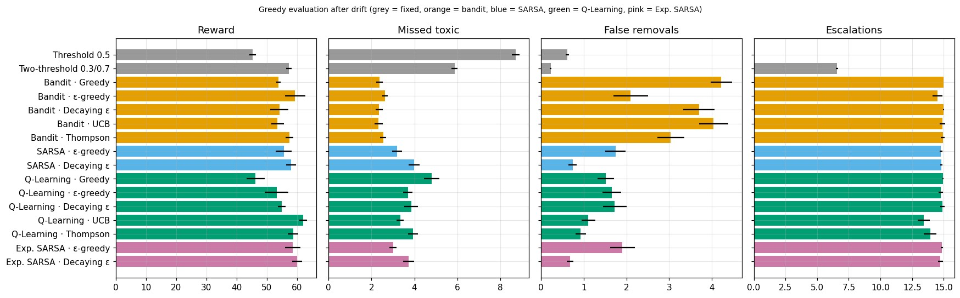
Figure 8.1: Greedy evaluation after drift for all policies (grey = fixed, orange = bandit, blue = SARSA, green = Q-Learning, pink = Expected SARSA)

8.2 Learning Algorithms
Figure 8.2 compares the learning rules with the same decaying-ε exploration. All learned agents start near −70 because ε = 1 means fully random actions, then improve steadily. Expected SARSA learns fastest and SARSA follows closely. Q-Learning is the slowest of the three before the drift and drops the most when the drift happens. The two-threshold rule is flat at about 83 before the drift because it does not learn, and after the drift all methods settle between 50 and 57.
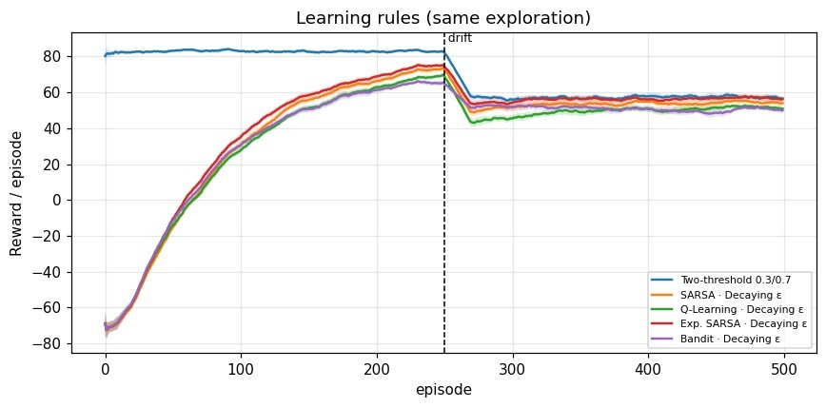
Figure 8.2: Training reward of the learning rules with decaying-ε exploration (mean ± 95% CI over 20 seeds)

8.3 Exploration Strategies
Figures 8.3 and 8.4 show that exploration has a large effect. With Q-Learning, UCB reaches about 82 within 30 episodes, matches the fixed rule before the drift and stays the best afterwards at about 61. Thompson Sampling is close behind. Pure greedy learns quickly but locks into an early, poor choice and ends at about 46. Constant ε-greedy is the weakest during training because 10% of its actions are always random, although its greedy evaluation is better than its training curve suggests.
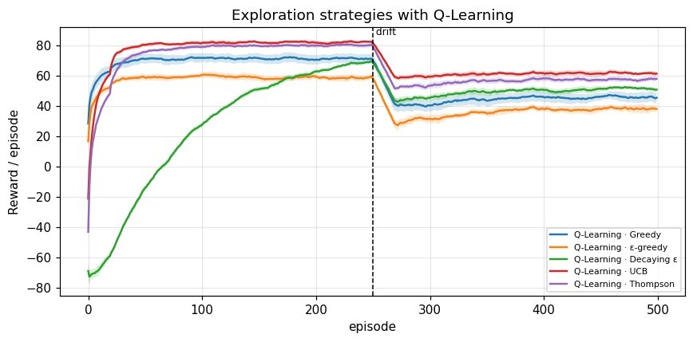
Figure 8.3: Training reward of Q-Learning under the five exploration strategies
For bandits the differences are smaller after the drift because all bandits share the same short-sighted target. Even so, constant ε-greedy again has the lowest training reward.
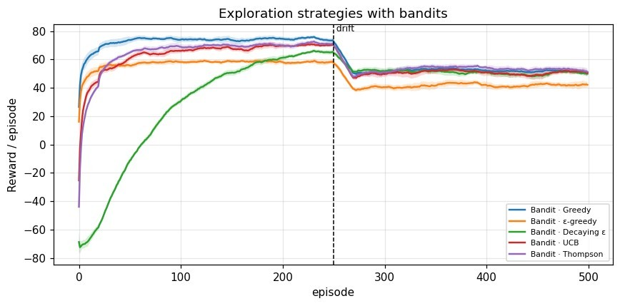
Figure 8.4: Training reward of contextual bandits under the five exploration strategies

8.4 Adaptation to Drift
Table 8.2: Mean training reward before and after the drift (selected policies)
Policy | Pre-drift | Right after drift | End of training
Two-threshold 0.3/0.7 | 83.0 | 57.0 | 57.1
Q-Learning · UCB | 82.3 | 59.3 | 61.7
Policy | Pre-drift | Right after drift | End of training
Q-Learning · Thompson | 80.4 | 52.8 | 57.6
Exp. SARSA · Decaying ε | 74.1 | 54.2 | 56.8
SARSA · Decaying ε | 72.0 | 50.6 | 54.6
Q-Learning · Decaying ε | 68.0 | 44.8 | 51.6
Bandit · Decaying ε | 65.2 | 51.9 | 50.6
Threshold 0.5 | 77.6 | 47.7 | 48.1
Every policy loses reward after the drift because a shift with 25% toxic content is harder. The fixed rules have no way to respond, so their reward stays at the new lower level. The TD agents keep learning and gain 2 to 7 points by the end of training. Q-Learning with UCB is the only policy that ends above the two-threshold rule in training reward as well as in evaluation.

8.5 Sensitivity to the Cost of a Miss
Because the reward values are assumptions, experiment E2 varied the miss penalty without drift. Table 8.3 and Figure 8.5 show the results.
Table 8.3: Reward per shift (missed toxic in brackets) for different miss penalties, no drift
Miss penalty | Threshold 0.5 | Two-threshold | Bandit · Dec. ε | Q-Learning · Dec. ε
−2 | 86.7 (3.44) | 90.1 (2.31) | 87.8 (1.43) | 78.5 (2.82)
−5 | 76.4 (3.44) | 83.2 (2.31) | 74.5 (1.96) | 73.4 (2.07)
−10 | 59.2 (3.44) | 71.6 (2.31) | 59.8 (0.95) | 63.3 (1.32)
−20 | 24.8 (3.44) | 48.5 (2.31) | 34.0 (0.79) | 50.0 (0.80)
Two clear patterns appear. First, without drift the tuned two-threshold rule is the strongest policy at the usual penalties: it wins at −2, −5 and −10, and only at −20 does Q-Learning catch up (50.0 versus 48.5, within the confidence interval). Second, only the learned agents change their behaviour with the costs. As the penalty grows, Q-Learning cuts its missed toxic comments from 2.82 to 0.80, while the fixed rules keep exactly the same number of misses because their thresholds do not move. The price is more false removals (up to 5.7 per shift at −20).
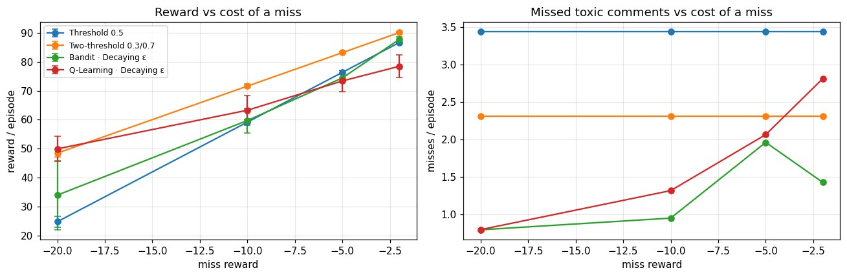
Figure 8.5: Sensitivity analysis: reward (left) and missed toxic comments (right) as the miss penalty changes

8.6 Effect of Classifier Quality
Table 8.4: Policy performance with a strong and a degraded classifier (no drift, 10 seeds)
Classifier (AUC) | Policy | Reward | Missed | False rem. | Escalations
TF-IDF + LogReg (0.972) | Two-threshold | 83.2 | 2.31 | 0.29 | 3.54
TF-IDF + LogReg (0.972) | Q-Learning · Dec. ε | 73.4 | 2.07 | 1.05 | 14.79
Degraded (0.891) | Two-threshold | 68.8 | 2.30 | 2.74 | 12.96
Degraded (0.891) | Q-Learning · Dec. ε | 64.2 | 3.66 | 1.41 | 15.00
A weaker classifier lowers the reward of both policies by 9 to 14 points. With noisier scores many more comments fall into the uncertain middle range, so the two-threshold rule's escalations rise from 3.5 to 13.0 and its false removals rise nearly tenfold. The learned agent cannot recover information the classifier does not provide: its misses rise from 2.1 to 3.7. Classifier quality therefore sets an upper limit on what the decision policy can achieve, which links this study directly to the transformer models of the companion case study.
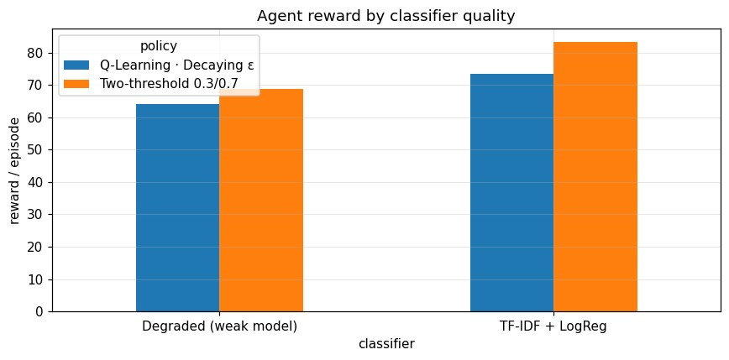
Figure 8.6: Reward of the two-threshold rule and Q-Learning with the original and the degraded classifier

8.7 Answers to the Research Questions
Table 8.5: Summary of findings
Question | Finding
RQ1: Learned vs fixed | Yes, under changing conditions: Q-Learning · UCB 62.0 vs two-threshold 57.3, with 44% fewer missed toxic comments. Under fixed conditions the tuned two-threshold rule is equal or better.
RQ2: SARSA vs QLearning | SARSA (decaying ε) earned more (58.0 vs 55.0), made fewer false removals (0.7 vs 1.7) and recovered faster after the drift (50.6 vs 44.8).
RQ3: Exploration vs algorithm | Exploration matters more: changing the exploration strategy of Q-Learning moved reward by 15.7 points, changing the algorithm by only 5.9.
RQ4: Classifier quality | A weaker classifier (AUC 0.891) cut Q-Learning reward from 73.4 to 64.2 and increased missed toxic comments.
Chapter 9

Sample Predictions

9.1 Worked Example of One Decision
Consider a comment that receives a toxicity score of 0.965, arriving as the 50th comment of the shift when 5 of the 15 reviews remain. The state is encoded as follows:
- Score bin = 0.965 × 10 = 9 (the highest bin).⌊ ⌋
- Budget level = 4 × 5 / 15 = 2 (medium).⌈ ⌉ • Shift position = 4 × 50 / 100 = 2 (third quarter).⌊ ⌋
- State index = (9 × 5 + 2) × 4 + 2 = 190.
If the comment is truly toxic, the three actions would give Approve = −5.0, Escalate = +0.5 (before drift) and Remove = +1.0. If it is actually clean, they would give Approve = +1.0, Escalate = +0.5 and Remove = −3.0. Since a score of 0.965 is very likely toxic, the agent learns over many such comments that Remove has the highest expected value in this state, while Escalate is a safe middle option when the score is less certain and reviewers are available.

9.2 Learned Decision Maps
Figure 9.1 shows, for one trained agent of each family, the action chosen in every combination of score bin and budget level in the second quarter of a shift. Green means approve, yellow escalate and red remove.
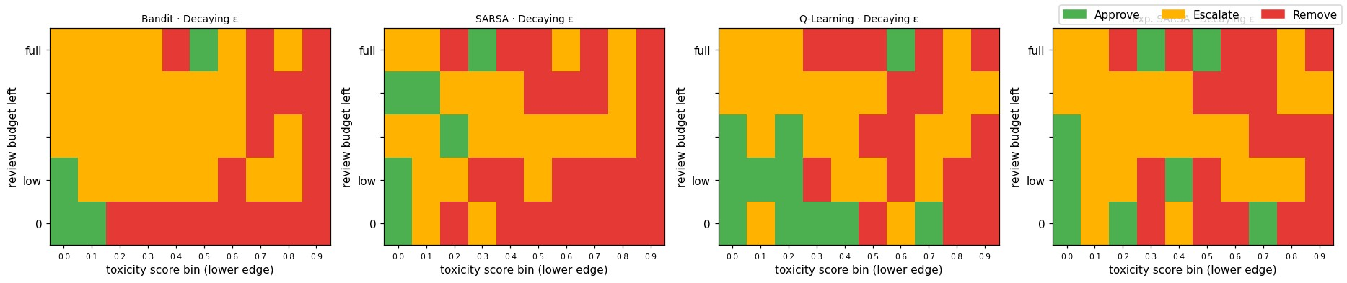
Figure 9.1: Decision maps of the learned policies (seed 0) by toxicity score and remaining review budget, second quarter of the shift
Table 9.1: Decision patterns read from the learned maps
Situation | Typical learned action | Interpretation
Score 0.9–1.0, any budget | Remove (almost all cells) | Clearly toxic; no need to spend a review
Score 0.0–0.1, budget empty or low | Approve | Clearly clean; save remaining reviews
Situation | Typical learned action | Interpretation
Middle scores, budget high | Escalate | Uncertain cases are sent to humans while capacity lasts
Budget empty, scores above about 0.2 (bandit) | Remove | Short-sighted bandit removes aggressively once reviews run out, causing false removals
Full budget, even low scores | Escalate | Reviews unused at the end of a shift are wasted, so agents spend them early
Some isolated cells, such as an approve inside a block of removes, occur in states that are visited rarely (for example a very high score with a full budget late in the shift). The tabular agent has seen too few examples there to learn a stable value. This is a known limitation of tabular methods and is discussed in Chapter 11.

9.3 Interactive Interface
A Gradio web interface was built on top of the trained agents. It has four tabs:
- Moderate a comment: the user types a comment, sets the remaining reviews and the position in the shift, and selects a policy. The interface shows the toxicity score, the encoded state, the chosen action, the Q-values of all three actions and what the two-threshold rule would do.
- Simulate a moderation shift: runs a chosen policy over a queue of held-out comments (with offensive words masked) and reports total reward, missed toxic comments, false removals and budget used.
- Policy map: displays the learned decision map of any agent for any quarter of the shift.
- Results: shows the comparison table of Chapter 8.
Table 9.2: Sample decisions from the interface (Q-Learning · UCB, 7 reviews left, comment 50 of 100)
Comment (masked) | Score | Agent action | Two-threshold action
Thanks for adding the source, the article reads much better now. | [fill] | [fill] | [fill]
You are a complete i****, stop editing this page. | [fill] | [fill] | [fill]
This argument is d*** but I see where you are coming from. | [fill] | [fill] | [fill]
Chapter 10

Discussion

10.1 Why Learned Policies Win Under Drift
The biggest practical difference between the learned agents and the fixed rules is how they use human reviewers. A fixed rule escalates only comments that fall inside a chosen score band, so on a typical shift it uses 6.6 of the 15 available reviews. The learned agents discover from the rewards that a review guarantees a correct outcome, while guessing on an uncertain comment risks −5 or −3. An unused review at the end of the shift earns nothing, so they spend the whole budget on the comments where it helps most. When the share of toxic content rises after the drift, this extra human checking prevents many misses, and the learned policies pull ahead.

10.2 Why Fixed Rules Remain Strong When Nothing Changes
When conditions are stable, a two-threshold rule built on a well-calibrated classifier is already close to optimal for these costs. The learned agents must first explore, which costs reward, and their discretised view of the score (10 bins) is coarser than the exact score used by the rule. This honest result suggests that RL is most valuable for platforms where content mix, costs or moderator capacity change over time, and less necessary for stable environments where thresholds can be tuned once.

10.3 On-Policy versus Off-Policy
SARSA learns the value of the policy it actually follows, including the risk that an exploratory action will be taken next. This makes it more cautious, which in moderation shows up as fewer false removals (0.7 versus 1.7) and a smaller drop after the drift. QLearning learns the value of the ideal greedy policy and ignores its own exploration, so it can be more aggressive. This mirrors the classic cliff-walking example from reinforcement learning theory, where SARSA takes the safer path. Expected SARSA combines the advantages of both: it uses the policy's own probabilities like SARSA but removes the noise of a single sampled action, and it was the best method under decaying-ε exploration.

10.4 Exploration Is the Larger Design Choice
Changing the exploration strategy changed Q-Learning's reward by 15.7 points, nearly three times the effect of changing the algorithm. Pure greedy exploration commits to whatever action looked good first and rarely corrects itself. Constant ε-greedy keeps making random decisions forever, which is costly in moderation because a random approve of a toxic comment costs −5. UCB explores systematically, trying each action in each state until its value is known and then focusing on the best one, which suits a problem with only 200 states and 3 actions. Thompson Sampling behaves similarly and was a close second.

10.5 Which Policy for Which Scenario
Table 10.1: Recommended policy by moderation scenario
Scenario | Recommended policy | Reason
Stable traffic, well-tuned classifier | Two-threshold rule | Strong, simple, no training needed
Traffic or costs change over time | Q-Learning · UCB | Highest reward and fastest adaptation in E1
False removals are especially costly | SARSA or Exp. SARSA · Decaying ε | Fewest false removals among learned policies (0.7)
Missing toxic content is very costly | Learned agent (Q-Learning) | Only learned policies reduce misses as the penalty grows
Weak classifier | Improve the classifier first | Policy quality is limited by score quality

Chapter 11

Limitations
- Simulation, not deployment: the study uses a simulated comment stream. The reward values are design assumptions rather than measured platform costs, which is why the sensitivity analysis was included.
- Perfect human moderators: escalated comments are assumed to be judged correctly. Real moderators make mistakes, disagree with each other and become tired.
- Tabular state: the score is reduced to 10 bins and the budget to 5 levels. This loses information and leaves rarely visited states with noisy decisions, as seen in the decision maps.
- Simple drift: only one sudden change in toxic share and review cost was tested. Real platforms face gradual and repeated changes.
- Single classifier family: the main experiments use TF-IDF with logistic regression, and the weaker classifier was simulated by adding noise rather than by training a real BiLSTM.
- Leakage risk with pretrained transformers: the optional pretrained toxic-bert model was itself trained on Jigsaw, so its scores on this data would be optimistic.
- Binary label: the six toxicity types were merged, so a threat and a mild insult carry the same penalty.
- Seed-0 policy maps: the decision maps show one trained agent per family and may not represent every seed.
Chapter 12

Future Enhancements
- Deep Q-Networks (DQN): replace the Q-table with a neural network that takes the exact score and budget as input, removing the binning step.
- Transformer scores: use calibrated outputs from the fine-tuned DistilBERT, BERT and RoBERTa models of the companion case study, trained only on the classifier split, to compare classifiers without leakage.
- Richer state: add comment features such as length, toxicity type, user history and thread context.
- Realistic moderators: model human error, review time and daily moderator schedules.
- Severity-aware rewards: give threats and identity hate larger penalties than mild insults by using all six labels.
- Continuous drift and change detection: simulate gradual and repeated drift and add a mechanism that raises exploration when performance drops.
- Offline and human-in-the-loop learning: learn from logged moderation decisions before going live, and let moderators correct the agent.
- Fairness analysis: check whether the learned policy removes comments that mention particular identity groups more often than others.

Bibliography
- Vaswani, A., Shazeer, N., Parmar, N., Uszkoreit, J., Jones, L., Gomez, A.N., Kaiser, Ł. and Polosukhin, I., 2017. Attention is all you need. Advances in neural information processing systems, 30.
- Devlin, J., Chang, M.W., Lee, K. and Toutanova, K., 2019, June. Bert: Pre-training of deep bidirectional transformers for language understanding. In Proceedings of the 2019 conference of the North American chapter of the association for computational linguistics: human language technologies, volume 1 (long and short papers) (pp. 4171-4186).
- Sanh, V., Debut, L., Chaumond, J. and Wolf, T., 2019. DistilBERT, a distilled version of BERT: smaller, faster, cheaper and lighter. arXiv preprint arXiv:1910.01108.
- Sutton, R.S. and Barto, A.G., 2018. Reinforcement learning: An introduction. 2nd ed. MIT Press.
- Watkins, C.J. and Dayan, P., 1992. Q-learning. Machine learning, 8(3), pp.279-292.
- Rummery, G.A. and Niranjan, M., 1994. On-line Q-learning using connectionist systems. Technical Report CUED/F-INFENG/TR 166, Cambridge University Engineering Department.
- Van Seijen, H., Van Hasselt, H., Whiteson, S. and Wiering, M., 2009. A theoretical and empirical analysis of Expected Sarsa. In 2009 IEEE Symposium on Adaptive Dynamic Programming and Reinforcement Learning (pp. 177-184).
- Auer, P., Cesa-Bianchi, N. and Fischer, P., 2002. Finite-time analysis of the multiarmed bandit problem. Machine learning, 47(2), pp.235-256.
- Thompson, W.R., 1933. On the likelihood that one unknown probability exceeds another in view of the evidence of two samples. Biometrika, 25(3/4), pp.285-294.
- Lattimore, T. and Szepesvári, C., 2020. Bandit algorithms. Cambridge University Press.
- Wulczyn, E., Thain, N. and Dixon, L., 2017. Ex machina: Personal attacks seen at scale. In Proceedings of the 26th International Conference on World Wide Web (pp. 1391-1399).
- cjadams, Sorensen, J., Elliott, J., Dixon, L., McDonald, M., nithum and Cukierski,
W., 2017. Toxic Comment Classification Challenge. Kaggle.
https://www.kaggle.com/c/jigsaw-toxic-comment-classification-challenge
- Pedregosa, F. et al., 2011. Scikit-learn: Machine learning in Python. Journal of Machine Learning Research, 12, pp.2825-2830.
Appendix A

Source Code
The complete Google Colab notebook (RL_Toxic_Moderation_Case_Study.ipynb) is listed below, cell by cell. Shell commands (lines starting with !) install packages in Colab.

A.1 Setup and imports
!pip -q install gradio import os, math, glob, time, zipfile, shutil, warnings import numpy as np import pandas as pd import matplotlib.pyplot as plt from matplotlib.colors import ListedColormap from sklearn.model_selection import train_test_split from sklearn.feature_extraction.text import TfidfVectorizer from sklearn.linear_model import LogisticRegression from sklearn.metrics import roc_auc_score, f1_score, average_precision_score warnings.filterwarnings("ignore") try:
import google.colab # noqa: F401 IN_COLAB = True except ImportError: IN_COLAB = False
plt.rcParams.update({"figure.dpi": 110, "axes.grid": True, "grid.alpha": 0.3}) RESULTS_DIR = "results" os.makedirs(RESULTS_DIR, exist_ok=True) print("Running in Colab:", IN_COLAB)

A.2 Configuration
QUICK = False # True = fast trial run
DATA_SOURCE = "auto" # "auto" (kaggle.json if present, else upload), "upload", "kaggle",
"demo"
USE_TRANSFORMER = False # True = also score comments with a pretrained transformer (use a GPU runtime) TRANSFORMER_MODEL = "unitary/toxic-bert"
MAX_TRANSFORMER_COMMENTS = 6000

CFG = dict(
N_SEEDS=20, # random seeds per agent (main experiment)
N_SEEDS_SMALL=10, # seeds for sensitivity / classifier-quality experiments
N_EPISODES=500, # training episodes per run
EP_LEN=100, # comments per episode (one moderation "shift")
BUDGET=15, # human reviews available per episode
N_BINS=10, # toxicity score bins
GAMMA=0.95, # discount for TD methods (bandits use 0)
ALPHA=0.1, # constant step size (lets agents track change)
EPS=0.1, # fixed epsilon
EPS_START=1.0, EPS_MIN=0.02, DECAY_EPISODES=300,
UCB_C=1.0,
TS_SIGMA=2.0, # Thompson Sampling prior scale
TOXIC_RATE=0.10, # share of toxic comments before drift
DRIFT_EPISODE=250, # when conditions change
DRIFT_TOXIC_RATE=0.25, # share of toxic comments after drift
DRIFT_REVIEW_COST=1.0, # review cost after drift
EVAL_EPISODES=100,
) REWARDS = dict( correct=1.0, # right approve / right remove miss=-5.0, # toxic comment approved false_remove=-3.0, # clean comment removed review_cost=0.5, # cost of one human review (human decides correctly)
no_budget=-1.0, # tried to escalate with no reviewers left (comment auto-approved) ) if QUICK: CFG.update(N_SEEDS=5, N_SEEDS_SMALL=3, N_EPISODES=200, DRIFT_EPISODE=100,
DECAY_EPISODES=120, EVAL_EPISODES=30)

ACTIONS = ["Approve", "Escalate", "Remove"]
N_ACTIONS = 3
N_BUDGET_BINS = 5
N_TIME_BINS = 4 N_STATES = CFG["N_BINS"] * N_BUDGET_BINS * N_TIME_BINS print("States:", N_STATES, "| Actions:", N_ACTIONS)

A.3 Load the Jigsaw dataset
LABEL_COLS = ["toxic", "severe_toxic", "obscene", "threat", "insult", "identity_hate"] def _find_train_csv():
for p in ["train.csv", "train.csv.zip", "/content/train.csv", "/content/train.csv.zip", "jigsaw/train.csv", "jigsaw/train.csv.zip"]: if os.path.exists(p):
return p return None def _try_kaggle():
home_key = os.path.expanduser("~/.kaggle/kaggle.json") if not os.path.exists(home_key): if os.path.exists("kaggle.json"):
os.makedirs(os.path.dirname(home_key), exist_ok=True) shutil.copy("kaggle.json", home_key) os.chmod(home_key, 0o600) else:
return False os.system("pip -q install kaggle") rc = os.system("kaggle competitions download -c jigsaw-toxic-comment-classificationchallenge -p jigsaw -q") zp = "jigsaw/jigsaw-toxic-comment-classification-challenge.zip" if rc != 0 or not os.path.exists(zp):
print("Kaggle download failed (did you accept the competition rules?)") return False with zipfile.ZipFile(zp) as z:
z.extractall("jigsaw") return True def make_demo_corpus(n=20000, seed=0): # Small synthetic corpus so the notebook runs without the real dataset. rng = np.random.default_rng(seed) topics = ["the election", "this article", "the new policy", "the match", "the movie", "climate data", "the edit", "the citation", "the budget", "this page"] clean_t = ["I think {t} needs a better source.", "Thanks for fixing {t}, looks good now.", "Can someone explain {t} in more detail?", "I disagree with {t} but respect the view.", "Please discuss {t} on the talk page first.", "Good point about {t}."] insults = ["idiot", "stupid", "moron", "loser", "pathetic", "dumb", "clown", "trash"] tox_t = ["You are a {i}, stop editing {t}.", "Only a {i} would write {t}.", "Shut up you {i}.", "{t} was written by a {i}, get lost.", "What a {i} take on {t}, you {i2}."] rows = [] for _ in range(n):
t = rng.choice(topics) if rng.random() < 0.10:
s = rng.choice(tox_t).format(t=t, i=rng.choice(insults), i2=rng.choice(insults)); y = 1 else:
s = rng.choice(clean_t).format(t=t); y = 0 if rng.random() < 0.05: # hard cases: clean text with a harsh word s += " That argument is " + rng.choice(["dumb", "trash", "pathetic"]) + "." if rng.random() < 0.05: # label noise y = 1 - y rows.append((s, y)) return pd.DataFrame(rows, columns=["text", "label"]) def load_data():
path = _find_train_csv() if path is None and DATA_SOURCE in ("auto", "kaggle") and _try_kaggle():
path = _find_train_csv() if path is None and IN_COLAB and DATA_SOURCE in ("auto", "upload"):
from google.colab import files print("Please upload Jigsaw train.csv or train.csv.zip") files.upload() path = _find_train_csv() if path is None or DATA_SOURCE == "demo":
print("WARNING: Jigsaw not found -> using DEMO corpus (results are only illustrative).") return make_demo_corpus(), True df = pd.read_csv(path) df["label"] = (df[LABEL_COLS].sum(axis=1) > 0).astype(int) df = df.rename(columns={"comment_text": "text"})[["text", "label"]] return df, False df, DEMO_MODE = load_data() df = df.dropna().reset_index(drop=True)
print(f"Comments: {len(df):,} | toxic share: {df.label.mean():.3f} | demo mode: {DEMO_MODE}") A.4 Data split
clf_df, env_df = train_test_split(df, test_size=0.4, stratify=df.label, random_state=42) env_train_df, env_test_df = train_test_split(env_df, test_size=0.5, stratify=env_df.label, random_state=42) clf_df, env_train_df, env_test_df = [d.reset_index(drop=True) for d in (clf_df, env_train_df, env_test_df)] print(f"Classifier train: {len(clf_df):,} | RL train pool: {len(env_train_df):,} | RL test pool: {len(env_test_df):,}") A.5 Toxicity classifier
t0 = time.time() vec = TfidfVectorizer(max_features=50000, ngram_range=(1, 2), sublinear_tf=True, min_df=2, strip_accents="unicode") X_clf = vec.fit_transform(clf_df.text) clf = LogisticRegression(C=4.0, max_iter=2000, solver="liblinear")
clf.fit(X_clf, clf_df.label) def score_texts(texts):
return clf.predict_proba(vec.transform(list(texts)))[:, 1] env_train_scores = score_texts(env_train_df.text) env_test_scores = score_texts(env_test_df.text) env_train_labels = env_train_df.label.values env_test_labels = env_test_df.label.values def clf_report(scores, labels):
return dict(AUC=roc_auc_score(labels, scores), PR_AUC=average_precision_score(labels, scores), F1_at_0_5=f1_score(labels, scores >= 0.5)) print(f"Trained in {time.time()-t0:.1f}s") print("Held-out quality:", {k: round(v, 3) for k, v in clf_report(env_test_scores, env_test_labels).items()}) fig, ax = plt.subplots(figsize=(7, 3.2)) ax.hist(env_test_scores[env_test_labels == 0], bins=40, alpha=0.6, label="clean", density=True) ax.hist(env_test_scores[env_test_labels == 1], bins=40, alpha=0.6, label="toxic", density=True) ax.set_xlabel("classifier toxicity score"); ax.set_ylabel("density"); ax.set_title("Score distribution (held-out)") ax.legend(); plt.tight_layout(); plt.savefig(f"{RESULTS_DIR}/score_distribution.png"); plt.show()

A.6 Classifier-quality variants
def degrade(scores, noise_sd=1.5, seed=0): rng = np.random.default_rng(seed) p = np.clip(scores, 1e-6, 1 - 1e-6) logit = np.log(p / (1 - p)) * 0.6 + rng.normal(0, noise_sd, len(p)) return 1 / (1 + np.exp(-logit))
CLASSIFIERS = {
"TF-IDF + LogReg": (env_train_scores, env_train_labels, env_test_scores, env_test_labels), "Degraded (weak model)": (degrade(env_train_scores, seed=1), env_train_labels, degrade(env_test_scores, seed=2), env_test_labels), } if USE_TRANSFORMER and not DEMO_MODE: import torch from transformers import pipeline pipe = pipeline("text-classification", model=TRANSFORMER_MODEL, top_k=None, truncation=True, max_length=256, function_to_apply="sigmoid", device=0 if torch.cuda.is_available() else -1) def bert_scores(texts):
out = pipe(list(texts), batch_size=64) return np.array([{d["label"].lower(): d["score"] for d in o}.get("toxic", max(d["score"] for d in o)) for o in out]) rng = np.random.default_rng(0) tr_i = rng.choice(len(env_train_df), min(MAX_TRANSFORMER_COMMENTS, len(env_train_df)), replace=False) te_i = rng.choice(len(env_test_df), min(MAX_TRANSFORMER_COMMENTS, len(env_test_df)), replace=False) t0 = time.time()
CLASSIFIERS["Transformer (toxic-bert)"] = (bert_scores(env_train_df.text.values[tr_i]), env_train_labels[tr_i], bert_scores(env_test_df.text.values[te_i]), env_test_labels[te_i]) print(f"Transformer scoring done in {time.time()-t0:.0f}s")
clf_quality = pd.DataFrame({k: clf_report(v[2], v[3]) for k, v in CLASSIFIERS.items()}).T.round(3) clf_quality

A.7 Moderation environment (MDP)
def encode_state(score, budget, t, cfg=CFG):
sb = min(int(score * cfg["N_BINS"]), cfg["N_BINS"] - 1) bb = math.ceil((N_BUDGET_BINS - 1) * budget / cfg["BUDGET"]) if cfg["BUDGET"] > 0 else 0 tb = min(N_TIME_BINS - 1, int(N_TIME_BINS * t / cfg["EP_LEN"])) return (sb * N_BUDGET_BINS + bb) * N_TIME_BINS + tb class ModerationEnv: def __init__(self, scores, labels, seed, rewards, cfg=CFG):
self.scores = np.asarray(scores, dtype=float) self.labels = np.asarray(labels).astype(int) self.tox = np.flatnonzero(self.labels == 1) self.cln = np.flatnonzero(self.labels == 0) self.rng = np.random.default_rng(seed) self.R = dict(rewards) self.cfg = cfg self.toxic_rate = cfg["TOXIC_RATE"] def set_conditions(self, toxic_rate=None, review_cost=None): if toxic_rate is not None: self.toxic_rate = toxic_rate if review_cost is not None: self.R["review_cost"] = review_cost def reset(self):
n = self.cfg["EP_LEN"] is_tox = self.rng.random(n) < self.toxic_rate self.ep_idx = np.where(is_tox, self.rng.choice(self.tox, n), self.rng.choice(self.cln, n)) self.ep_scores = self.scores[self.ep_idx].tolist() self.ep_labels = self.labels[self.ep_idx].tolist() self.t, self.budget = 0, self.cfg["BUDGET"] return self._state() @property def current_score(self):
return self.ep_scores[self.t] def _state(self):
return encode_state(self.ep_scores[self.t], self.budget, self.t, self.cfg) def step(self, a):
y, R = self.ep_labels[self.t], self.R if a == 0:
outcome = "miss" if y else "correct" elif a == 2:
outcome = "correct" if y else "false_remove" elif self.budget > 0: self.budget -= 1 outcome = "escalated" else:
outcome = "no_budget_miss" if y else "no_budget"
reward = {"correct": R["correct"], "miss": R["miss"], "false_remove": R["false_remove"],
"escalated": R["correct"] - R["review_cost"],
"no_budget": R["correct"] + R["no_budget"], "no_budget_miss": R["miss"] + R["no_budget"]}[outcome] self.t += 1 done = self.t >= self.cfg["EP_LEN"]
return (None if done else self._state()), reward, done, outcome A.8 Agents
class TabularAgent: def __init__(self, algo, explore, seed, cfg=CFG, n_states=N_STATES):
self.algo, self.explore, self.cfg = algo, explore, cfg self.rng = np.random.default_rng(seed + 7919) self.Q = self.rng.random((n_states, N_ACTIONS)) * 1e-4 self.N = np.zeros((n_states, N_ACTIONS)) self.gamma = 0.0 if algo == "bandit" else cfg["GAMMA"] self.decay = (cfg["EPS_MIN"] / cfg["EPS_START"]) ** (1 / max(1, cfg["DECAY_EPISODES"])) def epsilon(self, ep):
if self.explore == "eps": return self.cfg["EPS"] if self.explore == "decay": return max(self.cfg["EPS_MIN"], self.cfg["EPS_START"] * self.decay ** ep) return 0.0 def act(self, s, ep, env=None, greedy=False):
q = self.Q[s] if greedy or self.explore == "greedy":
return int(q.argmax()) if self.explore in ("eps", "decay"): if self.rng.random() < self.epsilon(ep): return int(self.rng.integers(N_ACTIONS)) return int(q.argmax()) n = self.N[s] if self.explore == "ucb": if (n == 0).any():
return int(np.flatnonzero(n == 0)[0]) return int((q + self.cfg["UCB_C"] * np.sqrt(np.log(n.sum()) / n)).argmax()) if self.explore == "thompson":
return int((q + self.rng.normal(0, 1, N_ACTIONS) * self.cfg["TS_SIGMA"] / np.sqrt(n + 1)).argmax())
raise ValueError(self.explore) def _policy_probs(self, s, ep):
e = self.epsilon(ep) if self.explore in ("eps", "decay") else self.cfg["EPS"] p = np.full(N_ACTIONS, e / N_ACTIONS) p[int(self.Q[s].argmax())] += 1 - e return p def update(self, s, a, r, s2, a2, done, ep):
self.N[s, a] += 1 if done or self.gamma == 0.0:
target = r elif self.algo == "sarsa":
target = r + self.gamma * self.Q[s2, a2] elif self.algo == "qlearning":
target = r + self.gamma * self.Q[s2].max() elif self.algo == "expected_sarsa":
target = r + self.gamma * float(self._policy_probs(s2, ep) @ self.Q[s2])
else:
target = r self.Q[s, a] += self.cfg["ALPHA"] * (target - self.Q[s, a]) class ThresholdAgent: # Single threshold: remove if p >= low. Two thresholds: approve < low <= escalate < high <= remove. def __init__(self, low, high=None): self.low, self.high = low, high def act(self, s, ep, env=None, greedy=False):
p = env.current_score if self.high is None:
return 2 if p >= self.low else 0 if p >= self.high: return 2 if p >= self.low: return 1 if env.budget > 0 else (2 if p >= 0.5 else 0) return 0 def update(self, *args): pass
AGENT_SPECS = {
"Threshold 0.5": ("fixed", (0.5, None)),
"Two-threshold 0.3/0.7": ("fixed", (0.3, 0.7)),
"Bandit · Greedy": ("bandit", "greedy"),
"Bandit · ε-greedy": ("bandit", "eps"),
"Bandit · Decaying ε": ("bandit", "decay"),
"Bandit · UCB": ("bandit", "ucb"),
"Bandit · Thompson": ("bandit", "thompson"),
"SARSA · ε-greedy": ("sarsa", "eps"),
"SARSA · Decaying ε": ("sarsa", "decay"),
"Q-Learning · Greedy": ("qlearning", "greedy"),
"Q-Learning · ε-greedy": ("qlearning", "eps"),
"Q-Learning · Decaying ε": ("qlearning", "decay"),
"Q-Learning · UCB": ("qlearning", "ucb"),
"Q-Learning · Thompson": ("qlearning", "thompson"),
"Exp. SARSA · ε-greedy": ("expected_sarsa", "eps"),
"Exp. SARSA · Decaying ε": ("expected_sarsa", "decay"),
} def make_agent(spec, seed, cfg=CFG):
algo, arg = spec if algo == "fixed":
return ThresholdAgent(*arg) return TabularAgent(algo, arg, seed, cfg)

A.9 Training and evaluation loop
METRICS = ["Reward", "Missed toxic", "False removals", "Escalations"] def run_episode(env, agent, ep, learn=True, greedy=False):
s = env.reset() a = agent.act(s, ep, env, greedy) tot = miss = fr = esc = 0.0 while True:
s2, r, done, out = env.step(a) a2 = None if done else agent.act(s2, ep, env, greedy) if learn: agent.update(s, a, r, s2, a2, done, ep) tot += r miss += out in ("miss", "no_budget_miss") fr += out == "false_remove" esc += out == "escalated" if done:
return tot, miss, fr, esc s, a = s2, a2 def train(spec, scores, labels, seed, rewards, drift=True, cfg=CFG):
env = ModerationEnv(scores, labels, seed, rewards, cfg) agent = make_agent(spec, seed, cfg) hist = np.zeros((cfg["N_EPISODES"], 4)) for ep in range(cfg["N_EPISODES"]): if drift and ep == cfg["DRIFT_EPISODE"]: env.set_conditions(cfg["DRIFT_TOXIC_RATE"], cfg["DRIFT_REVIEW_COST"]) hist[ep] = run_episode(env, agent, ep) return agent, hist def evaluate(agent, scores, labels, seed, rewards, toxic_rate, review_cost, cfg=CFG):
env = ModerationEnv(scores, labels, seed, rewards, cfg) env.set_conditions(toxic_rate, review_cost) return np.mean([run_episode(env, agent, 10**9, learn=False, greedy=True) for _ in range(cfg["EVAL_EPISODES"])], axis=0) def run_all(specs, tr_s, tr_y, te_s, te_y, rewards, n_seeds, drift=True, cfg=CFG, verbose=True):
curves, evals, agents = {}, {}, {} tox = cfg["DRIFT_TOXIC_RATE"] if drift else cfg["TOXIC_RATE"] cost = cfg["DRIFT_REVIEW_COST"] if drift else rewards["review_cost"] for name, spec in specs.items(): t0, H, E = time.time(), [], [] for seed in range(n_seeds):
ag, h = train(spec, tr_s, tr_y, seed, rewards, drift, cfg) H.append(h)
E.append(evaluate(ag, te_s, te_y, seed + 10_000, rewards, tox, cost, cfg)) if seed == 0:
agents[name] = ag curves[name], evals[name] = np.stack(H), np.stack(E) if verbose:
print(f"{name:<26} eval reward {evals[name][:,0].mean():8.1f} ({time.time()t0:.1f}s)") return curves, evals, agents def ci95(x, axis=0): n = x.shape[axis] return 1.96 * x.std(axis=axis, ddof=1) / np.sqrt(n) if n > 1 else np.zeros_like(x.mean(axis=axis)) def summarize(evals, curves=None, cfg=CFG, w=50):
rows = [] for name, E in evals.items(): m, c = E.mean(0), ci95(E) row = {"Policy": name} for i, k in enumerate(METRICS):
row[k] = f"{m[i]:.1f} ± {c[i]:.1f}" if curves is not None: H, d = curves[name][:, :, 0], cfg["DRIFT_EPISODE"] row["Train reward pre-drift"] = round(H[:, max(0, d - w):d].mean(), 1) row["Right after drift"] = round(H[:, d:d + w].mean(), 1) row["End of training"] = round(H[:, -w:].mean(), 1) row["_r"] = m[0] rows.append(row) return pd.DataFrame(rows).sort_values("_r", ascending=False).drop(columns="_r").reset_index(drop=True)

A.10 Main experiment
t_start = time.time() CURVES, EVALS, AGENTS = run_all(AGENT_SPECS, env_train_scores, env_train_labels, env_test_scores, env_test_labels, REWARDS, CFG["N_SEEDS"], drift=True)
print(f"\nTotal: {(time.time()-t_start)/60:.1f} min") RESULTS = summarize(EVALS, CURVES) RESULTS.to_csv(f"{RESULTS_DIR}/main_results.csv", index=False)
print("Evaluation = greedy policy on the held-out pool under post-drift conditions; mean ± 95% CI over seeds")
RESULTS

A.11 Learning curves
def smooth(H, w=20):
c = np.cumsum(np.pad(H, ((0, 0), (1, 0))), axis=1) out = np.empty_like(H, dtype=float) for t in range(H.shape[1]): lo = max(0, t - w + 1) out[:, t] = (c[:, t + 1] - c[:, lo]) / (t + 1 - lo) return out def plot_curves(names, title, metric=0, ax=None, fname=None, curves=None):
curves = CURVES if curves is None else curves own = ax is None if own:
fig, ax = plt.subplots(figsize=(8, 4)) for n in names: S = smooth(curves[n][:, :, metric]) m, c = S.mean(0), ci95(S) x = np.arange(len(m)) ax.plot(x, m, label=n, lw=1.6) ax.fill_between(x, m - c, m + c, alpha=0.18) ax.axvline(CFG["DRIFT_EPISODE"], color="k", ls="--", lw=1) ax.text(CFG["DRIFT_EPISODE"], ax.get_ylim()[1], " drift", va="top", fontsize=8) ax.set_title(title); ax.set_xlabel("episode"); ax.set_ylabel(METRICS[metric] + " / episode") ax.legend(fontsize=7) if own:
plt.tight_layout() if fname: plt.savefig(f"{RESULTS_DIR}/{fname}") plt.show() plot_curves(["Two-threshold 0.3/0.7", "SARSA · Decaying ε", "Q-Learning · Decaying ε", "Exp. SARSA · Decaying ε", "Bandit · Decaying ε"], "Learning rules (same exploration)", fname="curves_algorithms.png") plot_curves([n for n in AGENT_SPECS if n.startswith("Q-Learning")], "Exploration strategies with Q-Learning", fname="curves_exploration_q.png") plot_curves([n for n in AGENT_SPECS if n.startswith("Bandit")], "Exploration strategies with bandits",
fname="curves_exploration_bandit.png") A.12 Evaluation bar charts
names = list(EVALS) fig, axes = plt.subplots(1, 4, figsize=(16, 5), sharey=True) for i, ax in enumerate(axes):
m = [EVALS[n][:, i].mean() for n in names] c = [ci95(EVALS[n][:, i]) for n in names] colors = ["#999" if AGENT_SPECS[n][0] == "fixed" else {"bandit": "#e69f00", "sarsa": "#56b4e9", "qlearning": "#009e73", "expected_sarsa": "#cc79a7"}[AGENT_SPECS[n][0]] for n in names] ax.barh(names, m, xerr=c, color=colors) ax.set_title(METRICS[i]); ax.invert_yaxis() if i == 0 else None plt.suptitle("Greedy evaluation after drift (grey = fixed, orange = bandit, blue = SARSA, green = Q-Learning, pink = Exp. SARSA)", fontsize=9)
plt.tight_layout(); plt.savefig(f"{RESULTS_DIR}/eval_bars.png"); plt.show()

A.13 Policy maps
CMAP = ListedColormap(["#4caf50", "#ffb300", "#e53935"]) def policy_map(agent, time_bin=1): M = np.zeros((N_BUDGET_BINS, CFG["N_BINS"]), dtype=int) for b in range(N_BUDGET_BINS): for sb in range(CFG["N_BINS"]): M[b, sb] = int(agent.Q[(sb * N_BUDGET_BINS + b) * N_TIME_BINS + time_bin].argmax()) return M def plot_policy(agent, title, ax):
ax.imshow(policy_map(agent), cmap=CMAP, vmin=0, vmax=2, aspect="auto", origin="lower") ax.set_xticks(range(CFG["N_BINS"])) ax.set_xticklabels([f"{i/CFG['N_BINS']:.1f}" for i in range(CFG["N_BINS"])], fontsize=7) ax.set_yticks(range(N_BUDGET_BINS)); ax.set_yticklabels(["0", "low", "", "", "full"]) ax.set_xlabel("toxicity score bin (lower edge)"); ax.set_ylabel("review budget left") ax.set_title(title, fontsize=9); ax.grid(False)
show = ["Bandit · Decaying ε", "SARSA · Decaying ε", "Q-Learning · Decaying ε", "Exp. SARSA · Decaying ε"] fig, axes = plt.subplots(1, 4, figsize=(17, 3.6)) for n, ax in zip(show, axes): plot_policy(AGENTS[n], n, ax) handles = [plt.Rectangle((0, 0), 1, 1, color=CMAP(i)) for i in range(3)] fig.legend(handles, ACTIONS, loc="upper right", ncol=3)
plt.tight_layout(); plt.savefig(f"{RESULTS_DIR}/policy_maps.png"); plt.show()

A.14 Sensitivity analysis
SENS_SPECS = {k: AGENT_SPECS[k] for k in ["Threshold 0.5", "Two-threshold 0.3/0.7",
"Bandit · Decaying ε", "Q-Learning · Decaying ε"]} MISS_COSTS = [-2.0, -5.0, -10.0, -20.0] sens_rows = [] for mc in MISS_COSTS: R = dict(REWARDS, miss=mc) _, ev, _ = run_all(SENS_SPECS, env_train_scores, env_train_labels, env_test_scores, env_test_labels, R, CFG["N_SEEDS_SMALL"], drift=False, verbose=False) for n, E in ev.items(): sens_rows.append(dict(miss_cost=mc, policy=n, reward=E[:, 0].mean(), reward_ci=ci95(E[:, 0]), missed=E[:, 1].mean(), false_removals=E[:, 2].mean(), escalations=E[:, 3].mean())) print("done miss cost", mc) SENS = pd.DataFrame(sens_rows)
SENS.to_csv(f"{RESULTS_DIR}/sensitivity.csv", index=False) fig, axes = plt.subplots(1, 2, figsize=(12, 4)) for n in SENS_SPECS:
d = SENS[SENS.policy == n]
axes[0].errorbar(d.miss_cost, d.reward, yerr=d.reward_ci, marker="o", label=n, capsize=3) axes[1].plot(d.miss_cost, d.missed, marker="o", label=n) axes[0].set_title("Reward vs cost of a miss"); axes[0].set_xlabel("miss reward"); axes[0].set_ylabel("reward / episode") axes[1].set_title("Missed toxic comments vs cost of a miss"); axes[1].set_xlabel("miss reward"); axes[1].set_ylabel("misses / episode") axes[0].legend(fontsize=8); plt.tight_layout(); plt.savefig(f"{RESULTS_DIR}/sensitivity.png"); plt.show() SENS.round(2)

A.15 Classifier-quality experiment
CQ_SPECS = {k: AGENT_SPECS[k] for k in ["Two-threshold 0.3/0.7", "Q-Learning · Decaying ε"]} cq_rows = [] for cname, (trs, trl, tes, tel) in CLASSIFIERS.items(): _, ev, _ = run_all(CQ_SPECS, trs, trl, tes, tel, REWARDS, CFG["N_SEEDS_SMALL"], drift=False, verbose=False) for n, E in ev.items():
cq_rows.append(dict(classifier=cname, AUC=clf_quality.loc[cname, "AUC"], policy=n, reward=E[:, 0].mean(), missed=E[:, 1].mean(),
false_removals=E[:, 2].mean(), escalations=E[:, 3].mean())) CQ = pd.DataFrame(cq_rows)
CQ.to_csv(f"{RESULTS_DIR}/classifier_quality.csv", index=False) piv = CQ.pivot(index="classifier", columns="policy", values="reward") ax = piv.plot.bar(figsize=(8, 4), rot=0) ax.set_ylabel("reward / episode"); ax.set_title("Agent reward by classifier quality") plt.tight_layout(); plt.savefig(f"{RESULTS_DIR}/classifier_quality.png"); plt.show() CQ.round(3)

A.16 Research-question summary
def mean_r(n): return EVALS[n][:, 0].mean() best = RESULTS.iloc[0]["Policy"] best_fixed = max(["Threshold 0.5", "Two-threshold 0.3/0.7"], key=mean_r) learned = [n for n in AGENT_SPECS if AGENT_SPECS[n][0] != "fixed"] best_learned = max(learned, key=mean_r) print(f"RQ1 Best learned policy: {best_learned} ({mean_r(best_learned):.1f}) vs best fixed: {best_fixed} ({mean_r(best_fixed):.1f}).") s, q = "SARSA · Decaying ε", "Q-Learning · Decaying ε" print(f"RQ2 SARSA vs Q-Learning: reward {mean_r(s):.1f} vs {mean_r(q):.1f}; escalations " f"{EVALS[s][:,3].mean():.1f} vs {EVALS[q][:,3].mean():.1f}; training reward during drift window " f"{RESULTS.set_index('Policy').loc[s,'Right after drift']} vs {RESULTS.set_index('Policy').loc[q,'Right after drift']}.") algo_spread = np.ptp([mean_r(n) for n in ["Bandit · Decaying ε", s, q, "Exp. SARSA · Decaying ε"]]) expl_spread = np.ptp([mean_r(n) for n in AGENT_SPECS if n.startswith("Q-Learning")]) print(f"RQ3 Reward spread across learning rules (decaying ε): {algo_spread:.1f}; across exploration strategies (Q-Learning): {expl_spread:.1f}.") cq = CQ[CQ.policy == q].set_index("classifier")["reward"] print("RQ4 Q-Learning reward by classifier:", {k: round(v, 1) for k, v in cq.items()}) print(f"\nOverall best policy: {best}") A.17 Save results
shutil.make_archive("rl_moderation_results", "zip", RESULTS_DIR) print("Saved rl_moderation_results.zip with:", sorted(os.listdir(RESULTS_DIR))) if IN_COLAB:
from google.colab import files files.download("rl_moderation_results.zip")

A.18 Gradio interface
import re import gradio as gr
LEARNED_NAMES = [n for n in AGENTS if hasattr(AGENTS[n], "Q")]
ALL_NAMES = list(AGENTS)
MASK_WORDS = ["fuck", "shit", "bitch", "cunt", "dick", "asshole", "bastard", "idiot",
"stupid", "moron",
"faggot", "nigger", "retard", "whore", "slut", "dumb", "loser", "suck"]
MASK_RE = re.compile(r"\b(\w*(" + "|".join(MASK_WORDS) + r")\w*)\b", re.I) def mask_text(t, n=160):
t = MASK_RE.sub(lambda m: m.group(1)[0] + "*" * (len(m.group(1)) - 1), str(t).replace("\ n", " ")) return t[:n] + ("…" if len(t) > n else "") class _FakeEnv:
def __init__(self, p, budget): self.current_score, self.budget = p, budget
ICON = {0: " APPROVE", 1: " ESCALATE to human review", 2: " REMOVE"}✅ 🧑‍⚖️ ⛔
def ui_moderate(text, budget, position, agent_name): if not text or not text.strip(): return "Type a comment first.", None, None p = float(score_texts([text])[0]) budget, position = int(budget), int(position) s = encode_state(p, budget, position) ag = AGENTS[agent_name] a = ag.act(s, 10**9, _FakeEnv(p, budget), greedy=True) base = ThresholdAgent(0.3, 0.7).act(s, 0, _FakeEnv(p, budget)) md_out = (f"### {ICON[a]}\n" f"**Toxicity score:** {p:.3f} \n" f"**State:** score bin {min(int(p*CFG['N_BINS']), CFG['N_BINS']-1)}, budget {budget}/{CFG['BUDGET']}, " f"comment {position}/{CFG['EP_LEN']} of the shift \n" f"**Two-threshold baseline would:** {ACTIONS[base]}") if hasattr(ag, "Q"):
q = ag.Q[s] qdf = pd.DataFrame({"Action": ACTIONS, "Q-value (expected return)": np.round(q, 3), "Times tried in training": ag.N[s].astype(int)}) fig, ax = plt.subplots(figsize=(5, 2.6)) ax.barh(ACTIONS, q, color=[CMAP(i) for i in range(3)]) ax.set_title(f"{agent_name}: Q-values in this state"); ax.set_xlabel("Q-value") plt.tight_layout() return md_out, qdf, fig return md_out + "\n\n(Fixed rule — no Q-values.)", None, None def ui_simulate(agent_name, n_comments, toxic_rate, seed):
ag = AGENTS[agent_name] env = ModerationEnv(env_test_scores, env_test_labels, int(seed), REWARDS) env.set_conditions(float(toxic_rate), None) s = env.reset() rows, tot = [], 0.0 for _ in range(int(n_comments)):
idx, p, b = int(env.ep_idx[env.t]), env.current_score, env.budget a = ag.act(s, 10**9, env, greedy=True) s2, r, done, out = env.step(a) tot += r rows.append({"#": len(rows) + 1, "Comment (masked)":
mask_text(env_test_df.text.iloc[idx]),
"Score": round(p, 3), "True label": "toxic" if env_test_labels[idx] else
"clean", "Budget left": b, "Action": ACTIONS[a], "Outcome": out, "Reward": r}) if done: break s = s2 d = pd.DataFrame(rows) summary = (f"**Total reward:** {tot:.1f} | **Missed toxic:** {(d.Outcome.isin(['miss','no_budget_miss'])).sum()} | " f"**False removals:** {(d.Outcome=='false_remove').sum()} | **Escalations:** {(d.Outcome=='escalated').sum()} " f"| **Budget used:** {CFG['BUDGET']-env.budget}/{CFG['BUDGET']}") return summary, d def ui_policy(agent_name, time_bin):
fig, ax = plt.subplots(figsize=(7, 3.4)) ag = AGENTS[agent_name] ax.imshow(policy_map(ag, int(time_bin)), cmap=CMAP, vmin=0, vmax=2, aspect="auto", origin="lower") ax.set_xticks(range(CFG["N_BINS"])) ax.set_xticklabels([f"{i/CFG['N_BINS']:.1f}" for i in range(CFG["N_BINS"])])
ax.set_yticks(range(N_BUDGET_BINS)); ax.set_yticklabels(["none", "low", "mid", "high", "full"]) ax.set_xlabel("toxicity score"); ax.set_ylabel("review budget left"); ax.grid(False) ax.set_title(f"{agent_name} (shift quarter {int(time_bin)+1}/4)") fig.legend([plt.Rectangle((0, 0), 1, 1, color=CMAP(i)) for i in range(3)], ACTIONS, loc="lower center", ncol=3) plt.tight_layout(rect=(0, 0.08, 1, 1)) return fig with gr.Blocks(title="ModerateRL") as demo:
gr.Markdown("# ModerateRL — Learning When to Act\nReinforcement-learning moderation 🛡️ policies on Jigsaw toxicity scores"
+ (" \n *Running on the DEMO corpus.*" if DEMO_MODE else ""))⚠️ with gr.Tab("Moderate a comment"): with gr.Row(): with gr.Column():
txt = gr.Textbox(label="Comment", lines=4, placeholder="Type a comment…") agent_dd = gr.Dropdown(ALL_NAMES, value="Q-Learning · Decaying ε", label="Policy") bud = gr.Slider(0, CFG["BUDGET"], value=CFG["BUDGET"] // 2, step=1, label="Human reviews left") pos = gr.Slider(0, CFG["EP_LEN"] - 1, value=CFG["EP_LEN"] // 2, step=1, label="Position in shift") btn = gr.Button("Decide", variant="primary") gr.Examples([["Thanks for adding the source, the article reads much better now."], ["You are a complete idiot, stop editing this page."], ["This argument is dumb but I see where you are coming from."]], inputs=txt) with gr.Column():
out_md = gr.Markdown() out_q = gr.Dataframe(label="Q-values") out_plot = gr.Plot() btn.click(ui_moderate, [txt, bud, pos, agent_dd], [out_md, out_q, out_plot]) with gr.Tab("Simulate a moderation shift"):
with gr.Row():
sim_agent = gr.Dropdown(ALL_NAMES, value="Q-Learning · Decaying ε", label="Policy") sim_n = gr.Slider(10, CFG["EP_LEN"], value=50, step=10, label="Comments in queue") sim_tox = gr.Slider(0.05, 0.5, value=CFG["TOXIC_RATE"], step=0.05, label="Toxic share")
sim_seed = gr.Number(value=1, precision=0, label="Seed") sim_btn = gr.Button("Run shift", variant="primary") sim_sum = gr.Markdown() sim_tab = gr.Dataframe(wrap=True) sim_btn.click(ui_simulate, [sim_agent, sim_n, sim_tox, sim_seed], [sim_sum, sim_tab]) with gr.Tab("Policy map"): with gr.Row(): pm_agent = gr.Dropdown(LEARNED_NAMES, value="Q-Learning · Decaying ε", label="Learned policy") pm_time = gr.Slider(0, N_TIME_BINS - 1, value=1, step=1, label="Shift quarter (0 = start)") pm_plot = gr.Plot() pm_agent.change(ui_policy, [pm_agent, pm_time], pm_plot) pm_time.change(ui_policy, [pm_agent, pm_time], pm_plot) demo.load(ui_policy, [pm_agent, pm_time], pm_plot) with gr.Tab("Results"):
gr.Markdown("Greedy evaluation on the held-out pool after drift (mean ± 95% CI over seeds).") gr.Dataframe(RESULTS, wrap=True) demo.launch(share=IN_COLAB, debug=False)

