EXPERIMENT 4
CPU SCHEDULING ALGORITHMS
FCFS
C PROGRAM
#include<stdio.h>
int main()
{
int n,i;
int bt[20],wt[20],tat[20];
float avg_wt=0,avg_tat=0;
printf("Enter Number of Processes: ");
scanf("%d",&n);
for(i=0;i<n;i++)
{
printf("Enter Burst Time for P%d: ",i+1);
scanf("%d",&bt[i]);
}
wt[0]=0;
for(i=1;i<n;i++)
wt[i]=wt[i-1]+bt[i-1];
for(i=0;i<n;i++)
{
tat[i]=wt[i]+bt[i];
avg_wt+=wt[i];
avg_tat+=tat[i];
}
printf("\nProcess\tBT\tWT\tTAT\n");
for(i=0;i<n;i++)
printf("P%d\t%d\t%d\t%d\n",i+1,bt[i],wt[i],tat[i]);
printf("\nAverage Waiting Time = %.2f",avg_wt/n);
printf("\nAverage Turnaround Time = %.2f\n",avg_tat/n);
return 0;
}
OUTPUT
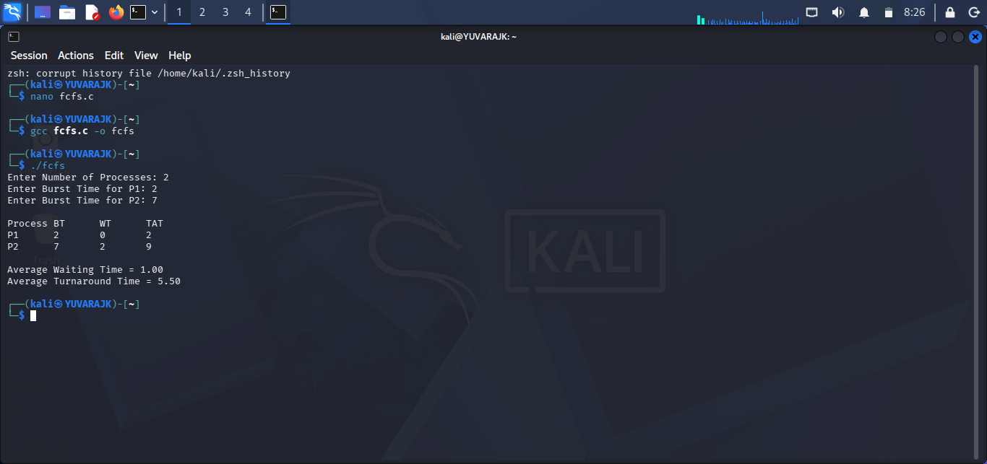
SHELL PROGRAM
#!/bin/bash
echo "Enter Number of Processes"
read n
for ((i=0;i<n;i++))
do
echo "Enter Burst Time for P$((i+1))"
read bt[$i]
done
wt[0]=0
for ((i=1;i<n;i++))
do
wt[$i]=$((wt[i-1]+bt[i-1]))
done
echo
echo -e "Process\tBT\tWT\tTAT"
total_wt=0
total_tat=0
for ((i=0;i<n;i++))
do
tat[$i]=$((wt[i]+bt[i]))
total_wt=$((total_wt+wt[i]))
total_tat=$((total_tat+tat[i]))
echo -e "P$((i+1))\t${bt[i]}\t${wt[i]}\t${tat[i]}"
done
avg_wt=$(awk "BEGIN {printf "%.2f", $total_wt/$n}")
avg_tat=$(awk "BEGIN {printf "%.2f", $total_tat/$n}")
echo
echo "Average Waiting Time = $avg_wt"
echo "Average Turnaround Time = $avg_tat"
OUTPUT
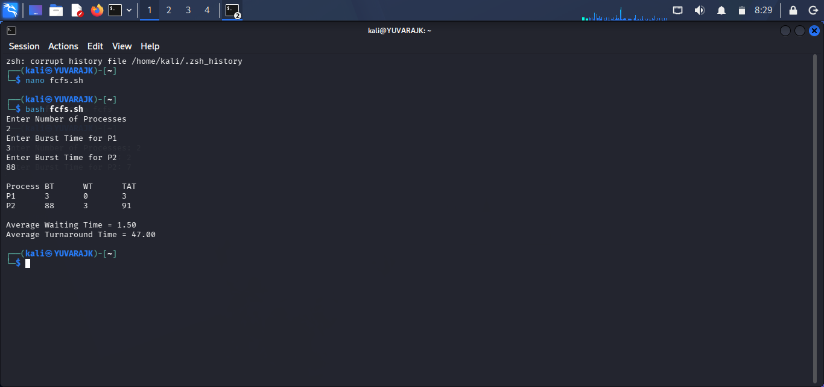

SJF
C PROGRAM
#include<stdio.h>
int main()
{
int n,i,j,temp;
int bt[20],wt[20],tat[20];
float avg_wt=0, avg_tat=0;
printf("Enter Number of Processes: ");
scanf("%d",&n);
for(i=0;i<n;i++)
{
printf("Enter Burst Time for P%d: ",i+1);
scanf("%d",&bt[i]);
}
// Sorting burst times in ascending order
for(i=0;i<n-1;i++)
{
for(j=i+1;j<n;j++)
{
if(bt[i] > bt[j])
{
temp = bt[i]; bt[i] = bt[j]; bt[j] = temp;
}
}
}
wt[0] = 0;
for(i=1;i<n;i++) wt[i] = wt[i-1] + bt[i-1];
printf("\nProcess\tBT\tWT\tTAT\n");
for(i=0;i<n;i++)
{
tat[i] = wt[i] + bt[i];
avg_wt += wt[i]; avg_tat += tat[i];
printf("P%d\t%d\t%d\t%d\n",i+1,bt[i],wt[i],tat[i]);
}
avg_wt /= n; avg_tat /= n;
printf("\nAverage Waiting Time = %.2f", avg_wt);
printf("\nAverage Turnaround Time = %.2f\n", avg_tat);
return 0;
}
OUTPUT
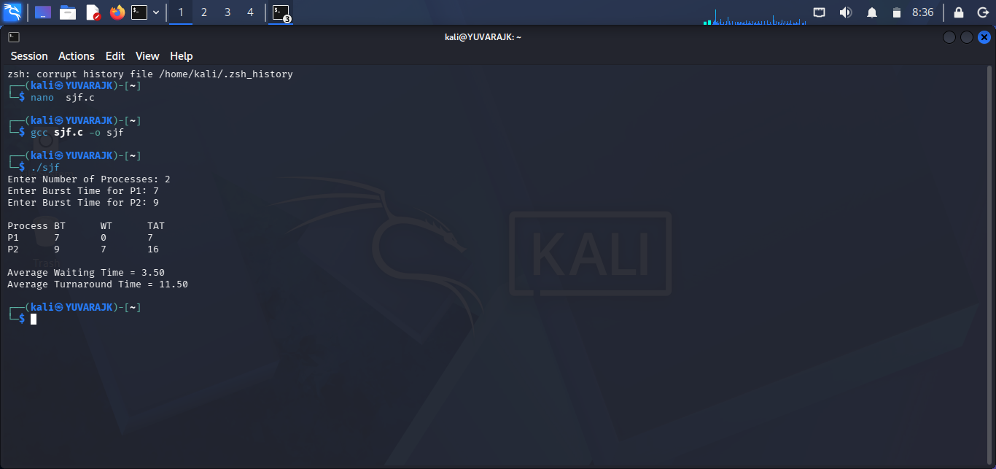
SHELL PROGRAM
#!/bin/bash
echo "Enter Number of Processes"
read n
for ((i=0;i<n;i++)); do
echo "Enter Burst Time for P$((i+1))"
read bt[$i]
done
# Sorting burst times (Ascending Order)
for ((i=0;i<n-1;i++)); do
for ((j=i+1;j<n;j++)); do
if [ ${bt[i]} -gt ${bt[j]} ]; then
temp=${bt[i]}; bt[$i]=${bt[j]}; bt[$j]=$temp
fi
done
done
wt[0]=0
echo
echo -e "Process\tBT\tWT\tTAT"
total_wt=0; total_tat=0
for ((i=0;i<n;i++)); do
if [ $i -ne 0 ]; then wt[$i]=$((wt[i-1]+bt[i-1])); fi
tat[$i]=$((wt[i]+bt[i]))
total_wt=$((total_wt+wt[i])); total_tat=$((total_tat+tat[i]))
echo -e "P$((i+1))\t${bt[i]}\t${wt[i]}\t${tat[i]}"
done
avg_wt=$(awk "BEGIN {printf "%.2f", $total_wt/$n}")
avg_tat=$(awk "BEGIN {printf "%.2f", $total_tat/$n}")
echo
echo "Average Waiting Time = $avg_wt"
echo "Average Turnaround Time = $avg_tat"
OUTPUT
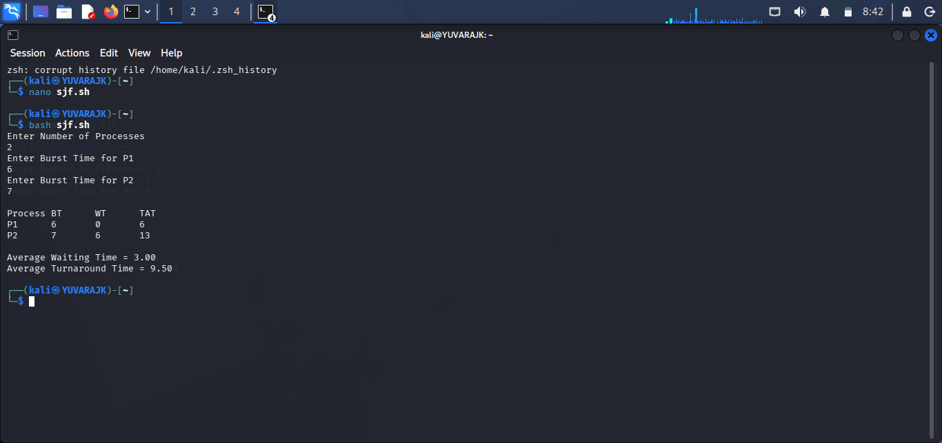

PRIORITY SCHEDULING
C PROGRAM
#include<stdio.h>
int main() {
int n,i,j,temp;
int bt[20],pr[20],wt[20],tat[20];
float avg_wt=0, avg_tat=0;
printf("Enter Number of Processes: ");
scanf("%d",&n);
for(i=0;i<n;i++) {
printf("\nEnter Burst Time for P%d: ",i+1);
scanf("%d",&bt[i]);
printf("Enter Priority for P%d: ",i+1);
scanf("%d",&pr[i]);
}
for(i=0;i<n-1;i++) {
for(j=i+1;j<n;j++) {
if(pr[i] > pr[j]) {
temp=pr[i]; pr[i]=pr[j]; pr[j]=temp;
temp=bt[i]; bt[i]=bt[j]; bt[j]=temp;
}
}
}
wt[0]=0;
for(i=1;i<n;i++) wt[i]=wt[i-1]+bt[i-1];
printf("\nProcess\tPriority\tBT\tWT\tTAT\n");
for(i=0;i<n;i++) {
tat[i]=wt[i]+bt[i]; avg_wt+=wt[i]; avg_tat+=tat[i];
printf("P%d\t%d\t\t%d\t%d\t%d\n",i+1,pr[i],bt[i],wt[i],tat[i]);
}
avg_wt/=n; avg_tat/=n;
printf("\nAverage Waiting Time = %.2f",avg_wt);
printf("\nAverage Turnaround Time = %.2f\n",avg_tat);
return 0;
}
OUTPUT
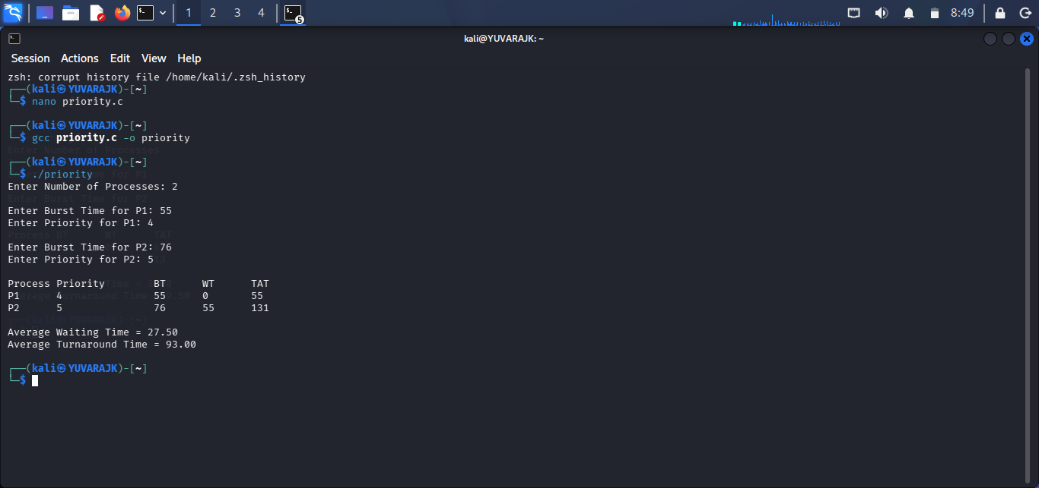
SHELL PROGRAM
#!/bin/bash
echo "Enter Number of Processes"
read n
for ((i=0;i<n;i++)); do
echo "Enter Burst Time for P$((i+1))"; read bt[$i]
echo "Enter Priority for P$((i+1))"; read pr[$i]
done
for ((i=0;i<n-1;i++)); do
for ((j=i+1;j<n;j++)); do
if [ ${pr[i]} -gt ${pr[j]} ]; then
temp=${pr[i]}; pr[$i]=${pr[j]}; pr[$j]=$temp
temp=${bt[i]}; bt[$i]=${bt[j]}; bt[$j]=$temp
fi
done
done
wt[0]=0
echo
echo -e "Process\tPriority\tBT\tWT\tTAT"
total_wt=0; total_tat=0
for ((i=0;i<n;i++)); do
if [ $i -ne 0 ]; then wt[$i]=$((wt[i-1]+bt[i-1])); fi
tat[$i]=$((wt[i]+bt[i])); total_wt=$((total_wt+wt[i])); total_tat=$((total_tat+tat[i]))
echo -e "P$((i+1))\t${pr[i]}\t\t${bt[i]}\t${wt[i]}\t${tat[i]}"
done
avg_wt=$(awk "BEGIN {printf "%.2f", $total_wt/$n}")
avg_tat=$(awk "BEGIN {printf "%.2f", $total_tat/$n}")
echo
echo "Average Waiting Time = $avg_wt"
echo "Average Turnaround Time = $avg_tat"
OUTPUT
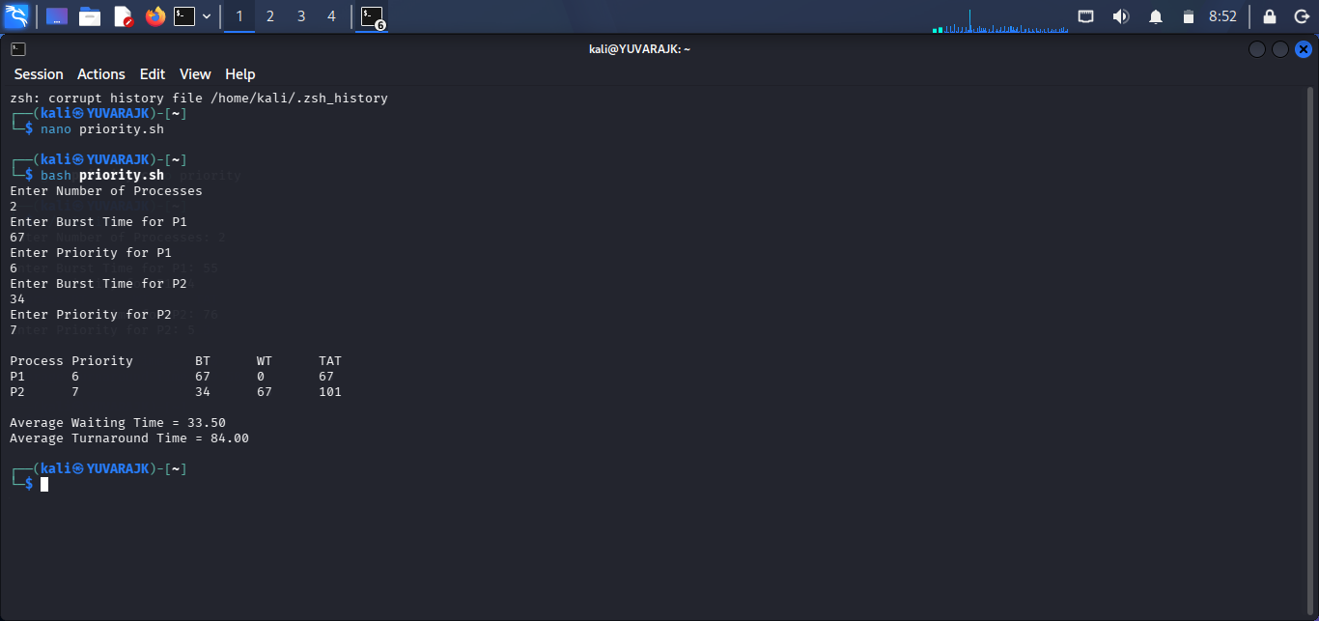

ROUND ROBIN
C PROGRAM
#include<stdio.h>
int main()
{
int n, tq, i;
int bt[20], rem_bt[20];
int wt[20] = {0}, tat[20];
int time = 0, done;
float avg_wt = 0, avg_tat = 0;
printf("Enter Number of Processes: "); scanf("%d", &n);
for(i=0;i<n;i++) {
printf("Enter Burst Time for P%d: ",i+1); scanf("%d",&bt[i]); rem_bt[i]=bt[i];
}
printf("Enter Time Quantum: "); scanf("%d",&tq);
do {
done=1;
for(i=0;i<n;i++) if(rem_bt[i]>0) {
done=0;
if(rem_bt[i]>tq) { time+=tq; rem_bt[i]-=tq; }
else { time+=rem_bt[i]; wt[i]=time-bt[i]; rem_bt[i]=0; }
}
} while(!done);
printf("\nProcess\tBT\tWT\tTAT\n");
for(i=0;i<n;i++) {
tat[i]=bt[i]+wt[i]; avg_wt+=wt[i]; avg_tat+=tat[i];
printf("P%d\t%d\t%d\t%d\n",i+1,bt[i],wt[i],tat[i]);
}
avg_wt/=n; avg_tat/=n;
printf("\nAverage Waiting Time = %.2f",avg_wt);
printf("\nAverage Turnaround Time = %.2f\n",avg_tat);
return 0;
}
OUTPUT
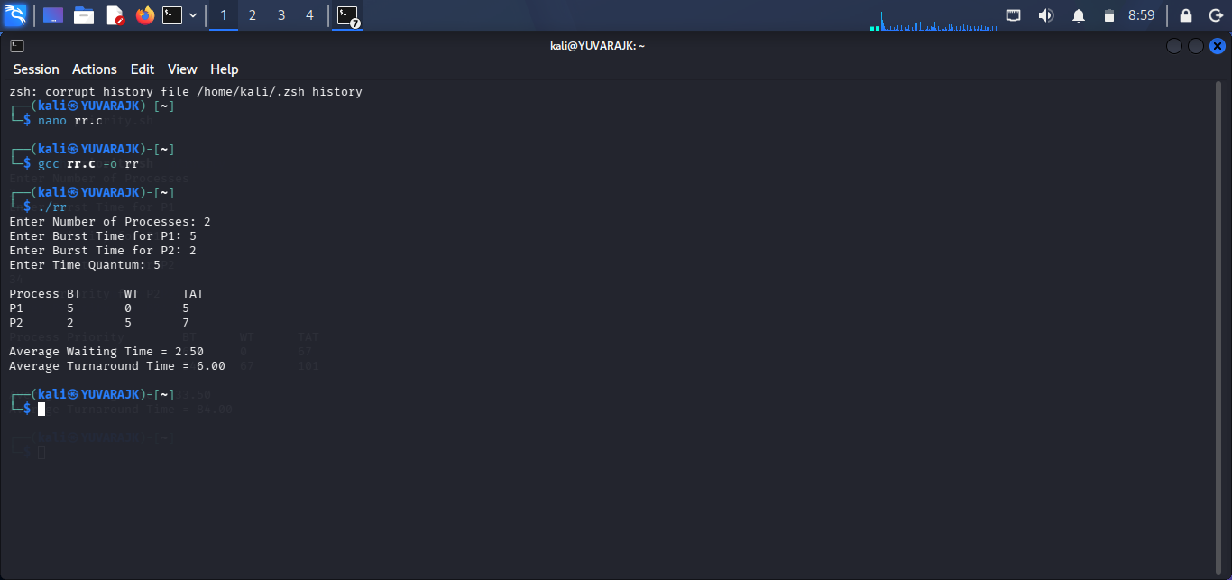
SHELL PROGRAM
#!/bin/bash
echo "Enter Number of Processes"
read n
for ((i=0;i<n;i++)); do
echo "Enter Burst Time for P$((i+1))"; read bt[$i]; rem_bt[$i]=${bt[$i]}
done
echo "Enter Time Quantum"; read tq
time=0
while true; do
done=1
for ((i=0;i<n;i++)); do
if [ ${rem_bt[i]} -gt 0 ]; then
done=0
if [ ${rem_bt[i]} -gt $tq ]; then time=$((time+tq)); rem_bt[$i]=$((rem_bt[i]-tq))
else time=$((time+rem_bt[i])); wt[$i]=$((time-bt[i])); rem_bt[$i]=0; fi
fi
done
[ $done -eq 1 ] && break
done
echo
echo -e "Process\tBT\tWT\tTAT"
total_wt=0; total_tat=0
for ((i=0;i<n;i++)); do
tat[$i]=$((bt[i]+wt[i])); total_wt=$((total_wt+wt[i])); total_tat=$((total_tat+tat[i]))
echo -e "P$((i+1))\t${bt[i]}\t${wt[i]}\t${tat[i]}"
done
avg_wt=$(awk "BEGIN {printf "%.2f", $total_wt/$n}")
avg_tat=$(awk "BEGIN {printf "%.2f", $total_tat/$n}")
echo
echo "Average Waiting Time = $avg_wt"
echo "Average Turnaround Time = $avg_tat"
OUTPUT
