**1.Create A new component which have news title(should print as h2), news detail(<p>), published date, source create this component using sling model.**

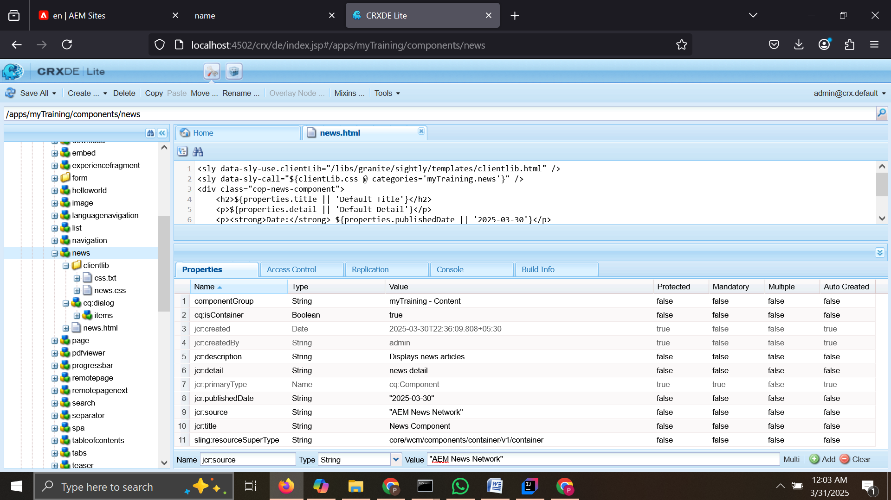

**Create clientlibs for news component and**

**4.Apply Green colour to the heading(h2) and yellow colour to news detail(<p) and date should be black in colour.**

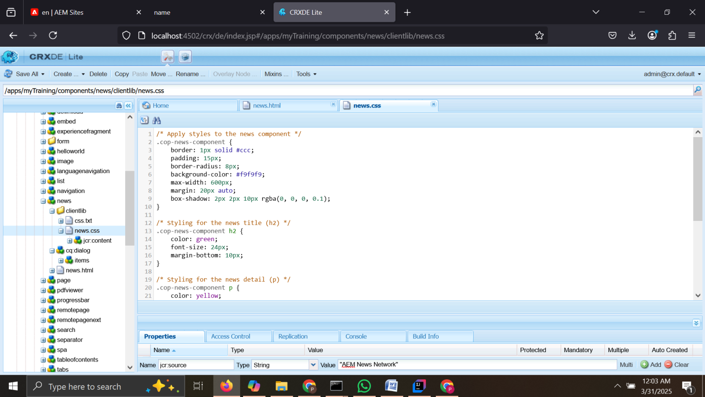

**6. Create a base page component and add new file as metadata so that it can print og:title, og:description and og:image link that file in base page.html**

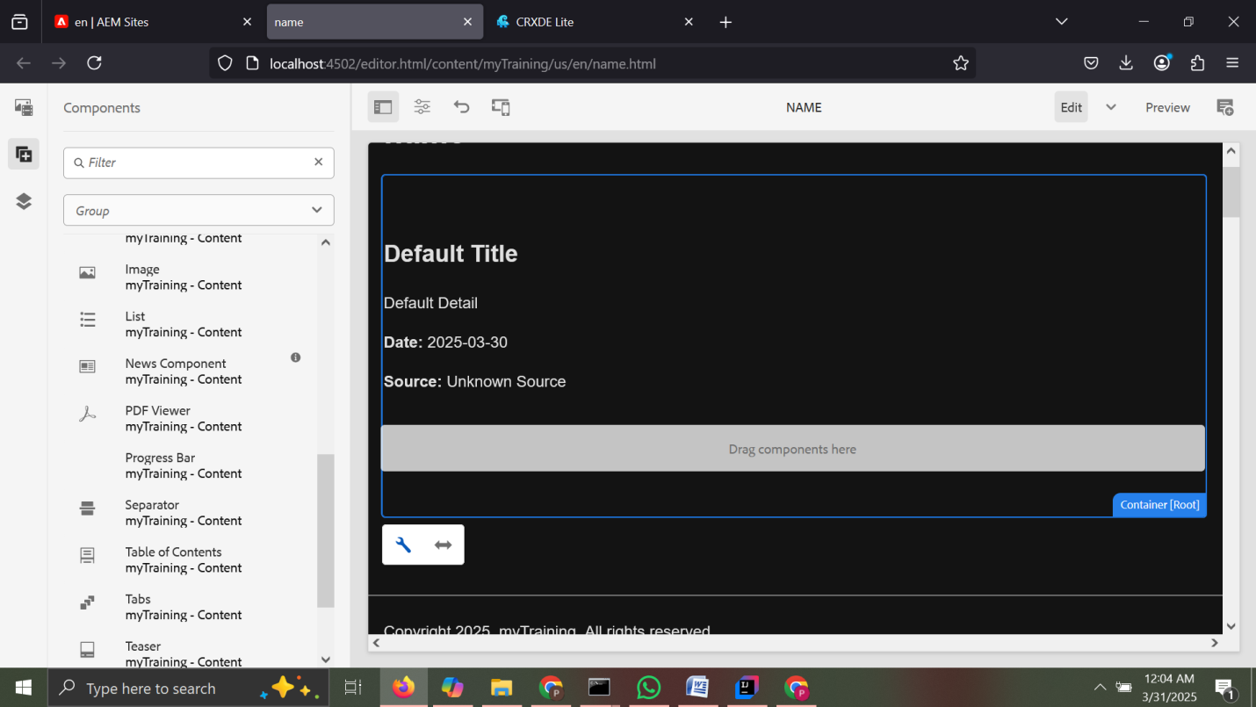

**8. What is extraclientlib add it this multi field component**

extraClientLibs is a **property in AEM component policies** that allows you to load additional **Client Libraries (CSS/JS)** for a specific component. This is useful when you want to apply extra styling or JavaScript **only when the component is present** on a page.