Hospital Patient Data Analysis
STUDENT NAME : PRIYADHARSHINI A
YEAR : II B.Sc Computer Science
COLLEGE NAME : Government Arts and Science College for Women
DEPARTMENT : Computer Science
SEMESTER : IV
ROLL NO :24082131802112133
NM ID :
TITLE : Hospital Patient Data Analysis
GITHUB LINK :
DATE :

1. ABSTRACT
This project focuses on analyzing hospital patient records to improve healthcare service efficiency and identify common diseases affecting patients. A hospital dataset containing patient details such as age, disease, admission date, discharge date, and treatment information is analyzed using Python Data Analytics techniques. Data cleaning is performed to handle missing values, remove duplicates, and ensure data consistency. Exploratory Data Analysis (EDA) is used to understand disease distribution, patient demographics, and admission patterns. Visualization techniques are applied to represent trends using charts and graphs. The project helps hospital management understand patient flow, identify peak admission periods, and make informed decisions regarding resource allocation and healthcare planning.

2. PROBLEM STATEMENT
Hospitals generate large amounts of patient data every day. Manual analysis of these records is difficult and time-consuming. Without proper analysis, hospitals may face challenges in resource planning, disease monitoring, and patient management. Data analytics helps transform raw patient data into meaningful insights that improve healthcare services.

3. OBJECTIVES
• Clean and preprocess hospital patient data.
• Analyze patient count by disease.
• Study patient distribution by age group.
• Identify peak admission periods.
• Visualize patient trends using charts.
• Generate useful insights for hospital management.

4. PROJECT SCOPE
The project focuses on analyzing hospital patient records using Python in Google Colab.
- The scope includes data cleaning,
- Exploratory data analysis
- Visualization
- Reporting
The analysis supports healthcare decision-making and resource management.

5. TECHNOLOGIES USED
Development Environment: Google Colab
Programming Language:
• Python
Libraries Used:
• Pandas
• NumPy
• Matplotlib
• Seaborn
Dataset Source:
• CSV File containing hospital patient records

6. APPLICATION FLOW
Step 1: Load Dataset
Step 2: Data Cleaning
Step 3: Handle Missing Values
Step 4: Remove Duplicate Records
Step 5: Disease Analysis
Step 6: Age Group Analysis
Step 7: Admission Trend Analysis
Step 8: Create Visualizations
Step 9: Generate Final Insights

7. KEY PYTHON DATA ANALYTICS CONCEPTS USED
1. Data Handling using Pandas
2. Data Cleaning
3. Exploratory Data Analysis (EDA)
4. Data Visualization
5. Grouping and Aggregation
6. Trend Analysis

8. EXPECTED OUTPUT
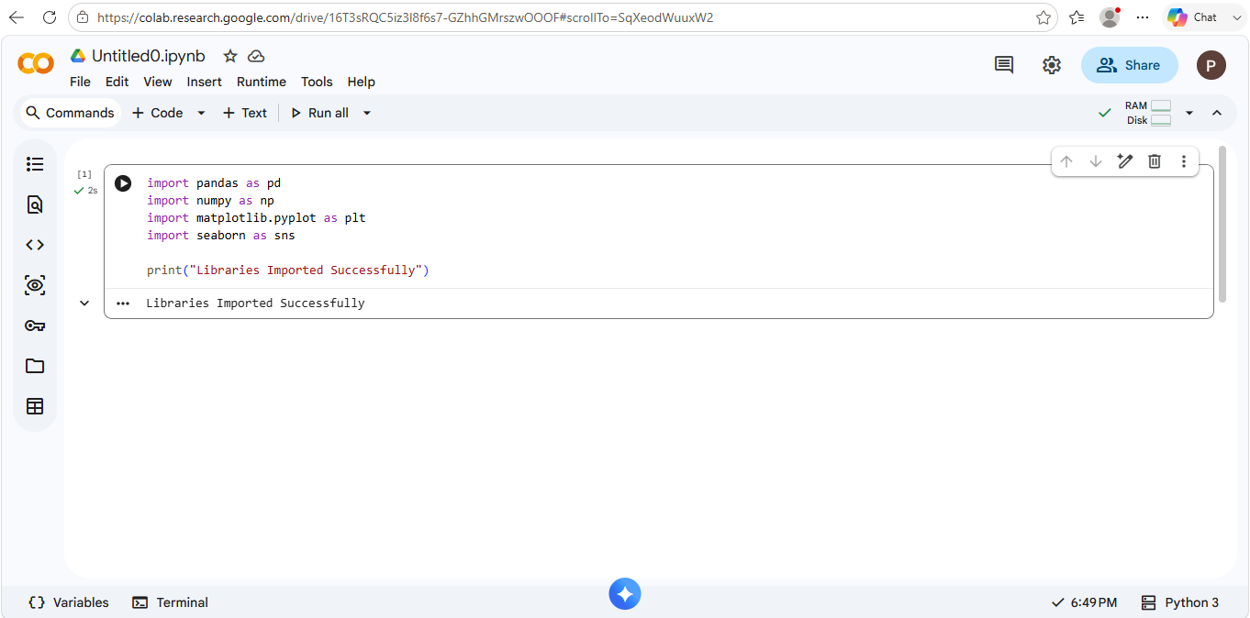
Dataset Preview

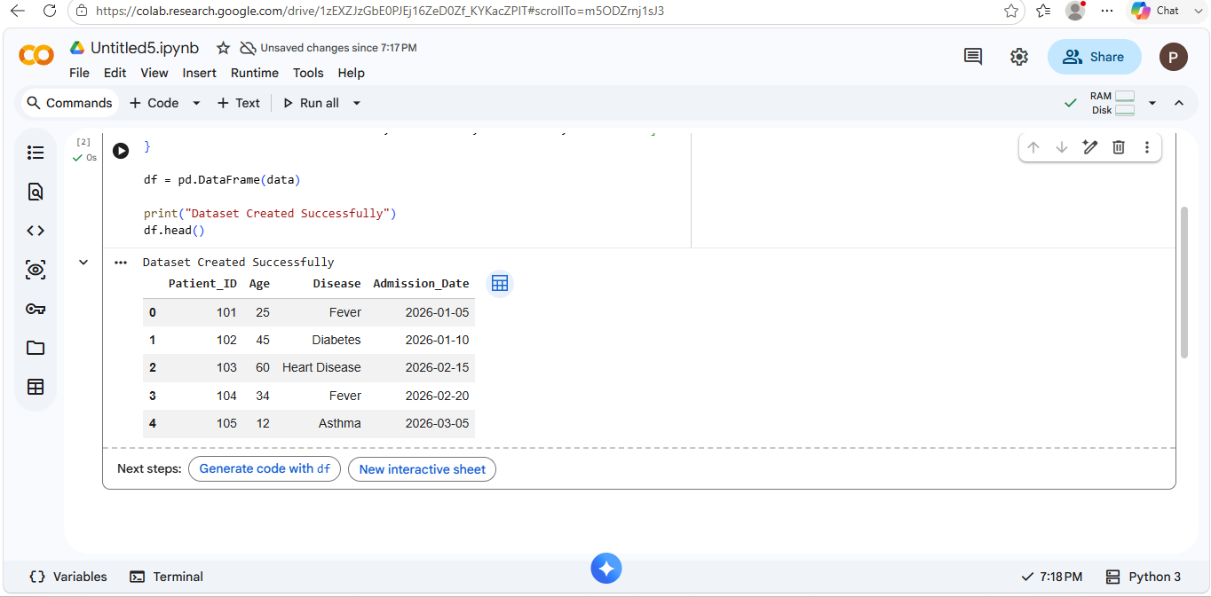
Dataset Information

Missing Values Check
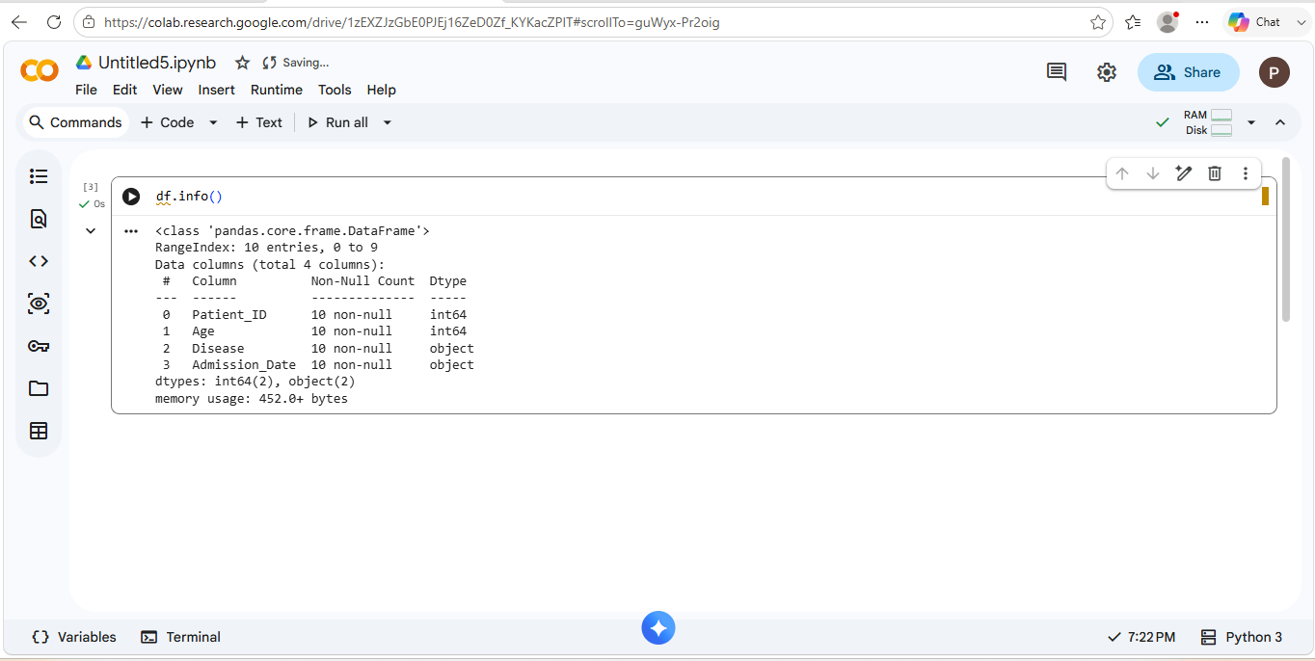
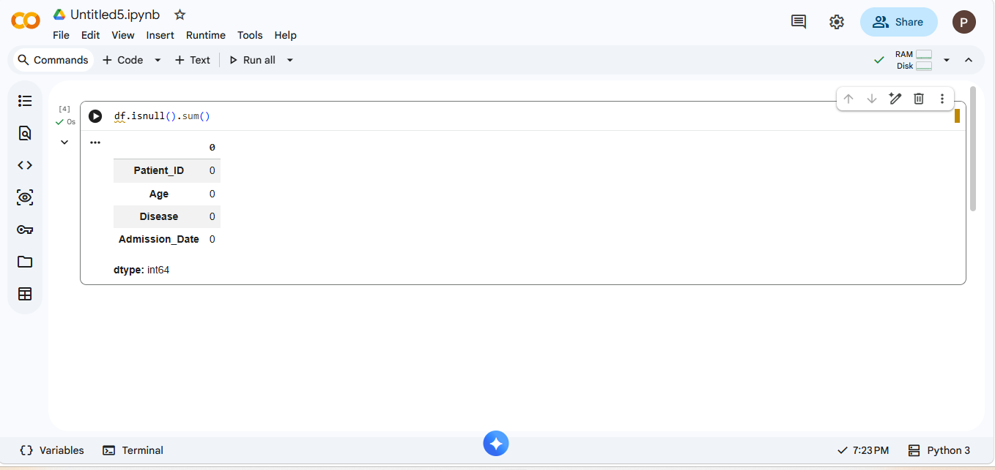
Cleaned Dataset

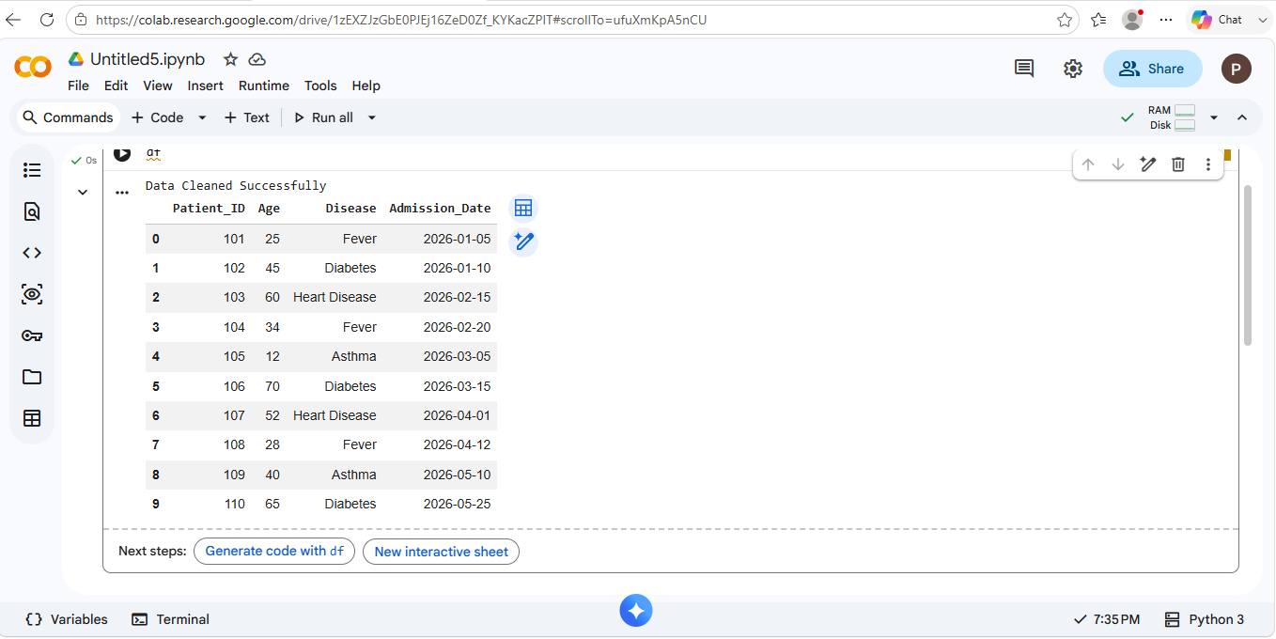
Disease Count Table

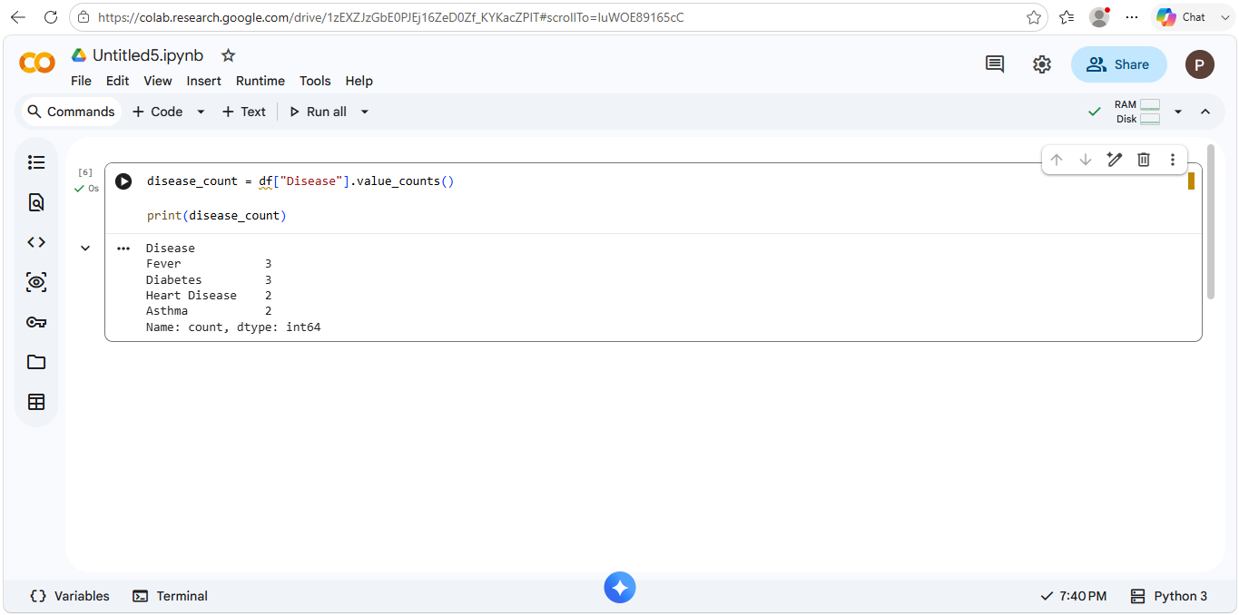
Disease Count Graph

Age Group Dataset
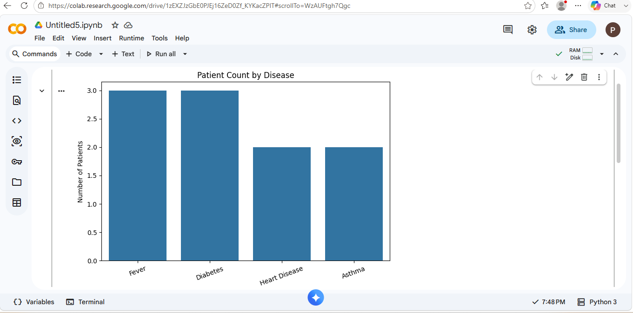

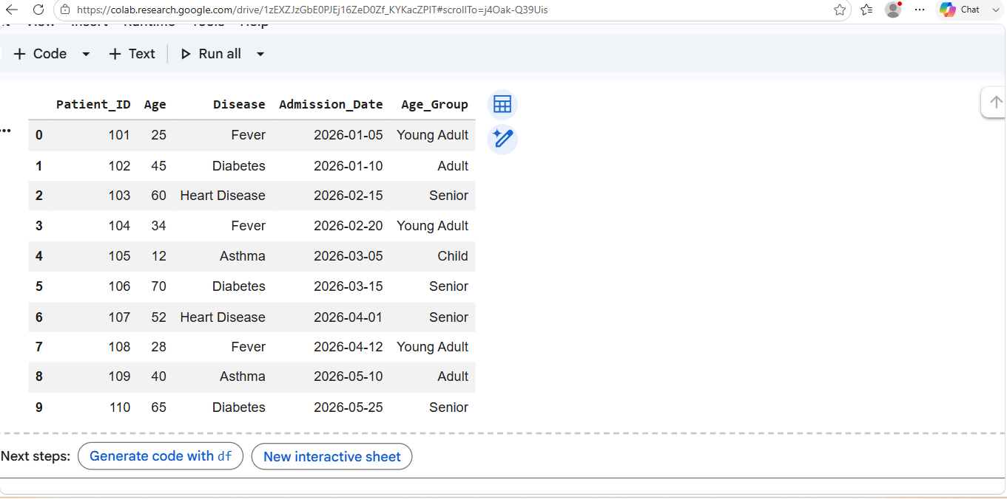
Age Group Count

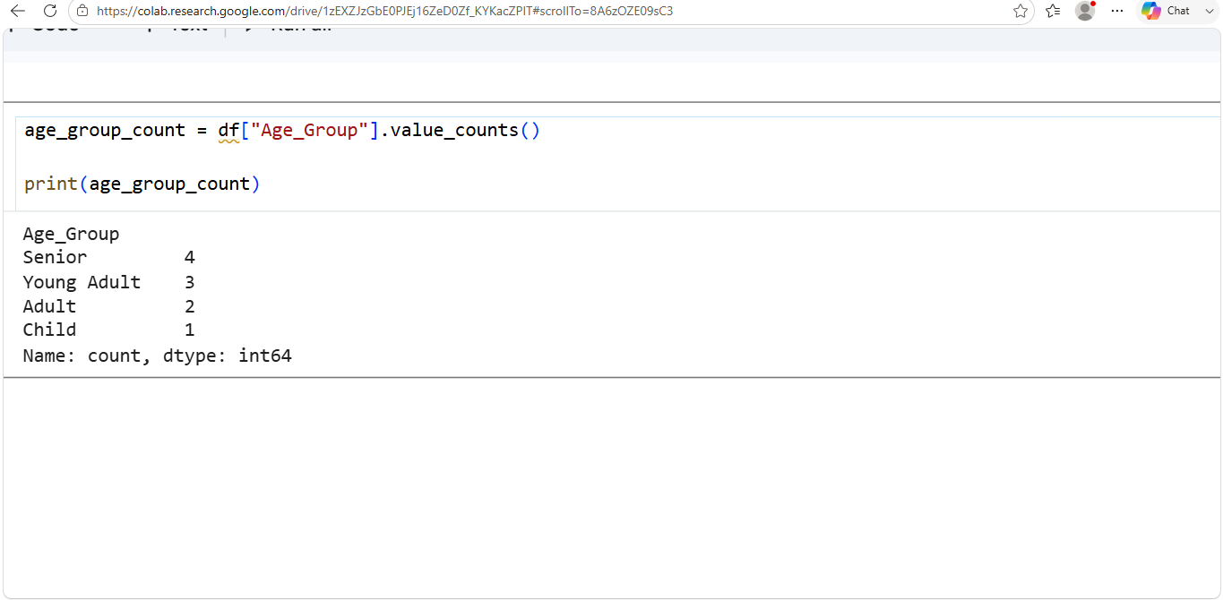
Age Group Graph

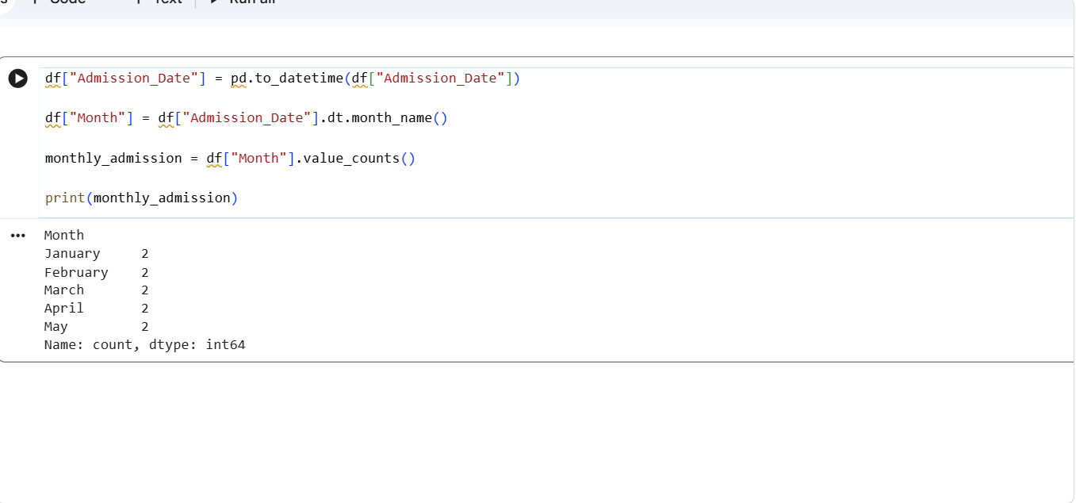
Monthly Admission Table

Monthly Admission Graph
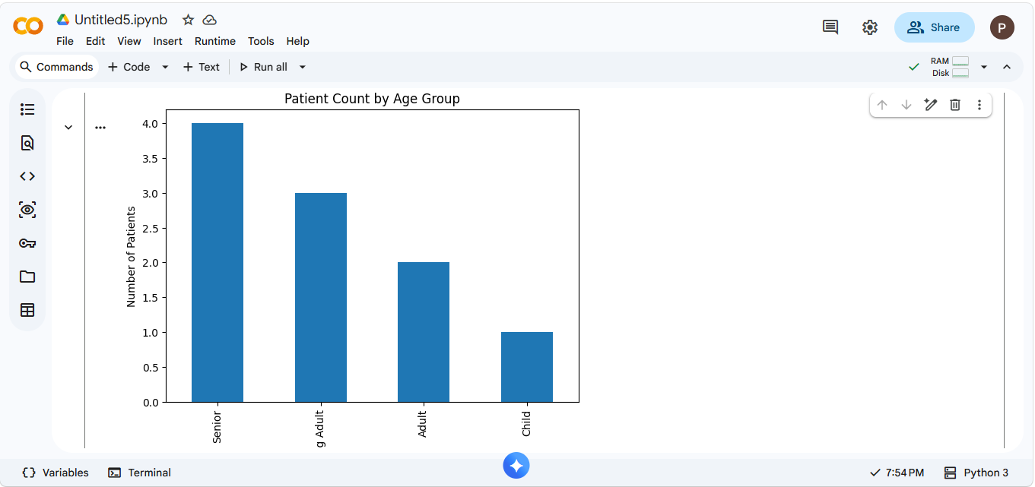

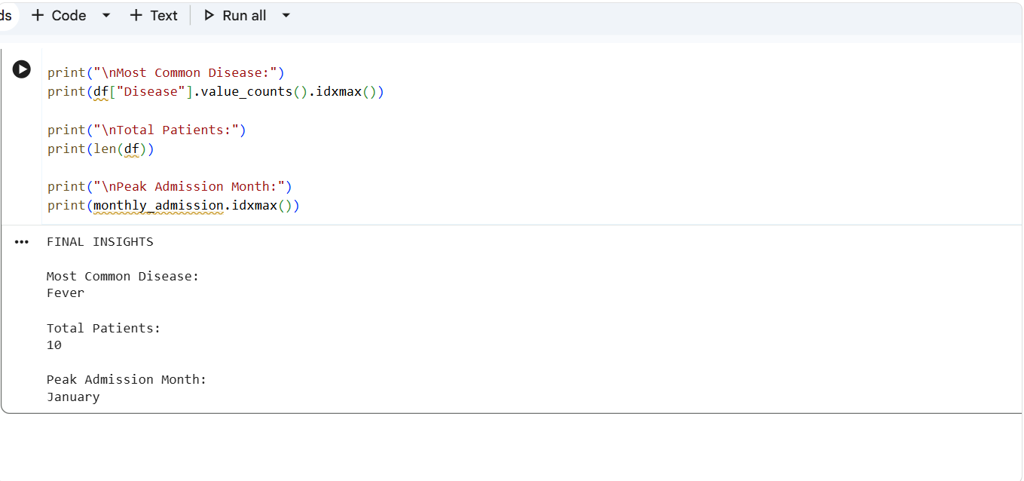
Final Insights

9. CHALLENGES FACED
• Missing values in patient records
• Duplicate entries
• Incorrect date formats
• Data inconsistency issues
• Large dataset handling

10. LEARNING OUTCOMES
• Learned data cleaning techniques.
• Improved Python programming skills.
• Gained practical experience with Pandas and NumPy.
• Learned data visualization using Matplotlib and Seaborn.
• Developed analytical thinking and problem-solving skills.

11. CONCLUSION
The Hospital Patient Data Analysis project successfully analyzes patient records and provides meaningful insights. The project identifies common diseases, analyzes patient demographics, and determines peak admission periods. The generated insights can help hospitals improve resource allocation, patient care, and operational efficiency. This project demonstrates the importance of data analytics in the healthcare sector.

