# CAREER CONNECT: YOUR JOB-HUNTING CHATBOT - ANYTIME, ANYWHERE !

## A PROJECT REPORT

***Submitted by***

**PRIYA DHARSHINI (2116210701197)**

**SAJAY PRAKASH K (2116210701222)**

**SIVASHANKAR S (2116210701252)**

***in partial fulfillment for the award of the degree of***

**BACHELOR OF ENGINEERING**

***in***

## COMPUTER SCIENCE AND ENGINEERING



**RAJALAKSHMI ENGINEERING COLLEGE ANNA UNIVERSITY, CHENNAI**

**MAY 2024**

# RAJALAKSHMI ENGINEERING COLLEGE, CHENNAI

**BONAFIDE CERTIFICATE**

Certified that this Thesis titled **“CAREER CONNECT: YOUR JOB-HUNTING CHATBOT - ANYTIME, ANYWHERE!**” is the bonafide work of “**PRIYA DHARSHINI (2116210701197), SAJAY PRAKASH K (2116210701222), SIVASHANKAR S (2116210701252)”** who carried out the work under my supervision. Certified further that to the best of my knowledge the work reported herein does not form part of any other thesis or dissertation on the basis of which a degree or award was conferred on an earlier occasion on this or any other candidate.

## SIGNATURE

Mr. Vijay K M.E.,

## PROJECT COORDINATOR

Professor

Department of Computer Science and Engineering Rajalakshmi Engineering College

Chennai - 602 105

Submitted to Project Viva-Voce Examination held on

**Internal Examiner External Examine**r

# ABSTRACT

In modern times, getting a candidate with a qualified career prospect is one of the core massive problems of today's fast-going and vibrant job market. The mission of this product is to present a skill/job recommender application utilizing open-source data coupled with state-of-the-art AI technologies as a new tool for creating a mode of counseling to help professionals find their best possible career prospect. It was created, first and foremost, for the young job seekers so as to allow them access to proper guidance in personal employment and career improvement. To have adequate knowledge and analyze many data sources which include user profiles, job vacancies and labor trends the program uses both machine learning techniques and natural language processing algorithms. System has an open-source career guidance module and job recommendations which yield from competence, passion, and aspirations of a single user. It uses the open-source data sets such as job postings, skills databases, and information from professional social networks. A wide range of information like school history, work experience, capabilities, and interests is contained in the detailed user profile system which is the integral of the system. As an AI engine does so, it can determine career paths and jobs that are open to the jumper by the means of this data. However, skills gap analysis is also integral as the program enhances learners' understanding of the courses and credentials as well as sheds light on the skills different occupations require.

# ACKNOWLEDGMENT

First, we thank the almighty god for the successful completion of the project. Our sincere thanks to our chairman **Mr. S. Meganathan B.E., F.I.E.,** for his sincere endeavor in educating us in his premier institution. We would like to express our deep gratitude to our beloved Chairperson **Dr. Thangam Meganathan Ph.D.,** for her enthusiastic motivation which inspired us a lot in completing this project and Vice Chairman **Mr. Abhay Shankar Meganathan B.E., M.S.,** for providing us with the requisite infrastructure.

We also express our sincere gratitude to our college Principal,

**Dr. S. N. Murugesan M.E., PhD.,** and **Dr. P. KUMAR M.E., PhD, Director computing and information science, and Head Of Department of Computer Science and Engineering** and our project coordinator **Mr. Vijay K M.E.,** for her encouragement and guiding us throughout the project towards successful completion of this project and to our parents, friends, all faculty members and supporting staffs for their direct and indirect involvement in successful completion of the project for their encouragement and support.

**PRIYA DHARSHINI**

**SAJAY PRAKASH K**

**SIVASHANKAR S**

## TABLE OF CONTENTS

| **CHAPTER NUMBER** | **TITLE** | **PAGE NUMBER** |
| --- | --- | --- |
|  | **ABSTRACT** | **1** |
|  | **LIST OF FIGURES** | **4** |
| **1.** | **INTRODUCTION**  1.1 Introduction  1.2 Problem Statement  1.3 Scope of the work  1.4 Aim and Objective of the project  1.5 Existing System  1.6 Proposed System | **5**  5  6  7  8  9  10 |
| **2.** | **LITERATURE SURVEY** | **11** |
| **3.** | **SYSTEM DESIGN**  3.1 System Architecture Diagram  3.2 Development Environment  3.2.1 Hardware Requirements  3.2.2 Software Requirements | **13**  13  16  16  16 |
| **4.** | **PROJECT DESCRIPTION**  4.1 Methodology  4.2 List of Modules  4.3 Module Description | **17**  17  18  18 |
| **5.** | **RESULT AND DISCUSSION**  5.1 Output  5.2 Results | **20**  20  26 |
| **6.** | **CONCLUSION AND FUTURE ENHANCEMENTS**  6.1 Conclusion  6.2 Future Enhancements | **27**  27  28 |
|  | **APPENDIX** | **29** |
|  | **REFERENCES** | **35** |

**LIST OF FIGURES**

| **Fig.No** | **TITLE** | **PAGE** |
| --- | --- | --- |
| **Fig 3** | **System Architecture Diagram** | **13** |
| **Fig 5.1** | **Landing Page** | **20** |
| **Fig 5.2 (i)** | **Uploading Resume** | **21** |
| **Fig 5.2 (ii)** | Success Message |  |
| **Fig 5.3** | **Model Selection** | **22** |
| **Fig 5.4 (i)** | **Response From Job Recommender - 1** | **23** |
| Fig 5.4 (ii) | Response From Job Recommender -2 |  |

## 

**CHAPTER 1**

## INTRODUCTION

## 1.1 INTRODUCTION

In this modern time of drastic change, young job seekers, attempting to determine what occupation to follow, and what skills they have to offer to the ever-changing market demands, often find themselves between the devil and the deep blue sea. Traditional methods of career guidance often are unable to provide effective assistance and to help professionals make their career progress more quickly, limiting the applicants pool and, thus, causing hiring process inefficiencies. Throughout this talk, bring my attention to the fact that crowdsourcing open-source data with AI approaches is a new avenue which can be explored in order to address this inequality. Through customized job module affiliations and skill improvement guidance, the app hopes to make the career advice service more effective and efficient and to create a successful employment environment and the possibility of career progression for young specialists.

The imputed software is to first analyze and interpret large datasets, including user profiles, by means of cutting edge machine learning algorithms paired with approaches which employ natural language processing. By way of open-source assets like the profiles on professional social networks and skills databases the application provides applicants with highly personalized career guidance. The platform consists of an in-depth system for gathering such information as an individual's hobbies, abilities, social - occupational background, and academic achievements. The AI analyzes the data to make recommendations and identify employment opportunities that are suitable for the user, through which the users can take actions on them. In addition, the program also offers skills gap analysis which is used to identify the skilled labor that is needed and offer suitable courses and certifications to help users become highly attractive in the market.

A feedback loop is developed and the interaction can be customized and improved the capability of the system to recommend is continued through learning from user interactions. Through this new approach of connecting companies and job seekers, this strategy aspires to be a solution that can assist the younger people in their job hunt, thus making their working career more fulfilling and fruitful.

## PROBLEM STATEMENT

## Nowadays the confusing job market brings difficulties for young people looking for work, which often does not contribute to the improvement of the employment process and the development of professional growth. While traditional methods for career counseling are filled with difficulties in delivering the adjustment most relevant to the unique interests of individuals while at the same time being able to give the most recent information on existing job openings. Consequently, the available jobs and employed workforce are not correctly matched, which is something unavoidably seen as a labor market deficiency as well as the advancement of individual engagement. One big issue is that currently there are not enough technologies that allow for the provision of data-oriented, personalized career counseling, adaptation to the need of the market, and delivery of some relevant insights. Young professionals have a hard time determining skill requirements, find work-oriented activities and make proper career choices without offering them career paving tools. Since a skill/job recommender app based on the latest AI features has long been fervently awaited, there is currently no choice but to wait. For individuals to gain special assistance in building their career, using suggestions from their personalized job, and implementing strategic advice and finally to increase their employability and economic development in the current labor market, an application is necessary which leverages AI and open- source data.

## SCOPE OF THE WORK

This project covers the invention, designing, as well as the kick-off of a job orientation recommender system that is going to change the occupation/career selection processes for our young job applicants. The first step will be to conduct requirements analysis to ensure comprehensive knowledge in the matter of costumer's tastes and likings. We will also adapt an approach of having an education background, work experiences, skill, and interests altogether then targeting advertisements to the audience. Data sources from the public domain such as listings of vacancies, skills databases and professional networks will serve as a base upon which the app will fetch, process and harmonize the content ensuring there are the latest contents made available in appropriate quantities. Businesses are utilizing this sophisticated processing power of machine learning algorithms and natural language processing with great focus on the collective filtering and content filtering systems.The development unit will be functioned by skills gap analysis which will determine the approach and a good training program that will cover a specific area. This will be brought about by the utilization of simple and interactive interfaces that will give customized jobs matching or other vital tips of career and skills development, job search among others. A constant learning process is then applied to re-define the recommendation system depending on activity of the user, which leads in a longer-term time span to more precision. The main goal of the tests is to reach that specific target. Thus, user tests are the next step that will be performed to let the users share their opinions about the app and give tips for revision. The second thing will be the application on a scalable structure so that we can allocate all the resources and the app runs smoothly. The maintenance plan will be created to review and update it.

## AIM AND OBJECTIVES OF THE PROJECT

**Aim:**

This project will provide a relevant career guidance tool, which can be personalized for individual usage and improvise the future job opportunities for the young adults.

**Objectives:**

It will put together a stand-alone mobile app linking to the AI technologies to propose appropriate career paths to the members. This app will help cover the gap between the set of goals and mentality of the young citizens and that oriented towards a job market that is stipulated as skill-appropriate.

Seize the development of open-source data science and machine learning products to create a leveling ground and boost the advancement of data science. The app of the Tripadvisor Mobile App is based on the open source data; therefore, it is freely available to millions of users and the machine learning takes place in the background; this thus helps in improving the accuracy of recommendations with regards to time.

Encourage youths to make informed, educated career choices by creating awareness of all options available. The app will craft its user by giving them competence and skills necessary for the purpose of helping these users to form rightful plans for their future. Through it, employers are given a convenient and reliable interface which matches them with the right candidates who have the relevant expertise and schooling backgrounds. Occupying these job spaces would be easier for job seekers since the range of searchable jobs will be reduced and therefore valuable opportunities can be uncovered for these people.

## EXISTING SYSTEM

Today's generation has to face market craziness everyday. The market is the quick change in the trend, and so they create a lot of job opportunities. It might be an adrenalin mixed with excitement and fear. The goal of career counseling is to find the perfect fit between the traditional workshops geared towards careers and the fast pace of selecting today’s career from a large number of opportunities. Here's a closer look at the limitations of existing systems:

Limited Personalization: They usually are not oriented specifically on one's career but rather provide some general information concerning one's GPA or having an aptitude test. Such a tool helps to have a general picture of prospective career options and one's own strengths, weaknesses and talents. On the contrary, the available categories for employment usually are too broad which makes the young adults who try to define for themselves specific titles or promotional prospects search for suitable platforms within the given categories.

Information Overload: A job board draws attention with many benefits, in the meantime, they are way too complex a matter. By the way, the keyword search can perhaps miss the point which is in the long collection of letters. Moreover, usually the category of a job board that is used by members of that age group does not have the essential skills/experience categories. Thus, sorting the jobs out may take more time and, as a consequence, some young adults can stop searching for jobs, which makes the process completely unattractive.

Limited Accessibility and Cost: A typical direction for a career is something that may be profitable but the cost can be one of the lowest. The industry might highly suffer from such a mistake, because the youngsters have not started their way up yet. In addition to the point that counselors’ services are not readily accessible in all locations, consequently, such landing might result in students not having face-to-face talk with those who are supposed to provide them with personalized advice.

## PROPOSED SYSTEM

The target is attained via an app which offers special advice on career matters for teenage audiences. The app uses Artificial Intelligence for this. It can be considered a gradual process that starts with the formulation of a perfect resume in a one-pager mode by filling in such sections as interests, skills, courses, general goals, and experiences among other relevant components. Aloha, this data is the Taski!AI really quaffs all of this on the spot, where it is already absorbed by the most powerful machine. These settings, such as a machine learning method based on a wide-open-source artifact database and external vocabulary, are quite capable of separating the tasks/roles and requirements there. NLP is used to make out considerable information from both employer and user profile for the job search engine to be able to analyze job seeker powers and what an employer seeks. Through digital intelligence, the sense of small always straightens out to great investments determined by user comprehension of this professional path only available for their particular competence, passions, and abilities. Whilst these recommendations can be offered, the app needs to also have area on skills development, educational assistance on pathways, contacts for network and mock interviews as well. It leads to a sort of democratization of education, where students can retrieve data after getting hold of it and there will be no entry requirements for the app. Similarly, with streamlining regulations the feature also enables the app to frequently refine its job suggestions as well as to adapt to market trends in the job world, which recommends itself for the changing world of work. This smart (AI) move (in the internet of things) brings youth with the customized instructions they need to see the job market confidently as well as to go on purposeful career journeys. The next generation of job seekers will be able to experience their job search differently because the presented technology has all the options needed to locate a job and to specify a career in an individual and personalized way. Data gathering is realized by the AI algorithms implementation for the user profile’s studies, skills, and given preferences, then for the last part it presents the job.

**CHAPTER 2**

**LITERATURE SURVEY**

Achieving a successful career often requires guidance, a role traditionally offered by career counselors, or standard assessments. But the emergence of artificial intelligence (AI) has ushered in a new era of new solutions; One of these is the introduction of chatbots. This research article delves into the world of chatbots, exploring their functions, the underlying technology that powers them, and the key user experiences that need to be considered during development. Chat with various features provided by chatbots. Gobachlu et al. [12] proposed a method using fuzzy logic to make personalized task recommendations. This system goes beyond recommendations and takes into account the user's history, interests, and skills to create a unique content experience. In their review of intelligent machines for business guidance, Deshpande and Patil [13] highlight the potential of chatbots for more than just giving advice. They can conduct interactive assessments to assess personal strengths and weaknesses, adjust performance studies based on these assessments, and ultimately provide personalized guidance to each person using specialized language. Yiu and Ngai [14] explore the potential of Web 2.0 technology in supporting decision making. They envision chatbots that could integrate with social media and online learning to create a more interactive and interactive way to search for jobs. Imagine a chatbot that recommends relevant educational videos on YouTube or links to professional profiles on LinkedIn, all on the same platform.The effectiveness of the chatbot service depends on the basis of many technologies. Kim et al. [17] emphasized that language processing (NLP) is important. As discussed in their study, conversational suggestions use NLP to help chatbots understand user questions and engage in meaningful conversations. By analyzing the user's responses, the chatbot can suggest the appropriate task and provide appropriate guidance throughout the search process.

Speech control was investigated by Walker et al. [22]. This includes understanding the intent behind the user's question, directing the conversation to important topics, and providing clear and concise answers. Imagine a chatbot that can switch between discussing salary requirements and exploring learning opportunities while maintaining an interactive and helpful experience. important. Porr and Lucas [24] discuss methods for human evaluation of conversational speech that can be adapted to chatbot evaluation. These metrics can identify areas that need improvement in NLP capabilities, conversation management strategies, and overall user experience. User experience (UX) is another important factor. Jeon Quan et al. [27] studied the relationship between cognitive anthropomorphism (such as human attributes) and the user experience of chatbots. Their research shows that users will find chatbots with more human characters more engaging and trustworthy. This highlights the importance of building chatbots that feel natural and relevant during interactions. Consider a chatbot that uses encouraging words and shows empathy, thus building trust and relationship between users. Xiao et al. [29] emphasized the importance of human evaluation of chatbot interactions. By allowing users to interact with the chatbot and then write feedback, developers can identify areas where the chatbot struggles to understand natural language or fails to deliver satisfaction to users. This feedback ensures that the chatbot remains functional and effective, allowing for continuous improvement. Research shows that AI-powered chatbots have the potential to provide personalized coaching using various capabilities of NLP, conversation management, and other AI technologies. Measuring the effectiveness of the chatbot through people analytics and prioritizing user experience is critical to success. As research continues, career advice chatbots have the potential to be a game changer in career guidance by providing personalized support to individuals and users using the platform to explore the complexities of career options. With the help of these chatbots, people can start their job search with confidence and clarity.

## CHAPTER 3

## SYSTEM DESIGN

## SYSTEM ARCHITECTURE DIAGRAM

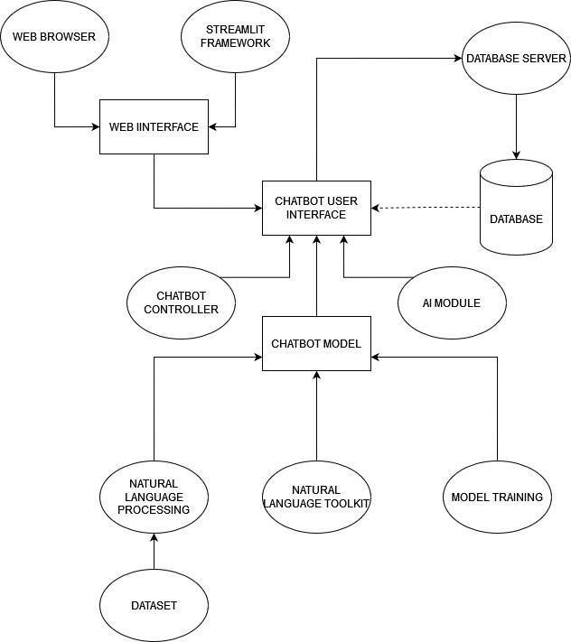

**Fig 3.1: System Architecture**

**Description :**

The following paper discusses the architecture of our web-based chatbot for career counseling. Customers will be able to open the chatbot through the web browser interface, which will allow them to avoid the installation of additional software. Streamlit which is a web framework most probably simplifies the creation of user interface and handles the user interaction in the browser window.

The main part is the chatbot controller which plays the role of the brain. It takes queries from the user interface and directs them to the processing unit that is in charge of them. An important component is the model of a chatbot, which is trained on a wide-ranging dataset containing text and code related to careers. This dataset enables the model to understand the queries of users regarding career choices, skills, and job opportunities. The chatbot controller interacts with the model to generate customized answers that are particular to every user's questions and their aspirations in the workplace.

The next step involves the NLP toolkit, which is a fundamental element. This toolkit provides the chatbot with a way to process and understand human language. It must execute functions such as text parsing, sentiment analysis, and identifying entities that are of relevance in the given user queries. By availing this toolkit, the chatbot can derive a sense from user messages and then compose a precise response specific to the career counseling domain.

The system is using a database server to store the data. This probably means that it has conversations history, user info (if applicable) and some other important data points in its memory. The information helps in doing multiple things. It can give the chatbot's replies a contextuality by reminding what was going on with a certain user during previous chats. On the other hand, it can be utilized to analyze users queries and fine-tune the chatbot’s performance in the long run.

The career guidance module is one of the most striking features of this architecture. In the next module there will be the integration with external resources or databases that contain information about careers such as job description, skill requirement, and educational pathways. When a chatbot controller realizes that the user's query needs career-specific advice, it may connect to this module to get the information and then display it to the user in a way that is logical and comprehensible. In the end, this architecture is developed to build a user-friendly career counseling platform through a chatbot interface. The web browser interface makes accessing your data very easy, and Streamlit lessens the user's interaction. The communication among the trained model that is managed by the chatbot controller, the NLP toolkit, and the career guidance module allows for natural language understanding, career-related generation of responses and potential retrieval of relevant career information. Lastly, the chatbot database is of utmost significance to store conversation history, as well as personal user information and information that can be used to improve its performance with time. This architecture is the groundwork for the chatbot system which is web-based and could offer career counseling and guidance that is customized to individual users.

## DEVELOPMENTAL ENVIRONMENT

* + 1. **HARDWARE REQUIREMENTS**

The hardware requirements may serve as the basis for a contract for the system’s implementation. It should therefore be a complete and consistent specification of the entire system. It is generally used by software engineers as the starting point for the system design.

## Table 3.1 Hardware Requirements

| **COMPONENTS** | **SPECIFICATION** |
| --- | --- |
| PROCESSOR | Intel Core i5 |
| RAM | 8 GB RAM |
| GPU | NVIDIA GeForce GTX 1650 |
| MONITOR | 15” COLOR |
| HARD DISK | 512 GB |
| PROCESSOR SPEED | MINIMUM 1.1 GHz |

* + 1. **SOFTWARE REQUIREMENTS**

The software requirements document is the specifications of the system. It should include both a definition and a specification of requirements. It is a set of what the system should rather be doing than focus on how it should be done. The software requirements provide a basis for creating the software requirements specification. It is useful in estimating the cost, planning team activities, performing tasks, tracking the team, and tracking the team’s progress throughout the development activity.

**Python IDLE,** and **chrome** would all be required

**CHAPTER 4**

**PROJECT DESCRIPTION**

## METHODOLOGY

This document outlines the methodology and module descriptions for a web-based job recommendation system designed to simplify the job search process.

The project prioritizes user experience by adopting a web-browser interface. Users can access the platform from any device with internet access, eliminating the need for additional software downloads. This accessibility broadens the system's reach and streamlines the job search process.

At the heart of the system lies a specialized text analysis model, meticulously trained on a massive dataset of resumes and corresponding job descriptions. When a user uploads their resume, a series of actions are triggered. The web interface likely interacts with a central processing unit (CPU) that directs the uploaded document to the machine learning model, the engine driving the recommendation process.

This model excels at understanding the intricacies of job descriptions and resumes. By meticulously dissecting the text within the uploaded resume, the model identifies key information like skills, experience, education, and qualifications relevant to the current job market. Once extracted, the model compares this information to the vast dataset it was trained on. This comparison allows the model to pinpoint job descriptions within its database that closely align with the user's profile. By analyzing these matches, the model generates a shortlist of suitable job recommendations, tailored to the user's unique skills and experience.

## LIST OF MODULES

1. Web Interfaces
2. Machine Learning Model
3. Natural Language Processing (NLP) Toolkit
4. Career Guidance Module
5. Database Server

## MODULE DESCRIPTION

**1. Web Interface:** This user-friendly interface allows users to upload their resumes and interact with the system to view job recommendations. Streamlit (or a similar framework) might be used to manage user interactions and potentially data visualization within the web browser window.

**2. Machine Learning Model:** This core module houses the specialized model trained for text analysis. It extracts key information from user resumes and compares it to job descriptions in its database to generate personalized recommendations.

**3. Natural Language Processing (NLP) Toolkit:** This module bridges the gap between human language and machine understanding. NLP techniques like text parsing break down resume text into smaller, more manageable components for the machine learning model to comprehend. Additionally, sentiment analysis techniques might be used to identify the overall tone or message conveyed within the resume content.

**4. Career Guidance Module :** This module represents the potential for future enhancement by integrating with external resources containing career information. Such resources might include job boards, company websites, or educational pathways databases. By interacting with this module, the system can retrieve additional relevant information like detailed job descriptions, salary ranges, or educational pathways that align with the user's profile.

**5. Database Server :** This module stores user resumes, job recommendations, and user interactions with the system. This data serves multiple purposes. It can inform the machine learning model's future recommendations by providing context about user preferences and the effectiveness of past suggestions. Additionally, the system might analyze user interactions to identify areas for improvement in NLP techniques or interaction with external resources.

In conclusion, this web-based job recommendation system offers a user-centric approach by combining a user-friendly interface, machine learning for personalized recommendations, and the potential for future enhancement through integration with external career resources. The system's ability to learn from user interactions allows for continuous improvement and enhanced effectiveness over time. This project empowers individuals by streamlining the job search process and providing them with data-driven and personalized job recommendations.

## CHAPTER 5

**RESULTS AND DISCUSSIONS**

## OUTPUT

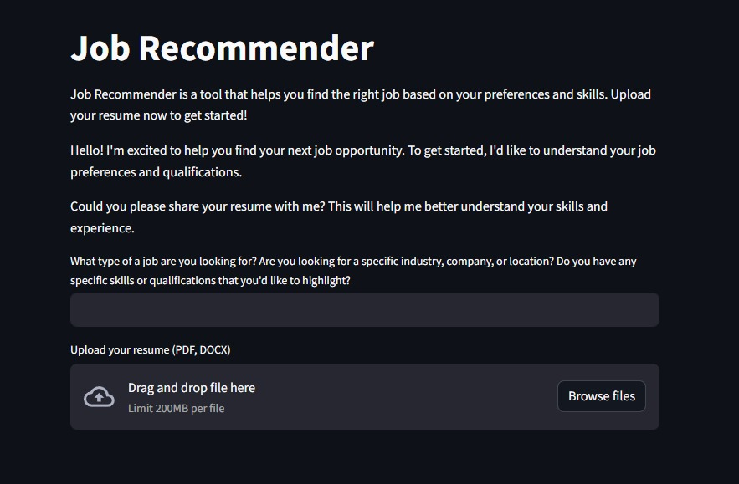

## Fig 5.1: Landing Page

This image depicts a user interface for our "Job Recommender" tool. It guides users to upload their resumes in PDF or DOCX format, with a file size limit of 200MB, to receive job recommendations tailored to their skills and preferences. The interface includes a text input field for specifying job preferences and a drag-and-drop area for file uploads.

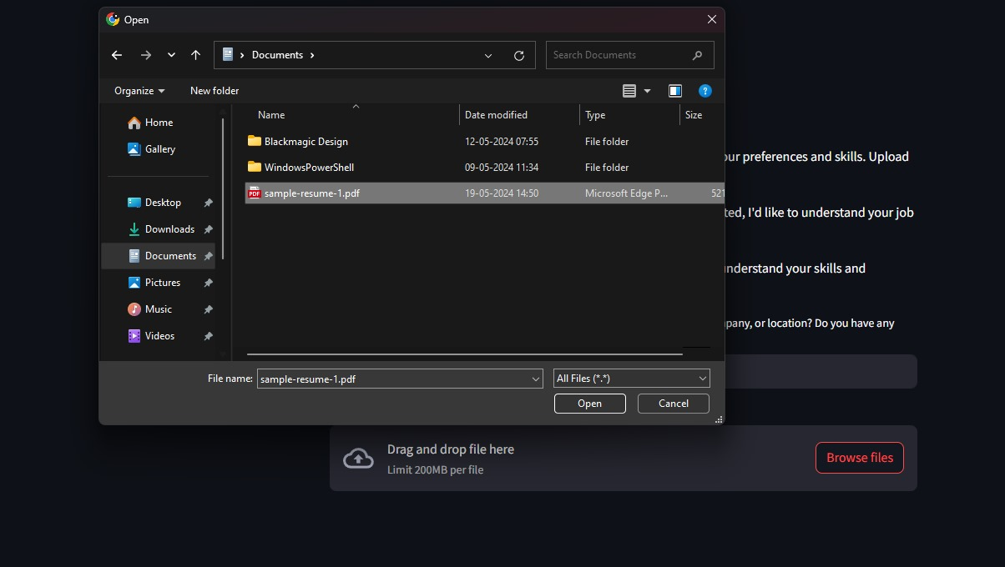

## Fig 5.2 (i) : Uploading Resume

In this image the user is prompted to upload their resume from the local directory to the Job Recommender System. The uploaded document ( resume ) must be either of a PDF or a .doc format.

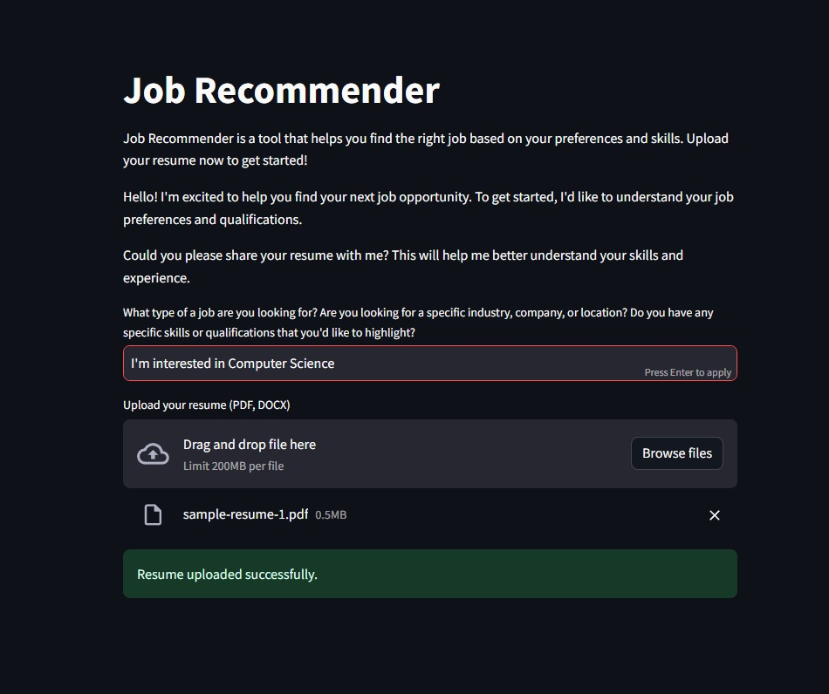

## Fig 5.2 (ii) : Success Message

In this image a success message is displayed if the user successfully uploaded their resume to the Job Recommender tool. This tool also allows the user to describe their qualifications and field of interest which allows our model to give desired job recommendations that would be helpful for the users.

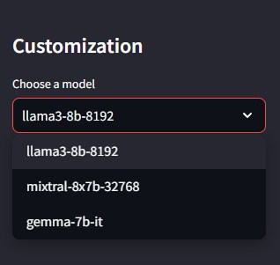

## 

## Fig 5.3: Model Selection

The image refers to the model selection menu. Our project uses more than one model for recommending the desired jobs for the users based on the selected model. They are llama 3b-8b-8192, llama3-8b-8192, mixtral-8x7b-32768 and gemma-7b-it. Out of which, one has to be chosen.

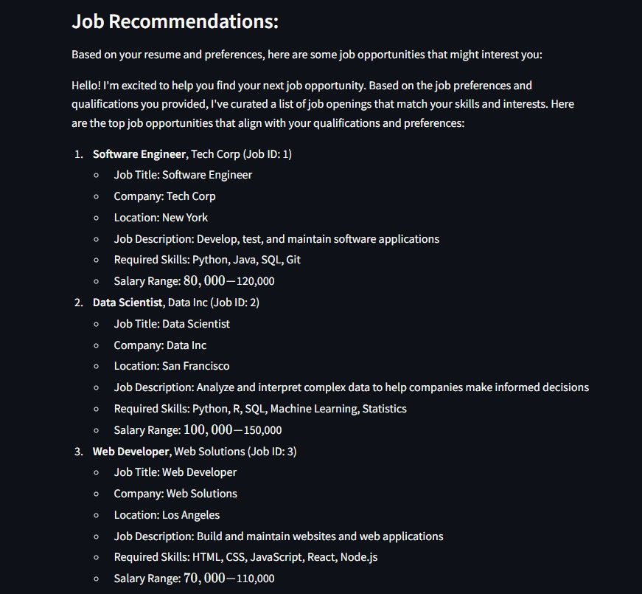

## Fig 5.4 (i) : Response From Job Recommender -1

## 

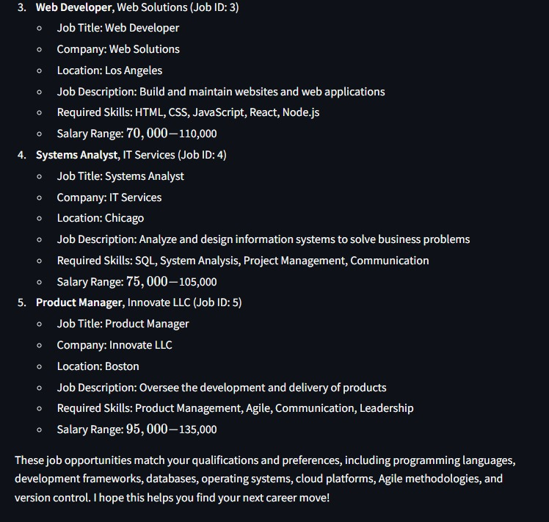

## Fig 5.4 (ii) : Response From Job Recommender - 2

These images (fig 5.4 (i) and fig 5.4 (ii) ) for shows the results from our Job Recommender System, providing personalized job recommendations based on the user's resume and preferences. The recommendations are tailored to the user's qualifications and preferences, featuring detailed information about each job including the title, company, location, description, required skills, and salary range.

* 1. **RESULT**

The transfer of the suggested job recommendation and career guidance system is expected to give rise to numerous outcomes which will affect both the user and the broader world of employment in a profound way. The first advantage of this setup would be the experience of users which would improve dramatically due to highly customized recommendations. AI algorithms will be built upon using the data such as user profiles, skills, and career preferences for the system to determine the diverse jobs that will be tailored against each learner’s aspiration and strength. The personalization of these services are therefore intended to foster improved satisfaction and involvement as users identify more with the platform's relevance and utility. Lastly, the set of interactive tools such as assessment skills, the career advancement function and might be helpful to the users to gain more power to control their professional development on their own, and this contributes to the enrichment of the experience.

Noteworthy, the proposed system will have a positive impact on the career development goal attainment for users. Learning sources of a personal nature and training programs would provide individuals with an avenue to improve their skills all the time and remain relevant in the job sector. Job market trends, up-to-the-minute salary data in real-time will give users an insight necessary to make the best decisions about their careers. These professionals will end up with better long-term outcomes for themselves. By personalizing recommended career paths and creating networks with actual professionals of the industry, the system will help people tackle their career track progress with more confidence and discover ways for further development and advancement.

## CHAPTER 6

**CONCLUSION AND FUTURE ENHANCEMENT**

## 6.1 CONCLUSION

To sum up, the new job advisory and vocational guidance system is an innovative recommendation which aims to change the current employment regulation that insecure young people are subjected to. The system strives to achieve this goal by implementing sophisticated AI algorithms and through the provision of personalized features and interactive functionalities that, in turn, will empower users with job recommendation services that are highly-tuned to their requirements, those that offer skill development resources, and a support system for career management. This system offers improved user experiences with the developed career opportunities and brings about the positive effect to the whole employment ecosystem. Thus, the system becomes an instrument of change. On the other hand, the system would show more concern in the areas of data privacy, security and inclusivity which would allow for the creation of a trustful and accountable environment thus eliminating the inequality in access to opportunities. Of significance is the fact that, whereas the position or the system to be put in place can achieve the proposed goal of guiding the decision, which is to facilitate the careers path, then encourage everyone to work without problems and ultimately, the work force landscape will be developed into an inclusive, efficient and worthwhile as expected.

## 6.2 FUTURE ENHANCEMENT

Personalized career path steerage may be offered by means of analyzing the person's capabilities, work records, and enterprise tendencies, suggesting capability career trajectories, vital skill development, and applicable schooling packages to help users prepare for rising process roles and industries.

An AI-driven interview practice module may want to simulate ability interview questions based totally on process descriptions, offering guidelines on answering them and offering personalized remarks and development recommendations the usage of herbal language technology strategies.

Additionally, implementing multilingual assistance could allow non-English speaking customers to engage with the tool in their favored language, broadening its accessibility and usability across different areas. Those upgrades can rework the job Recommender device into a complete career development platform, offering personalized and effective help in job seek and career development.

**APPENDIX**

**SOURCE CODE:**

import streamlit as st

import pandas as pd

import os

from crewai import Agent, Task, Crew

from langchain_groq import ChatGroq

from dotenv import load_dotenv

load_dotenv()

# Load job dataset

def load_job_data(filepath):

return pd.read_csv(filepath)

def main():

# Set up the customization options

st.sidebar.title('Customization')

model = st.sidebar.selectbox(

'Choose a model',

['llama3-8b-8192', 'mixtral-8x7b-32768', 'gemma-7b-it']

)

llm = ChatGroq(

temperature=0,

groq_api_key=os.environ.get("GROQ_API_KEY"),

model_name=model

)

# Load job dataset

job_data = load_job_data('jobs.csv')

# Streamlit UI

st.title('Job Recommender')

multiline_text = """

Job Recommender is a tool that helps you find the right job based on your preferences and skills. Upload your resume now to get started!

"""

st.markdown(multiline_text, unsafe_allow_html=True)

# Conversational prompts

st.write("Hello! I'm excited to help you find your next job opportunity. To get started, I'd like to understand your job preferences and qualifications.")

st.write("Could you please share your resume with me? This will help me better understand your skills and experience.")

user_question = st.text_input("What type of a job are you looking for? Are you looking for a specific industry, company, or location? Do you have any specific skills or qualifications that you'd like to highlight?")

uploaded_file = st.file_uploader("Upload your resume (PDF, DOCX)")

if uploaded_file is not None:

st.success("Resume uploaded successfully.")

if user_question and uploaded_file is not None:

st.write("Great! Let me process your resume and find some job opportunities for you.")

Resume_Parsing_Agent = Agent(

role='Resume_Parsing_Agent',

goal="""Analyze the user's resume to extract relevant information such as skills, experience, and qualifications. Find out their most recent job title and the skills they have.""",

backstory="""You are an expert in understanding and analyzing resumes.

Your goal is to extract the most relevant information from the user's resume and use it to recommend suitable job roles.""",

verbose=True,

allow_delegation=False,

llm=llm,

)

Job_Finder_Agent = Agent(

role='Job_Finder_Agent',

goal="""Search and identify job opportunities that match the user's qualifications and preferences based on the extracted resume data and specified job criteria.""",

backstory="""You have extensive knowledge of job databases and search algorithms.

Your mission is to find and recommend job listings that best align with the user's skills, experience, and job preferences.""",

verbose=True,

allow_delegation=False,

llm=llm,

)

User_Interaction_Agent = Agent(

role='User_Interaction_Agent',

goal="""Engage with the user to gather their job preferences, assist with the resume upload process, and present matched job opportunities. Provide support and answer any questions the user may have.""",

backstory="""You are a friendly and knowledgeable assistant dedicated to helping users navigate the job search process.

Your primary objective is to ensure users have a smooth and efficient experience finding job opportunities.""",

verbose=True,

allow_delegation=False,

llm=llm,

)

# Define tasks

task_parse_resume = Task(

description="""Parse the user's uploaded resume to extract skills, experience, and qualifications.""",

agent=Resume_Parsing_Agent,

expected_output="Extracted skills, experience, and qualifications from the resume."

)

task_find_jobs = Task(

description=f"""Find job listings from the job dataset that match the user's extracted resume data and specified job preferences.

Here is the job dataset: {job_data}""",

agent=Job_Finder_Agent,

expected_output="A list of job opportunities that match the user's qualifications and preferences."

)

task_interact_with_user = Task(

description="""Interact with the user to understand their job preferences and present the matched job opportunities.""",

agent=User_Interaction_Agent,

expected_output="Engaged user with relevant job listings and provided support as needed."

)

crew = Crew(

agents=[Resume_Parsing_Agent, Job_Finder_Agent, User_Interaction_Agent],

tasks=[task_parse_resume, task_find_jobs, task_interact_with_user],

verbose=2

)

result = crew.kickoff()

# Displaying the results in Streamlit UI

st.subheader("Job Recommendations:")

st.write("Based on your resume and preferences, here are some job opportunities that might interest you:")

st.write(result)

if __name__ == "__main__":

main()

## REFERENCES

[1] [Rasa Technologies GmbH. Rasa: Open source conversational AI [Online].](https://rasa.com/)

[2] [Microsoft. Microsoft Bot Framework [Online].](https://www.botframework.com/)

[3] [Wit.ai. [Online].](http://wit.ai)

[4] [Botkit [Online].](https://botkit.ai/)

[5] [BotMan - The PHP messaging and chatbot library [Online].](https://botman.io/)

[6] [J.M.K. Deepika, V. Tilekya, T. Subetha, "Jollity chatbot- a contextual AI assistant," in 2020 3rd International Conference on Smart Systems and Inventive Technology (ICSSIT), (2020), pp. 1196–1200.](https://ieeexplore.ieee.org/abstract/document/9214076)

[7] [S.J.S. Mohapatra, N. Shukla, S. Chachra, "Nsmav-bot: Intelligent dual language tutor system" in 2018 4th International Conference on Computing Communication Control and Automation (ICCUBEA), (2018),](https://ieeexplore.ieee.org/abstract/document/8697582)

[8] [E. Handoyo, M. Arfan, Y.A.A. Soetrisno, M. Somantri, A. Sofwan, E.W. Sinuraya, "Ticketing chatbot service using serverless nlp technology," in 2018 5th International Conference on Information Technology, Computer, and Electrical Engineering (ICITACEE), (2018),](https://ieeexplore.ieee.org/abstract/document/8576921)

[9] [E.G.K. Mauro de Gennaro, G. Lucas, "Effectiveness of an empathic chatbot in combating adverse effects of social exclusion on mood in," (2018).](https://www.frontiersin.org/journals/psychology/articles/10.3389/fpsyg.2019.03061/full)

[10] [E. Adamopoulou, L. Moussiades, "An overview of chatbot technology," in IFIP International Conference on Artificial Intelligence Applications and Innovations (2020, Springer), pp 373–383.](https://link.springer.com/chapter/10.1007/978-3-030-49186-4_31?ref=blog.min.io)

[11] [A. Bashar, "Survey on evolving deep learning neural network](https://scholar.google.com/scholar_lookup?&title=Survey%20on%20evolving%20deep%20learning%20neural%20network%20architectures&journal=J.%20Artif.%20Intell.&volume=1&issue=02&pages=73-82&publication_year=2019&author=Bashar%2CA)

[architectures," J. Artif. Intell. 1(02), 73–82 (2019). (This reference provides a broader context of deep learning, which can be relevant for some chatbot architectures)](https://scholar.google.com/scholar_lookup?&title=Survey%20on%20evolving%20deep%20learning%20neural%20network%20architectures&journal=J.%20Artif.%20Intell.&volume=1&issue=02&pages=73-82&publication_year=2019&author=Bashar%2CA)

[12] N. A. Ghobakhloo, M. R. Amini, and H. Arabzadeh, "A context-aware career guidance system using a fuzzy logic approach," International Journal of Intelligent Systems, vol. 33, 2018.

[13] S. P. Deshpande and A. A. Patil, "A review of intelligent systems for career guidance," International Journal of Computer Applications, vol. 97, no. 2014.

[14] M. C. Yiu and E. W. Ngai, "Developing a career decision support system using web 2.0 technologies," Journal of Education and Human Development, 2012.

[15] S. S. Bhowmik, S. K. Pal, and S. Pal, "A knowledge-based career guidance system for students," International Journal of Advanced Computer Science and Applications, 2015.

[16] Y. Wang and D. Miao, "A review of career decision-making support systems," Journal of Educational Technology Development and Exchange (JETDE), 2015.

[17] J. D. Kim, Y. Kwon, S. Kim, S. Na, and J. Moon, "Conversational recommender systems: A survey," ACM Computing Surveys (CSUR), 2019.

[18] H. Schütze, "The fallacy of cloze tests as measures of language processing," in Proceedings of the 20th Meeting of the Association for Computational Linguistics, 1992.

[19] Y. Bengio, R. DuCharme, P. Vincent, and C. Déchène, "Learning deep representations for unsupervised and supervised learning," in Neural networks: Tricks of the trade, Springer, 2012.

[20] D. Jurafsky and J. H. Martin, Speech and language processing, Pearson Education Limited, 2014.

[21] J. Williams and A. Zweig, "Embedded dialogue management for real-time spoken language translation," in Proceedings of the 38th Annual Meeting on Association for Computational Linguistics, 2000.

[22] M. Walker, D. J. Litman, K. Aist, and M. Kearns, "Plans, rules, and discourse models for dialogue systems," in The handbook of natural language processing, CRC Press, 2010.

[23] S. Young, "Dialogue act tagging in spoken language dialog systems," in Engineering spoken language systems, Springer, 2000.

[24] B. Porr and M. Lucas, "Human evaluation of spoken dialogue systems," in The handbook of natural language processing, CRC Press, 2010.

[25] M. L. Littman, J. Burstein, K. E. Moore, S. A. Smith, M. E. Walker, and I. H. Witten, "Eclipse: a platform for agent development," Communications of the ACM, 1998.

[26] W. A. Walker, N. C. Howes, and D. J. Litman, "Evaluating dialogue systems for adaptive educational technology," in User modeling 2005.

[27] J. Jeon, S. Yoon, and D. G. Wohn, "Perceived anthropomorphism and user experience of chatbots," International Journal of Human-Computer Interaction, vol. 35, no. 14, pp. 1180-1192, 2019.

[28] P. Alexa, M. Murabito, and F. D’Alessandro, "Conversational agents and user experience: A research framework for chatbot design," in International Conference on Wirtschaftsinformatik, Springer, 2018, pp. 311-324.

[29] L. M. Xiao, L. Luo, J. Fan, Y. Qin, H. W. Jing, and J. Y. Yang, "Human evaluation of chatbot conversations," arXiv preprint arXiv:1801.06373, 2018.

[30] S. Ahn, H. Lee, and J. Park, "Understanding user experience of chatbots: A systematic literature review," International Journal of Human-Computer Interaction, vol. 37, no. 4, pp. 376-404, 2021.