1. Login/Registration Page.

The Page will be divided into 4 parts i.e.

* 1. **Top bar**

The top bar will have the logo on the left side and login option on the right side asking for username, password with login and forgot password option as shown in the image.

* 1. **Bottom bar**

On the left side, there will be Helfis logo. After the logo, there will be web links of About Helfis, contact us, Blog, FAQs and Terms.

* 1. **Middle Left**

On the left side of the middle page, there will be a picture focusing on corporate wellness program and advertising Helfis.

* 1. **Middle Right**

Below the login, on the middle page there will be registration option asking for details. The middle page will be divided into 60:40 ratio. The details asked will be First name, Last name, gender, official email id, phone number, enter password, re-enter password and a register button

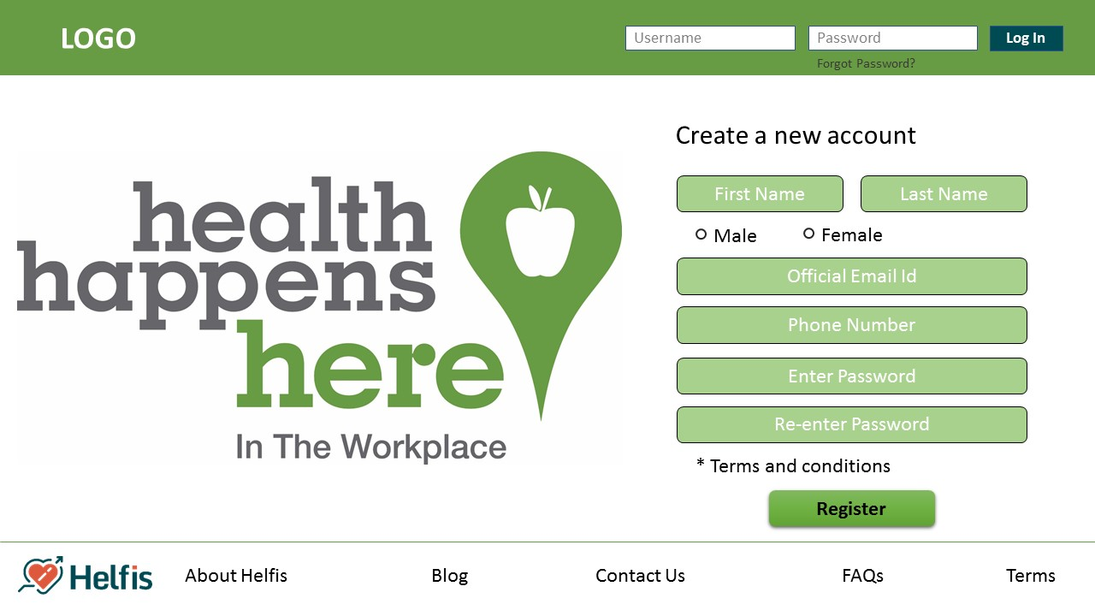

1. Psychometric Assessment

Make a page asking for user details.

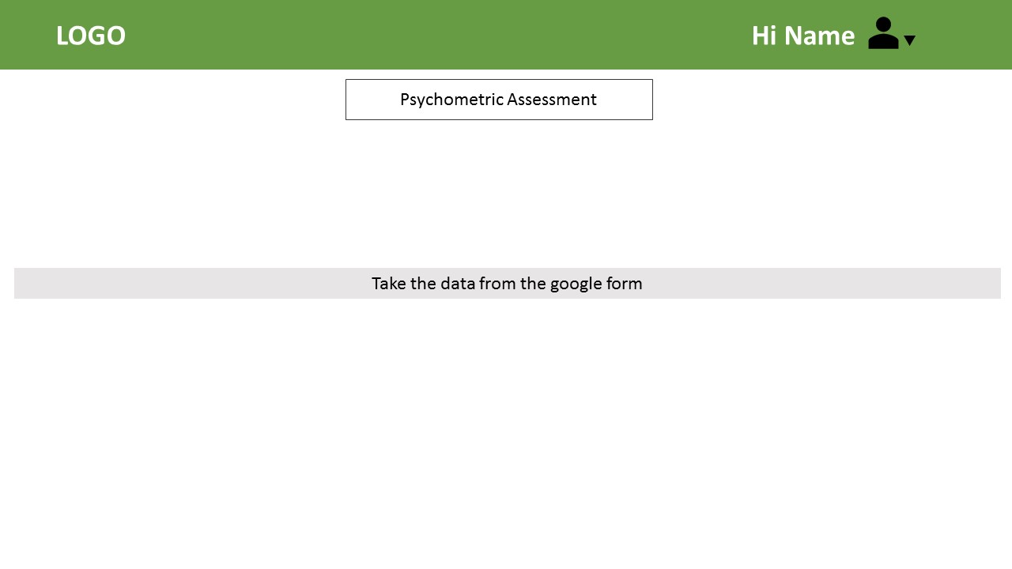

1. Profile Details

* This will show user details. User can change his/her profile picture by clicking anywhere on the space allotted for the picture.
* User details collected from the previous page will be shown under 4 sections:
  + Basic Info:
  + Health Conditions:
  + Family History
  + Lifestyle & Diet

An option underneath it will allow them to edit and update the information.

* Goals and Challenges: This section will show activities as per taken by users. An option will be there underneath it by “**Take a new challenge**”, showing options in a pop-up window to select and edit new goal and challenges. A settings option (gear icon) will be on the right top of the goals providing options to edit that specific goal/challenge or delete it.
* Your Activities: A chart showing users’ activities till date i.e. how many classes he/she has taken of a category (i.e. health, art, music, dance etc.) till date. When the user points the cursor on the category, it will show the classes taken of its sub-categories.
* There will be the users’ image on the right top of the page with a dropdown sign to select out of 3 options i.e. Profile, Account Settings and Logout.

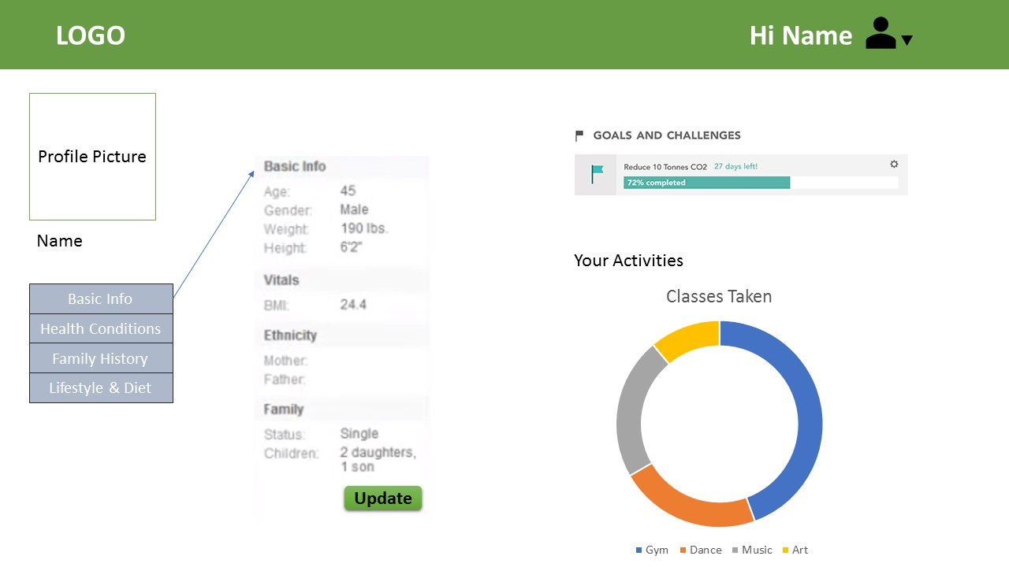

1. Account Settings (allowing user to edit and update account information)

* Showing username
* Phone number
* Company Email address
* Google Account Email address

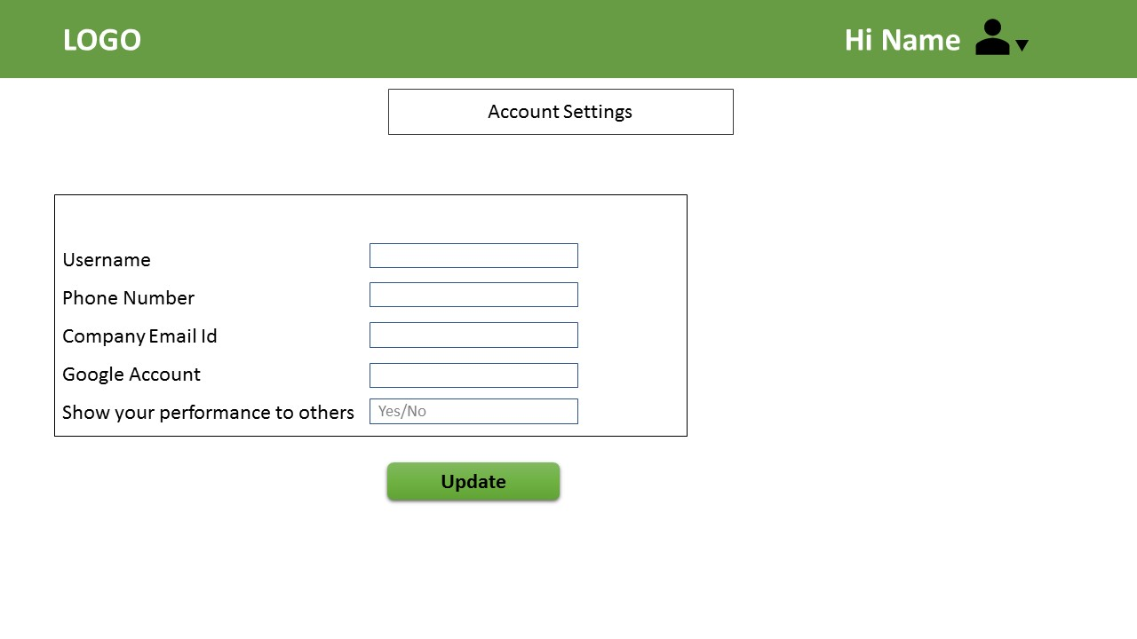

1. Dashboard

This page is divided into 5 parts:

* Your Bookings: Showing all the bookings the user has done and an option at the bottom of the bookings of “Make a new appointment” which will direct the user on the classes page.
* Today’s Diet Plan: This will show the diet plan of the user as provide by the dietitian at the backend.
* Rewards: The user will be given reward points according to the goals and challenges completed and activities enrolled. An activity enrolled to will be give then 5 points and goal completed will give them 50 points. An option of charity will be there where they can use those coins to donate to people in need through helfis platform. 1 reward coin = 1 INR. The user can also use those points on helfis store or to buy coupons from Helfis store.
* A quote for the day will be shown and is supposed to change at 12 midnight every day automatically.
* Health Blog: This will be connected with the Helfis Blog. Heading of the blog will be shown under the header of Health Blog. The user will be redirected to the helfis blog by clicking on read more.

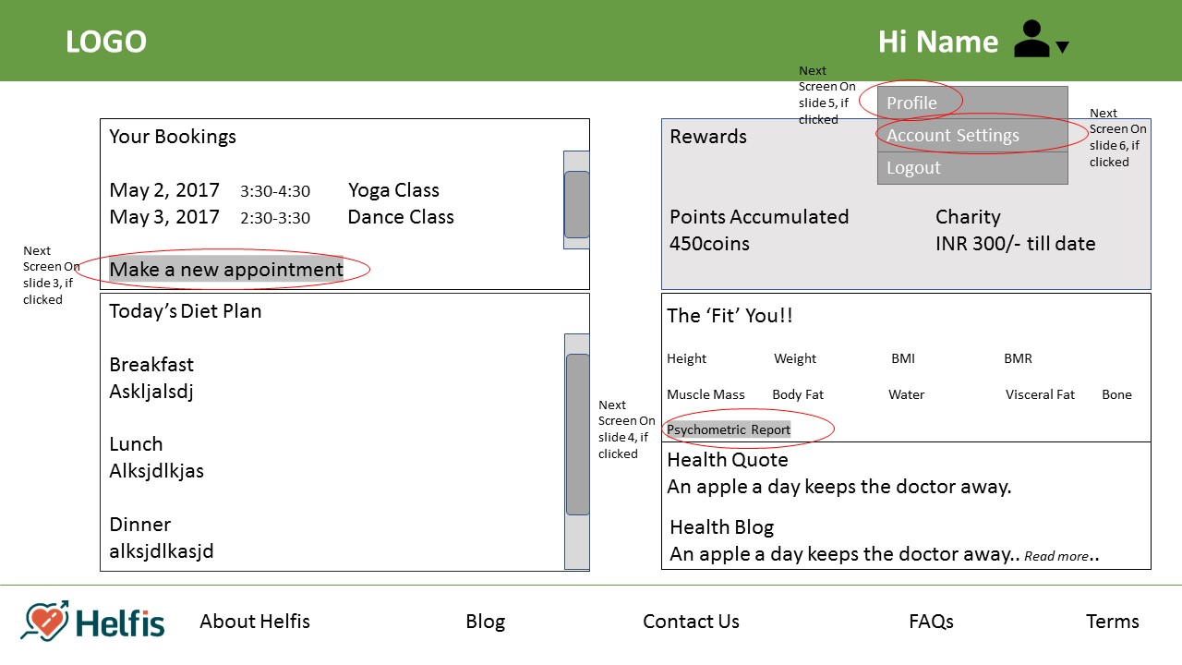

1. Classes on Google Calendar

A calendar synchronized with google calendar will show the classes/activities/sessions to be organized this month and at what time. Sessions can be booked/cancelled from the very same calendar.

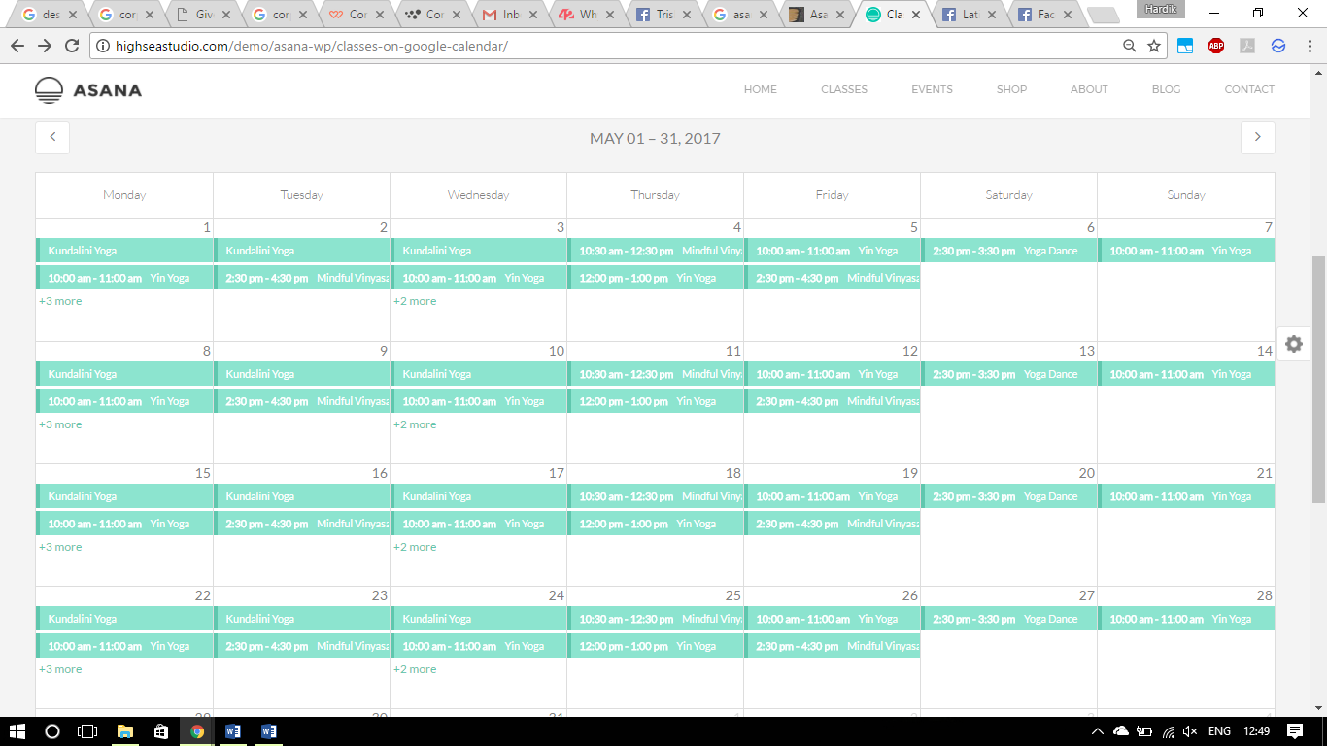

All the classes with marked with different colours e.g. all yoga classes will be shown in green. The sessions with all the seats full will be marked red and will be unclickable until there is a seat available. On selecting any activity, a new dialogue box will open showing the current status, no. of classes available, Book/Cancel a session, any gender specific, group/single activity. E.g.

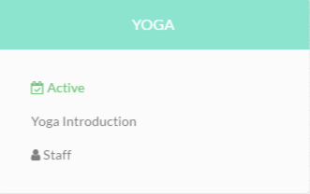

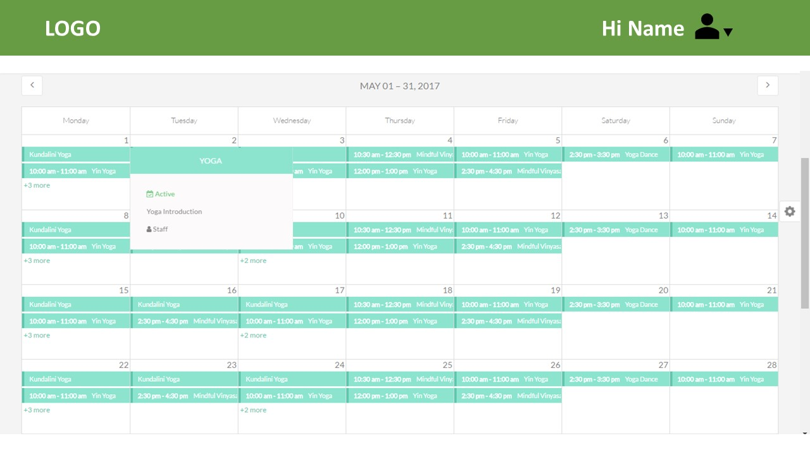

1. Helfis Store and Store Manager

Use Shopify.

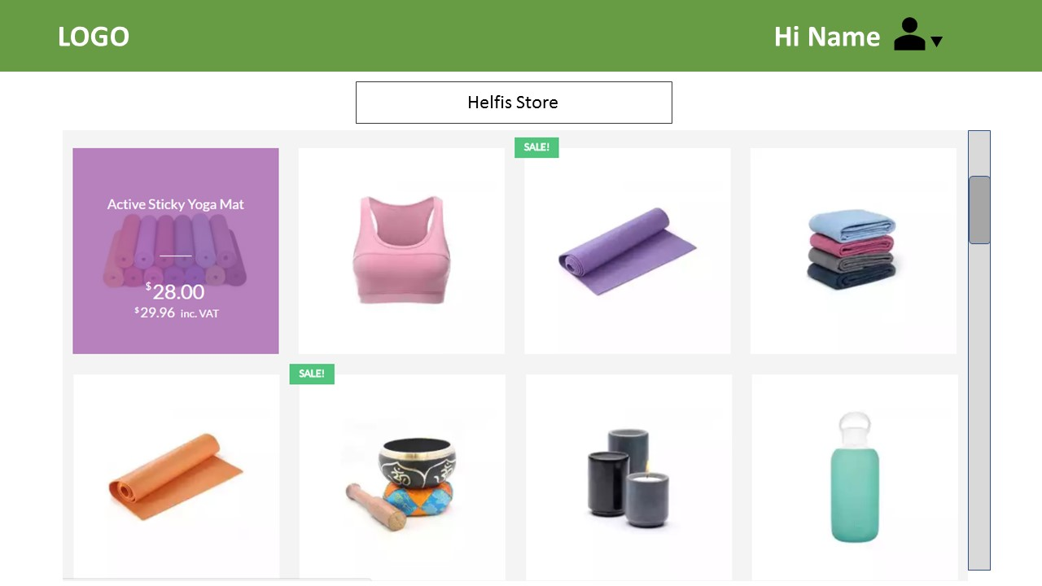

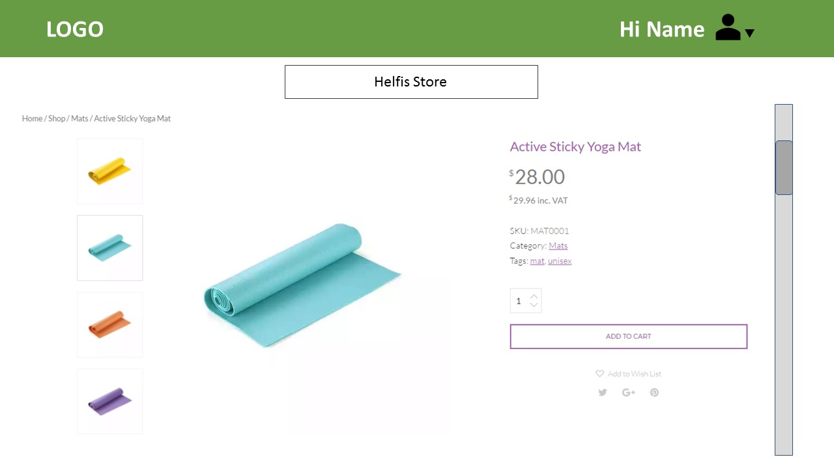

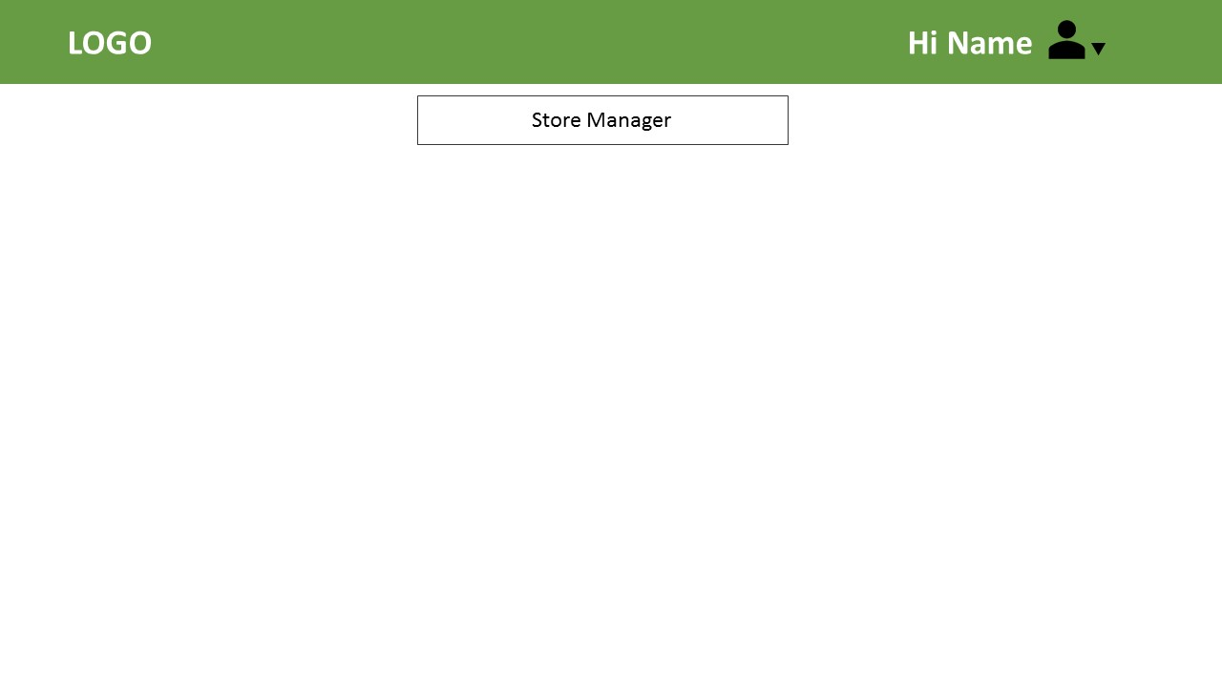

1. FAQs

* A bar where user can type and ask questions and showing him/her questions asked related to it and its answers with an option of “is this what you are looking for”, “ask the community” and “contact us”.
* Below the bar, there will be a list of questions. The answer will be shown if the user clicks on the question. A 2nd click on the question will the answer.

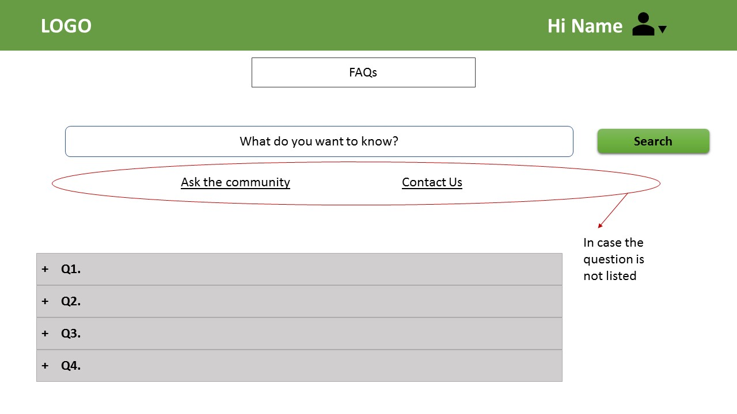

1. Terms

All the terms and conditions for using our platform will be listed down here.

**Helfis Backend Portal**

1. Create Event

* All day event: A check box option.
* Date: A dropdown calendar to select the date.
* Time Slot: 1 hour time slots starting from 8am-8pm (e.g. 3pm-4pm). Only one time slot can be selected at one time. The time slot selection is compulsory but will fade away (no to be filled) if the “All day event” check box is clicked. For events on Saturday and Sunday, the user can set any time he/she wants for that event, the user will not be restricted to selecting a time slot of 1 hour.
* Event Name: user can take anything of max 25 characters (optional section)
* Category: A dropdown menu showing option of activities i.e. Dance, Music, And & Craft, Yoga, Health check-up and Sports.
* Sub-category: All the sub-categories will be shown according to the category selected above.
  + Dance: Zumba, Hip-Hop
  + Art & Craft: Painting
  + Health Check-up: Dietitian, Physiotherapist
  + Music: Vocal, Guitar, Piano
  + Sports: Cricket, Football

Only one of the above 5 will be shown.

* Teacher: A name is supposed to be entered (Compulsory)
* Max. No. of entries: Only numbers can be entered.
* Other Information: Anything can be typed with 250-300 characters limit (Optional section)

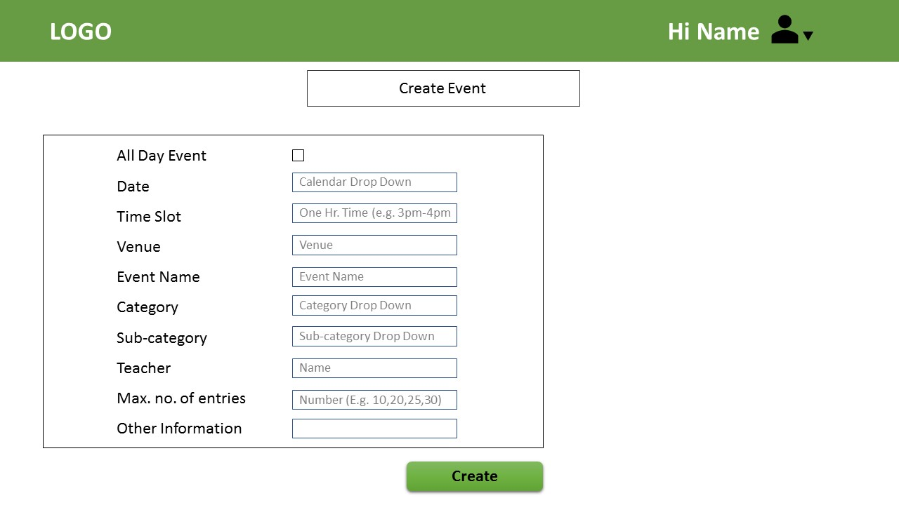

1. Manage Event

* Filter on the top with the following options:
  + Category
  + Sub-category
  + Event Status
  + Date
  + Search

The user can use one or multiple filters at a time

* Below the filter all the events will be listed under the headers of Event Name, Category, Sub-category, Event Date, Status, Attendees, Max. no. of Enrolments, Manage.
* On clicking the manage option, a pop-up will open with same options as create event but will the previous information already filled.
* Only 10 events will be shown at a time. A next page option will be there at the bottom.

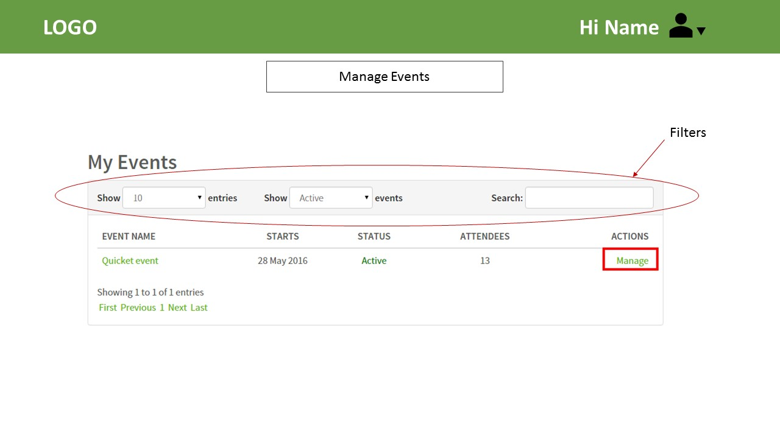

1. Helfis Dashboard

* Filter on the top with the following options:
  1. Company: Dropdown list of companies enrolled on our platform
  2. Category: Dropdown list of Dance, Music, And & Craft, Health check-up and Sports.
  3. Employee: List of employee Names of that company
  4. Search

The user can use one or multiple filters at a time

* A graph showing employees enrolled in activities. There will be an option to see the graph monthly or weekly.
* How much company is billed by hefis will be shown on the right side of the engagement graph with all the break-ups of the bill.
* A speedometer graph showing no. of employees engaged till date vs no. of employees in the company/listed on our platform.
* A chart for Traffic: Search Traffic, Referral Traffic, Direct Traffic, Campaigns.
* List of most enrolled activities name, %age of those activities as compared to other and hike in enrolment of those activates from last week.
* List showing: No. of Visits, Unique Visitors, Pages per visit, Avg. time on dashboard, New Visits and a chart for new and returning visitors.
* List of best performers of the company on the basis of their activities on our platform.

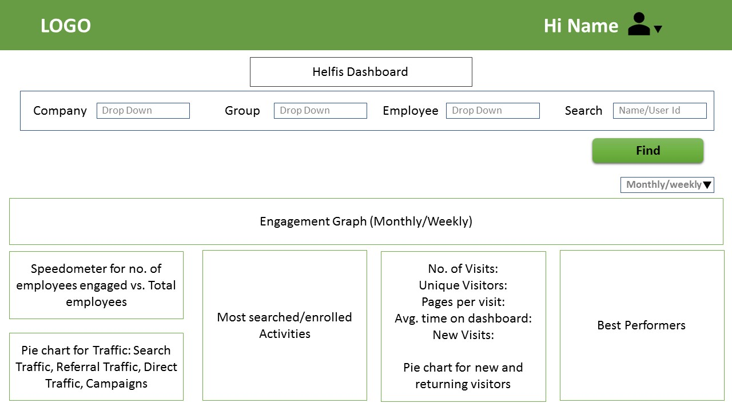

**Company Portal**

1. Company Registration

* Free for 15 days should be written in big on the top. Below that “After your trial ends, pick a plan that best fits your needs”.
* 3 plans will be shown with all the benefits provided to the client under that plan.
* Company can change his plan during those 15 days and the billing cycle will start at the end of 15 days. (Should be written below the plans advised).
* When the user clicks on “Choose Plan”, the plans will page will go up and a page giving all the in-depth details of that plan will be shown. On the left side of the details, the user is supposed to fill the details for registering.

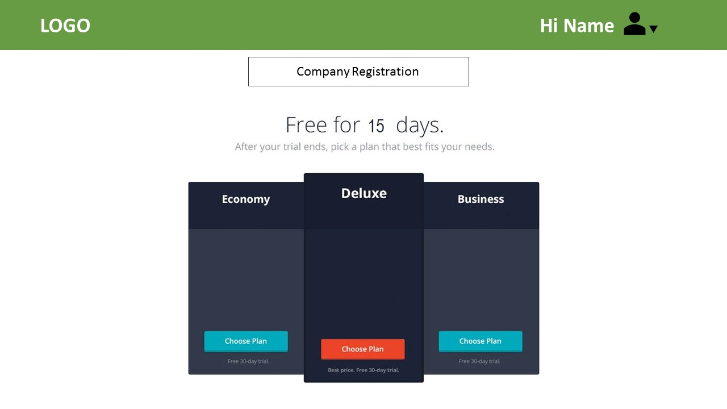

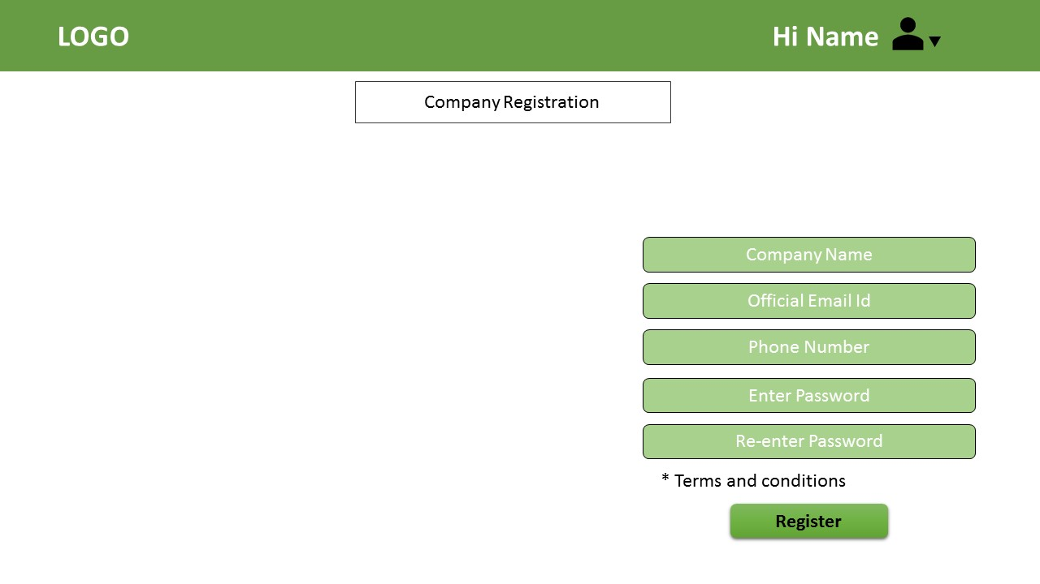

1. HR Dashboard

* A graph showing employees enrolled in activities. There will be an option to see the graph monthly or weekly.
* How much company is billed by hefis will be shown on the right side of the engagement graph with all the break-ups of the bill.
* A speedometer graph showing no. of employees engaged till date vs no. of employees in the company/listed on our platform.
* A chart for Traffic: Search Traffic, Referral Traffic, Direct Traffic, Campaigns.
* List of most enrolled activities name, %age of those activities as compared to other and hike in enrolment of those activates from last week.
* List of best performers of the company on the basis of their activities on our platform.

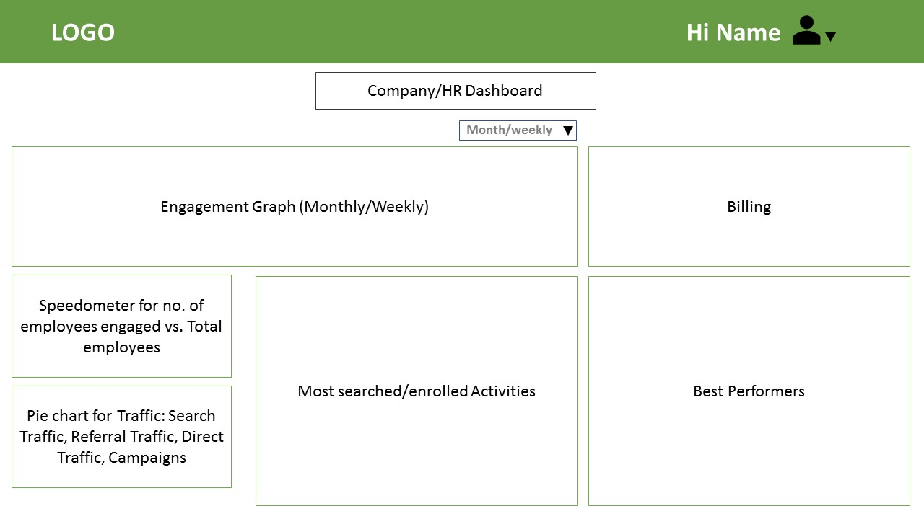

**Important links:**

Links for Calendar:

<http://angular-ui.github.io/ui-calendar/>

<https://github.com/angular-ui/ui-calendar>