**Exp no: 1**

**Date: 21/1/25**

### ****Objectives:****

The objective of this preprocessing pipeline for a time series Google trends dataset is to prepare the data for predictive modeling. The steps aim for time series data loading, cleaning and handling missing values. The goal is to process the data so that models can accurately predict future trends, detect patterns, and generate forecasts.

**Procedure:**

1) Import the necessary libraries.

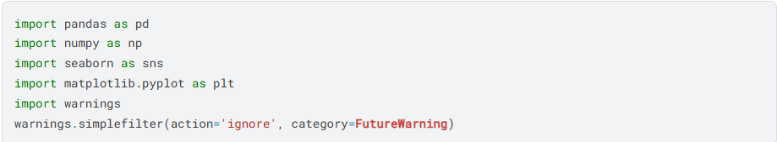

2) Load the dataset and study about the structure and information of the dataset.



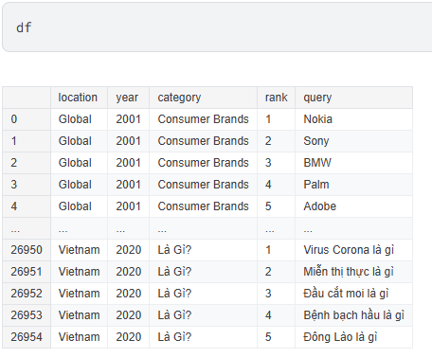

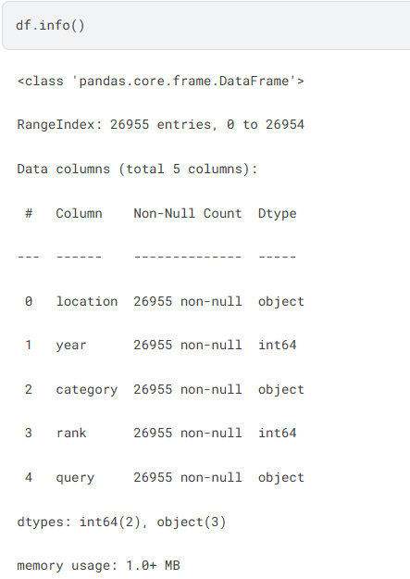

3) Check for missing values.

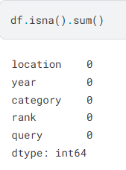

4) Check for duplicate values. If any, drop those duplicates.

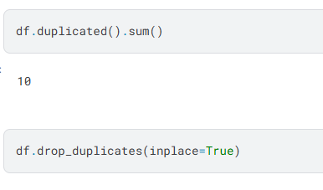

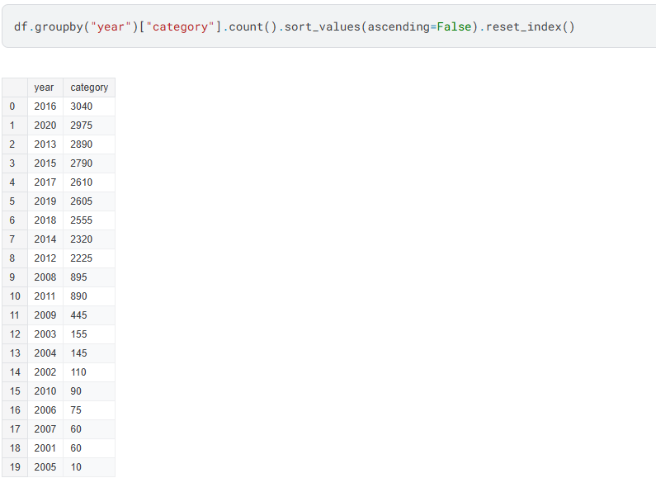

5) Using grid() method to visualize the dataset with assigning labels to each axis

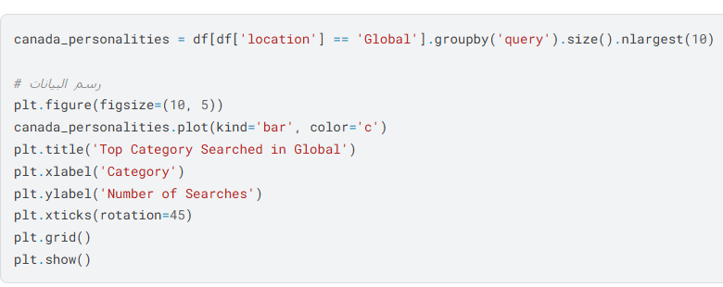

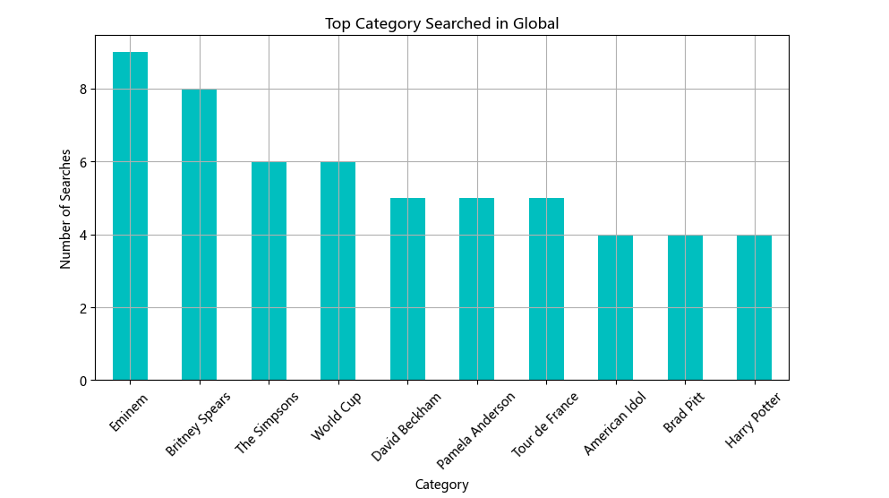

**Result:**

Python program for time series data loading, cleaning and handling missing values has been executed and verified successfully.