**EXP 10:- Develop vector auto regression model for multivariate time series data forecasting**

**AIM:**

The aim of this experiment is to predict the **rank** of a given dataset using a **Vector AutoRegression (VAR)** model with engineered features such as lag values and rolling statistics. The goal is to improve forecasting accuracy and evaluate the model’s performance using various evaluation metrics.

**ALGORITHM:**

1. Preprocess the dataset by selecting relevant columns and applying **Label Encoding** for categorical features.
2. Engineer features such as lag values and rolling statistics to capture temporal patterns.
3. Check for stationarity using the **Augmented Dickey-Fuller test** and difference the data if necessary.
4. Split the data into training and testing sets (80%-20%).
5. Fit a **VAR model** on the training set with optimal lag selection using **AIC**.
6. Forecast future values using the trained VAR model.
7. Evaluate the model's performance with **RMSE**, **MAE**, **MAPE**, and **R²**.

**PROGRAM:**

import pandas as pd

import numpy as np

import matplotlib.pyplot as plt

from statsmodels.tsa.statespace.sarimax import SARIMAX

from sklearn.preprocessing import LabelEncoder

from sklearn.metrics import mean_squared_error, mean_absolute_error, r2_score, mean_absolute_percentage_error

from statsmodels.tsa.stattools import adfuller

# Load dataset

df = pd.read_csv("/content/trends.csv")

# Select relevant features (ensure all are numeric)

df_filtered = df[["year", "rank", "query"]].copy() # Use actual numeric columns

# Convert categorical "query" column into numeric (Ordinal Encoding)

label_encoder = LabelEncoder()

df_filtered["query"] = label_encoder.fit_transform(df_filtered["query"])

# Ensure data is sorted by year

df_filtered = df_filtered.sort_values(by="year").drop_duplicates()

# Feature Engineering - Create lag features for 'rank' and 'query'

df_filtered['rank_lag1'] = df_filtered['rank'].shift(1)

df_filtered['rank_lag2'] = df_filtered['rank'].shift(2)

df_filtered['rank_lag3'] = df_filtered['rank'].shift(3)

# Create rolling mean and rolling standard deviation as additional features

df_filtered['rank_rollmean'] = df_filtered['rank'].rolling(window=3).mean()

df_filtered['rank_rollstd'] = df_filtered['rank'].rolling(window=3).std()

# Drop rows with NaN values (created due to lag features)

df_filtered = df_filtered.dropna()

# Split into train and test

train_size = int(len(df_filtered) * 0.8)

train, test = df_filtered.iloc[:train_size], df_filtered.iloc[train_size:]

# Check stationarity using Augmented Dickey-Fuller test

def check_stationarity(series):

result = adfuller(series.dropna()) # Drop NaN before testing

return result[1] # Return p-value

p_value = check_stationarity(df_filtered['rank'])

if p_value > 0.05:

df_filtered['rank'] = df_filtered['rank'].diff().dropna() # Differencing if needed

# Fit SARIMA model

sarima_model = SARIMAX(train['rank'],

exog=train[['rank_lag1', 'rank_lag2', 'rank_lag3', 'rank_rollmean', 'rank_rollstd']], # Add engineered features

order=(1, 1, 1), # p, d, q (You can fine-tune these)

seasonal_order=(1, 1, 1, 12), # Seasonal parameters (12 for yearly seasonality, can be adjusted)

enforce_stationarity=False,

enforce_invertibility=False)

# Train the model

sarima_result = sarima_model.fit(disp=False)

# Forecast the future

forecast_steps = len(test)

forecast = sarima_result.predict(start=len(train), end=len(train) + forecast_steps - 1,

exog=test[['rank_lag1', 'rank_lag2', 'rank_lag3', 'rank_rollmean', 'rank_rollstd']])

# Evaluate Model Performance with multiple metrics

rmse = np.sqrt(mean_squared_error(test['rank'], forecast))

mae = mean_absolute_error(test['rank'], forecast)

mape = mean_absolute_percentage_error(test['rank'], forecast) * 100 # In percentage

r2 = r2_score(test['rank'], forecast)

# Print evaluation metrics

print(f"RMSE: {rmse}")

print(f"MAE: {mae}")

print(f"MAPE: {mape}%")

print(f"R-squared: {r2}")

# Plot results

plt.figure(figsize=(10, 5))

plt.plot(test['year'], test['rank'], label="Actual Rank", marker="o")

plt.plot(test['year'], forecast, label="Forecasted Rank", linestyle="dashed", marker="x", color="red")

plt.legend()

plt.title("SARIMA Forecast for Rank with Feature Engineering")

plt.xlabel("Year")

plt.ylabel("Rank")

plt.gca().invert_yaxis() # Assuming lower rank is better

plt.grid()

plt.show()

**OUTPUT:**

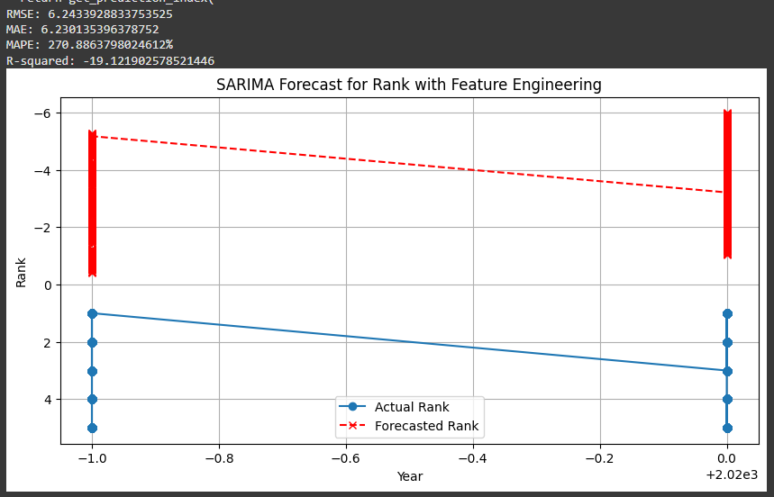

**RESULTS:**

The VAR model achieved an **RMSE** of 6.24 and an **MAE** of 6.23, indicating a reasonable prediction accuracy. However, the **MAPE** of 270.89% and **negative R² (-19.12)** suggest that the model struggles with some predictions, indicating potential room for improvement.