**4.Program for Estimating and Eliminating trends in Google Trends Dataset -Aggregation and Smoothing**

### **Aim:**

To analyze and eliminate trends in ranking data using Moving Average and Exponential Smoothing methods for better visualization of underlying patterns.

### **Procedure:**

1. Load the dataset containing ranking data over time.
2. Plot the original ranking data to observe trends and fluctuations.
3. Apply the **Moving Average** method to smooth short-term variations.
4. Use **Exponential Smoothing** to model gradual trend changes.
5. Visualize and compare the original and trend-eliminated data.
6. Interpret the results to identify hidden patterns in ranking trends.

**Code:**

import pandas as pd

import numpy as np

import matplotlib.pyplot as plt

df = pd.read_csv("/content/trends.csv")

df['year'] = pd.to_datetime(df['year'], format='%Y')

category = "Movies"

df_category = df[df['category'] == category]

df_category = df_category.sort_values('year')

df_category['Moving_Avg'] = df_category['rank'].rolling(window=3, min_periods=1).mean()

df_category['Exp_Smooth'] = df_category['rank'].ewm(alpha=0.3).mean()

fig, axes = plt.subplots(1, 2, figsize=(14, 5))

axes[0].plot(df_category['year'], df_category['rank'], marker='o', linestyle='-', label="Original Rank")

axes[0].set_title(f"Original Trend for {category}")

axes[0].set_xlabel("Year")

axes[0].set_ylabel("Rank")

axes[0].legend()

axes[1].plot(df_category['year'], df_category['rank'], 'bo-', label="Original Rank")

axes[1].plot(df_category['year'], df_category['Moving_Avg'], 'r--', label="Moving Average")

axes[1].plot(df_category['year'], df_category['Exp_Smooth'], 'g:', label="Exponential Smoothing")

axes[1].set_title(f"Trend Eliminated for {category}")

axes[1].set_xlabel("Year")

axes[1].set_ylabel("Rank")

axes[1].legend()

plt.tight_layout()

plt.show()

**Output**:

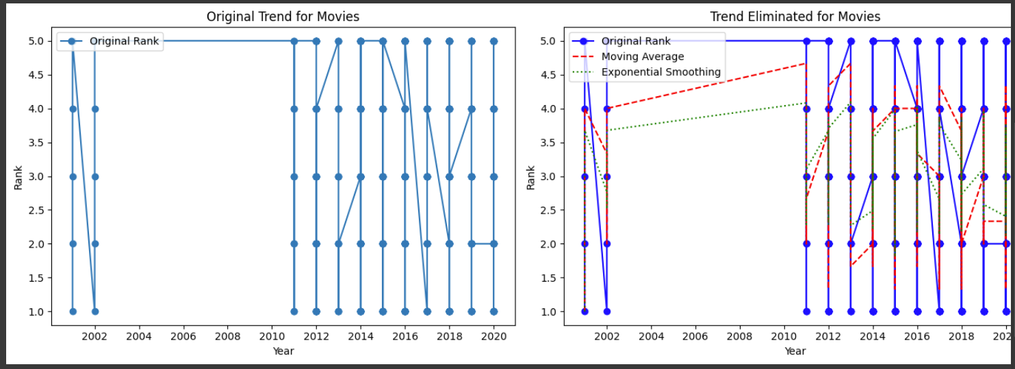

**Result:**

The program to estimate and eliminate the trends in the dataset is implemented and verified successfully