**Implement program for decomposing time series data into trend and seasonality.**

**Aim:**

To apply **time series decomposition** on Google Trends data to analyze trends and seasonality.

**Procedure:**

1. Load the Google Trends dataset and convert the year column into a date time format.
2. Sort the dataset based on year for time-series analysis.
3. Apply moving average smoothing to the rank column to remove short-term fluctuations.
4. Use seasonal decomposition to separate the time series into trend, seasonal, and residual components.
5. Plot the original, smoothed, and decomposed components for analysis.
6. Interpret the results to understand long-term trends and periodic patterns in search rankings.

**Code:**

import numpy as np

import pandas as pd

import matplotlib.pyplot as plt

from statsmodels.tsa.seasonal import seasonal_decompose

def moving_average_smoothing(data, window_size):

return data.rolling(window=window_size, min_periods=1).mean()

def decompose_time_series(data, period):

Return seasonal_decompose(data, period=period, model='additive')

if __name__ == "__main__":

df = pd.read_csv("/content/trends.csv") # Replace with your file path

df['year'] = pd.to_datetime(df['year'], format='%Y')

df = df.sort_values(by='year')

time_series_data = df.set_index('year')['rank']

window_size = 5

smoothed_data = moving_average_smoothing(time_series_data, window_size)

period = 12

decomposition = decompose_time_series(time_series_data, period)

plt.figure(figsize=(10, 5))

plt.plot(time_series_data, label='Original Data', linestyle='dashed')

plt.plot(smoothed_data, label=f'Smoothed Data (Window={window_size})', linewidth=2)

plt.legend()

plt.title('Moving Average Smoothing')

plt.show()

fig, axes = plt.subplots(3, 1, figsize=(10, 8), sharex=True)

decomposition.trend.plot(ax=axes[0], title='Trend')

decomposition.seasonal.plot(ax=axes[1], title='Seasonality')

decomposition.resid.plot(ax=axes[2], title='Residuals')

plt.xlabel("Time")

plt.show(

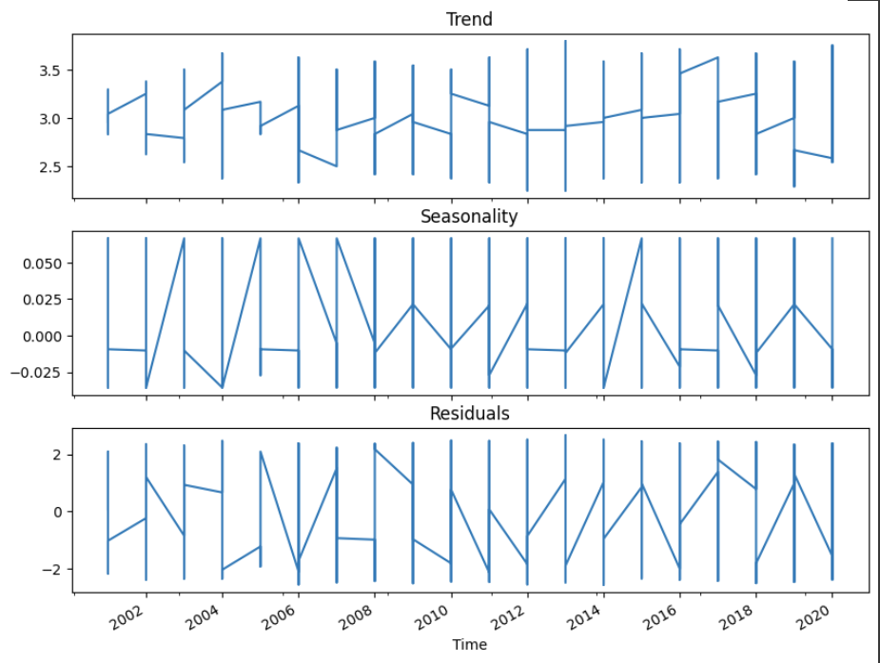

**Result:**

The program to decompose the google trends dataset has been successfully implemented and verified