MolmoAct2 on LIBERO_10
Evaluation Results and Subgoal Analysis
500-episode evaluation across 10 LIBERO long-horizon tasks

Metric | Value
Total episodes | 500
Successful episodes | 484
Overall success rate | 96.8%
Failed episodes | 16
Hardest task | Task 8: put both moka pots on the stove
Hardest task success rate | 41/50 = 82%
All task-level CSVs were merged into all_tasks_results_final.csv and independently verified: 500 rows, 50 episodes per task, no duplicate task+episode pairs, and 484 successes.

1. Overview
This report summarizes the completed MolmoAct2 evaluation on the LIBERO_10 benchmark. The final evaluation used the current eval_molmoact2_mounika_v2.py script for all ten tasks. Each task was evaluated for 50 episodes, producing a total of 500 episodes.
The evaluation was executed in chunks to make the long run robust to external process kills. Chunking/resume controls changed only the evaluation execution flow; they did not change the model, action generation, or inference logic. Legitimate task failures were not rerun. Failures were retained as valid evaluation outcomes and recorded in the final results.

2. Evaluation Methodology
- Benchmark: LIBERO_10, consisting of 10 long-horizon manipulation tasks.
- Policy/model: MolmoAct2-LIBERO-LeRobot evaluation setup.
- Episodes: 50 episodes per task, 500 total episodes.
- Execution: tasks were run in five 10-episode chunks per task, using task_ids, episode_start, n_episodes, device, and output_dir controls.
- Validation: each final task CSV was checked for exactly 50 rows, episodes 0-49, correct task_id, no duplicates, and failed episodes.
- Failure handling: if a process was killed before writing rows, the same chunk was rerun; if killed after partial rows, completed rows were kept and only missing episodes were resumed.
- Final deliverables: all_tasks_results_final.csv, task_level_summary.csv, failure_summary.csv, subgoal_analysis.csv, and the three result plots included below.

3. Task-Level Results
Table 1 summarizes the final success rate, average steps, and failed episodes for each LIBERO_10 task.
Task | Instruction | Success | Success rate | Avg steps | Max steps | Failed episodes
Task 0 | put both the alphabet soup and the tomato sauce in the basket | 50/50 | 100.0% | 254.0 | 314 | -
Task 1 | put both the cream cheese box and the butter in the basket | 50/50 | 100.0% | 237.5 | 271 | -
Task 2 | turn on the stove and put the moka pot on it | 50/50 | 100.0% | 235.4 | 277 | -
Task 3 | put the black bowl in the bottom drawer of the cabinet and close it | 49/50 | 98.0% | 221.6 | 520 | 13
Task 4 | put the white mug on the left plate and put the yellow and white mug on the right plate | 50/50 | 100.0% | 216.4 | 231 | -
Task 5 | pick up the book and place it in the back compartment of the caddy | 50/50 | 100.0% | 165.1 | 193 | -
Task 6 | put the white mug on the plate and put the chocolate pudding to the right of the plate | 48/50 | 96.0% | 225.5 | 520 | 11, 35
Task 7 | put both the alphabet soup and the cream cheese box in the basket | 50/50 | 100.0% | 247.5 | 307 | -
Task 8 | put both moka pots on the stove | 41/50 | 82.0% | 409.1 | 520 | 1, 5, 9, 12, 15, 24, 25, 40, 42
Task 9 | put the yellow and white mug in the microwave and close it | 46/50 | 92.0% | 277.8 | 520 | 11, 14, 25, 44
Table 1. Final per-task results for the 500-episode LIBERO_10 evaluation.

4. Plots and Key Trends
The following plots show success rate, average steps, and failure count by task. The same trend appears across all three: task 8 is the clear outlier.
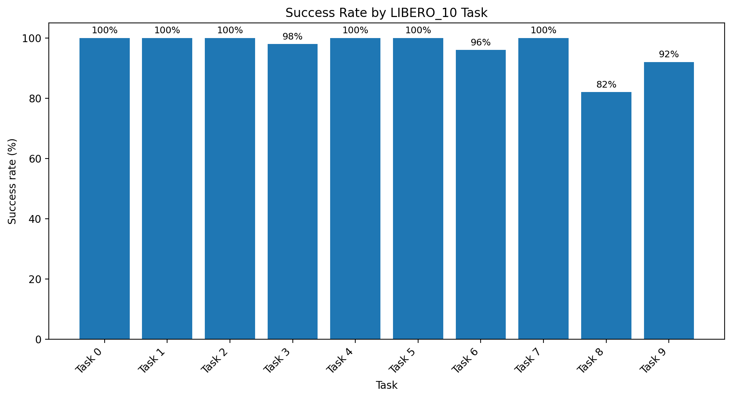
Figure 1. Success rate by task. Task 8 has the lowest success rate at 82%.
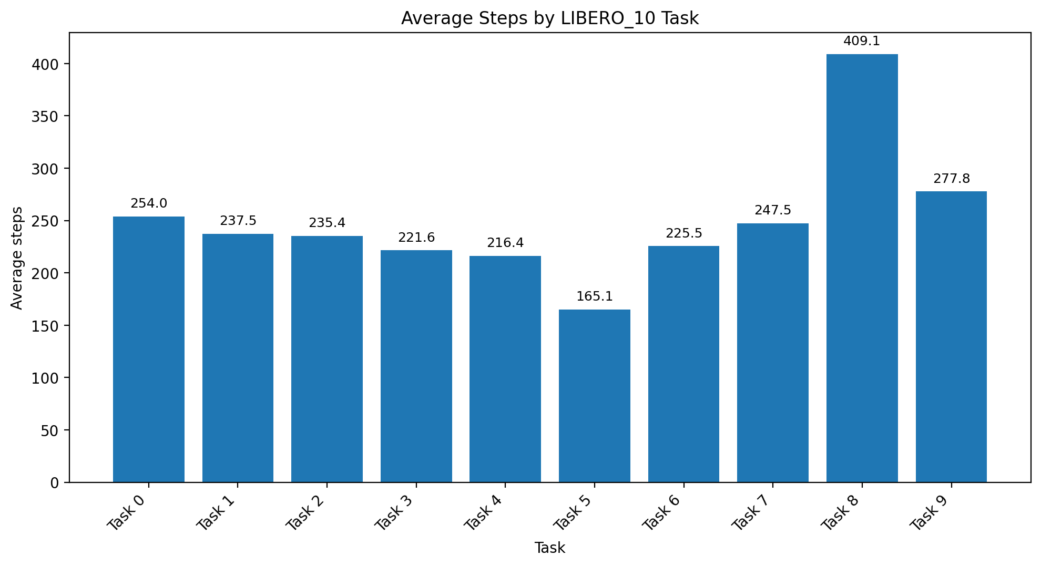
Figure 2. Average steps by task. Task 8 also has the highest average episode length, around 409 steps.
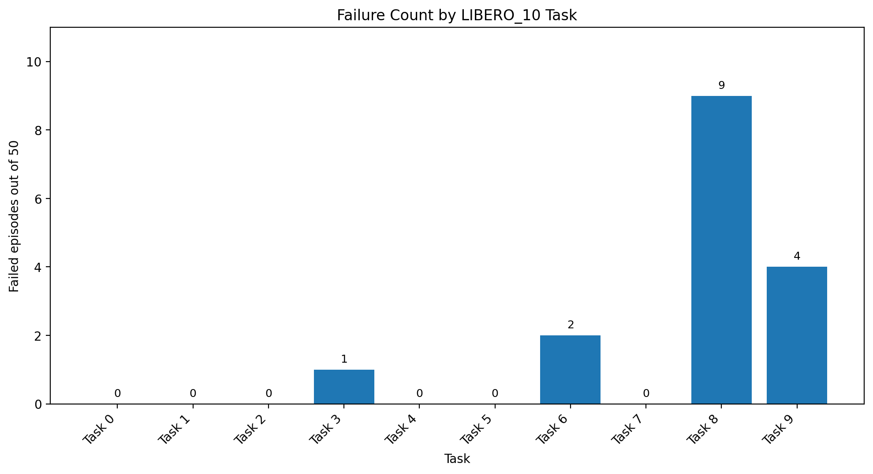
Figure 3. Failure count by task. Task 8 accounts for 9 of the 16 total failures.

5. Failure Analysis
There were 16 failed episodes across four tasks. Every failed episode reached max_steps = 520, so all failures are timeout failures rather than early process crashes. Failure frames were saved for each failed episode, and matching videos were saved in the corresponding videos/failures directories.
Task | Episode | Steps | Instruction | Failure artifact
libero_10_3 | 13 | 520 | put the black bowl in the bottom drawer of the cabinet and close it | outputs\...\mounika_task3_v2_chunk_10_19\libero_10\frames\failures\libero_10_3_ep13_fail.jpg
libero_10_6 | 11 | 520 | put the white mug on the plate and put the chocolate pudding to the right of the plate | outputs\...\mounika_task6_v2_chunk_10_19\libero_10\frames\failures\libero_10_6_ep11_fail.jpg
libero_10_6 | 35 | 520 | put the white mug on the plate and put the chocolate pudding to the right of the plate | outputs\...\mounika_task6_v2_chunk_30_39\libero_10\frames\failures\libero_10_6_ep35_fail.jpg
libero_10_8 | 1 | 520 | put both moka pots on the stove | outputs\...\mounika_task8_v2_chunk_00_09\libero_10\frames\failures\libero_10_8_ep1_fail.jpg
libero_10_8 | 5 | 520 | put both moka pots on the stove | outputs\...\mounika_task8_v2_chunk_00_09\libero_10\frames\failures\libero_10_8_ep5_fail.jpg
libero_10_8 | 9 | 520 | put both moka pots on the stove | outputs\...\mounika_task8_v2_chunk_00_09\libero_10\frames\failures\libero_10_8_ep9_fail.jpg
libero_10_8 | 12 | 520 | put both moka pots on the stove | outputs\...\mounika_task8_v2_chunk_10_19\libero_10\frames\failures\libero_10_8_ep12_fail.jpg
libero_10_8 | 15 | 520 | put both moka pots on the stove | outputs\...\mounika_task8_v2_chunk_10_19\libero_10\frames\failures\libero_10_8_ep15_fail.jpg
libero_10_8 | 24 | 520 | put both moka pots on the stove | outputs\...\mounika_task8_v2_chunk_20_29\libero_10\frames\failures\libero_10_8_ep24_fail.jpg
libero_10_8 | 25 | 520 | put both moka pots on the stove | outputs\...\mounika_task8_v2_chunk_20_29\libero_10\frames\failures\libero_10_8_ep25_fail.jpg
libero_10_8 | 40 | 520 | put both moka pots on the stove | outputs\...\mounika_task8_v2_chunk_40_49\libero_10\frames\failures\libero_10_8_ep40_fail.jpg
libero_10_8 | 42 | 520 | put both moka pots on the stove | outputs\...\mounika_task8_v2_chunk_40_49\libero_10\frames\failures\libero_10_8_ep42_fail.jpg
libero_10_9 | 11 | 520 | put the yellow and white mug in the microwave and close it | outputs\...\mounika_task9_v2_chunk_10_19\libero_10\frames\failures\libero_10_9_ep11_fail.jpg
libero_10_9 | 14 | 520 | put the yellow and white mug in the microwave and close it | outputs\...\mounika_task9_v2_chunk_10_19\libero_10\frames\failures\libero_10_9_ep14_fail.jpg
libero_10_9 | 25 | 520 | put the yellow and white mug in the microwave and close it | outputs\...\mounika_task9_v2_chunk_20_29\libero_10\frames\failures\libero_10_9_ep25_fail.jpg
libero_10_9 | 44 | 520 | put the yellow and white mug in the microwave and close it | outputs\...\mounika_task9_v2_chunk_40_49\libero_10\frames\failures\libero_10_9_ep44_fail.jpg
Table 2. Failure summary. Full paths are available in failure_summary.csv.

5.1 Observations from Failures
- Task 8 accounts for 9/16 failures and is the only task below 90% success.
- Task 9 is the next hardest by success rate, with 4 failures and 92% success.
- Task 6 has 2 failures; task 3 has 1 failure.
- All failures are timeout failures at 520 steps, suggesting incomplete task execution rather than runtime crashes.
- Task 8 also has the highest average steps, indicating higher difficulty even among successful episodes.

6. Subgoal Analysis
A post-processing subgoal_analysis.csv file was created to annotate each instruction with subgoal structure. This is an instruction-level annotation. It does not claim automatic per-subgoal success logging, because the rollout did not record environment-level subgoal completion states.
Exact failed subgoals were then analyzed through manual review of the saved failure videos. The subgoal annotations below should be interpreted as post-hoc manual analysis, not automatic environment-level subgoal logging.
Task | Subgoals | Subgoal structure | Objects / locations | Flags | Success | Failed eps
libero_10_0 | 2: put alphabet soup in basket; put tomato sauce in basket | two-object placement into same receptacle | Objects: alphabet soup; tomato sauce  Locations: basket | multi-object, container | 50/50 (100.0%) | -
libero_10_1 | 2: put cream cheese box in basket; put butter in basket | two-object placement into same receptacle | Objects: cream cheese box; butter  Locations: basket | multi-object, container | 50/50 (100.0%) | -
libero_10_2 | 2: turn on stove; put moka pot on stove | state-change then placement | Objects: moka pot  Locations: stove | turn-on, appliance | 50/50 (100.0%) | -
libero_10_3 | 2: put black bowl in bottom drawer of cabinet; close cabinet/drawer | container placement then close action | Objects: black bowl  Locations: bottom drawer of cabinet | container, open/close, spatial | 49/50 (98.0%) | 13
libero_10_4 | 2: put white mug on left plate; put yellow and white mug on right plate | two-object placement with left/right spatial assignment | Objects: white mug; yellow and white mug  Locations: left plate; right plate | multi-object, spatial | 50/50 (100.0%) | -
libero_10_5 | 1: put book in back compartment of caddy | single-object placement into specified compartment | Objects: book  Locations: back compartment of caddy | container, spatial | 50/50 (100.0%) | -
libero_10_6 | 2: put white mug on plate; put chocolate pudding to the right of plate | two-object placement with relative spatial relation | Objects: white mug; chocolate pudding  Locations: plate; right of plate | multi-object, spatial | 48/50 (96.0%) | 11, 35
libero_10_7 | 2: put alphabet soup in basket; put cream cheese box in basket | two-object placement into same receptacle | Objects: alphabet soup; cream cheese box  Locations: basket | multi-object, container | 50/50 (100.0%) | -
libero_10_8 | 2: put first moka pot on stove; put second moka pot on stove | two similar objects placed on same appliance/location | Objects: two moka pots  Locations: stove | multi-object, appliance | 41/50 (82.0%) | 1, 5, 9, 12, 15, 24, 25, 40, 42
libero_10_9 | 2: put yellow and white mug in microwave; close microwave | appliance/container placement then close action | Objects: yellow and white mug  Locations: microwave | container, open/close, appliance | 46/50 (92.0%) | 11, 14, 25, 44
Table 3. Instruction-level subgoal annotations used for post-hoc analysis.

7. Interpretation and Manual Failure-Video Review
Overall, MolmoAct2 performs strongly on LIBERO_10, achieving 96.8% full-task success across 500 episodes. Six tasks reached 100% success, and two more exceeded 95%. The failures are concentrated in a small number of tasks rather than spread uniformly across the benchmark.
The clearest outlier is Task 8, “put both moka pots on the stove.” It has the lowest success rate (41/50 = 82%), the largest number of failures (9 of the 16 total failures), and the highest average number of steps (about 409). This makes Task 8 the strongest evidence for where the policy struggles.

7.1 Task 8: second-subgoal failure pattern
Manual review of all nine Task 8 failure videos shows a consistent pattern: the policy generally completes the first moka-pot placement, but times out while attempting to place the second moka pot. This suggests that the low Task 8 success rate is mainly driven by repeated difficulty completing a two-object same-target task, not by failure to localize or manipulate the first object.
- Episodes 1, 9, 12, 24, and 40: one moka pot is placed on the stove, while the second moka pot remains on the table at timeout.
- Episodes 5, 15, 25, and 42: one moka pot is placed on the stove, and the second moka pot is contacted, partially moved, or moved near the stove, but the final accepted placement is not completed before timeout.
This points to a later-stage failure mode involving repeated placement of visually similar objects into the same target location. The policy often makes meaningful progress, but does not reliably finish the second object placement within the episode horizon.

7.2 Other failed-task patterns
- Task 3, episode 13: the black bowl placement mostly succeeds, but the final drawer/cabinet close action or accepted closed state fails before timeout.
- Task 6, episodes 11 and 35: the white mug is placed on the plate, but the chocolate pudding is not successfully placed to the right of the plate. This suggests a later spatial-placement failure.
- Task 9, episodes 11, 14, 25, and 44: the mug is moved toward or into the microwave, but the microwave close action or final accepted microwave state is not completed before timeout.

7.3 Overall interpretation
Across the failed episodes, the model usually does not fail immediately. Instead, most failures occur after partial progress. This is important because it suggests that the bottleneck is often completing later subgoals, not understanding the instruction from the beginning.
The failure cases fall into three main categories: repeated same-target object placement (Task 8), relative spatial placement (Task 6), and articulated-object closure or final-state completion (Tasks 3 and 9). These are natural stress points for long-horizon manipulation because the policy must maintain task state, sequence subgoals correctly, and satisfy a precise final condition.
In summary, the evaluation shows strong overall performance, but the remaining errors are concentrated in later subgoals that require sequencing, spatial precision, or closure/final-state completion. Task 8 is the clearest target for deeper analysis because it combines two similar objects, one shared goal location, high average step count, and the largest number of timeouts.

8. Deliverables
The final package contains the following deliverables:
- all_tasks_results_final.csv: full 500-row episode-level result table.
- task_level_summary.csv: per-task success rate, step statistics, and failed episodes.
- failure_summary.csv: all failed episodes with frame and expected video paths.
- subgoal_analysis.csv: instruction-level subgoal and task-structure annotations.
- success_rate_by_task.png, avg_steps_by_task.png, failure_count_by_task.png: plots for report/slides.

9. Conclusion
The completed LIBERO_10 evaluation shows high overall performance from MolmoAct2, with 484 successes out of 500 episodes. The results are cleanly merged and verified. The main remaining weakness is not broad task failure, but difficulty completing later subgoals in a small set of long-horizon tasks, especially Task 8. Manual video review shows that failures usually occur after partial task progress, most often during second-object placement, spatial placement, or final close-action completion.

