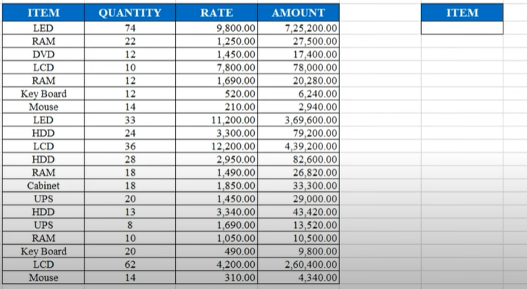

Math Functions:

* **SUM:** Adds a range of numbers.
* **PRODUCT:** Multiplies numbers together.
* **ROUND:** Rounds a number to a specified number of decimal places.
* **ABS:** Returns the absolute value of a number.
* **QUOTIENT:** Returns the integer portion of a division.
* **SQRT:** Returns the square root of a number.
* **MOD:** Returns the remainder of a division.
* **POWER:** Calculates a number raised to a power.
* **RAND:** Returns a random number between 0 and 1.
* **SUMIF:** Adds cells based on a given criteria.
* **SUMIFS:** Adds cells based on multiple criteria.
* **SUMPRODUCT:** Multiplies corresponding array components and then sums the results.
* **SUBTOTAL:** Returns a subtotal in a list or database.

Trigonometric Functions:

* **SIN:** Returns the sine of an angle (in radians).
* **COS:** Returns the cosine of an angle (in radians).
* **TAN:** Returns the tangent of an angle (in radians).
* **ASIN:** Returns the arcsine (inverse sine) of a number.
* **ACOS:** Returns the arccosine (inverse cosine) of a number.
* **ATAN:** Returns the arctangent (inverse tangent) of a number.
* **RADIANS:** Converts degrees to radians.
* **DEGREES:** Converts radians to degrees.