**3. I have a bunch of files in CSV format (with same set of fields) and**

**to aid non-programmers I need to make it easy to access the same. Can you develop a web application which has a drop-down to select one file and one or more fields in the file and extract the information? Write both the front-end code and back-end code.**

# DOCUMENTATION :

1. Install virtualenv for development environment

pip install virtualenv

After Installation, Create “upload_data” folder

mkdir upload_data

cd upload_data

virtualenv venv

venv\scripts\activate

pip install Flask

Output window:

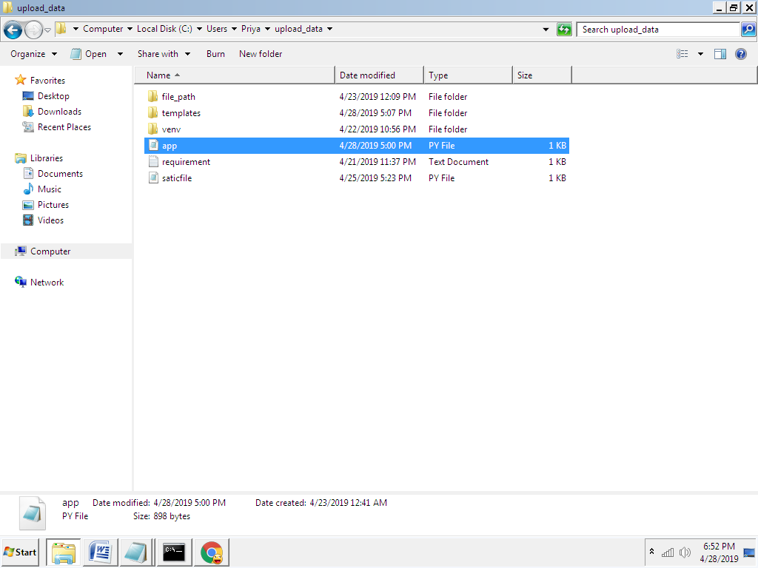

**Folder Introduction:**

* File_path folder :-contains bunch of csv file
* Templates folder :- contains “dropdown.html” html file
* App.py is python program file

**App.py** file :

**This is a flask program file .**

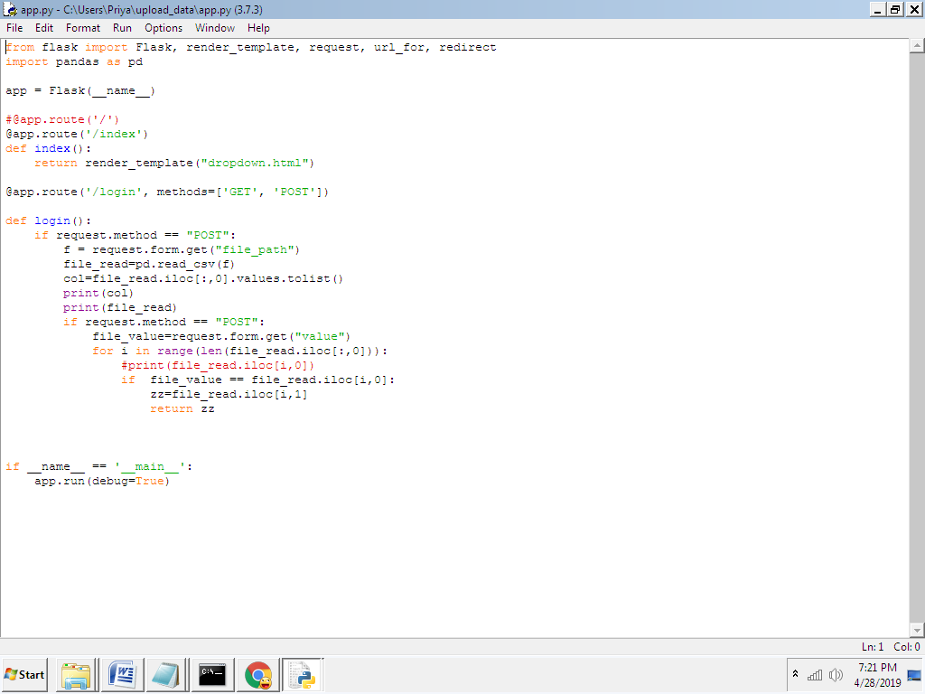

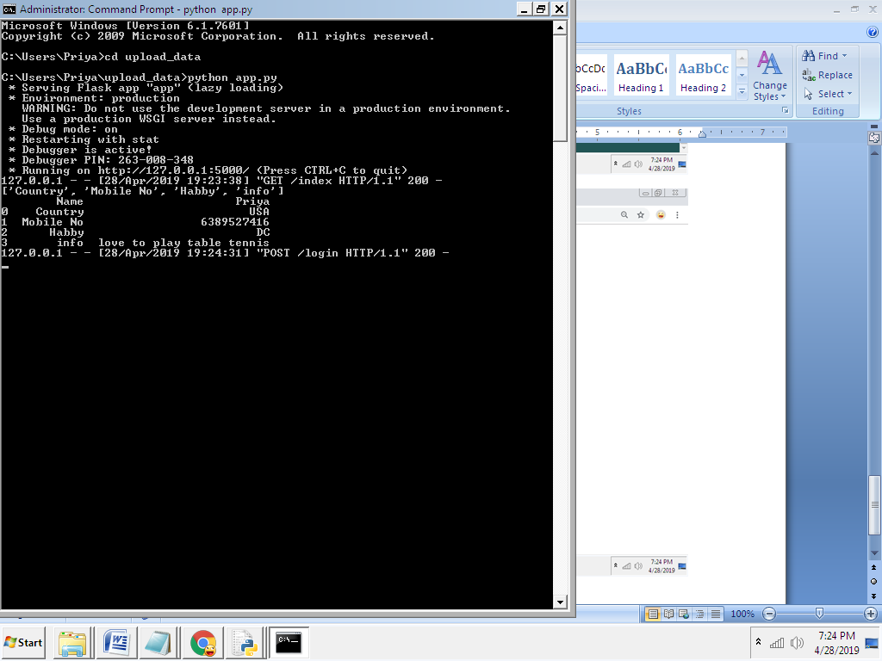

Fig:cmd window to run app.py file

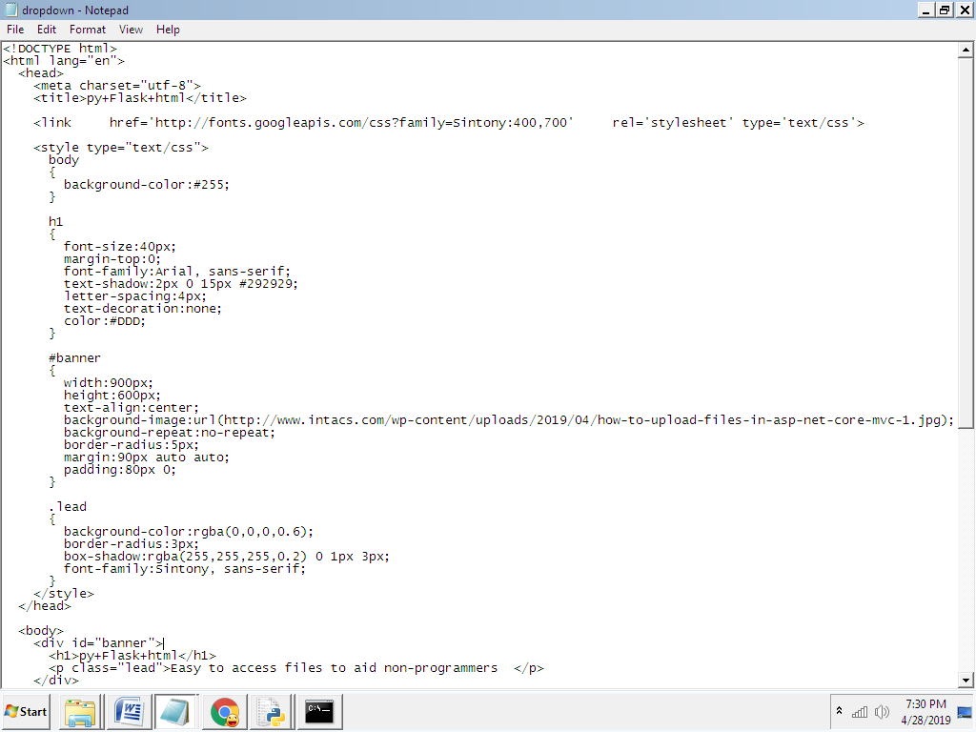

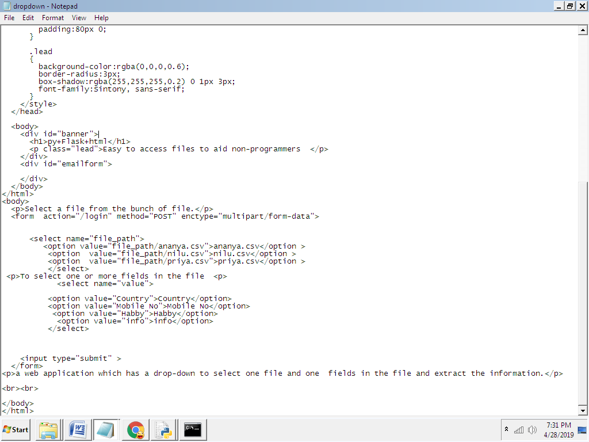

Fig:html code

After running the above code from Python Shell. Visit the URL **http://localhost:5000/index** in the browser. Thus we get following website.

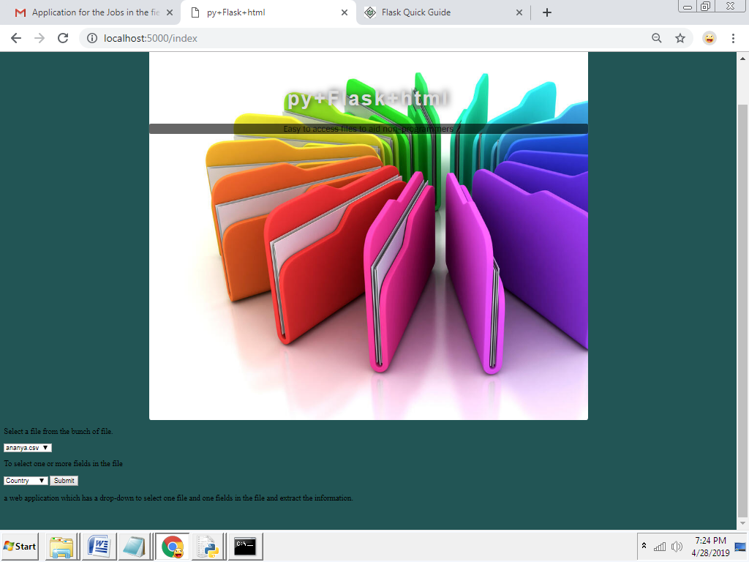

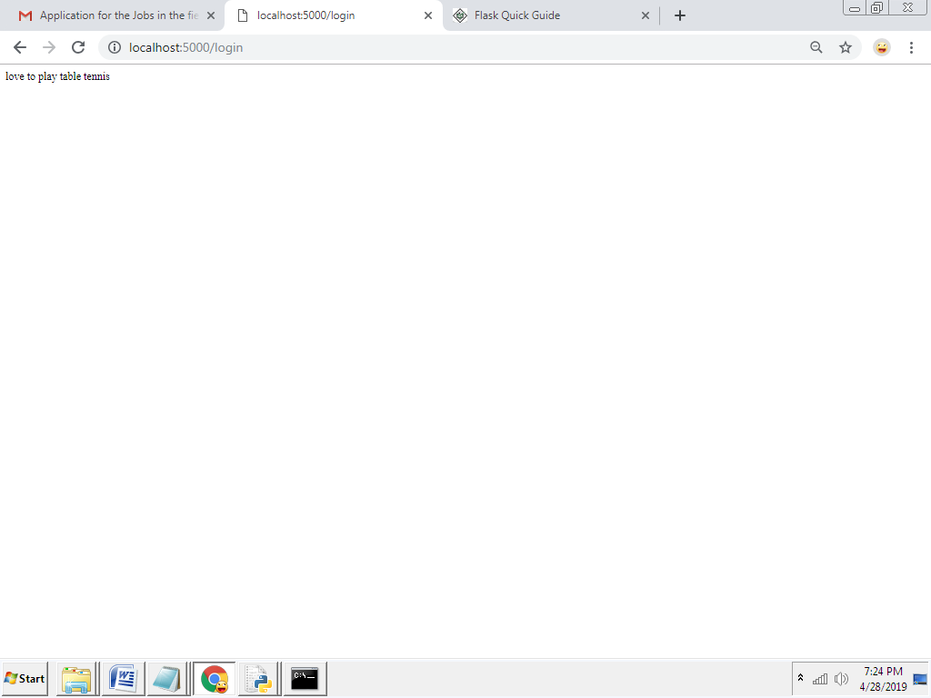

Fig: Final output window