Week 3: Advanced Data Analysis and Visualization in Logistics
Project: Logistics Performance & Delivery Analytics using Python
Organization (hypothetical): FastTrack Logistics Pvt. Ltd.
Prepared by: Priya M Jadhav
Note: All records in this project are simulated for academic and demonstration purposes. They are not real operational data.

1. Executive Summary
This report explores a simulated dataset of 300 logistics shipments to demonstrate how Python-based exploratory data analysis (EDA) can support operational decisions. The average actual delivery time is 3.16 days (median 2.98 days), average transportation cost is ₹2,076.11 per shipment, and 64.7% of shipments meet the promised delivery time. Approximately 35.3% of shipments are late under the defined comparison. The analysis compares transport modes and regions, evaluates distance-cost relationships, and presents seven visualizations. The results are illustrative; real operational decisions should be validated against verified company data.

2. Objectives
- Define and document a hypothetical logistics dataset with shipment, route, mode, delivery, volume, and cost variables.
- Perform data-quality checks and exploratory analysis using pandas and NumPy.
- Calculate central tendency, spread, distributions, and correlations.
- Build visualizations that compare delivery performance, transport costs, geography, and time trends.
- Translate the analysis into practical recommendations for logistics planning.

3. Dataset Design and Data Simulation
The CSV contains 300 simulated shipment records dated from January 2026 onward. Each row represents one shipment. Shipment IDs are unique identifiers; regions represent broad Indian operating regions; transport modes are Road, Rail, Air, and Sea. Delivery times and costs are generated with random variation and mode/distance factors so that the data contains realistic-looking differences for analysis.
Variable | Type | Meaning
shipment_id | Text | Unique simulated shipment key
shipment_date | Date | Shipment date
region | Category | South, North, West, East, Central
transport_mode | Category | Road, Rail, Air, Sea
shipment_type | Category | Standard, Express, Fragile, Bulk
distance_km | Numeric | Route distance in kilometres
shipment_volume_units | Integer | Number of units in shipment
weight_kg | Numeric | Shipment weight in kilograms
promised_delivery_days | Integer | Expected delivery duration
actual_delivery_days | Numeric | Observed simulated delivery duration
transportation_cost_inr | Numeric | Simulated transportation cost in INR
delay_days | Numeric | Positive lateness beyond promise; otherwise zero
on_time | Boolean | True when actual days are no greater than promised days

4. Methodology and Data Quality
The workflow used Python, pandas, NumPy, Matplotlib, and Plotly. The raw CSV was inspected for row/column count, missing values, and duplicate shipment identifiers. Three fields include a small number of intentionally introduced missing values to demonstrate cleaning. Missing numeric weight and cost values were filled with the median; missing region values were filled with the most frequent region. Median imputation is less sensitive to outliers than mean imputation. The cleaned dataset was saved separately so the raw data remains unchanged.
Derived measures: delay_days = max(actual_delivery_days − promised_delivery_days, 0); on_time = actual_delivery_days ≤ promised_delivery_days. The on-time rate is the proportion of records marked on time. Costs are in Indian rupees (INR).

5. Exploratory Data Analysis
Central tendency: mean actual delivery time = 3.16 days; median = 2.98 days. Mean transportation cost = ₹2,076.11 per shipment. The difference between mean and median delivery time can indicate skew; the histogram should be checked for a long tail and unusual high-duration cases.
Performance: 64.7% of shipments are on time and 35.3% have positive delay. The slowest average-delivery region in this simulated sample is North. The mode with the highest average cost is Air. The highest on-time rate by mode is Sea. These are descriptive results for this dataset only.
Relationship analysis: Pearson correlation between distance and transportation cost is 0.702. A positive value indicates that longer routes tend to be associated with higher costs in the simulation, but correlation alone does not prove causation. Transport mode, shipment weight, volume, and route characteristics can also influence cost.
Detailed numeric outputs are saved under outputs/tables: descriptive_statistics.csv, correlation_matrix.csv, transport_mode_summary.csv, and region_summary.csv.

6. Visualizations and Why They Were Chosen

Histogram — delivery time distribution
A histogram reveals the typical delivery-time range, spread, skewness, and possible unusually long deliveries. It helps operations teams decide whether to investigate tail cases rather than relying only on the average.
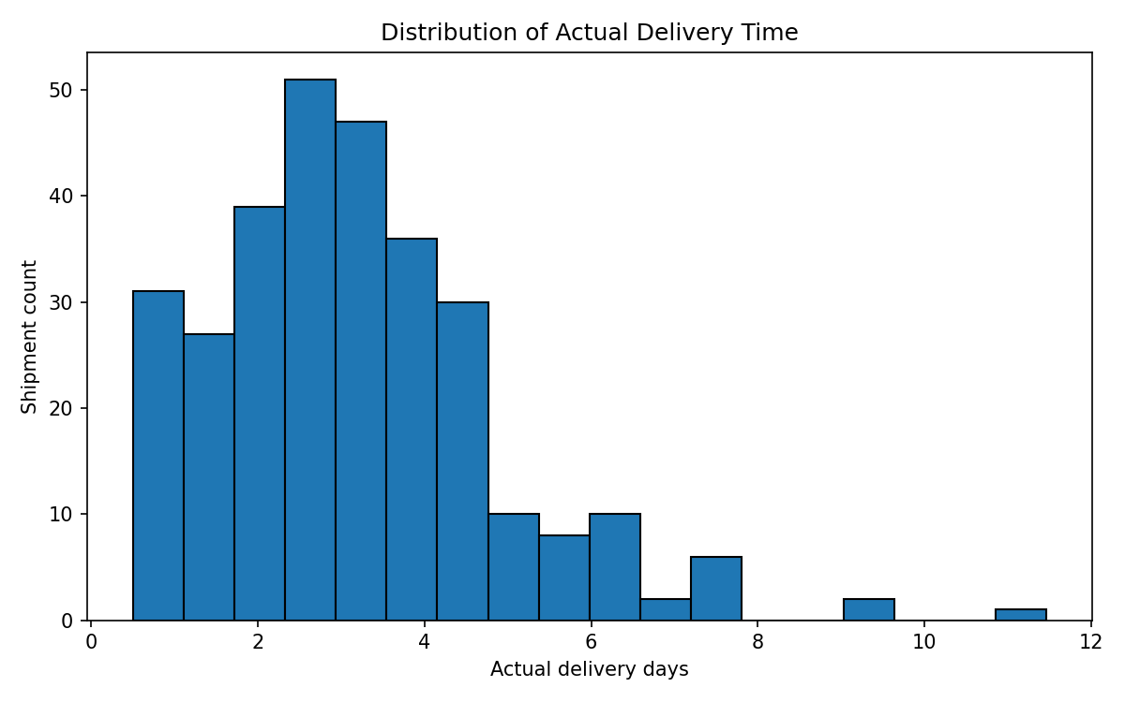

Bar chart — average transportation cost by mode
A bar chart makes the mean cost of Road, Rail, Air, and Sea easy to compare. It helps identify high-cost modes, while route urgency and service-level needs must also be considered.
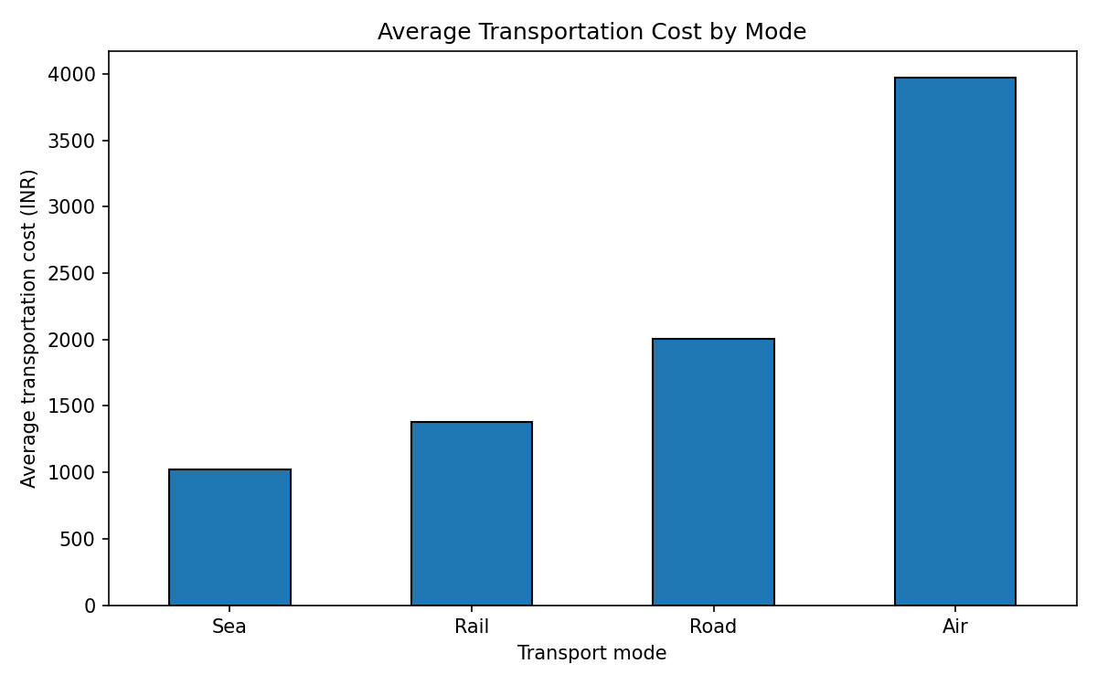

Boxplot — delivery time by region
Boxplots compare medians, variation, and potential outliers across regions. This helps locate regions where delays are inconsistent or delivery times are typically longer.
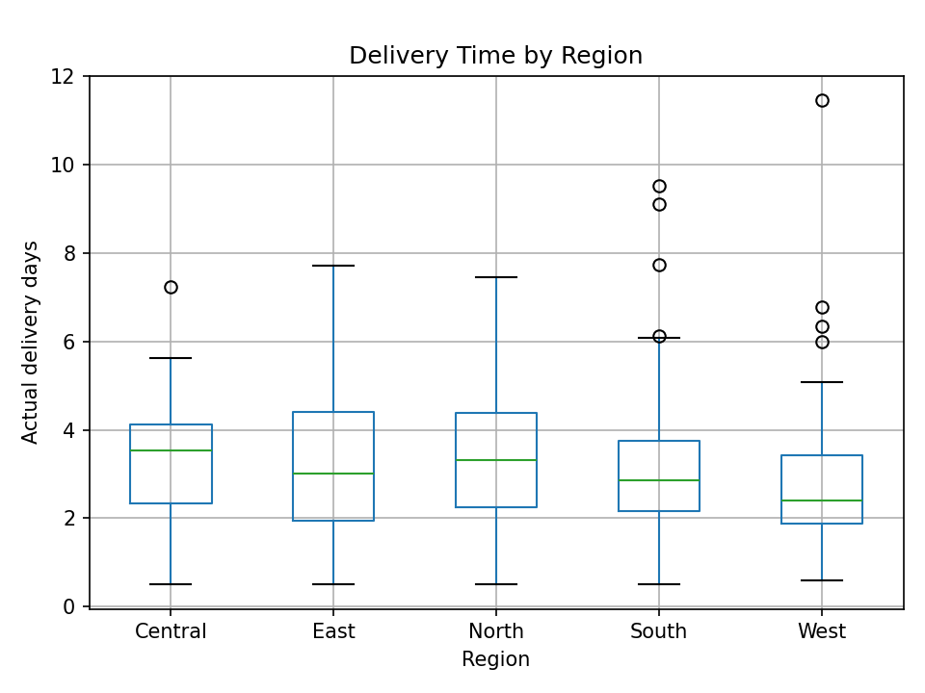

Scatter plot — distance versus cost
A scatter plot reveals the direction and strength of the relationship, possible clusters by mode, and unusual cost observations. Colour separates transport modes.
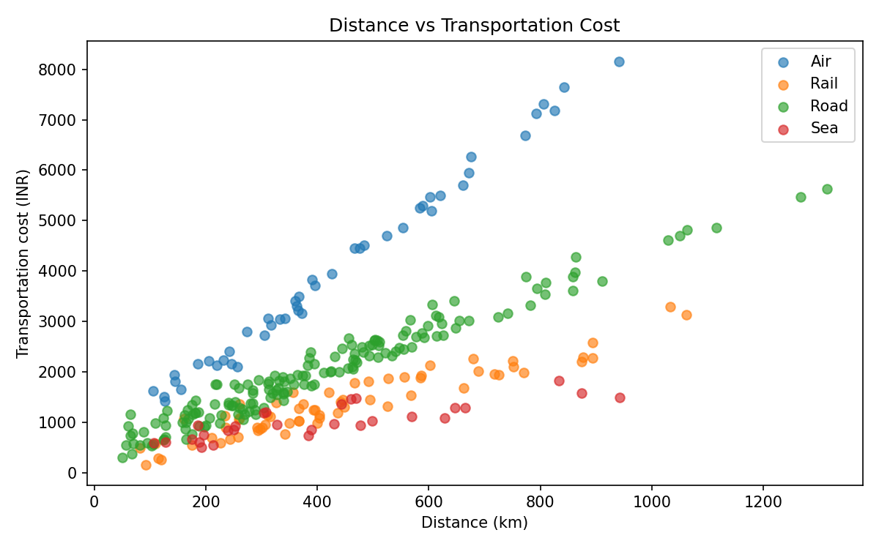

Correlation matrix — numeric variables
The correlation matrix provides a compact overview of linear relationships between distance, weight, volume, delivery time, delay, and cost. It is useful for selecting variables for further investigation.
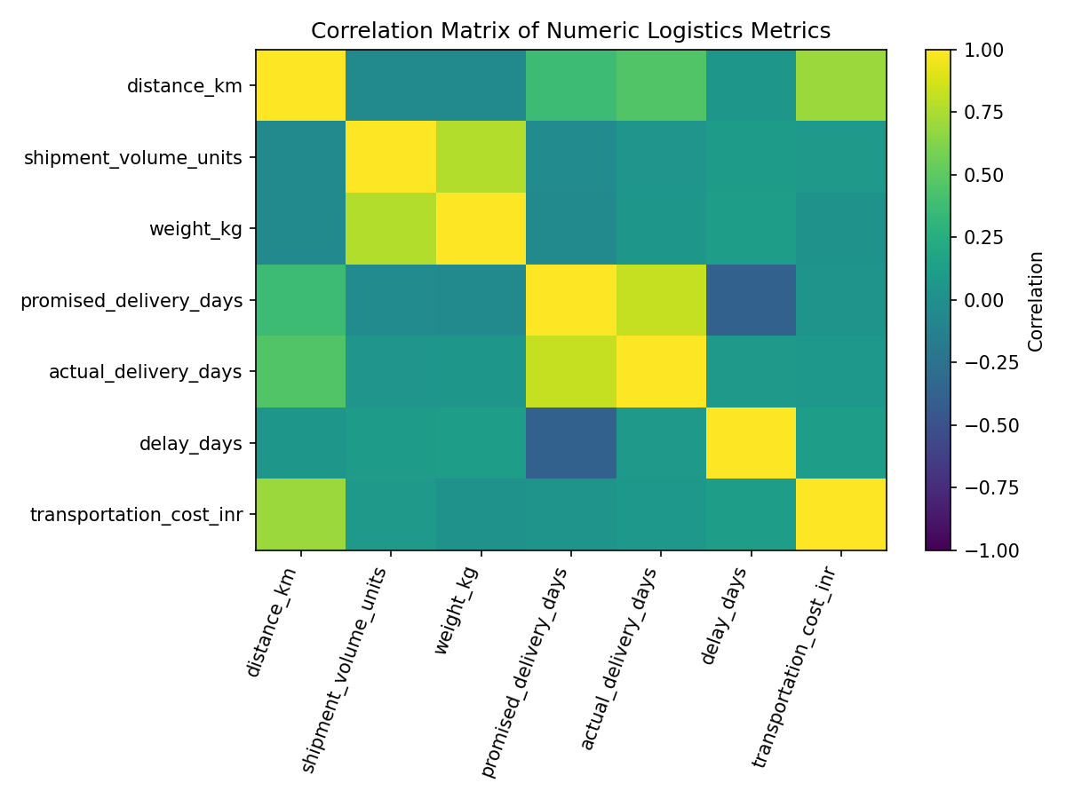

Bar chart — on-time rate by mode
A percentage bar chart compares service reliability between modes. It complements the cost chart because the cheapest mode is not automatically the most reliable.
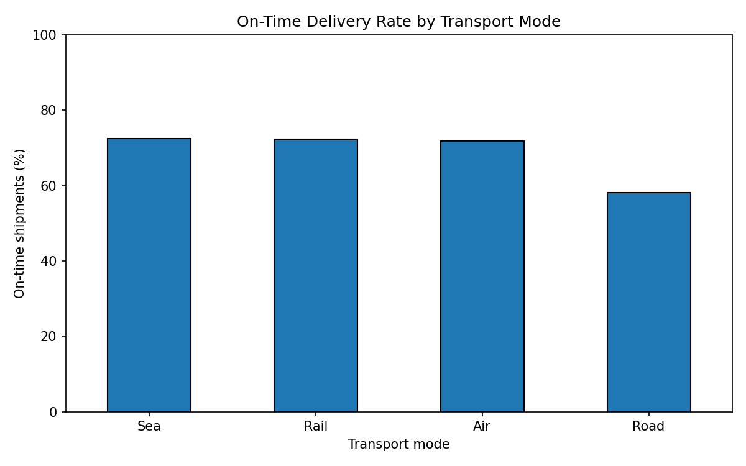

Line chart — seven-day rolling cost trend
A rolling average smooths day-to-day fluctuations and helps reveal broader cost trends. It is a monitoring aid, not a forecast.
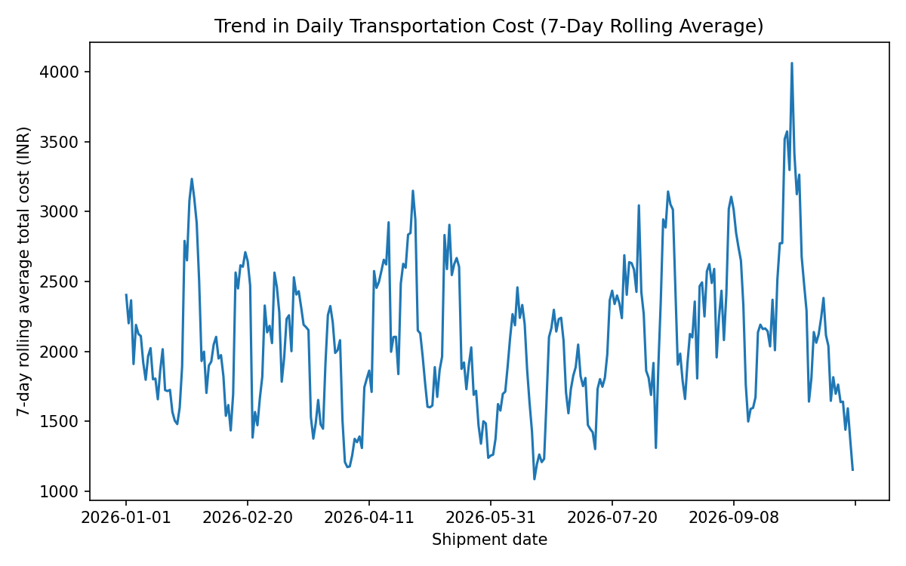

7. Key Insights
- Delivery service: the simulated on-time rate is 64.7%. Review late shipments individually by region, transport mode, distance, and shipment type to determine whether delays cluster around specific operating conditions.
- Cost management: average cost is ₹2,076.11 per shipment. The Air mode has the highest average cost in this sample; compare cost per kilometre and on-time performance before changing mode allocation.
- Regional bottlenecks: North has the highest average delivery time in the generated data. Investigate route distance, handoffs, dispatch schedules, and regional capacity before concluding that the region itself causes delays.
- Distance-cost relationship: correlation is 0.702. Longer routes generally tend to cost more in this simulation. A multivariable model would be needed to isolate distance from mode, weight, and volume.
- Volume and weight: use shipment volume and weight together with cost to identify shipments that may be expensive relative to their load. Consider cost per unit and cost per kilometre for fairer comparisons.
- Data quality: missing values were handled transparently and raw data was retained. In a production setting, record why data is missing and verify imputation choices with logistics stakeholders.

8. Recommendations
- Create a weekly KPI review for on-time delivery, average/median delivery days, delay rate, average cost, and cost per kilometre.
- Investigate late shipments by route, region, transport mode, and shipment type; validate operational causes with dispatch and carrier records.
- Evaluate mode selection using both cost and service reliability. Avoid switching modes based on cost alone where delivery commitments are strict.
- Track shipment cost per unit and per kilometre to compare loads of different sizes and distances more fairly.
- Improve data capture for promised and actual delivery timestamps, weight, route distance, cost, and delay reasons. Add validation rules for missing or impossible values.
- Use a dashboard with filters so managers can inspect trends by region, mode, and shipment type. Recalculate KPIs regularly as new records arrive.

9. Limitations
This dataset is simulated and small. It is not evidence of the performance of any real logistics company. Cost values do not include fuel-price changes, labour, warehousing, tolls, taxes, returns, or contractual discounts as separate fields. No causal conclusions should be drawn from correlations. The dataset covers a limited date window and does not include weather, traffic, service-level agreements, or actual timestamps. Validate all patterns on real data before making business decisions.

10. Reproducibility: Python Tools and Code
The complete script is available at src/analyze_logistics.py. It reads the raw CSV, performs data cleaning, computes descriptive statistics and correlations, and generates chart PNGs under outputs/charts. The interactive Streamlit dashboard is in dashboard.py and uses Plotly for hoverable charts and sidebar filters.
Example EDA code:
import pandas as pd
df = pd.read_csv("data/hypothetical_logistics_dataset.csv")
print(df.shape)
print(df.isna().sum())
print(df[["distance_km", "actual_delivery_days",
"transportation_cost_inr"]].describe())
print(df[["distance_km", "actual_delivery_days",
"transportation_cost_inr"]].corr())

11. Conclusion
This project demonstrates a reproducible logistics analytics workflow: simulate a dataset, assess quality, calculate summary statistics, visualize distributions and relationships, and convert findings into actionable questions and recommendations. The report and dashboard work together: the report documents methodology and interpretation, while the dashboard supports interactive exploration. The most important next step is to validate the same KPIs on real, well-defined operational data.

Appendix: Project Files
- data/hypothetical_logistics_dataset.csv — simulated raw data
- outputs/cleaned_logistics_dataset.csv — cleaned analysis data
- outputs/charts/ — seven visualization images
- outputs/tables/ — statistics and group summaries
- src/analyze_logistics.py — reproducible analysis script
- dashboard.py — interactive Streamlit dashboard
- requirements.txt — Python dependencies
- README.md — setup and run instructions

