Week 4: Predictive Modeling and Optimization in Logistics Systems
Project: Delivery Time Prediction and Logistics Optimization
Prepared by: Priya Jadhav
Dataset note: All records are synthetic and created for educational demonstration, not real company operations.

1. Executive Summary
This project develops a supervised machine-learning workflow to predict shipment delivery duration in days and translate predictions into operational planning recommendations. A synthetic dataset of 650 shipments was generated with route distance, transport mode, region, shipment type, load size, traffic, and weather features. Four models were compared on a held-out test set using MAE, RMSE, and R-squared. The best initial model by test RMSE was Linear Regression; a Random Forest was also tuned using five-fold cross-validation. The tuned model achieved MAE 0.680 days, RMSE 0.845 days, and R² 0.791 on the test split. Results are illustrative and should be validated on real operational data before deployment.

2. Problem Definition
The business problem is to estimate how many days a shipment may take to arrive, using information available at planning time. Earlier estimates can help customer-service teams set realistic delivery expectations, dispatchers identify potentially late shipments, and planners compare service and cost trade-offs. The target variable is actual_delivery_days. This is a regression problem because the target is continuous.

3. Dataset and Features
The dataset contains 650 records and 12 columns. Each row represents one hypothetical shipment. Features include region, transport mode, shipment type, distance in kilometres, shipment volume, weight, traffic level (1–5), and weather condition. The target is actual delivery duration in days. Shipment ID is an identifier and is not used as a predictor. The shipment date is retained for context but excluded from the baseline model. Since the data is simulated, it is suitable for demonstrating the workflow rather than claiming real-world predictive accuracy.
Feature | Data type | Role
region | Categorical | Route/operating region
transport_mode | Categorical | Road, Rail, Air, or Sea
shipment_type | Categorical | Standard, Express, Fragile, Bulk
distance_km | Numeric | Route distance
shipment_volume_units | Numeric | Shipment size in units
weight_kg | Numeric | Shipment weight
traffic_level_1_to_5 | Ordinal numeric | Traffic intensity
weather_condition | Categorical | Clear, Rain, Severe
actual_delivery_days | Numeric | Target to predict

4. Data Preparation
The dataset was checked for missing values and the target was separated from the input features. A scikit-learn Pipeline and ColumnTransformer were used to prevent preprocessing leakage: numeric columns are median-imputed and standardized, while categorical columns are imputed with their most frequent category and one-hot encoded. A fixed random seed and an 80/20 train-test split support reproducibility. The test set is held aside for final performance evaluation.

5. Model Selection and Rationale
Four regression algorithms were compared. Linear Regression provides an interpretable baseline but may miss nonlinear relationships. Decision Tree Regression captures nonlinear rules but can overfit. Random Forest averages many trees and can model interactions more robustly. Gradient Boosting builds sequential trees to reduce residual errors. The model comparison table and RMSE chart are included below. The model with the lowest test RMSE is the best initial candidate by that metric; model selection should also consider MAE, stability, interpretability, and operational cost of prediction errors.

6. Model Evaluation and Validation
MAE (Mean Absolute Error) is the average absolute difference between actual and predicted delivery days and is easy to interpret in days. RMSE (Root Mean Squared Error) penalizes larger errors more heavily. R² describes the proportion of target variation explained by the model relative to a mean-only baseline; it can be negative on poor test predictions. A single held-out 20% test split was used for comparison. Five-fold shuffled cross-validation was applied to the training data for Random Forest MAE, and GridSearchCV tuned tree count, depth, and minimum leaf size. The held-out test set was not used during tuning.

7. Model Comparison Results
Model | MAE (days) | RMSE (days) | R²
Linear Regression | 0.644 | 0.814 | 0.806
Gradient Boosting | 0.670 | 0.842 | 0.792
Random Forest | 0.677 | 0.844 | 0.791
Decision Tree | 0.805 | 1.013 | 0.699
Tuned Random Forest test metrics: MAE = 0.680 days; RMSE = 0.845 days; R² = 0.791. The exact results are also saved in outputs/tables/tuned_model_metrics.csv. These metrics quantify performance on this simulated test split only.

Model Comparison by RMSE
Lower RMSE indicates smaller typical squared prediction error; RMSE is sensitive to occasional large misses.
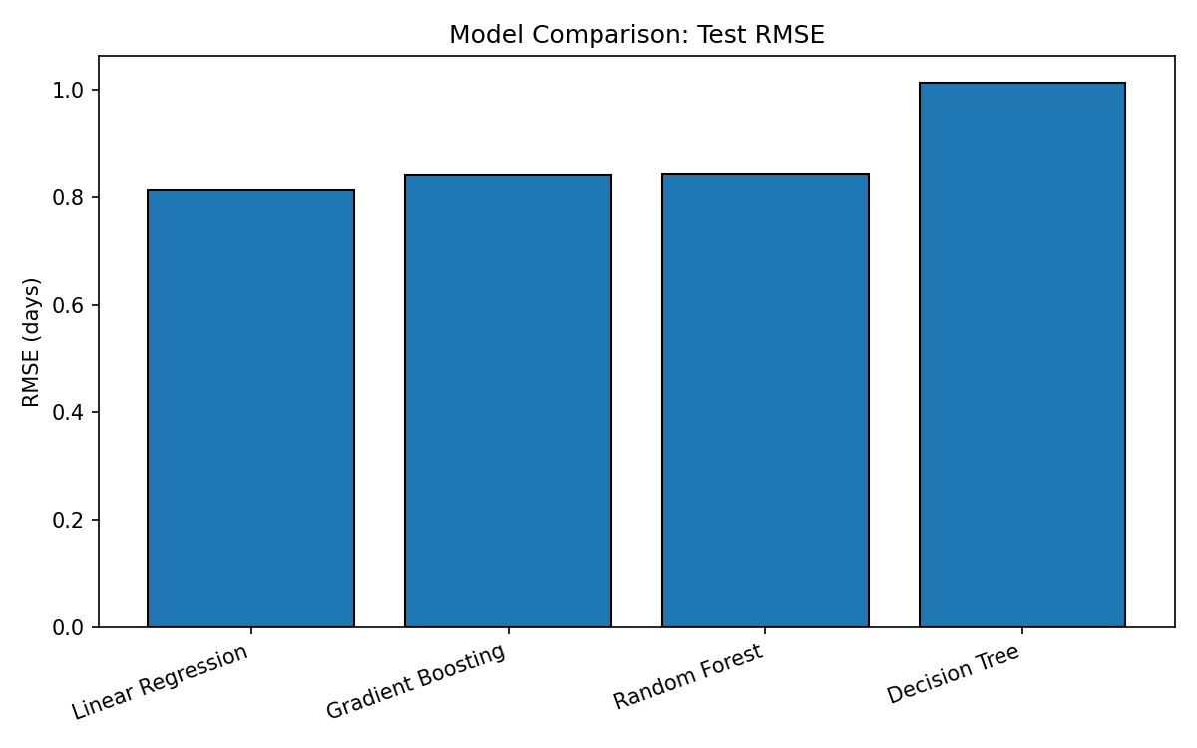

Actual vs Predicted Delivery Time
Points near the diagonal represent accurate predictions. Systematic deviations can indicate bias at short or long delivery times.
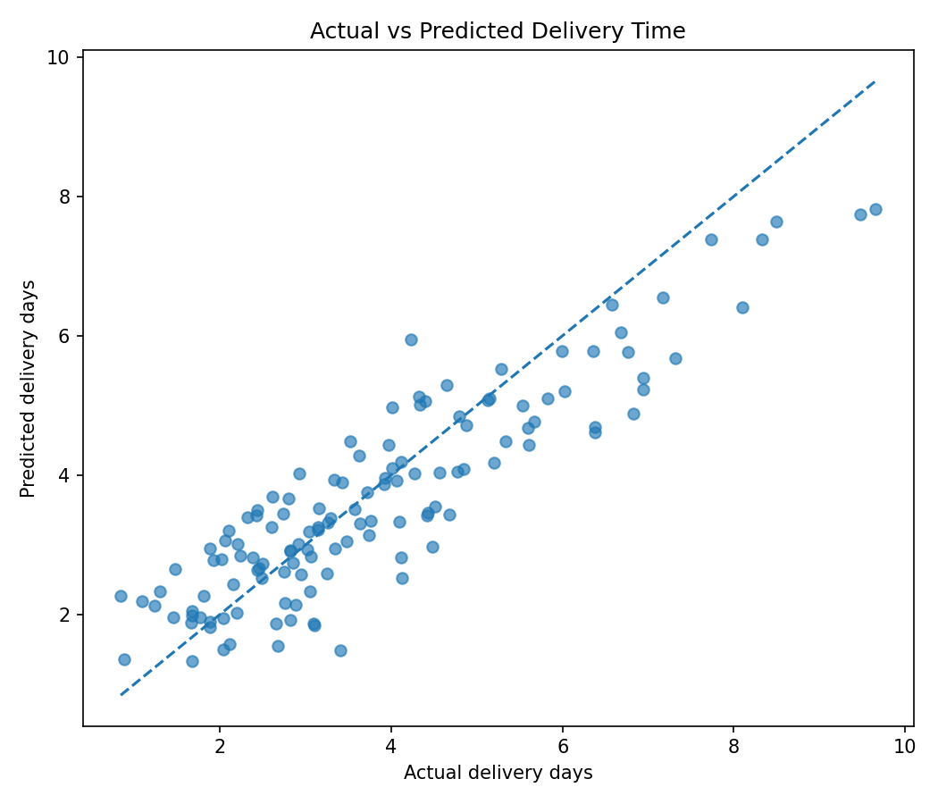

Prediction Error Distribution
Errors centred around zero suggest limited overall bias; a wide distribution indicates uncertainty that should be reflected in delivery buffers.
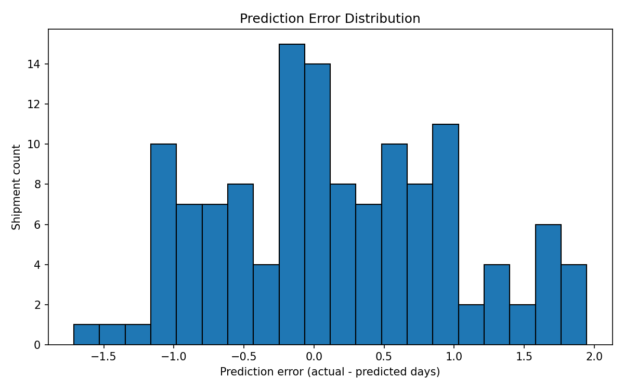

Top Predictors
Random Forest feature importance shows which encoded variables contributed most to tree splits. Importance is associative, not causal, and correlated features can share or distort importance.
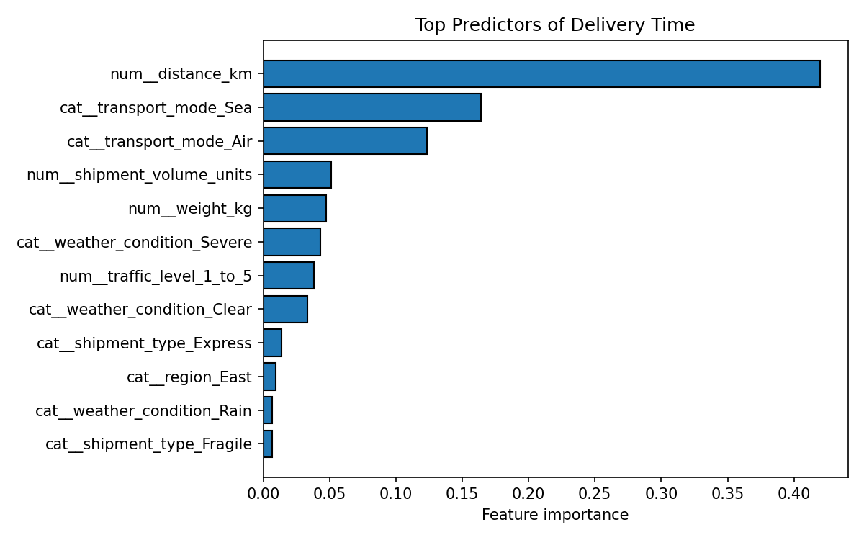

8. Optimization Strategies
- Risk-based shipment monitoring: flag shipments whose predicted delivery time is in the top quartile of the planning set. Review them early for carrier confirmation, customer updates, or contingency planning. A prediction is a risk signal, not a guarantee of lateness.
- Route and mode trade-offs: compare average delivery time and average cost by transport mode using outputs/tables/mode_tradeoff_summary.csv. Test alternate modes only when capacity, service commitments, emissions, and actual route constraints are considered.
- Delivery buffers: use historical prediction-error quantiles to set a conservative buffer for customer-facing ETAs, and recalibrate the buffer by region and mode as more real data becomes available.
- Resource allocation: use predicted high-duration workload by region/day to schedule dispatch capacity and customer-service attention. Validate against operational constraints before reallocating resources.
- Cost optimization: monitor cost per kilometre and cost per unit, then investigate expensive shipments with unusually high predicted duration. Do not minimize cost at the expense of promised service levels.
- Model monitoring: track MAE/RMSE and on-time delivery weekly, inspect drift in traffic/weather/mode patterns, and retrain only after checking data quality and time-based validation.

9. Example Python Workflow
from sklearn.model_selection import train_test_split, GridSearchCV, KFold
from sklearn.ensemble import RandomForestRegressor
from sklearn.pipeline import Pipeline
from sklearn.metrics import mean_absolute_error, mean_squared_error, r2_score
X_train, X_test, y_train, y_test = train_test_split(
X, y, test_size=0.20, random_state=42
)
pipe = Pipeline([
("preprocess", preprocessor),
("model", RandomForestRegressor(random_state=42))
])
pipe.fit(X_train, y_train)
pred = pipe.predict(X_test)
mae = mean_absolute_error(y_test, pred)
rmse = mean_squared_error(y_test, pred) ** 0.5
r2 = r2_score(y_test, pred)
The full executable code is in src/train_model.py. It creates comparison metrics, cross-validation results, a tuned model artifact, test predictions, and the charts.

10. Limitations and Responsible Use
The dataset is synthetic and deliberately generated with simplified relationships. High scores may reflect the simulation rules and should not be interpreted as evidence of real-world performance. Weather and traffic values are assumed to be available at prediction time; in a live system, forecasts or observed values must be timestamped to avoid data leakage. Before deployment, collect real historical data, use time-based validation, evaluate performance by region and transport mode, document model uncertainty, and maintain human oversight.

11. Conclusion
This project demonstrates a complete predictive analytics workflow for logistics: define a regression target, simulate relevant features, preprocess data within a pipeline, compare multiple models, evaluate with MAE/RMSE/R², tune a Random Forest with cross-validation, and translate predictions into operational recommendations. The accompanying dashboard makes the results accessible for scenario exploration. The next step is to validate the approach using real, time-stamped logistics data and constraints before operational use.

Appendix: Deliverables
- data/logistics_predictive_dataset.csv — simulated dataset
- src/train_model.py — training, evaluation, tuning, chart and model export pipeline
- dashboard.py — interactive Streamlit dashboard for predictions and scenario exploration
- outputs/charts/ — four evaluation charts
- outputs/tables/ — model metrics, cross-validation scores, feature importance, predictions, and mode trade-offs
- models/delivery_time_model.joblib — tuned model artifact
- requirements.txt — dependencies
- README.md — setup and run instructions

