Project Design Phase-II
Solution Requirements (Functional & Non-functional)

Date | 29 September 2026
Team ID | SWTID-2026-2843
Project Name | AI-WeatherWise API
Maximum Marks | 4 Marks

Functional Requirements:
Following are the functional requirements of the proposed solution.
FR No. | Functional Requirement (Epic) | Sub Requirement (Story / Sub-Task)
FR-1 | Location Management | Select or search for a location  Capture user location when permitted  Validate location details
FR-2 | Weather Data Retrieval | Retrieve current weather data  Display temperature, humidity and wind speed  Retrieve forecast information from Weather API
FR-3 | AI Weather Prediction | Analyze weather parameters using AI  Generate weather insights and predictions  Identify possible extreme weather conditions
FR-4 | Weather Alerts & Dashboard | Display weather alerts and warnings  Show forecast through a simple dashboard  Provide timely weather notifications

Non-functional Requirements:
Following are the non-functional requirements of the proposed solution.
FR No. | Non-Functional Requirement | Description
NFR-1 | Usability | Provide a simple, clear and responsive interface for viewing weather information.
NFR-2 | Security | Protect user data and API credentials using authentication, authorization and secure HTTPS communication.
NFR-3 | Reliability | Provide accurate weather responses and handle API failures or unavailable data gracefully.
NFR-4 | Performance | Return weather information and AI insights with low response time under normal usage.
NFR-5 | Availability | Keep the WeatherWise service available and accessible whenever weather data is required.
NFR-6 | Scalability | Support increasing users, locations, weather requests and AI processing without major redesign.

Technical Architecture Diagram – AI WeatherWise
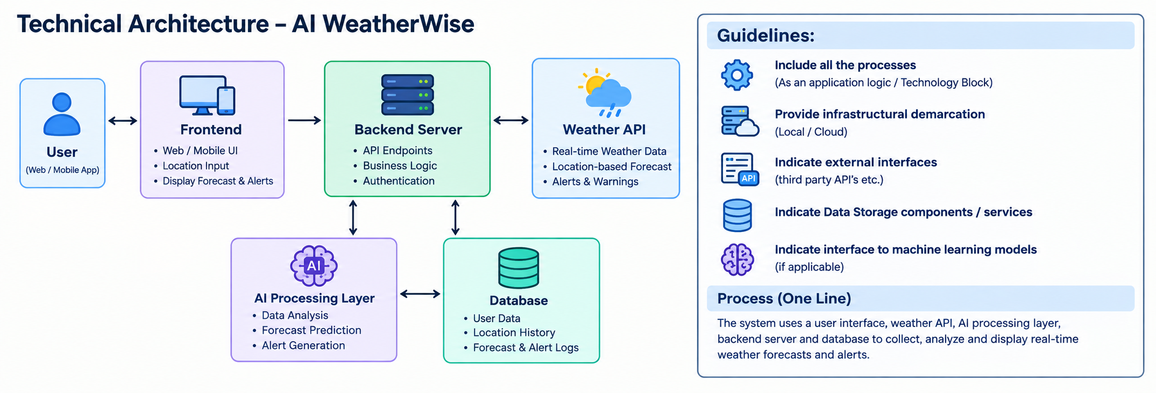
ER Diagram – AI WeatherWise
