library("tm")
library("SnowballC")
library("wordcloud")
library("RColorBrewer")

LOAD:

> filepath <- "retail_transaction_seurvey_data.csv"
> text<-readLines(filepath)
> docs <- Corpus(VectorSource(text))

> docs <- Corpus(VectorSource(text))
> toSpace <-content_transformer(function (x , pattern)gsub(pattern, " ", x))
> docs <- tm_map(docs, toSpace, "/")
> docs <- tm_map(docs, toSpace, "@")
> docs <- tm_map(docs, toSpace, "\\|")

Clean text:

> docs <- tm_map(docs, content_transformer(tolower))
> docs <- tm_map(docs, removeNumbers)
> docs <- tm_map(docs, removeWords,stopwords("english"))
> docs <- tm_map(docs, removeWords, c("blabla1","blabla2"))
> docs <- tm_map(docs, stripWhitespace)
> docs <- tm_map(docs, stemDocument)

> set.seed(1234)
> wordcloud(words = d$word, freq = d$freq,c(8,.3),2,, min.freq = 1, max.words = 200, random.order = FALSE, rot.per = 0.35, colors=brewer.pal(8, "Dark2"))

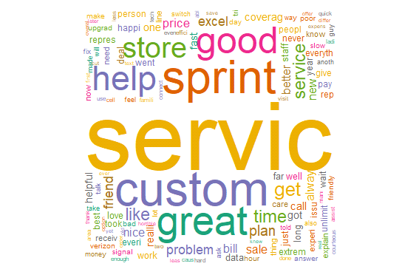

barplot(d[1:10,]$freq, las = 2, names.arg = d[1:10,]$word,
+ col ="orange", main ="Most frequent words",
+ ylab = "Word frequencies")

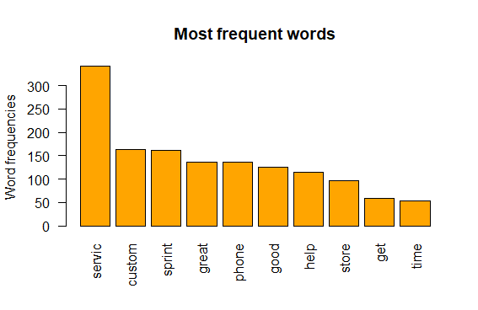

> findFreqTerms(dtm, lowfreq=100)
[1] "servic" "help" "good" "phone" "sprint" "custom" "great"

Only 7 words above occur atleast 100 times.

> dtm <- TermDocumentMatrix(docs)
> m <- as.matrix(dtm)
> v <- sort(rowSums(m),decreasing = TRUE)
> d <- data.frame(word = names(v),freq=v)
> head(d, 10)

word freq
servic servic 341
custom custom 164
sprint sprint 161
great great 137
phone phone 136
good good 125
help help 115
store store 97
get get 58
time time 54

Based on the most frequent occurring words, it looks like this text document is a customer service (word service occurring 341 times and word custom probably stemmed from the word customer occurring 164 times) review ( words great, good and help clearly indicate a kind of review) for sprint(which occurs 161 times). It is also clear from the word “phone” and “store” that it is store review of the phone service.
And the words “great”,” help” and “good” indicate that customer mostly have positive review on the service provided.

