
Online Food Delivery Analysis: Data-Driven Business Insights
Data Analyst Project | Python • SQL • Power BI
PROJECT REPORT

Project Overview
This project analyses online food delivery operations to understand order outcomes, customer behaviour, payment preferences, restaurant performance, delivery efficiency, and financial patterns.
The objective is to convert raw order data into actionable insights that can support operational improvements and better business decisions.
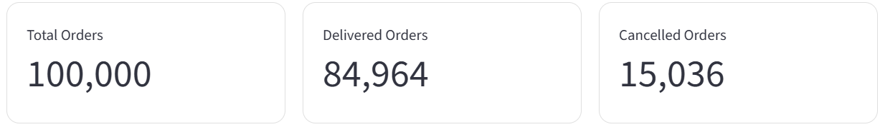

Tools & Technologies

Additional tools used in this project: Pandas, Plotly and Streamlit.
Business Problem
Food delivery platforms need to monitor order performance and identify operational issues.
Key business questions
- What percentage of orders are delivered and cancelled?
- Which cities and cuisines generate the most orders?
- What payment methods do customers prefer?
- How do delivery time and distance relate to performance?
- Which factors may be associated with cancellations?
- What patterns can be observed in order values, discounts, and profit margins?
Project Methodology
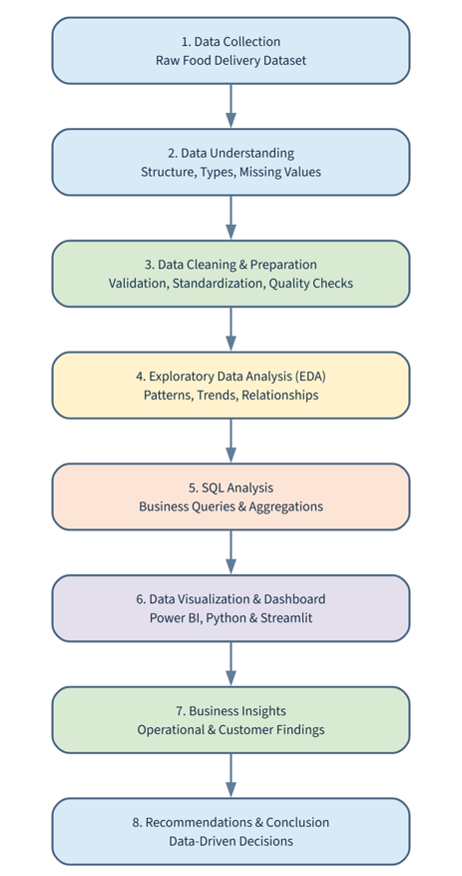
Dataset Description
The dataset contains 100,000 order records and 25 original features. It includes customer, restaurant, order, delivery, payment, and financial information.
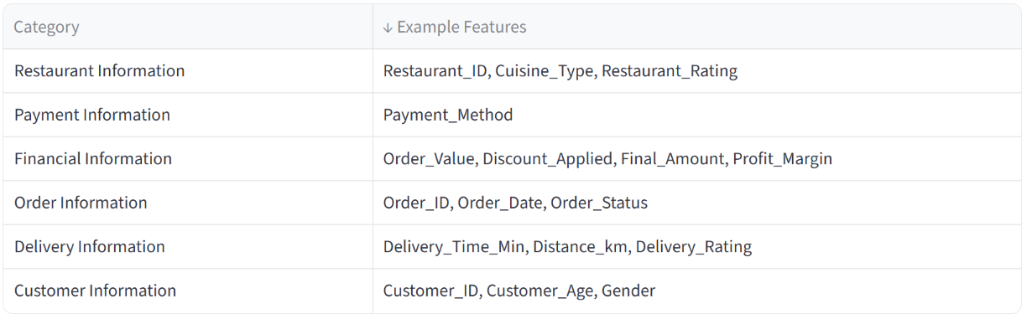
Data Understanding
Data understanding is the initial stage of the data analysis process. It involves examining the dataset structure, identifying data types, understanding feature distributions, and assessing data quality.
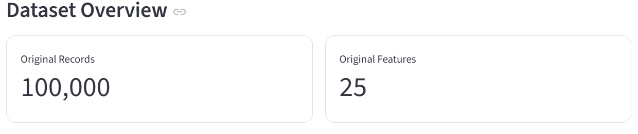
- Loaded the raw CSV dataset using Pandas.
- Reviewed dataset dimensions, column names, and data types.
- Inspected sample records using head() and tail().
- Generated descriptive statistics for numerical columns.
- Examined unique values and frequency distributions for categorical columns.
- Calculated missing-value counts and percentages.
- Checked duplicate records and potential data inconsistencies.
- Reviewed numerical ranges and relationships between important features.

Python Functions Used

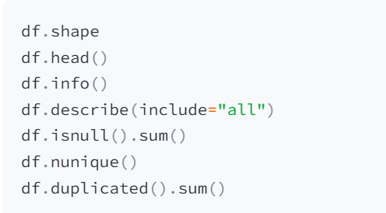

Cleaning & Preparation Steps

The raw dataset was inspected and cleaned to improve data quality, consistency, and suitability for exploratory data analysis and business reporting.

1. Data Loading and Inspection:
- Loaded the raw CSV dataset using Pandas.
- Inspected the number of rows and columns.
- Reviewed column names, data types, and sample records.
- Examined numerical and categorical feature distributions.

2. Missing Value Analysis
- Identified missing values and calculated missing percentages.
- Investigated missing values by order status where relevant.
- Applied suitable handling rules based on each feature's meaning.
- Preserved missing values when a reliable replacement could not be justified.

3. Data Type Standardization
- Converted date fields into appropriate datetime formats.
- Inspected and standardized time-related values.
- Checked numerical columns for invalid or inconsistent values.
- Reviewed categorical columns for inconsistent labels.

4. Order Status and Cancellation Information
- Checked the Delivered and Cancelled order categories.
- Examined cancellation reasons in relation to order status.
- Distinguished missing cancellation information from genuinely applicable values.
- Used explicit labels only when supported by business logic.

5. Customer and Location Data
- Inspected customer demographic fields.
- Reviewed city, area, and other location categories.
- Checked inconsistent or invalid categorical values.
- Avoided unsupported assumptions when handling missing data.

6. Financial Data Validation
- Inspected Order_Value, Discount_Applied, and Final_Amount.
- Compared Final_Amount with Order_Value minus Discount_Applied.
- Identified negative final amounts and other potential anomalies.
- Retained original Profit_Margin values because the source formula was not verified.

7. Duplicate and Consistency Checks
- Checked for duplicate records.
- Reviewed numerical ranges and categorical consistency.
- Investigated suspicious values before deciding how to handle them.
- Avoided deleting records without a valid reason.

8. Final Dataset Preparation
- Reviewed the cleaned dataset's dimensions and data types.
- Rechecked missing values and key business rules.
- Saved the cleaned dataset for downstream analysis.
- Prepared the data for Python analysis, MySQL queries, and dashboard development.

Note: The steps describe the cleaning workflow. Only report an operation as completed if it was actually performed and verified in the cleaning scripts.

Exploratory Data Analysis (EDA)
The Exploratory Data Analysis (EDA) approach was used to identify patterns, trends, relationships, and anomalies in the Online Food Delivery dataset. The analysis was conducted systematically to understand operational performance and support data-driven business decisions.
EDA Workflow
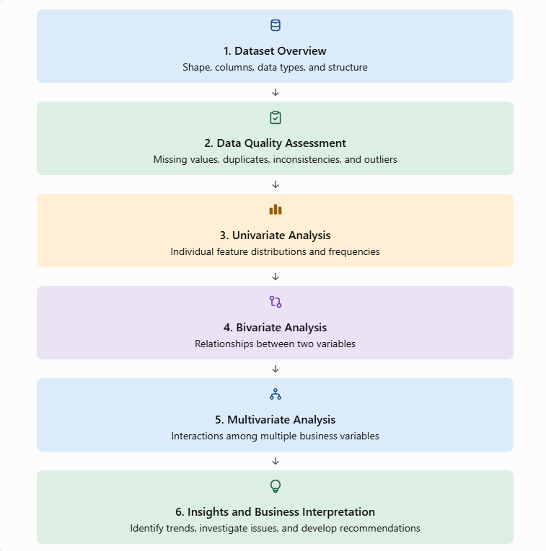
1. Dataset Overview
The Online Food Delivery dataset contains order-level information covering customers, restaurants, delivery operations, payment methods, order outcomes, and financial transactions.
The dataset is used to understand operational performance, customer ordering patterns, delivery efficiency, and business outcomes.
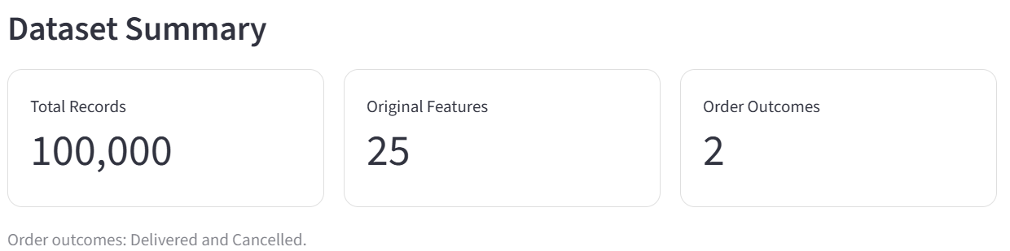
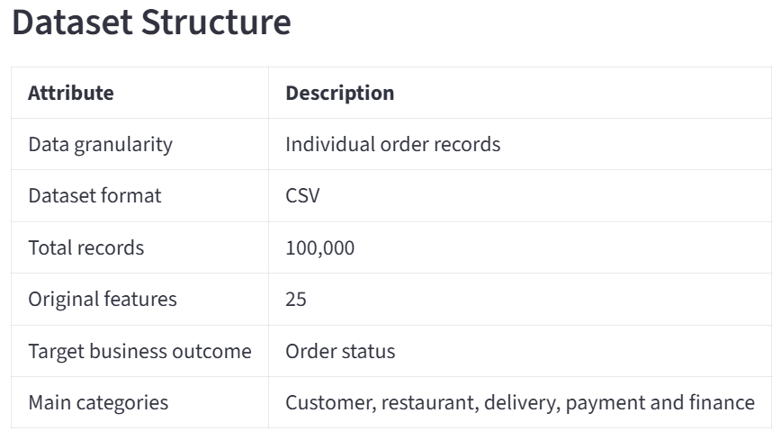

- Analyze delivered and cancelled orders.
- Identify city-wise and cuisine-wise order patterns.
- Evaluate delivery time and delivery distance.
- Study customer payment preferences.
- Investigate missing values and data quality issues.
- Validate order values, discounts and final amounts.
- Prepare reliable data for EDA, SQL and dashboard reporting.
The dataset must be examined for missing values, data type inconsistencies, duplicates, invalid values and business-rule violations before drawing conclusions.

2. Data Quality Assessment
Data quality assessment is the process of evaluating the accuracy, completeness, consistency, validity, and uniqueness of a dataset before performing data analysis.
In this project, the raw food delivery dataset is assessed to identify missing values, duplicate records, incorrect data types, invalid numerical values, and inconsistencies in business-related fields.

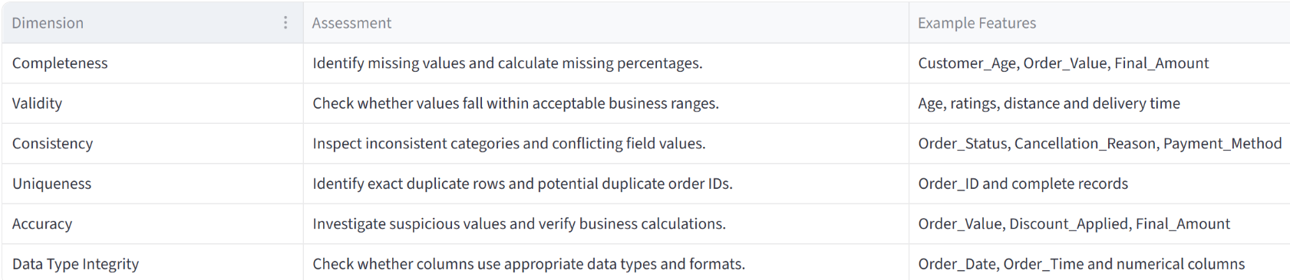

The following checks help establish the quality of the raw dataset:
- Missing values: Determine the number and percentage of null values.
- Duplicate records: Identify repeated rows and investigate duplicate IDs.
- Data types: Verify date, time, numerical and categorical formats.
- Invalid values: Investigate negative amounts and implausible measurements.
- Category consistency: Review unique values and category frequencies.
- Business rules: Check order status, cancellation reasons and financial relationships.


The assessment provides a baseline for deciding which cleaning techniques are appropriate for each feature. Findings should be investigated before replacing missing values, correcting anomalies, or removing records.
3. Univariate Analysis
Univariate analysis examines one variable at a time to understand its distribution, frequency, central tendency, variability, and potential anomalies.
In this project, numerical and categorical features of the Online Food Delivery dataset are analysed independently to understand customer characteristics, order patterns, delivery performance, and financial information.
- Understand individual feature distributions.
- Summarize numerical features using descriptive statistics.
- Identify the most frequent categorical values.
- Detect potential outliers and unusual observations.
- Examine missing values and unique categories.
- Prepare features for bivariate and multivariate analysis.
Numerical variables are examined using descriptive statistics, histograms, and box plots to understand their distributions, spread, and potential outliers.
Features considered
Customer_Age, Delivery_Time_Min, Distance_km, Order_Value, Discount_Applied, Final_Amount, Restaurant_Rating, Delivery_Rating, Profit_Margin
Statistical techniques
- Mean and median: central tendency.
- Standard deviation: variability.
- Minimum, maximum and quartiles: distribution range.
- Skewness: distribution asymmetry.
- Histograms: frequency distribution.
- Box plots: spread and potential outliers.
Variable-by-Variable Analysis
Customer Age (Customer_Age)
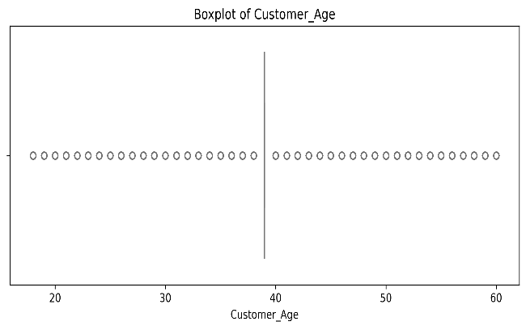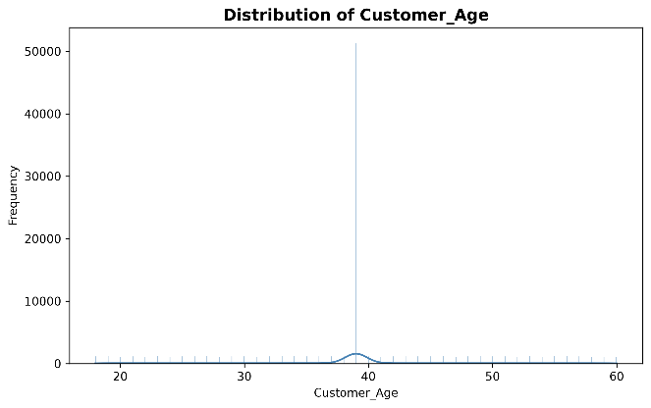
Box Plot Analysis
The box plot shows a median age of approximately 39 years. The box appears collapsed or unusually narrow, while individual points extend across the age range of 18–60 years. This pattern may occur when a large proportion of observations share the same value, reducing the interquartile range.
Distribution Plot Analysis
The distribution plot shows a prominent spike at age 39, with more than 50,000 observations reported at this value. Outside this spike, ages are distributed across the 18–60 range, with relatively sparse observations at other ages.
Data Quality Interpretation
The concentration at age 39 may indicate that missing age values were replaced using median imputation. However, a high frequency at 39 does not prove that these records were imputed. Genuine observations and imputed values cannot be distinguished from the cleaned column alone.
Recommended Action
Compare the raw and cleaned datasets, check the original missing-age count, and verify the imputation procedure. If the values were imputed, document the limitation when interpreting customer demographics.
Delivery Distance (Distance_km)
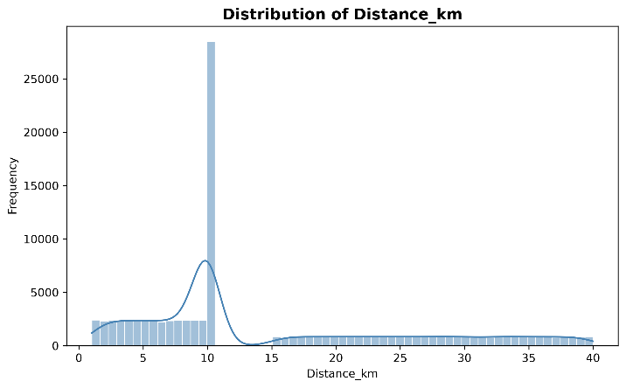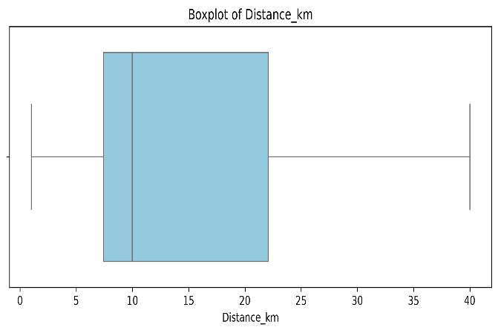

Box Plot Analysis
The median delivery distance is approximately 10 km. The interquartile range extends from around 7 km (Q1) to 22 km (Q3), with whiskers extending approximately from 1 km to 40 km.
Distribution Plot Analysis
The distribution contains a pronounced spike at 10 km, reportedly exceeding 28,000 observations. Distances below 10 km appear broadly distributed between 1 km and 10 km, while larger distances extend toward 40 km.
Data Quality Interpretation
The large concentration at exactly 10 km may reflect a default value, distance rounding, a fixed-distance assumption, or a genuine concentration of orders. It may also indicate synthetic data generation.
Recommended Action
Check the raw distance values and determine whether the distance was calculated from actual coordinates or entered using a predefined value. Validate extreme distances and confirm that the recorded distances are realistic before using them for delivery-efficiency analysis or predictive modelling.

Order Value (Order_Value)

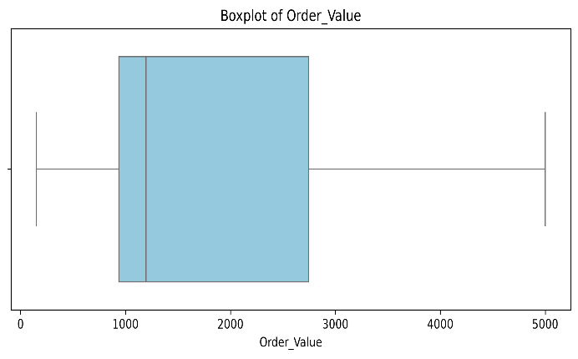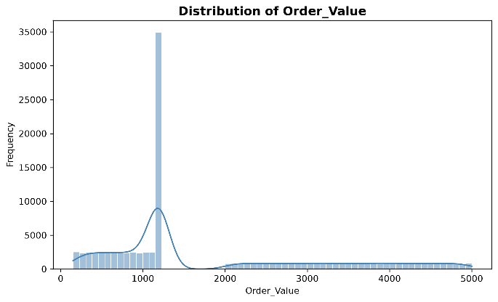

Box Plot Analysis
The median order value is approximately ₹1,200. The middle 50% of observations range from approximately ₹950 (Q1) to ₹2,800 (Q3), with values extending from around ₹150 to ₹5,000.
Distribution Plot Analysis
A pronounced spike appears around ₹1,200, with nearly 35,000 observations reported at this level. Lower values are spread across approximately ₹150–₹1,100, while higher values extend toward ₹5,000.
Data Quality Interpretation
The spike may represent a common order-value tier, a default value used during data generation, or an imputation artifact. A high-frequency value should not automatically be treated as incorrect.
Recommended Action
Compare the raw dataset with the cleaned dataset to determine whether the ₹1,200 concentration existed originally. Validate the minimum and maximum values, check for unexpected duplicates or default entries, and confirm that order values are consistent with the business context.

Final Amount (Final_Amount)

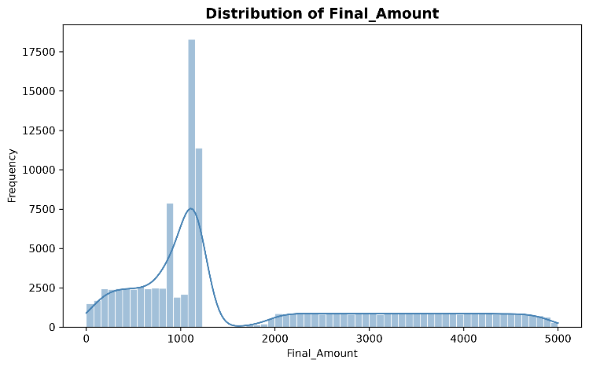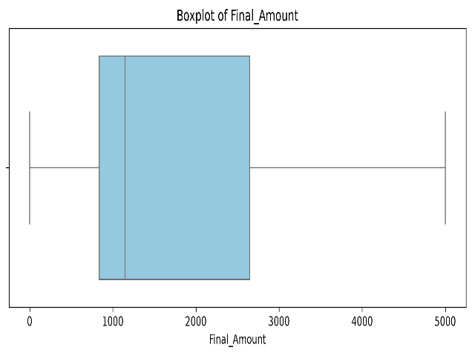

Box Plot Analysis
The median final amount is approximately ₹1,200. The interquartile range extends from approximately ₹850 (Q1) to ₹2,650 (Q3), with values ranging from near ₹0 to ₹5,000.
Distribution Plot Analysis
The distribution shows prominent peaks around ₹1,100 and ₹1,200, with reported frequencies between approximately 11,000 and 18,000. A smaller peak appears around ₹900. Other values are spread across the lower and upper ranges.
Data Quality Interpretation
The peaks may reflect common order values after discounts are applied. However, the distribution alone cannot establish whether the values result from discount calculations, imputation, or synthetic data patterns.
Recommended Action
Validate Final_Amount against Order_Value and Discount_Applied. Where the business rule is that the final amount equals the order value minus the discount, check that the relationship holds and investigate negative final amounts or other inconsistent records.

Discount Applied (Discount_Applied)

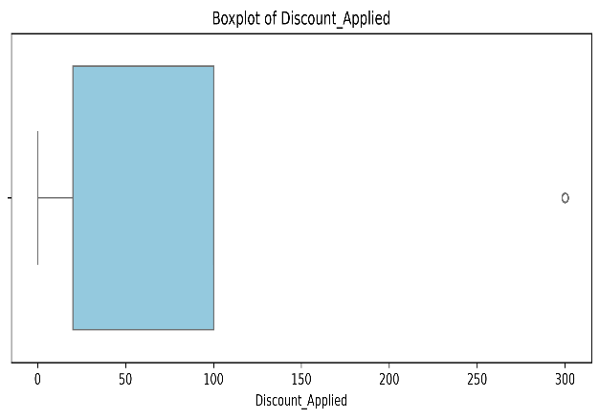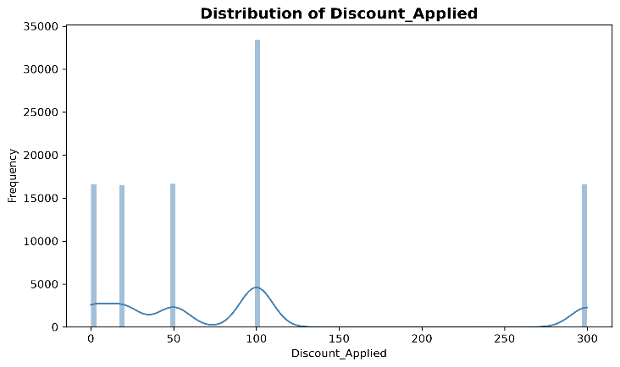
Box Plot Analysis
The first quartile is approximately ₹20, while the third quartile is approximately ₹100. The box plot identifies ₹300 as a potential high-value outlier.
Distribution Plot Analysis
The variable contains distinct discount tiers of ₹0, ₹20, ₹50, ₹100, and ₹300. The ₹100 discount has the highest reported frequency, exceeding 33,000 observations, while the other tiers each have approximately 16,500 observations.
Data Quality Interpretation
The discrete values suggest a predefined discount structure rather than a continuous numerical distribution. The ₹300 discount may be a legitimate promotional tier even though it is flagged as an outlier.
Recommended Action
Validate the allowed discount tiers and confirm whether the ₹300 discount is permitted. Treat the variable as a discrete feature; when appropriate, model it as a categorical variable or use its numerical meaning while preserving the fixed tiers. Check whether any discount exceeds the corresponding order value.

Delivery Time (Delivery_Time_Min)

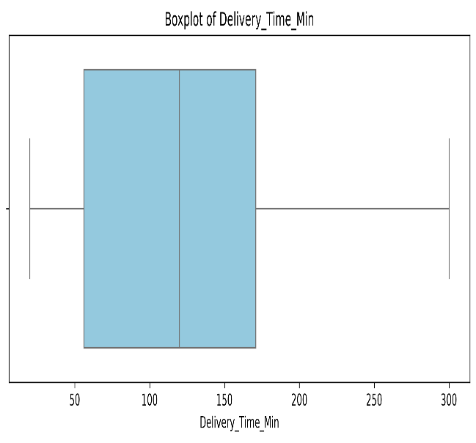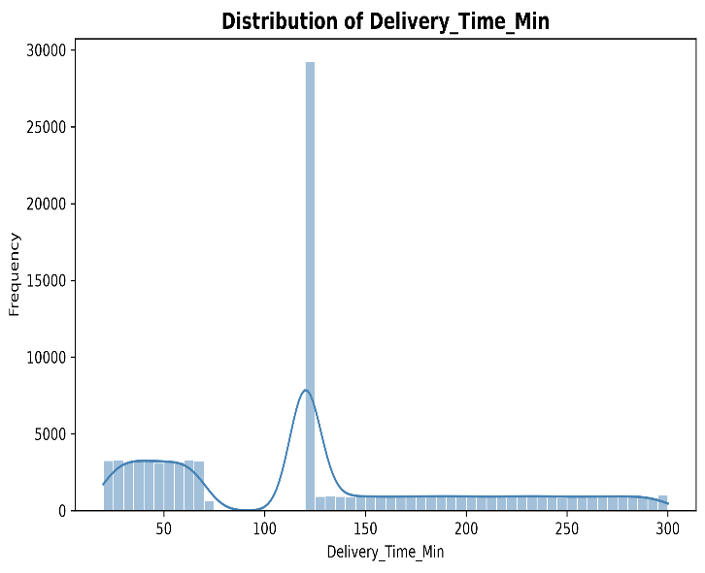
Box Plot Analysis
The median delivery time is approximately 120 minutes. The interquartile range extends from around 55 minutes (Q1) to 170 minutes (Q3), with the overall range extending toward 300 minutes.
Distribution Plot Analysis
The distribution contains a sharp spike at 120 minutes, with nearly 30,000 observations reported at this value. Other observations appear across shorter delivery times of approximately 20–70 minutes and longer delivery times extending from 130 to 300 minutes.
Data Quality Interpretation
The spike at 120 minutes may indicate a default placeholder used when delivery tracking data is unavailable. Alternatively, it may reflect a concentration of orders recorded at that duration. The distribution alone cannot confirm which explanation is correct.
Recommended Action
Compare the raw and cleaned data and investigate the original source of the 120-minute values. Validate unusually long delivery times against operational rules and determine whether they represent genuine delays, missing tracking information, or recording errors. Preserve verified long deliveries because they may be important for operational analysis.

Restaurant Rating (Restaurant_Rating)

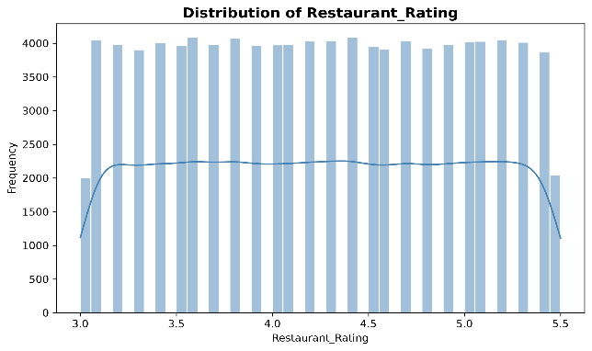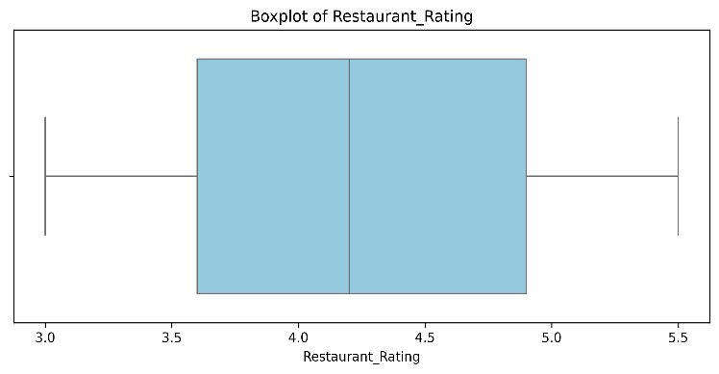

Box Plot Analysis
The median restaurant rating is approximately 4.2. The interquartile range extends from 3.6 (Q1) to 4.9 (Q3), while the reported overall range extends from 3.0 to 5.5.
Distribution Plot Analysis
The distribution appears approximately uniform across the reported range, with relatively similar frequencies across the bins.
Data Quality Interpretation
A uniform distribution may reflect synthetic data generation, rounding, or the way the data was sampled. More importantly, ratings above 5.0 are outside the conventional five-point rating scale and require validation.
Recommended Action
Check the original rating scale and the data source. If restaurant ratings are intended to be restricted to 1–5, investigate values above 5 and correct them only when the original value can be established. Do not cap or replace invalid values without documenting the chosen rule.

Delivery Rating (Delivery_Rating)

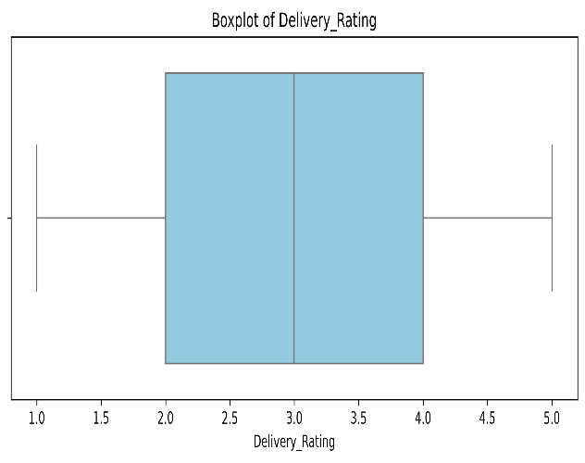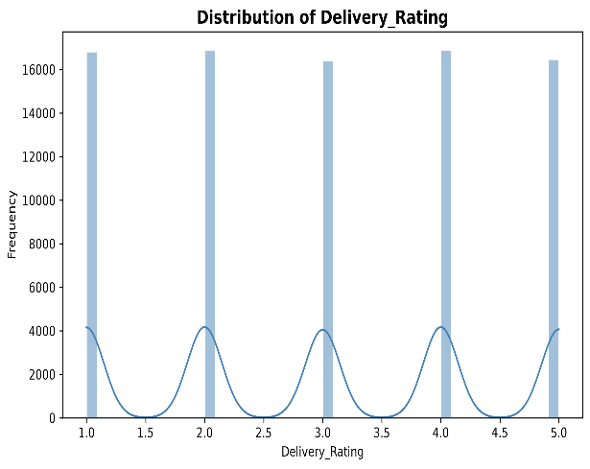
Box Plot Analysis
The median delivery rating is 3.0. The interquartile range extends from 2.0 (Q1) to 4.0 (Q3), and the reported rating range is 1–5.
Distribution Plot Analysis
The distribution contains discrete integer ratings of 1, 2, 3, 4, and 5, with approximately 16,500–17,000 observations at each level.
Data Quality Interpretation
The values are consistent with a five-point rating scale. However, the nearly equal frequencies across all five categories may suggest synthetic data generation or deliberate balancing rather than naturally occurring customer feedback.
Recommended Action
Validate the rating values and compare their frequencies with the original source. Treat delivery ratings as an ordinal feature when the order of the rating levels is meaningful. Consider whether the observed distribution reflects genuine customer satisfaction before drawing business conclusions.

Profit Margin (Profit_Margin)
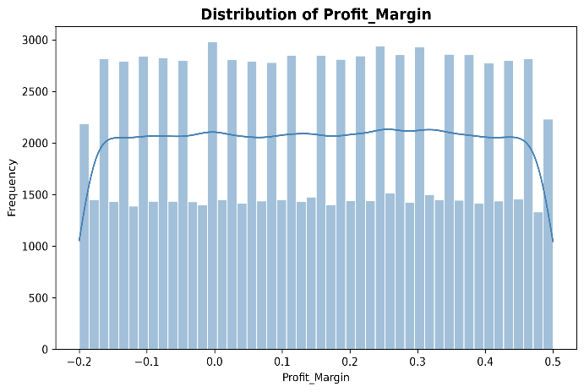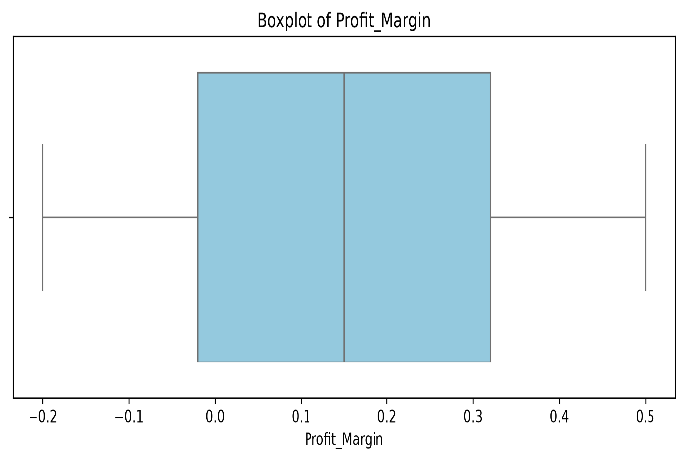
Box Plot Analysis
The median profit margin is approximately 0.15, or 15%. The interquartile range extends from approximately −0.02 (−2%) to 0.32 (32%), while the overall range is reported as −0.20 (−20%) to 0.50 (50%).
Distribution Plot Analysis
The distribution appears approximately uniform across the range of −20% to 50%, with observations spread across negative and positive margins.
Business Interpretation
Negative profit margins indicate potentially unprofitable transactions, while positive margins indicate profitable transactions under the dataset's definition of profit margin. However, a uniform distribution may not reflect the actual distribution of profitability in a real delivery business.
Recommended Action
Validate the profit-margin calculation and confirm the definition of revenue and cost used. Analyze negative-margin orders by discount, order value, delivery distance, delivery time, and order status to identify potential loss drivers. Do not conclude that a specific percentage of orders is unprofitable without calculating it directly from the data.
Conclusion
The univariate analysis reveals unusual concentrations, potential data-quality concerns, and important operational patterns across customer demographics, delivery distances, order values, discounts, ratings, delivery times, and profit margins.
Categorical Bar Chart Analysis
Executive Overview
The dataset contains 100,000 orders, with approximately 85% delivered and 15% cancelled. Many categorical features show nearly uniform distributions, which may indicate synthetic data generation or balanced sampling. Several features also contain substantial Unknown or Missing values.
Feature-Wise Insights
Order Status (Order_Status)
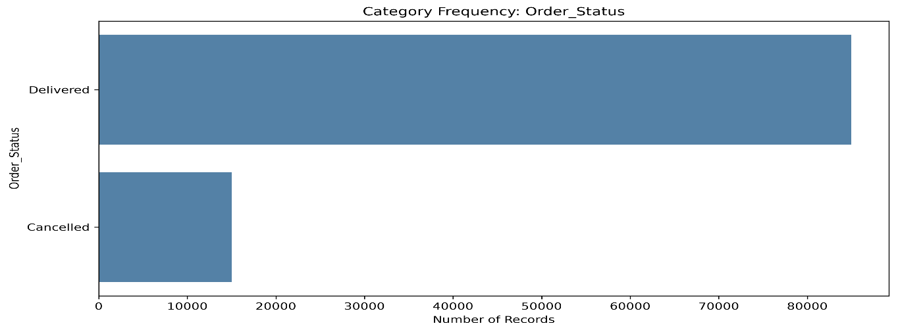
Approximately 85,000 orders (85%) were delivered, while 15,000 (15%) were cancelled.
Cancellation Reason (Cancellation_Reason)
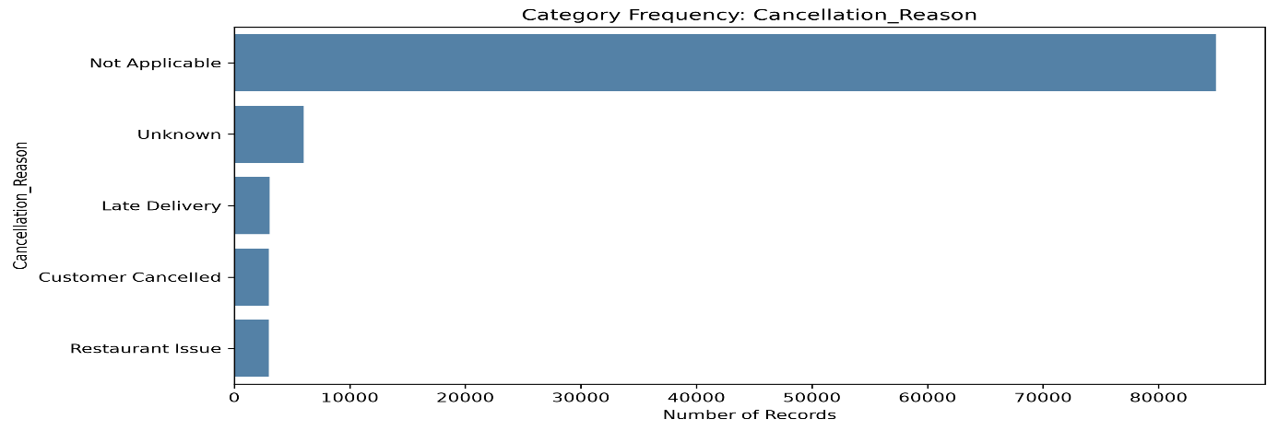
Around 85,000 orders are marked Not Applicable. Among cancelled orders, approximately 40% have an Unknown reason, while the remaining known reasons are distributed almost equally across late delivery, customer cancellation, and restaurant issues.
City (City)
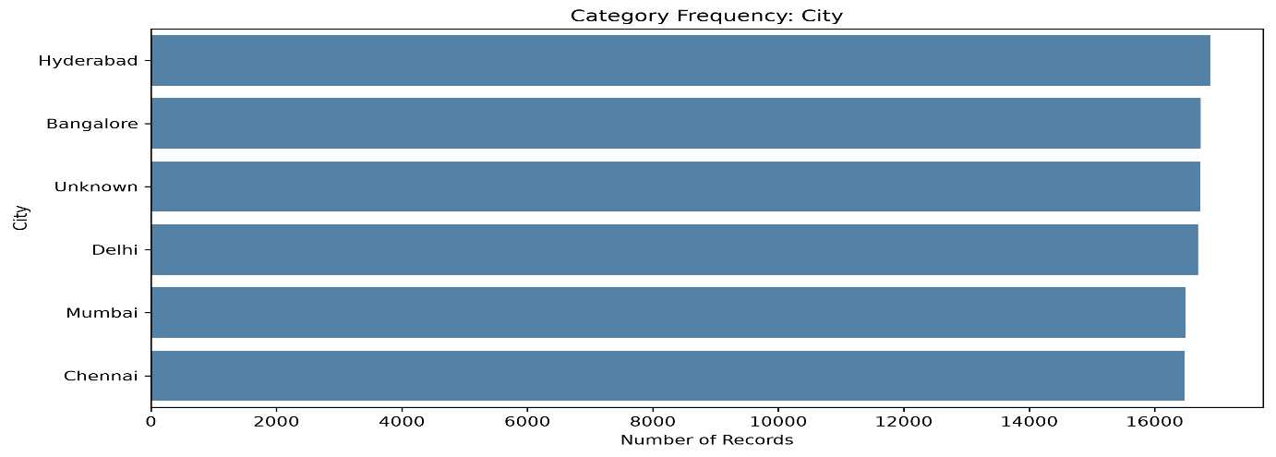
Hyderabad, Bangalore, Delhi, Mumbai, Chennai, and Unknown have nearly equal representation, at approximately 16.7% each.
Area (Area)
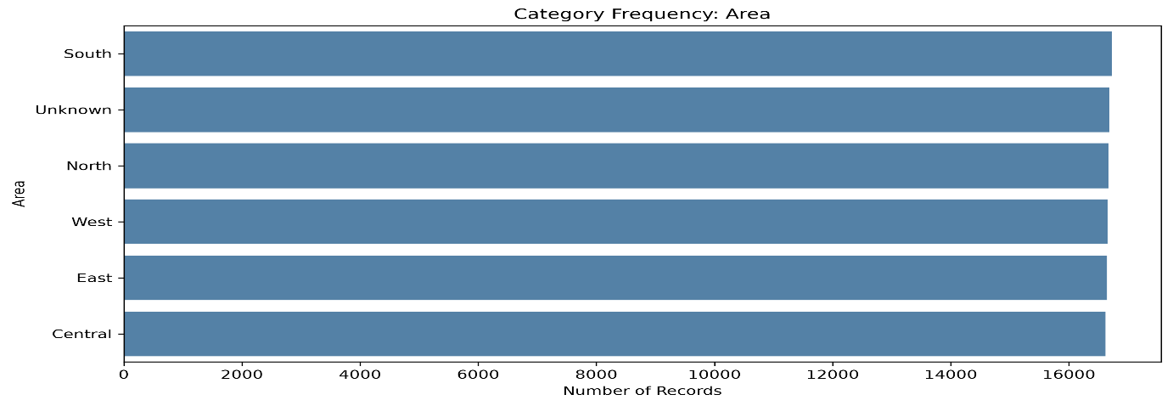
North, South, East, West, Central, and Unknown each account for roughly 16.7% of records.
Cuisine Type (Cuisine_Type)
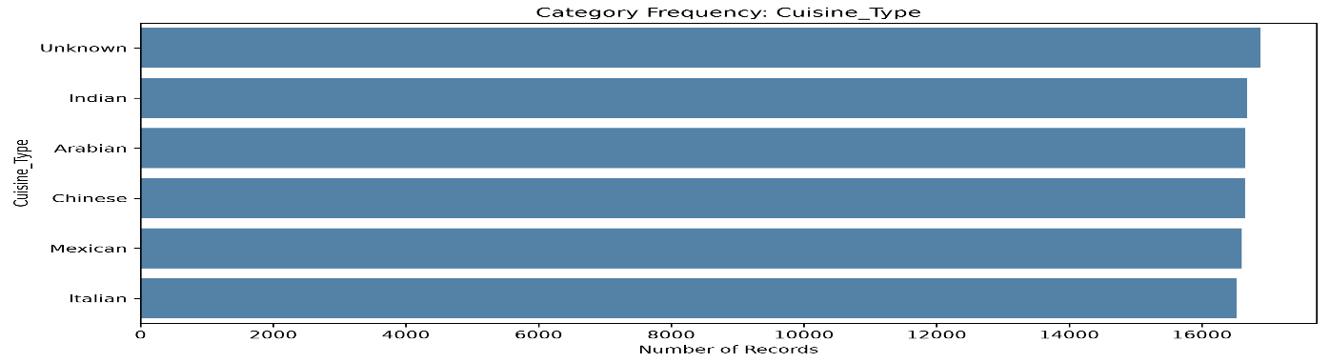
Indian, Arabian, Chinese, Mexican, Italian, and Unknown show nearly uniform distributions, with approximately 16.7% each.
Payment Mode (Payment_Mode)
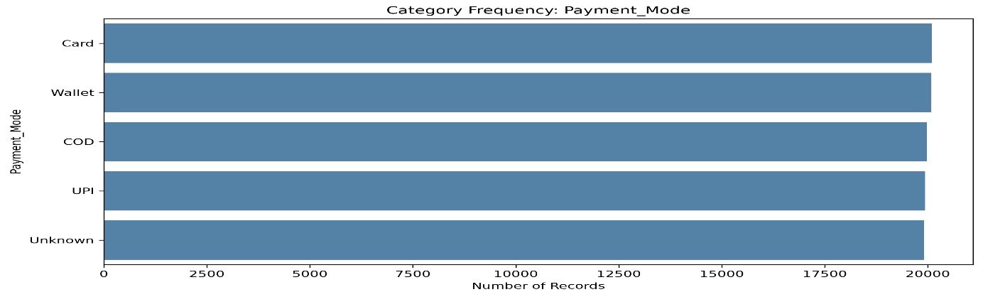
Card, Wallet, COD, UPI, and Unknown each represent approximately 20% of orders.
Customer Gender (Customer_Gender)
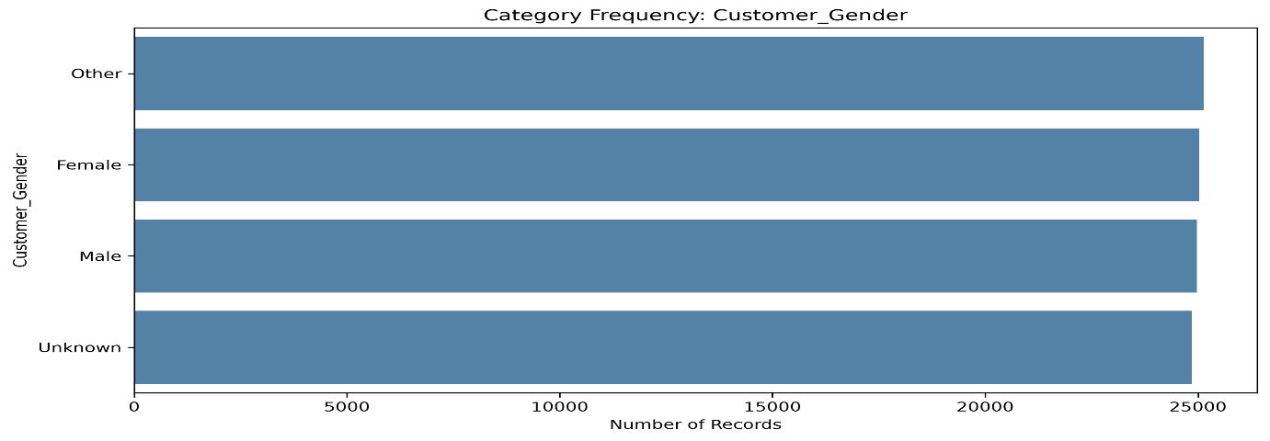
Male, Female, Other, and Unknown each account for approximately 25% of records.
Peak Hour (Peak_Hour)
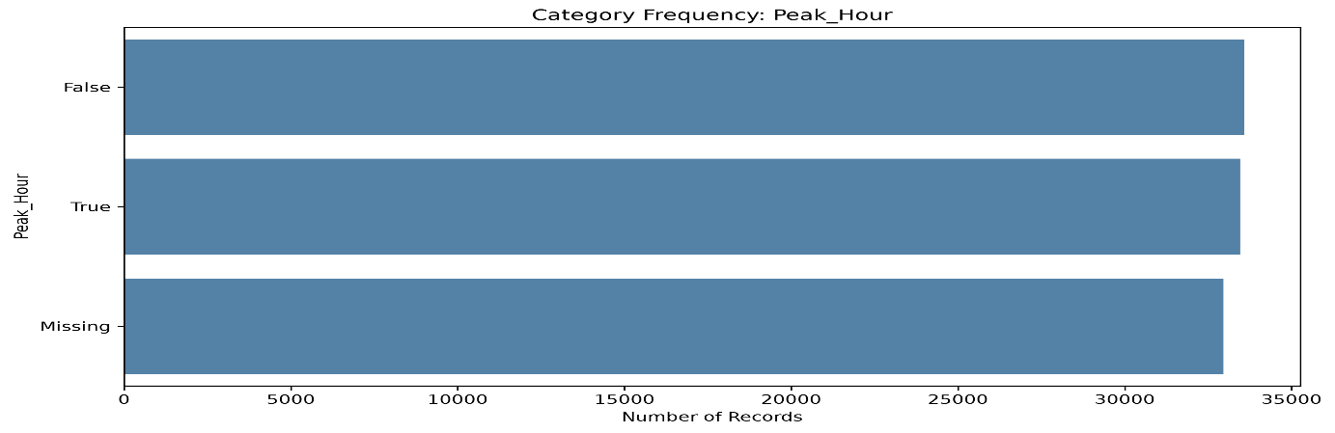
Approximately 33.5% of orders are classified as peak-hour, 33.5% as non-peak-hour, and 33% are marked Missing.

Order Day (Order_Day)
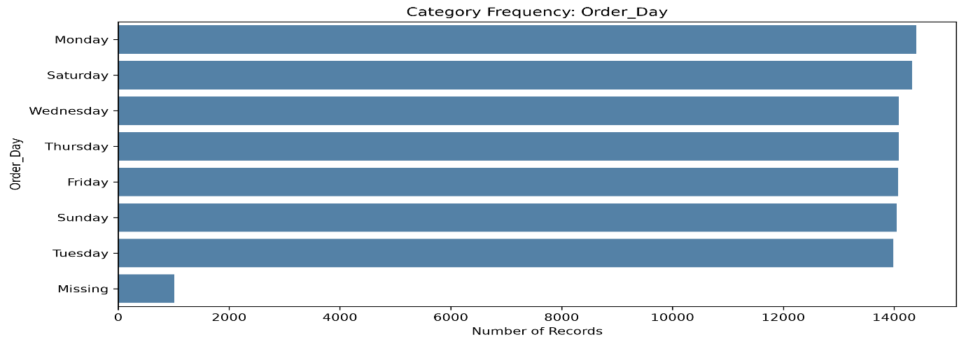
Order volumes are relatively consistent across the seven days, with approximately 14% per day and around 1% missing values.
Univariate analysis helps establish the individual characteristics of food delivery features before investigating relationships between variables.
- Order status distributions help summarize delivery outcomes.
- Payment frequencies help describe customer payment preferences.
- Delivery time and distance distributions help examine delivery performance.
- Financial distributions help identify unusual order amounts and discount values.
- Customer and restaurant ratings help assess rating patterns.

Univariate analysis provides an initial understanding of the dataset through descriptive statistics and individual-feature visualizations. The results support data quality assessment, feature-level interpretation, and subsequent bivariate and multivariate analysis.

4. Bivariate Analysis
Bivariate analysis was performed to examine the relationships between pairs of variables in the online food delivery dataset. The objective was to identify patterns in customer behaviour, order value, delivery performance, discounts, customer satisfaction, and profitability.
Scatter plots, grouped bar charts, box plots, and correlation analysis were used where appropriate to investigate relationships between numerical and categorical variables.
Objectives
- Understand the relationship between order value and final amount.
- Investigate the impact of delivery distance on delivery time.
- Examine the relationship between discounts and order profitability.
- Compare delivery performance across order statuses.
- Explore the relationship between service ratings and delivery outcomes.
- Identify patterns that may support operational and business decisions.
Categorical vs Categorical
Analyses relationships between two categorical variables.
Bivariate analysis was conducted to examine the relationship between Order_Status and five categorical features: City, Cuisine_Type, Customer_Gender, Payment_Mode, and Peak_Hour.
Across all five comparisons, the charts show a nearly uniform order-status distribution, with approximately 15% of orders cancelled and 85% delivered in each category. This indicates that cancellation rates do not visibly differ across the examined groups.
The consistent proportions and balanced category volumes may indicate that order status was generated independently of these features, particularly if the dataset is synthetic. However, the charts alone cannot establish how the data was generated or prove complete statistical independence.

City vs. Order Status
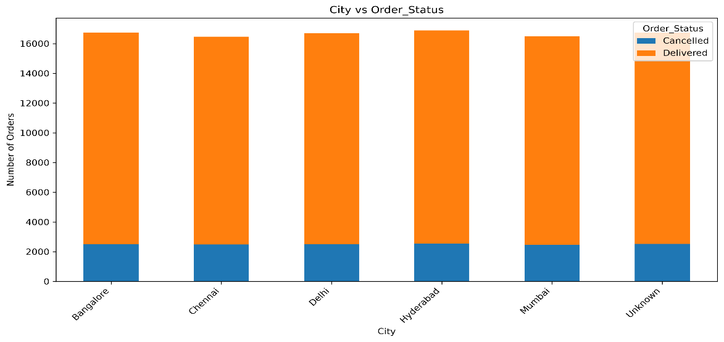
Visualization: city_vs_order_status.png
- Total volume: Approximately 16,600–16,900 orders per city.
- Cancelled orders: Around 2,500 per city, representing approximately 15%.
- Delivered orders: Around 14,200–14,400 per city, representing approximately 85%.
Insight: Cancellation rates appear similar across Bangalore, Chennai, Delhi, Hyderabad, Mumbai, and Unknown. No clear location-based difference is visible.
Business implication: The chart does not identify a particular city as having a higher cancellation rate. City-specific interventions should be supported by additional operational evidence.
Cuisine Type vs. Order Status
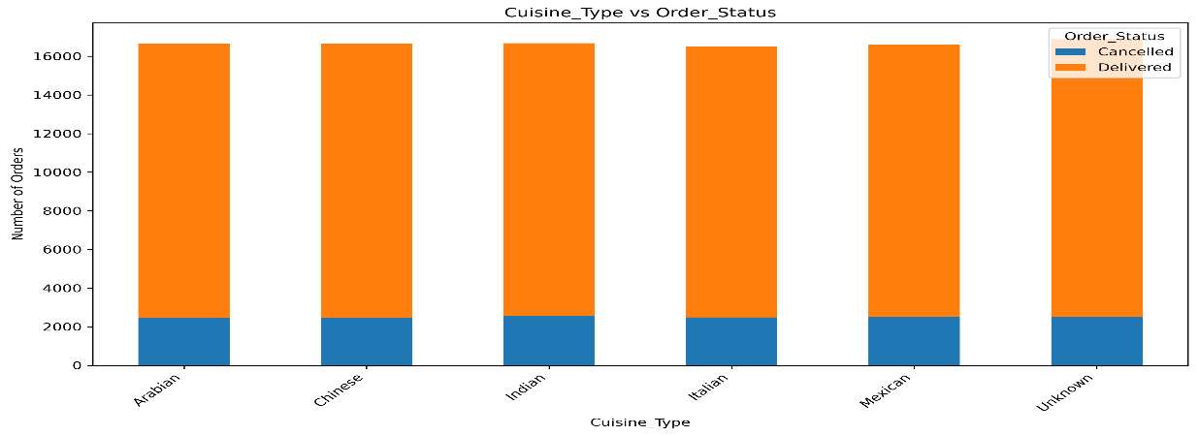
Visualization: cuisine_type_vs_order_status.png
- Total volume: Approximately 16,500–16,900 orders per cuisine category.
- Cancelled orders: Around 2,500 per category, representing approximately 15%.
- Delivered orders: Around 14,000–14,200 per category, representing approximately 85%.
Insight: Arabian, Chinese, Indian, Italian, Mexican, and Unknown categories show similar cancellation proportions.
Business implication: Cuisine type does not show a visible association with cancellation status in these charts. Further analysis could investigate restaurant preparation time, availability, and order-level factors.
Customer Gender vs. Order Status
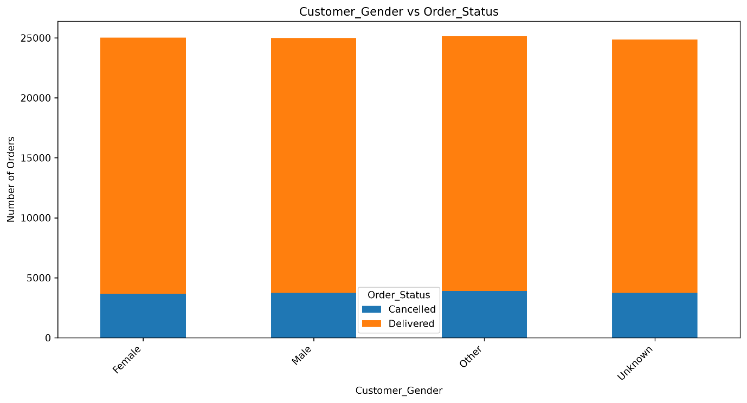
Visualization: customer_gender_vs_order_status.png
- Total volume: Approximately 25,000 orders per gender category.
- Cancelled orders: Around 3,750 per category, representing approximately 15%.
- Delivered orders: Around 21,250 per category, representing approximately 85%.
Insight: Female, Male, Other, and Unknown categories display nearly identical cancellation proportions.
Business implication: The chart provides no clear evidence that cancellation rates differ by customer gender. Business decisions should not assume demographic differences without further evidence.

Payment Mode vs. Order Status
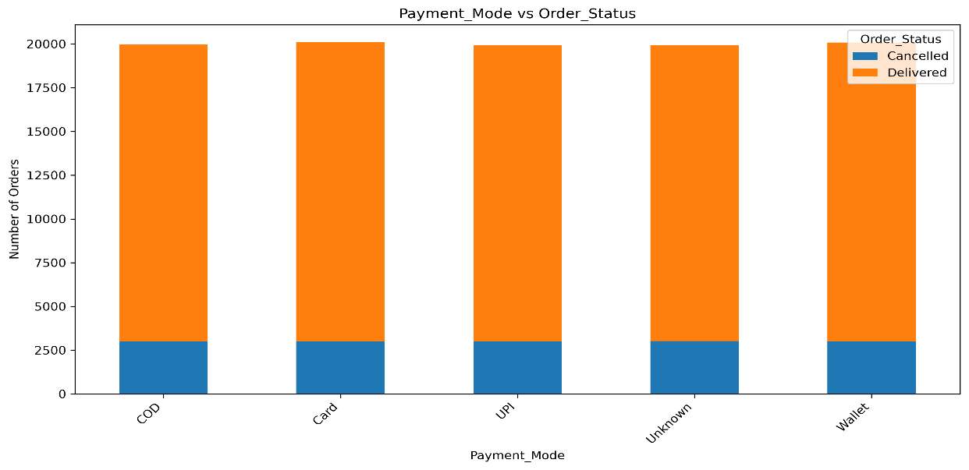
Visualization: payment_mode_vs_order_status.png
- Total volume: Approximately 20,000 orders per payment category.
- Cancelled orders: Around 3,000 per category, representing approximately 15%.
- Delivered orders: Around 17,000 per category, representing approximately 85%.
Insight: COD, Card, UPI, Unknown, and Wallet categories show approximately the same cancellation rate.
Business implication: No visible difference suggests that payment mode alone may not explain cancellation patterns in this dataset. Further investigation could examine payment failures, transaction status, and cancellation timing if those data are available.
Peak Hour vs. Order Status
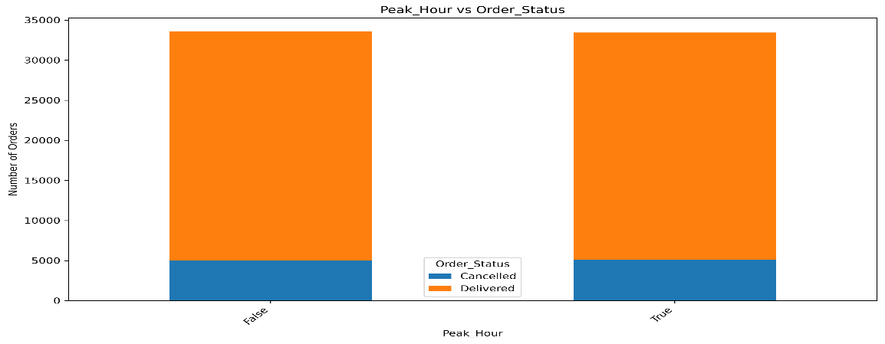
Visualization: peak_hour_vs_order_status.png
- Total volume: Approximately 33,500 orders in each peak-hour category, based on the supplied figures.
- Cancelled orders: Around 5,000 per category, representing approximately 15%.
- Delivered orders: Around 28,500 per category, representing approximately 85%.
Insight: Peak-hour and non-peak-hour orders show similar cancellation proportions, with no obvious increase during peak periods.
Business implication: The chart does not demonstrate a higher cancellation rate during peak hours. However, delivery-time distributions and restaurant preparation delays should also be examined to assess operational pressure.
Cross-Feature Findings
The five comparisons reveal a consistent pattern:
- Similar cancellation rates: Each category has approximately 15% cancelled and 85% delivered orders.
- Balanced category volumes: The reported counts are relatively similar across the categories of each feature.
- Limited visible differentiation: City, cuisine type, customer gender, payment mode, and peak-hour status do not show obvious differences in cancellation proportions.
- Possible synthetic-data pattern: The repeated proportions may indicate that Order_Status was assigned independently of these categorical features during data generation. This remains a hypothesis until the dataset-generation process or statistical tests confirm it.
- Need for further analysis: Other variables, including delivery time, distance, discounts, and restaurant-related operational factors, should be investigated for potentially more informative patterns.
Conclusion
The categorical bivariate analysis shows a remarkably consistent cancellation rate of approximately 15% across city, cuisine type, customer gender, payment mode, and peak-hour categories. None of these charts reveals an obvious category-specific cancellation pattern.

Categorical vs Numerical
Analyses relationships between categorical variables and numeric values.
Bivariate analysis was conducted using box plots to compare numerical variables across different order statuses, payment methods, and cuisine categories. The objective was to identify differences in central tendency, variability, and potential outliers between groups.
The results show highly similar distributions across most comparisons. Customer age, delivery rating, delivery time, delivery distance, final amount, order value, profit margin, and restaurant rating generally exhibit similar medians and interquartile ranges across the respective groups.
These patterns suggest limited visible separation between the selected numerical features and categorical outcomes. The repeated similarity may indicate that some variables were generated independently or follow predefined distributions in the dataset. However, visual similarity alone cannot confirm statistical independence or establish how the data was generated.
Customer Age by Order Status
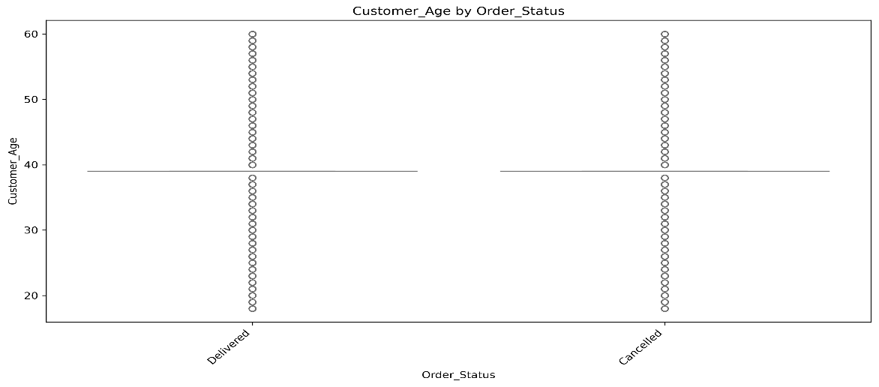
Visualization: customer_age_by_order_status.png
Observations
- Both Delivered and Cancelled groups have a median age of approximately 39 years.
- The box plots show a collapsed or unusually narrow box, with individual points spanning ages 18–60.
- The large concentration at age 39 is consistent with the distribution pattern identified during univariate analysis.
Insight: Customer age shows no visible difference between delivered and cancelled orders. The concentration at 39 may reflect median imputation or another data-generation pattern, but the original records must be checked to confirm its source.
Recommendation: Validate the raw age data and original missing-value handling before using customer age for demographic analysis or cancellation prediction.

Delivery Rating by Order Status
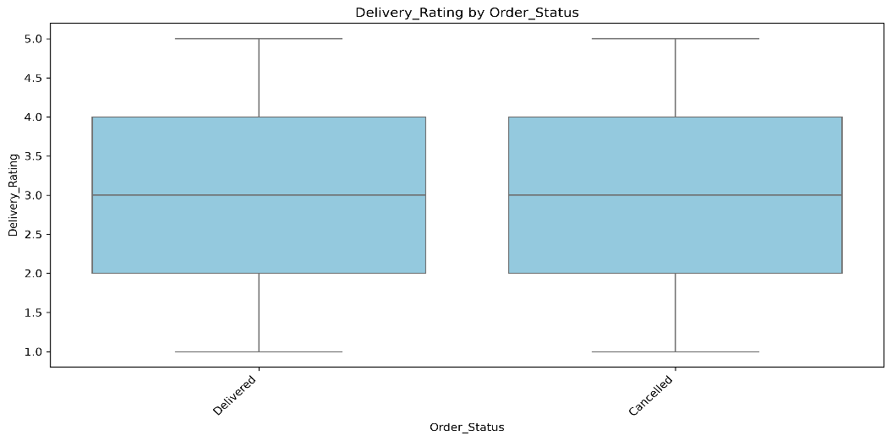
Visualization: delivery_rating_by_order_status.png
Observations
- Median delivery rating: 3.0 for both groups.
- Interquartile range: 2.0–4.0.
- Whiskers extend from approximately 1.0 to 5.0.
Insight:
The distributions appear identical across delivered and cancelled orders. This suggests that the recorded delivery rating does not visibly distinguish between the two groups.
Recommendation:
Check when delivery ratings are recorded. If ratings are only available after completed deliveries, their presence in cancelled orders should be investigated before using this feature for modelling.

Delivery Time by Order Status

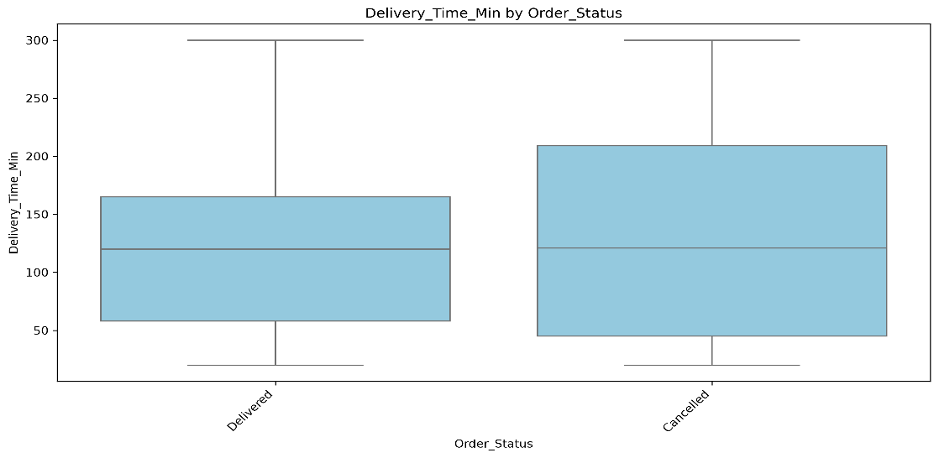

Visualization: delivery_time_min_by_order_status.png
Observations
- Median delivery time: approximately 120 minutes for both groups.
- Delivered orders have an IQR of approximately 58–165 minutes.
- Cancelled orders have an IQR of approximately 45–210 minutes.
- Both groups span approximately 20–300 minutes.
Insight:
The median delivery time is similar for both groups, although the cancelled group shows a wider interquartile range. This indicates some difference in variability despite the similar medians.
The spike at 120 minutes may represent a default value or a genuine concentration of recorded times. The box plot alone cannot determine which explanation is correct.
Recommendation:
Investigate the 120-minute spike and validate delivery-time recording rules. Examine cancellation timing and whether the recorded delivery time represents an actual completed delivery or an estimate for cancelled orders.
Delivery Distance by Order Status
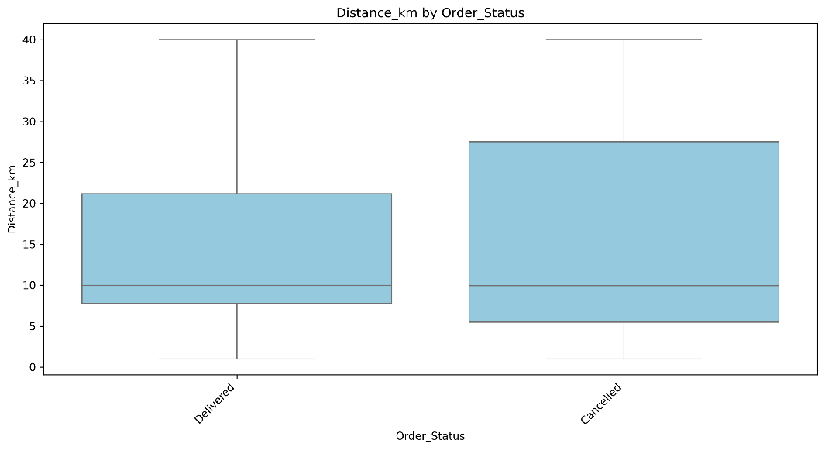
Visualization: distance_km_by_order_status.png
Observations
- Median distance: approximately 10 km for both groups.
- Delivered orders have an IQR of approximately 8–21 km.
- Cancelled orders have an IQR of approximately 5.5–27.5 km.
- Both groups span approximately 1–40 km.
Insight
The median distance is identical, but cancelled orders show a wider distribution. This may indicate greater variation in cancellation distances, although statistical testing is required to establish whether the difference is meaningful.
Recommendation
Validate the concentration at 10 km and compare distance distributions using suitable statistical tests. Investigate whether distance interacts with delivery time, delivery fees, or cancellation reasons.

Final Amount by Order Status
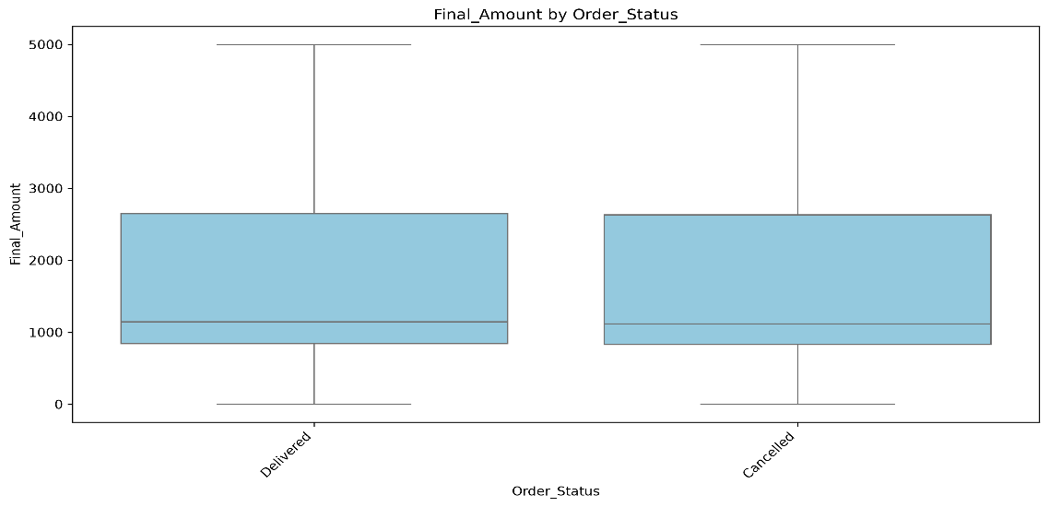
Visualization: final_amount_by_order_status.png
Observations
- Median final amount: approximately ₹1,150 for both groups.
- IQR: approximately ₹850–₹2,650.
- Values extend from approximately ₹0 to ₹5,000.
Insight
The box plots show no visible difference in the final amount between delivered and cancelled orders. This suggests limited separation based on the displayed financial distribution.
However, cancelled orders may have a final amount recorded as an intended or estimated payment rather than a completed transaction.
Recommendation
Validate the meaning of Final_Amount for cancelled orders and check its consistency with Order_Value and Discount_Applied. Use only information available at prediction time when building a cancellation model.

Order Value by Payment Mode

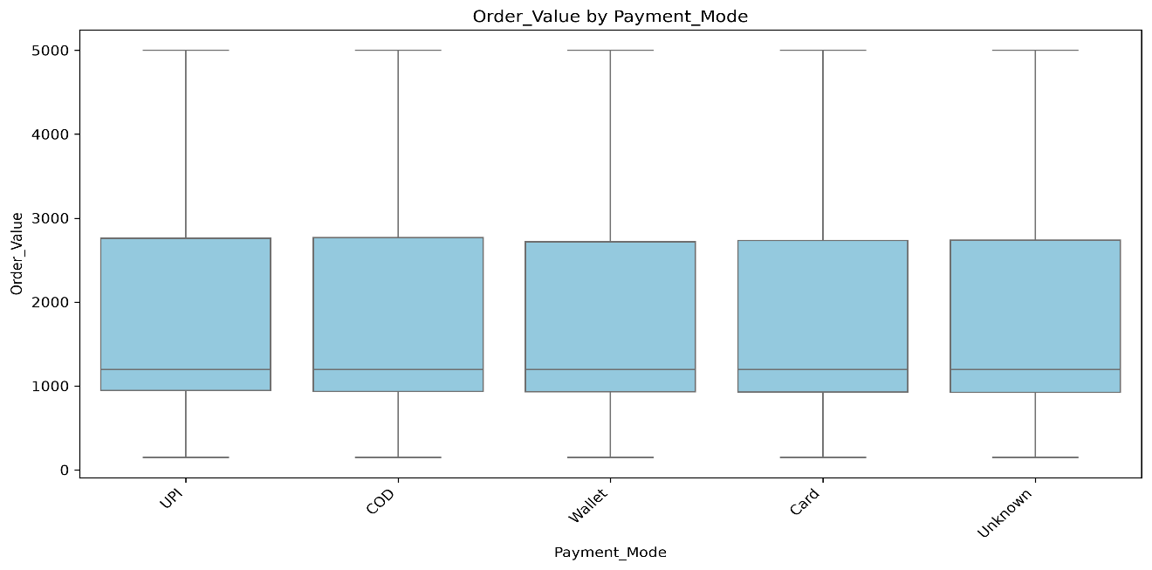
Visualization: order_value_by_payment_mode.png
Observations
- Median order value: approximately ₹1,200 across payment methods.
- IQR: approximately ₹950–₹2,750.
- Values extend from approximately ₹150 to ₹5,000.
- UPI, COD, Wallet, Card, and Unknown categories show similar distributions.
Insight
Order values appear consistent across payment methods, suggesting no obvious difference in basket size by payment preference in the supplied charts.
Recommendation
Use contingency tables or suitable statistical tests to investigate payment-method relationships with other outcomes. Validate the Unknown category and examine payment failures separately if transaction-level information is available.

Profit Margin by Cuisine Type
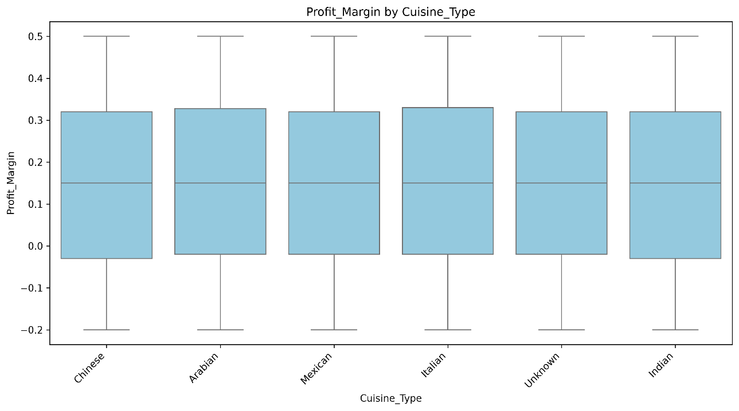
Visualization: profit_margin_by_cuisine_type.png
Observations
- Median profit margin: approximately 15% across cuisine categories.
- IQR: approximately −2% to 32%.
- Reported margins range from −20% to +50%.
- Chinese, Arabian, Mexican, Italian, Unknown, and Indian categories show similar distributions.
Insight
Profit-margin distributions appear consistent across cuisine categories. Negative margins indicate potentially unprofitable transactions, but the box plots do not identify whether these losses are associated with particular order characteristics.
Recommendation
Validate the profit-margin calculation and compare profitability by discount tier, order value, delivery distance, and order status. Calculate the actual proportion of negative-margin orders rather than inferring it from the chart alone.

Restaurant Rating by Cuisine Type
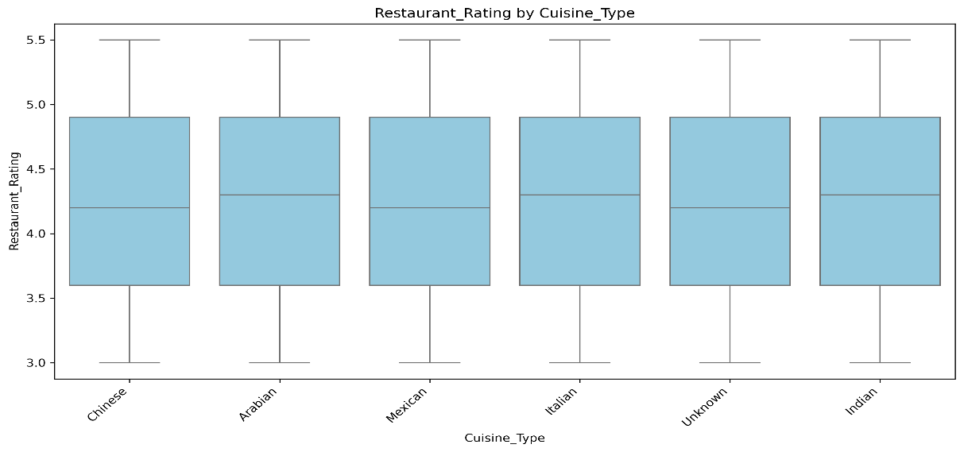
Visualization: restaurant_rating_by_cuisine_type.png
Observations
- Median rating: approximately 4.3 across cuisine categories.
- IQR: approximately 3.6–4.9.
- Reported values extend from 3.0 to 5.5.
- The box plots show similar medians and variability across cuisine categories.
Insight
Restaurant-rating distributions appear similar across cuisines, with no clear visual evidence that one cuisine category has consistently higher ratings.
The upper value of 5.5 requires validation if the intended rating scale is limited to 1–5.
Recommendation
Verify the rating scale and investigate values outside the valid range. Examine individual restaurants and sample sizes before drawing conclusions about customer satisfaction by cuisine.
Conclusion
The bivariate box plot analysis indicates that numerical distributions are broadly similar across the examined order statuses, payment methods, and cuisine categories. Although most group medians are nearly identical, some differences in spread remain, particularly for delivery time and distance.
Numerical vs Numerical
Correlation Matrix Heatmap Overview
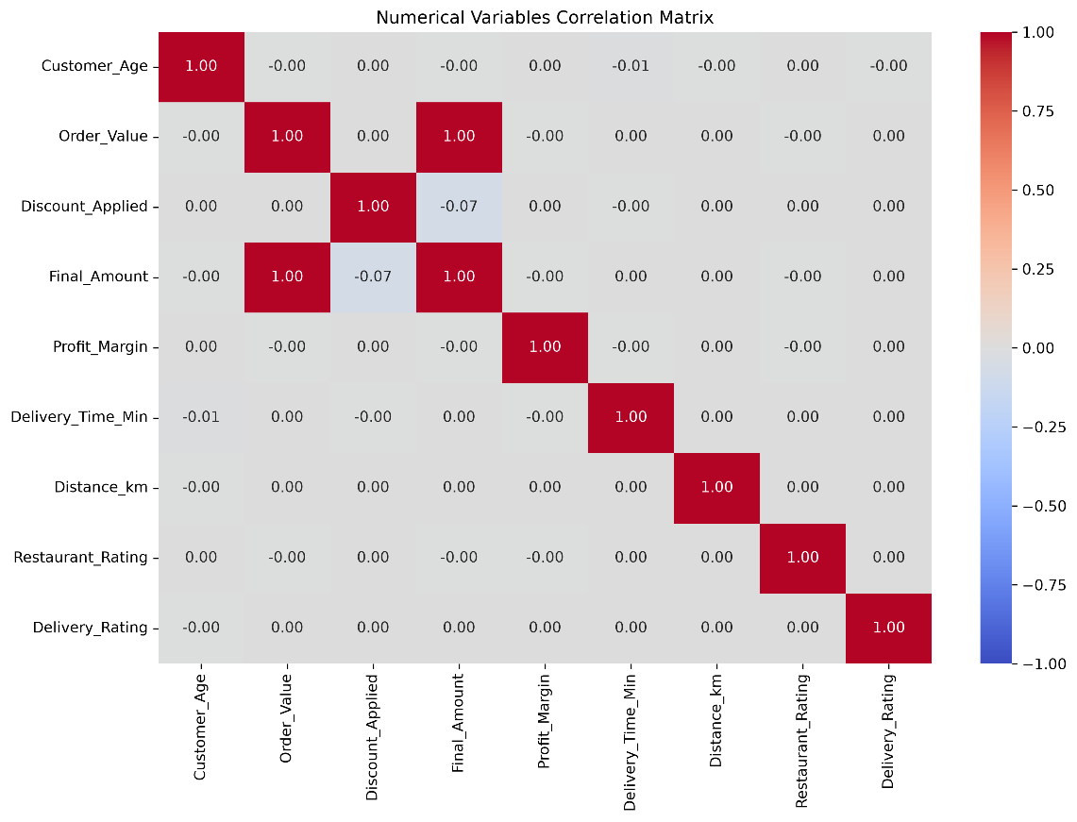
The Pearson correlation heatmap indicates that most numerical feature pairs have correlation coefficients close to zero, suggesting little or no linear relationship between them. The most notable exception is the perfect positive correlation between Order_Value and Final_Amount.
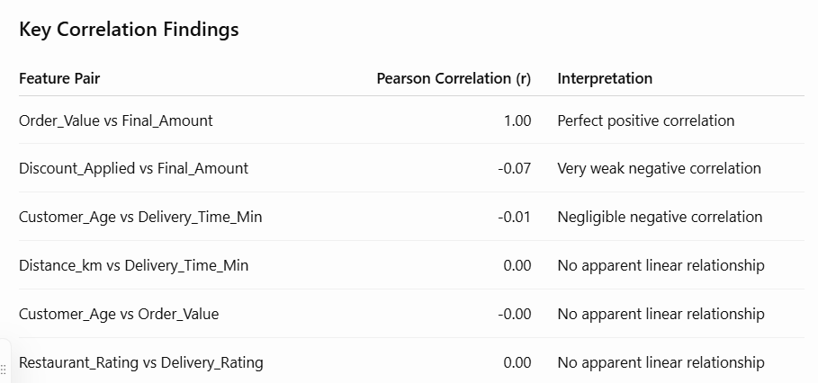
Note: A correlation near zero indicates little or no linear association, not necessarily complete statistical independence.
Scatter Plot Analysis
Order Value vs Final Amount
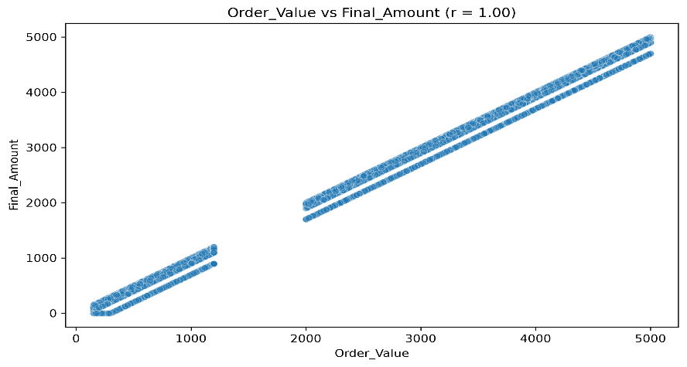
Correlation: r = 1.00
The scatter plot displays a strong diagonal pattern with parallel bands, suggesting a direct mathematical relationship between the two variables. The bands may reflect fixed discount deductions.
A visible gap appears in Order_Value between approximately ₹1,200 and ₹2,000.
Insight: The perfect correlation suggests that Final_Amount may closely follow Order_Value. However, because discounts are applied, verify the calculation rule and actual records. If Final_Amount = Order_Value - Discount_Applied, the relationship is not generally a perfect linear relationship unless the discount effect is constant or the reported correlation was calculated differently.
Discount Applied vs Final Amount
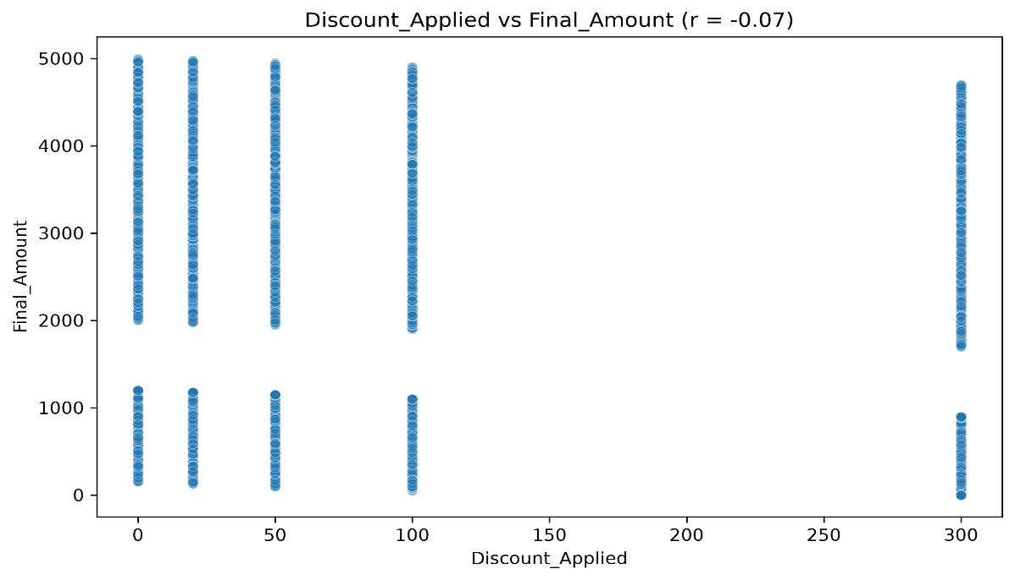
Correlation: r = -0.07
The scatter plot forms five vertical bands corresponding to the reported discount values of ₹0, ₹20, ₹50, ₹100, and ₹300. The final amounts vary considerably within each discount category.
The weak negative correlation suggests that higher discounts are associated with slightly lower final amounts overall. However, Order_Value also influences Final_Amount, so this relationship should not be interpreted as the isolated effect of discounts.
Insight: The discrete bands reflect the use of fixed discount tiers, while the weak correlation indicates little overall linear association between discount amount and final payment.
Customer Age vs Order Value
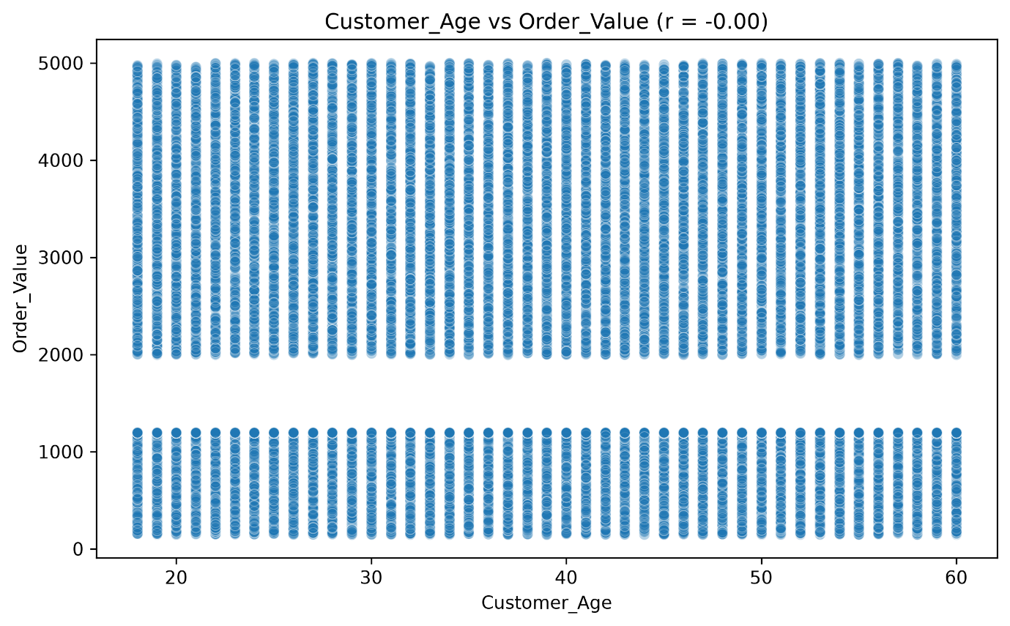
Correlation: r ≈ 0.00
The scatter plot shows dense vertical stripes across customer ages of approximately 18–60 years. Order values appear across a broad range, with a visible gap between approximately ₹1,200 and ₹2,000.
Insight: There is no apparent linear relationship between customer age and order value in the reported analysis. The observed pattern suggests that age alone may have limited usefulness for predicting spending through a simple linear model.
Distance vs Delivery Time
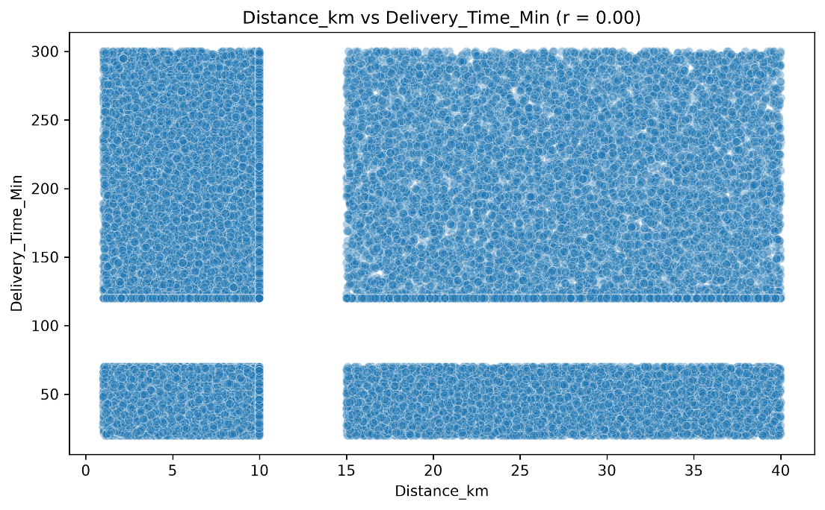
Correlation: r ≈ 0.00
The scatter plot displays several dense rectangular clusters. A gap appears between approximately 10 km and 15 km in Distance_km, and another between approximately 70 and 120 minutes in Delivery_Time_Min.
Long delivery times occur across both shorter and longer distances, with no visible linear trend.
Insight: The reported data does not show the expected positive linear association between distance and delivery time. This may indicate independently generated features, simplified data-generation rules, coarse time categories, or limitations in the recorded data.
Restaurant Rating vs Delivery Rating
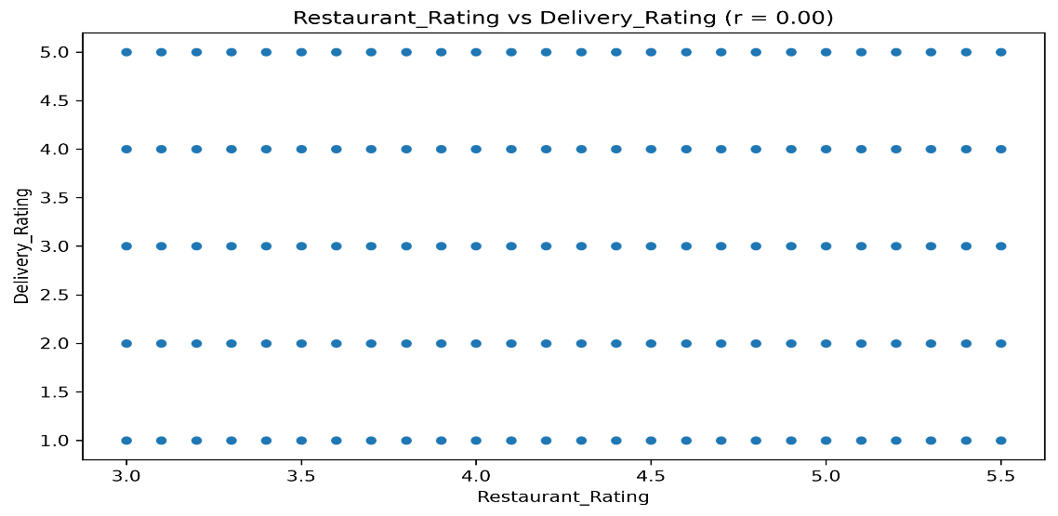
Correlation: r ≈ 0.00
The scatter plot forms a grid-like pattern because Delivery_Rating takes discrete integer values from 1 to 5, while Restaurant_Rating spans approximately 3.0–5.5.
Insight: No apparent linear relationship exists between restaurant ratings and delivery ratings in the reported results. This suggests that the two rating variables may capture different aspects of the customer experience.
Conclusion
The numerical analysis reveals a strong reported relationship between order value and final amount, while most other examined feature pairs show little or no linear correlation. The scatter plots also reveal distinct clusters, fixed discount tiers, and gaps in several distributions.
These findings highlight the need to validate pricing calculations, investigate unexpected patterns, and select model features according to the prediction objective. Although the results raise the possibility of synthetic data or preprocessing artifacts, further validation is required before confirming their cause.
4. Multivariate Analysis
The multivariate analysis examines interactions among delivery distance, delivery time, peak-hour status, city, cuisine type, payment mode, order value, and cancellation status.
The main findings are:
- Consistent cancellation rates: Cancellation rates remain close to 15% across the examined city–cuisine and payment–peak-hour combinations.
- Limited variation in order value: Average order values range from approximately ₹1,770 to ₹1,795 across payment modes and peak-hour categories.
- Nearly constant delivery times: Average delivery times remain around 121–127 minutes across distance bands, with limited variation between peak and non-peak periods.
- Potential data-quality concerns: Repeated values at 120 minutes and gaps in distance and delivery-time distributions warrant investigation.
- Limited visible segment differences: The charts do not reveal pronounced operational differences across the analysed groups.
These patterns suggest limited observed variation across segments. However, the charts alone cannot establish that the features are statistically independent or that the dataset was synthetically generated.
Chart-by-Chart Analysis
Delivery Distance vs Delivery Time by Peak Hour
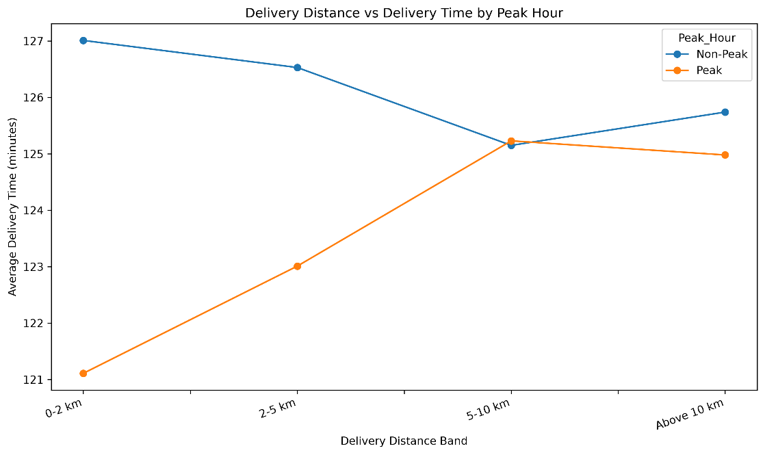
Chart: peak_distance_delivery_time.png
The chart compares average delivery duration across distance bands during peak and non-peak hours.
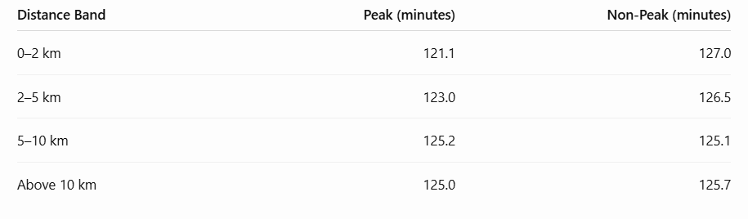
Insight: Average delivery times remain within approximately 121–127 minutes across the distance bands. The expected increase in delivery time with distance is not evident in these averages. Non-peak orders in the shortest distance band also have a higher average duration than peak-hour orders.

City–Cuisine Combinations by Cancellation Rate
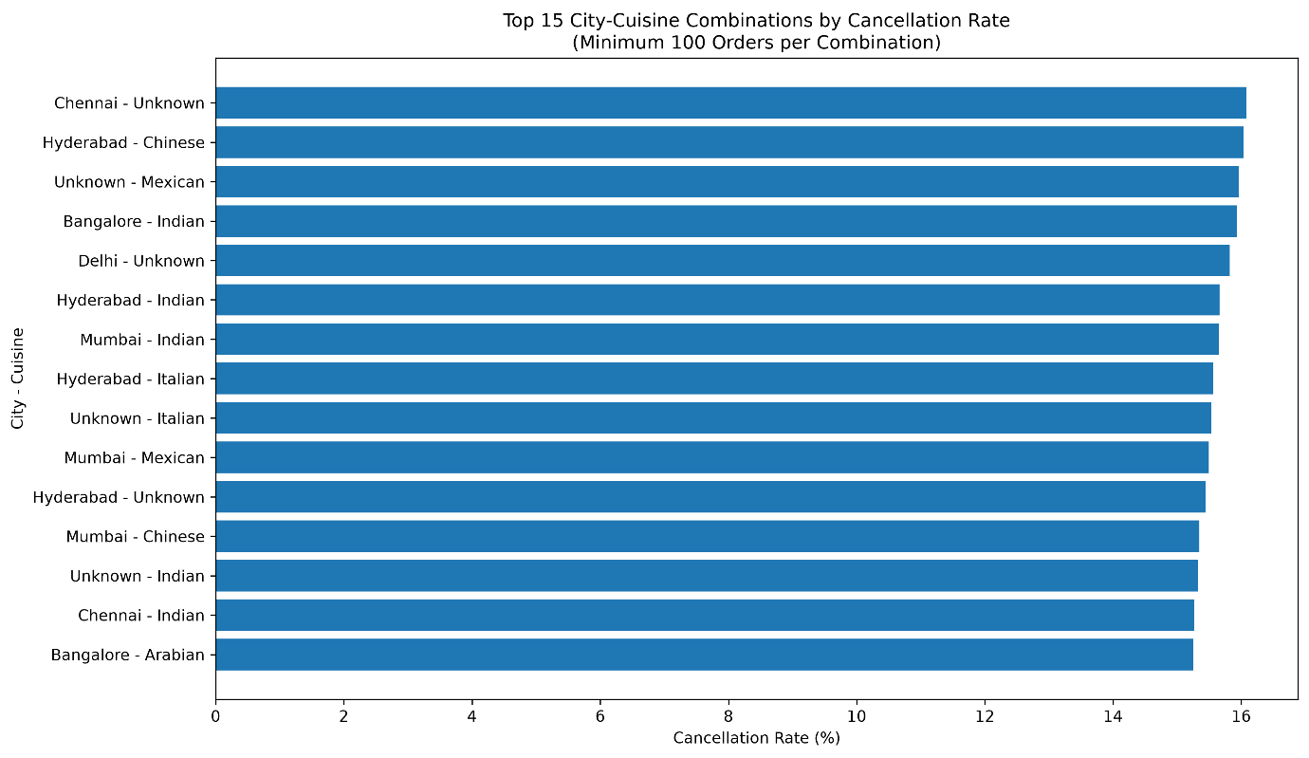
Chart: city_cuisine_cancellation_rates.png
The top 15 city–cuisine combinations, filtered to groups with at least 100 orders, have cancellation rates ranging from approximately 15.2% to 16.1%.
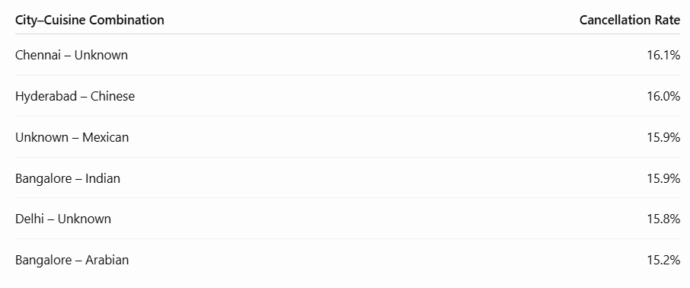
Insight: The observed cancellation rates vary by less than one percentage point across these examples. No substantial difference is apparent in the displayed combinations.

Payment Preferences Across Cities and Peak Hours
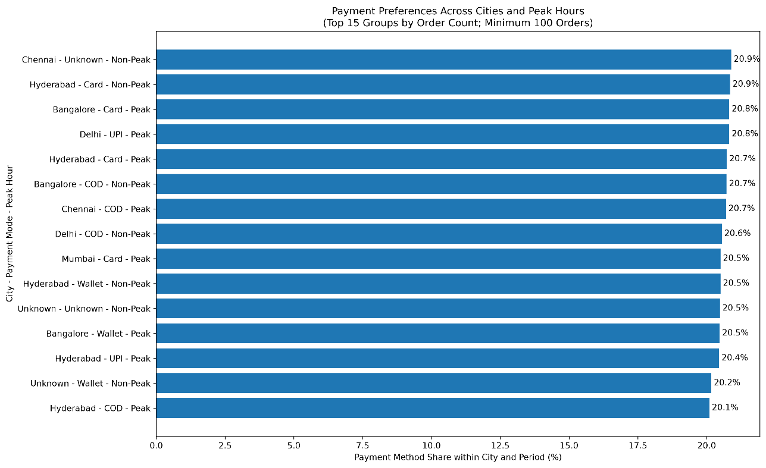
Chart: city_payment_peak_preferences.jpg
Payment-mode shares across the displayed city and peak-hour segments are generally around 20–21%.
The highest reported shares include Chennai – Unknown during non-peak hours and Hyderabad – Card during non-peak hours, both at approximately 20.9%.
Insight: Payment preferences appear broadly balanced across the analyzed segments, with no pronounced dominant payment mode.
Average Order Value by Payment Mode and Peak Hour
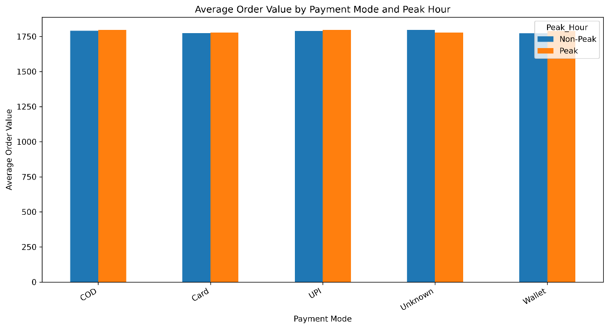
Chart: payment_order_value_peak.png
Average order values range from approximately ₹1,770 to ₹1,795 across the five payment categories and peak-hour groups.
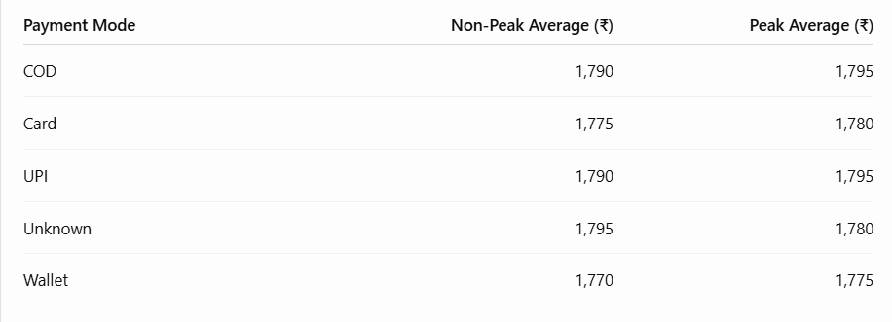

Insight: Average order values differ only slightly across payment modes and peak-hour categories. The chart does not show a substantial difference in spending between peak and non-peak periods.
Payment Mode and Peak Hour by Cancellation Rate
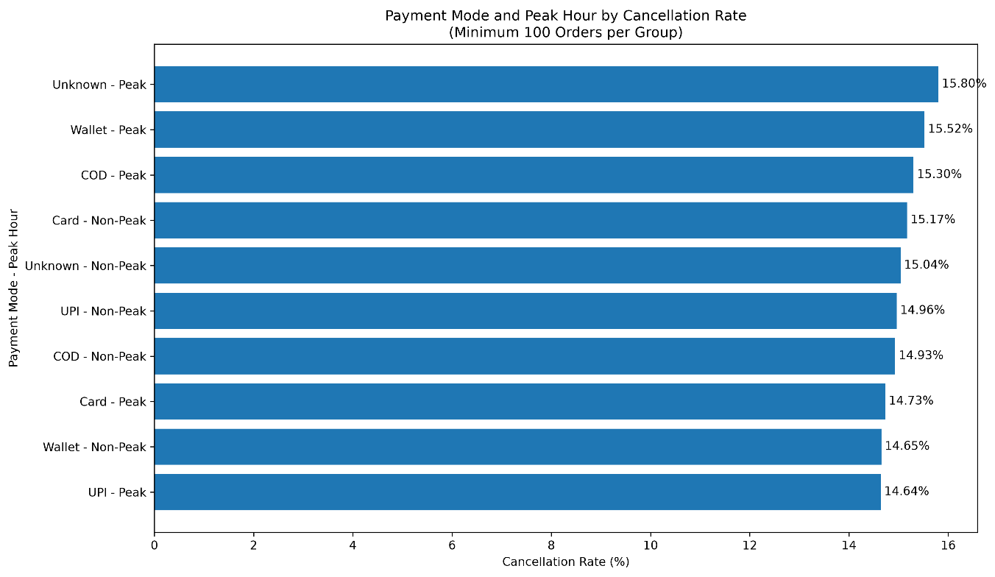
Chart: payment_peak_cancellation_rates.png
The reported cancellation rates range from 14.64% to 15.80%.
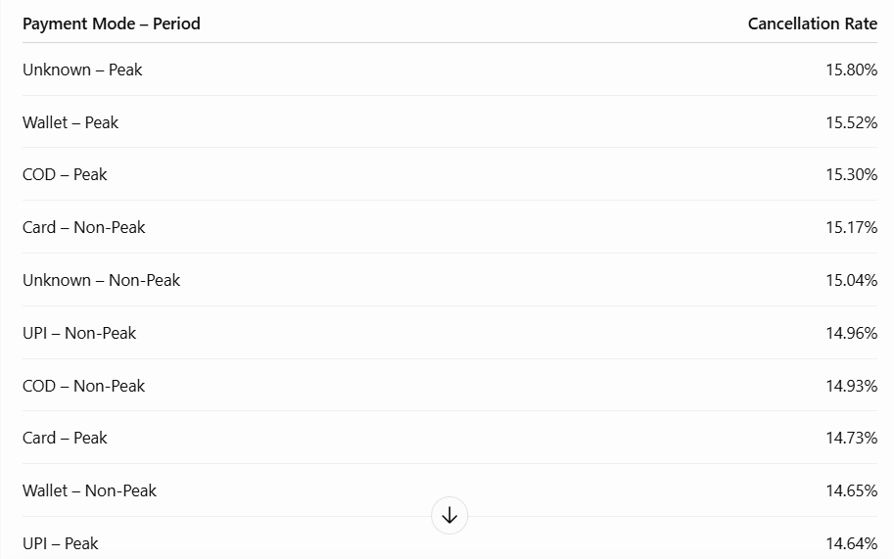
Insight: Cancellation rates remain within a relatively narrow range across payment-mode and peak-hour combinations. The highest and lowest reported rates differ by 1.16 percentage points.
Average Delivery Time by Peak Hour and Order Status
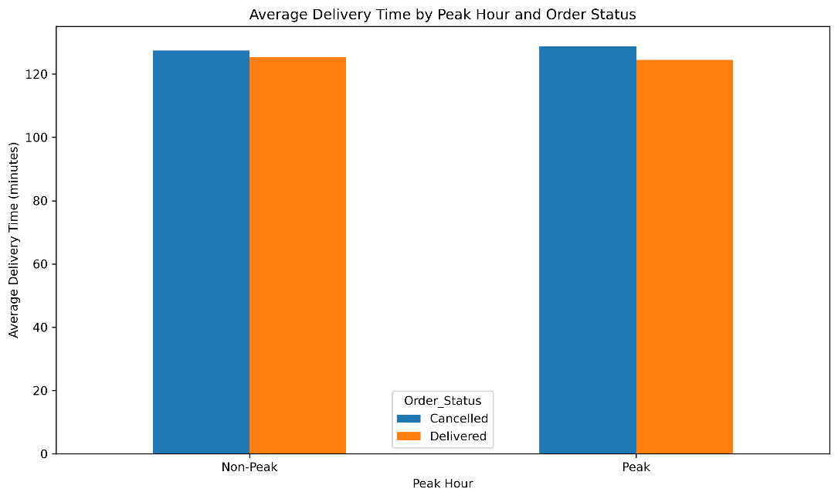
Chart: peak_delivery_time_by_status.png
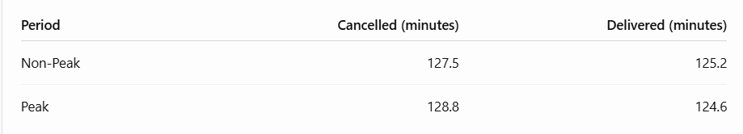
Insight: Cancelled orders have higher average logged delivery times than delivered orders by approximately 2.3 minutes during non-peak hours and 4.2 minutes during peak hours.
However, delivery-time values for cancelled orders require careful interpretation: a cancelled order may not have a completed delivery duration. The meaning of this field for cancelled orders should be verified before interpreting these differences operationally.
Delivery Distance vs Delivery Time During Peak and Non-Peak Hours
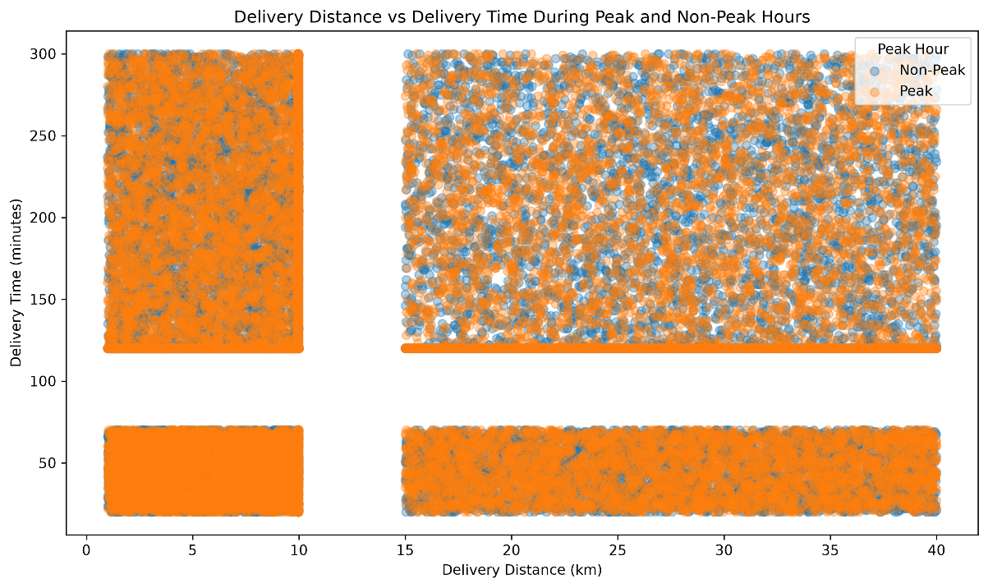
Chart: peak_distance_delivery_scatter.jpg
The scatter plot displays substantial overlap between peak and non-peak observations. A horizontal band at 120 minutes is visible across distance ranges. Gaps also appear between approximately 10 and 15 km and between 70 and 120 minutes.
Insight: The plot does not show a clear separation between peak and non-peak delivery-time patterns. The concentration at 120 minutes may be influencing the observed relationship.
Conclusion
The multivariate charts show relatively stable cancellation rates, similar average order values, and limited variation in average delivery times across the analyzed segments. The most important follow-up is to investigate the repeated 120-minute delivery-time value, the observed distribution gaps, and the meaning of delivery-time measurements for cancelled orders.

5.Insights and Business interpretation
1. Executive Summary — Insights
- The dataset contains 100,000 orders, with 84.96% delivered and 15.04% cancelled.
- The cancellation rate warrants further investigation into order fulfilment and customer experience.
- Average order value is 1,786.94; however, delivery-time performance cannot be assessed because no valid delivery-time records are available.
2. Data Overview — Insights
- The dataset contains 100,000 rows and 25 columns, with 63,659 missing cells (2.55%) and no duplicate complete rows.
- There are 1,014 invalid or missing order dates.
- Customer age is concentrated around a median of 39 years; confirm whether preprocessing or imputation influenced this pattern.
- Duplicate complete rows are absent, but Order_ID uniqueness should still be checked independently.
3. Key Findings — Insights
- Order fulfilment is predominantly successful, but approximately 15 in every 100 orders are cancelled.
- The average order value (1,786.94) is higher than the median (1,197.00), suggesting that higher-value orders may raise the average.
- Hyderabad has the largest city record count, while Unknown is the most frequently recorded cuisine category; the category distributions are otherwise close to uniform.
- Missingness statistics reflect the supplied dataset and may not show values already filled during cleaning.
4. KPI Analysis — Insights
- All 100,000 records have unique Order_ID values in the supplied data.
- Average final amount is 1,692.59, compared with an average order value of 1,786.94.
- Delivery-time and distance KPIs cannot be calculated from the current data because no valid records were available for those measures.
- City, cuisine, and payment categories provide useful dimensions for ongoing KPI monitoring.
5. Trend Analysis — Insights
- July recorded the highest monthly order volume (8,513), while February recorded the lowest (7,921).
- October had the highest observed monthly cancellation rate at 15.72%.
- September had the highest average order value (1,811.24), while March had the lowest (1,768.23); the variation is relatively small.
- Trend comparisons are based on 98,986 valid order dates, so missing dates may affect the results.
6. Root Cause Analysis — Insights
- Cancellation rates vary only modestly across the reported cities, cuisines, payment modes, and gender categories; these differences identify groups to investigate but do not establish causes.
- Among 9,031 cancelled orders with a usable reason, Late Delivery accounts for 33.87%, Customer Cancelled for 33.14%, and Restaurant Issue for 32.99%.
- The dataset does not support delivery-time or distance analysis because those fields have no valid records.
- There are 773 records where Final_Amount differs from Order_Value minus Discount_Applied by more than 0.01; confirm the actual pricing rules before treating these as errors.
7. Business Recommendations — Key Actions
- Investigate cancellation patterns by city, cuisine, payment mode, and recorded reason, and improve the capture of cancellation reasons.
- Repair and validate delivery-time and distance fields before evaluating delivery speed or peak-hour effects.
- Validate discount and final-amount calculations against documented business rules.
- Monitor cancellation rate, order value, final amount, and data completeness consistently over time.
- Retain the raw dataset and document each cleaning step so changes in data quality can be tracked.
8. Business Impact — Insights
- The 15.04% cancellation rate represents a clear opportunity to improve fulfilment, though actual revenue lost cannot be calculated reliably from the available fields.
- Order value and final amount describe transaction values, but they should not be interpreted as profit or confirmed collected revenue.
- Delivery-delay impact and customer-rating impact cannot be assessed because valid delivery-time data and the Customer_Rating column are unavailable.
- Management should prioritize cancellation reduction, financial-field validation, and restoration of reliable delivery metrics.
Data Quality & Limitations
- Missing Data: The dataset contains 63,659 missing cells (2.55%), including 1,014 missing or invalid order dates.
- Unavailable Metrics: Delivery time and distance lack valid records, limiting delivery performance analysis.
- Unknown Categories: Several categorical features contain substantial Unknown or Missing values, reducing analytical reliability.
- Potential Synthetic Patterns: Nearly uniform categorical distributions may indicate synthetic data generation or balanced sampling.
- Imputation Impact: Previously imputed values may hide original missingness and influence statistical interpretations.
- Financial Inconsistencies: 773 records have final amounts that differ from the simple order value minus discount formula and require validation.
- Analytical Limitations: Observed relationships do not establish causation, and actual profit or revenue lost cannot be reliably determined from the available data.
Analyst Methodology & Skills
- Data Understanding: Examined dataset structure, dimensions, data types, distributions, and summary statistics.
- Data Cleaning: Identified missing values, duplicates, invalid entries, and inconsistencies in dates and financial fields.
- Exploratory Data Analysis (EDA): Used descriptive statistics and visualizations to identify patterns, trends, and anomalies.
- Univariate Analysis: Analysed individual numerical and categorical features using distribution plots, histograms, and bar charts.
- Bivariate & Multivariate Analysis: Investigated relationships between categorical and numerical variables using bar charts, box plots, scatter plots, and correlation heatmaps.
- SQL Analysis: Applied queries and aggregations to summarize order performance and business metrics.
- Business Intelligence: Evaluated order fulfilment, cancellation patterns, order values, and data quality to identify improvement opportunities.
- Analytical Thinking: Interpreted findings objectively, acknowledged data limitations, and developed data-driven business recommendations.

Power BI Dashboard Development
Objective
Power BI was used to develop an interactive dashboard to analyse food delivery operations, customer behaviour, restaurant performance, delivery efficiency, and revenue trends. The dashboard converts the analysed data into meaningful visual insights to support data-driven business decisions.
Dashboard Screenshot
The Power BI report consists of six interactive pages designed to examine different aspects of food delivery operations.
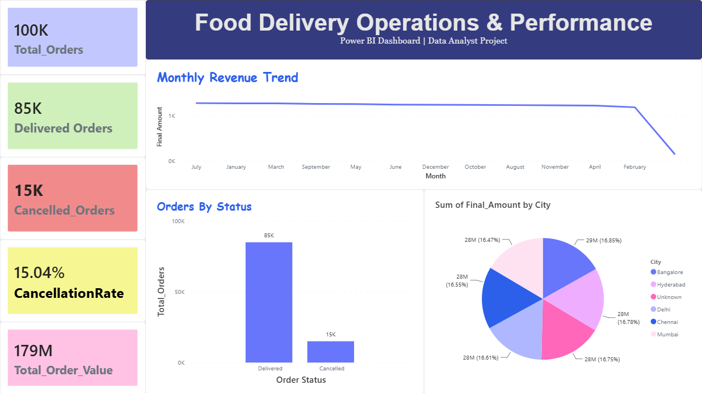
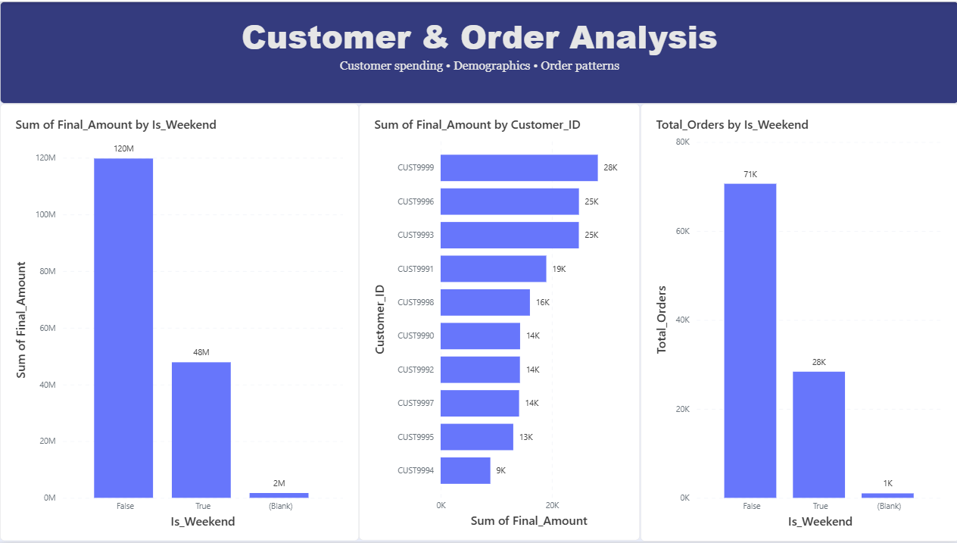
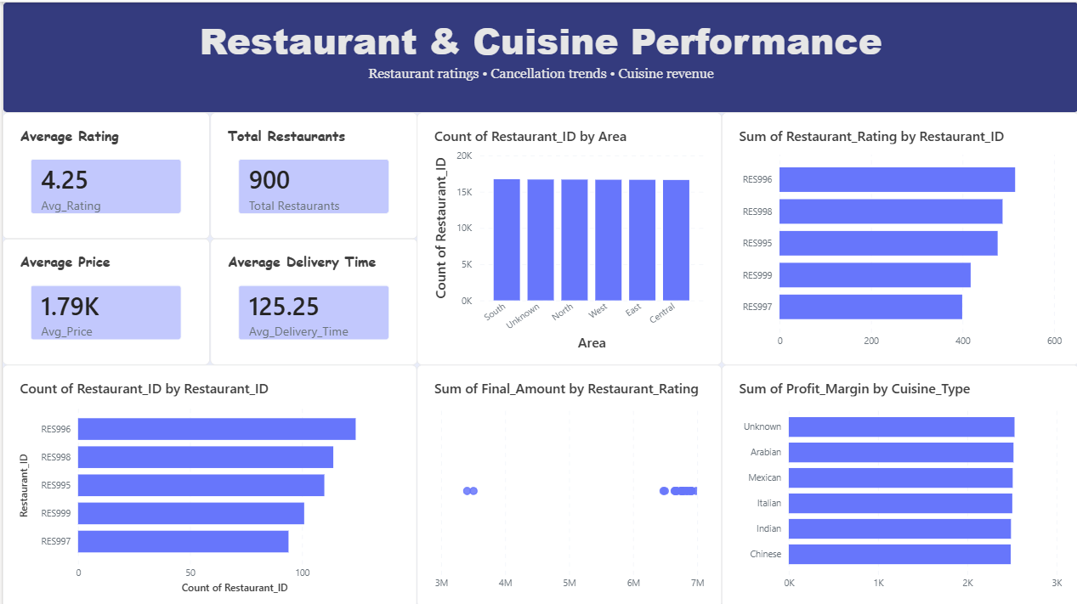
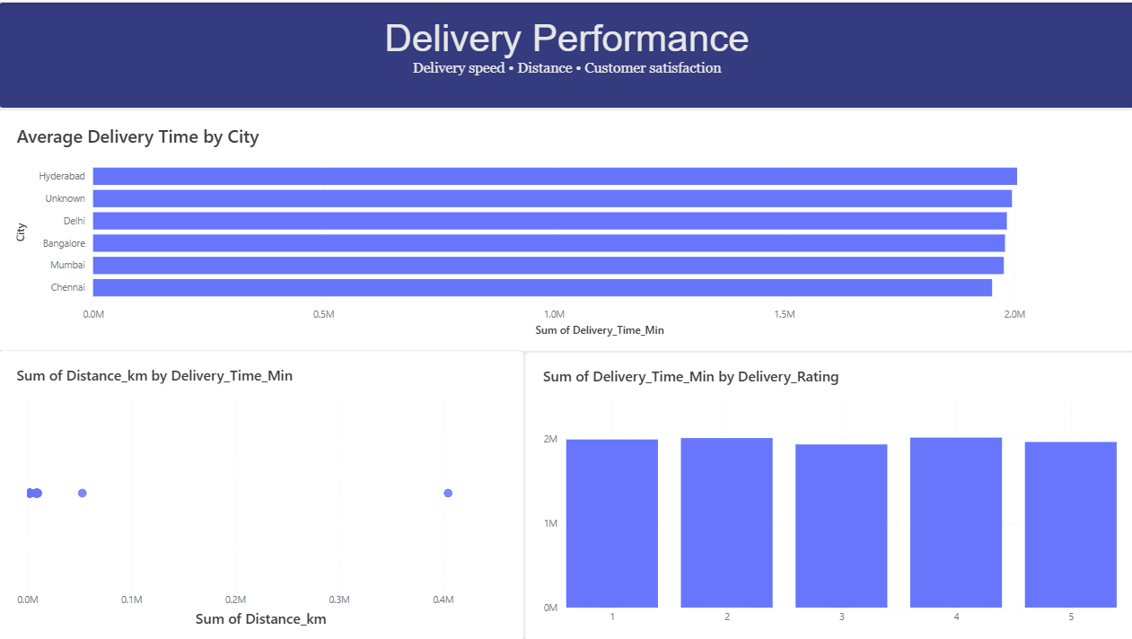

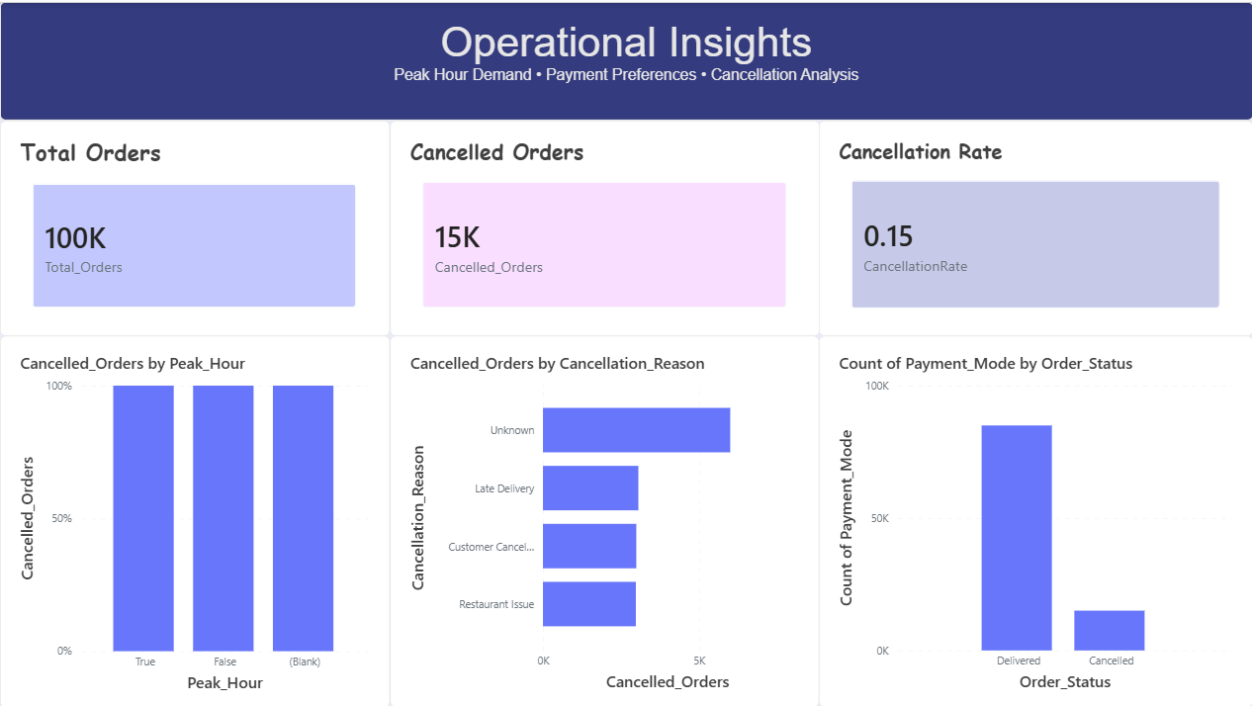
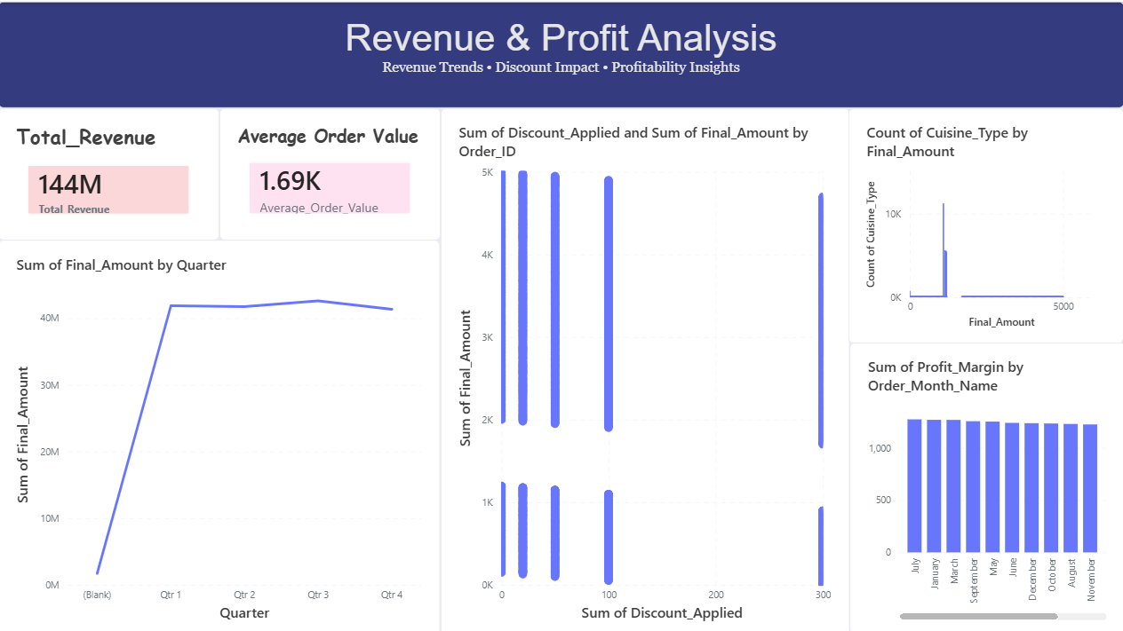
Key KPIs
The dashboard includes the following key performance indicators:
- Total Orders
- Delivered Orders
- Cancelled Orders
- Cancellation Rate
- Total Revenue
- Average Order Value
- Average Restaurant Rating
- Average Delivery Time
- Total Restaurants
- Total Discount and Total Profit, where supported by reliable data
6. Business Value
The Power BI dashboard provides a consolidated view of food delivery performance. It helps stakeholders identify cancellation patterns, evaluate restaurant and cuisine performance, understand customer ordering behaviour, and monitor revenue-related metrics. These insights can support operational planning and improvement initiatives.

