SYNOPSIS REPORT
ON
BHARAT DARSHAN- A DIGITAL HISTORY ATLAS OF INDIA
BY
CHAVHAN POOJA
DHAMALE RUTUJA
KULKARNI PRIYA

Course : B.Sc.IT
Semester : V and VI
Roll no. : 15, 22, 44
Guide Name : Snehal Varpe ma’am
Junnar Education Society
Shankarrao Butte Patil Senior (B.Sc. IT college)
Junnar, Pune 410502
2025-26
Introduction to the project
India's history is long, varied, and rich, covering many different civilizations, empires, cultural changes, and fights for freedom over hundreds of years. Usually, history lessons are not very interesting, which makes it tough for students to understand how events are connected in time and space. This project helps by offering an interactive digital map that shows India's history in a lively and easy-to-understand way.
  - Existing system and its drawbacks:
Conventional history learning tools (textbooks, static timelines, and maps) fail to offer:
- Interactive exploration
- Layered visualization of events, empires, and cultural sites
- Real-time geographic context
- Customization or personalized engagement

  - Purpose or need of System:
To make history learning interactive, visual, and memorable, especially for students. The system allows users to explore Indian history through time and space using intuitive maps, popups, timelines, and quizzes—enabling deeper understanding.
Proposed System
2.1 Problem Statement:
How can we enhance history learning for students by building an interactive, map-based educational platform that combines historical data, timelines, geography, and user interaction?
2.2 Objectives of the Proposed System:
• Create an interactive atlas covering major Indian historical events, empires, routes, and heritage.
• Help students visualize historical geography using GeoJSON map layers.
• Provide an engaging UI with popups, quizzes, and timeline filters.
• Offer clickable educational content for deeper insights.
2.3 Project Overview (Functionality Modules)
The system includes the following key modules:
- Empires & Kingdoms Module – Colored map layers for historical boundaries.
- Battles & Events Module – Pin markers with event popups and descriptions.
- Cultural Sites Module – Icons showing temples, caves, and ruins with media.
- Trade Routes Module – Animated lines showing key historical trade paths.
- Freedom Movement Timeline – Filterable timeline with major independence milestones.
- Sidebar Interface – Display empire info, maps, rulers, and additional notes.
- Quiz Module (Optional) – Interactive student self-checks based on map content.
2.4 Functional Requirements
- Map with toggleable layers (GeoJSON integration)
- Event popups with images and descriptions
- Timeline-based filtering and display
- Responsive layout for desktops/tablets
- Admin panel to update content (optional)
2.5 Non functional requirements
- Performance: Smooth rendering of maps and data
- Scalability: Easy addition of new events or layers
- Usability: Student-friendly UI/UX
- Reliability: Stable deployment for classroom use
- Portability: Works on major browsers and devices
2.6 Scope of the System
- Focused on Indian history (from 300 BCE to 1947 CE)
- Designed for higher secondary students and educators
- Expandable to cover world history or state-wise history in future

System Analysis and Designing
3.1 Zero Level DFD
Shows the interaction between the user and the system:
- User → selects timeline/layer → system → displays map content → user interaction

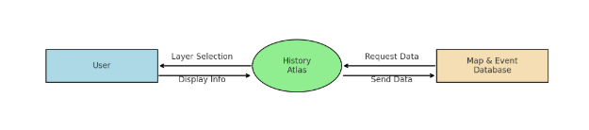
3.2 ER Diagram
Entities:
- User
- Empire
- Event
- Route
- Cultural Site
Relations:
- User interacts with Map Layers
- Events are tied to Empires or Periods
- Routes connect geographic points

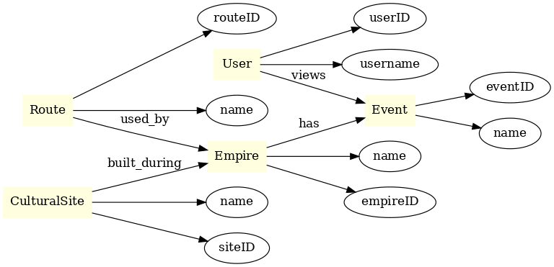

3.3 Activity Diagram
Describes the sequence:
- User opens platform
- Selects layer or timeline range
- System displays corresponding data
- User clicks markers or layers
- Popups or sidebar info appears
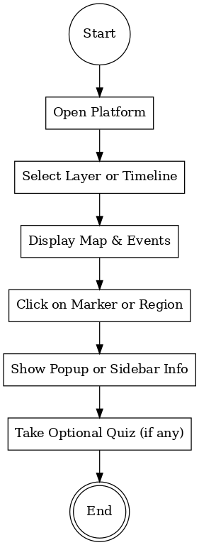

Hardware and Software Requirements
4.1 At Server Side
Hardware Configuration
Name | Details
Processor Intel | Core i5 or higher
RAM | 8 GB or more
Hard Drive | 256 GB SSD (minimum)

Software Environment
Name | Details
Operating System | Windows 10 / Ubuntu Linux
Database Server | MongoDB / Firebase / MySQL (if needed)
Web Server | Node.js / Express / Apache
Browser | Google Chrome / Mozilla Firefox
Framework | React.js + Leaflet.js (for mapping)
IDE | Visual Studio Code

4.2 At Client Side
Hardware Configuration
Component | Specification
Processor | Dual Core or higher (Intel/AMD)
RAM | Minimum 4 GB
Storage | 100 MB free space (for cache/data)
Display | 13" or larger, HD (1280×720) minimum

Software Environment
Component | Details
Operating System | Windows 10 / Linux / macOS / Android
Browser | Chrome (latest), Firefox, Edge
Plugins | JavaScript enabled, modern CSS support
Network | Internet connection (minimum 2 Mbps)

Future Scope of the Project
The Digital History Atlas of India lays the groundwork for a modern, interactive way of teaching and exploring history. In the future, the system can be significantly expanded and enhanced through the following directions:
1.Expansion to Global History
Extend the atlas to include world civilizations such as the Roman, Greek, Chinese, and Egyptian empires, allowing students to explore comparative timelines and historical overlaps.
2. 3D & Augmented Reality Integration
Introduce 3D views of ancient cities and AR-based virtual walkthroughs of historical sites like Nalanda University or Hampi to enrich learning experiences.
3.Integration with Educational Syllabi
Map modules to national and state-level history curricula (e.g., CBSE, ICSE, SSC) and provide structured lesson plans for teachers and educators.
4.AI-Assisted Learning
Use AI to recommend related historical topics based on user interaction and quiz results, or offer voice-based storytelling in multiple regional languages.
5.Collaborative Features
Enable student accounts, bookmarks, shared timelines, and peer discussion forums for group learning or classroom projects.
6.Advanced Timeline and Layer Controls
Support dynamic timeline sliders, multi-era comparisons, and real-time overlays of historical and modern geographic data.
7.Localization and Accessibility
Offer regional language support (Hindi, Marathi, Tamil, etc.), screen reader compatibility, and keyboard-based navigation to ensure inclusivity.
8.GIS and Satellite Map Integration
Combine historical data with modern satellite imagery to show archaeological relevance and terrain changes over centuries.
9.Gamification and Certification
Include quiz-based missions, history puzzles, and achievement badges with optional certification to motivate student engagement.

Conclusion
The Digital History Atlas of India is a step toward transforming traditional history education into an interactive, visual, and engaging learning experience. By combining geographic information with historical events, empires, routes, and cultural heritage, the system makes history more accessible and memorable for students.
With its modular structure, timeline integration, and visual layers, the platform not only enhances learning but also encourages curiosity and exploration. The project serves as a strong foundation for future educational innovations, including AR, AI-assisted learning, and broader curricular integration.
Overall, the Digital History Atlas bridges the gap between historical knowledge and modern technology—making the study of India’s rich past more meaningful, intuitive, and learner-friendly.

