Django:

Context:
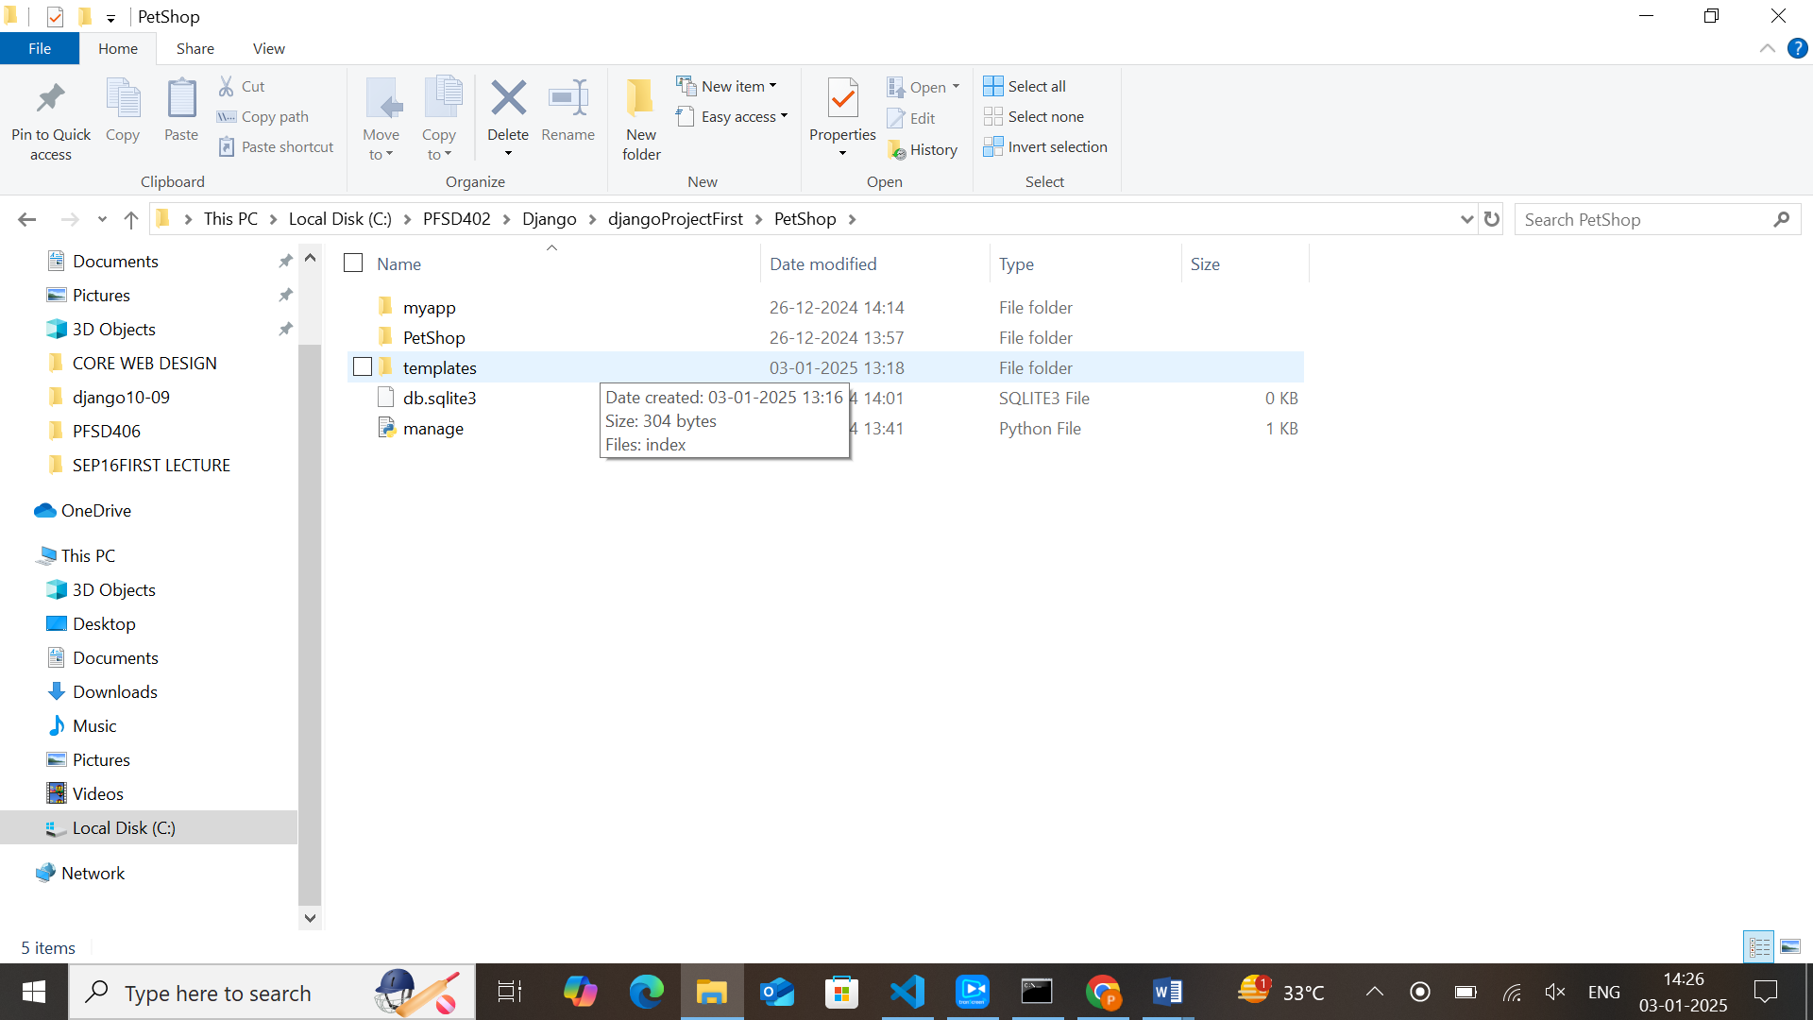
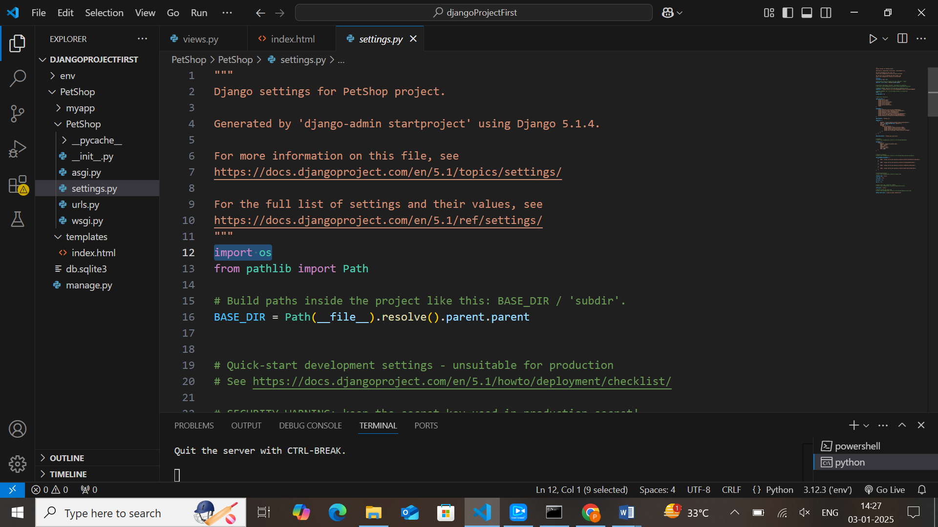

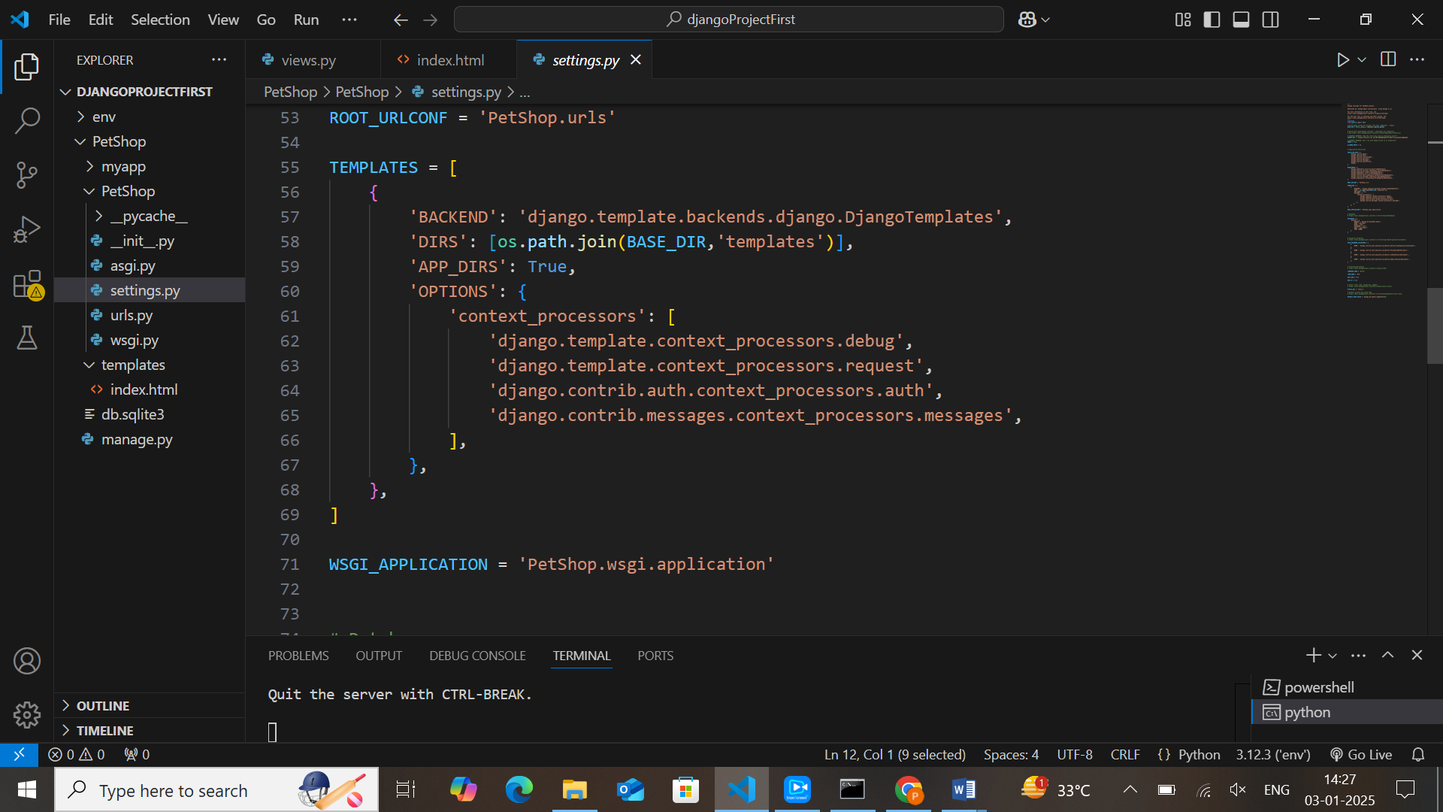
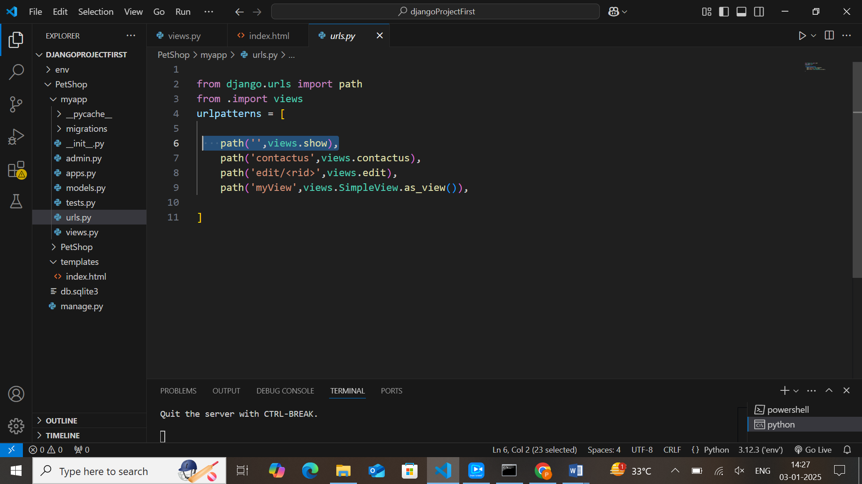

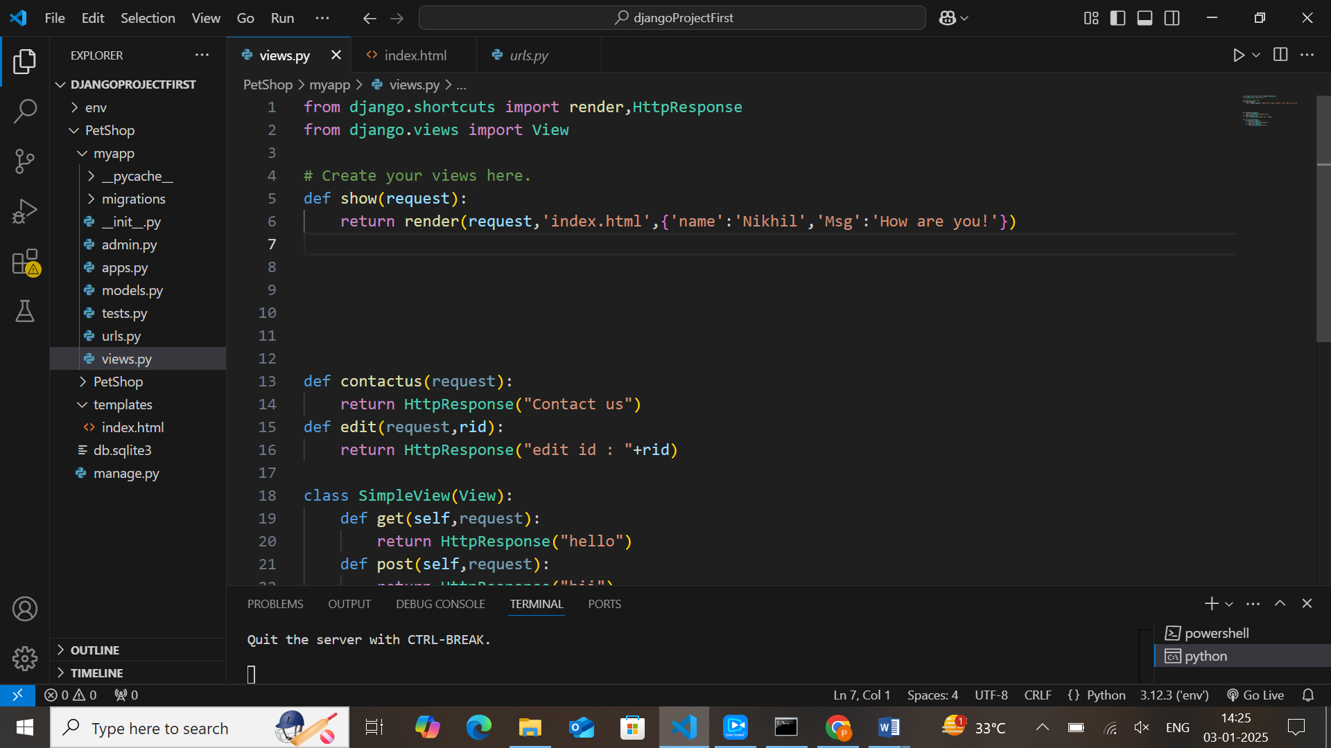

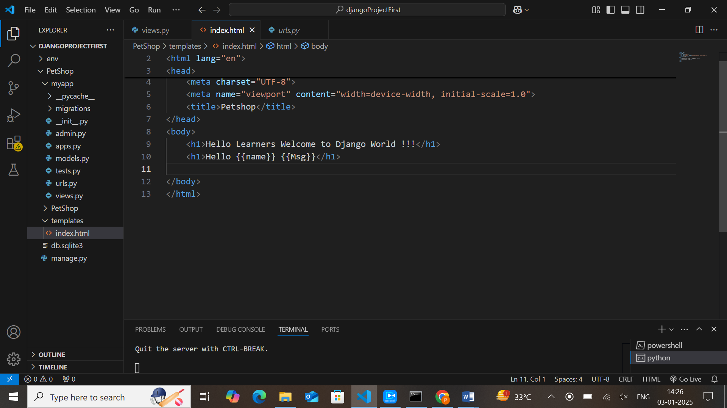

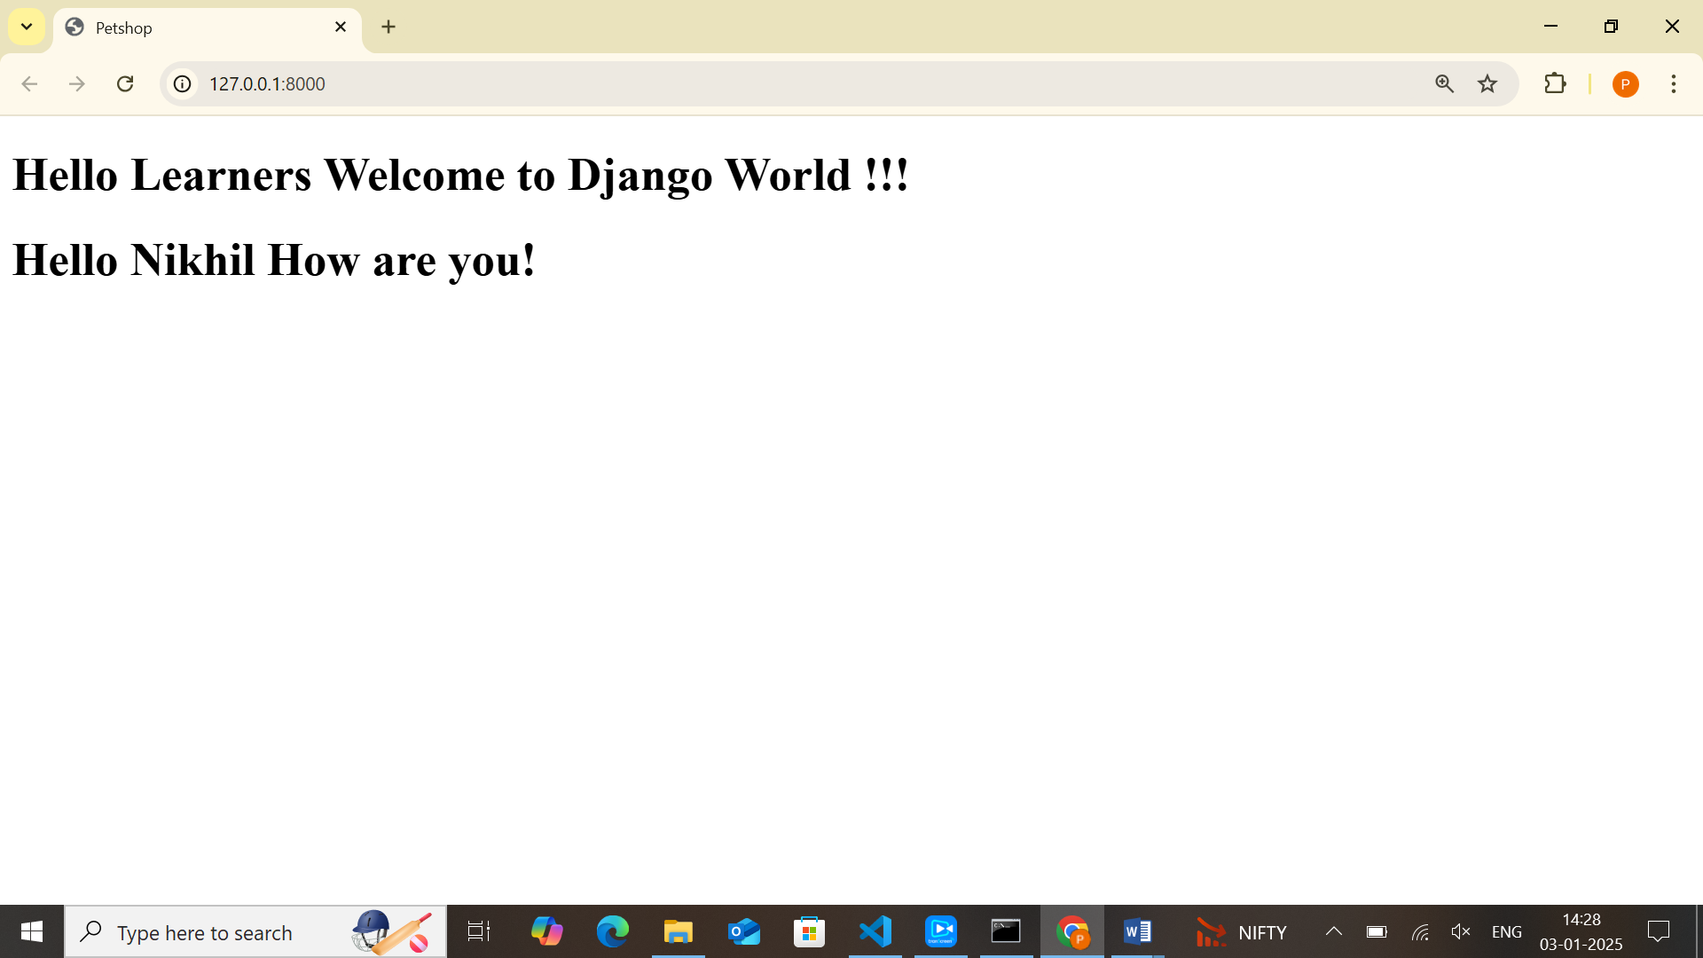

Django template tags:
{% tag %}
Tags are complex than variables
To execute template tags we surround them in {% %} brackets

If and for are called template tags
1)comment:

{% comment %}

{% endcomment %}

2)extends:

{% extends ‘base.html’ %}

3)if
Values are: {{x}} and {{y}}
{% if x < y %}
<h1> {{x}} is greater</h1>
{% else %}
<h1> {{y}} is greater</h1>
{% endif %}

4)for loop:
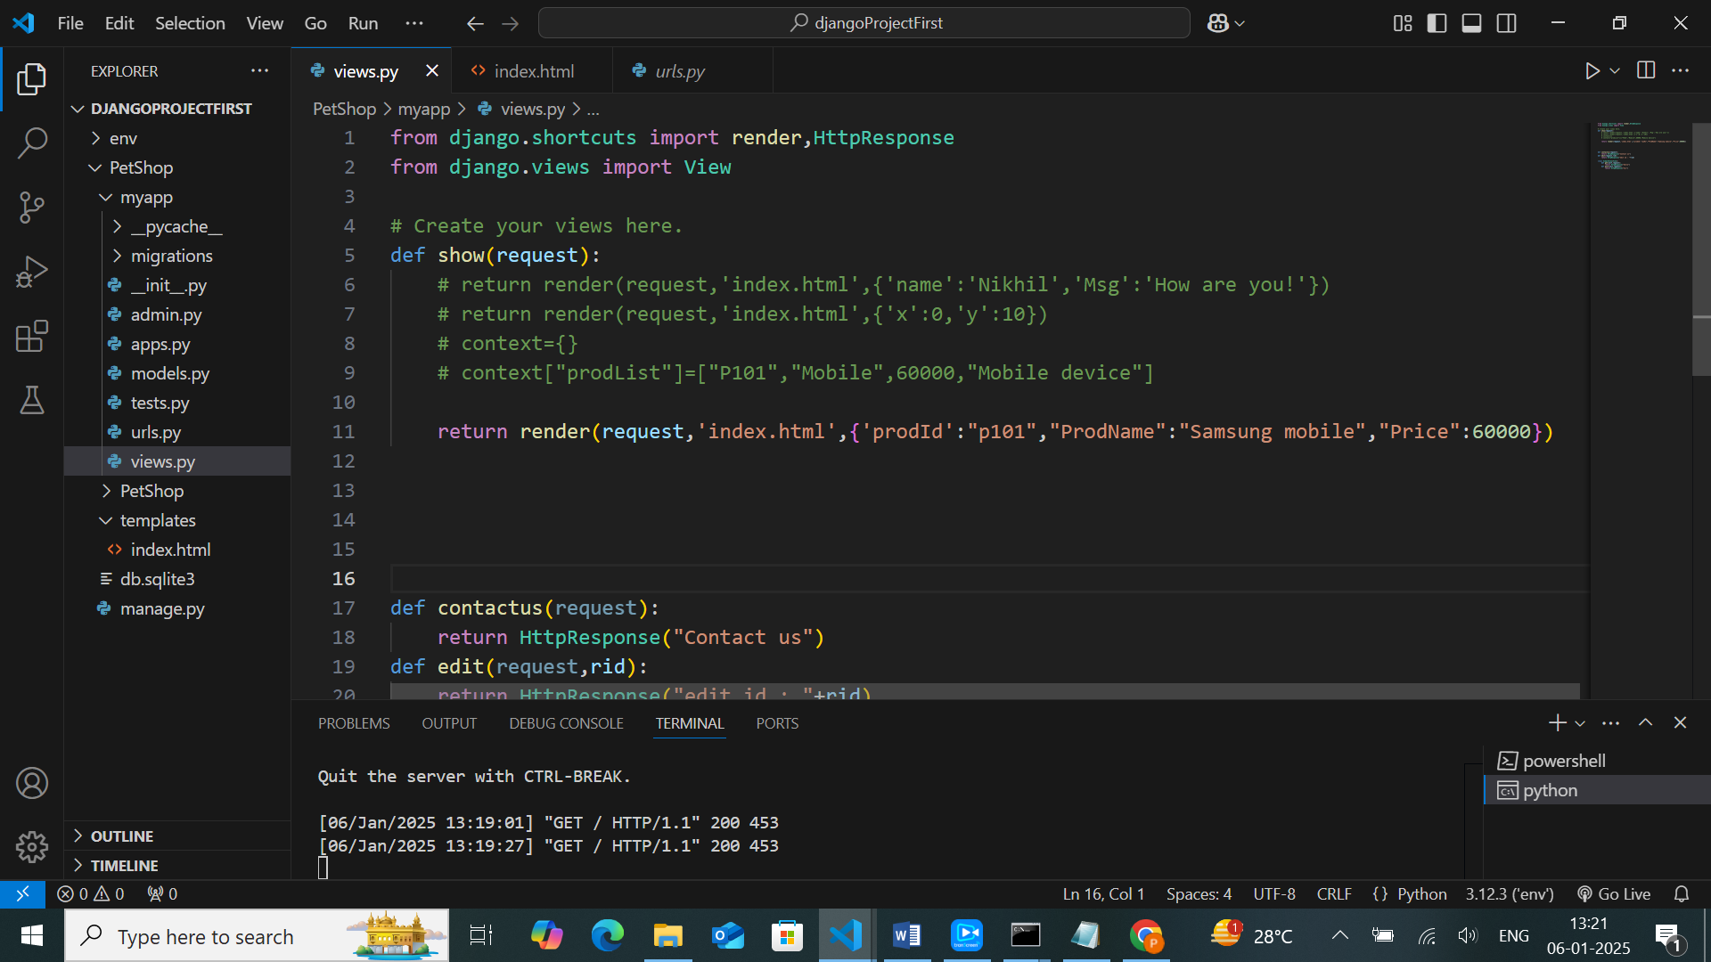

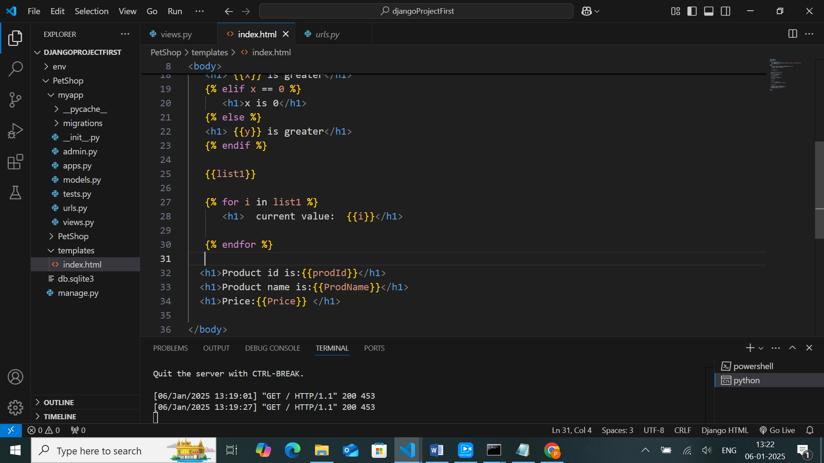

Include:
{% include ‘new.html’ %}
Include tag loads a template and renders it with current context
This is the way where we can include one template to another template

Date :
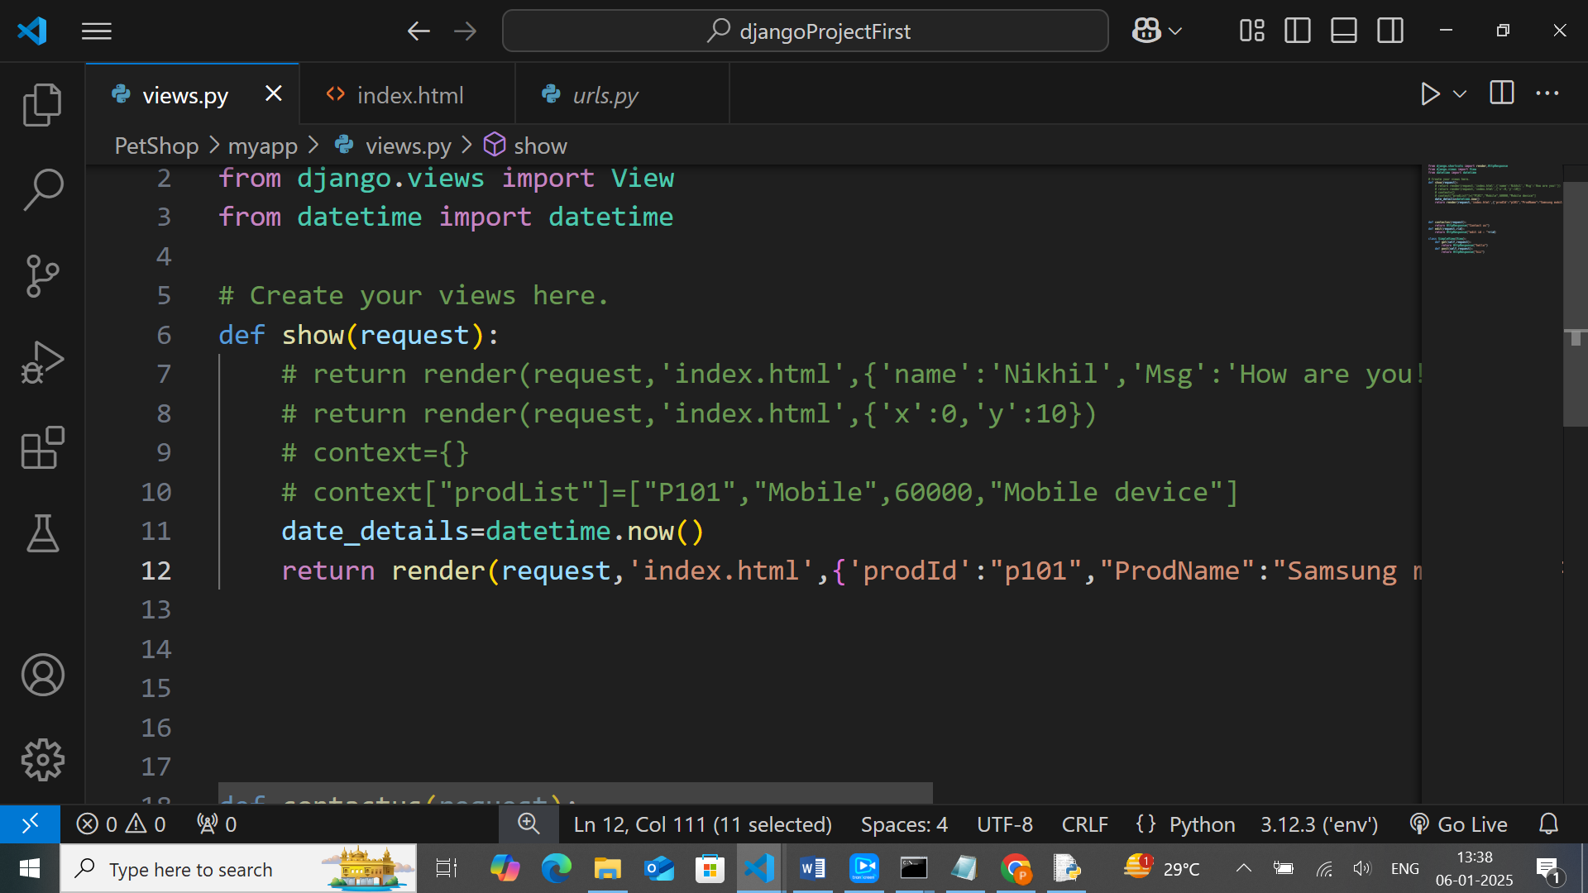
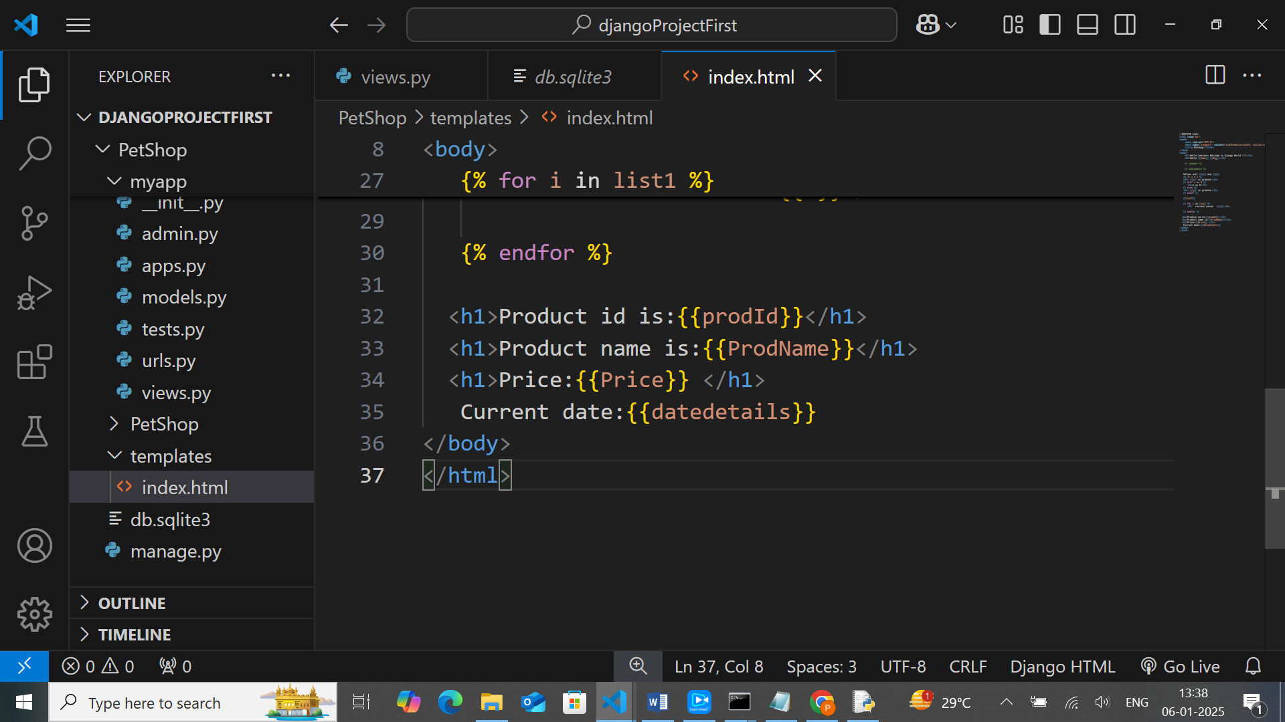

Jinja variable:
Variables, output a value from the context which is dict like object mapping,keys to values
{{ key }}->template show ->value

