Bike Riding Analysis Documentation

1.Project Overview:

This project analyzes bike riding data collected from multiple stations. The objective is to understand usage patterns, popular stations, peak riding hours, and overall performance using Advanced Excel and Power BI.

2.Dataset Description:

The dataset includes details such as Ride ID, Bike ID, Station Name, City, Rider Type, Ride Start Time, Ride End Time, Duration and Distance.

Column Name | Description
Ride_ID | Unique ride identifier
Bike_ID | Unique bike number
Station_Name | Pickup station
City | City name
Start_Time | Ride start time
End_Time | Ride end time
Duration_Min | Ride duration in minutes
Distance_KM | Distance covered
Rider_Type | Member / Casual

3.Advanced Excel Analysis:

Advanced Excel techniques used in this project include:
Data Cleaning using Filters and IF formulas
Ride Duration calculation using Excel formulas
Pivot Tables for station-wise and city-wise analysis
Charts for peak hours and top stations
VLOOKUP / XLOOKUP for station and bike mapping

4.Power BI Analysis
Power BI is used for interactive visualization and dashboards:
- Data model with Date and Station dimensions
- DAX measures for Total Rides, Avg Duration, Total Distance
- Slicers for City, Station, Rider Type
- Visuals: Bar charts, Line charts, Maps, KPI cards
DATA MODEL
One to Many
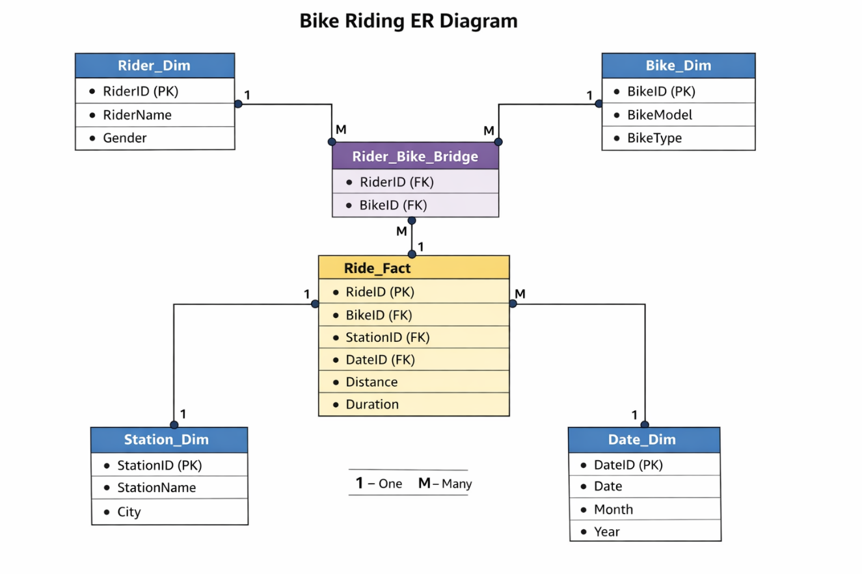

Many to Many

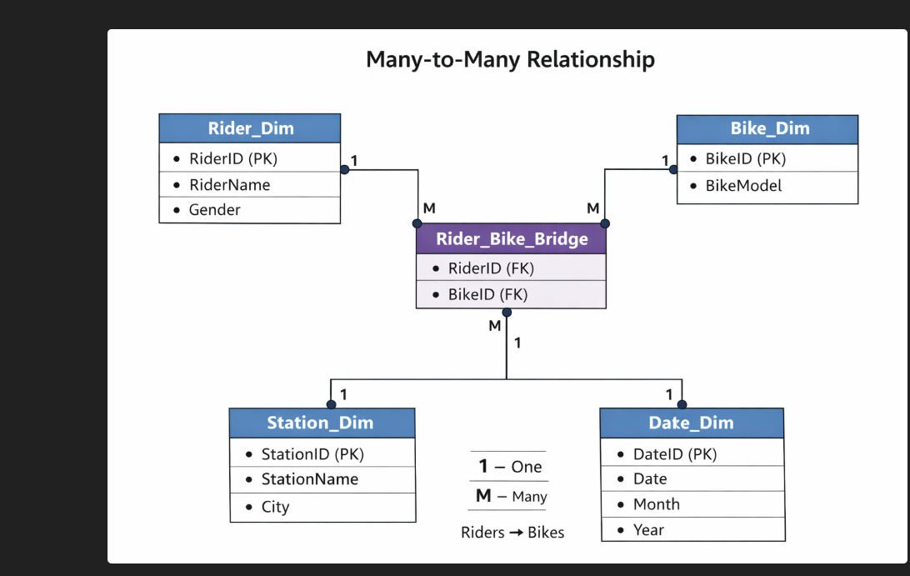

Tools Used

- Microsoft Excel (Advanced)
- Power BI Desktop
- CSV Dataset
- PDF Reporting

Advance Excel-Pivot Table,Pivot Chart
-------------------------------------
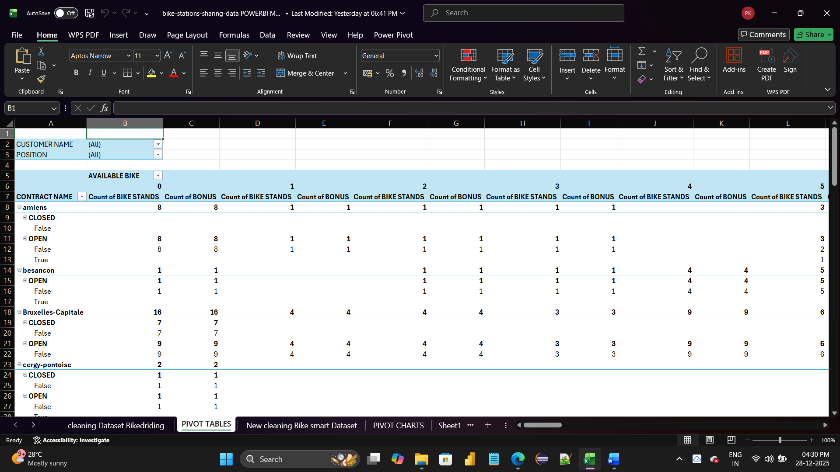

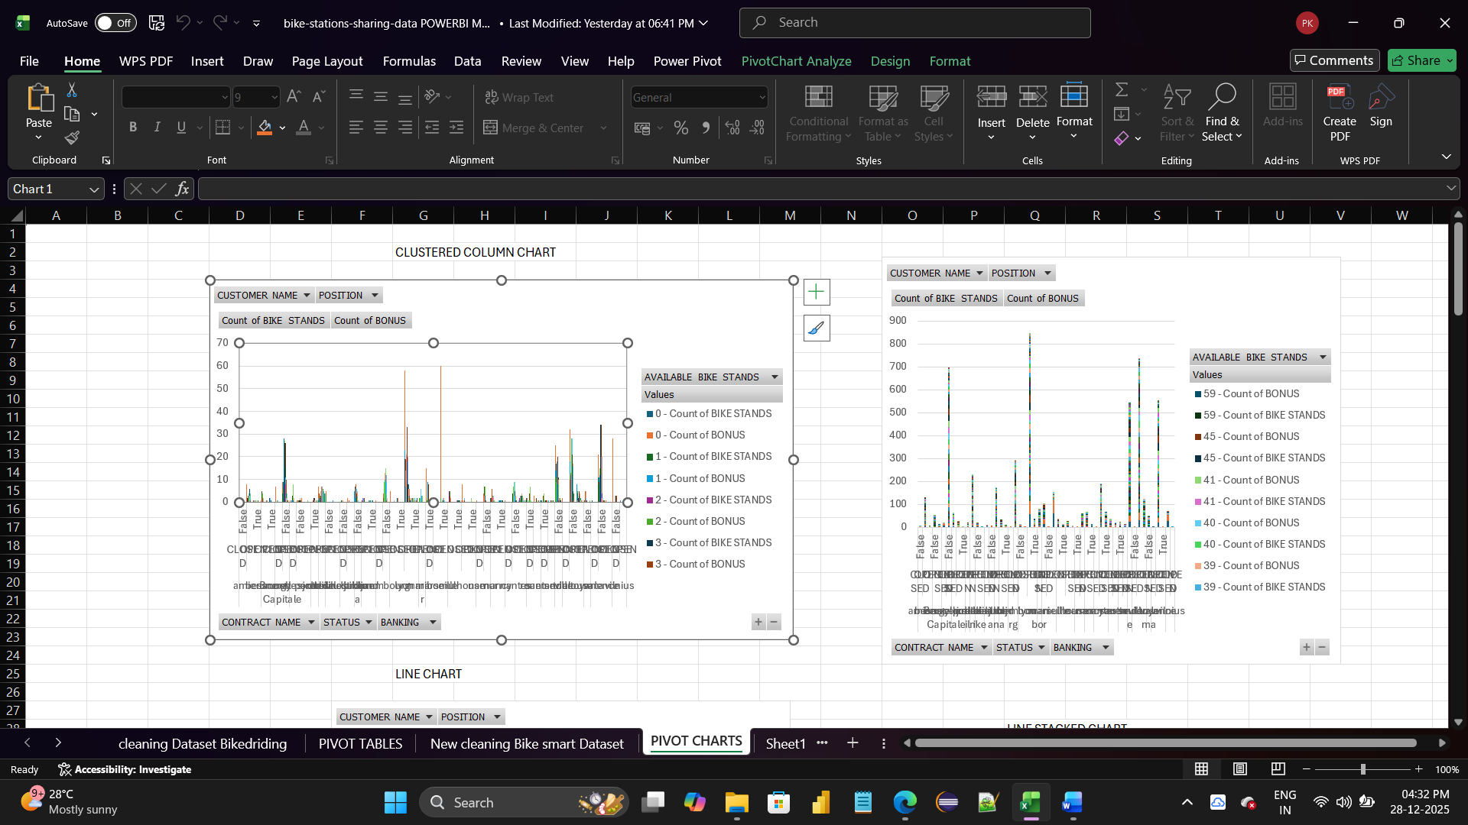

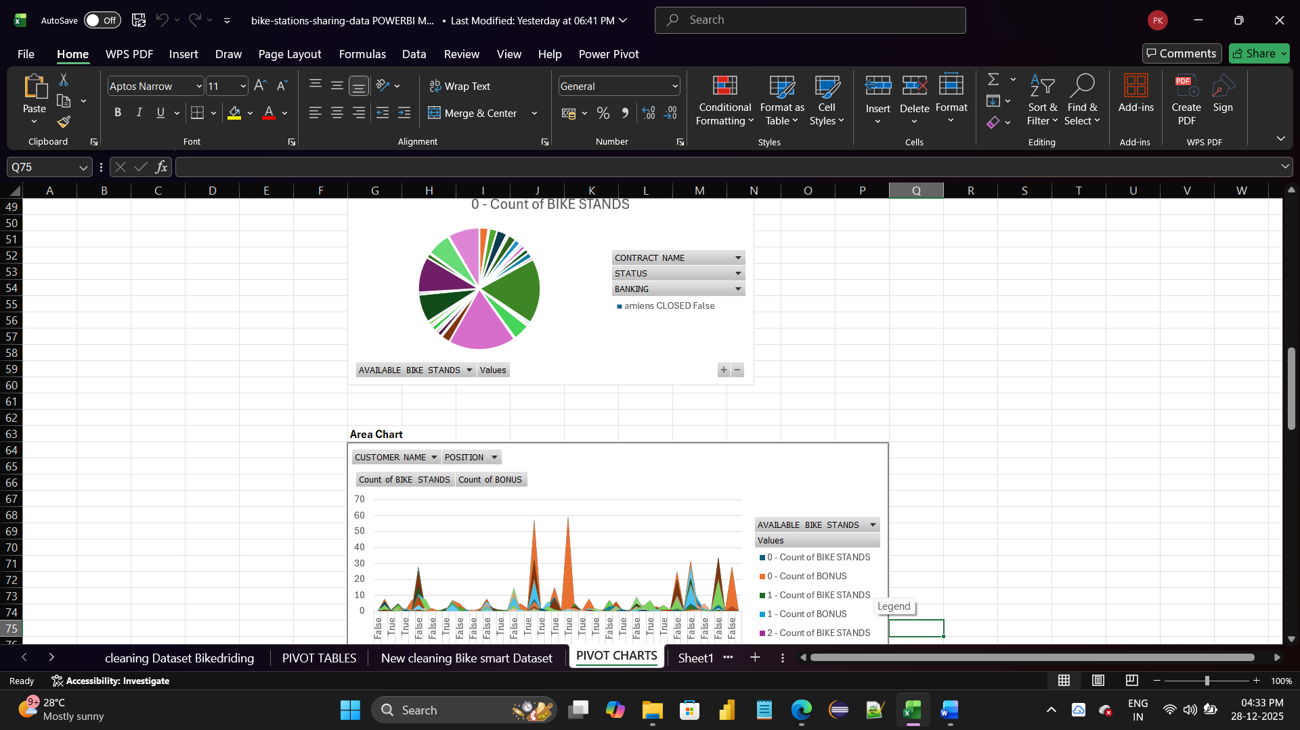

POWERBI
BEFORE BIKE RIDING VARIATION DASHBOARD REPORT:

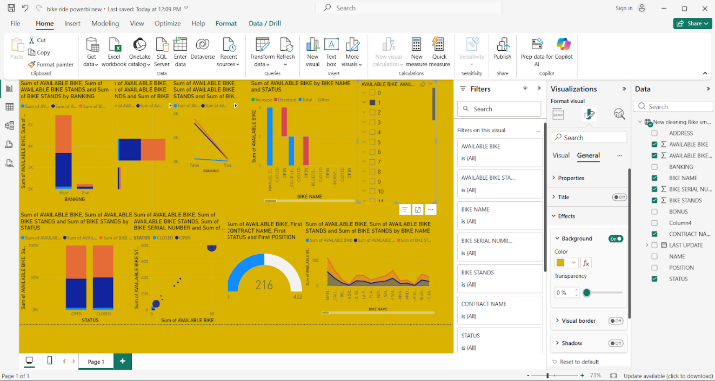

AFTER BIKE RIDING VARIATION STATUS REPORT
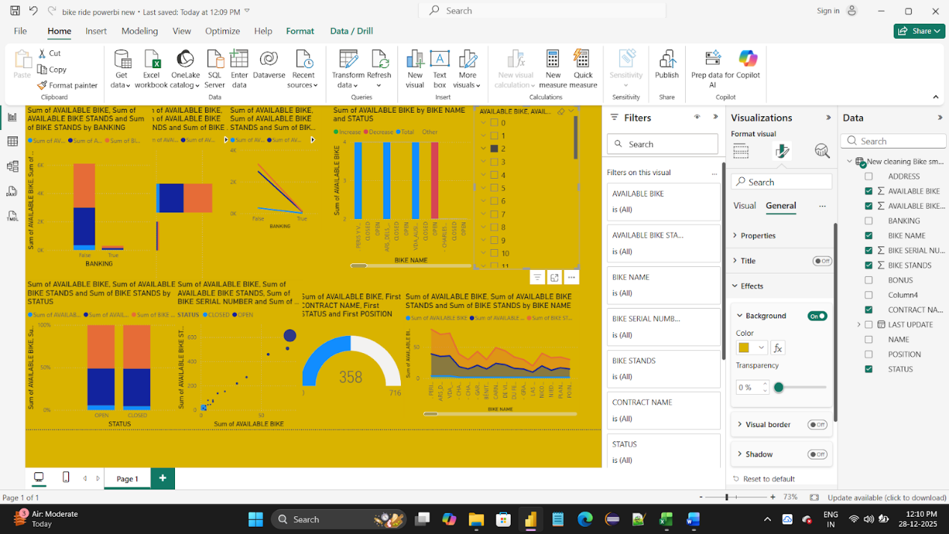

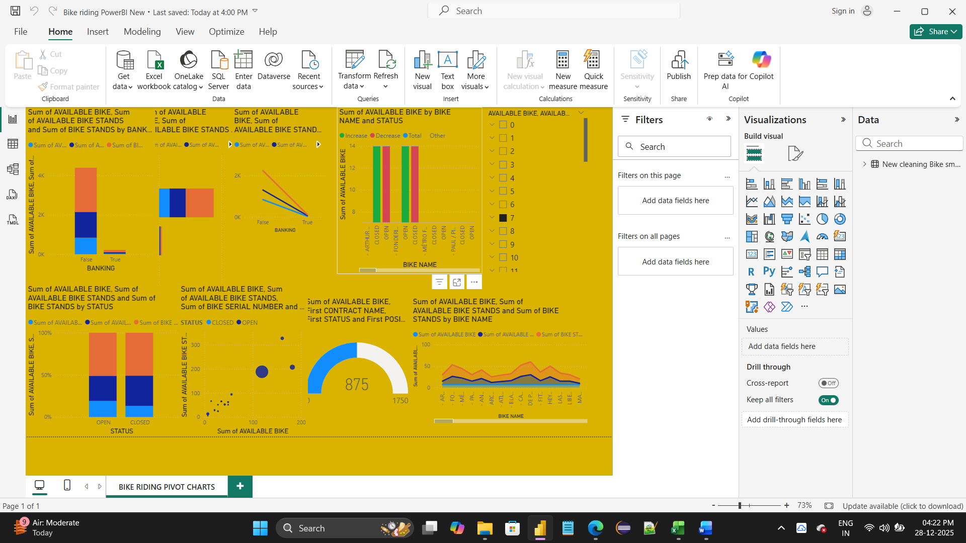

Key Insights

- Morning and evening hours show peak ride activity
- Metro stations have higher ride counts
- Member riders use bikes more frequently than casual riders
- Certain stations require more bike availability due to high demand

Conclusion:
This bike riding analysis helps stakeholders improve bike allocation, optimize station performance, and enhance customer experience. Advanced Excel supports detailed analysis, while Power BI provides interactive insights for decision-making.

