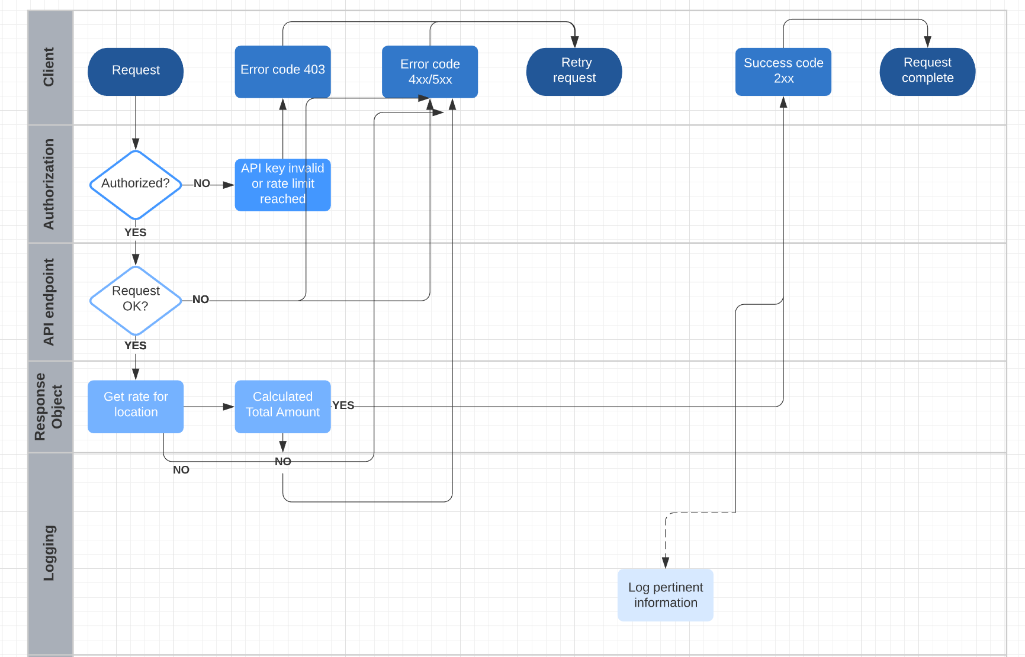

Implementation:

I created two classes RatesForLocation to get tax based on zipcode and TaxForOrder by passing TaxOrderRequest object to get total tax for an order in TaxService method.

Future Enhancements:

1. I declared TaxJarApi in appsettings.json but you can add it in KeyVault in Azure
2. You implement application error logs
3. You can also implement several taxcalulators based on client requirement