DATA DIGGER
E-Commerce Relational Database Architecture & Query Implementation
Student Name | Priyal Patel
Course & Subject | SQL & Relational Database Management System (RDBMS)
DBMS Platform | MySQL Server & phpMyAdmin (Apache / XAMPP)
GitHub Repository | github.com/priyal-24/Data-Digger
――――――――――――――――――――――――――――――――――――――――――――――――――
Executive Summary & Overview
Data Digger is a comprehensive relational database system designed to simulate core e-commerce backend operations. The schema integrates four relational entities (Customers, Orders, Products, and OrderDetails) enforcing primary and foreign key constraints. This practical report documents full end-to-end execution of DDL schema definitions, CRUD operations, date-interval queries, aggregate metrics, and multi-table relational JOINs.

1. DATABASE SCHEMA & TABLE CREATION

● 1.1 Create Customers Table
CREATE TABLE Customers (
CustomerID INT AUTO_INCREMENT PRIMARY KEY,
Name VARCHAR(100),
Email VARCHAR(100),
Address VARCHAR(255)
);

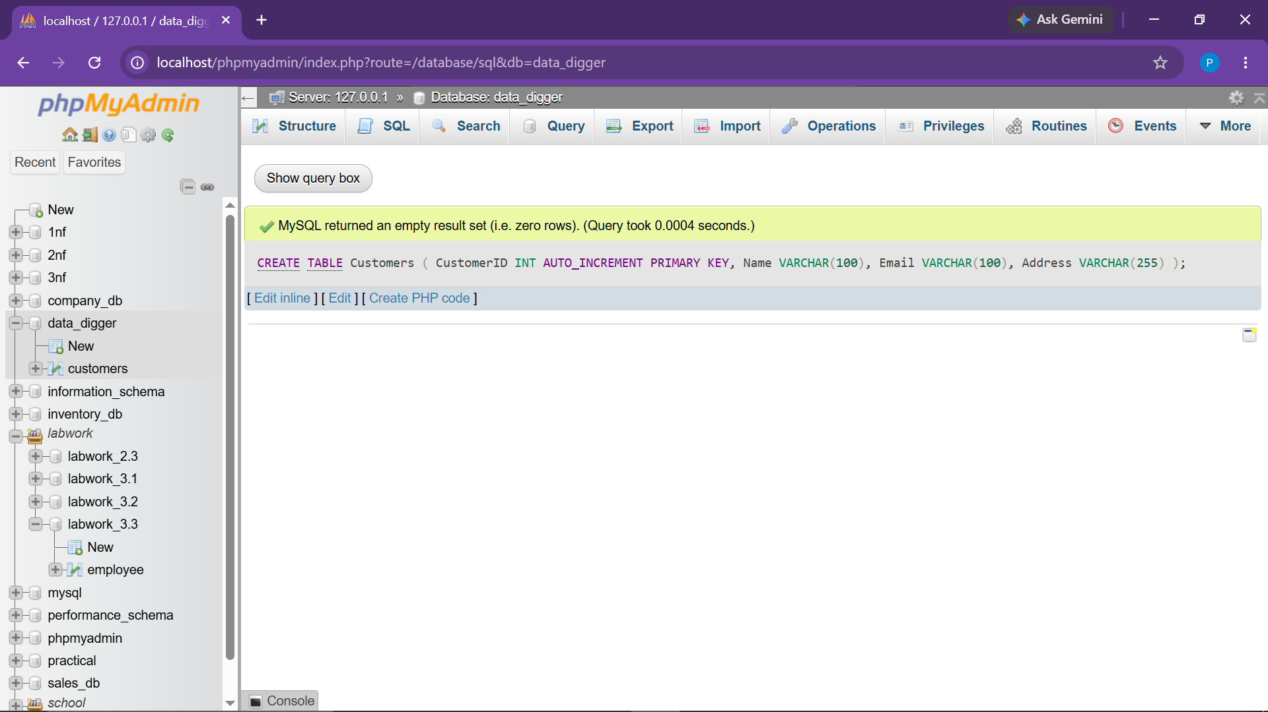

● 1.2 Create Orders Table
CREATE TABLE Orders (
OrderID INT AUTO_INCREMENT PRIMARY KEY,
CustomerID INT,
OrderDate DATE,
TotalAmount DECIMAL(10, 2),
FOREIGN KEY (CustomerID) REFERENCES Customers(CustomerID)
);

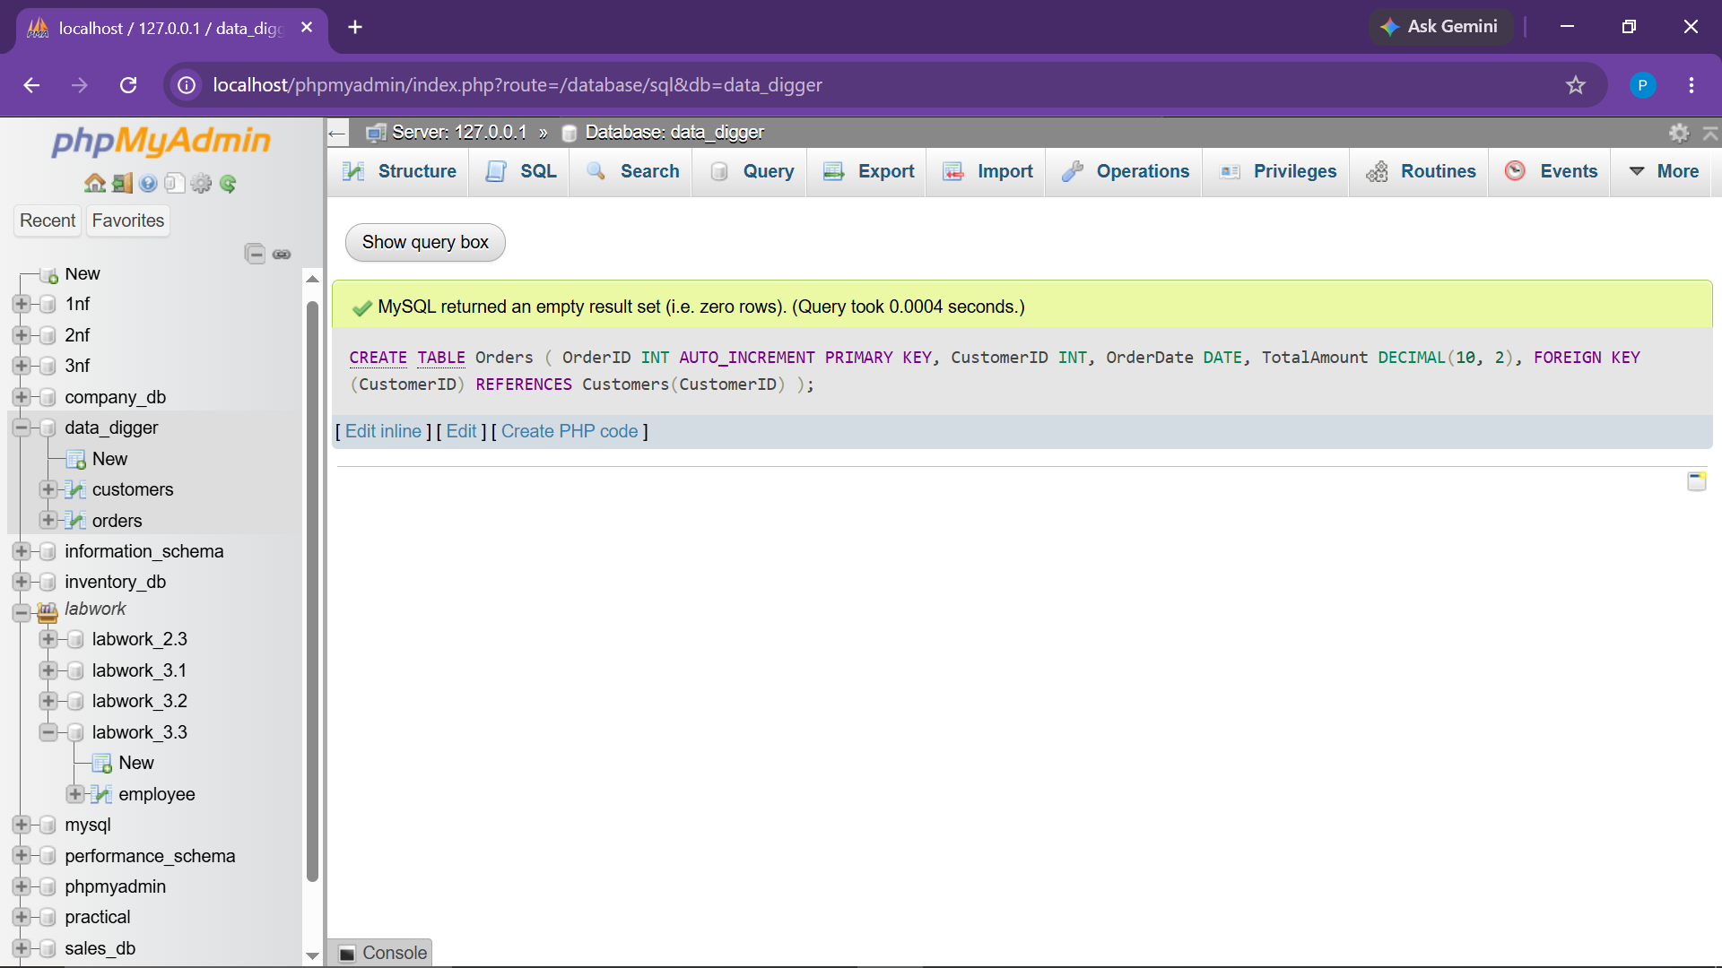

● 1.3 Create Products Table
CREATE TABLE Products (
ProductID INT AUTO_INCREMENT PRIMARY KEY,
ProductName VARCHAR(100),
Price DECIMAL(10, 2),
Stock INT
);

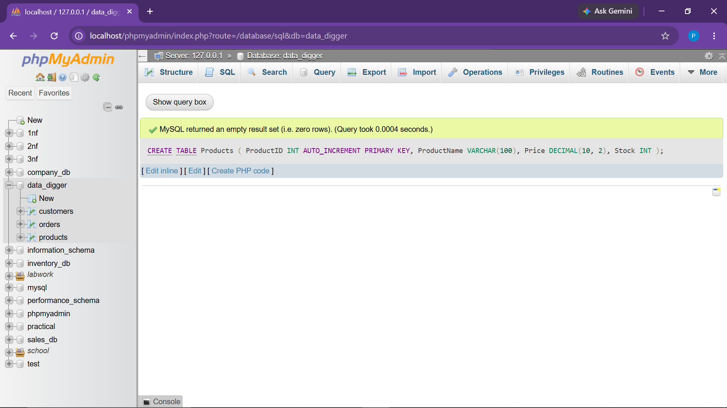

● 1.4 Create OrderDetails Table
CREATE TABLE OrderDetails (
OrderDetailID INT AUTO_INCREMENT PRIMARY KEY,
OrderID INT,
ProductID INT,
Quantity INT,
SubTotal DECIMAL(10, 2),
FOREIGN KEY (OrderID) REFERENCES Orders(OrderID),
FOREIGN KEY (ProductID) REFERENCES Products(ProductID)
);

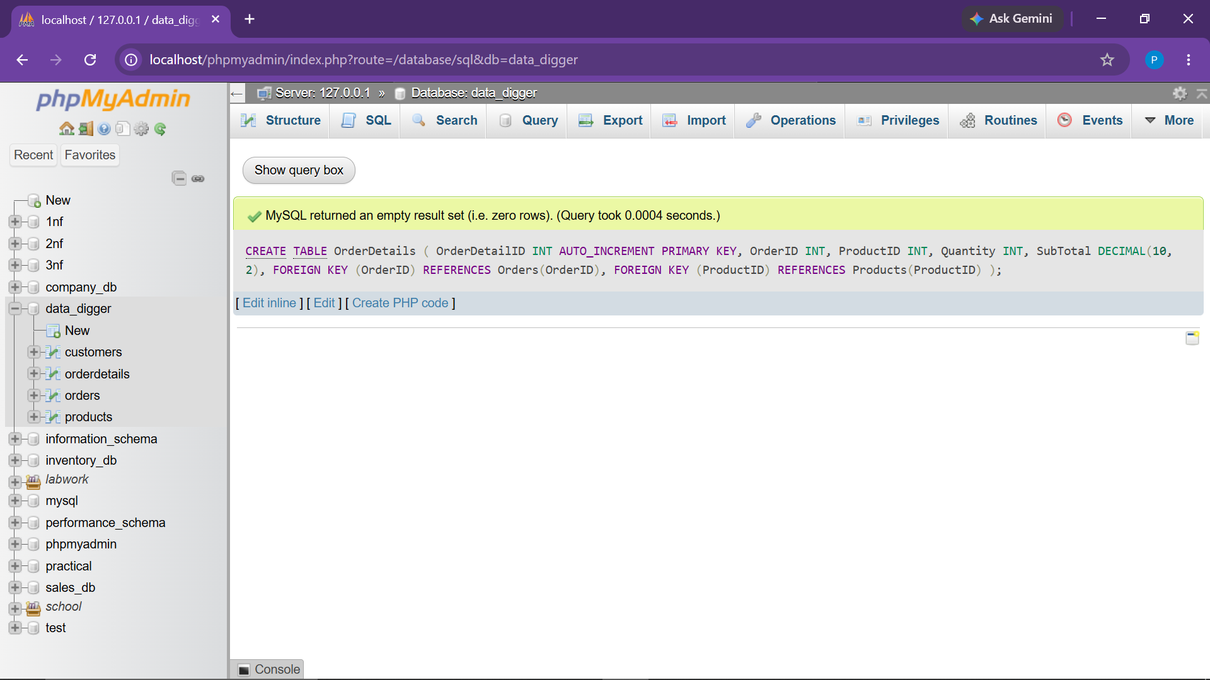

2. CUSTOMERS TABLE - DATA MANIPULATION & QUERIES

● 2.1 Insert Records into Customers
INSERT INTO Customers (Name, Email, Address) VALUES
('Alice', 'alice@example.com', '123 MG Road, Mumbai'),
('Bob Smith', 'bob@example.com', '456 Park Avenue, Delhi'),
('Charlie Brown', 'charlie@example.com', '789 Ring Road, Bangalore'),
('Alice', 'alice.wonder@example.com', '12 Lake View, Pune'),
('David Warner', 'david@example.com', '34 Civil Lines, Jaipur');

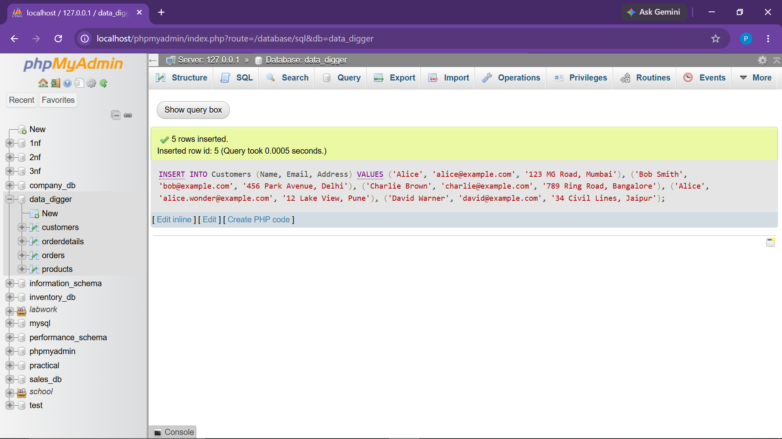

● 2.2 Retrieve All Customers
SELECT * FROM Customers;

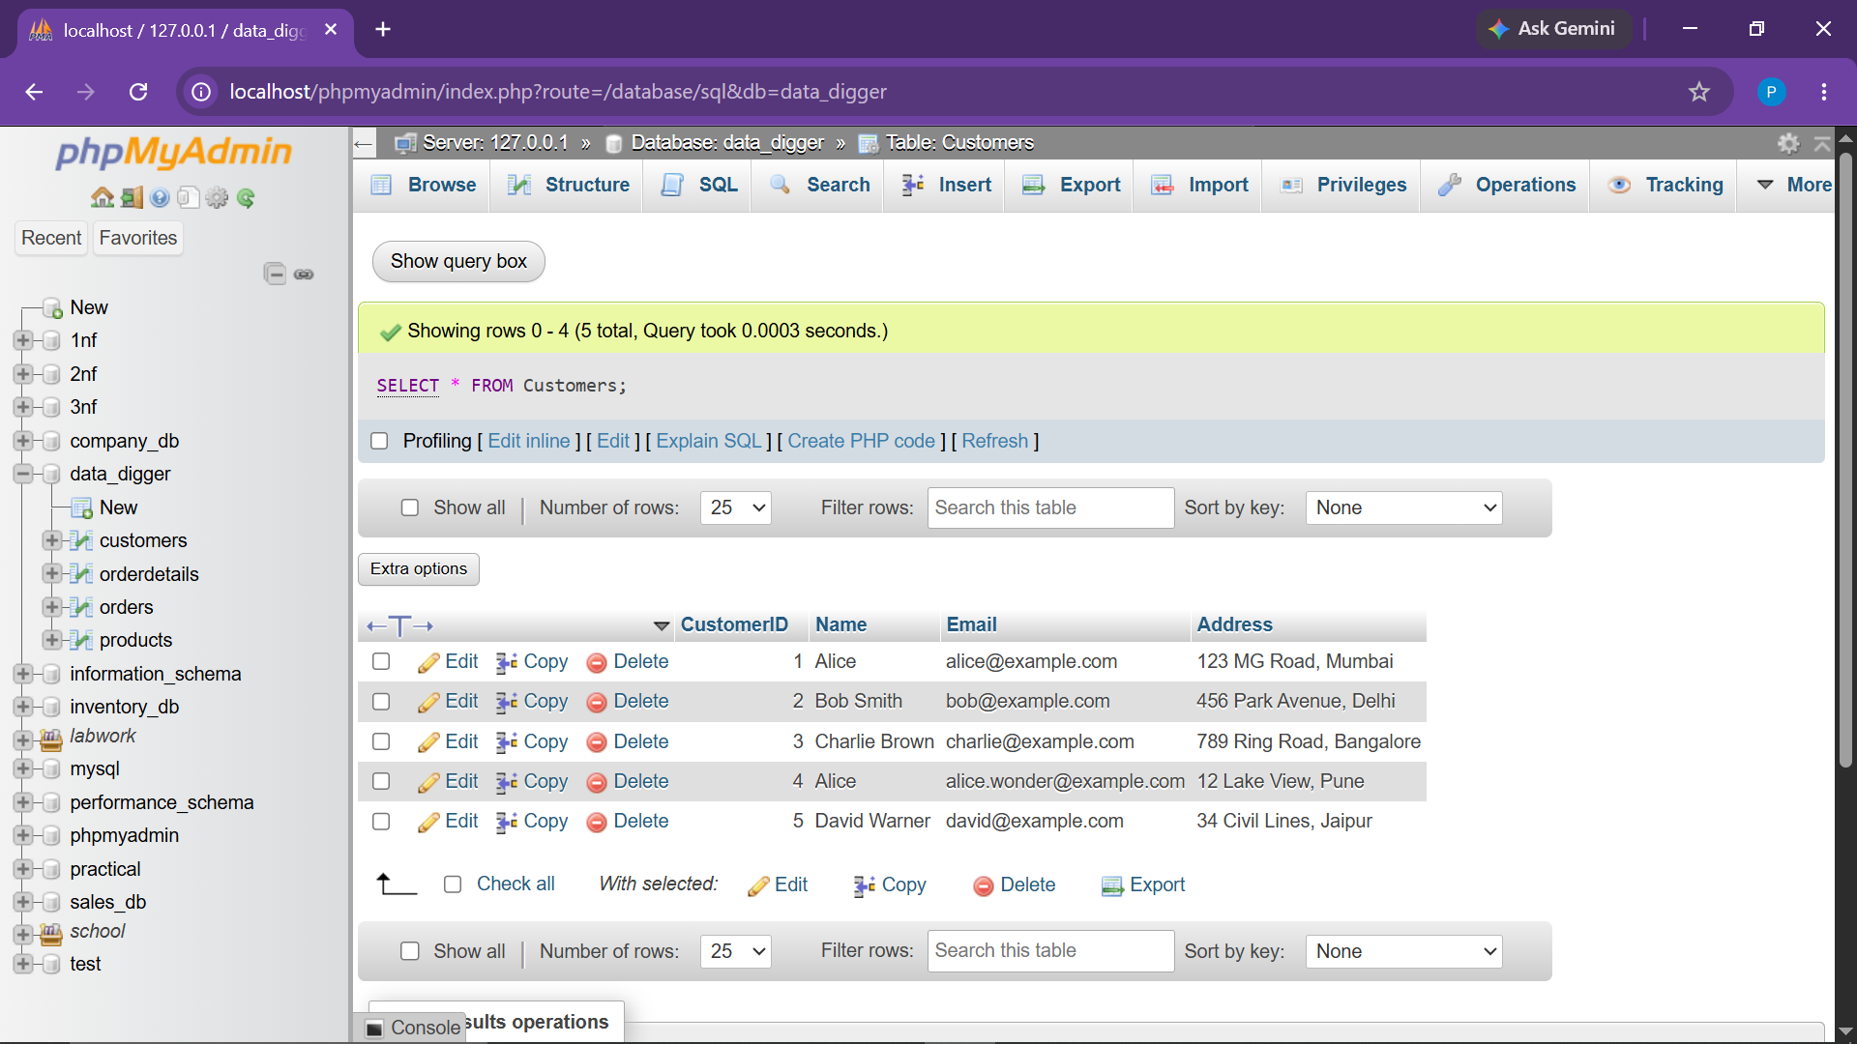

● 2.3 Update Customer Address (CustomerID = 1)
UPDATE Customers
SET Address = '999 New Residency, Mumbai'
WHERE CustomerID = 1;

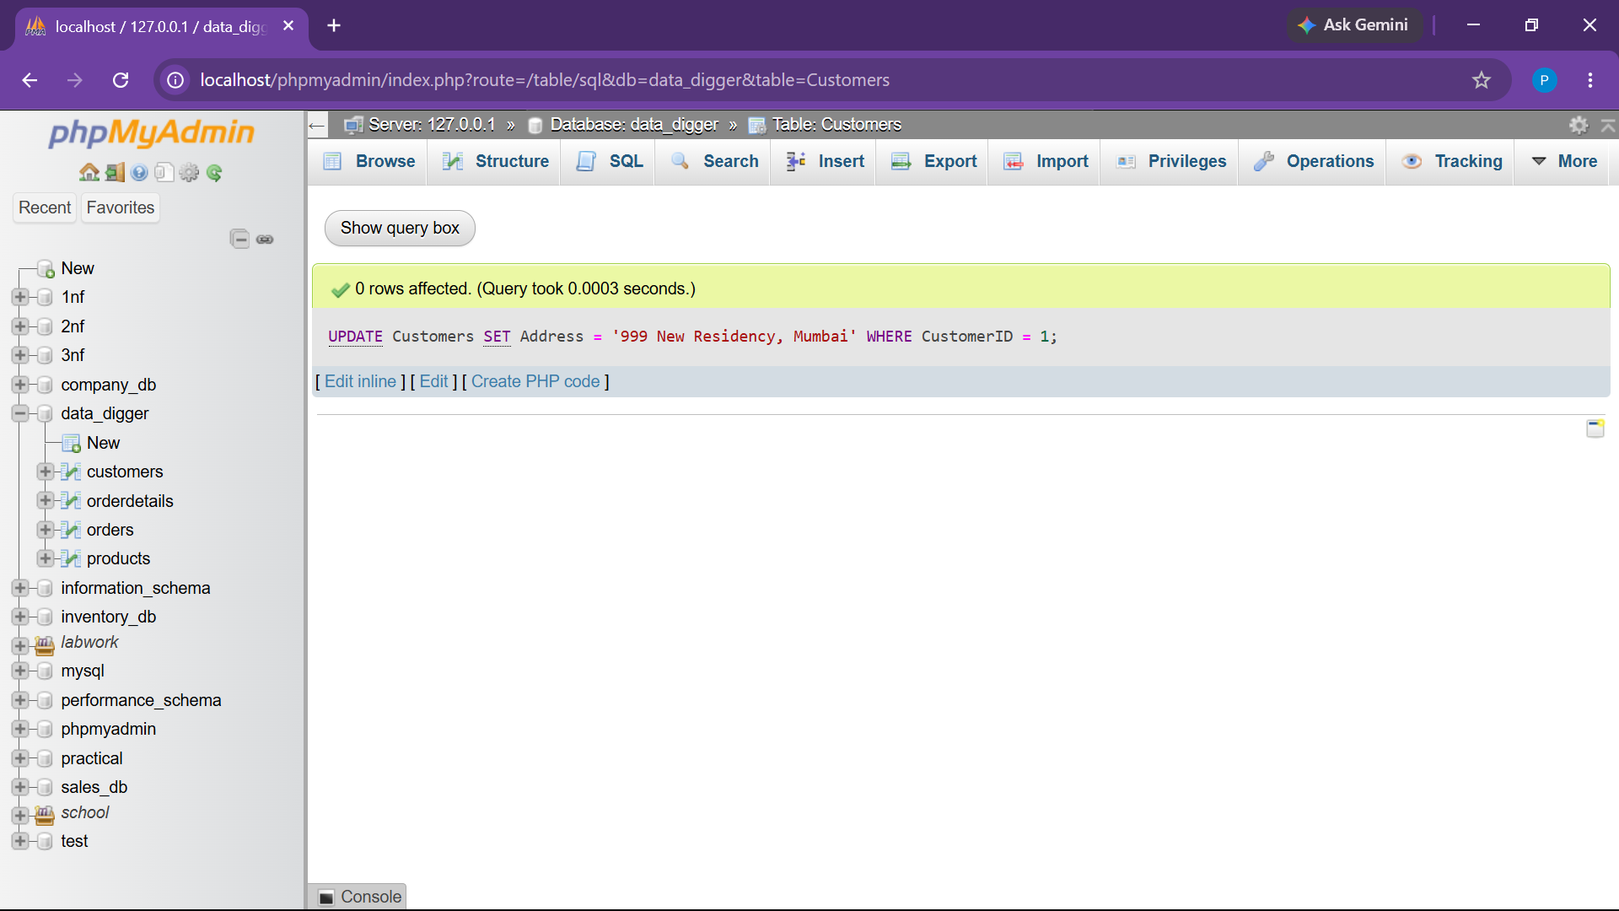

● 2.4 Delete a Customer using CustomerID (CustomerID = 5)
DELETE FROM Customers
WHERE CustomerID = 5;

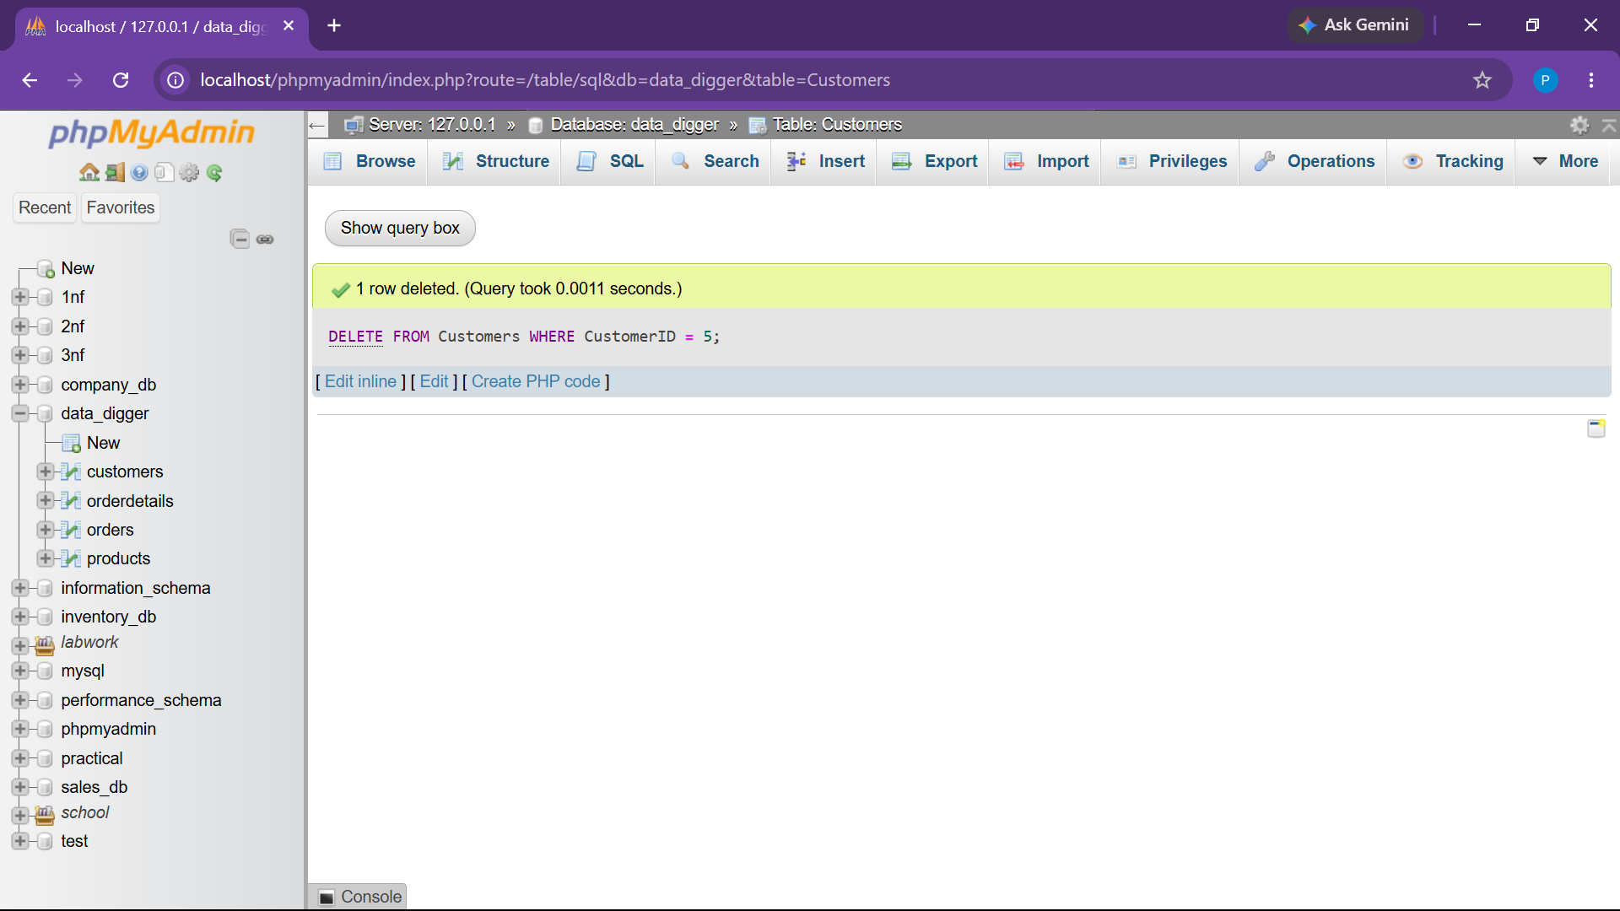

● 2.5 Retrieve Customers by Name ('Alice')
SELECT * FROM Customers
WHERE Name = 'Alice';

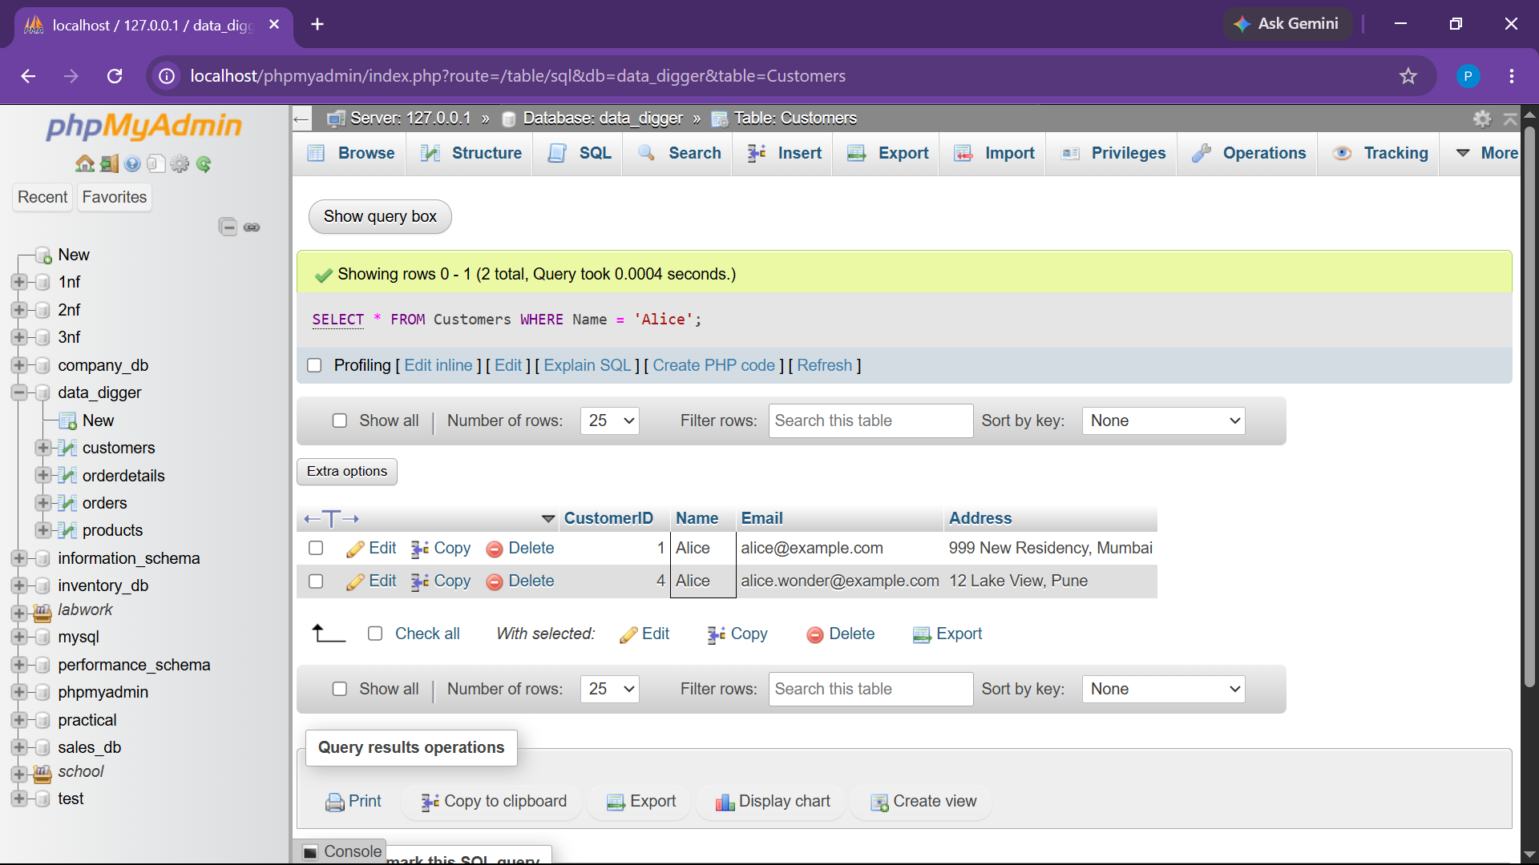

3. ORDERS TABLE - DATA MANIPULATION & QUERIES

● 3.1 Insert Sample Records into Orders
INSERT INTO Orders (CustomerID, OrderDate, TotalAmount) VALUES
(1, CURDATE(), 2500.00),
(2, DATE_SUB(CURDATE(), INTERVAL 10 DAY), 1200.00),
(3, DATE_SUB(CURDATE(), INTERVAL 25 DAY), 4500.00),
(1, DATE_SUB(CURDATE(), INTERVAL 45 DAY), 800.00),
(4, CURDATE(), 1500.00);

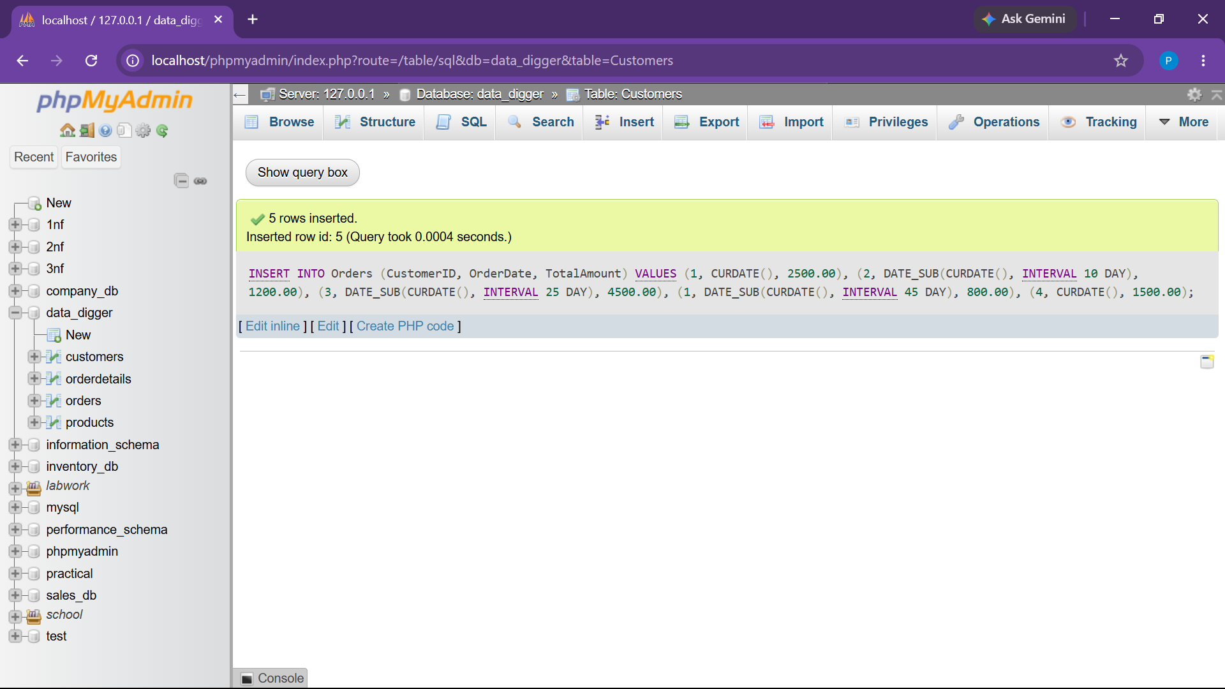

● 3.2 Retrieve Orders for a Specific Customer (CustomerID = 1)
SELECT * FROM Orders
WHERE CustomerID = 1;

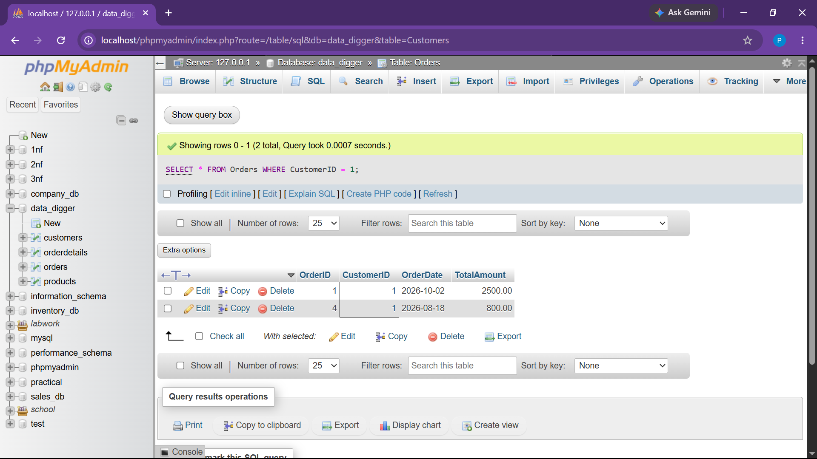

● 3.3 Update TotalAmount for Specific Order (OrderID = 1)
UPDATE Orders
SET TotalAmount = 2800.00
WHERE OrderID = 1;

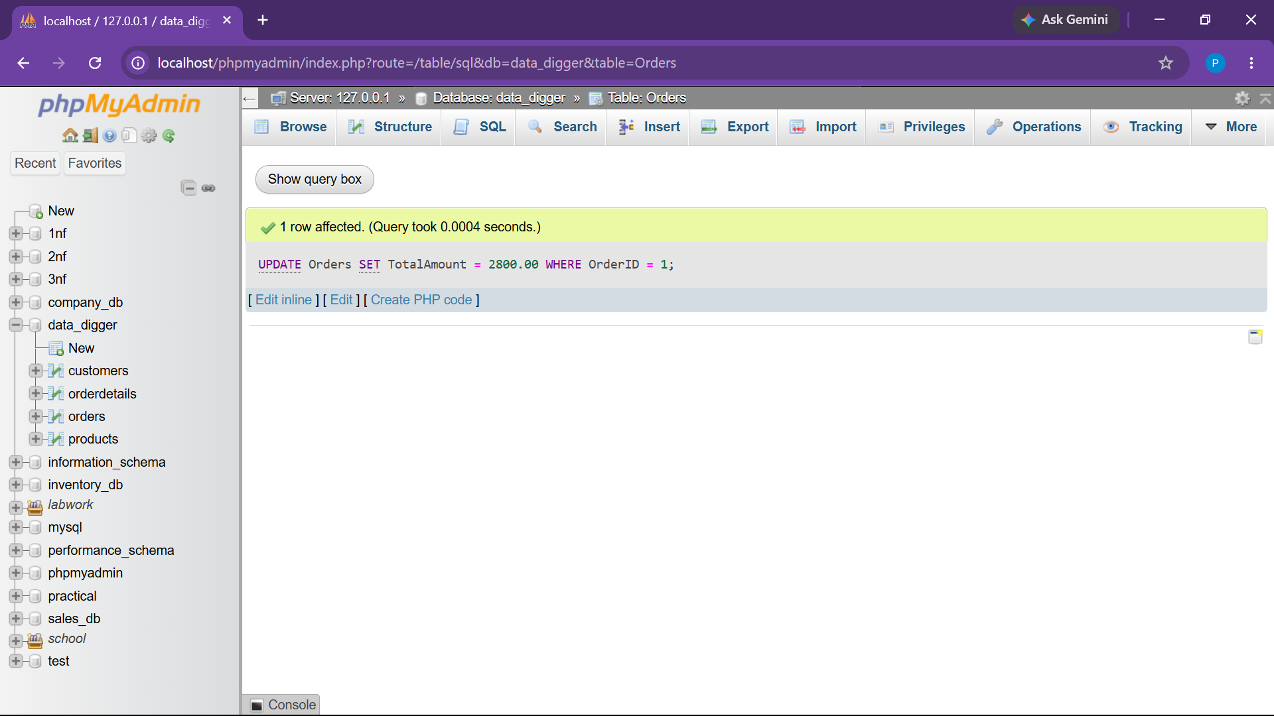

● 3.4 Delete an Order using its OrderID (OrderID = 5)
DELETE FROM Orders
WHERE OrderID = 5;

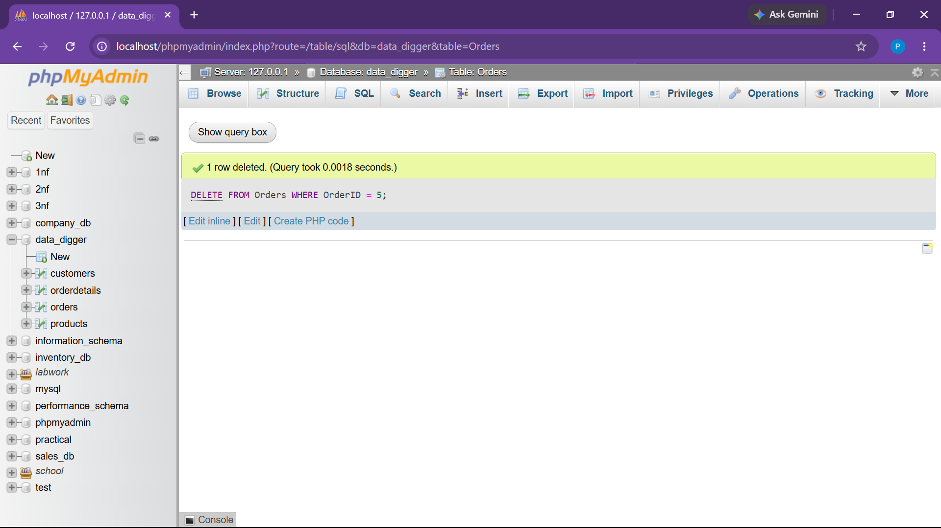

● 3.5 Retrieve Orders Placed in the Last 30 Days
SELECT * FROM Orders
WHERE OrderDate >= DATE_SUB(CURDATE(), INTERVAL 30 DAY);

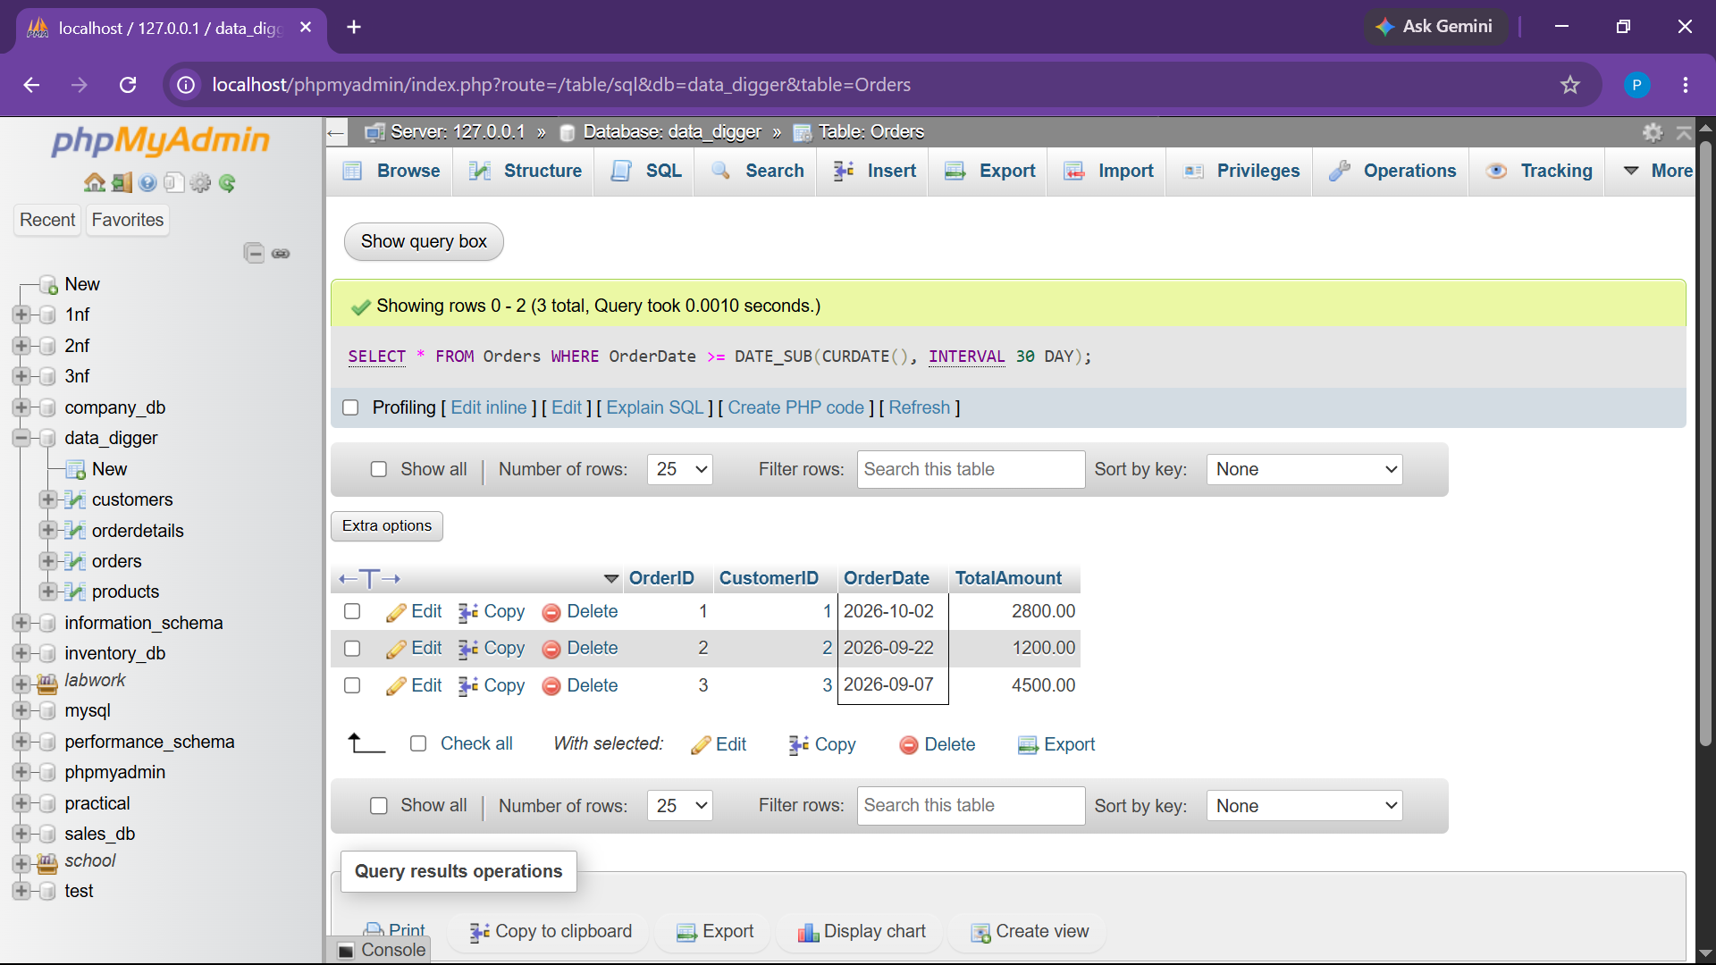

● 3.6 Retrieve the Highest, Lowest, and Average Order Amount using Aggregate Functions
SELECT
MAX(TotalAmount) AS HighestOrderAmount,
MIN(TotalAmount) AS LowestOrderAmount,
AVG(TotalAmount) AS AverageOrderAmount
FROM Orders;

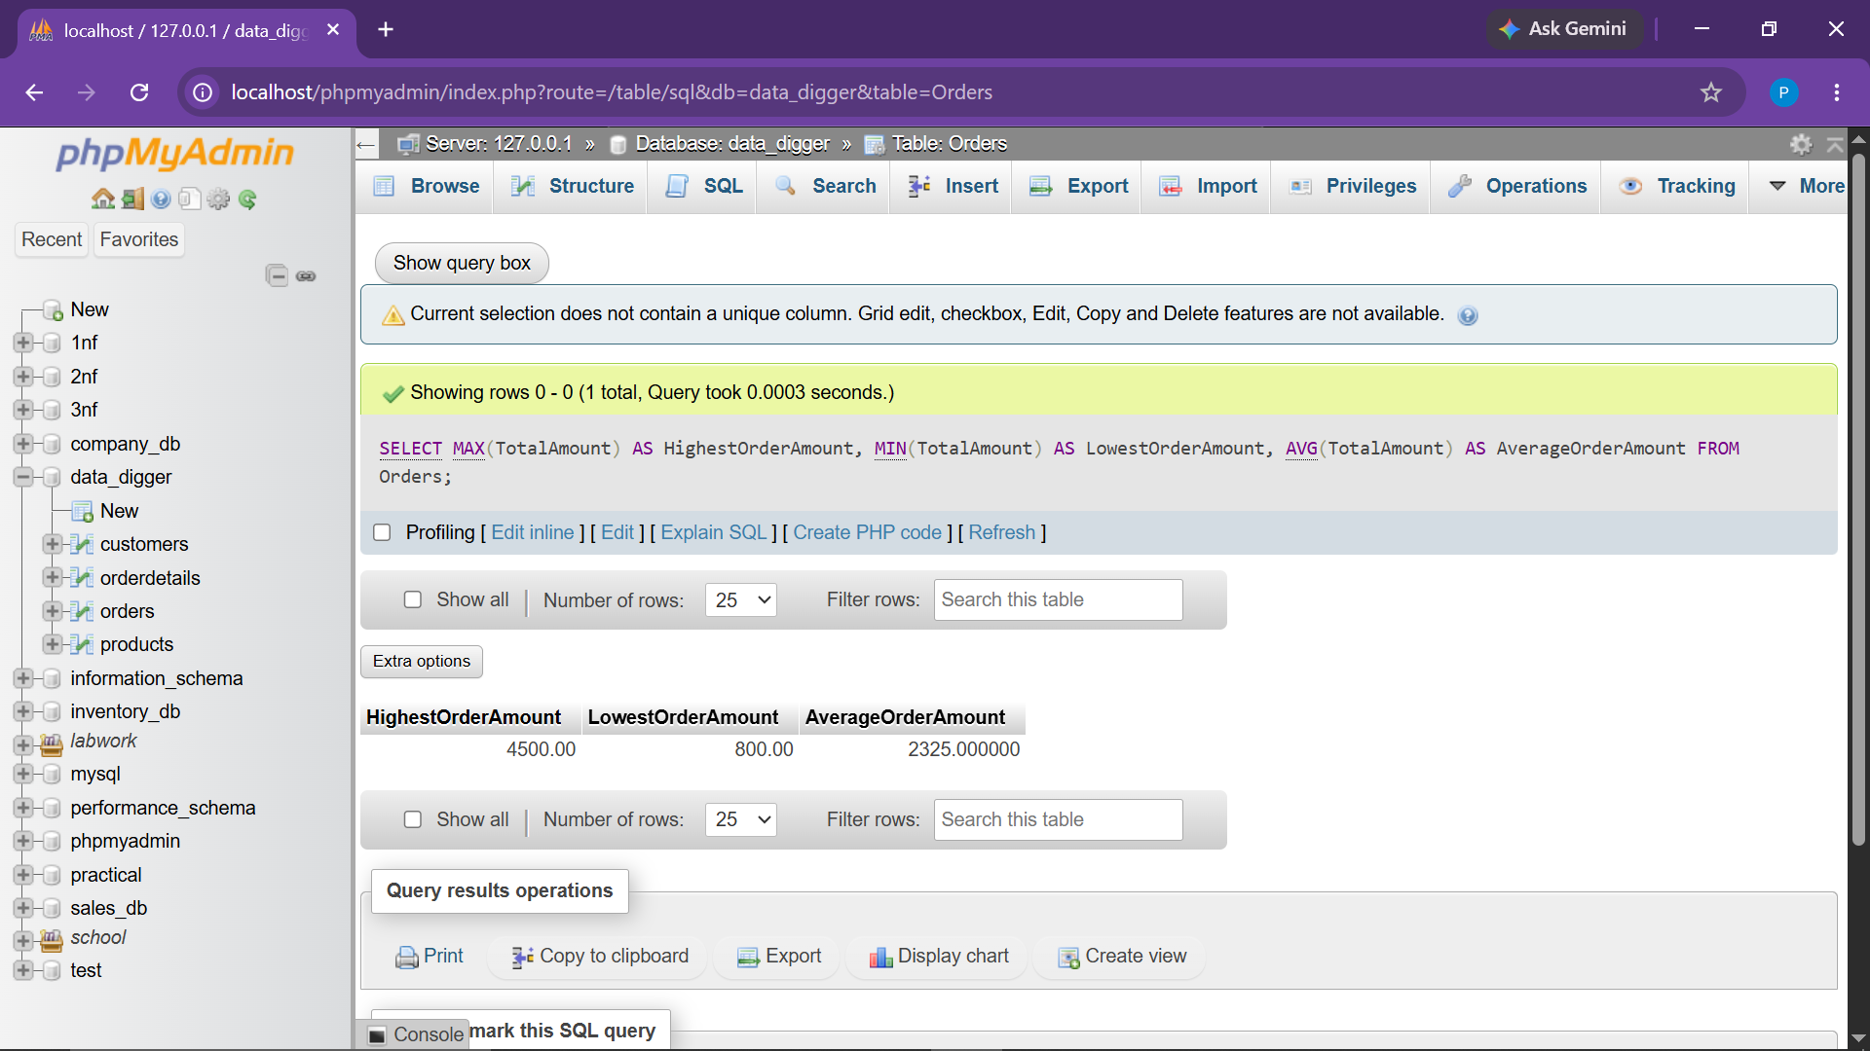

4. PRODUCTS TABLE - DATA MANIPULATION & ANALYSIS

● 4.1 Insert at least 5 sample products into the Products table
INSERT INTO Products (ProductName, Price, Stock) VALUES
('Wireless Mouse', 650.00, 50),
('Mechanical Keyboard', 1800.00, 20),
('USB-C Hub', 450.00, 0), -- Out of stock
('Gaming Headset', 2200.00, 15),
('Bluetooth Speaker', 1200.00, 30);

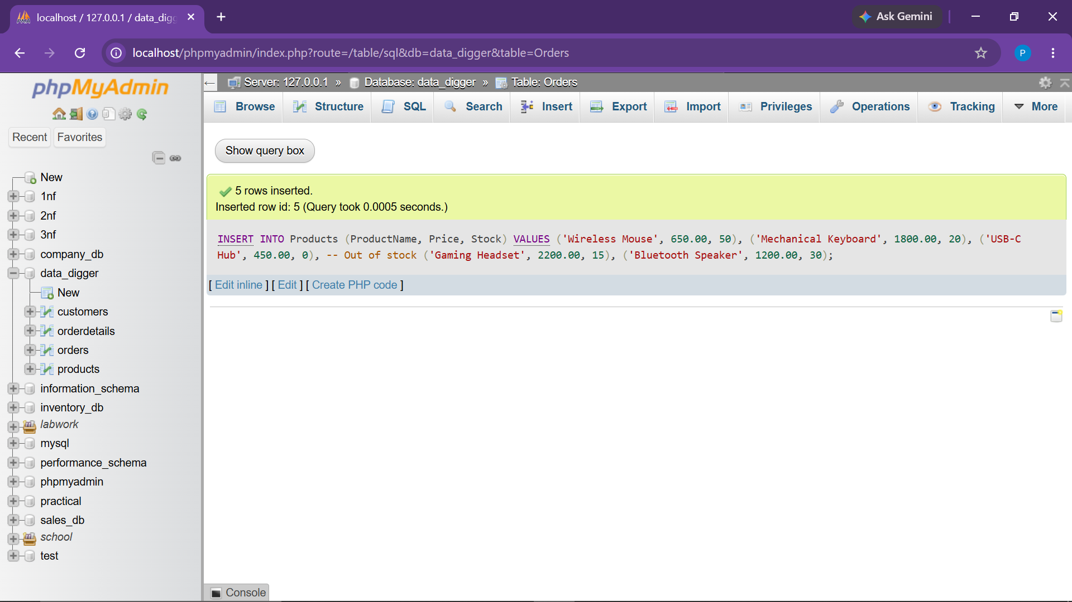

● 4.2 Retrieve all products sorted by price in descending order
SELECT * FROM Products
ORDER BY Price DESC;

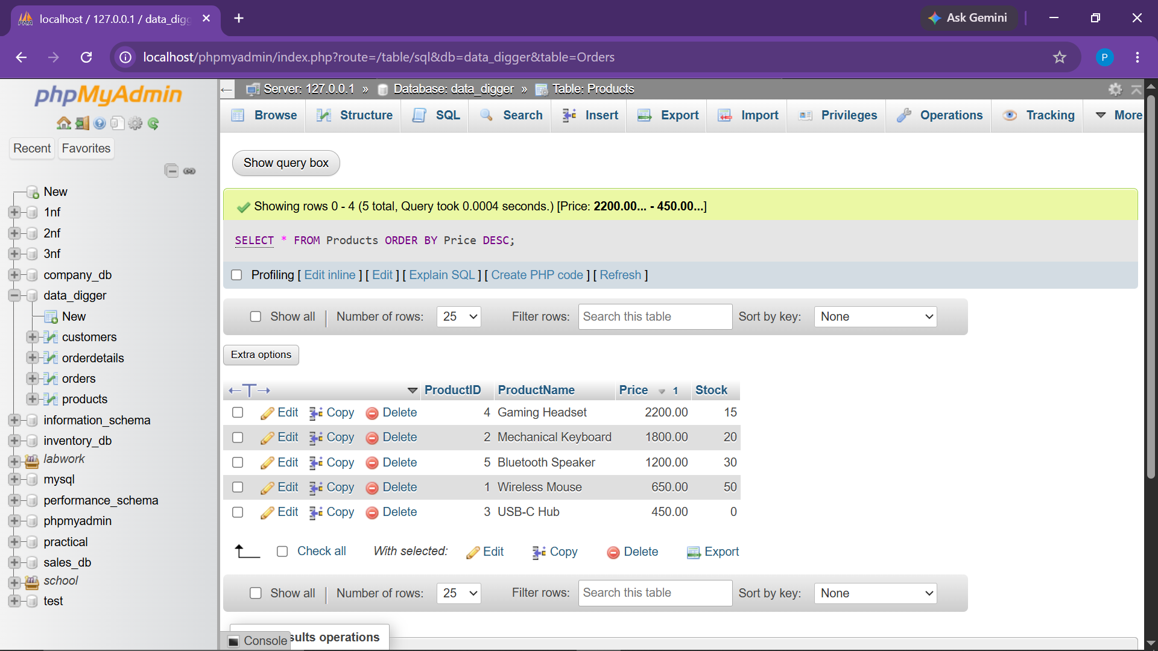

● 4.3 Update the price of a specific product
UPDATE Products
SET Price = 1950.00
WHERE ProductID = 2;

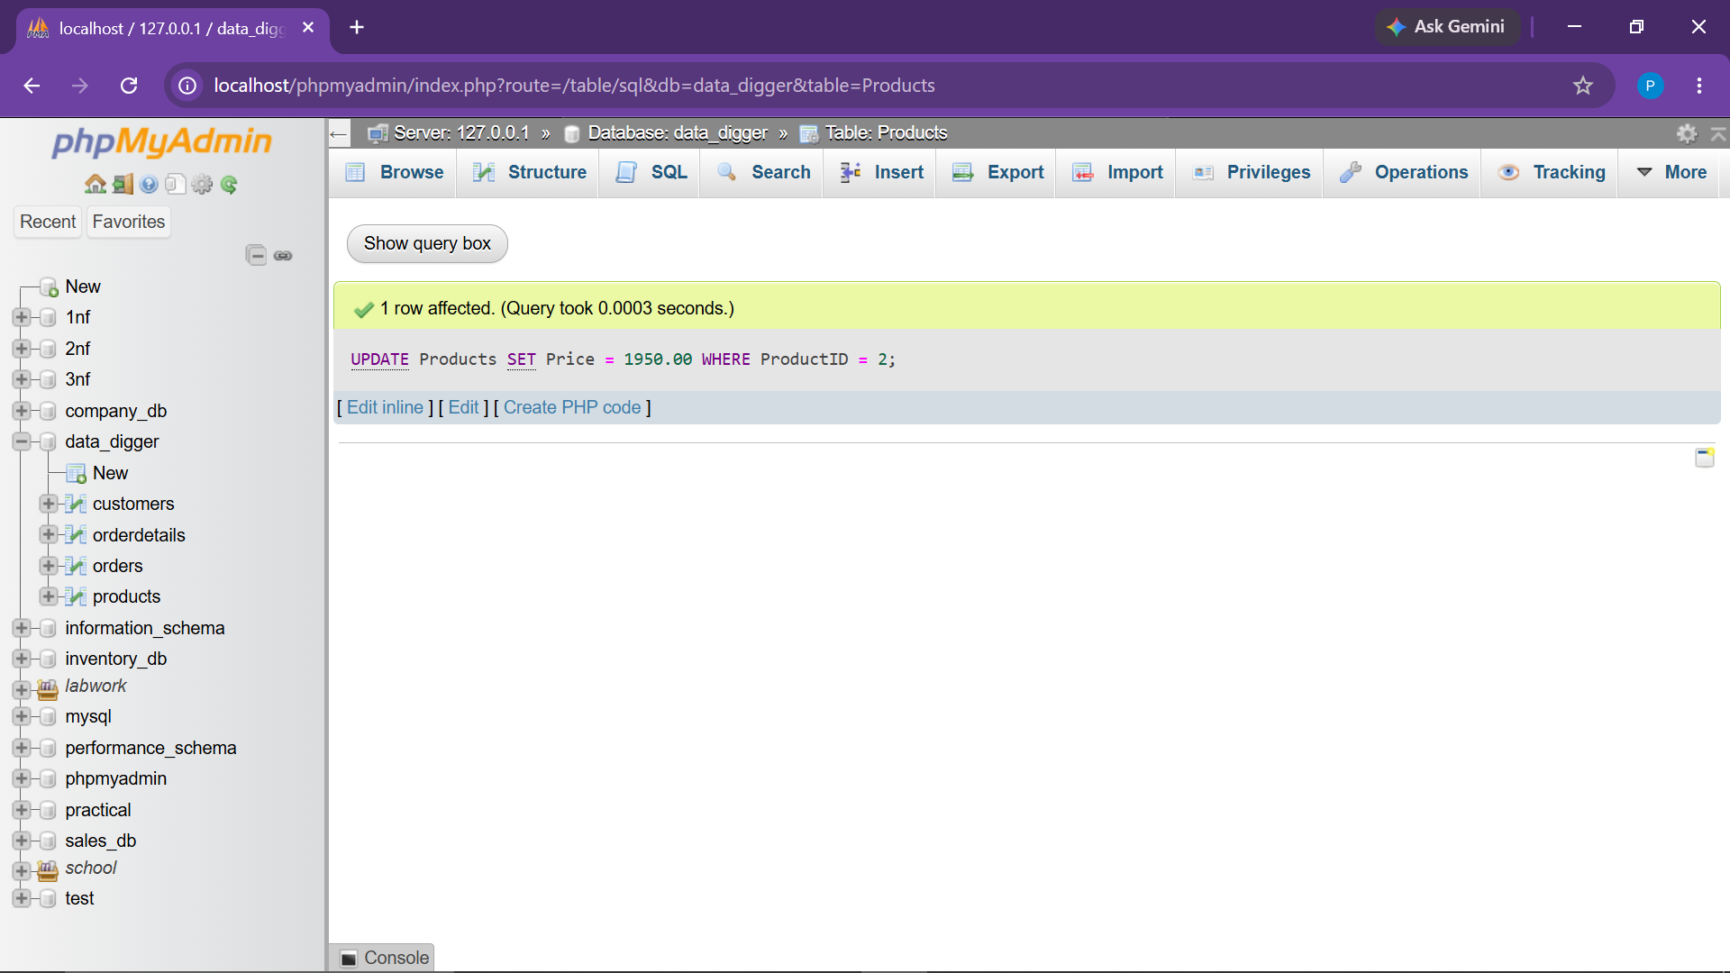

● 4.4 Delete a product if it's out of stock
DELETE FROM Products
WHERE Stock = 0;

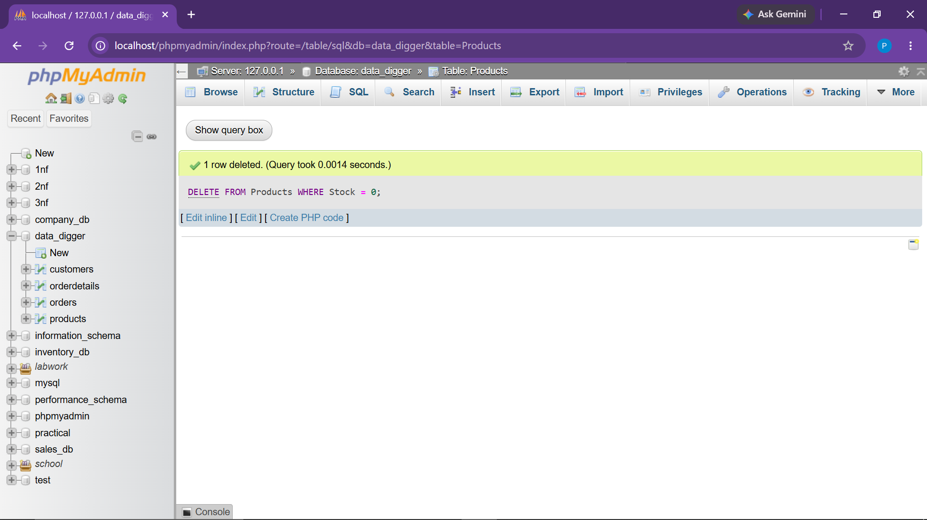

● 4.5 Retrieve products whose price is between ₹500 and ₹2000
SELECT * FROM Products
WHERE Price BETWEEN 500 AND 2000;

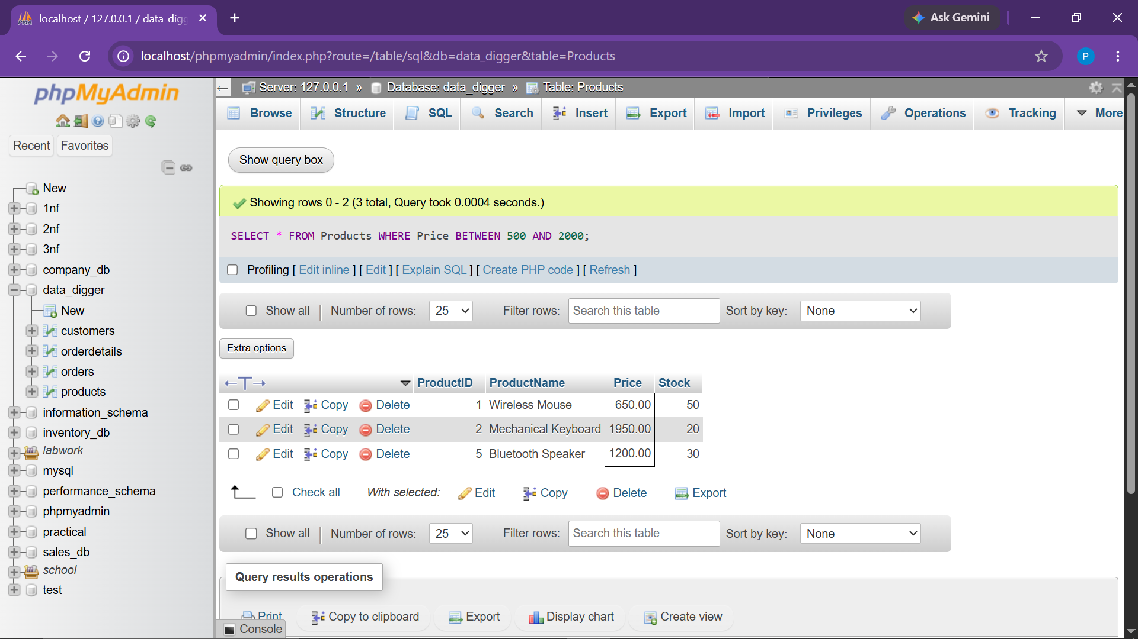

● 4.6 Retrieve the most expensive and cheapest product using MAX() and MIN()
SELECT
MAX(Price) AS MostExpensivePrice,
MIN(Price) AS CheapestPrice
FROM Products;

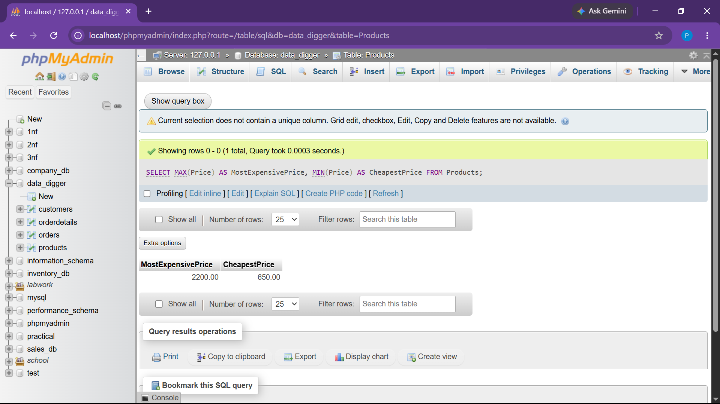

5. ORDERDETAILS TABLE - RELATIONAL JOINS & AGGREGATIONS

● 5.1 Insert Records into OrderDetails
INSERT INTO OrderDetails (OrderID, ProductID, Quantity, SubTotal) VALUES
(1, 1, 2, 1300.00),
(1, 2, 1, 1950.00),
(2, 5, 1, 1200.00),
(3, 4, 2, 4400.00),
(4, 1, 1, 650.00);

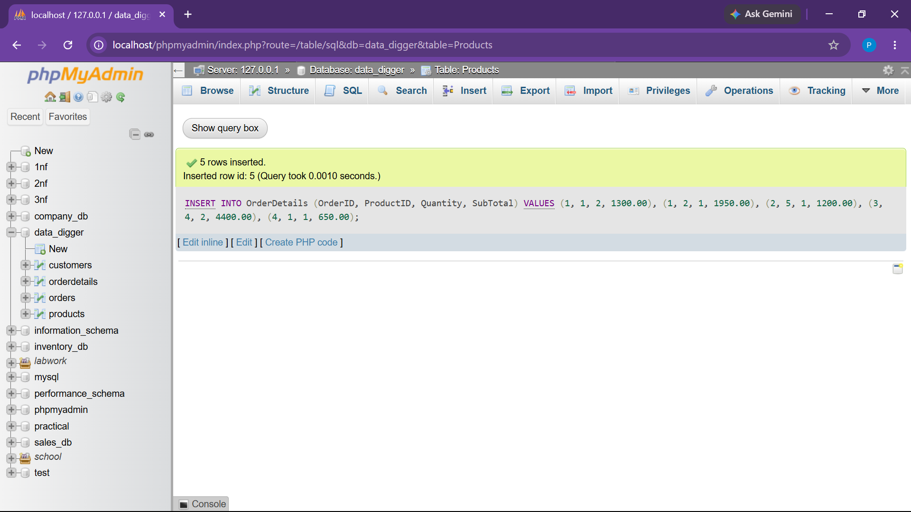

● 5.2 Retrieve Details for a Specific Order (OrderID = 1)
SELECT * FROM OrderDetails
WHERE OrderID = 1;

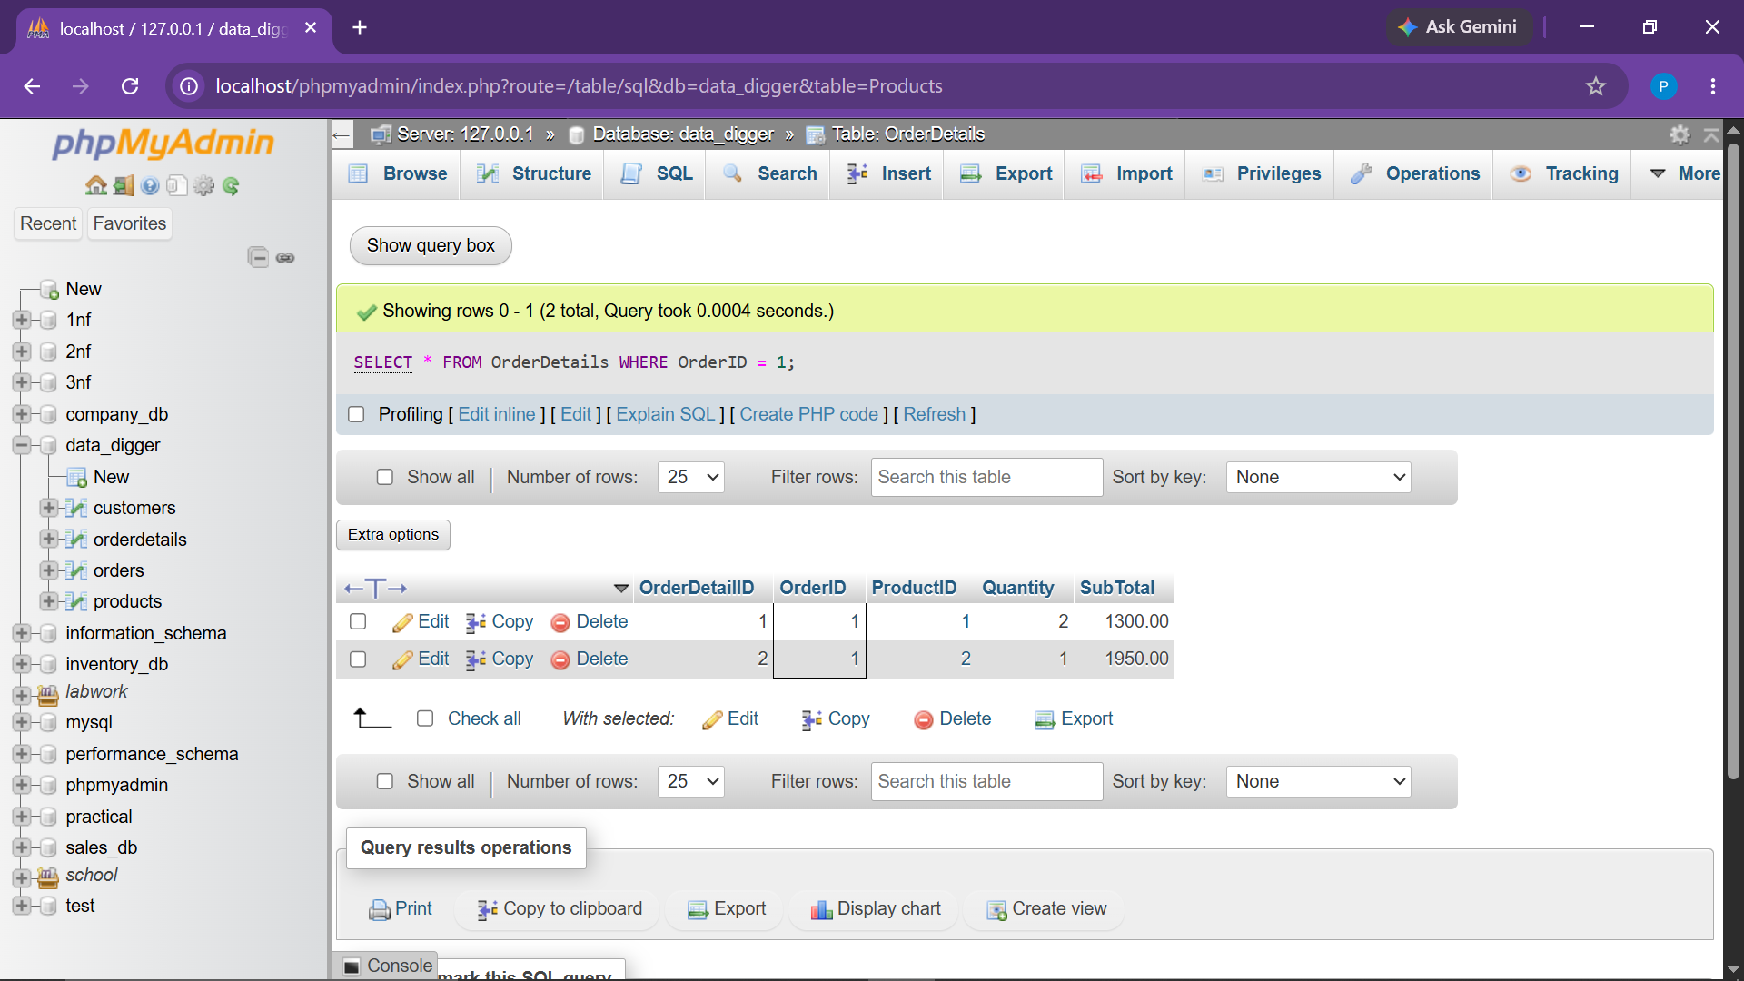

● 5.3 Calculate Total Revenue (SUM)
SELECT SUM(SubTotal) AS TotalRevenue
FROM OrderDetails;

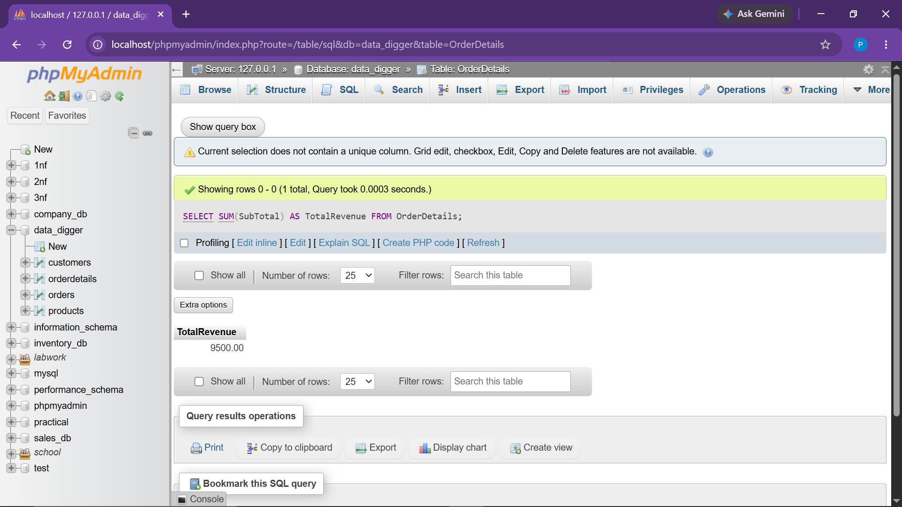

● 5.4 Retrieve Top 3 Most Ordered Products (JOIN + GROUP BY + ORDER BY)
SELECT
p.ProductID,
p.ProductName,
SUM(od.Quantity) AS TotalQuantityOrdered
FROM OrderDetails od
JOIN Products p ON od.ProductID = p.ProductID
GROUP BY p.ProductID, p.ProductName
ORDER BY TotalQuantityOrdered DESC
LIMIT 3;

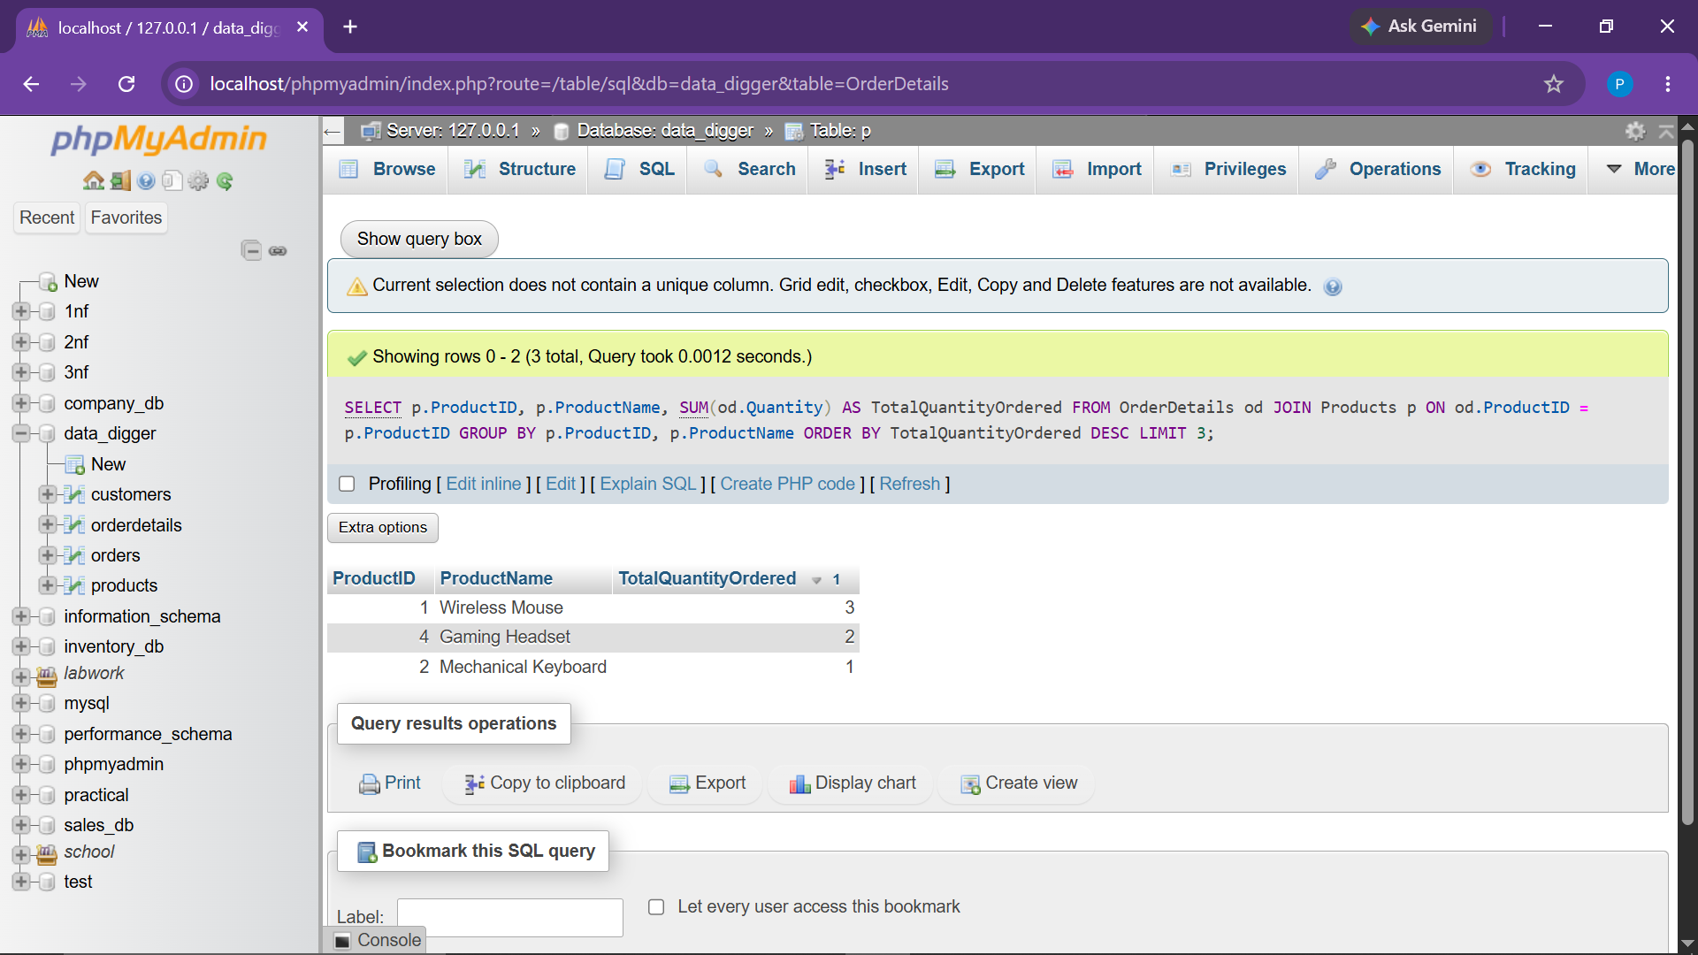

● 5.5 Count Number of Times a Specific Product Was Sold (ProductID = 1)
SELECT COUNT(*) AS TimesSold
FROM OrderDetails
WHERE ProductID = 1;

