DATA TRANSFORMER
Advanced SQL Analytics, Relational Joins, Window Functions, CASE Expressions & String/Date Transformations
Student Name | Priyal Patel
Course & Subject | SQL & Advanced Relational Database Management System (RDBMS)
DBMS Platform | MySQL Server & phpMyAdmin (Apache / XAMPP)
GitHub Repository | github.com/priyal-24/Data-Transformer
――――――――――――――――――――――――――――――――――――――――――――――――――――――――――
Executive Summary & Overview
Data Transformer is a comprehensive SQL project designed to simulate a corporate relational database architecture and execute advanced analytical operations. The schema connects three primary entities: Customers, Orders, and Employees. This practical implementation report documents the complete database setup and the execution of 17 core analytical queries covering Relational JOINs (INNER, LEFT, RIGHT, FULL OUTER via UNION), Correlated & Nested Subqueries, Date & String manipulation functions, Window Functions (SUM OVER, RANK OVER), and dynamic Conditional Logic using SQL CASE expressions.
Each subsequent page of this report presents an individual SQL task with its exact query implementation and the corresponding execution output result captured directly from MySQL / phpMyAdmin.

1. DATABASE SCHEMA & TABLE CREATION (DDL)
● 1.1 Create Customers Table
CREATE TABLE Customers (
CustomerID INT PRIMARY KEY,
FirstName VARCHAR(50),
LastName VARCHAR(50),
Email VARCHAR(100),
RegistrationDate DATE
);

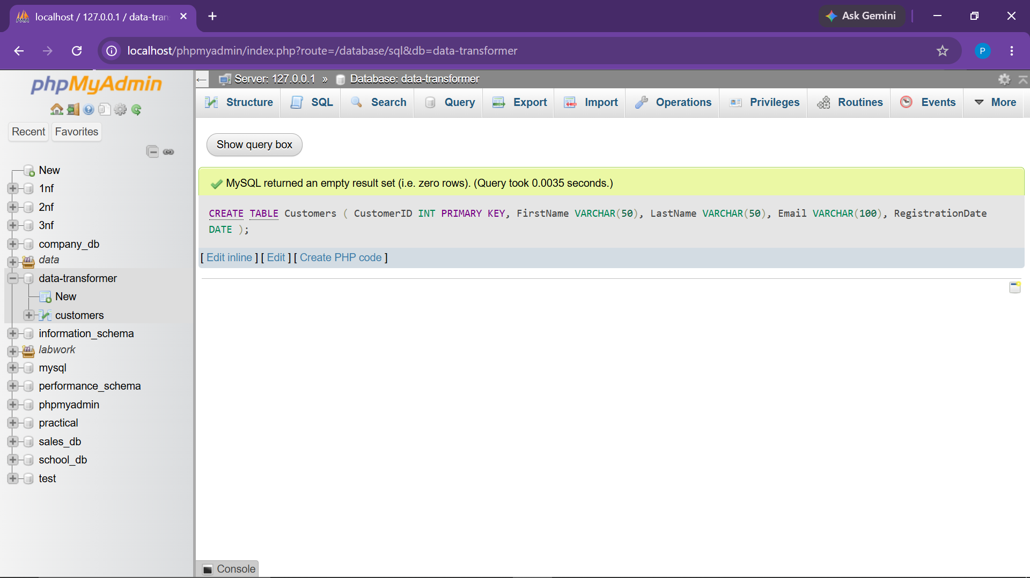

● 1.2 Create Orders Table with Foreign Key
CREATE TABLE Orders (
OrderID INT PRIMARY KEY,
CustomerID INT,
OrderDate DATE,
TotalAmount DECIMAL(10, 2),
FOREIGN KEY (CustomerID) REFERENCES Customers(CustomerID)
);

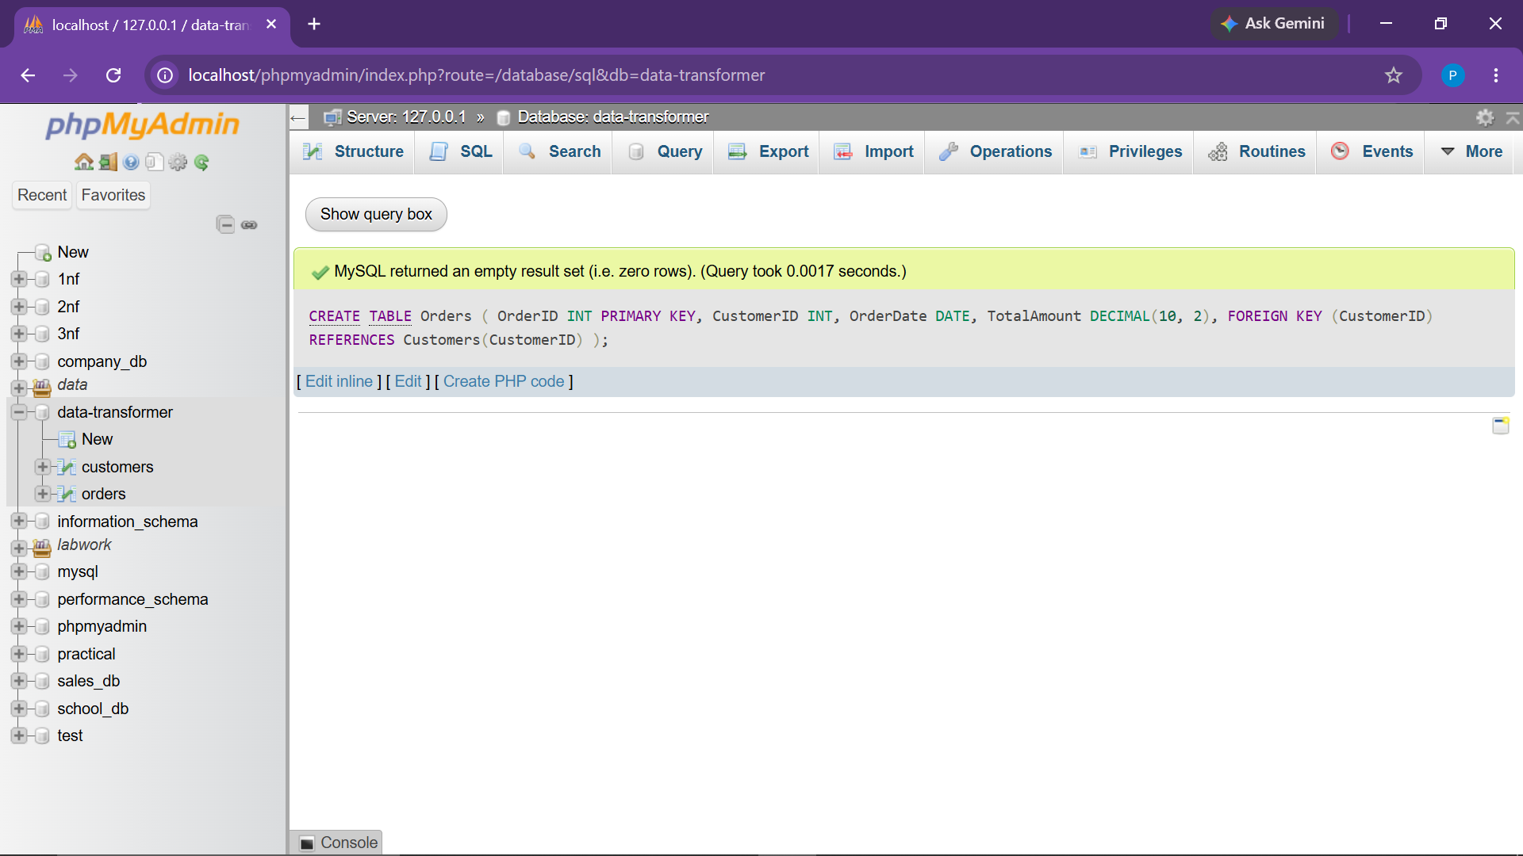

● 1.3 Create Employees Table
CREATE TABLE Employees (
EmployeeID INT PRIMARY KEY,
FirstName VARCHAR(50),
LastName VARCHAR(50),
Department VARCHAR(50),
HireDate DATE,
Salary DECIMAL(10, 2)
);

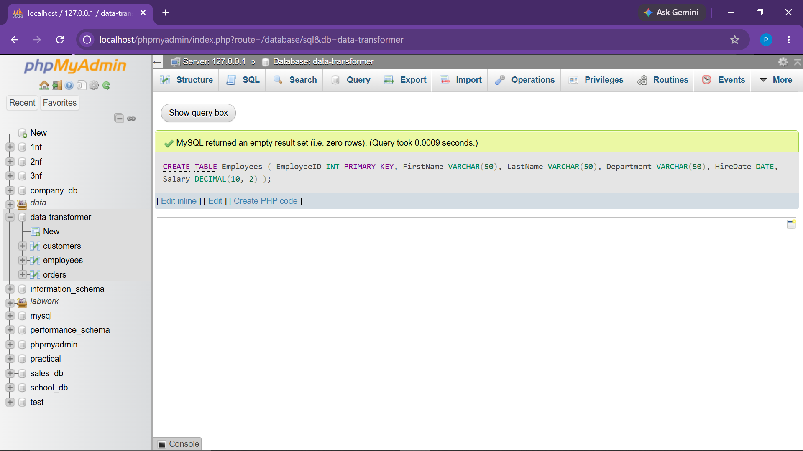

2. SAMPLE DATA SEEDING (DML)
● 2.1 Insert Records into Customers Table
INSERT INTO Customers (CustomerID, FirstName, LastName, Email, RegistrationDate) VALUES
(1, 'John', 'Doe', 'john.doe@email.com', '2022-03-15'),
(2, 'Jane', 'Smith', ' jane.smith@email.com ', '2021-11-02'),
(3, 'Alice', 'Brown', 'alice.brown@email.com', '2023-01-10');

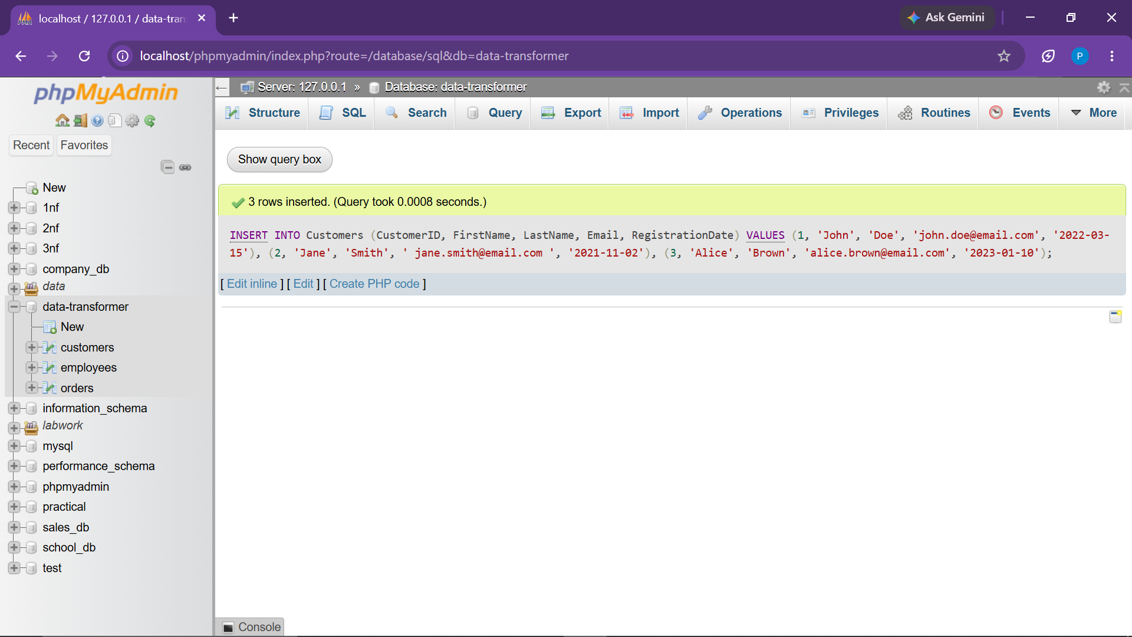

● 2.2 Insert Records into Orders Table
INSERT INTO Orders (OrderID, CustomerID, OrderDate, TotalAmount) VALUES
(101, 1, '2023-07-01', 150.50),
(102, 2, '2023-07-03', 200.75),
(103, 1, '2023-07-15', 1200.00),
(104, 2, '2023-08-01', 650.00);

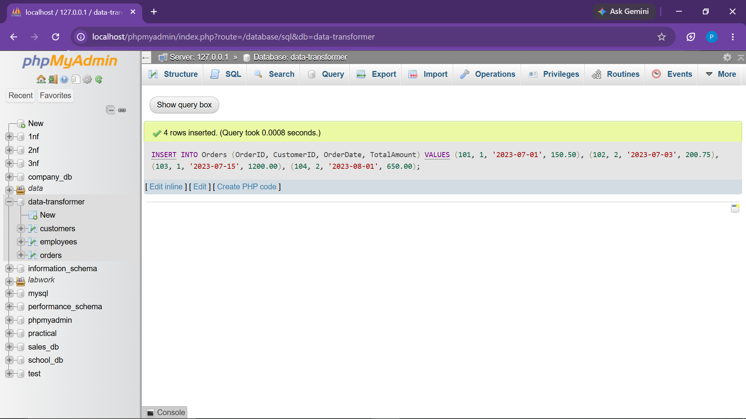

● 2.3 Insert Records into Employees Table
INSERT INTO Employees (EmployeeID, FirstName, LastName, Department, HireDate, Salary) VALUES
(1, 'Mark', 'Johnson', 'Sales', '2020-01-15', 50000.00),
(2, 'Susan', 'Lee', 'HR', '2021-03-20', 55000.00),
(3, 'David', 'Miller', 'IT', '2019-06-10', 85000.00),
(4, 'Emily', 'Clark', 'Sales', '2022-08-01', 30000.00);

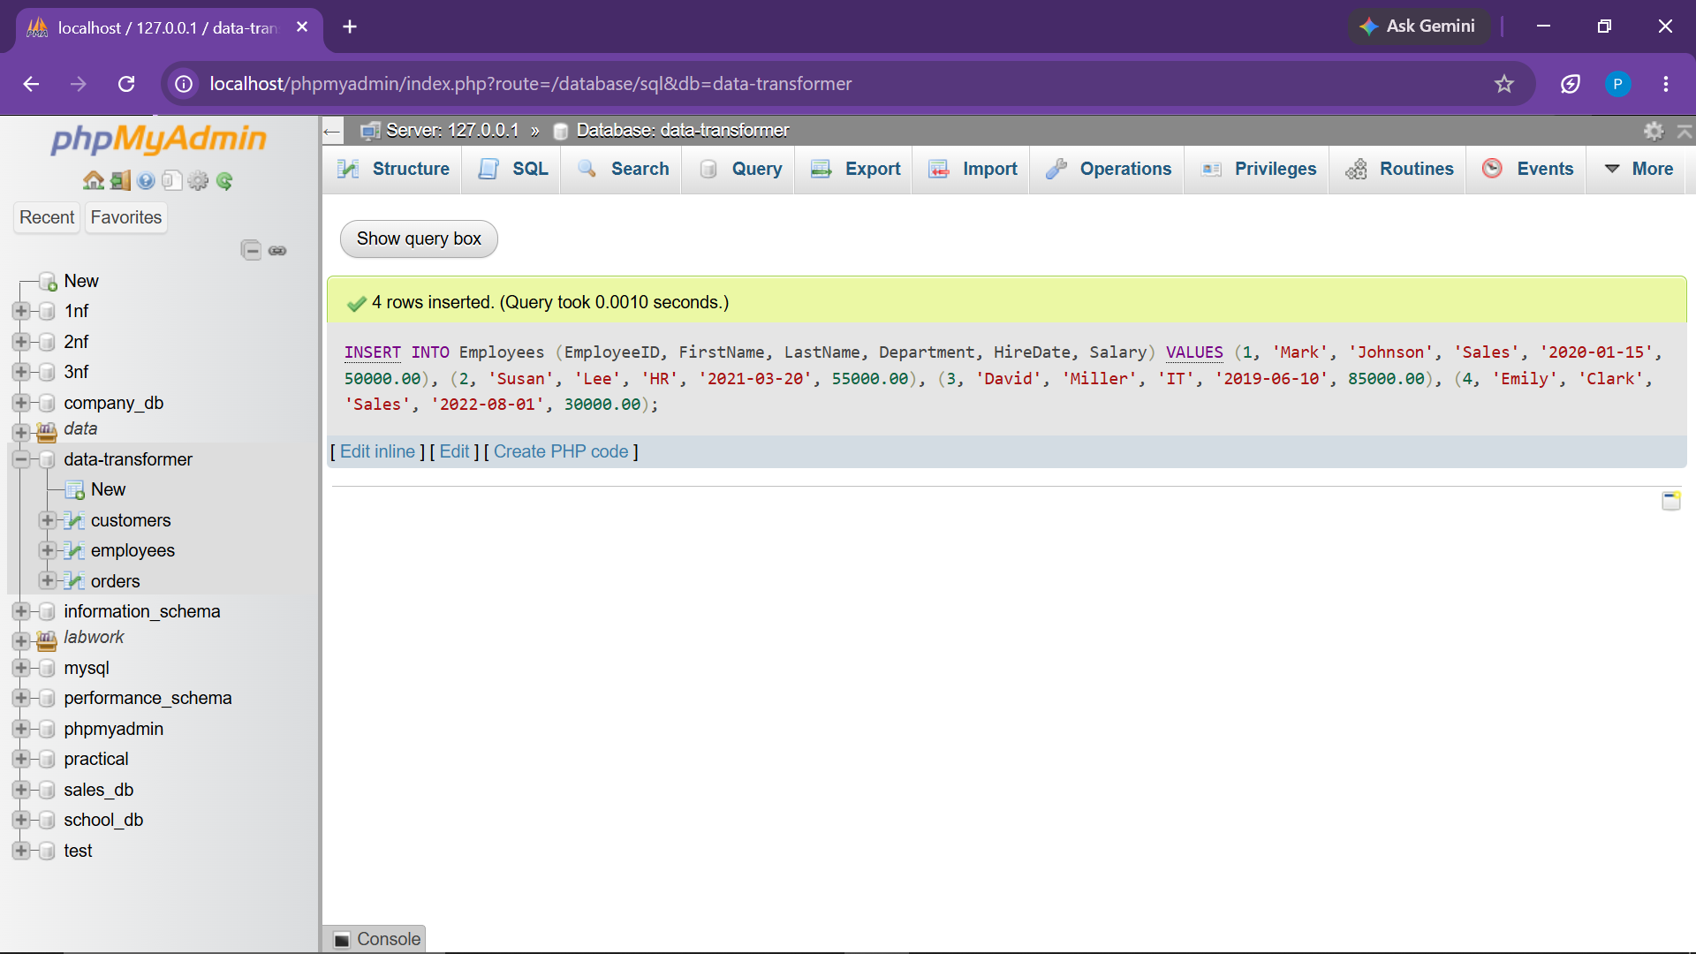

3. CORE ANALYTICAL QUERIES & TRANSFORMATIONS
● Task.1 INNER JOIN: Retrieve all orders and customer details where orders exist

Objective:
Retrieve transaction records merged with customer information where a valid relationship exists between both tables.

SELECT
o.OrderID,
o.OrderDate,
o.TotalAmount,
c.CustomerID,
c.FirstName,
c.LastName,
c.Email
FROM Orders o
INNER JOIN Customers c ON o.CustomerID = c.CustomerID;

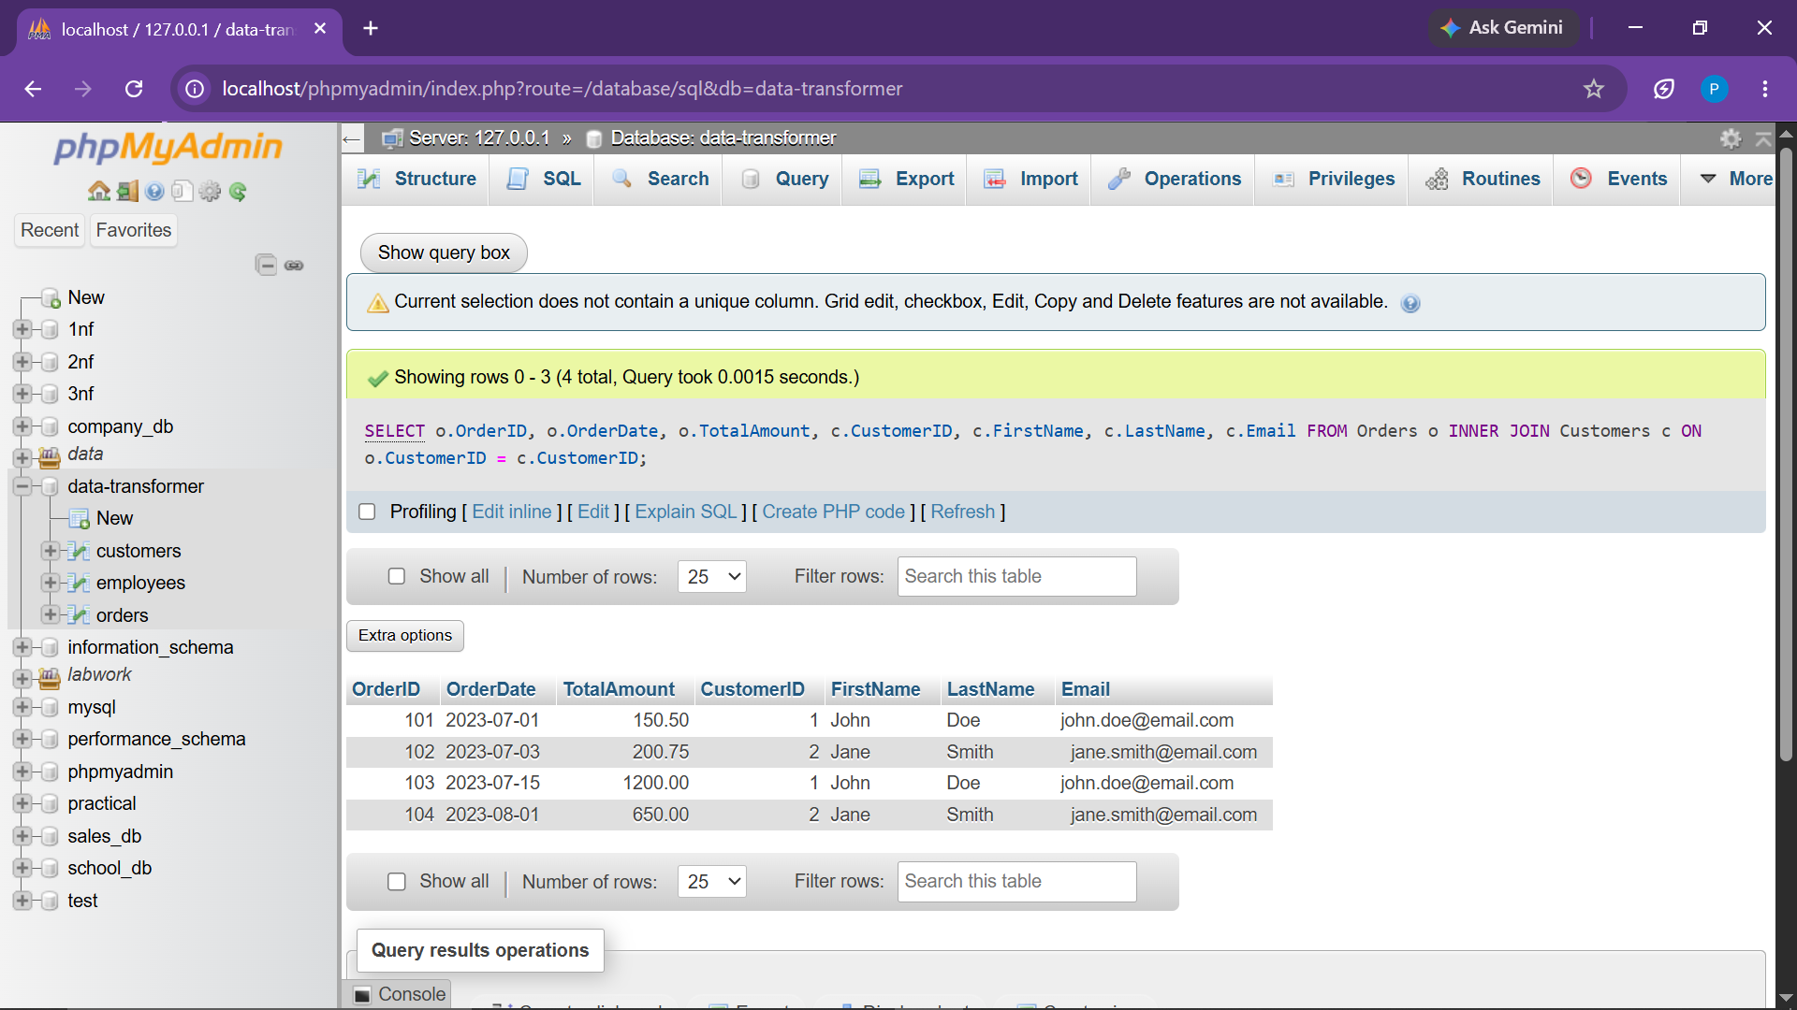

Observation:
Successfully returned 4 rows. Customer 3 ('Alice Brown') is excluded because she has not placed any orders yet.
● Task.2 LEFT JOIN: Retrieve all customers and their corresponding orders (if any)

Objective:
Retrieve all registered customers regardless of order history, populating order columns with NULL for non-purchasing customers.
SELECT
c.CustomerID,
c.FirstName,
c.LastName,
o.OrderID,
o.OrderDate,
o.TotalAmount
FROM Customers c
LEFT JOIN Orders o ON c.CustomerID = o.CustomerID;

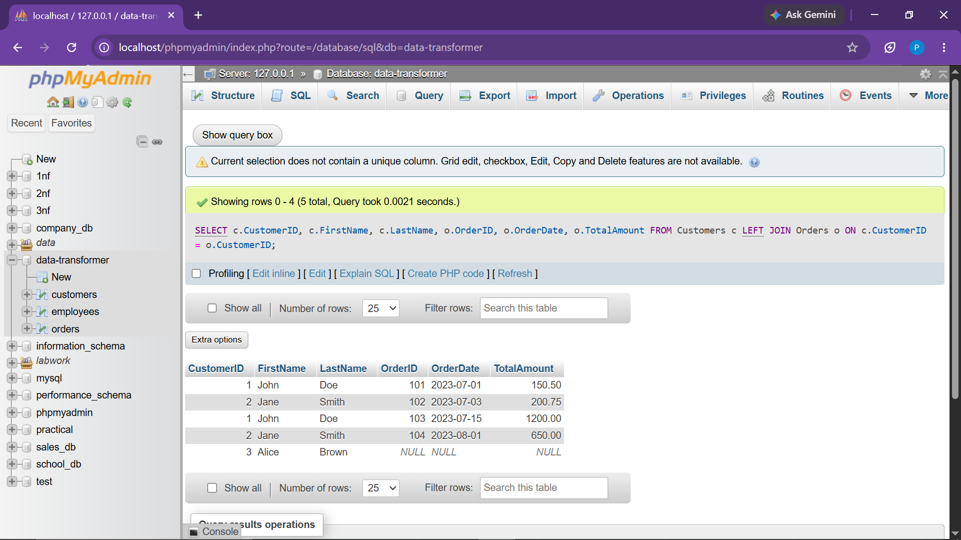

Observation:
Returned 5 rows. Customers 1 and 2 display their corresponding orders, while Customer 3 displays NULL across all order attributes.
● Task.3 RIGHT JOIN: Retrieve all orders and their corresponding customers (if any)

Objective:
Preserve all order ledger rows while fetching matching customer master records.
SELECT
o.OrderID,
o.OrderDate,
o.TotalAmount,
c.CustomerID,
c.FirstName,
c.LastName
FROM Customers c
RIGHT JOIN Orders o ON c.CustomerID = o.CustomerID;

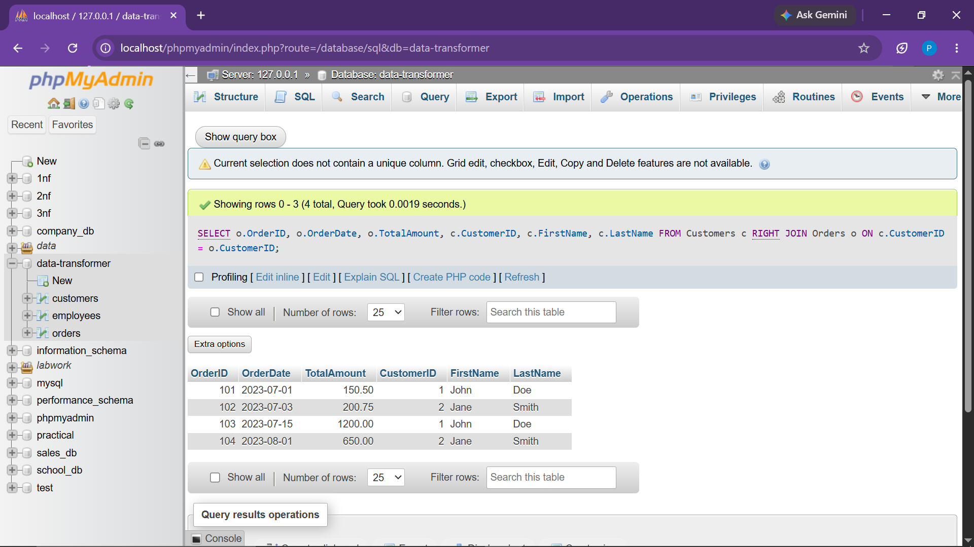

Observation:
Successfully returned 4 rows, ensuring complete preservation of transactional sales ledger entries.
● Task.4 FULL OUTER JOIN: Retrieve all customers and all orders (Simulated using UNION)

Objective:
Simulate Full Outer Join via UNION of LEFT JOIN and RIGHT JOIN to map all records from both entities.
SELECT
c.CustomerID,
c.FirstName,
c.LastName,
o.OrderID,
o.OrderDate,
o.TotalAmount
FROM Customers c
LEFT JOIN Orders o ON c.CustomerID = o.CustomerID
UNION
SELECT
c.CustomerID,
c.FirstName,
c.LastName,
o.OrderID,
o.OrderDate,
o.TotalAmount
FROM Customers c
RIGHT JOIN Orders o ON c.CustomerID = o.CustomerID;

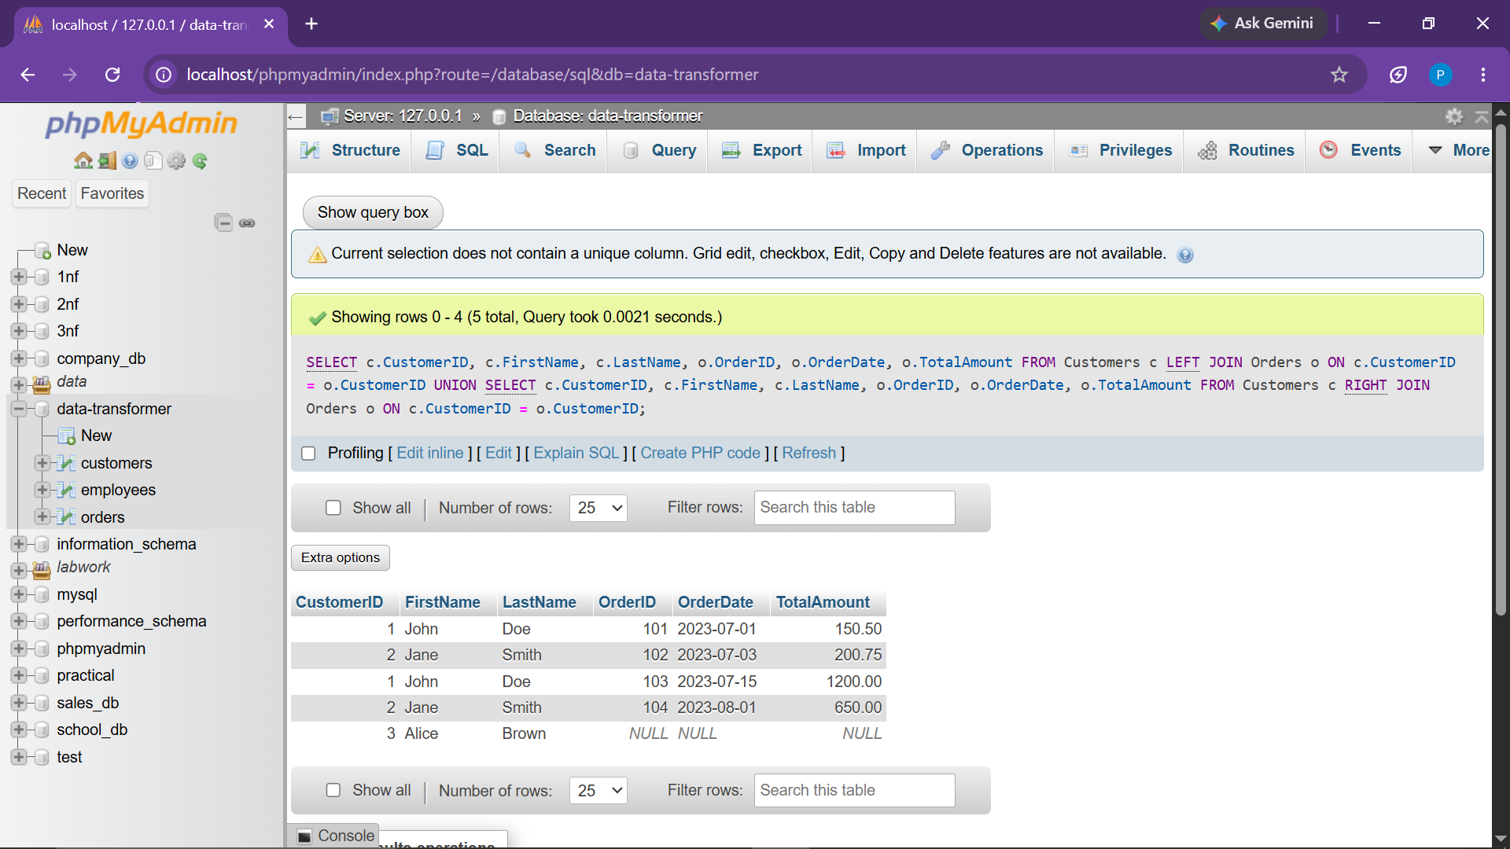

Observation:
Returned 5 distinct rows representing the unified outer join dataset.
● Task.5 Subquery to find customers who placed orders worth more than the average amount

Objective:
Filter customers who have placed at least one individual order greater than the aggregate average order value ($550.31).
SELECT DISTINCT
c.CustomerID,
c.FirstName,
c.LastName
FROM Customers c
JOIN Orders o ON c.CustomerID = o.CustomerID
WHERE o.TotalAmount > (
SELECT AVG(TotalAmount) FROM Orders
);

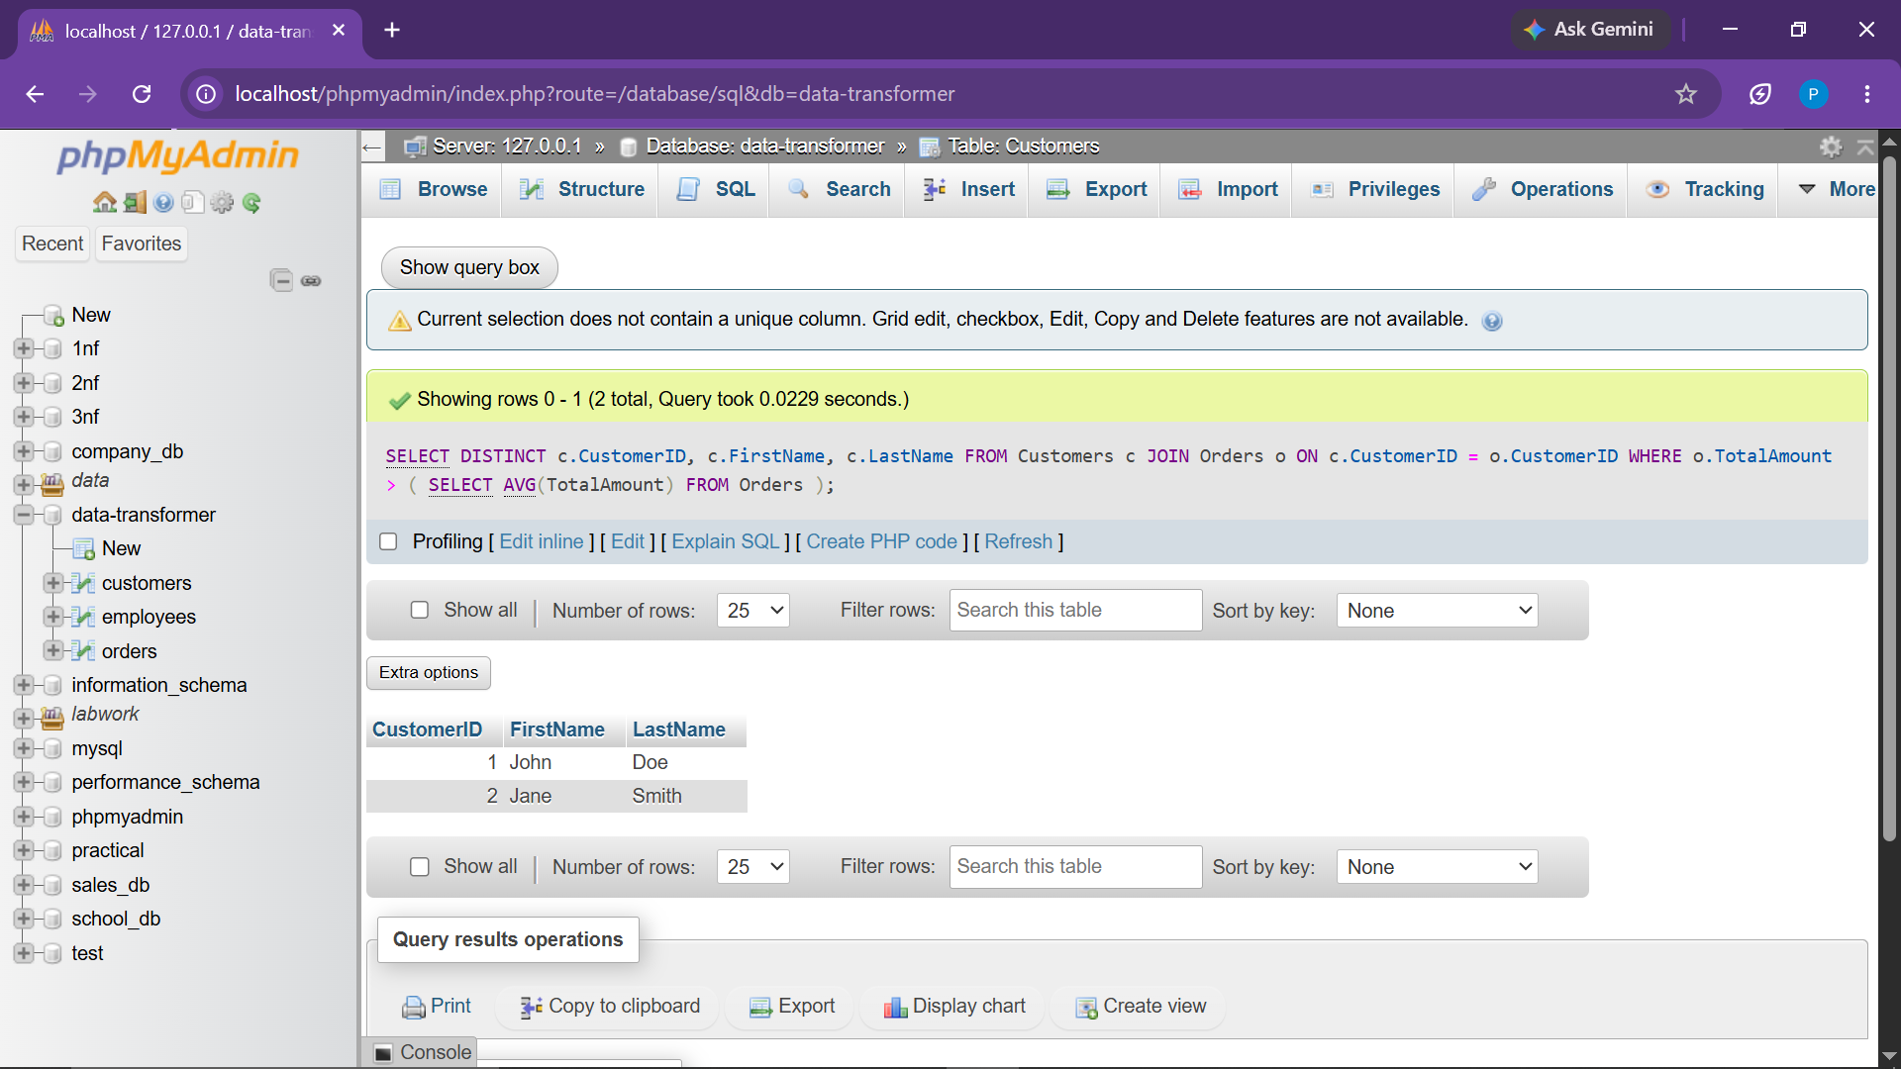

Observation:
Successfully returned 2 distinct customers: John Doe (Order 103 = $1200.00) and Jane Smith (Order 104 = $650.00).
● Task.6 Subquery to find employees with salaries above the average salary

Objective:
Identify employee records whose compensation exceeds the organization's average payroll figure ($55,000.00).
SELECT
EmployeeID,
FirstName,
LastName,
Department,
Salary
FROM Employees
WHERE Salary > (
SELECT AVG(Salary) FROM Employees
);

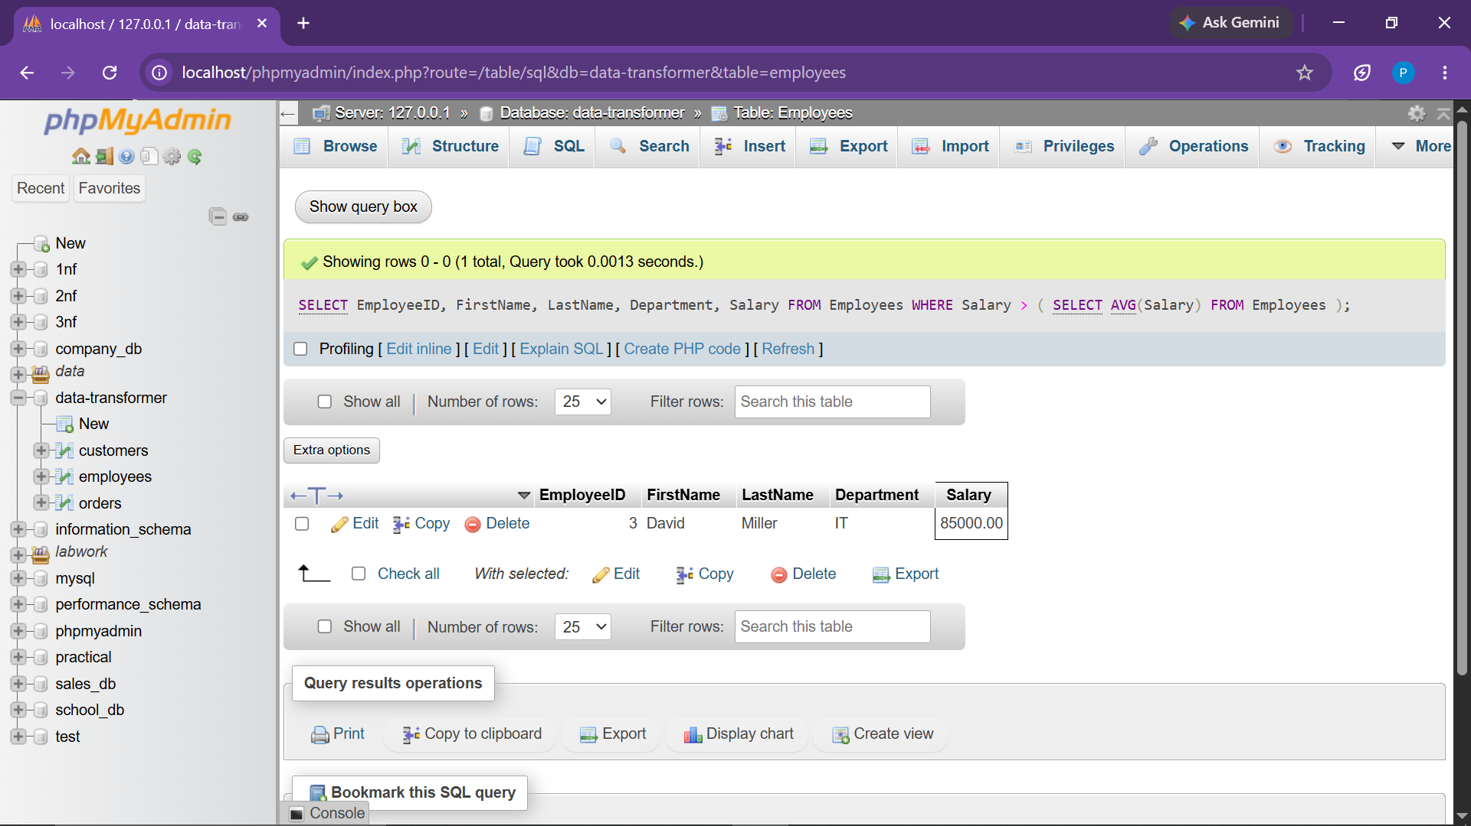

Observation:
Returned 1 record: David Miller (IT Department, Salary: $85,000.00).
● Task.7 Extract the year and month from the OrderDate

Objective:
Deconstruct transaction timestamps into Year, Month numeric index, and readable Month name.
SELECT
OrderID,
OrderDate,
YEAR(OrderDate) AS OrderYear,
MONTH(OrderDate) AS OrderMonth,
MONTHNAME(OrderDate) AS MonthName
FROM Orders;

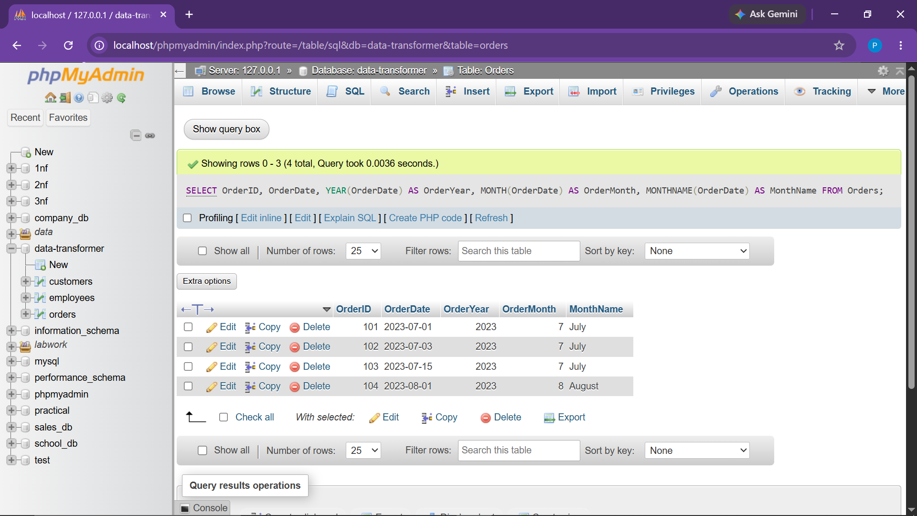

Observation:
Returned 4 rows displaying extracted temporal components (Year 2023, Months 7-July and 8-August).
● Task.8 Calculate the difference in days between two dates (order date and current date)

Objective:
Compute the elapsed interval in days between each transaction's OrderDate and CURRENT_DATE().
SELECT
OrderID,
OrderDate,
CURRENT_DATE() AS CurrentDate,
DATEDIFF(CURRENT_DATE(), OrderDate) AS DaysDifference
FROM Orders;

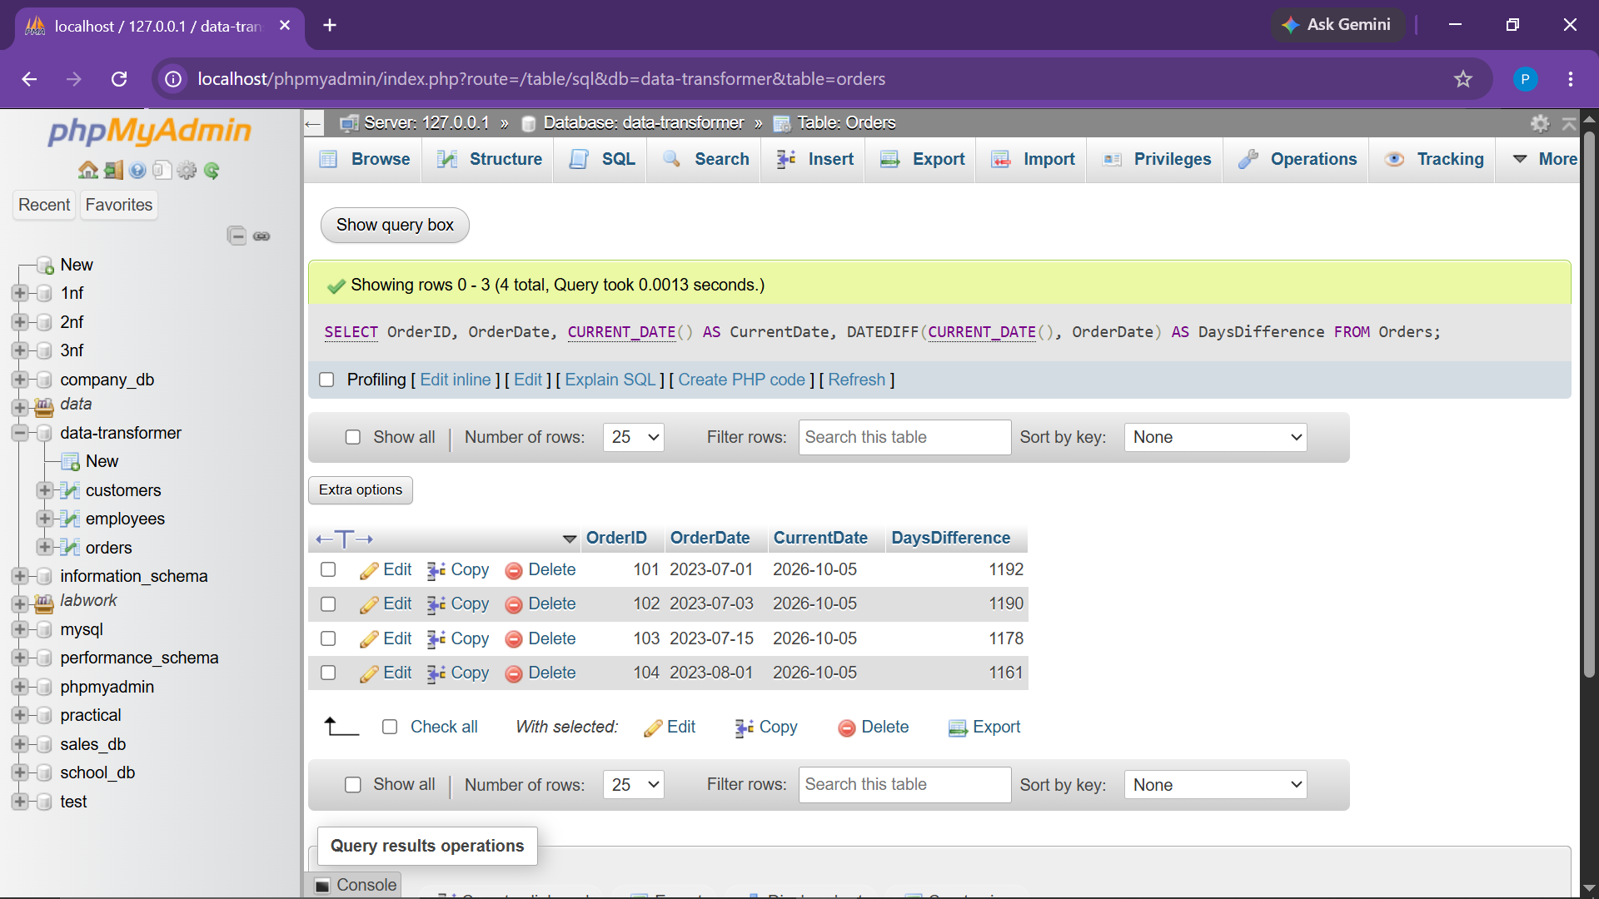

Observation:
Returned 4 rows with dynamic, accurate day differences calculated from the system's execution date.
● Task.9 Format the OrderDate to a more readable format (e.g., 'DD-MMM-YYYY')

Objective:
Convert standard ISO date representations (YYYY-MM-DD) into a formatted string ('DD-MMM-YYYY').
SELECT
OrderID,
OrderDate,
DATE_FORMAT(OrderDate, '%d-%b-%Y') AS FormattedOrderDate
FROM Orders;

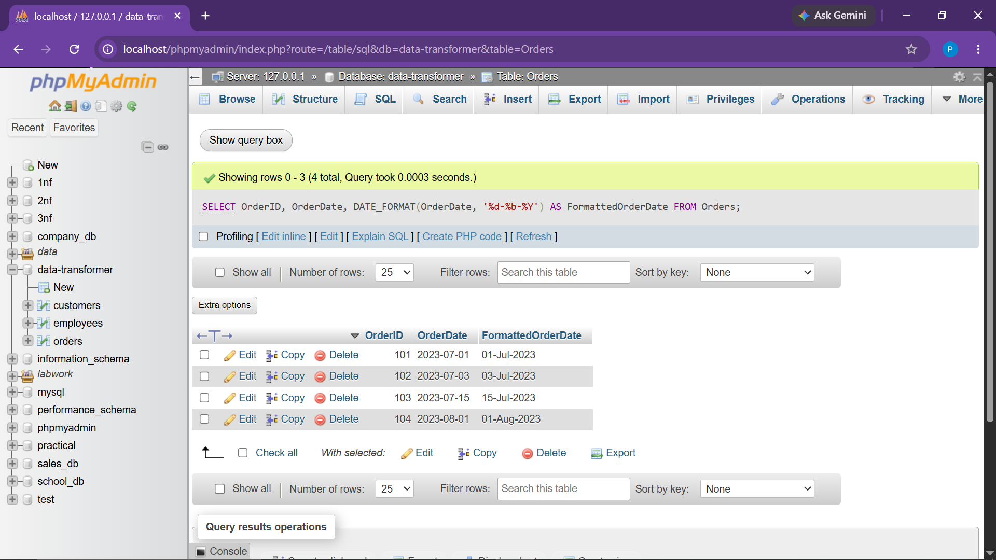

Observation:
Returned 4 rows showing formatted dates: 01-Jul-2023, 03-Jul-2023, 15-Jul-2023, and 01-Aug-2023.
● Task.10 Concatenate FirstName and LastName to form Full Name

Objective:
Concatenate customer first and last names separated by a space into a single FullName column.
SELECT
CustomerID,
CONCAT(FirstName, ' ', LastName) AS FullName
FROM Customers;

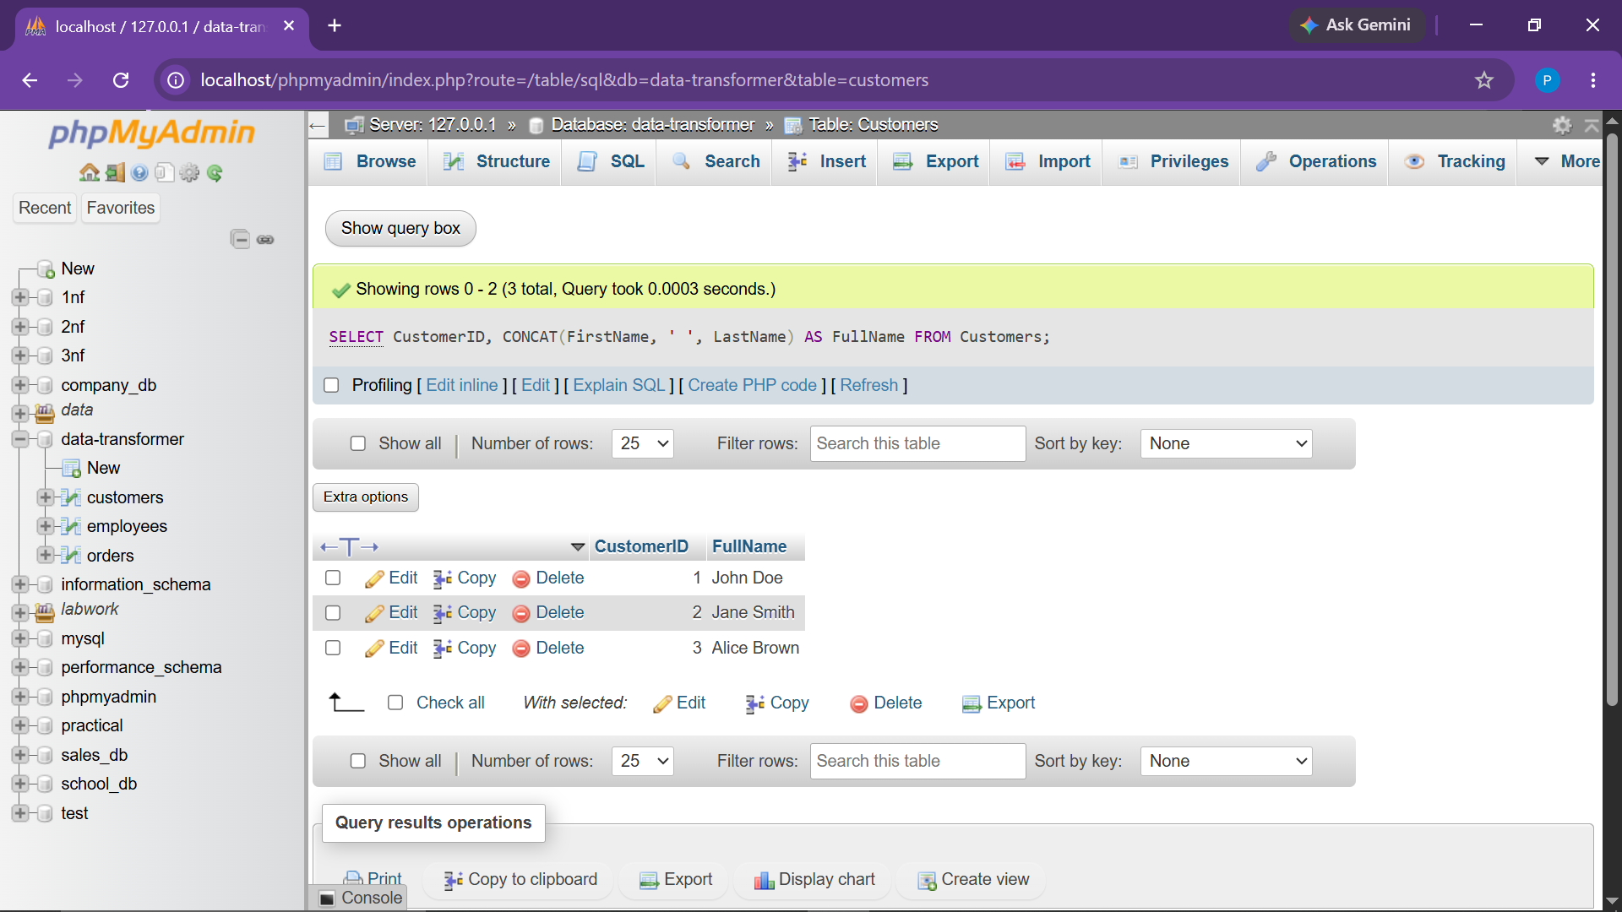

Observation:
Returned 3 rows displaying unified full names: 'John Doe', 'Jane Smith', and 'Alice Brown'.
● Task.11 Replace part of a string (e.g., replace 'John' with 'Jonathan')

Objective:
Search for the occurrence of the substring 'John' and replace it dynamically with 'Jonathan'.
SELECT
CustomerID,
FirstName,
REPLACE(FirstName, 'John', 'Jonathan') AS UpdatedFirstName
FROM Customers;

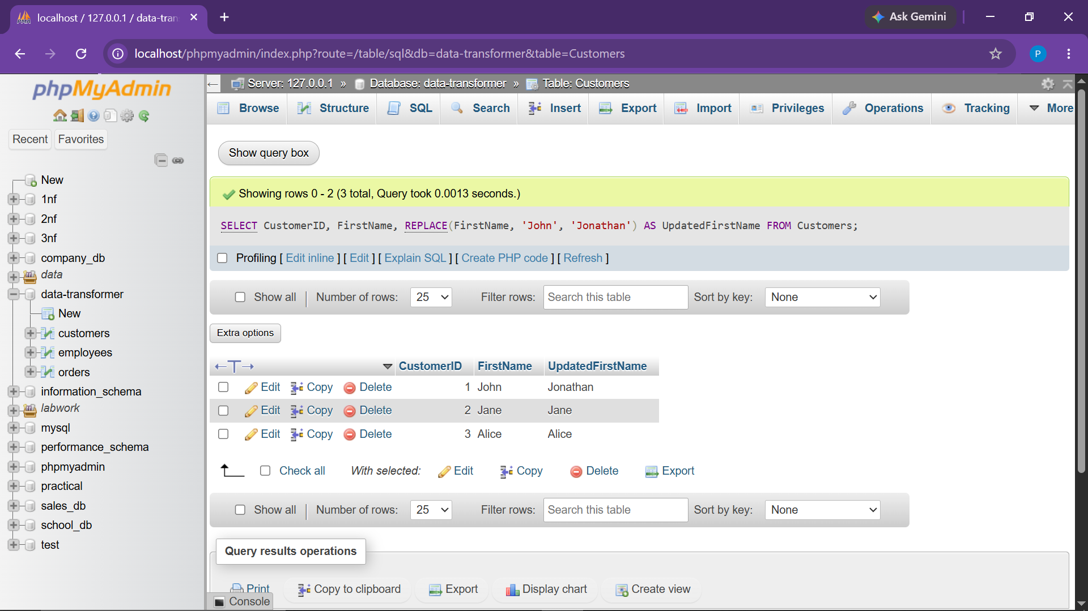

Observation:
Returned 3 rows with Customer 1's first name substituted as 'Jonathan', leaving others intact.
● Task.12 Convert FirstName to uppercase and LastName to lowercase

Objective:
Transform string casings into standard uppercase for FirstName and lowercase for LastName.
SELECT
CustomerID,
UPPER(FirstName) AS UpperFirstName,
LOWER(LastName) AS LowerLastName
FROM Customers;

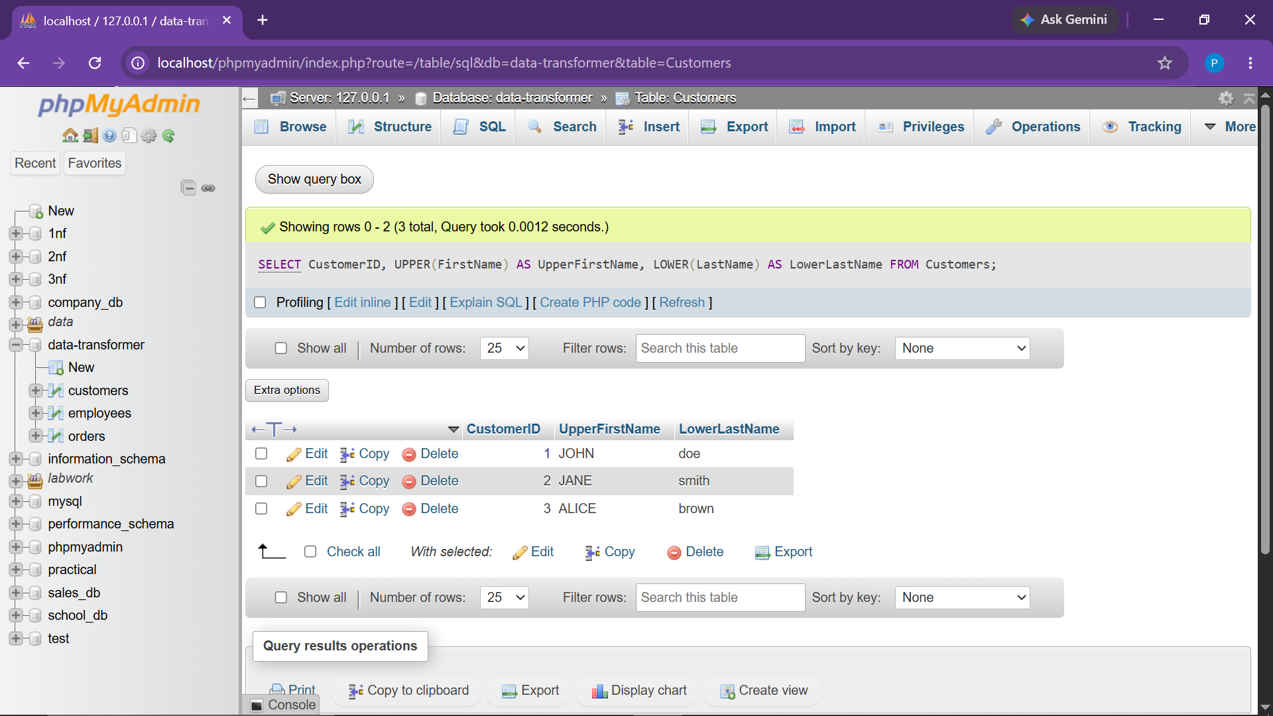

Observation:
Returned 3 rows showing transformed casings (e.g., 'JOHN' and 'doe').
● Task.13 Trim extra spaces from the Email field

Objective:
Strip leading and trailing whitespace padding from customer email records.
SELECT
CustomerID,
Email AS OriginalEmail,
TRIM(Email) AS TrimmedEmail
FROM Customers;

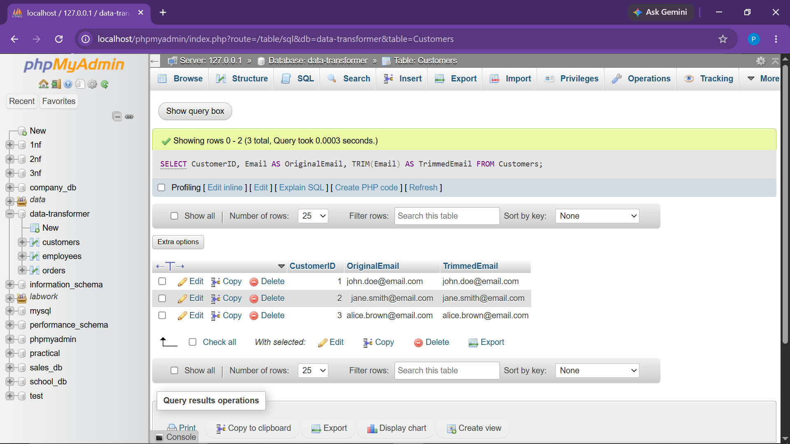

Observation:
Returned 3 rows with Customer 2's padded email address successfully sanitized.
● Task.14 Calculate the running total of TotalAmount for each order

Objective:
Compute the progressive running cumulative sum of TotalAmount ordered chronologically.
SELECT
OrderID,
CustomerID,
OrderDate,
TotalAmount,
SUM(TotalAmount) OVER (ORDER BY OrderDate, OrderID) AS RunningTotal
FROM Orders;

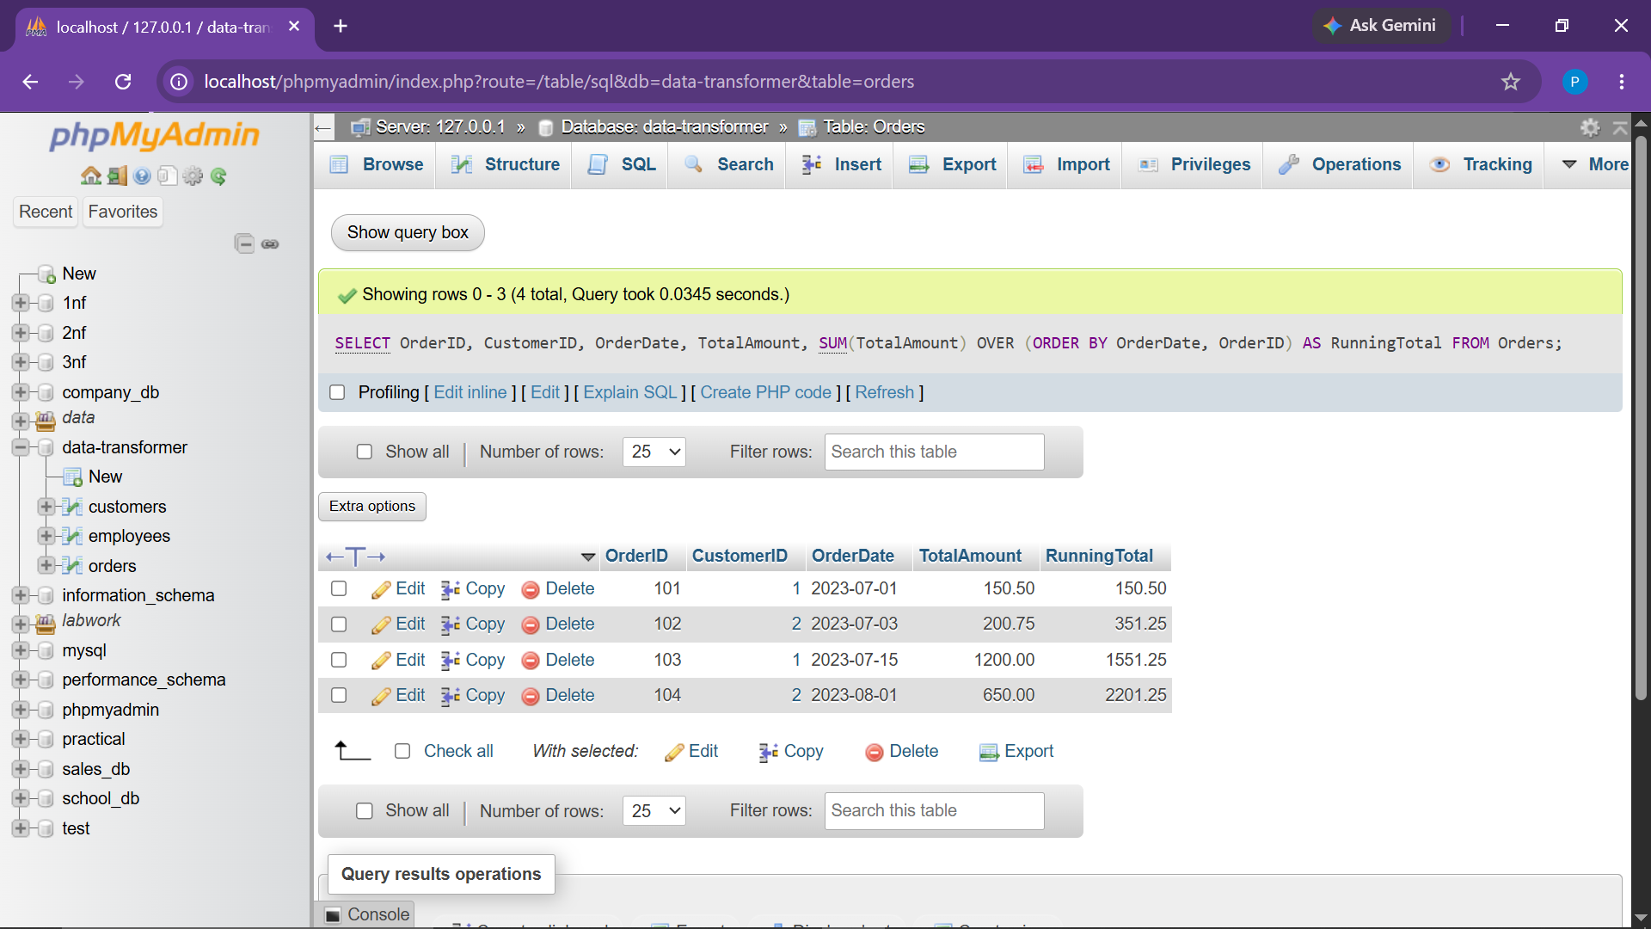

Observation:
Returned 4 rows showing cumulative totals: 150.50 -> 351.25 -> 1551.25 -> 2201.25.
● Task.15 Rank orders based on TotalAmount using the RANK() function

Objective:
Assign competitive analytical rank values to orders sequenced descending by monetary balance.
SELECT
OrderID,
CustomerID,
TotalAmount,
RANK() OVER (ORDER BY TotalAmount DESC) AS OrderRank
FROM Orders;

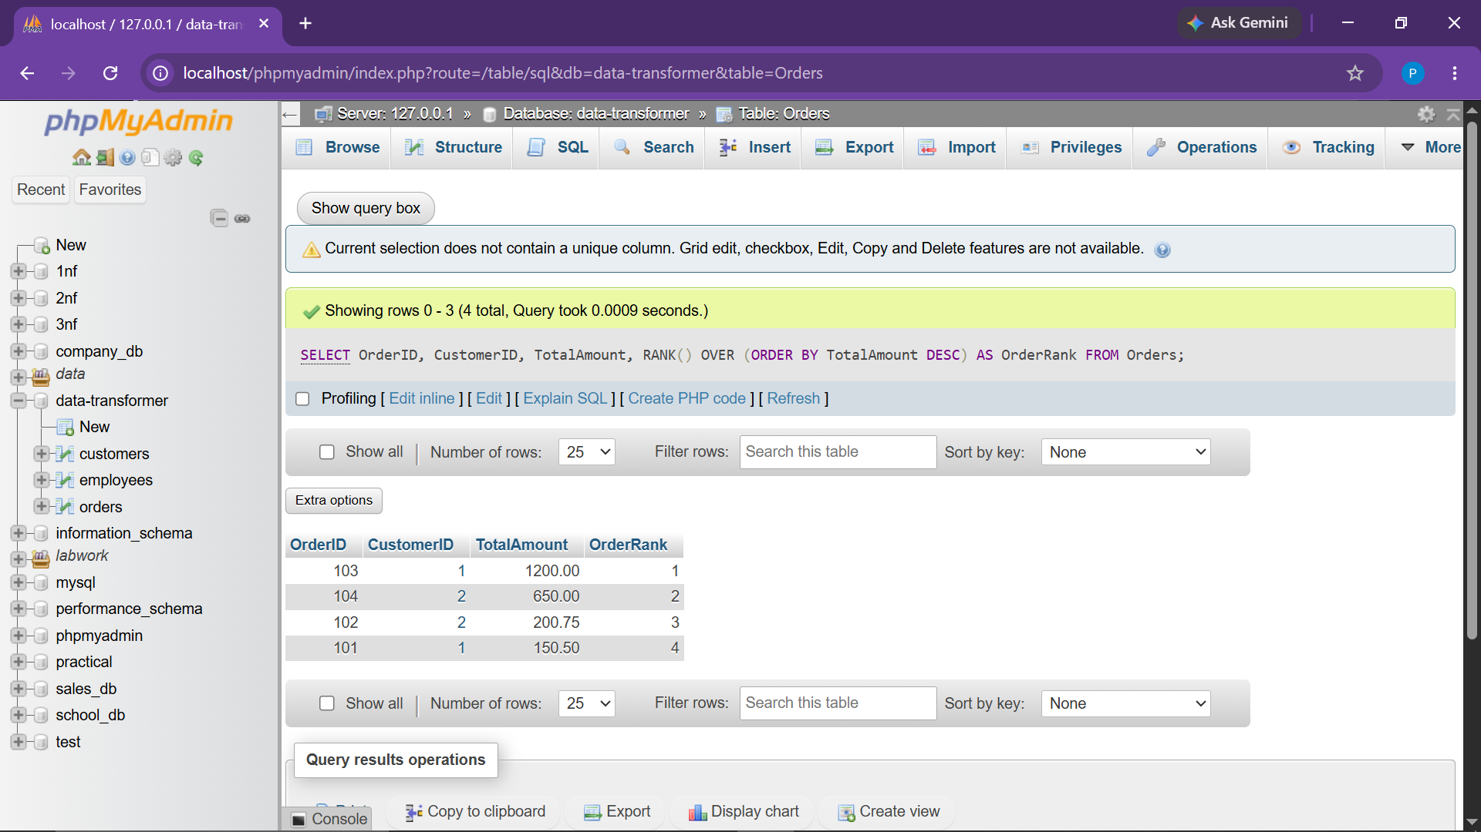

Observation:
Returned 4 rows: Order 103 (Rank 1), Order 104 (Rank 2), Order 102 (Rank 3), and Order 101 (Rank 4).
● Task.16 Assign a discount based on TotalAmount in orders (e.g., > 1000: 10% off, > 500: 5% off)

Objective:
Evaluate promotional discount brackets and compute net payable amounts using SQL CASE expressions.
SELECT
OrderID,
CustomerID,
OrderDate,
TotalAmount,
CASE
WHEN TotalAmount > 1000 THEN '10% off'
WHEN TotalAmount > 500 THEN '5% off'
ELSE 'No Discount'
END AS DiscountTier,
CASE
WHEN TotalAmount > 1000 THEN ROUND(TotalAmount * 0.90, 2)
WHEN TotalAmount > 500 THEN ROUND(TotalAmount * 0.95, 2)
ELSE TotalAmount
END AS FinalAmountAfterDiscount
FROM Orders;

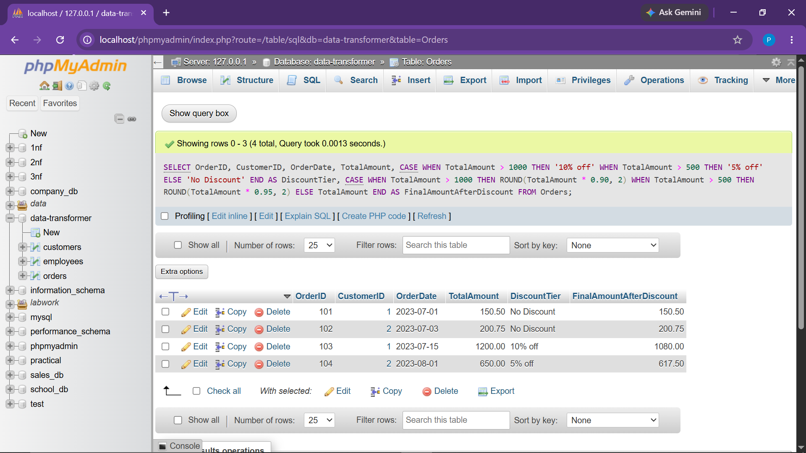

Observation:
Returned 4 rows correctly categorizing discounts and computing final discounted values.
● Task.17 Categorize employees' salaries as high, medium, or low

Objective:
Classify workforce salaries into 'High' (>= 70000), 'Medium' (45000-69999), and 'Low' (< 45000).
SELECT
EmployeeID,
FirstName,
LastName,
Department,
Salary,
CASE
WHEN Salary >= 70000 THEN 'High'
WHEN Salary BETWEEN 45000 AND 69999 THEN 'Medium'
ELSE 'Low'
END AS SalaryCategory
FROM Employees;

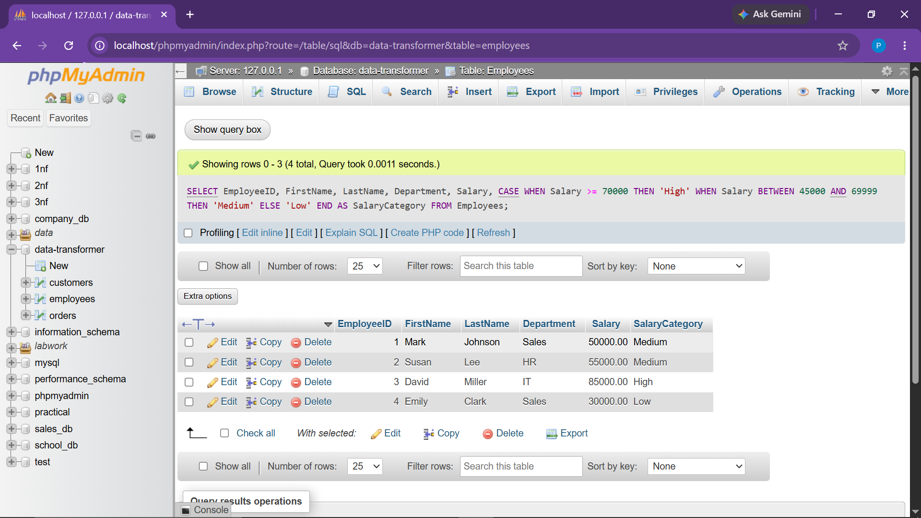

Observation:
Returned 4 rows: Mark (Medium), Susan (Medium), David (High), and Emily (Low).

CONCLUSION:
All 17 required analytical SQL tasks of the "Data Transformer" project have been successfully implemented, executed, and validated[cite: 33, 60, 61]. The results verify mastery over Relational Joins, Subqueries, Date & String Manipulations, Window Analytic Functions, and Conditional Business Logic.

