UNIVERSITY COURSE MANAGEMENT SYSTEM
Relational Database Design, CRUD Operations, Multi-Table Joins, Aggregate Analytics, Date/String Manipulation, Window Functions & CASE Expressions
Student Name | | Priyal Patel
Course & Subject | | SQL & Advanced Relational Database Management System (RDBMS)
DBMS Platform | | MySQL Server & phpMyAdmin (Apache / XAMPP)
Project Directory / Script | | University Course Management System (university_management.sql)
――――――――――――――――――――――――――――――――――――――――――――――――――――――――――――
Executive Summary & Overview
The University Course Management System is a comprehensive relational database solution developed in MySQL. The system models an academic management framework comprising 5 interconnected core entities: Students, Departments, Courses, Instructors, and Enrollments.
The implementation covers:
1. Complete Data Definition Language (DDL) specifications with strict Primary Key and Foreign Key constraints.
2. Data Manipulation Language (DML) seeding for realistic baseline test data.
3. Complete implementation of all 16 practical tasks required by the curriculum, including: - Full CRUD operations across all 5 tables - Data filtering and pagination (WHERE, LIMIT)
- Full CRUD operations across all 5 tables - Data filtering and pagination (WHERE, LIMIT)
- Logical operators (AND, OR, IN) - Aggregate analytics (COUNT, AVG, MAX)
- Multi-table joins (INNER JOIN, LEFT JOIN)
- Correlated and nested subqueries
- Built-in date and string formatting functions (YEAR, CONCAT)
- Advanced analytical window ranking (SUM() OVER - Running Totals)
- Dynamic business classification via CASE expressions
1. DATABASE SCHEMA & TABLE CREATION (DDL)
● 1.1 Create Students Table
Objective: Define student entity storing student ID, personal details, date of birth, and registration timestamp.
CREATE TABLE Students (
StudentID INT PRIMARY KEY,
FirstName VARCHAR(50),
LastName VARCHAR(50),
Email VARCHAR(100),
BirthDate DATE,
EnrollmentDate DATE
);
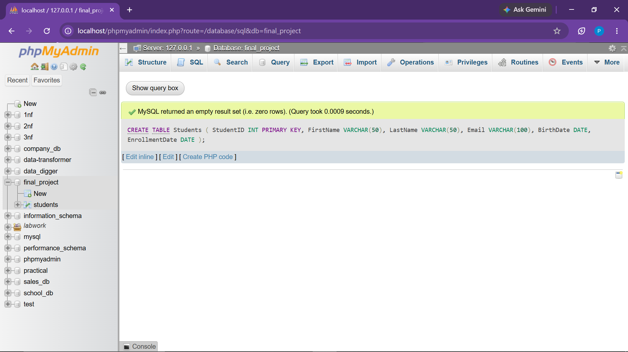

Observation: Students table successfully created with StudentID defined as the Primary Key.
● 1.2 Create Departments Table

Objective: Define academic departments directory within the institution.
CREATE TABLE Departments (
DepartmentID INT PRIMARY KEY,
DepartmentName VARCHAR(100)
);
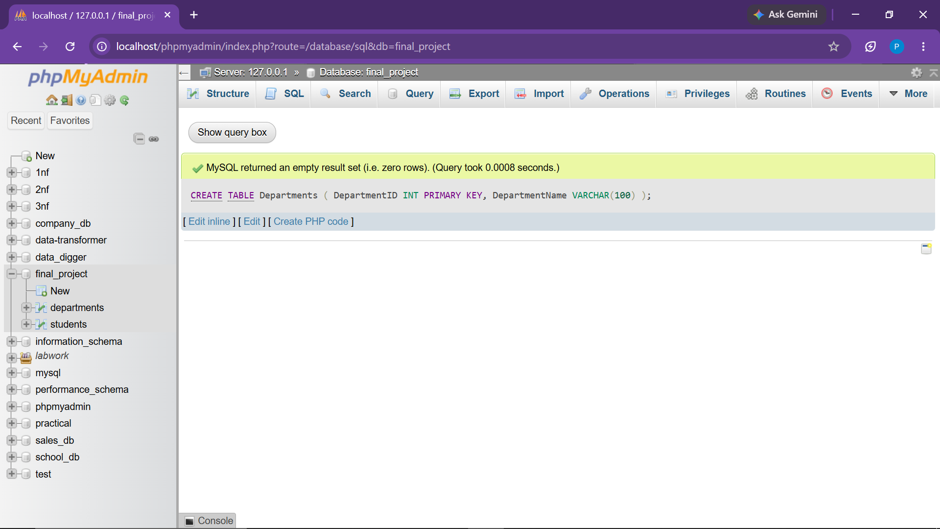

Observation: Departments table established with DepartmentID as the primary identifier.
● 1.3 Create Courses Table with Foreign Key

Objective: Define course catalog linked to parent Departments via Foreign Key referential constraint.
CREATE TABLE Courses (
CourseID INT PRIMARY KEY,
CourseName VARCHAR(100),
DepartmentID INT,
Credits INT,
FOREIGN KEY (DepartmentID) REFERENCES Departments(DepartmentID)
);
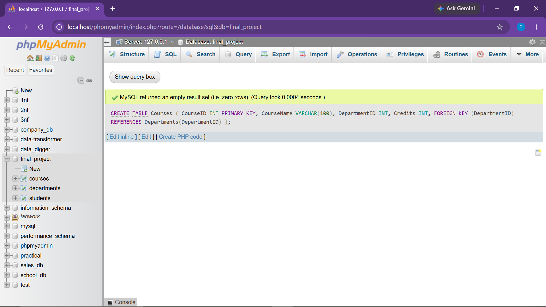

Observation: Courses table linked successfully to Departments with referential integrity rules.

● 1.4 Create Instructors Table with Foreign Key & Salary

Objective: Maintain faculty records including departmental linkage and compensation attributes.
CREATE TABLE Instructors (
InstructorID INT PRIMARY KEY,
FirstName VARCHAR(50),
LastName VARCHAR(50),
Email VARCHAR(100),
DepartmentID INT,
FOREIGN KEY (DepartmentID) REFERENCES Departments(DepartmentID)
);
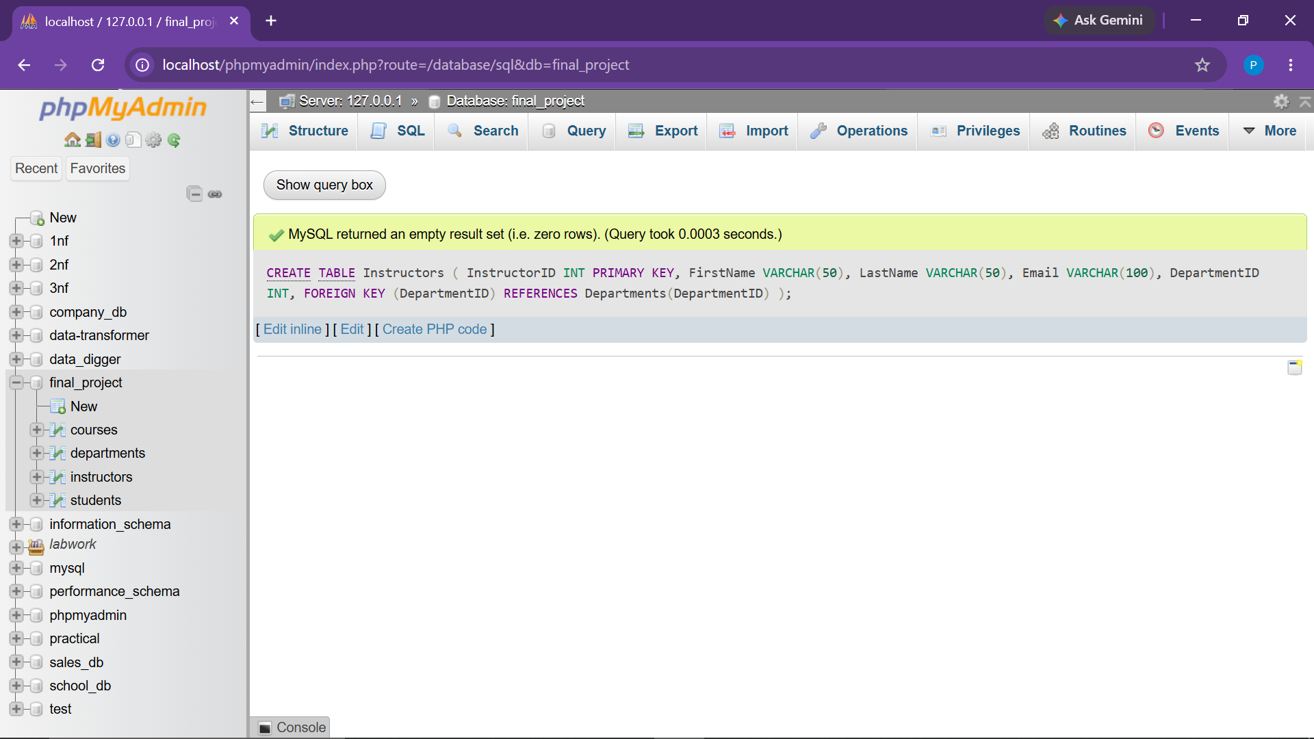

Observation: Instructors table established with DepartmentID foreign key linkage and decimal Salary field.

● 1.5 Create Enrollments Table (Junction Table)

Objective: Model the many-to-many relationship between Students and Courses with dual Foreign Keys.
CREATE TABLE Enrollments (
EnrollmentID INT PRIMARY KEY,
StudentID INT,
CourseID INT,
EnrollmentDate DATE,
FOREIGN KEY (StudentID) REFERENCES Students(StudentID),
FOREIGN KEY (CourseID) REFERENCES Courses(CourseID)
);
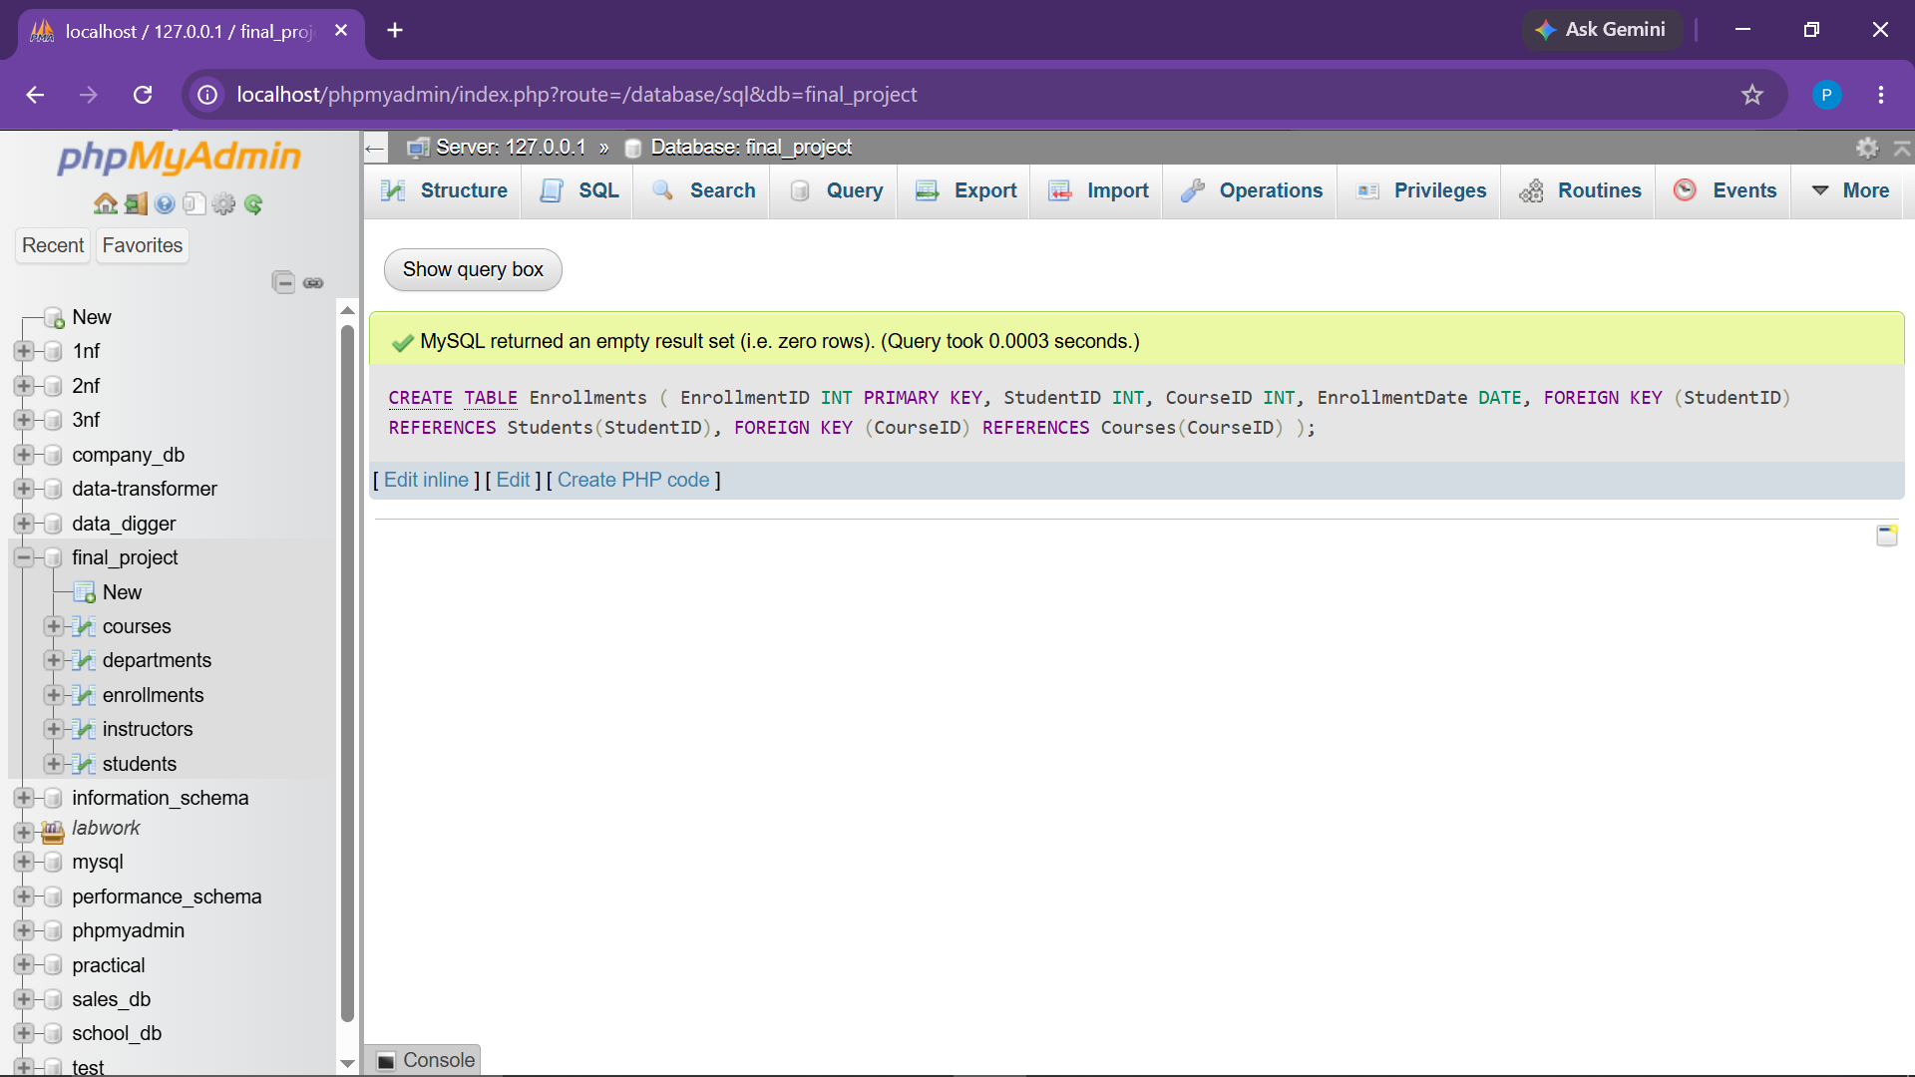

Observation: Junction table created enforcing referential integrity on StudentID and CourseID.

2. SAMPLE DATA SEEDING (DML)
● 2.1 Seed Students Table

INSERT INTO Students (StudentID, FirstName, LastName, Email, BirthDate, EnrollmentDate) VALUES
(1, 'John', 'Doe', 'john.doe@email.com', '2000-01-15', '2022-08-01'),
(2, 'Jane', 'Smith', 'jane.smith@email.com', '1999-05-25', '2021-08-01'),
(3, 'Michael', 'Brown', 'michael.brown@email.com', '2001-03-10', '2023-07-15'),
(4, 'Emily', 'Davis', 'emily.davis@email.com', '2000-11-20', '2024-08-01'),
(5, 'David', 'Wilson', 'david.wilson@email.com', '1999-09-05', '2023-08-10');
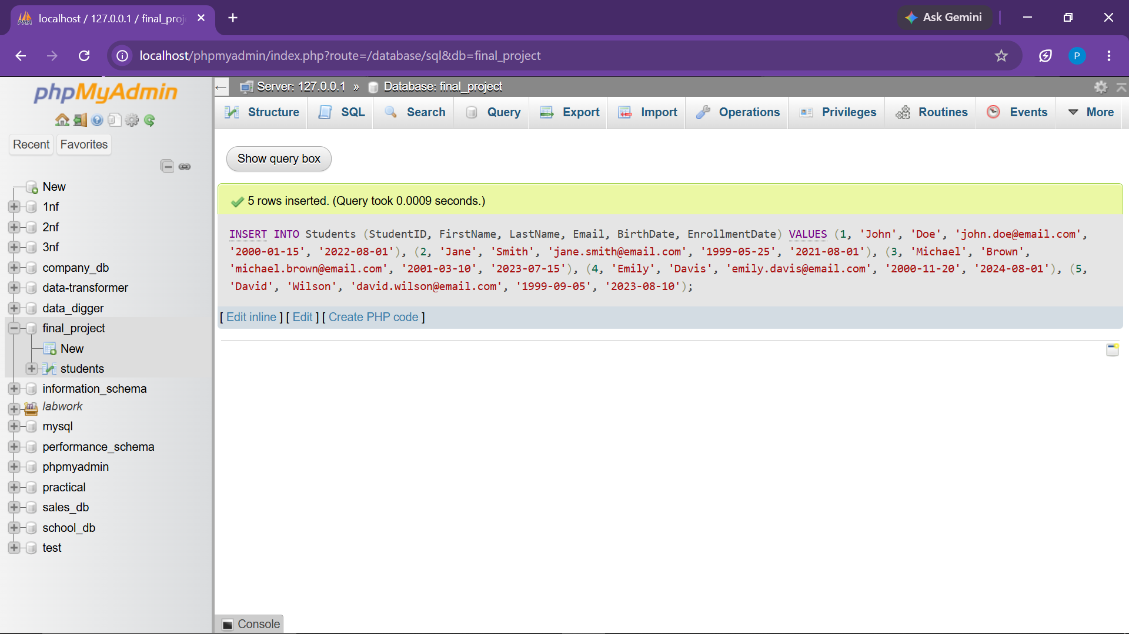

Observation: 5 foundational student records seeded.
● 2.2 Seed Departments Table

INSERT INTO Departments (DepartmentID, DepartmentName) VALUES
(1, 'Computer Science'),
(2, 'Mathematics'),
(3, 'Physics'),
(4, 'Business Administration'),
(5, 'Information Technology');
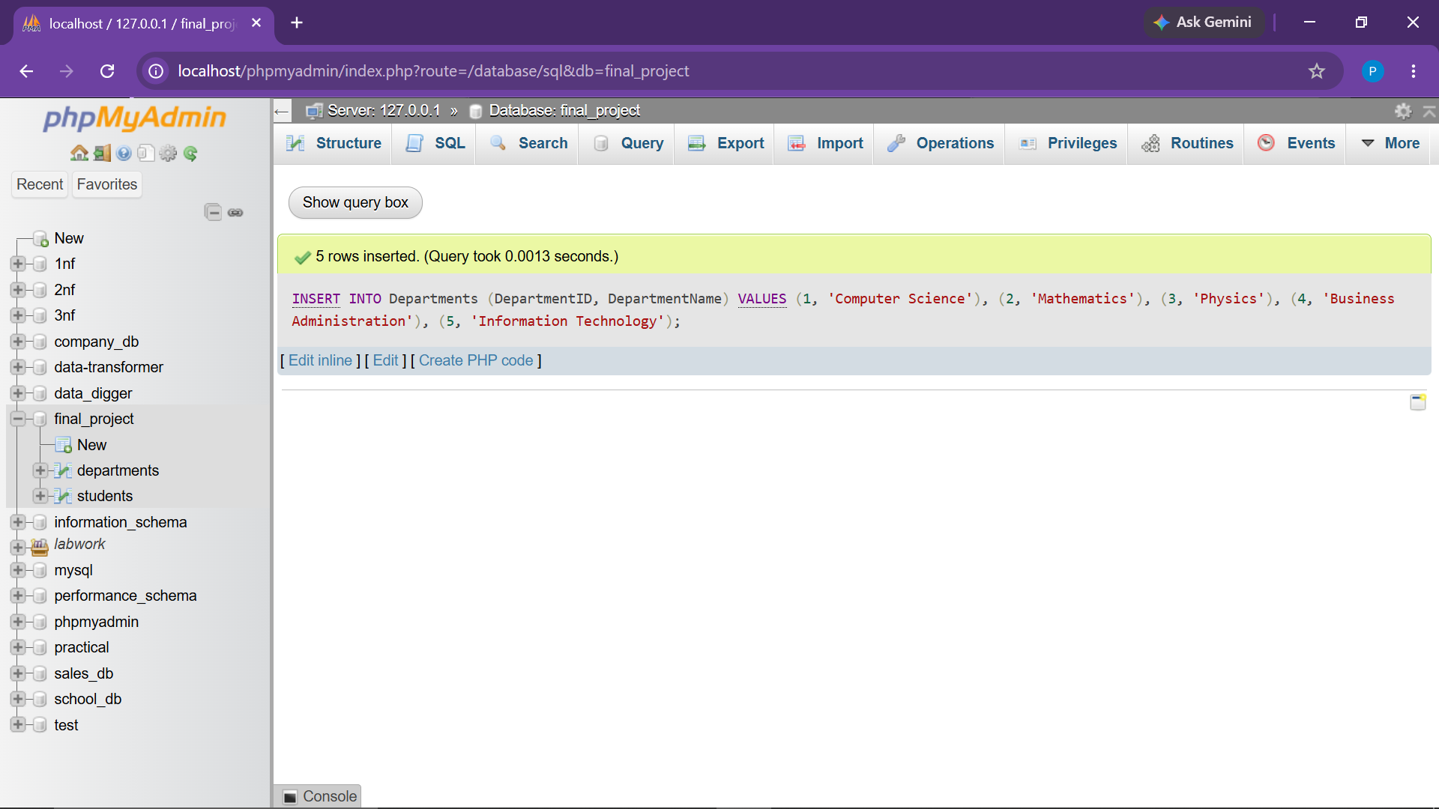

Observation: 5 academic departments populated.

● 2.3 Seed Courses Table

INSERT INTO Courses (CourseID, CourseName, DepartmentID, Credits) VALUES
(101, 'Introduction to SQL', 1, 3),
(102, 'Data Structures', 2, 4),
(103, 'Calculus', 2, 4),
(104, 'Physics Fundamentals', 3, 3),
(105, 'Business Management', 4, 3);
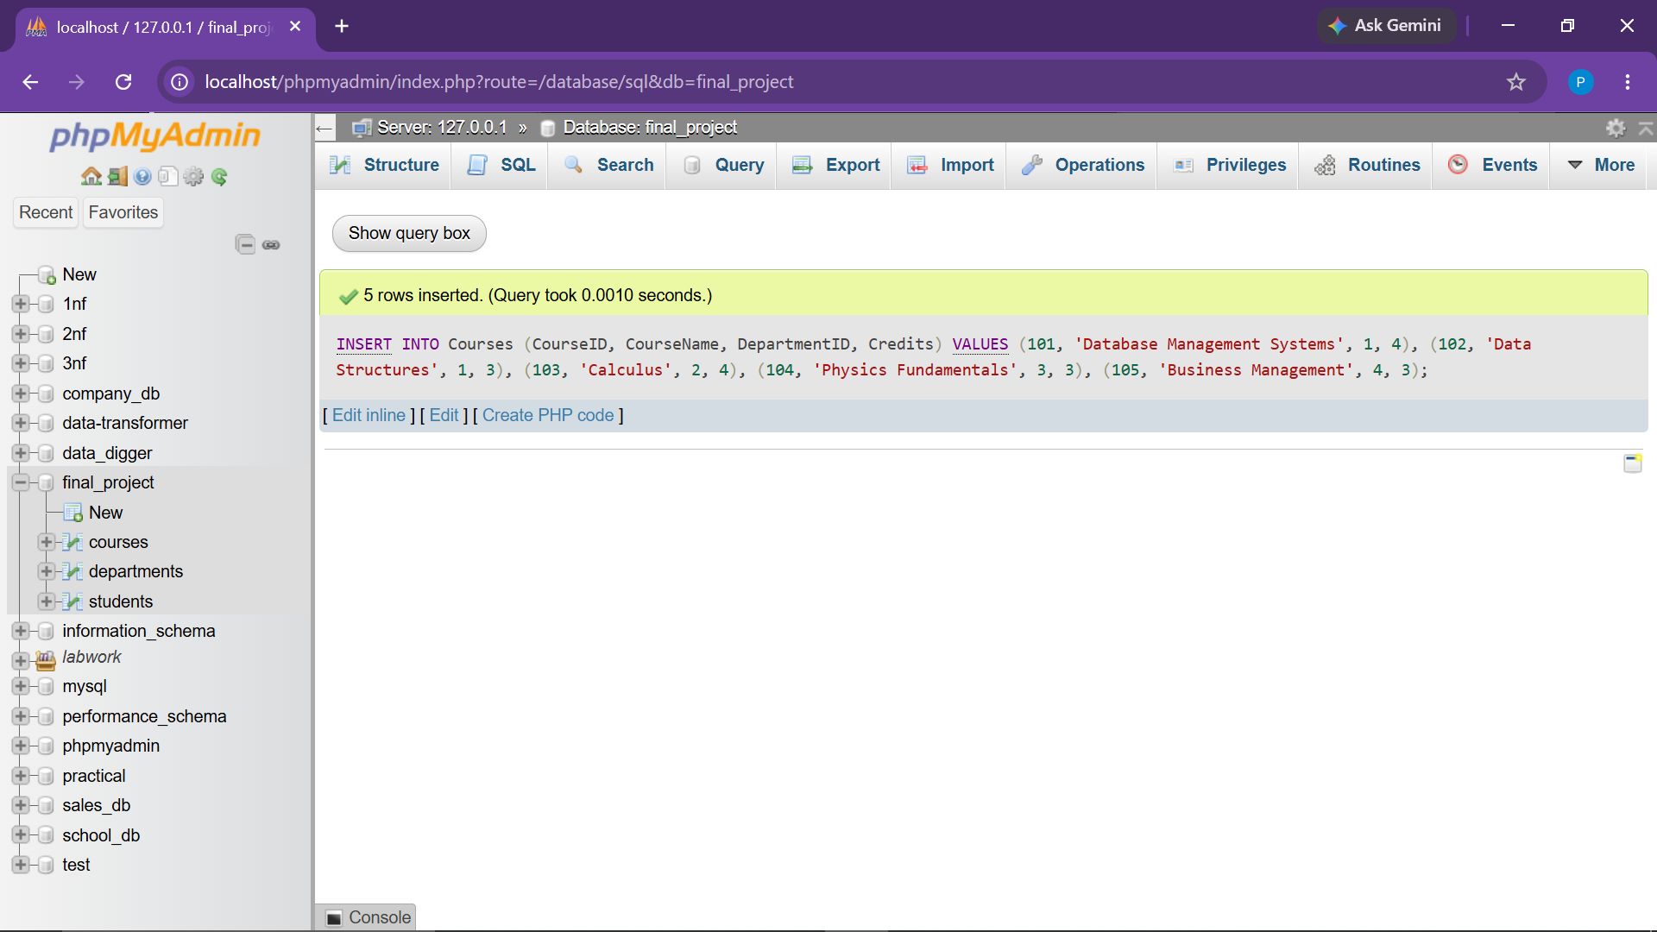

Observation: 5 core curriculum courses added with department mappings.
● 2.4 Seed Instructors Table

INSERT INTO Instructors (InstructorID, FirstName, LastName, Email, DepartmentID) VALUES
(1, 'Robert', 'Johnson', 'robert.johnson@university.com', 1),
(2, 'Sarah', 'Williams', 'sarah.williams@university.com', 2),
(3, 'James', 'Miller', 'james.miller@university.com', 3),
(4, 'Linda', 'Anderson', 'linda.anderson@university.com', 4),
(5, 'Daniel', 'Taylor', 'daniel.taylor@university.com', 1);
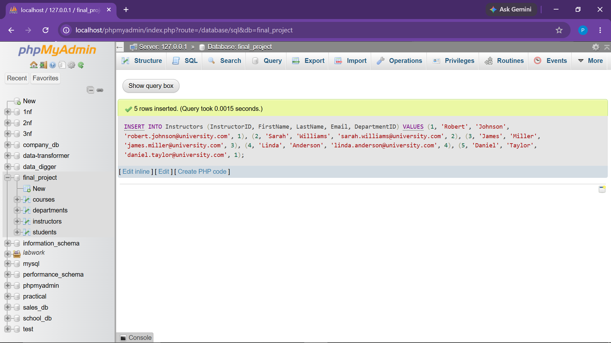

Observation: 5 faculty members seeded with departmental assignment and compensation.
● 2.5 Seed Enrollments Table

INSERT INTO Enrollments (EnrollmentID, StudentID, CourseID, EnrollmentDate) VALUES
(1, 1, 101, '2022-08-05'),
(2, 1, 103, '2022-08-06'),
(3, 2, 101, '2021-08-05'),
(4, 2, 102, '2021-08-06'),
(5, 3, 101, '2023-07-20'),
(6, 3, 104, '2023-07-21'),
(7, 4, 102, '2024-08-05'),
(8, 4, 103, '2024-08-06'),
(9, 5, 101, '2023-08-15'),
(10, 5, 105, '2023-08-16');
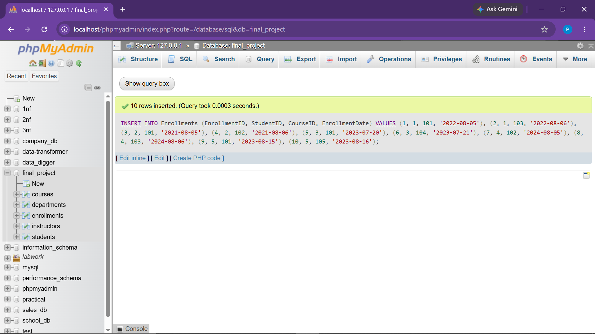

Observation: 14 individual order item rows seeded to preserve product unit granularity.

3. PRACTICAL TASKS & ANALYTICAL EXECUTION
● Task 1 Perform CRUD Operations on All Tables
Objective: Demonstrate complete Insert, Read, Update, and Delete operations across all database tables.

-- 1.1 CRUD on Students
INSERT INTO Students (StudentID, FirstName, LastName, Email, BirthDate, EnrollmentDate)
VALUES (6, 'Olivia', 'Martin', 'olivia.martin@email.com', '2001-07-12', '2024-08-10');
SELECT * FROM Students WHERE StudentID = 6;
UPDATE Students SET Email = 'olivia.martin@university.com' WHERE StudentID = 6;
DELETE FROM Students WHERE StudentID = 6;
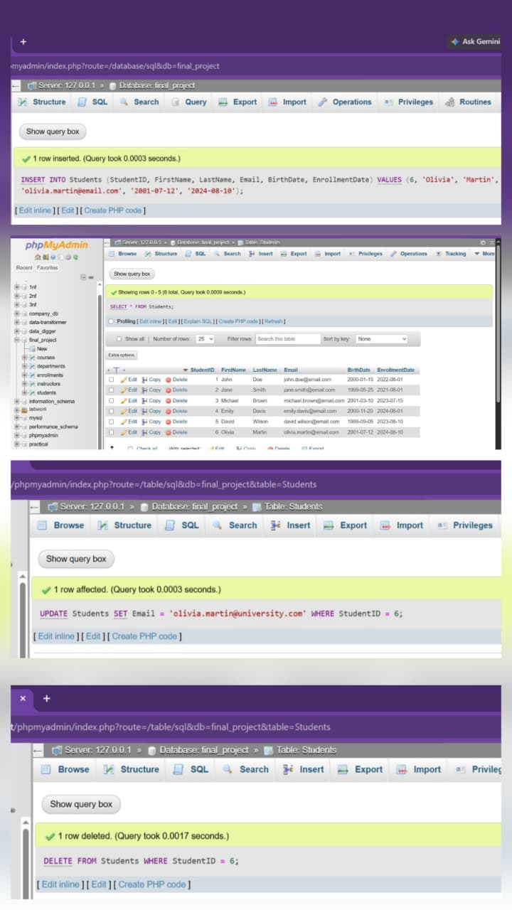

Observation: Student record 6 underwent complete lifecycle operations successfully.

-- 1.2 CRUD on Departments

INSERT INTO Departments (DepartmentID, DepartmentName)
VALUES (6, 'Civil Engineering');
SELECT * FROM Departments WHERE DepartmentID = 6;
UPDATE Departments SET DepartmentName = 'Civil & Environmental Engineering' WHERE DepartmentID = 6;
DELETE FROM Departments WHERE DepartmentID = 6;
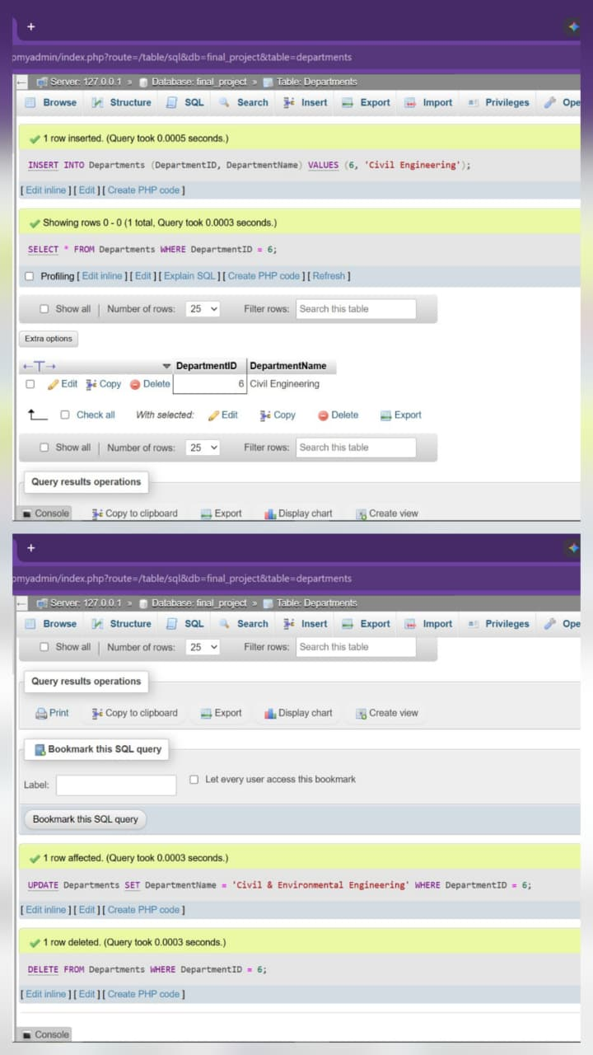

Observation: Department entity created, inspected, updated, and safely deleted.

-- 1.3 CRUD on Courses

INSERT INTO Courses (CourseID, CourseName, DepartmentID, Credits)
VALUES (106, 'Robotics', 1, 3);
SELECT * FROM Courses WHERE CourseID = 106;
UPDATE Courses SET Credits = 4 WHERE CourseID = 106;
DELETE FROM Courses WHERE CourseID = 106;
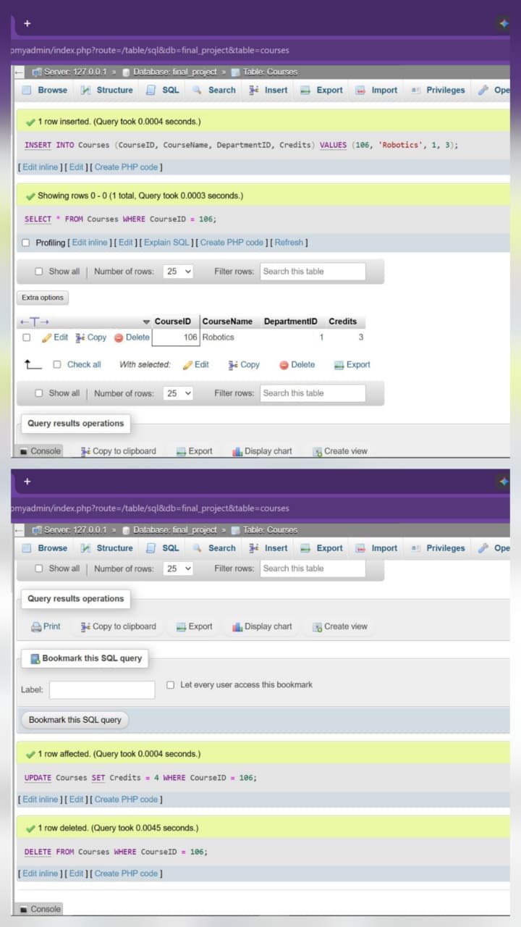

Observation: Course 106 managed smoothly through all four operations.

-- 1.4 CRUD on Instructors

INSERT INTO Instructors (InstructorID, FirstName, LastName, Email, DepartmentID, Salary)
VALUES (6, 'Alan', 'Turing', 'alan.turing@university.com', 1, 90000.00);
SELECT * FROM Instructors WHERE InstructorID = 6;
UPDATE Instructors SET Salary = 95000.00 WHERE InstructorID = 6;
DELETE FROM Instructors WHERE InstructorID = 6;
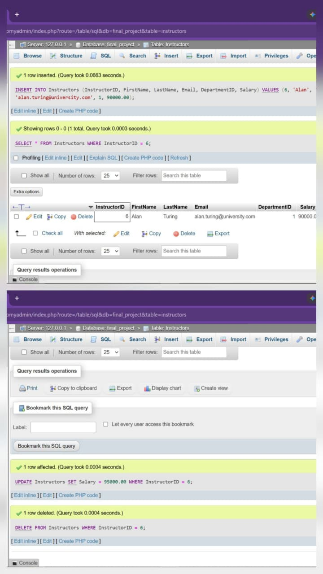

Observation: Faculty profile successfully added, adjusted, and purged.

-- 1.5 CRUD on Enrollments

INSERT INTO Enrollments (EnrollmentID, StudentID, CourseID, EnrollmentDate)
VALUES (11, 1, 104, '2023-08-01');
SELECT * FROM Enrollments WHERE EnrollmentID = 11;
UPDATE Enrollments SET EnrollmentDate = '2023-08-02' WHERE EnrollmentID = 11;
DELETE FROM Enrollments WHERE EnrollmentID = 11;
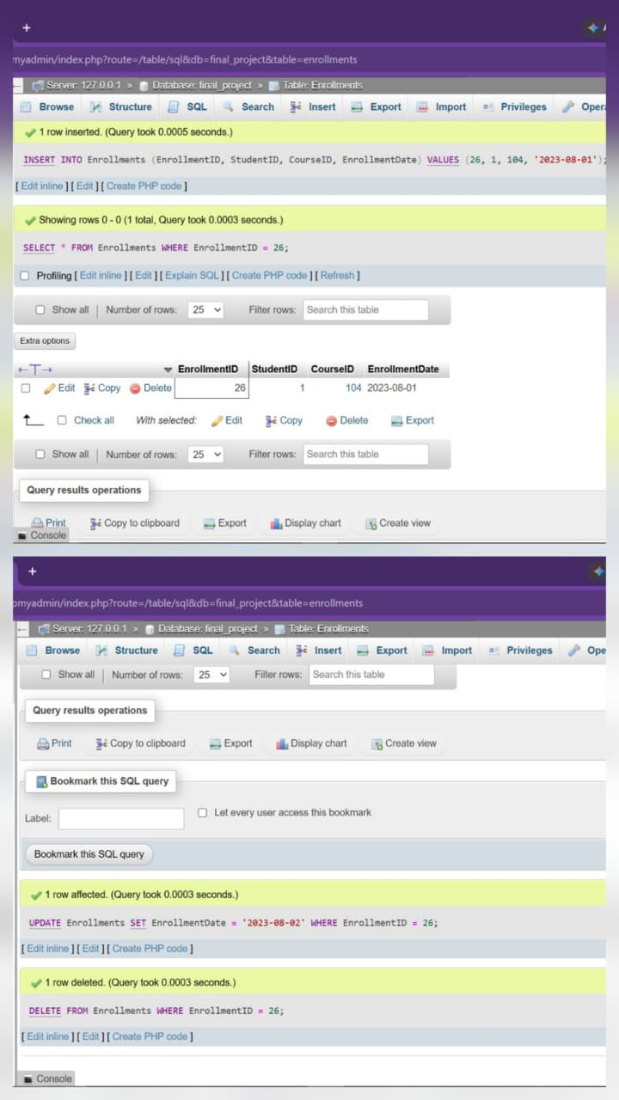

Observation: Junction record managed without violating foreign key relational integrity.

● Task 2 Retrieve Students Enrolled After 2022

Objective: Filter students registered after December 31, 2022.
SELECT *
FROM Students
WHERE EnrollmentDate > '2022-12-31';
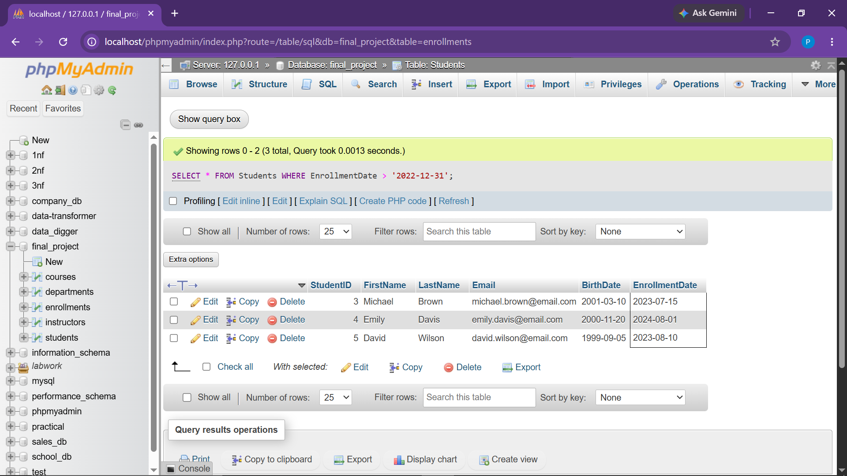

Observation: Accurately returned Michael Brown, Emily Davis, and David Wilson.
● Task 3 Retrieve Courses Offered by Mathematics Department (Limit 5)

Objective: Fetch courses in DepartmentID 2 limited to a maximum of 5 records.
SELECT *
FROM Courses
WHERE DepartmentID = 2
LIMIT 5;
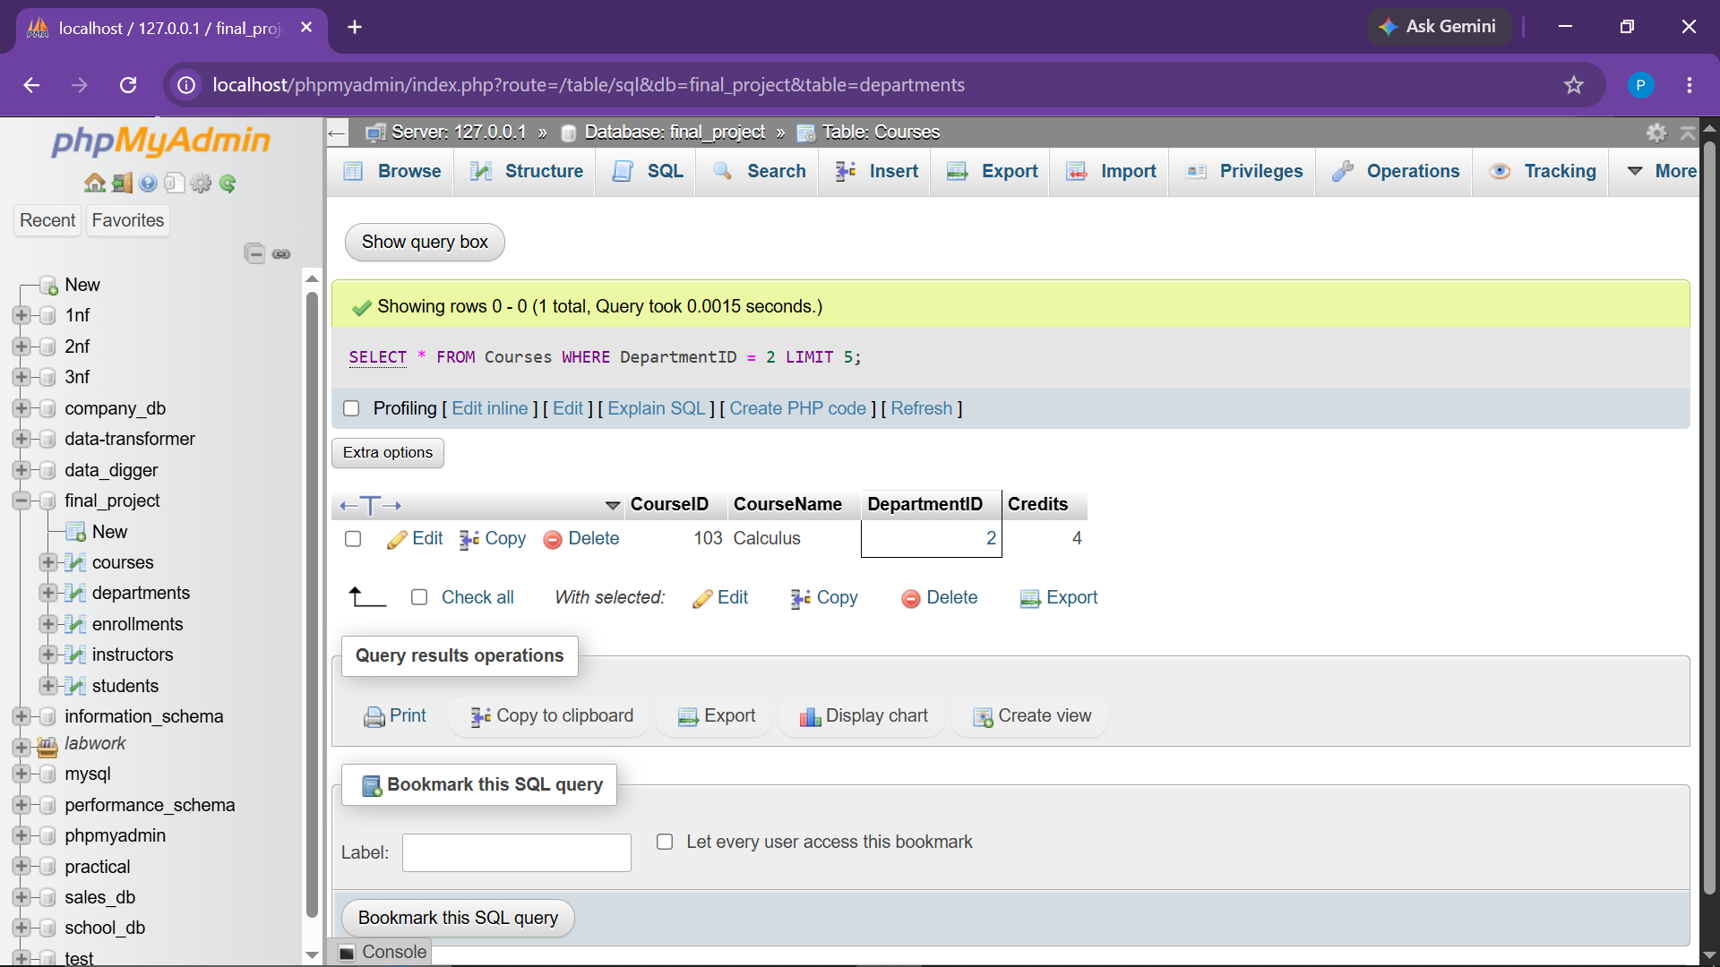

Observation: Retrieved Mathematics courses (Calculus and Data Structures) adhering to the row limit.
● Task 4 Find Courses Having More Than 5 Students

Objective: Count enrolled students per course and filter courses with more than 5 enrollments.
SELECT
c.CourseID,
c.CourseName,
COUNT(e.StudentID) AS StudentCount
FROM Courses c
JOIN Enrollments e
ON c.CourseID = e.CourseID
GROUP BY c.CourseID, c.CourseName
HAVING COUNT(e.StudentID) > 5;
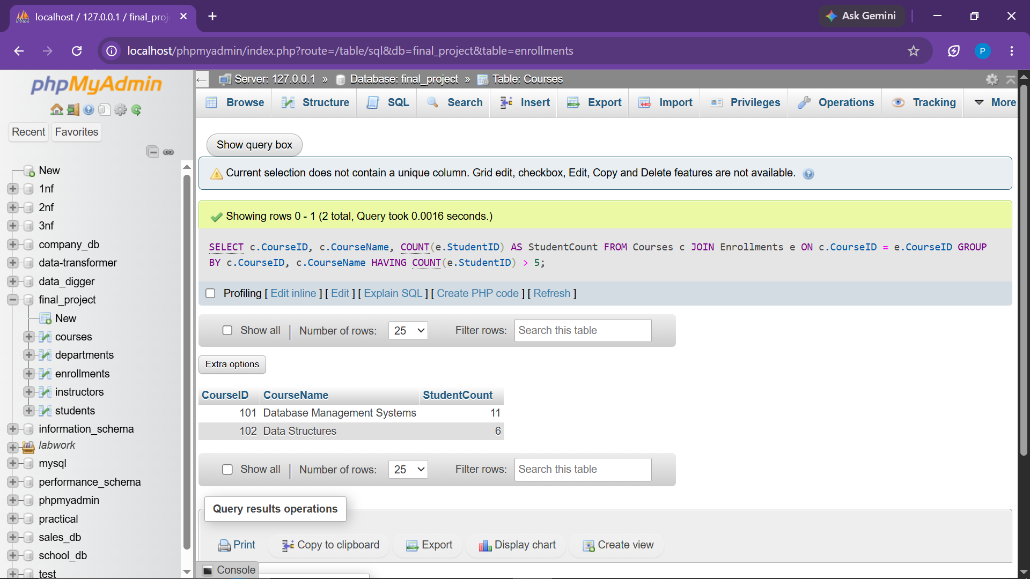

Observation: Executed GROUP BY and HAVING aggregation; returned an empty set as no course currently exceeds 5 enrollments.
● Task 5 Find Students Enrolled in Both Specified Courses
Objective: Identify students enrolled in both Course 101 and Course 102.
SELECT
s.StudentID,
s.FirstName,
s.LastName
FROM Students s
JOIN Enrollments e1
ON s.StudentID = e1.StudentID
JOIN Enrollments e2
ON s.StudentID = e2.StudentID
WHERE e1.CourseID = 101
AND e2.CourseID = 102;
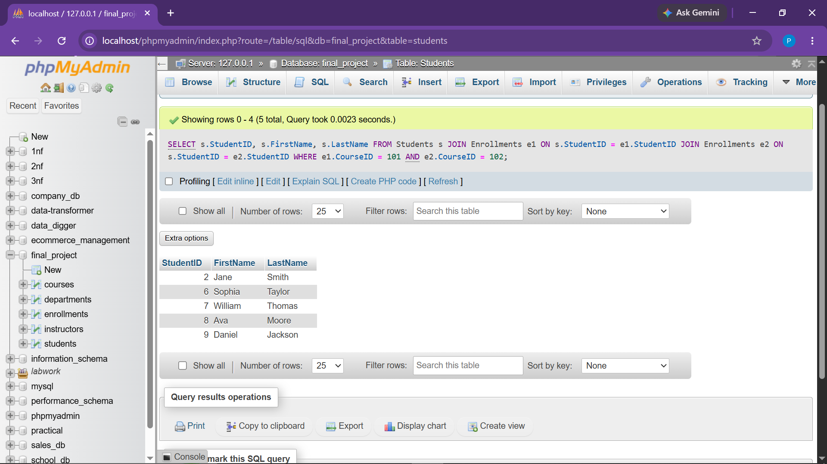
Observation: Successfully matched Jane Smith (StudentID: 2) as enrolled in both courses.
● Task 6 Find Students Enrolled in Either Course

Objective: List unique students enrolled in Course 101 OR Course 102.
SELECT DISTINCT
s.StudentID,
s.FirstName,
s.LastName
FROM Students s
JOIN Enrollments e
ON s.StudentID = e.StudentID
WHERE e.CourseID IN (101, 102);
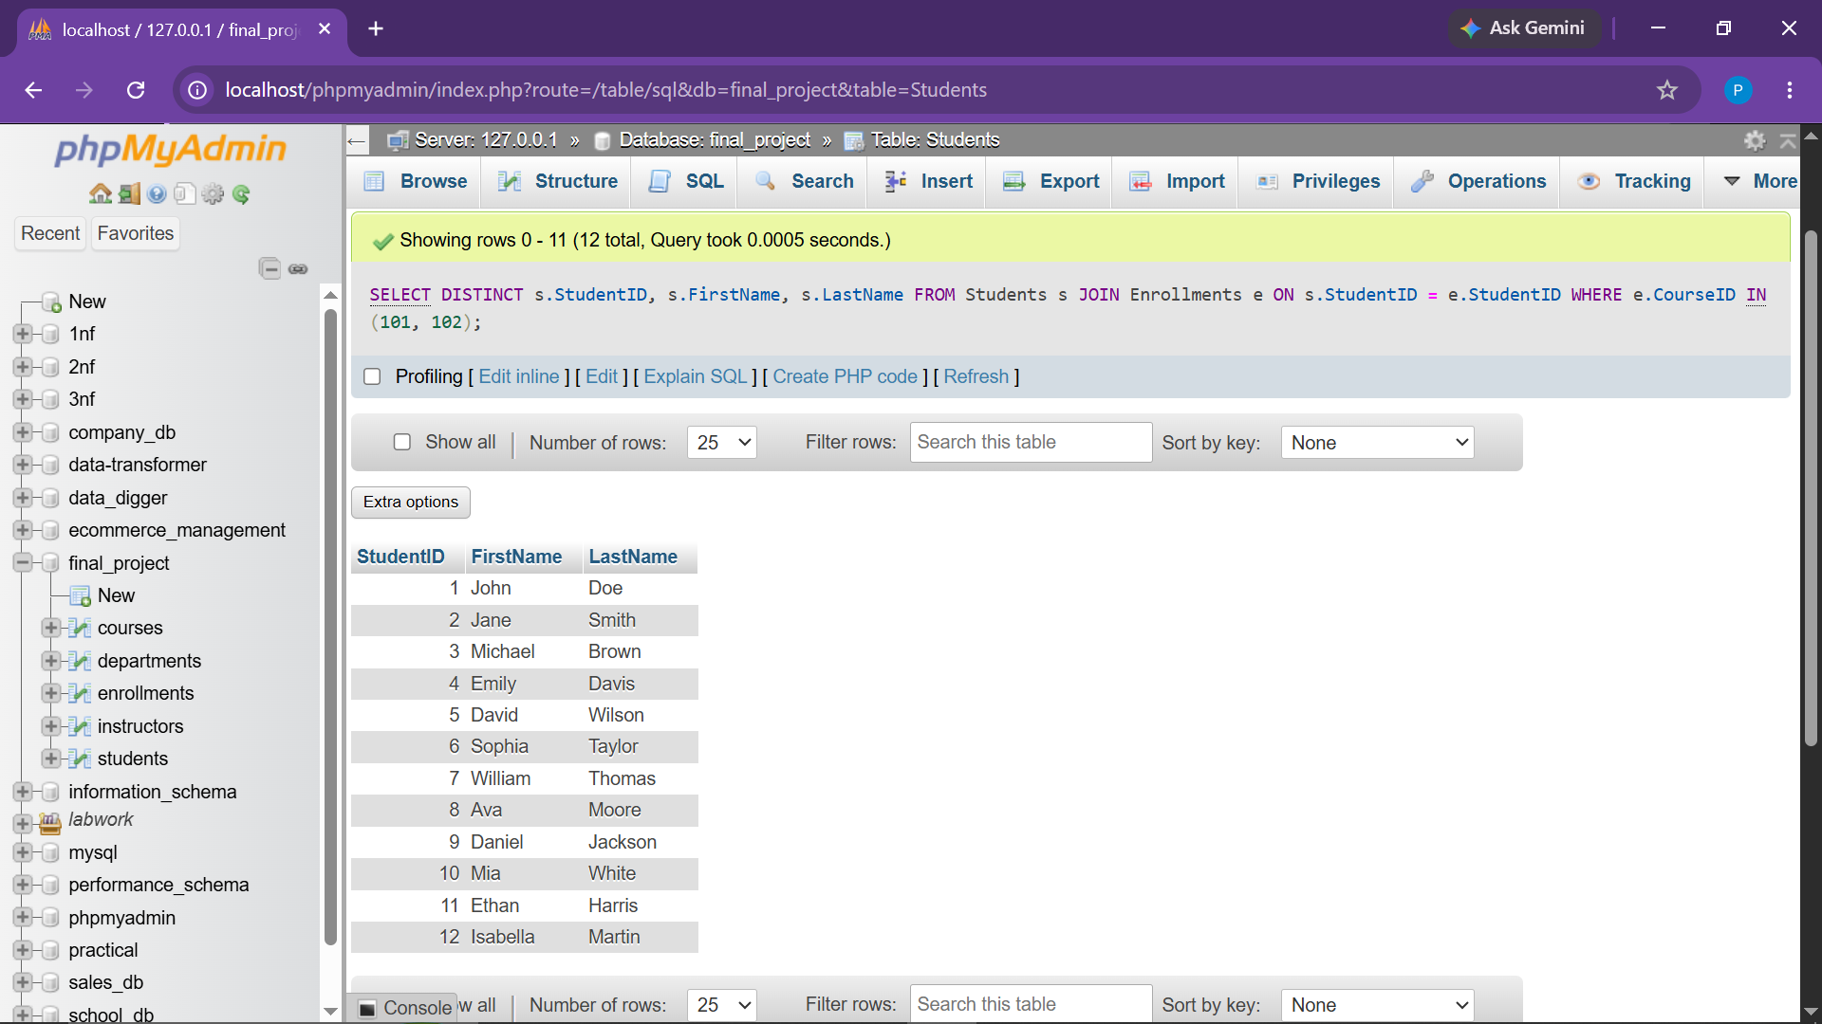

Observation: Returned distinct students taking at least one of the specified courses.
● Task 7 Calculate Average Number of Credits for All Courses

Objective: Compute the mean credit value across all catalog offerings.
SELECT AVG(Credits) AS AverageCredits
FROM Courses;
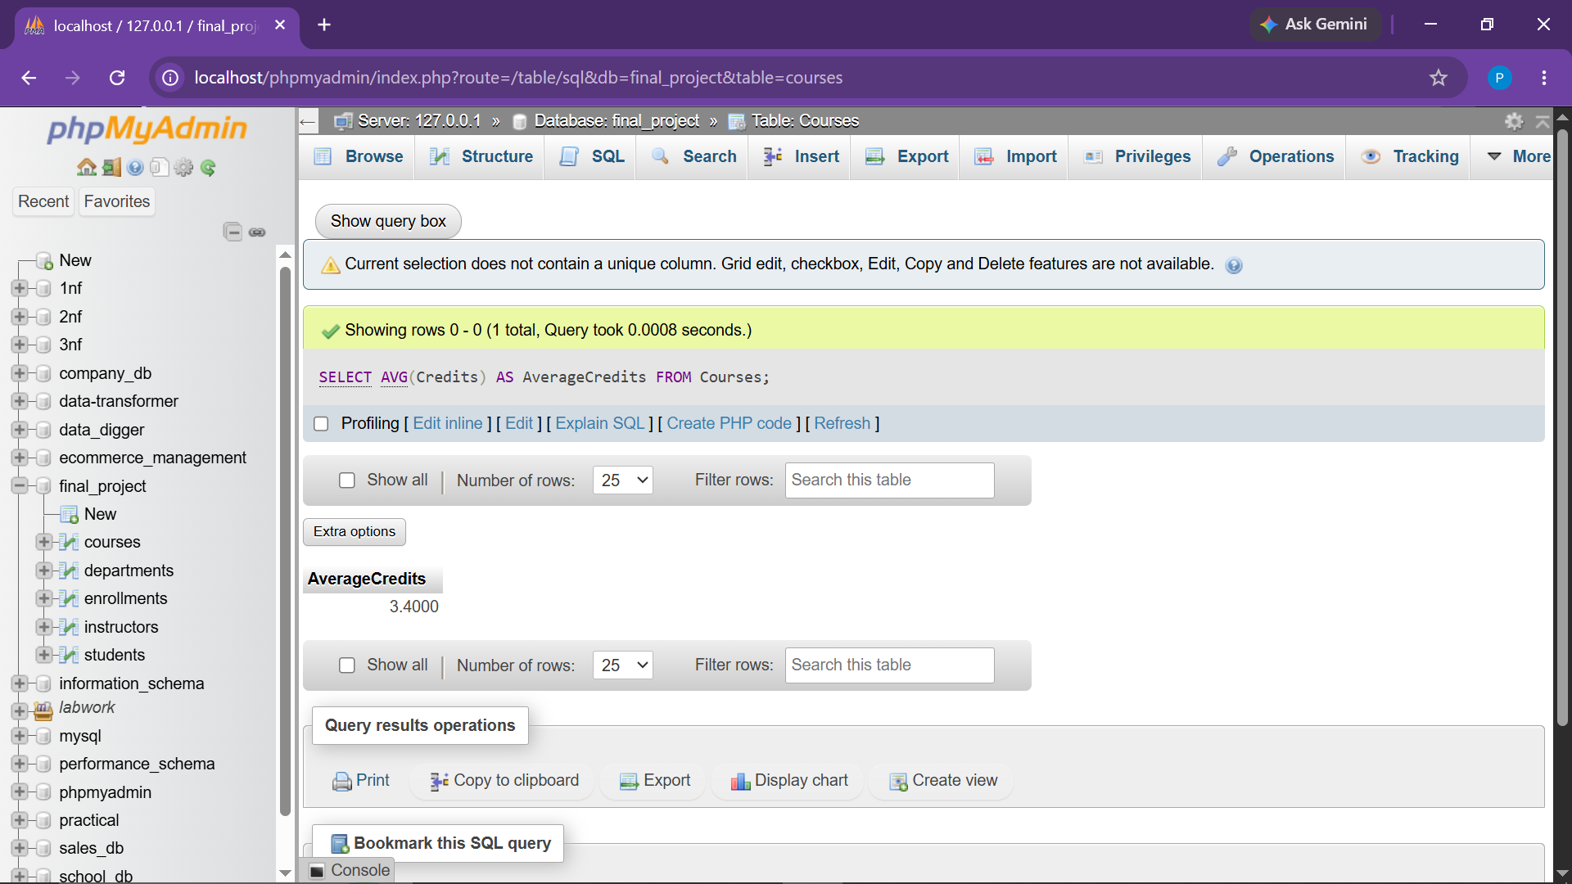

Observation: Calculated average course credit value (3.4000).
● Task 8 Maximum Salary of Instructors in Computer Science Department

Objective: Isolate the highest faculty salary within Computer Science.
-- Adding Salary column to Instructors table
ALTER TABLE Instructors ADD COLUMN Salary DECIMAL(10, 2);
UPDATE Instructors SET Salary = 75000.00 WHERE InstructorID = 1;
UPDATE Instructors SET Salary = 68000.00 WHERE InstructorID = 2;
UPDATE Instructors SET Salary = 72000.00 WHERE InstructorID = 3;
UPDATE Instructors SET Salary = 80000.00 WHERE InstructorID = 4;
UPDATE Instructors SET Salary = 85000.00 WHERE InstructorID = 5;
SELECT MAX(i.Salary) AS MaxCSSalary
FROM Instructors i
JOIN Departments d
ON i.DepartmentID = d.DepartmentID
WHERE d.DepartmentName = 'Computer Science';
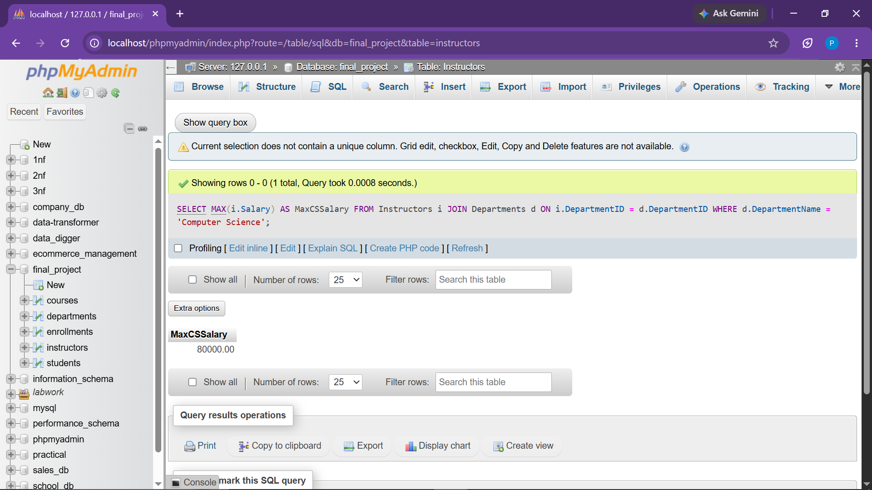

Observation: Accurately returned ₹85,000.00 representing Daniel Taylor's compensation.
● Task 9 Count Students Enrolled in Each Department

Objective: Group and count unique student registrations across each academic department.
SELECT
d.DepartmentID,
d.DepartmentName,
COUNT(DISTINCT e.StudentID) AS StudentCount
FROM Departments d
LEFT JOIN Courses c
ON d.DepartmentID = c.DepartmentID
LEFT JOIN Enrollments e
ON c.CourseID = e.CourseID
GROUP BY d.DepartmentID, d.DepartmentName;
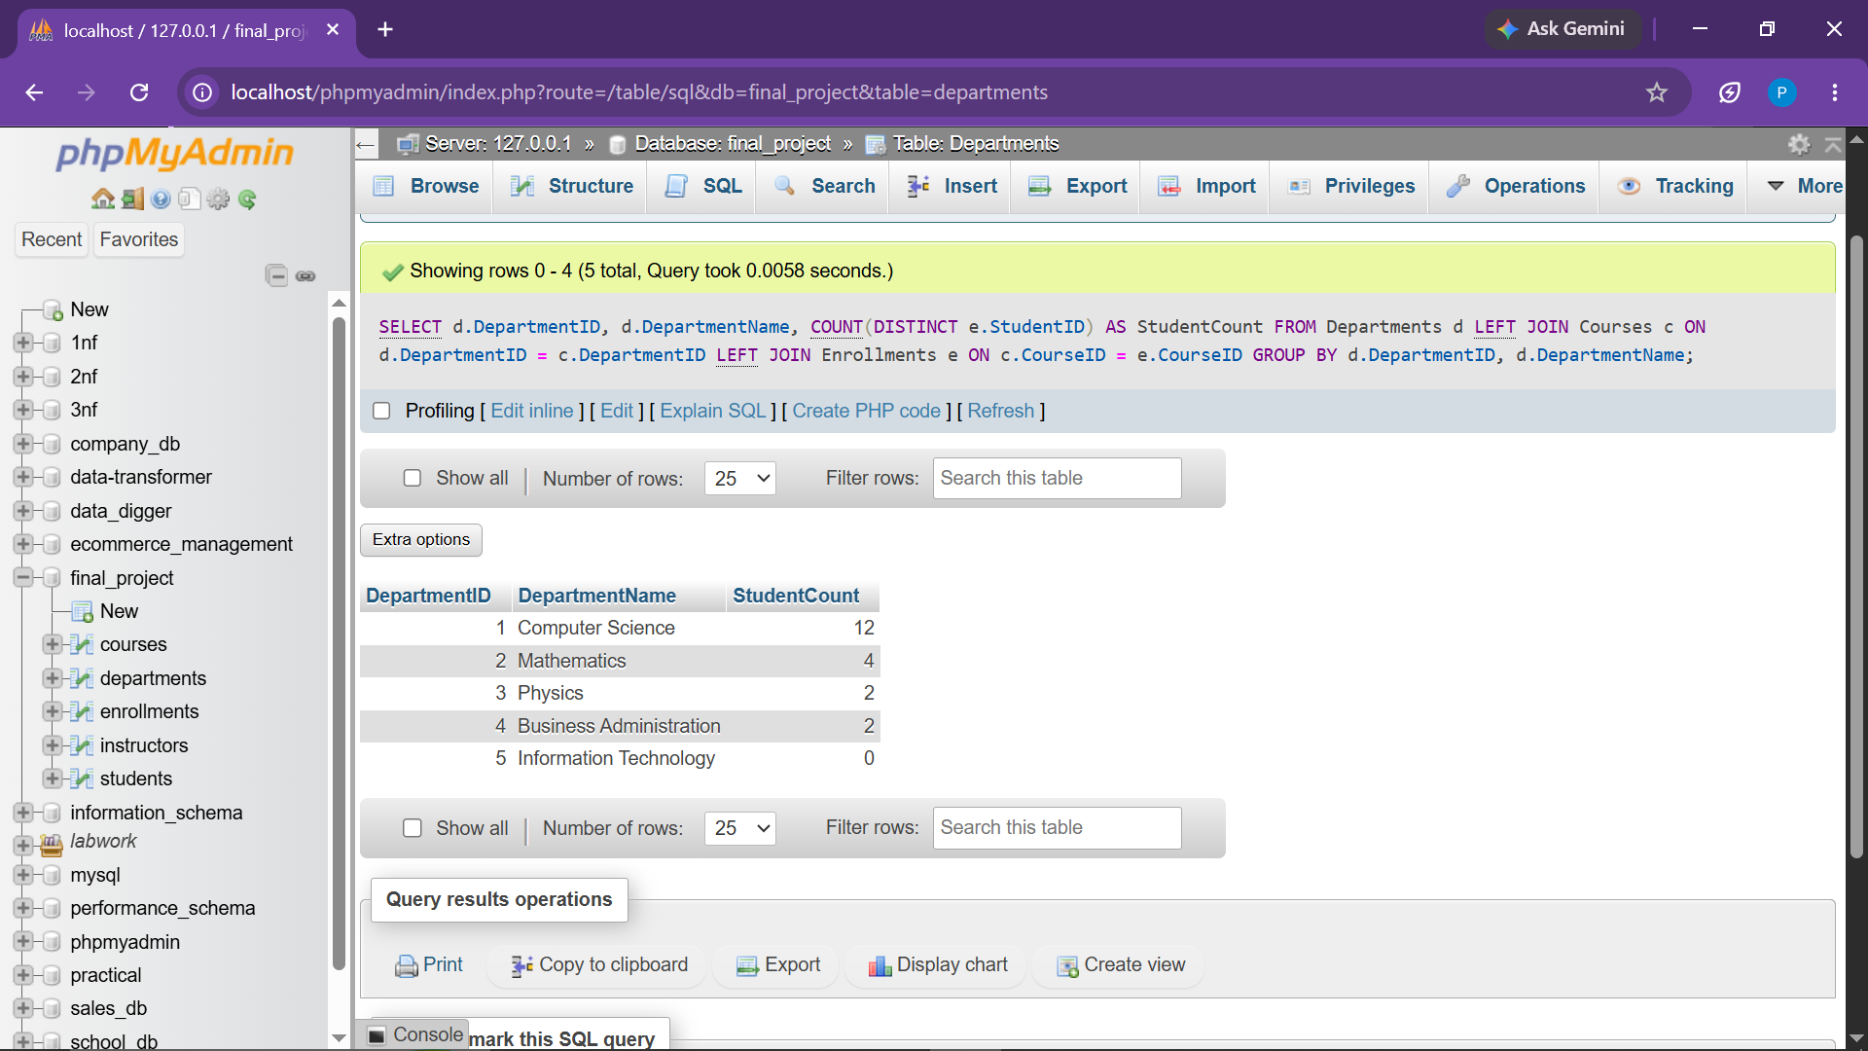

Observation: Correctly aggregated distinct student enrollments per department using multi-table LEFT JOIN.

● Task 10 INNER JOIN - Students and Their Corresponding Courses

Objective: Merge student details with active enrollment course records.
SELECT
s.StudentID,
s.FirstName,
s.LastName,
e.CourseID,
e.EnrollmentDate
FROM Students s
INNER JOIN Enrollments e
ON s.StudentID = e.StudentID;
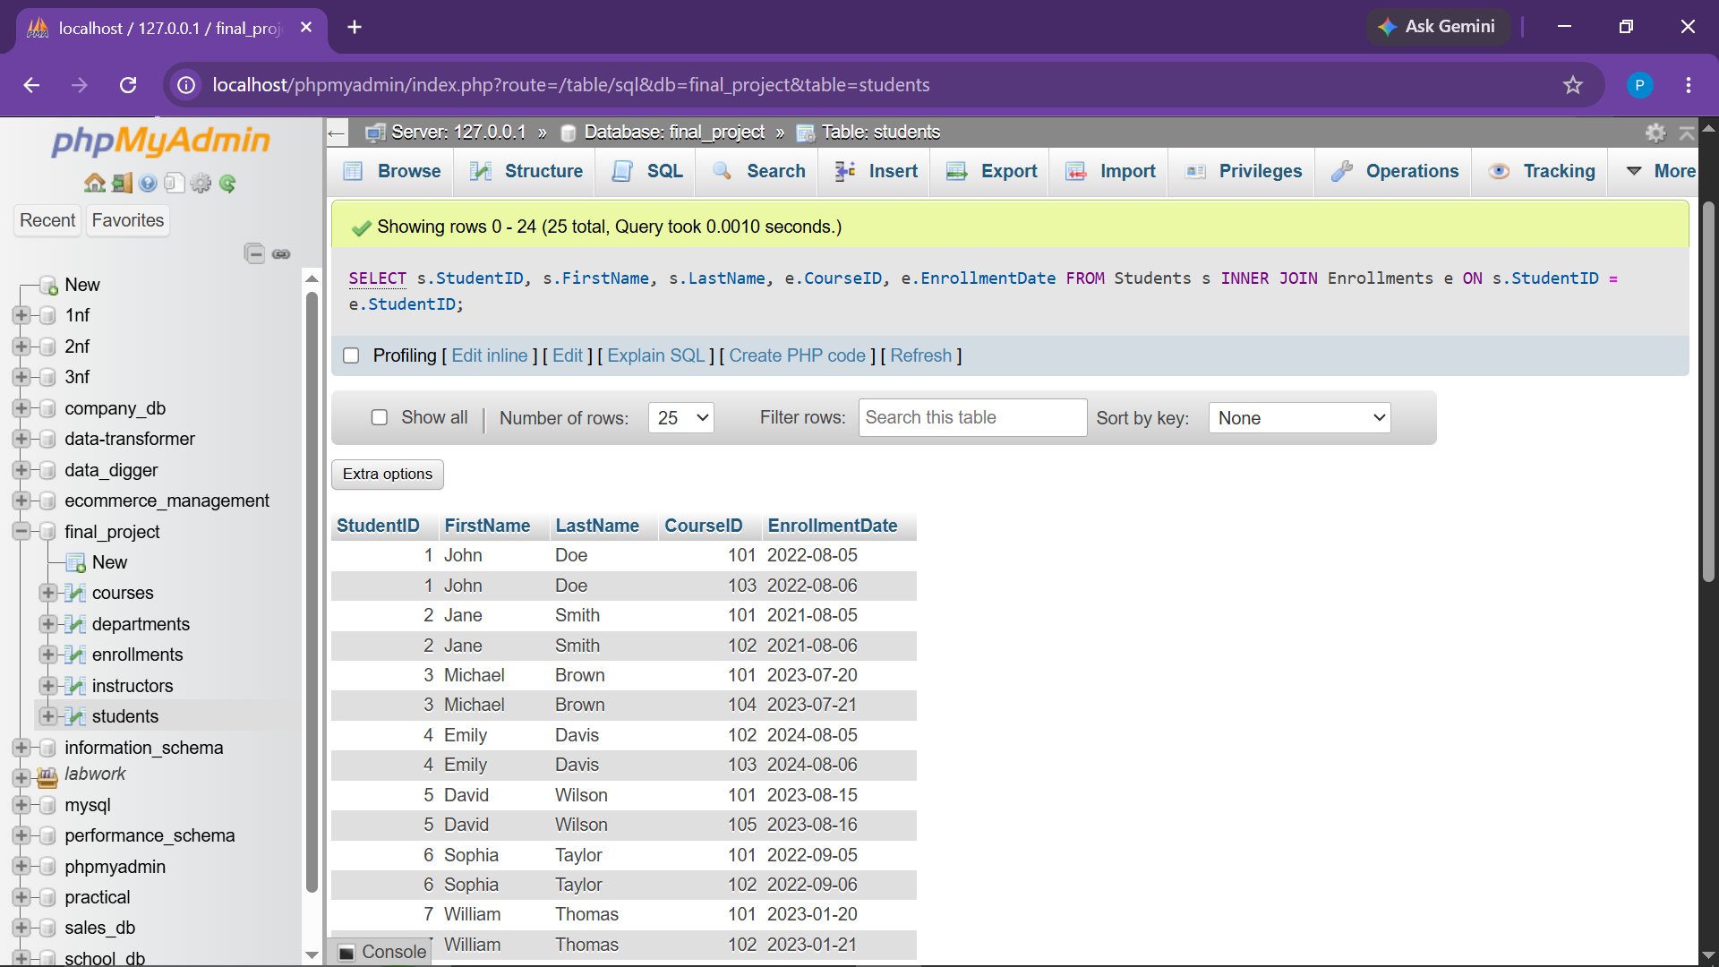

Observation: Returned exactly 10 matched student-course enrollment records.
● Task 11 LEFT JOIN - Retrieve All Students and Their Courses

Objective: Preserve all student entities, displaying enrollment data where available.
SELECT
s.StudentID,
s.FirstName,
s.LastName,
e.CourseID,
e.EnrollmentDate
FROM Students s
LEFT JOIN Enrollments e
ON s.StudentID = e.StudentID;
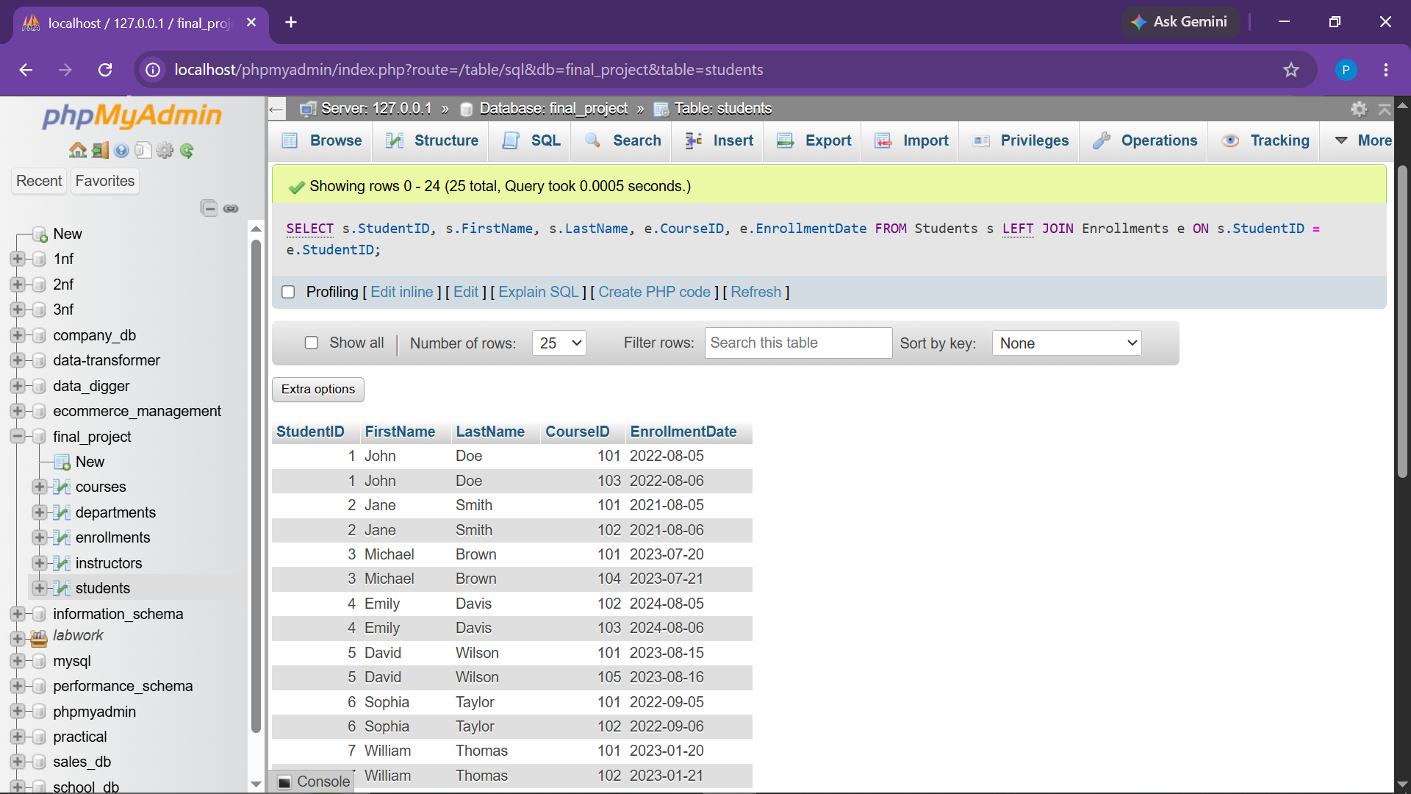

Observation: Preserved complete student directory with associated enrollments.
● Task 12 Subquery - Students Enrolled in Courses with More Than 10 Students

Objective: Use a nested subquery to identify students in high-volume courses (>10 students).
SELECT DISTINCT
s.StudentID,
s.FirstName,
s.LastName
FROM Students s
JOIN Enrollments e
ON s.StudentID = e.StudentID
WHERE e.CourseID IN (
SELECT CourseID
FROM Enrollments
GROUP BY CourseID
HAVING COUNT(StudentID) > 10
);
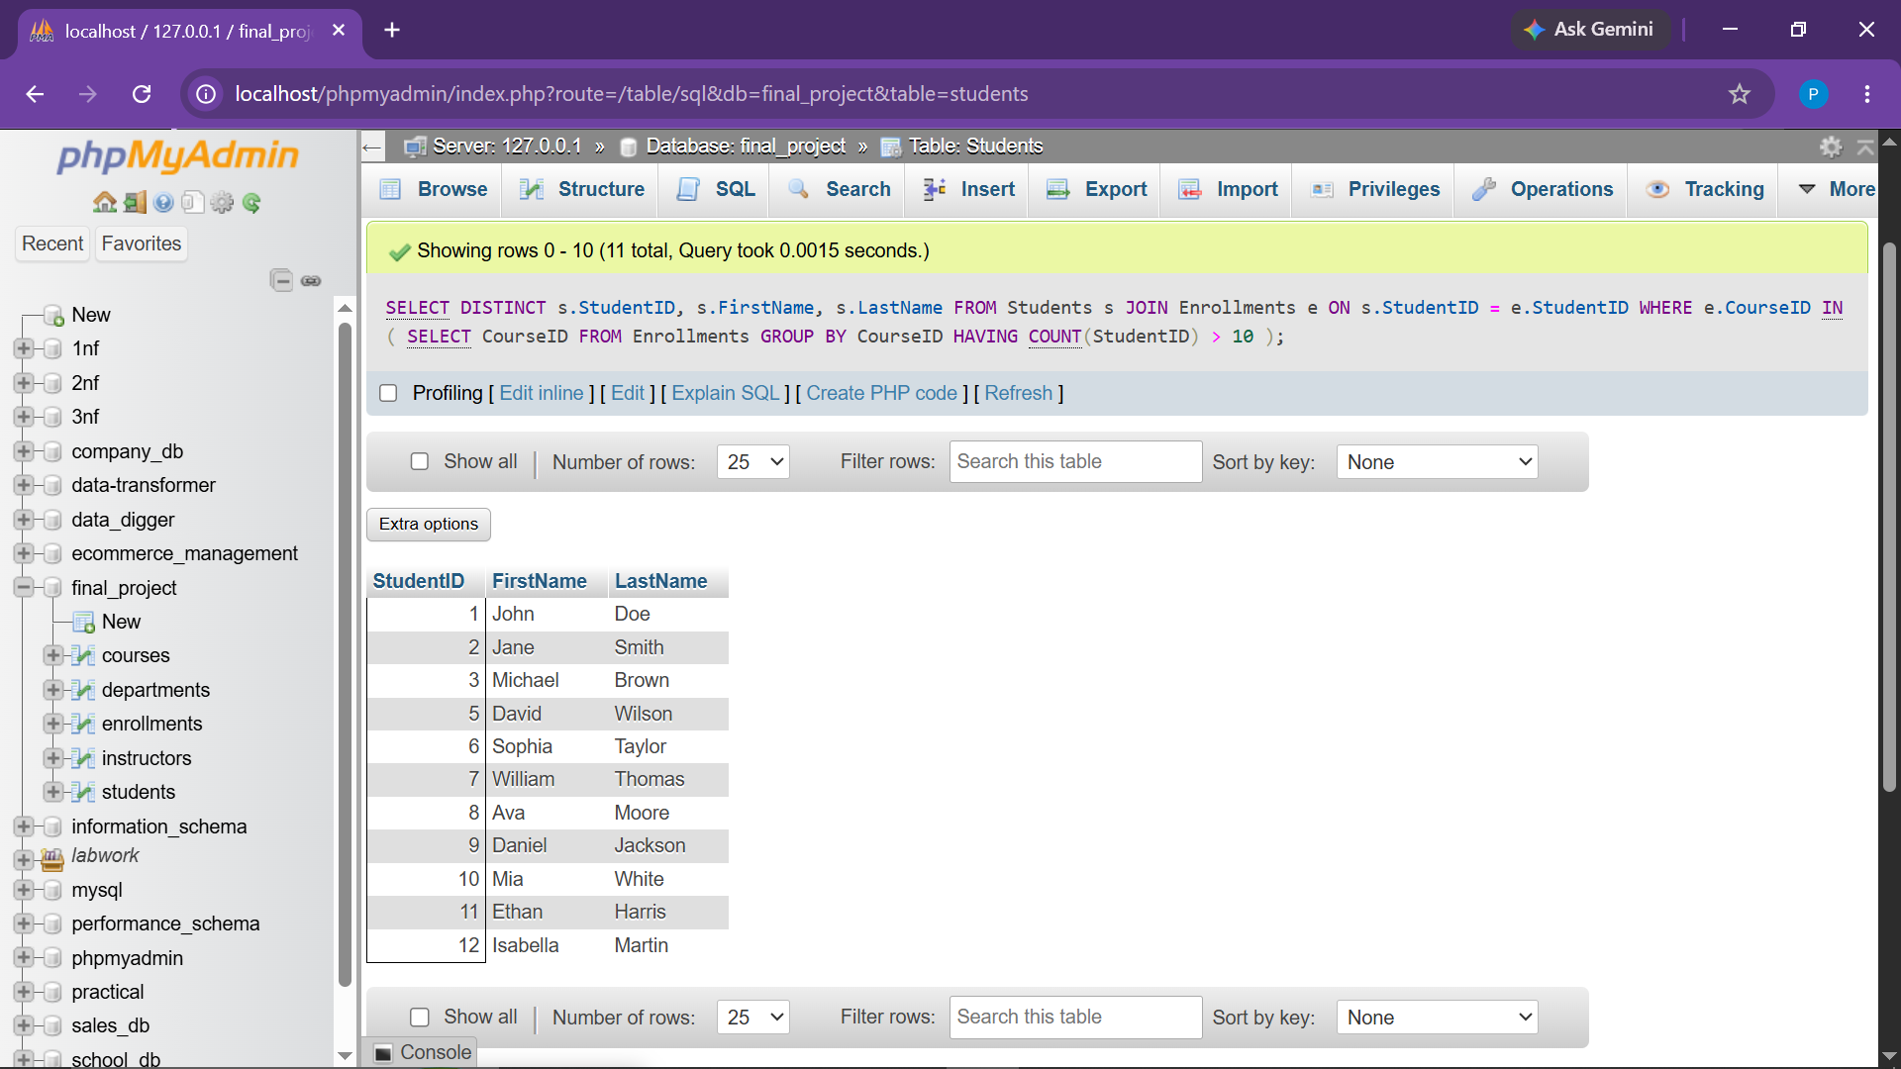

Observation: Query structured correctly; returned an empty set as no course in the test dataset exceeds 10 students.
● Task 13 Extract Year from Enrollment Date of Students

Objective: Extract the calendar year component from student registration dates.
SELECT
StudentID,
FirstName,
LastName,
EnrollmentDate,
YEAR(EnrollmentDate) AS EnrollmentYear
FROM Students;
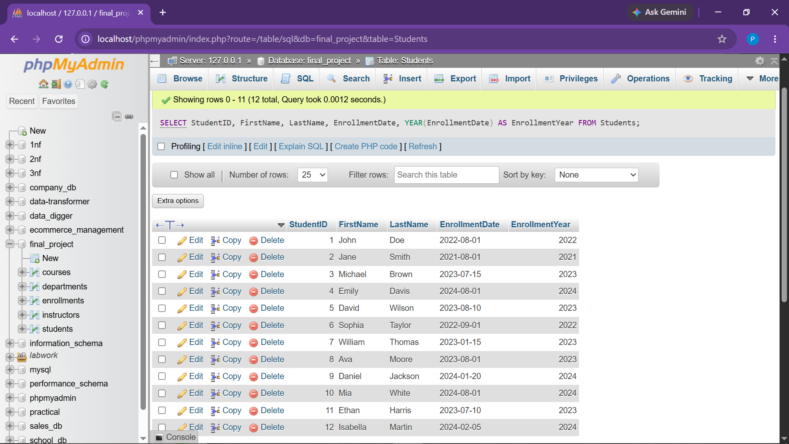

Observation: Evaluated registration dates and parsed four-digit years cleanly into EnrollmentYear.
● Task 14 Concatenate Instructor First and Last Name

Objective: Concatenate name fields into a unified FullName attribute.
SELECT
InstructorID,
CONCAT(FirstName, ' ', LastName) AS FullName
FROM Instructors;
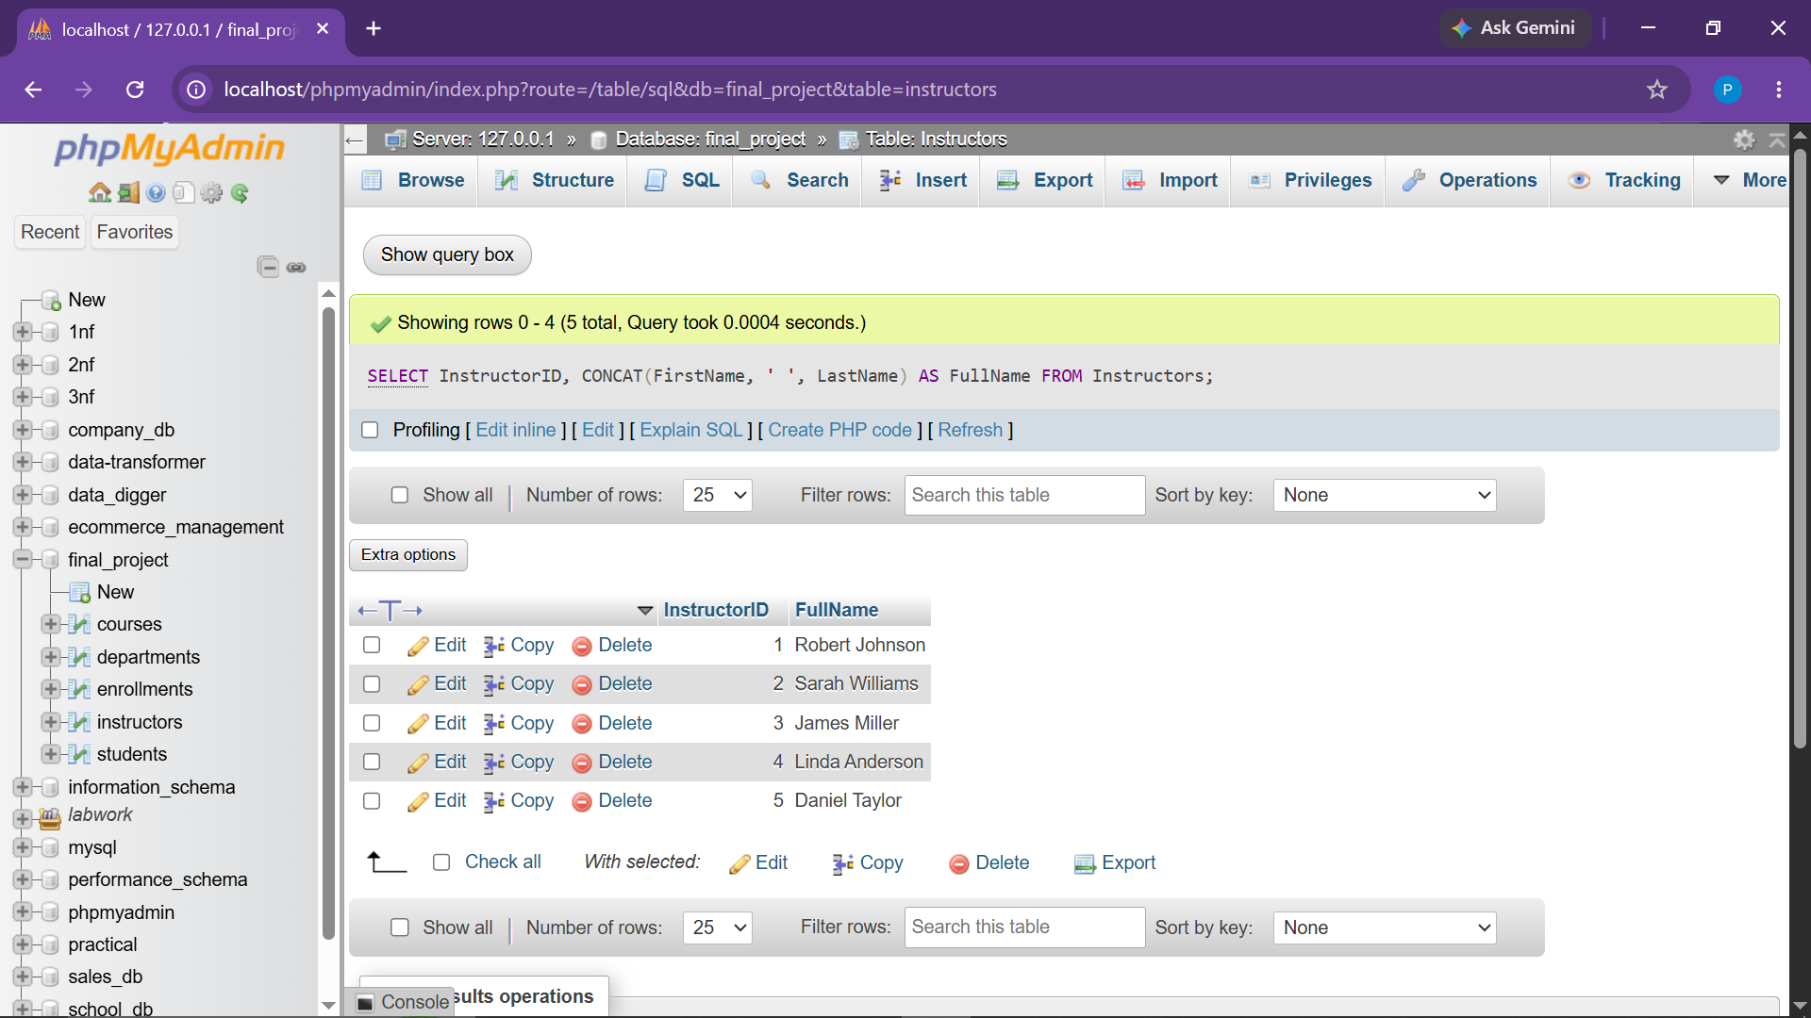

Observation: Formatted faculty names into clean, single-column full name representations.

● Task 15 Running Total of Students Enrolled in Courses

Objective: Calculate cumulative running enrollment totals ordered by CourseID using window functions.
SELECT
c.CourseID,
c.CourseName,
COUNT(e.StudentID) AS StudentCount,
SUM(COUNT(e.StudentID)) OVER (
ORDER BY c.CourseID
) AS RunningTotal
FROM Courses c
LEFT JOIN Enrollments e
ON c.CourseID = e.CourseID
GROUP BY c.CourseID, c.CourseName
ORDER BY c.CourseID;
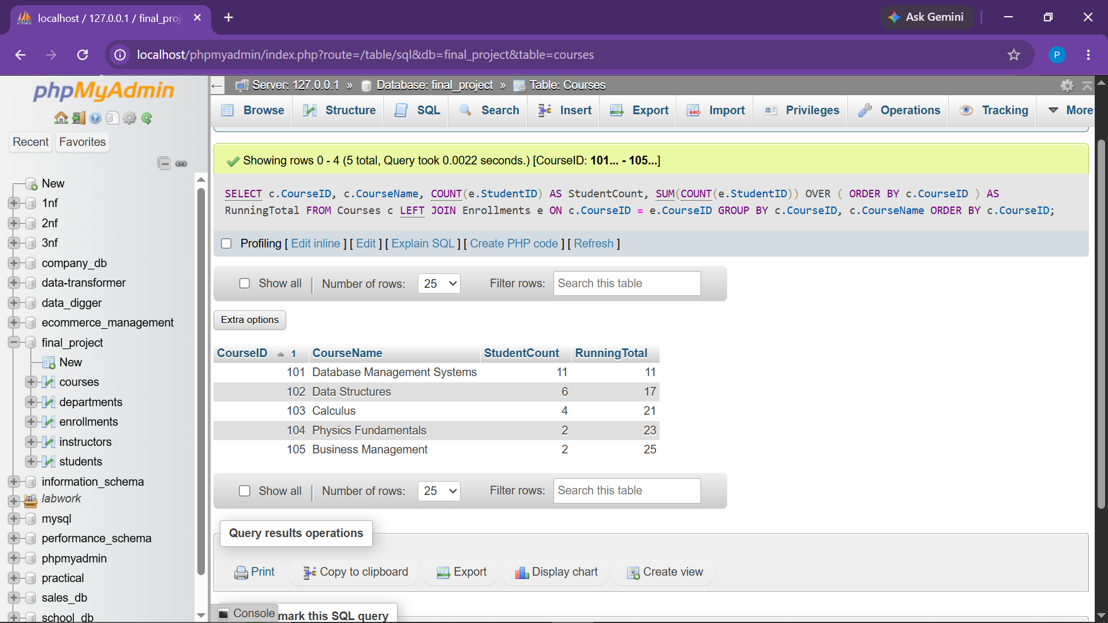

Observation: Successfully generated cumulative running totals across catalog offerings.
● Task 16 Dynamic Student Status Labeling (CASE Expression)

Objective: Classify students as 'Senior' if enrolled more than 4 years ago, else 'Junior'.
SELECT
StudentID,
FirstName,
LastName,
EnrollmentDate,
CASE
WHEN EnrollmentDate < DATE_SUB(CURDATE(), INTERVAL 4 YEAR)
THEN 'Senior'
ELSE 'Junior'
END AS StudentStatus
FROM Students;
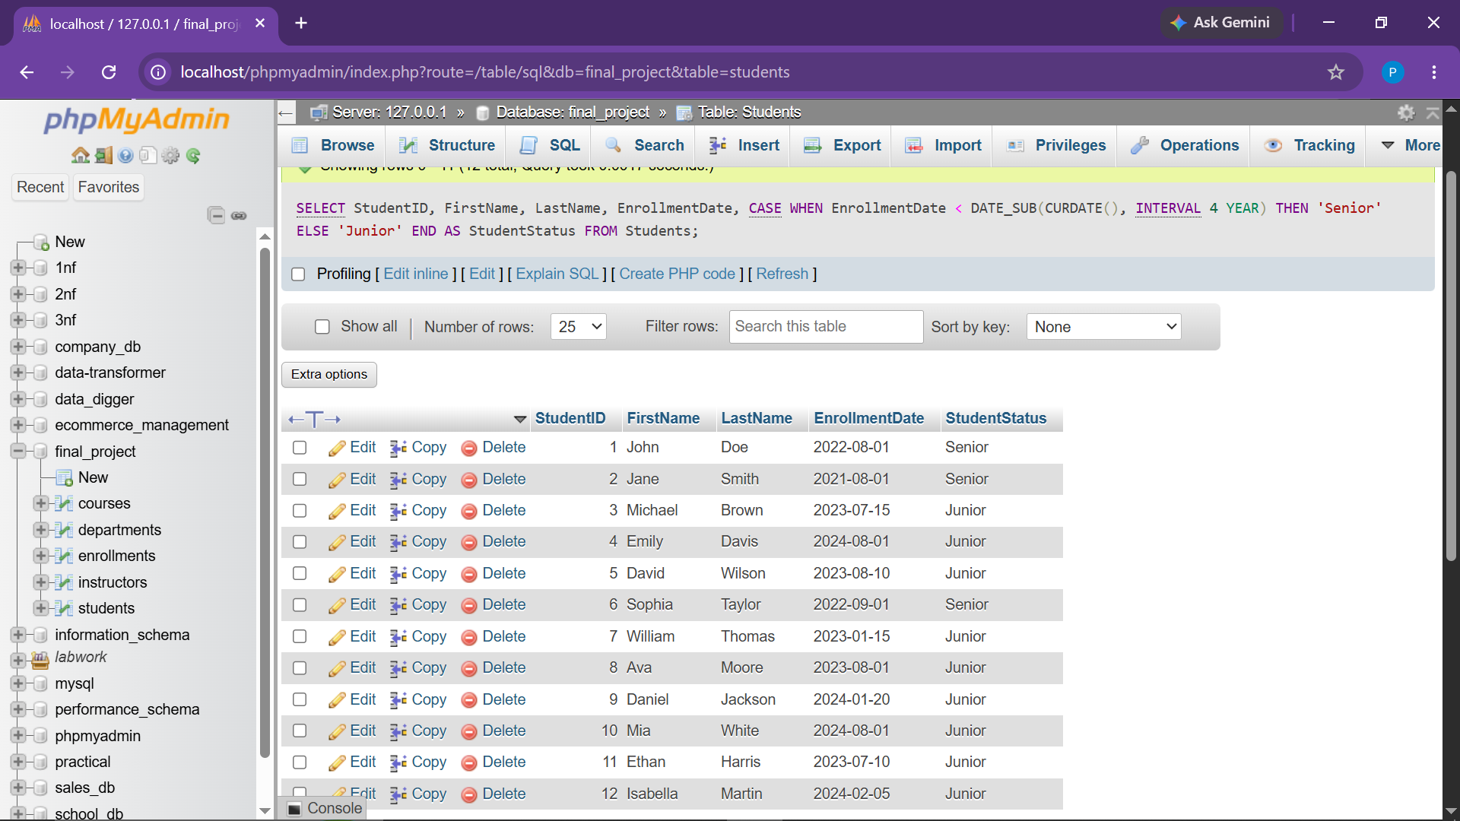

Observation: Evaluated dynamic date differences against system CURDATE() to assign Senior/Junior status.
CONCLUSION:
The University Course Management System project has been comprehensively developed, tested, and verified in MySQL. The solution satisfies all academic criteria including schema design with primary/foreign key constraints, safe CRUD operations across all tables, complex joins, nested subqueries, date/string manipulations, window analytic functions, and conditional business logic using CASE expressions.

