**Question:** Write a program for implementing the Linear Search.

**Algorithm:**

Step-1: Read the search element from the user.

Step-2: Compare the search element with the first element in the list.

Step-3: If both are matched, then display “Given element is found!!!” and terminate the

function.

Step-4: If both are not matched, then compare search element with the next element in the

list.

Step-5: Repeat steps 3 and 4 until search element is compared with the last element in the list.

Step-6: If the last element in the list also doesn’t match, then display “Element is not

found!!!” and terminate the function.

**Code:**

#include<iostream.h>

#include<conio.h>

#include<stdio.h>

void main()

{

clrscr();

int item,i,c=0,size,a[20];

cout<<"Enter the size of an array:";

cin>>size;

cout<<"Enter the elements";

for(i=0;i<size;i++)

{

cin>>a[i];

}

cout<<"Enter the element to search:";

cin>>item;

for(i=0;i<size;i++)

{

if(a[i]==item)

{

c++;

}

}

cout<<"Item Found" <<" "<<c<<" times in the list";

if (c==0)

{

cout<<"Item not found in the list";

}

getch();

}

**Output:**

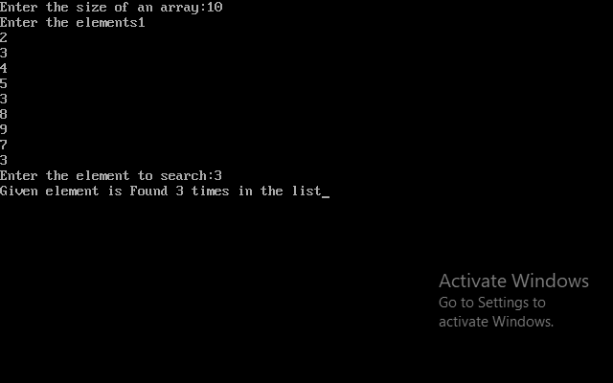

**Complexity:**

Best Case : O(1)

Average Case : O(n)

Worst Case : O(n)