Documentation Bug Report
Get Started With Building a Website (Building Websites section)
contentstack.com/docs/headless-cms/get-started-with-building-a-website
Reported: July 13, 2026 Reporter: Priyal Patil (Docs QA Automation) Severity: Medium — the guide's home page works; its own navigation 404s
Method: Automated verbatim execution — every step performed as written: stack created in the dashboard UI, the doc's zip downloaded and all four content types imported via the Import modal in the doc's order, the development environment and “PlateStack” delivery token created in the UI, entries created with the doc's exact values (via Management API, method flagged), .env configured, app run and verified with screenshots. Fresh stack per run, deleted afterwards.

Result: the promised home page works — but the guide's own navigation is broken
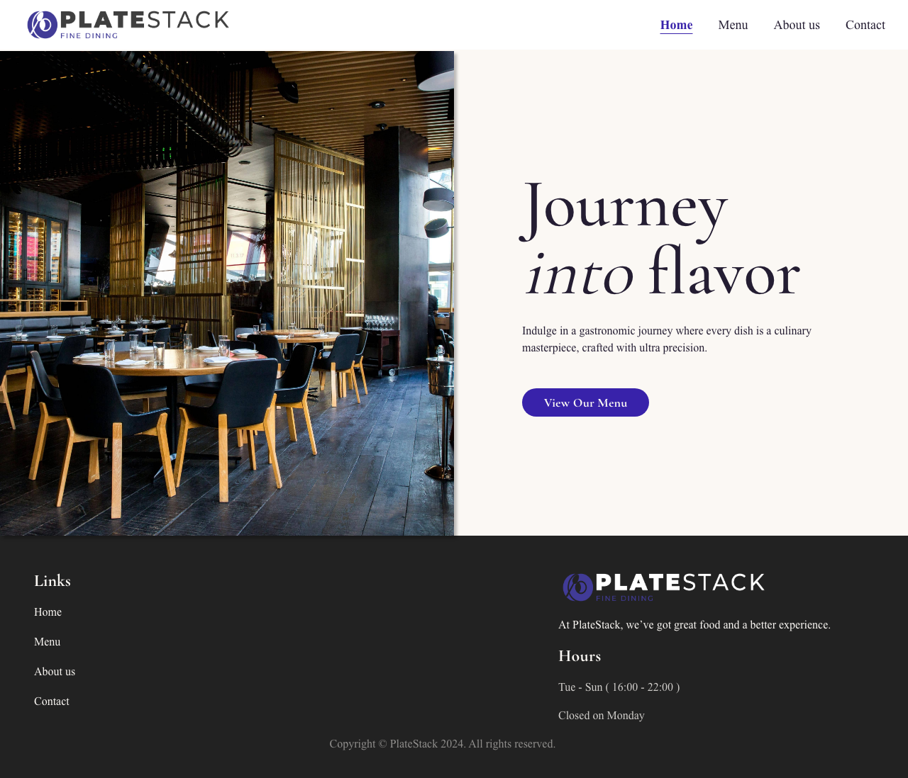
Figure 1 — The result of following the guide: the PlateStack home page renders at http://localhost:3000 exactly as promised (header, hero, footer).
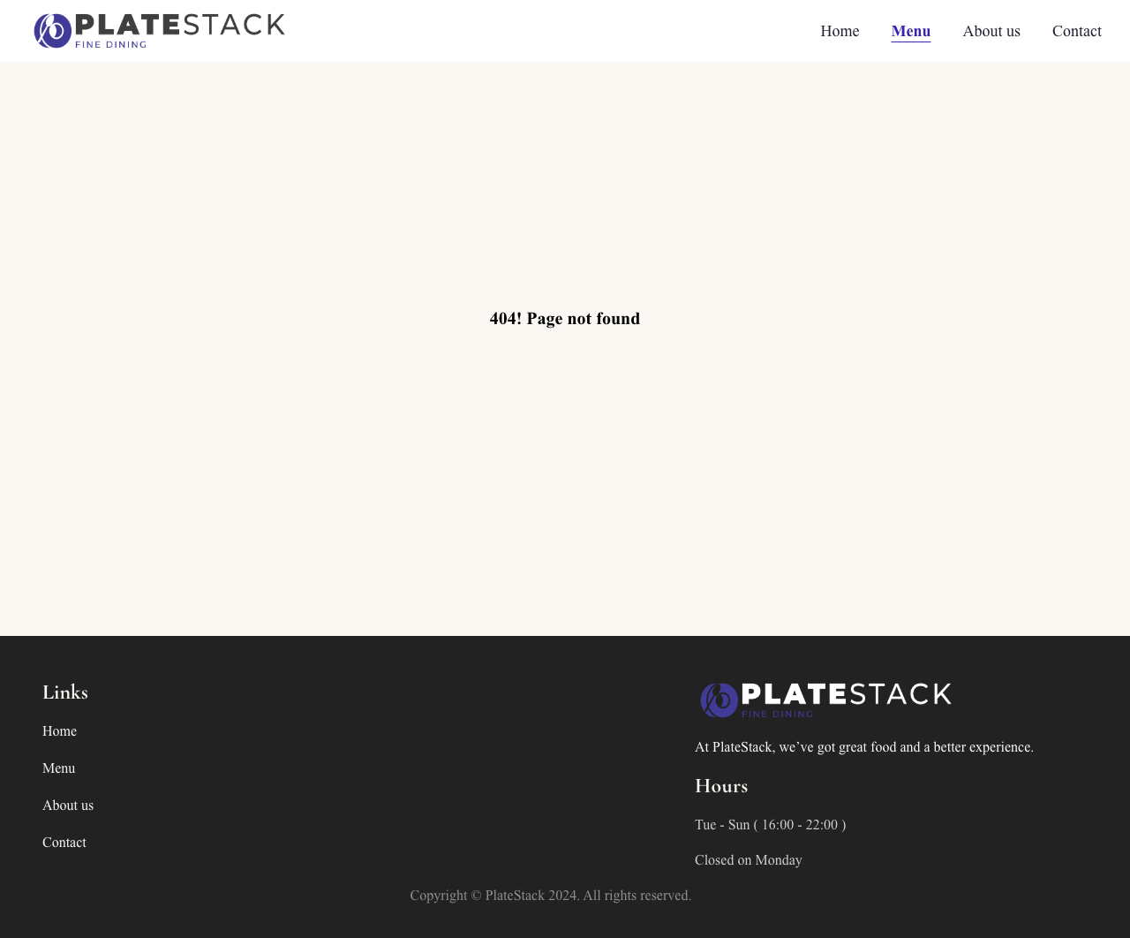
Figure 2 — Clicking the Menu link the guide itself builds: “404! Page not found”. Same for About us and Contact — the guide never creates entries for these routes.

Finding 1: entries for the app's own navigation targets are never created
- The Import step imports the Dishes content type and the guide's zip ships dish images (Assets/Page - Menu/APPETIZERS, MAIN DISHES, DESSERTS, BEVERAGES) — but no Dishes entries are ever created.
- Only ONE Page entry (“Home”) is created, while the Header/Footer navigation links the guide configures point to /menu, /about-us, /contact — none of which get a Page entry.
Impact: a user completing the guide clicks the app's own navigation and lands on 404 pages (Figure 2, verified for all three routes).

Finding 2: env variables missing from the machine-readable export
The “Configure Contentstack” code block is empty in the markdown / “Copy for LLM” export — the variable names (REACT_APP_CONTENTSTACK_API_KEY, …) are only visible on the webpage. Same export-pipeline issue as reported on the Kickstart Nuxt page.

Finding 3: “Import Content Type button” is an unlabeled icon
The doc says “Click on the Import Content Type button”; the actual UI control on the Content Models page is an icon with no visible text (aria-label “Import List”).

Finding 4: the doc's own bug note appears stale
The Page-entry section says: “The URL for the Home page will be empty after publishing. So you need to update the URL with ‘/’ and publish again. This is a bug that will be fixed soon.” In execution the bug did not reproduce — the URL survived publishing as “/”. The bug seems fixed; the workaround paragraph can likely be removed.

Finding 5: fork step's clone command uses placeholders
The clone command is git clone https://github.com/your-username/your-repo-name.git — executable only after manual substitution. Consider showing the real starter URL with a note to swap in the fork.

Recommended corrections
- Add entry-creation steps for the Dishes content type and for the Menu / About us / Contact pages — or scope the navigation to Home only.
- Fix the empty env code block in the markdown export pipeline.
- Update “Import Content Type button” to describe the icon (or label the icon in the product).
- Remove the stale “URL empty after publishing” bug note if the fix is confirmed.

Verification notes
Step | How performed / result
Create a New Stack | ✓ dashboard UI — redirect to Stack Dashboard asserted (the doc's promised outcome)
Import Content Types | ✓ dashboard UI — doc's zip downloaded; dishes, header, footer, page imported in the doc's order
Create Environment + Token | ✓ dashboard UI — development env (localhost:3000) + “PlateStack” token
Create Entries | ✓ doc's exact values via Management API (method flagged); 3 assets uploaded + published
Fork / Install / .env / Run | ✓ upstream starter cloned (fork adapted), npm install, npm start → HTTP 200
Deploy via Launch | ⏭ report-only by design (no real cloud deployments)

- macOS, Node 22, Contentstack QA org (AWS-NA); stack created and deleted per run.
- Full per-step log and all screenshots: building-websites-automation/reports/ (latest.json, index.html).

