Documentation Validation Report
Kickstart Astro Guide
contentstack.com/docs/headless-cms/astro
Reported: July 10, 2026 Reporter: Priyal Patil (Docs QA Automation) Severity: None — no issues found
Method: Automated verbatim execution — every step performed exactly as written (terminal, CLI, dashboard actions in a real browser with click-path labels asserted against the live UI, app boot + render verification with screenshots).

Result: PASS — the guide works end to end as written
Step | Result
Stack setup (CLI region, login, seed) | ✓ executed as written; Org ID read via the dashboard as instructed
Clone + install | ✓ doc's exact commands
Delivery & preview tokens | ✓ created in the dashboard UI; click-path labels verified on screen
Environment variables | ✓ doc's keys match what the app reads
Enable Live Preview | ✓ enabled in the dashboard
Project Structure vs repo | ✓ every listed item exists
Run the app | ✓ npm run dev → http://localhost:4321 responds HTTP 200 and renders the Kickstart content

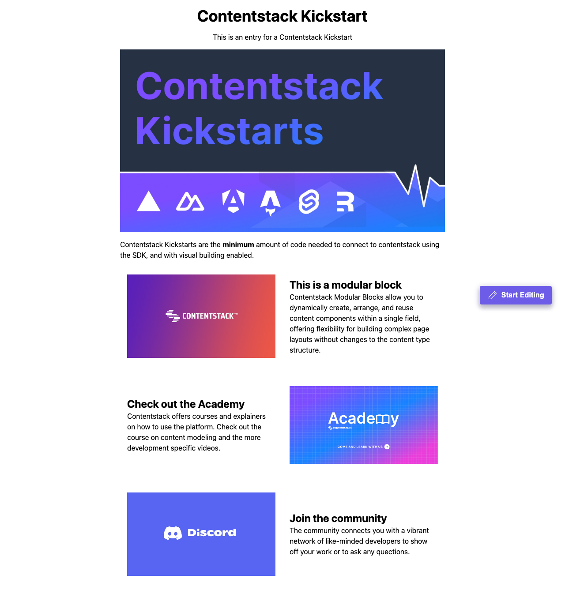
Figure — the app as rendered at http://localhost:4321 at the end of the verbatim run (the guide's promised result, achieved).

Notes
- Astro hard-requires Node ≥ 22.12 — the doc's prerequisite correctly states this; on older Node the dev server refuses to start.

Verification notes
- macOS, Node 22.23.1, Contentstack QA org (AWS-NA); fresh stack seeded and deleted after the run.
- Dashboard actions performed in a real headless browser; the doc's click-path labels asserted against the live UI.

