Documentation Bug Report
Kickstart Next.js — CSR (base) section
contentstack.com/docs/headless-cms/next#kickstart-nextjs-csr
Reported: July 10, 2026 Reporter: Priyal Patil (Docs QA Automation) Severity: Medium — app works; doc content is stale
Method: Automated verbatim execution of this section: cloned kickstart-next, installed dependencies, reused the stack seeded by the base section (as the page instructs), created/reused tokens via the real dashboard, wrote .env with the doc's exact keys, booted the app, and verified rendering.

Summary
All steps complete and the app renders (HTTP 200). Four documentation accuracy issues were found in this section.
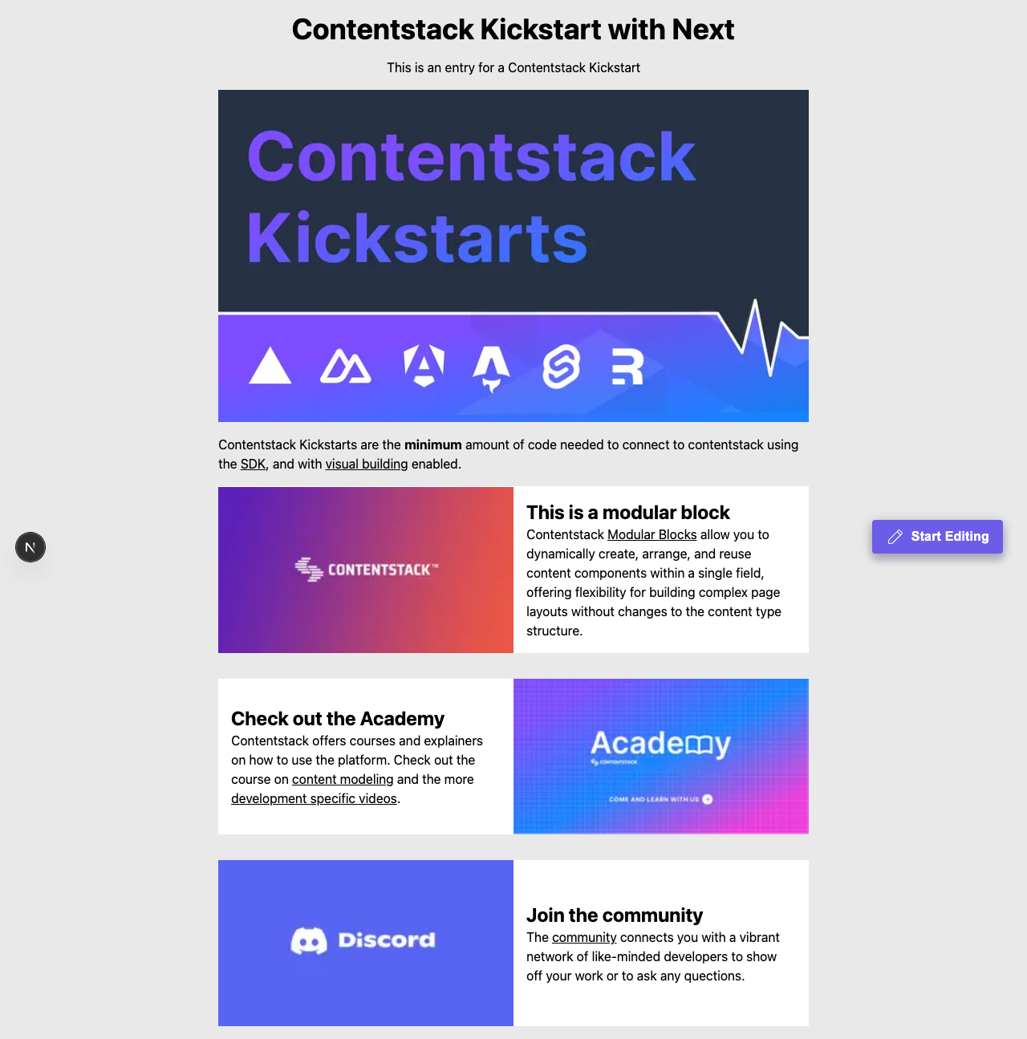
Figure — the CSR app rendering at http://localhost:3000 at the end of the verbatim run: the outcome works; the findings are content-accuracy issues.

Finding 1: Project Structure lists a file that does not exist
The diagram shows lib/utils.ts; the repository's lib/ contains only contentstack.ts and types.ts.

Finding 2: contentstack.ts code snippet is outdated
The snippet imports getContentstackEndpoints / getRegionForString from @timbenniks/contentstack-endpoints (default "AWS-EU"); the repository uses getContentstackEndpoint from @contentstack/utils (default 'NA'). Only ~83% of the snippet's lines exist in the real file.

Finding 3: “Org Admin > Info” click-path is outdated
Verified against the live dashboard: the App Switcher item is now Administration (the Info page is “Org Info” inside it).

Finding 4: “Settings > Live Preview” click-path is outdated
Verified live: the Settings sidebar item is now Visual Experience. (“Settings > Tokens” was verified correct.)

Recommended corrections
- Remove lib/utils.ts from the structure diagram (or add the file to the repo).
- Regenerate the contentstack.ts snippet from the current repository.
- Update click-paths to Administration → Org Info and Settings > Visual Experience.

Verification notes
- macOS, Node 22.23.1, Contentstack QA org (AWS-NA); stack seeded once for the page, shared across variants per the doc, deleted afterwards.
- Dashboard actions performed in a real headless browser; the doc's click-path labels asserted against the live UI.

