Documentation Bug Report
Kickstart Next.js Guide (5 variants)
contentstack.com/docs/headless-cms/next
Reported: July 10, 2026 Reporter: Priyal Patil (Docs QA Automation) Severity: Medium — all apps work; doc content is stale/incomplete
Method: Automated verbatim execution of all five variants on one page (CSR, SSR, middleware, GraphQL, SSG). One stack was seeded and reused across variants exactly as the guide instructs. All five apps boot and render successfully — the issues below are documentation accuracy problems, not broken outcomes.

Verdict per variant
Variant | App renders | Doc findings
next (CSR) | ✓ HTTP 200 | Findings 1–4
next-ssr | ✓ HTTP 200 | clean
next-middleware | ✓ HTTP 200 | Finding 5
next-graphql | ✓ HTTP 200 | clean
next-ssg | ✓ HTTP 200 | clean

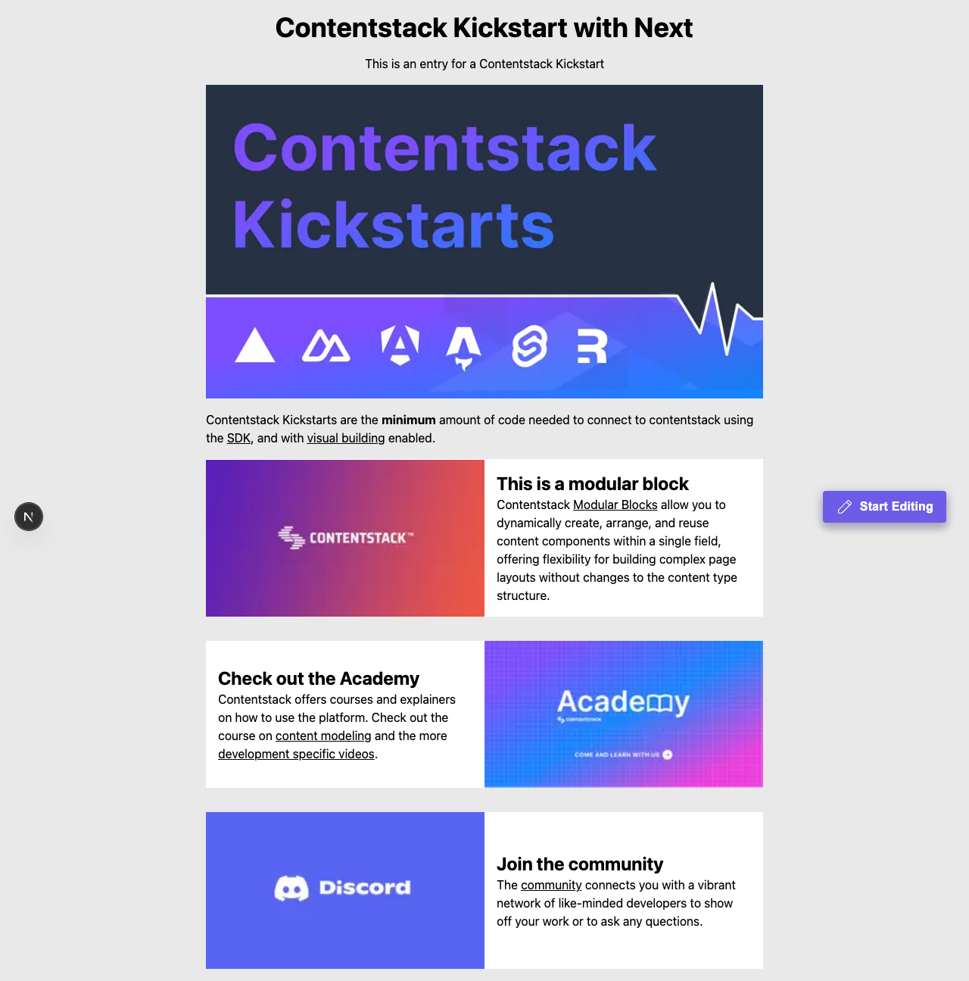
Figure — the base (CSR) app rendering at http://localhost:3000: the outcome works; the findings below are doc-content accuracy issues.

Finding 1: Project Structure lists a file that does not exist
The structure diagram shows lib/utils.ts. The repository's lib/ contains only contentstack.ts and types.ts.

Finding 2: contentstack.ts code snippet is outdated
The doc's snippet imports getContentstackEndpoints / getRegionForString from @timbenniks/contentstack-endpoints with default "AWS-EU". The actual repository uses getContentstackEndpoint from @contentstack/utils with default 'NA'. Only ~83% of the snippet's lines exist in the real file.

Finding 3: “Org Admin > Info” click-path is outdated
Verified against the live dashboard during execution: the App Switcher item is now Administration (the Info page lives inside it as “Org Info”). Users looking for “Org Admin” won’t find it.

Finding 4: “Settings > Live Preview” click-path is outdated
Verified live: the Settings sidebar item is now Visual Experience (the page heading inside is “Live Preview”). “Settings > Tokens” was verified correct.

Finding 5 (middleware variant): env variable list is incomplete
The middleware section says the required environment variables are “the same ones listed earlier”, but kickstart-next-middleware additionally reads:
- NEXT_PUBLIC_CONTENTSTACK_SSR
- NEXT_PUBLIC_CONTENTSTACK_EDITABLE_TAGS
Neither is documented; users won’t configure SSR mode or editable tags as the variant intends.

Recommended corrections
- Remove lib/utils.ts from the Project Structure diagram (or add the file to the repo).
- Regenerate the contentstack.ts snippet from the current repository.
- Update click-paths: “select Administration from the App Switcher → Org Info”, and “Settings > Visual Experience”.
- Add the two middleware-only env vars to that variant’s env section.

Verification notes
- macOS, Node 22.23.1, Contentstack QA org (AWS-NA); stack seeded once for the page, shared across variants per the doc, deleted afterwards.
- Dashboard actions performed in a real headless browser; the doc's click-path labels asserted against the live UI.

