Documentation Validation Report
Kickstart Next.js — GraphQL section
contentstack.com/docs/headless-cms/next#kickstart-nextjs-graphql
Reported: July 10, 2026 Reporter: Priyal Patil (Docs QA Automation) Severity: None — no issues found
Method: Automated verbatim execution of this section: cloned kickstart-next-graphql, installed dependencies, reused the stack seeded by the base section (as the page instructs), created/reused tokens via the real dashboard, wrote .env with the doc's exact keys, booted the app, and verified rendering.

Result: PASS — this section works end to end as written
Step | Result
Clone + install | ✓ kickstart-next-graphql — doc's exact commands
Stack | ✓ reused the stack from the base section, as instructed
Delivery/Preview token | ✓ reused/created as instructed
Environment variables | ✓ doc's keys match what the app reads
Enable Live Preview | ✓ enabled in the dashboard
Run the app | ✓ npm run dev → http://localhost:3000 responds HTTP 200 and renders content

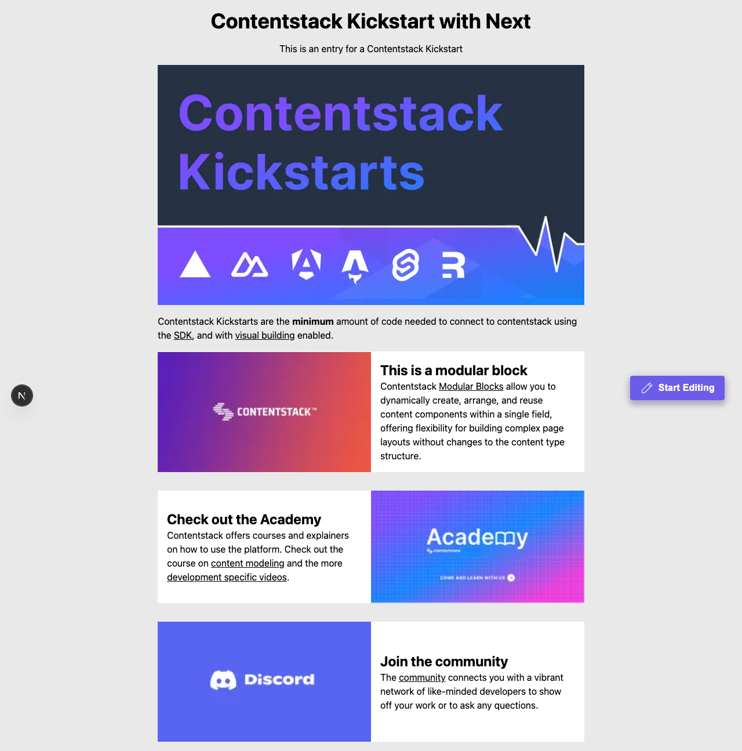
Figure — the GraphQL app as rendered at http://localhost:3000 at the end of the verbatim run.

Verification notes
- macOS, Node 22.23.1, Contentstack QA org (AWS-NA); stack seeded once for the page, shared across variants per the doc, deleted afterwards.
- Dashboard actions performed in a real headless browser; the doc's click-path labels asserted against the live UI.

