Documentation Bug Report
Kickstart Next.js — Middleware section
contentstack.com/docs/headless-cms/next#kickstart-nextjs-middleware
Reported: July 10, 2026 Reporter: Priyal Patil (Docs QA Automation) Severity: Medium — app works; env list is incomplete
Method: Automated verbatim execution of this section: cloned kickstart-next-middleware, installed dependencies, reused the stack seeded by the base section (as the page instructs), created/reused tokens via the real dashboard, wrote .env with the doc's exact keys, booted the app, and verified rendering.

Summary
All steps complete and the app renders (HTTP 200). One documentation gap: the section says the required environment variables are “the same ones listed earlier”, but this variant's repository reads two additional variables the page never documents.
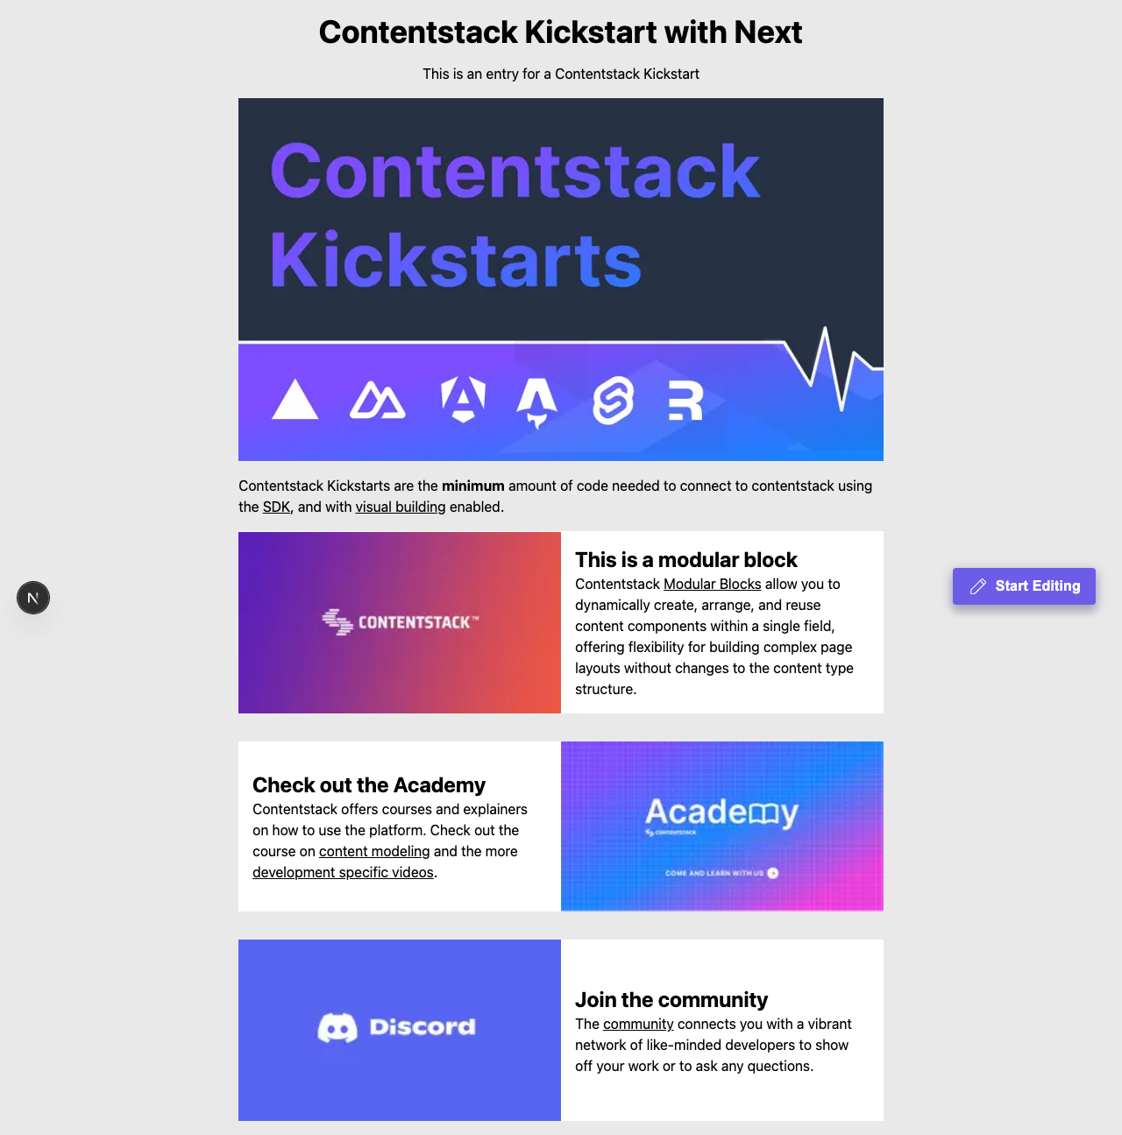
Figure — the Middleware app rendering at http://localhost:3000 at the end of the verbatim run.

Finding: env variable list is incomplete
kickstart-next-middleware's .env.example additionally requires:
- NEXT_PUBLIC_CONTENTSTACK_SSR
- NEXT_PUBLIC_CONTENTSTACK_EDITABLE_TAGS
Impact: users won't configure SSR mode or editable tags as this variant intends — features silently fall back to defaults.

Recommended correction
- Add both variables (with recommended values, e.g. true) to this section's environment-variable instructions instead of referring to “the same ones listed earlier”.

Verification notes
- macOS, Node 22.23.1, Contentstack QA org (AWS-NA); stack seeded once for the page, shared across variants per the doc, deleted afterwards.
- Dashboard actions performed in a real headless browser; the doc's click-path labels asserted against the live UI.

