Documentation Bug Report
Kickstart Nuxt Guide — contentstack.com/docs/headless-cms/nuxt
Reported: July 10, 2026 (rev. 2 — adds UI click-path findings) Reporter: Priyal Patil (Docs QA Automation) Severity: High — guide outcome is broken
Method: Automated verbatim execution — every step performed exactly as written (terminal commands, Contentstack dashboard actions in a real browser, app boot). The actual result is compared against the result the guide promises, and every UI label the guide names is asserted against the live app's navigation.

Summary
Following the Kickstart Nuxt guide exactly as written does not produce the promised outcome: the final step (“Open http://localhost:3000 … to see your app in action”) ends at a 500 error page. The root cause is one blocker — the environment variable names in Step 5 don’t match what the application reads. Five further issues were found, including two dashboard click-paths that reference menu names that no longer exist in the app. With the Finding 1 fix alone, the guide works end to end (Figure 2).

Finding 1 (Blocker): Step 5 environment variable names are wrong
The guide instructs creating a .env with keys prefixed NUXT_PUBLIC_CONTENTSTACK_. The application (repo’s .env.example and nuxt.config.ts) reads NUXT_CONTENTSTACK_ — no “PUBLIC_”. All six keys are affected, so the SDK receives no configuration and the app fails with “API key for Stack is required” (HTTP 500).
Doc says (wrong) | App reads (correct)
NUXT_PUBLIC_CONTENTSTACK_API_KEY | NUXT_CONTENTSTACK_API_KEY
NUXT_PUBLIC_CONTENTSTACK_DELIVERY_TOKEN | NUXT_CONTENTSTACK_DELIVERY_TOKEN
… same for PREVIEW_TOKEN, REGION, ENVIRONMENT, PREVIEW | … all six keys drop “PUBLIC_”

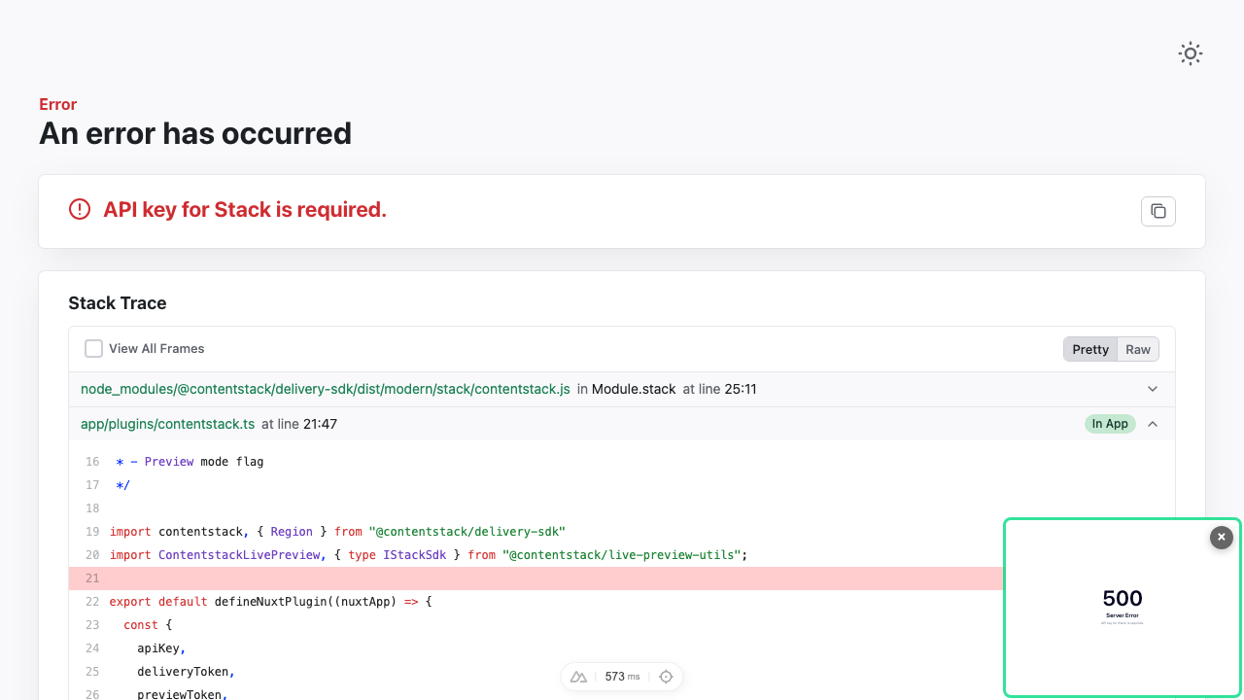
Figure 1 — What a user actually sees at localhost:3000 after following the guide verbatim: “An error has occurred: API key for Stack is required” (HTTP 500).
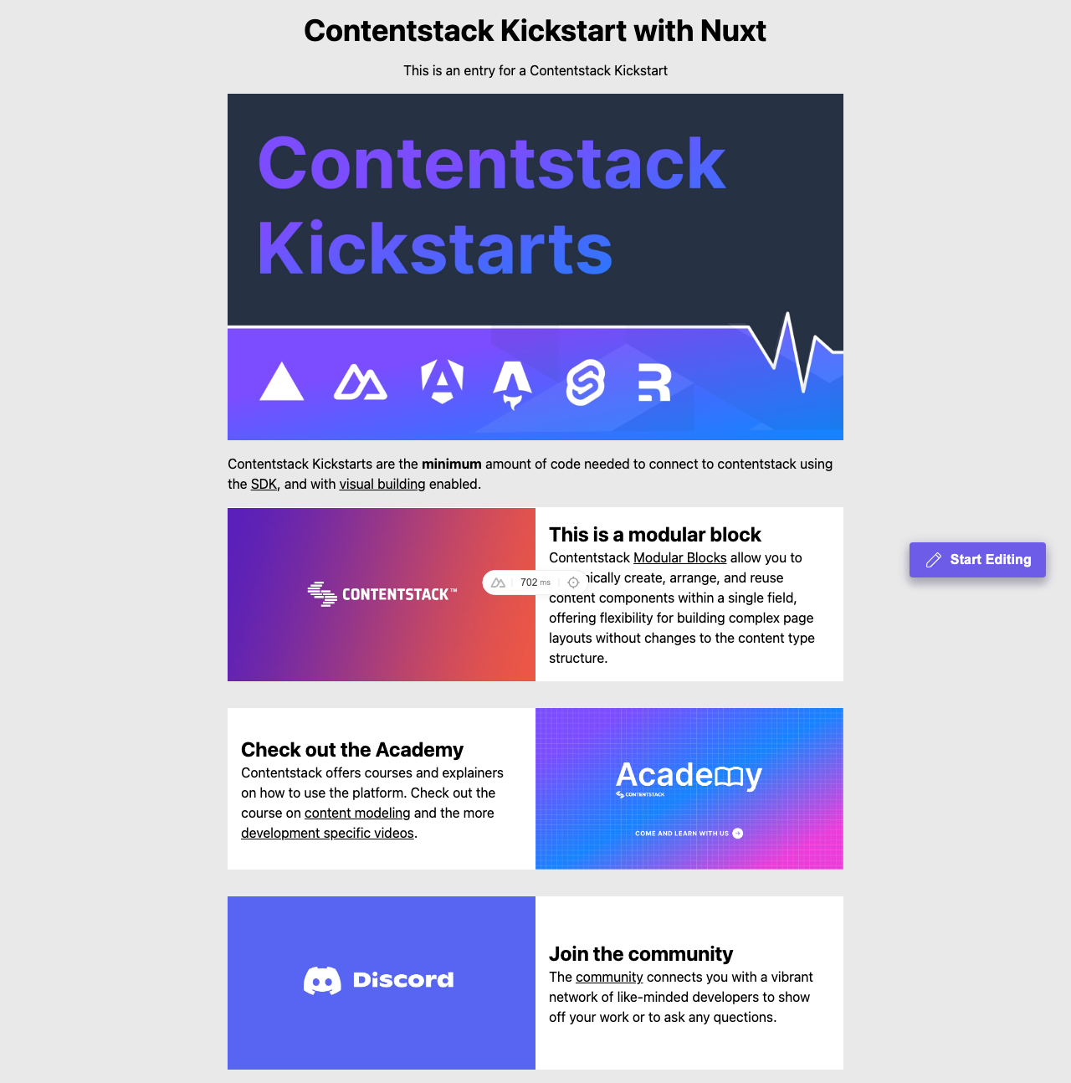
Figure 2 — Same steps with only the env variable names corrected: the app renders completely, including the Start Editing (Live Preview) button.

Finding 2: Dashboard click-paths name menu items that no longer exist
Verified live against app.contentstack.com during execution — the flows still work, but the names the guide tells users to look for aren’t there:
Doc says | App actually shows
“Go to Org Admin > Info and copy the Org ID” | App Switcher item is “Administration” (the Info page exists inside it)
“Go to Settings > Live Preview” | Settings sidebar item is “Visual Experience” (the page heading inside is “Live Preview”)
“Settings > Tokens” (Step 4) | Correct — verified on screen ✓

Finding 3: Valid region values are not stated
Step 5 shows REGION=<YOUR_REGION_NAME> with no valid values. The app expects one of: NA, EU, AU, AZURE-NA, AZURE-EU, GCP-NA, GCP-EU. A user could reasonably type “AWS-NA” (the CLI format used two steps earlier) — which fails.

Finding 4: Code snippet references a file that does not exist
The “Key Files and Code Breakdown” section labels a snippet File name: composables/getPageData.ts. No such file exists — the repository file is composables/useGetPage.ts. The guide’s own “Project Structure” section lists useGetPage.ts correctly, so the document is internally inconsistent.

Finding 5: SSR section contains copy-paste leftovers from the Next.js guide
- Tells the user to reuse the stack “CS Kickstart Next” — should be Nuxt.
- Says to configure .env in the “kickstart-next-ssr” project — the repository is kickstart-nuxt-ssr.
- Its env list begins with NEXT_PUBLIC_CONTENTSTACK_API_KEY — a Next.js prefix in a Nuxt guide.

Finding 6: “Copy for LLM” / markdown export formatting artifacts
- The clone block exports as one glued line: git clone …kickstart-nuxt.gitcd kickstart-nuxt
- All six .env lines export concatenated into a single line.
- The webpage renders correctly; this affects the promoted “Copy for LLM” / “View as Markdown” output and any tooling built on it.

Recommended corrections
1. Replace the Step 5 env block with the keys the app actually reads, including valid region values:
NUXT_CONTENTSTACK_API_KEY=<YOUR_API_KEY>
NUXT_CONTENTSTACK_DELIVERY_TOKEN=<YOUR_DELIVERY_TOKEN>
NUXT_CONTENTSTACK_PREVIEW_TOKEN=<YOUR_PREVIEW_TOKEN>
NUXT_CONTENTSTACK_REGION=NA # NA, EU, AU, AZURE-NA, AZURE-EU, GCP-NA, GCP-EU
NUXT_CONTENTSTACK_ENVIRONMENT=preview
NUXT_CONTENTSTACK_PREVIEW=true

2. Update the click-paths to current UI names: “select Administration from the App Switcher, then Org Info” and “Settings > Visual Experience”.
3. Rename the snippet heading to File name: composables/useGetPage.ts and re-verify the snippet against the current repository.
4. Fix the SSR section names: “CS Kickstart Nuxt”, kickstart-nuxt-ssr, NUXT_ prefixes.
5. Add an expected-result note to the final step (e.g. “you should see the Kickstart landing page with a Start Editing button”).
6. Route the line-glue issue to the owner of the markdown/“Copy for LLM” export pipeline.

Verification notes
- Environment: macOS, Node 22.23.1, Contentstack QA org (AWS-NA); fresh stack seeded per run and deleted afterwards.
- Every step executed exactly as written: git clone, npm install, CLI region/login/seed, delivery token created in the dashboard UI, Live Preview enabled in the dashboard, .env written with the doc’s exact keys, npm run dev.
- UI click-path assertion: every label the doc names is checked against the app’s live navigation; “Settings” and “Tokens” verified present, “Org Admin” and “Live Preview” absent (renamed).
- For comparison, the React, Angular, SvelteKit, and Astro kickstart guides pass the same verbatim test end to end.

