Documentation Bug Report
Kickstart Nuxt — SSR (Server-Side Rendering) section
contentstack.com/docs/headless-cms/nuxt — section “Kickstart Nuxt (Server-Side Rendering – SSR Mode)”
Reported: July 10, 2026 Reporter: Priyal Patil (Docs QA Automation) Severity: High — section outcome is broken
Method: Automated verbatim execution of this section: cloned kickstart-nuxt-ssr, installed dependencies, reused the stack seeded by the base section (as the page instructs), created/reused tokens via the real dashboard, wrote .env with the doc's exact keys, booted the app, and verified rendering.

Summary
Following the SSR section verbatim ends at an error page, not the app. It inherits the base guide's environment-variable bug and adds its own: the section is partially copy-pasted from the Next.js guide, so several names are wrong for Nuxt.
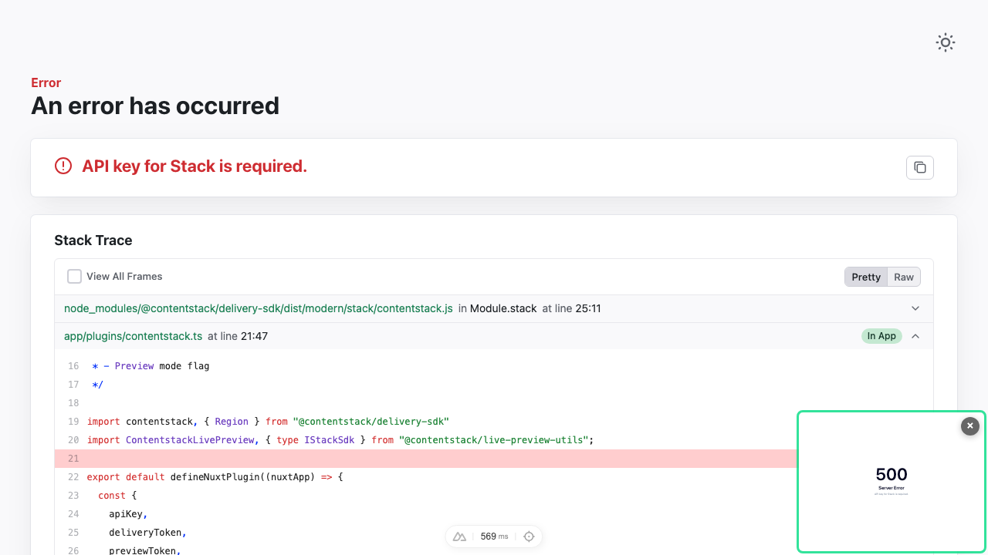
Figure — what a user actually sees at http://localhost:3000 after following this section verbatim: HTTP 500 “Server Error” (the app receives no configuration).

Finding 1 (Blocker): env variable names are wrong — and the first key has a Next.js prefix
The section's env list is doubly wrong: every key carries the PUBLIC_ segment the app does not read (same blocker as the base guide), and the FIRST key even uses the Next.js prefix NEXT_:
Doc says (wrong) | App reads (correct)
NEXT_PUBLIC_CONTENTSTACK_API_KEY | NUXT_CONTENTSTACK_API_KEY
NUXT_PUBLIC_CONTENTSTACK_DELIVERY_TOKEN | NUXT_CONTENTSTACK_DELIVERY_TOKEN
… PUBLIC_ on all remaining keys | … all keys drop PUBLIC_

Finding 2: copy-paste leftovers from the Next.js guide
- “Create or Reuse a Contentstack Stack” tells the user to reuse the stack “CS Kickstart Next” — this is the Nuxt guide; the base section creates “CS Kickstart Nuxt”.
- “Set Up Environment Variables” says to configure .env in the “kickstart-next-ssr” project — the repository cloned in Step 1 is kickstart-nuxt-ssr.

Finding 3 (page-level): code snippet references a non-existent file
The page's “Key Files” section labels a snippet composables/getPageData.ts; the repositories contain composables/useGetPage.ts. (Also reported in the base Nuxt bug report — listed here because it affects SSR users too.)

What worked
- Clone (kickstart-nuxt-ssr) and npm install — doc's exact commands ✓
- Reusing the base section's stack and delivery/preview tokens ✓
- Enabling Live Preview ✓

Recommended corrections
- Fix the env block: all keys NUXT_CONTENTSTACK_* (drop PUBLIC_, and fix the NEXT_ typo on the first key).
- Replace “CS Kickstart Next” with “CS Kickstart Nuxt”.
- Replace “kickstart-next-ssr” with “kickstart-nuxt-ssr”.
- Apply the base-guide corrections (region values, click-path names) wherever this section repeats them.

Verification notes
- macOS, Node 22.23.1, Contentstack QA org (AWS-NA); stack seeded once for the page, shared across variants per the doc, deleted afterwards.
- Dashboard actions performed in a real headless browser; the doc's click-path labels asserted against the live UI.

