Documentation Bug Report
Kickstart Veda Guide
contentstack.com/docs/headless-cms/veda
Reported: July 10, 2026 Reporter: Priyal Patil (Docs QA Automation) Severity: High — guide outcome is broken
Method: Automated verbatim execution — every step performed exactly as written (terminal, CLI, dashboard actions in a real browser with click-path labels asserted against the live UI, app boot + render verification with screenshots).

Summary
Following the Veda guide verbatim cannot succeed: the guide instructs using a publishing environment named preview, but the stack its own seed command creates has no such environment. Token creation as instructed fails, and the app ends at an error page instead of “The Revival Collection”.
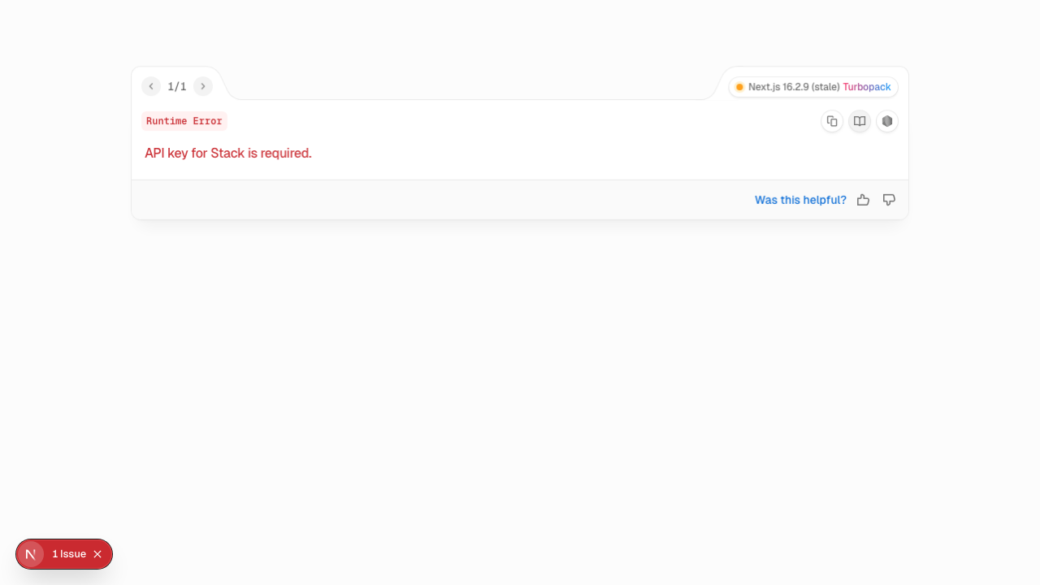
Figure — what a user actually sees at http://localhost:3000 after following the guide verbatim: “API key for Stack is required” (HTTP 500), because no delivery token can be scoped to the non-existent “preview” environment.

Finding 1 (Blocker): the doc's environment name does not exist in the seeded stack
- The guide's .env.local sample says NEXT_PUBLIC_CONTENTSTACK_ENVIRONMENT=preview and states the value “must match the name of the environment in Contentstack where entries are published for this app (the sample in .env.example is preview)”.
- The token step says to confirm “your target publishing environment (e.g., preview)”.
- But the stack created by csdx cm:stacks:seed --repo "contentstack/kickstart-veda-seed" contains only production and development (verified in the seed repo's stack/environments/environments.json and via the live API error: “preview environment(s) not found”).
Impact: a delivery token cannot be scoped to “preview” (HTTP 422), and an app configured with ENVIRONMENT=preview fetches no content — HTTP 500 / “API key for Stack is required” at localhost:3000 (Figure above).

Finding 2: seeding takes far longer than other kickstarts
“Veda: The Revival Collection” is a much larger seed (assets/entries) — over 5 minutes vs ~1 minute for the standard kickstart seed. Consider a note in the doc so users don’t assume the CLI has hung.

Recommended corrections
- Align doc and seed on one environment name: either seed a preview environment in kickstart-veda-seed, or change the doc/.env.example to development (its URL is already http://localhost:3000).
- Update the token step to name the environment(s) that actually exist after seeding.
- Add a note that seeding this stack can take several minutes.

Verification notes
- macOS, Node 22.23.1, Contentstack QA org (AWS-NA); stack seeded per run and deleted afterwards.
- Clone/install ✓, seed ✓ (with extended timeout), Project Structure ✓, “Settings > Tokens” labels verified on screen ✓ — the failure is precisely at the environment mismatch above.

