SOFTWARE REQUIREMENTS SPECIFICATION
Hospital Management System (HMS)
Prepared in accordance with the IEEE 830 SRS structure
Prepared by: Sanduni
BSc (Hons) in Computer Science — 3rd Year
CINEC Campus
Version 1.0 — August 2026

Table of Contents
1. Introduction 3
2. Overall Description 3
3. System Architecture 4
4. Functional Requirements 5
5. Process Flow 6
6. System Design (UML Class Diagram) 7
7. Database Design (ER Diagram) 8
8. Database Schema 9
9. External Interface Requirements 11
10. Non-Functional Requirements 12
11. Backup and Recovery 12

1. Introduction

1.1 Purpose
This Software Requirements Specification (SRS) describes the functional and non-functional requirements of the Hospital Management System (HMS). It is intended to guide the design, development and testing of the system, and to serve as an agreement between the project author and any reviewers on what the system will do.

1.2 Document Conventions
Functional requirements are identified with the prefix FR (e.g. FR-1) and non-functional requirements with the prefix NFR (e.g. NFR-1). Priority is implied by module order; core clinical and administrative functions (registration, appointments, records) are treated as highest priority.

1.3 Intended Audience
This document is intended for the project author, academic supervisors and evaluators, and any future developer who continues work on the system. No prior knowledge of the hospital's internal processes is assumed.

1.4 Project Scope
The HMS automates patient registration, doctor management, appointment scheduling, electronic medical records, laboratory management, pharmacy management, billing and payments, staff management, and reporting, replacing fragmented manual and paper-based hospital workflows with a centralised, role-based web application.

1.5 References
- Hospital Management System (HMS) — Software Specification Document (source specification for this SRS).
- IEEE Std 830-1998 — Recommended Practice for Software Requirements Specifications.

2. Overall Description

2.1 Product Perspective
The HMS is a new, self-contained web-based system. It follows a four-layer architecture (Presentation, Application, Business Logic and Database, detailed in Section 3) and is not dependent on any pre-existing hospital software.

2.2 Product Functions
- Centralised patient registration and medical record keeping.
- Appointment scheduling across doctors and departments.
- Laboratory test tracking from request to result.
- Pharmacy inventory and prescription processing.
- Consolidated billing across consultation, lab, pharmacy and admission charges.
- Staff management and attendance tracking.
- Management reporting and analytics.

2.3 User Classes and Characteristics
- Administrator — configures the system, manages users and access control, and views reports.
- Doctors — access patient records, record diagnoses and prescriptions, manage their schedule.
- Nurses & Receptionists — register patients and coordinate appointments.
- Laboratory Staff — manage test requests, samples and results.
- Pharmacists — manage medicine inventory and process prescriptions.
- Accountants — generate invoices and record payments.

2.4 Operating Environment
The system runs on a standard hospital LAN, with a central application/database server and client access through a modern web browser (Chrome, Edge or Firefox) on Windows 10/11 workstations. Full hardware and software requirements are listed in Section 9.

2.5 Design and Implementation Constraints
- Must support multiple concurrent users without performance degradation.
- Must enforce role-based access control at every layer.
- Must run on commonly available server software (Apache/Nginx/IIS with PHP, Java, .NET or Node.js).

2.6 Assumptions and Dependencies
- Hospital staff have basic computer literacy and access to a workstation or terminal.
- A reliable LAN/internet connection is available at all times during hospital operating hours.
- A relational database server (MySQL, PostgreSQL, SQL Server or Oracle) is available for deployment.

3. System Architecture
The system follows a four-layer architecture, separating the user interface from request handling, core business rules and data storage. This separation of concerns improves maintainability, testability and scalability.
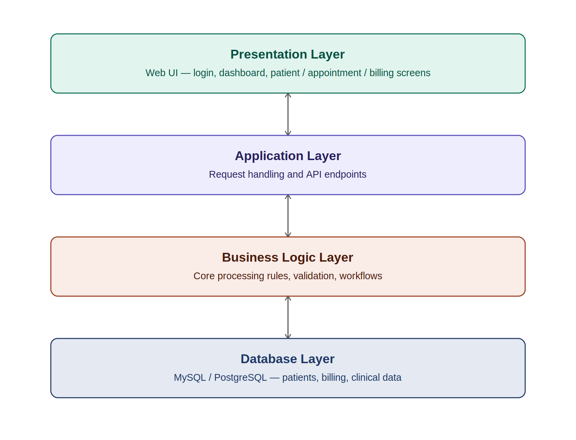
Figure 1 — Four-layer system architecture
- Presentation Layer — the web UI: login, dashboard, and the patient, appointment and billing screens.
- Application Layer — handles incoming requests and exposes API endpoints to the presentation layer.
- Business Logic Layer — applies core processing rules, validation and workflow logic.
- Database Layer — persists all data in a relational database (Section 7-8).

4. Functional Requirements
Functional requirements are grouped by module below. Each module maps directly to a section of the Hospital Management System specification document.
Requirement | Details
FR-1 User Management | • Login and logout  • Password management  • User roles and role-based access control
FR-2 Patient Management | • Register patient  • Update patient information  • Search patient  • View medical history  • Upload documents
FR-3 Doctor Management | • Add and update doctor details  • Department assignment  • Schedule management
FR-4 Appointment Management | • Book, cancel and reschedule appointments  • Appointment status tracking
FR-5 Electronic Medical Records | • Record patient diagnosis and prescriptions  • Maintain treatment history  • Generate medical reports
FR-6 Laboratory Management | • Test requests and sample collection  • Result entry and report generation
FR-7 Pharmacy Management | • Medicine inventory and stock management  • Prescription processing  • Expiry monitoring
FR-8 Billing System | • Consultation, laboratory, pharmacy and admission charges  • Invoice generation and payment recording
FR-9 Staff Management | • Employee registration and attendance  • Department assignment and leave records
FR-10 Reports & Analytics | • Patient, appointment, revenue, pharmacy, laboratory and staff reports

5. Process Flow
The diagram below illustrates the end-to-end process a patient follows through the system, from arrival to discharge, and shows how the functional modules in Section 4 connect in practice.
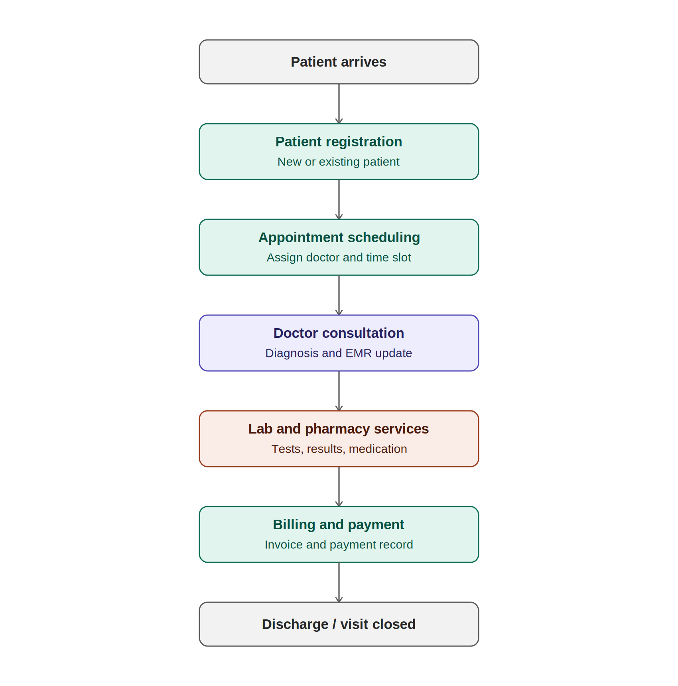
Figure 2 — Patient process flow through the HMS

6. System Design — UML Class Diagram
The system's object-oriented structure is expressed as the UML class diagram below. A single abstract User class is specialised into each staff role, so authentication and session handling are implemented once and reused across all role-specific behaviour. Patient, Appointment and MedicalRecord are modelled as the core domain classes that these roles operate on.
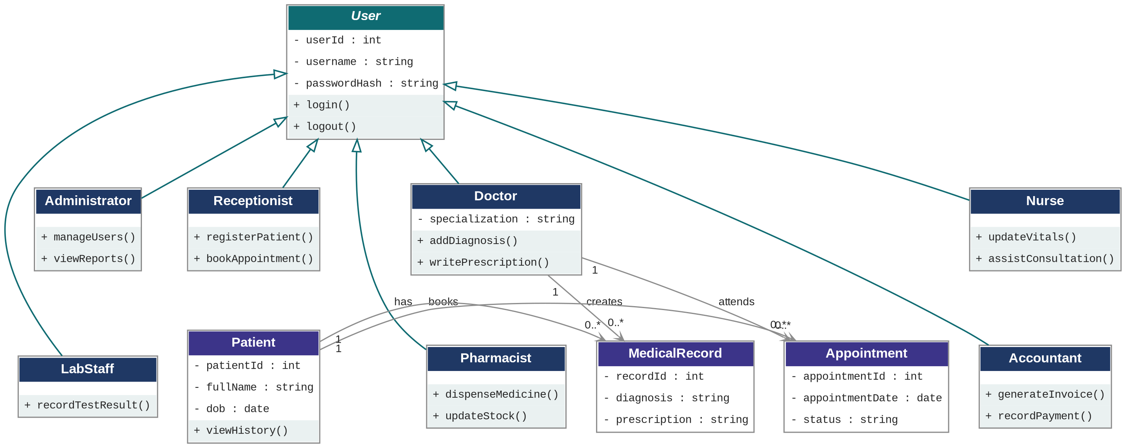
Figure 3 — UML class diagram: role hierarchy and core domain classes

7. Database Design — Entity Relationship Diagram
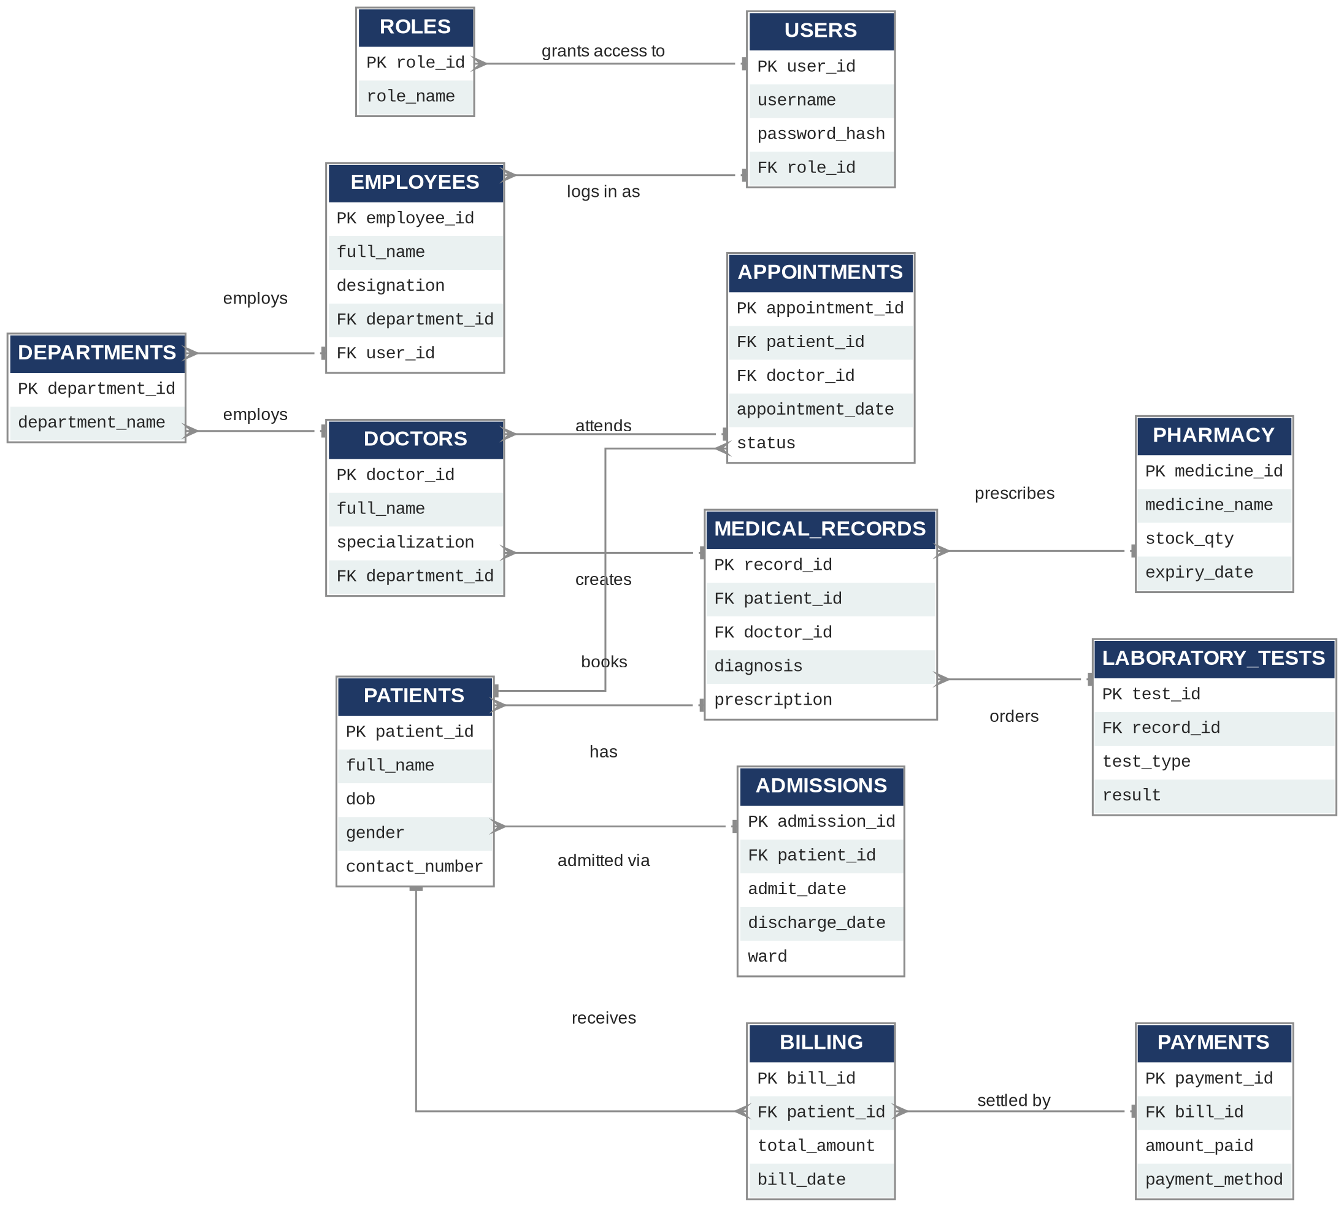
Figure 4 — Entity relationship diagram for the HMS database

8. Database Schema
The table below lists every entity shown in Figure 4, with its fields, data types and keys (PK = primary key, FK = foreign key).
Entity | Fields
ROLES | • PK role_id : int — unique role identifier  • role_name : varchar(50) — e.g. Admin, Doctor, Nurse
USERS | • PK user_id : int  • username : varchar(50)  • password_hash : varchar(255)  • FK role_id : int → ROLES.role_id
DEPARTMENTS | • PK department_id : int  • department_name : varchar(100)
DOCTORS | • PK doctor_id : int  • full_name : varchar(100)  • specialization : varchar(100)  • FK department_id : int → DEPARTMENTS.department_id
EMPLOYEES | • PK employee_id : int  • full_name : varchar(100)  • designation : varchar(100)  • FK department_id : int  • FK user_id : int
PATIENTS | • PK patient_id : int  • full_name : varchar(100)  • dob : date  • gender : varchar(10)  • contact_number : varchar(20)
APPOINTMENTS | • PK appointment_id : int  • FK patient_id : int  • FK doctor_id : int  • appointment_date : datetime  • status : varchar(20) — Scheduled / Completed / Cancelled
ADMISSIONS | • PK admission_id : int  • FK patient_id : int  • admit_date : date  • discharge_date : date  • ward : varchar(50)
MEDICAL_RECORDS | • PK record_id : int  • FK patient_id : int  • FK doctor_id : int  • diagnosis : text  • prescription : text
LABORATORY_TESTS | • PK test_id : int  • FK record_id : int  • test_type : varchar(100)  • result : text
PHARMACY | • PK medicine_id : int  • medicine_name : varchar(100)  • stock_qty : int  • expiry_date : date
BILLING | • PK bill_id : int  • FK patient_id : int  • total_amount : decimal(10,2)  • bill_date : date
PAYMENTS | • PK payment_id : int  • FK bill_id : int  • amount_paid : decimal(10,2)  • payment_method : varchar(30) — Cash / Card / Insurance

9. External Interface Requirements

9.1 User Interfaces
Screen | Elements
Login Page | • Username field  • Password field  • Login button
Dashboard | • Total patients  • Today's appointments  • Revenue summary  • Laboratory requests  • Pharmacy alerts
Patient Screen | • Add patient  • Edit patient  • Search patient  • View history
Appointment Screen | • Schedule appointment  • Calendar view  • Doctor selection
Billing Screen | • Generate bill  • Receive payment  • Print receipt

9.2 Hardware Interfaces
Tier | Requirements
Minimum | • Intel Core i5 processor  • 8 GB RAM  • 256 GB SSD  • Printer  • LAN connection
Recommended | • Intel Core i7 processor  • 16 GB RAM  • SSD storage  • Backup server

9.3 Software Interfaces
Tier | Requirements
Server | • Windows Server or Linux  • Apache / Nginx / IIS  • PHP, Java, .NET, or Node.js  • MySQL, PostgreSQL, SQL Server, or Oracle
Client | • Windows 10/11  • Google Chrome  • Microsoft Edge  • Mozilla Firefox

10. Non-Functional Requirements
Category | Requirement
NFR-1 Performance | • Support multiple concurrent users  • Fast response time for all transactions  • Optimised database performance
NFR-2 Security | • Secure login and password encryption  • Role-based access control  • Audit logs for all critical actions  • Automatic session timeout
NFR-3 Reliability | • Daily automated database backup  • High availability of the system  • Reliable data recovery support
NFR-4 Usability | • User-friendly, intuitive interface  • Responsive design across devices  • Easy navigation between modules

11. Backup and Recovery
- Automatic daily backup of the production database.
- Weekly full backup retained off-site or on a separate backup server.
- Documented disaster recovery plan covering restoration steps and responsible personnel.
- Audit trail retained for all critical data changes.

