**Report Assignment 2**

**Step 1:**

* As specified from the assignment document downloaded the data set from kaggle.
* The files contain properties file, Train dataset, sample_submission, and data dictionary.
* After downloading the dataset, the files are stored on local machine.
* Performed EDA on the dataset
* The results and conclusions are Witten in python notebook RAWDATAEDA
* The graphs of the Eda can be seen below:

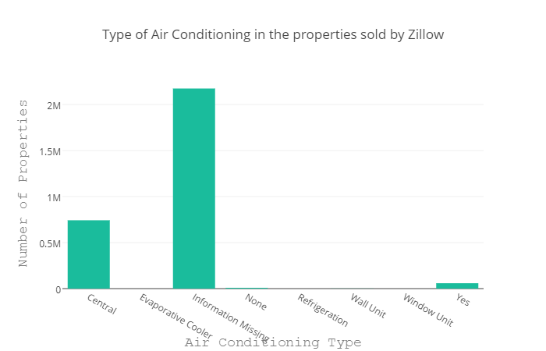

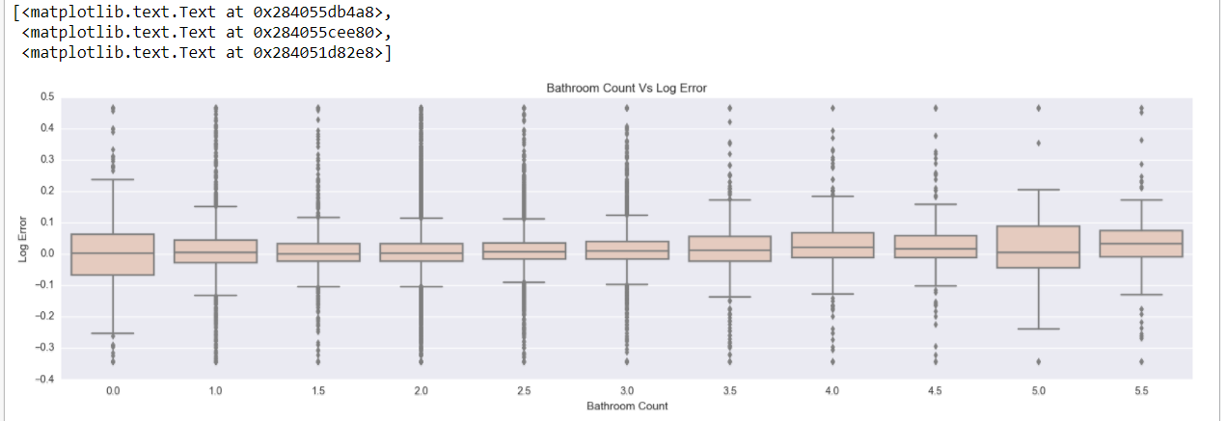

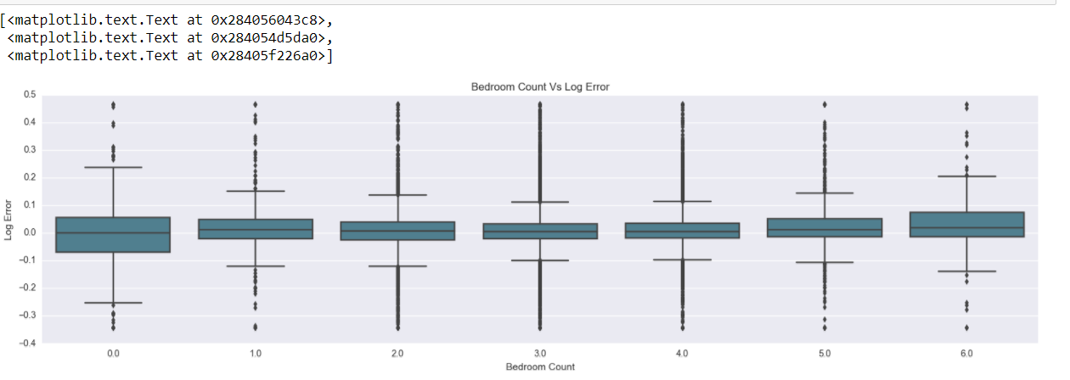

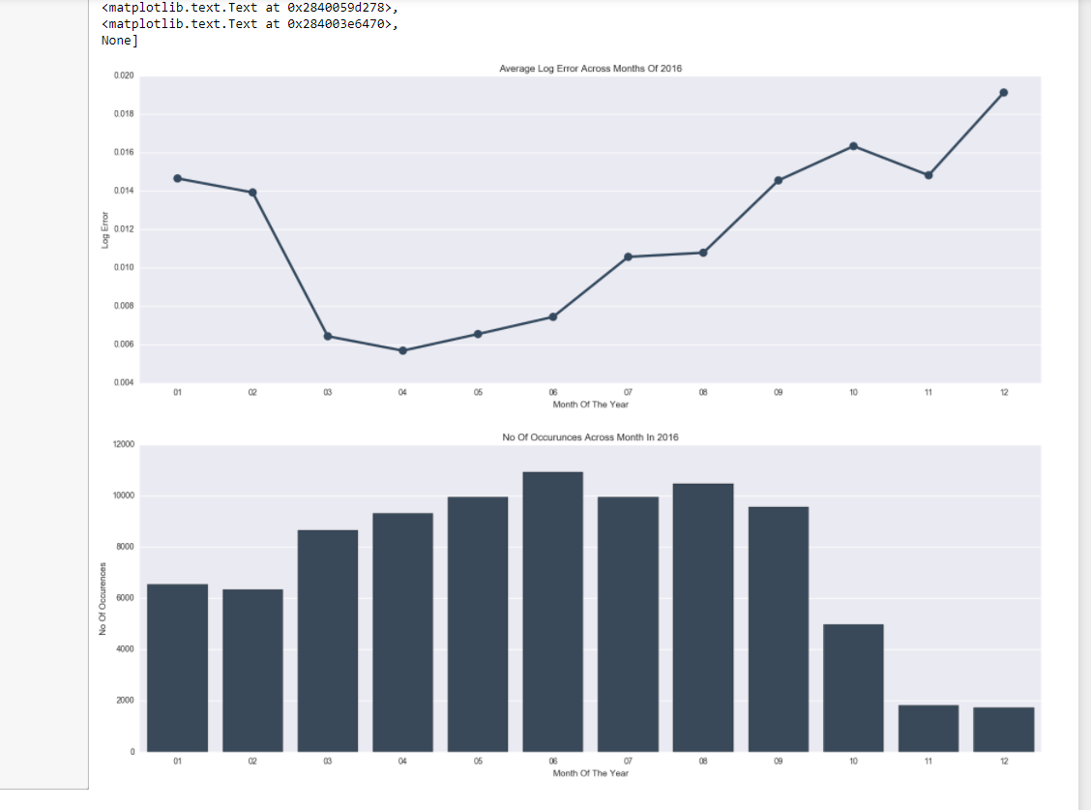

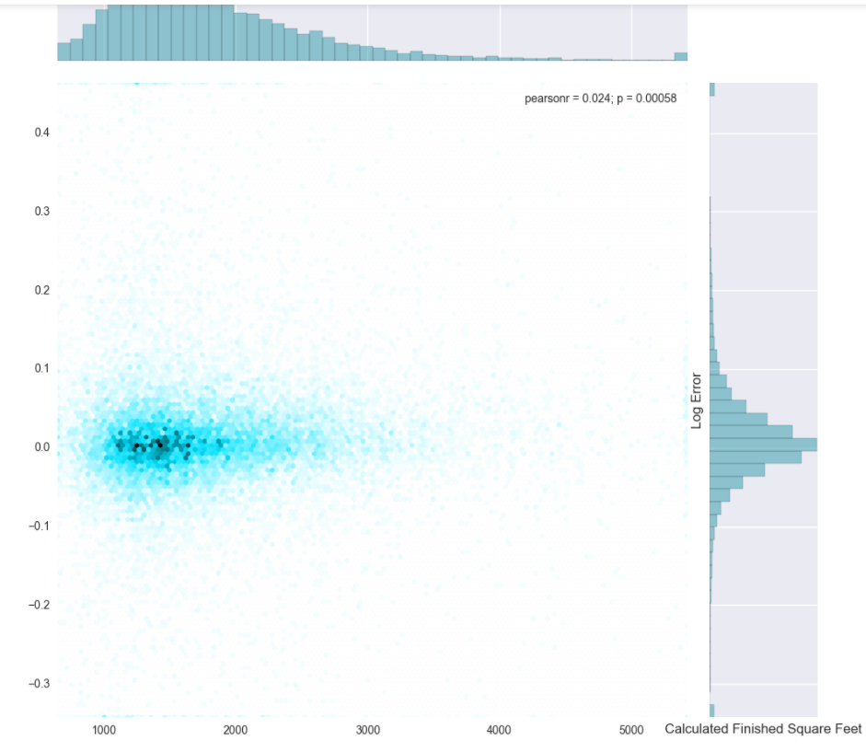

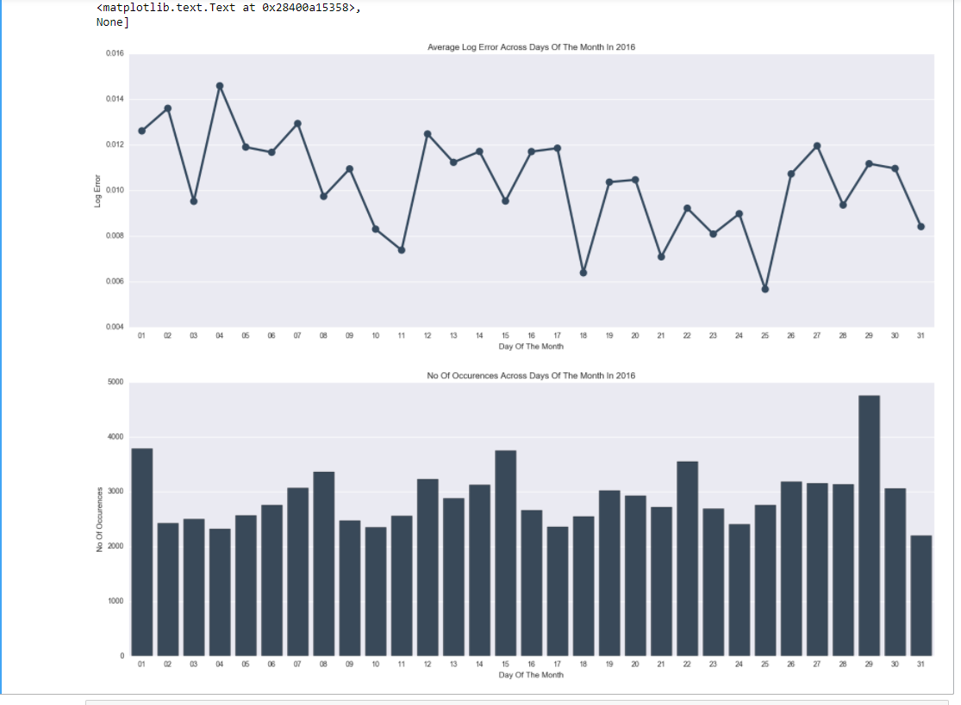

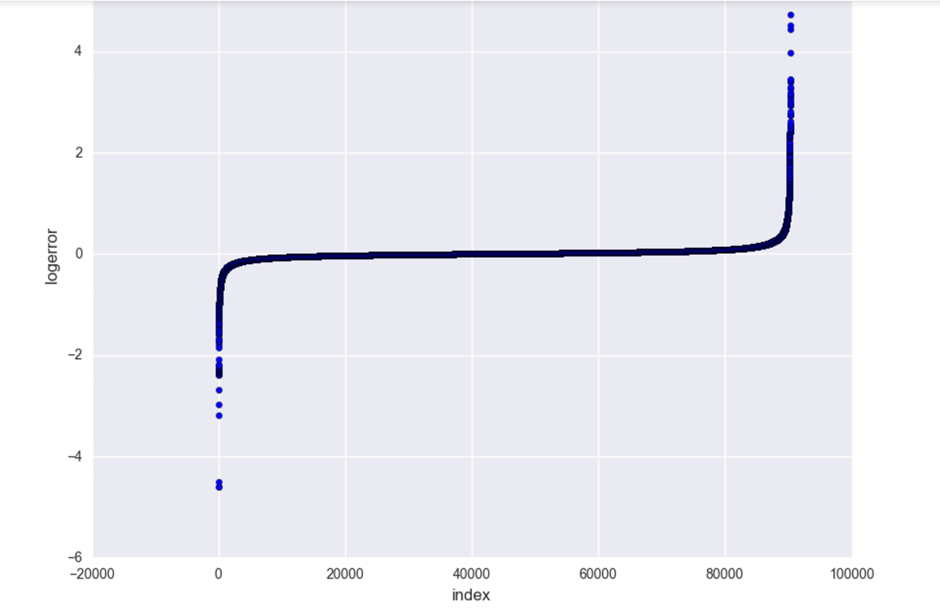

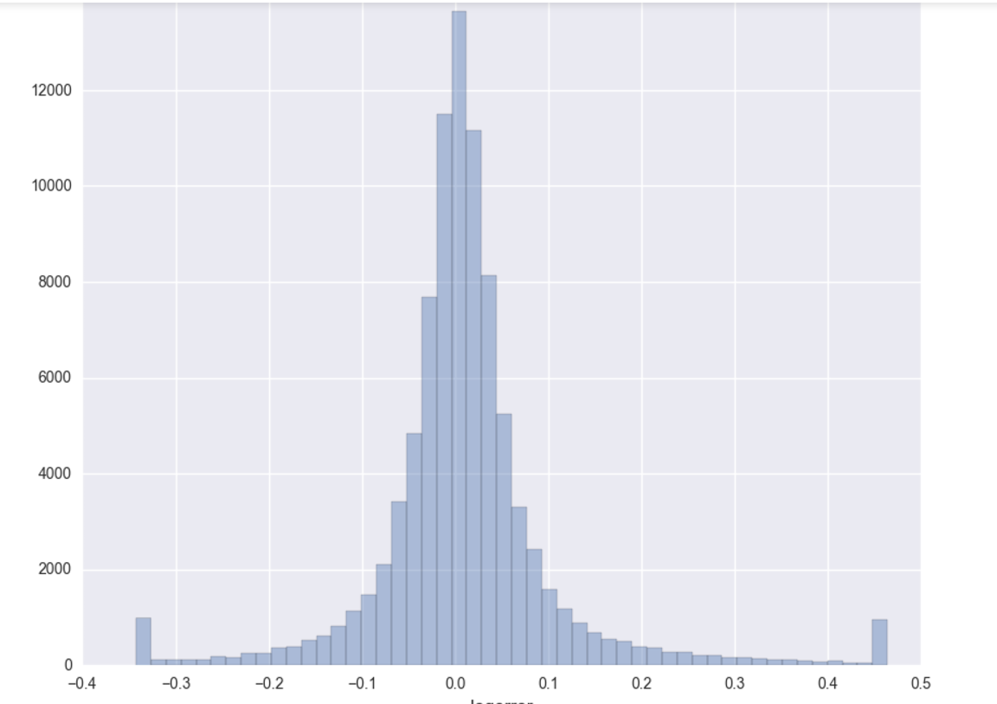

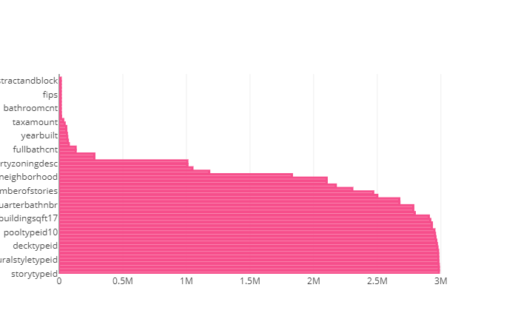

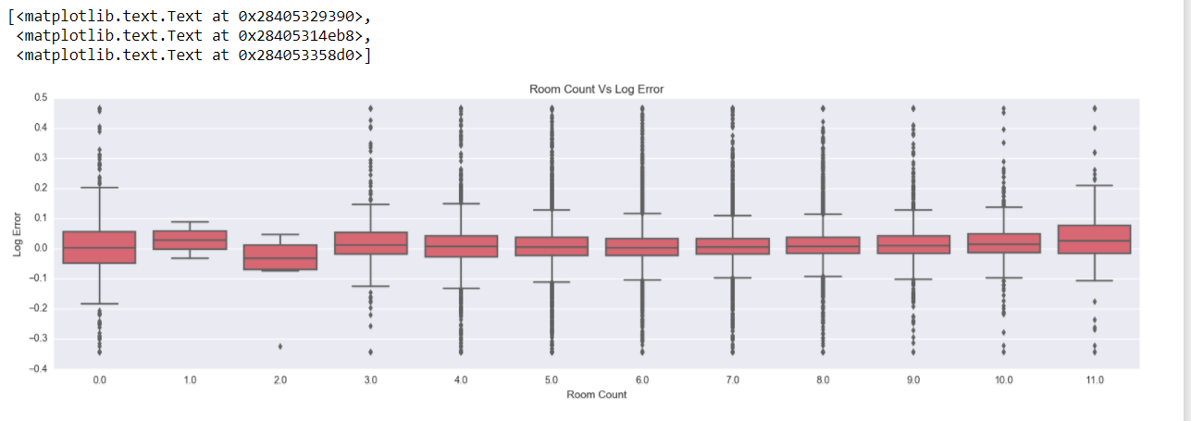

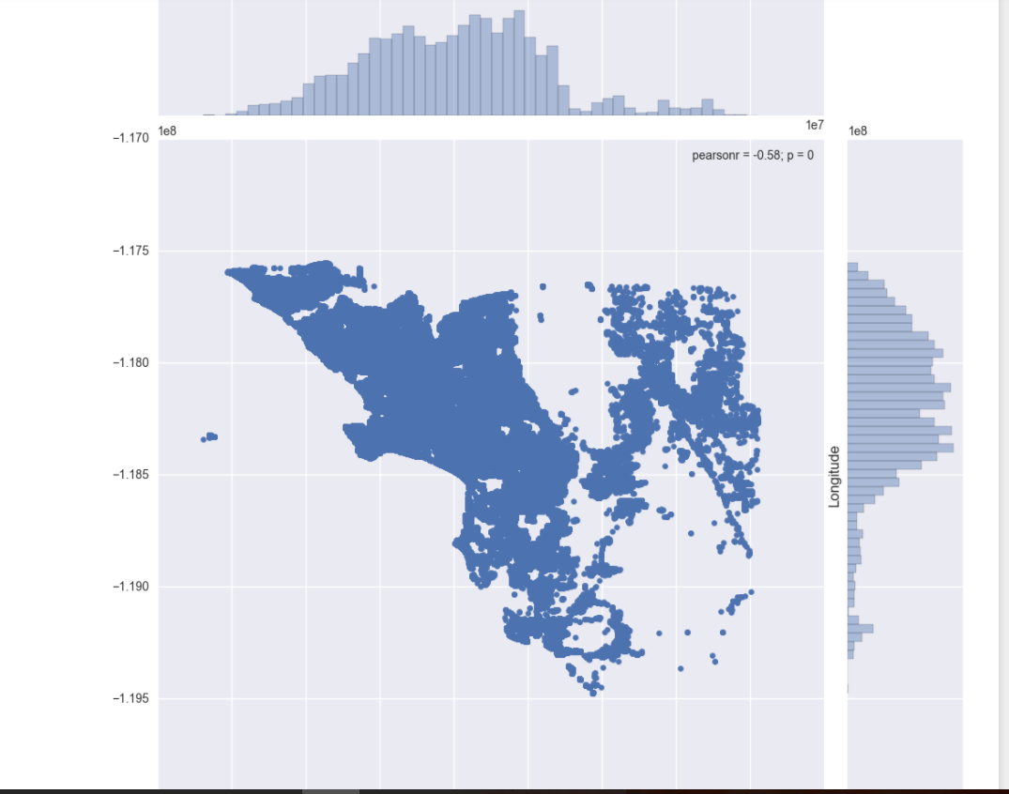

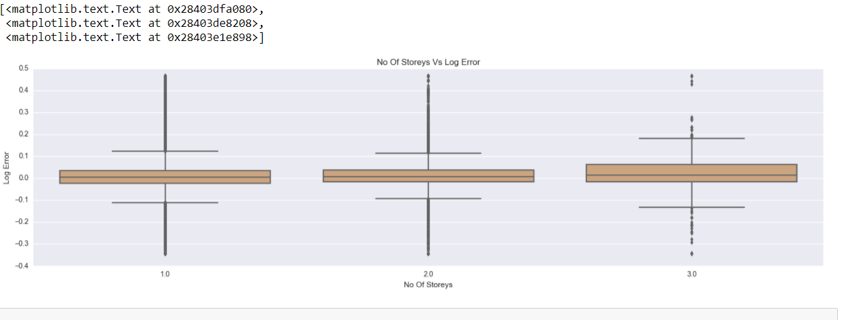

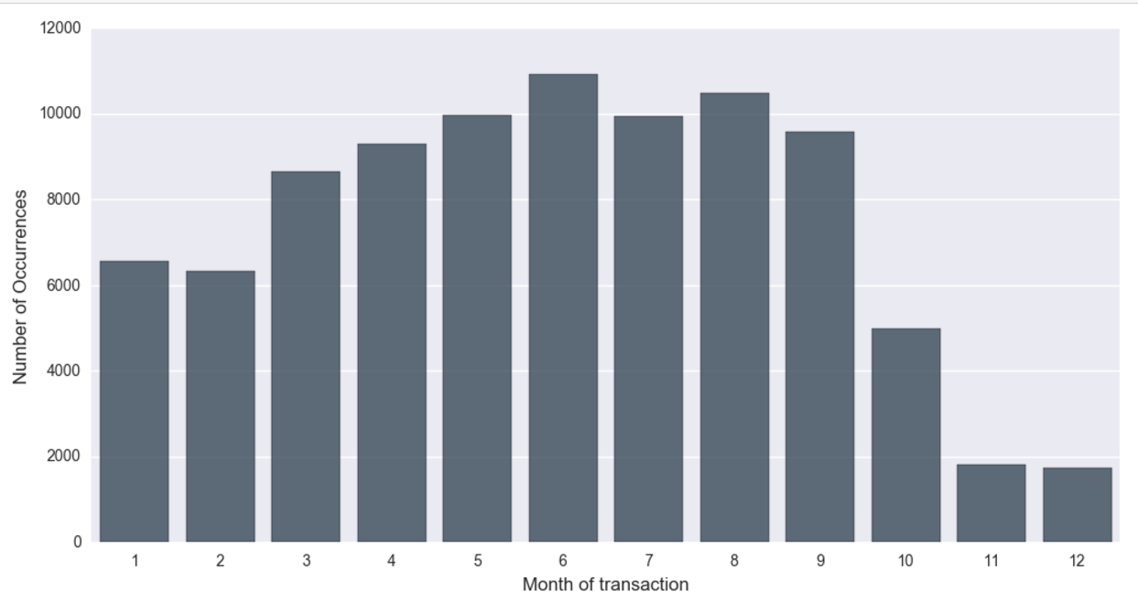

**Step 2:**

**Create a DBaas (Database as a service)**

* + As required in the document, created an account on Microsoft azure
  + Using that account created the DB on SQL server Online db.
  + Using SQL CMD, we created a table and a function inside Zillow database
  + After creating table and function, uploaded the cleaned data to azure
  + Wrangling details of the files are written in ipython notebook.

**Step 3:**

**Create a Rest API to serve the data:**

* + We created a flask application which connects to azure database and retrieves the results online.
  + In this application, we connected to database using “pyodbc” drivers in python.
  + By specifying the query in flask code we retrieved the results.

**Step 4:**

* We developed a function in database which will give you nearest 10 places.
* As input we need latitude and longitude and we pass those to our function and that function will retrieve the result for us.
* This flask application will fetch the result from cloud.
* This is the definition of the function we wrote:

function [dbo].[distance](@latitude float, @longitude float)

returns TABLE

as

return

(

select z.parcelid, z.latitude, z.longitude,3956*2*ASIN( SQRT(

POWER(SIN((@latitude-abs(z.latitude)) * pi()/180/2),

2) + COS(@latitude * pi()/180) * COS(abs(z.latitude) *

pi()/180) * POWER(SIN((@longitude - z.longitude) *

pi()/180/2), 2) )) as distance

from ZillowData as z

)

* And when we pass the values we will get result in this format.

