**Altius Technical Test – Test Framework**

**GITHUB path of the project**

https://github.com/priyalhdp/AltiusTestFramework

**Folder Hierarchy of the Project**

* src/test/java/
  + pageObjects # All page elements and functions define here
    - VardenisiffrorPage.java
  + stepDefinitions # All Step Definitions of the Feature files define here
    - VardenisiffrorSteps.java
  + testRunner # This consists of Junit test run class.
    - TestRunner.java

# Property file reading and Screenshot Capturing methods define here

* + Utilities
    - ReadConfig.java
    - ScreenshotCapture.java
* Configuration # This consists of input values and parameter values of
  + Config.properties the project and information for template
  + extent.properties
  + extent.properties
* Drivers # Executable files to the web browsers stored here
  + chromedriver.exe
  + geckodriver.exe
  + IEDriverServer.exe
* Features # All the Features and scenarios of the BDD defines here
  + VardenisiffrorTest.feature
* log # All the logs triggered during the tests, stored here
* Screenshots # Screenshots stored here
* Pom.xml # All dependencies required for the project defines here

**Technologies used in the Test Framework**

1. Selenium WebDriver
2. TestNG
3. Junit
4. Cucumber
5. Cucumber-gherkin
6. Maven
7. Java jdk 13
8. Extent Reports
9. JavaScript
10. Eclipse

**How to Run the Project**

* Open the project in eclipse
* Right click on TestRunner.java under TestRunner Package 🡪 Run As 🡪 Junit Test
* (TestRunner.java is located in AltiusTechnicalTest🡪src🡪test🡪java🡪testRunner Package

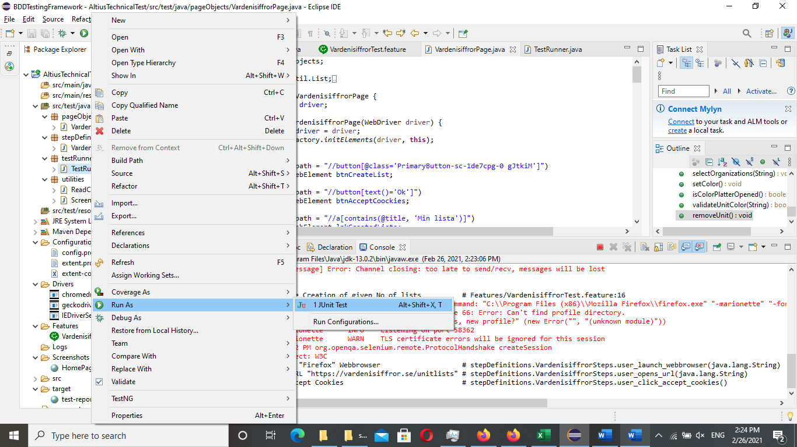

* Screenshots captured for the failure test cases and stored in the Screenshots folder

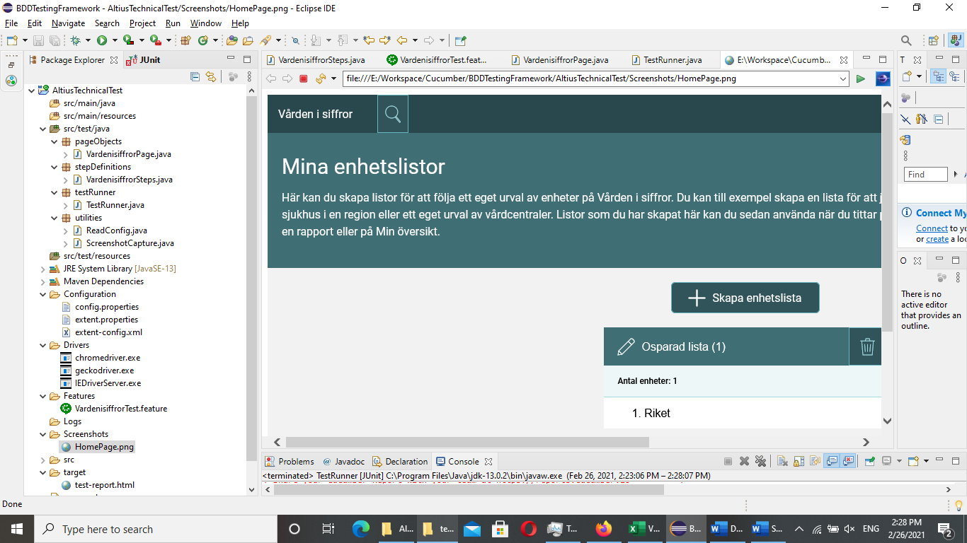

* Report will be generated under the target folder as test-report.html

