

|  |
| --- |
|  |

**Continuous Deployment Guidelines and Best Practices**

# Table of Contents

Table of Contents 2

1. Introduction 3

**2. BEST PRACTICE S FOR CONTINOUS DEPLOYMENT……………………………………………………….....3**

# 

# Introduction

This document is aimed to help you better understand how to better deal with deployments in your development workflow and provide some best practices for deployments. Sometimes a bad production deployment can ruin all the effort you invested in a development process. Having a solid deployment workflow can become one of the greatest advantages of your team.

A deployment pipeline is, in essence, an automated implementation of your application’s build, deploy, test, and release process.

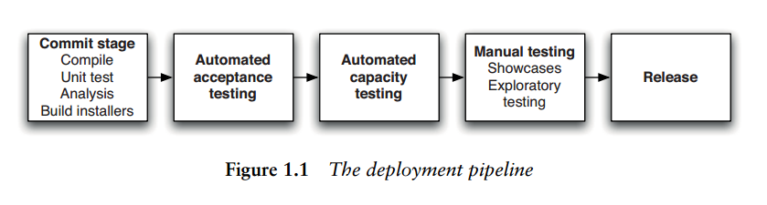

# BEST PRACTICES FOR CONTINOUs DEPLOYMENT

**Following are the best practices for developers:**

1. Deployments should be treated as part of a development workflow, not as an afterthought. If you are developing a web site or an application, your workflow will usually include at least three environments: Development, Staging and Production.

* Development Environment:

You don’t need a remote development environment, every developer should have their own local setup. Testing on a local computer removes the need to commit, push and deploy completely.

* Staging Environment:

 It will allow developers to deploy multiple branches to the same server simultaneously, simply by merging everything that needs to be deployed to the staging branch.

* Production Environment:

**Always deploying major releases to production at a scheduled time, of which the whole team is aware of.**

1. Rolling Back :

Sometimes deployments don’t go as planned and things break. In that case you have the possibility to rollback.

1. Use Git Tagging :

Tags are like labels on commits, so you can mark some commits as being 'special'. Most commonly, this is used to tag releases, so you can always go back and see exactly what was in that release if a customer reports a bug.

1. Use Configuration Management Tool for Deploying an app into multiple servers.