* Prerequisite:- need to have cloud foundry command line interface
* On your cmd you perform:

C:\>cd C:\Users\priyal\Documents\ALM\eco

C:\Users\priyal\Documents\ALM\eco>cd ..

C:\Users\priyal\Documents\ALM>cf api https://api.au-syd.bluemix.net

Setting api endpoint to https://api.au-syd.bluemix.net...

OK

API endpoint: https://api.au-syd.bluemix.net (API version: 2.40.0)

Not logged in. Use 'cf login' to log in.

C:\Users\priyal\Documents\ALM>cf login -u priyalohakare27@gmail.com -o priyaloha

kare27@gmail.com -s dev

API endpoint: https://api.au-syd.bluemix.net

Password>

Authenticating...

OK

Targeted org priyalohakare27@gmail.com

Targeted space dev

API endpoint: https://api.au-syd.bluemix.net (API version: 2.40.0)

User: priyalohakare27@gmail.com

Org: priyalohakare27@gmail.com

Space: dev

* Now created a web app : go to create app-> choose language(php)-> follow instructions
* Set git url
* Edit that code with ur code. Go to hub.jazz.net(like github, for ibm bluemix)
* Push code. Click build and deploy
* After successful deployment go to the given url.

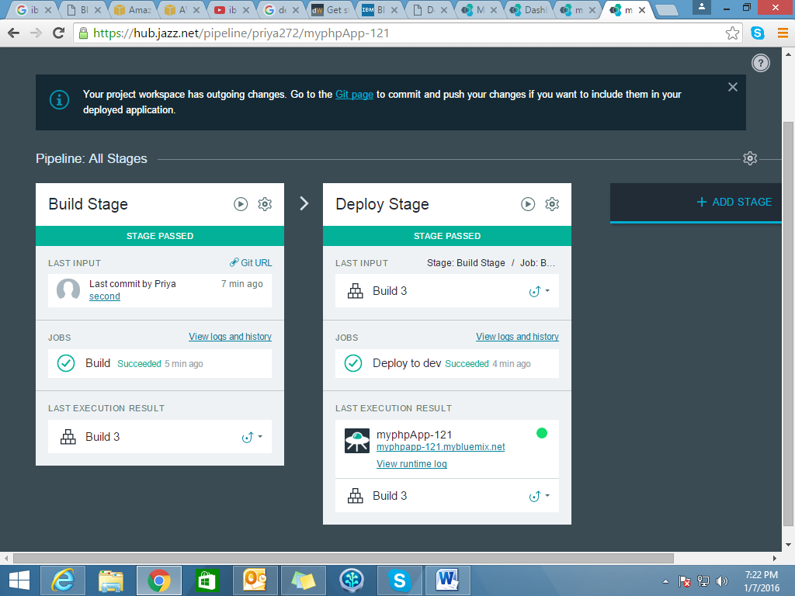

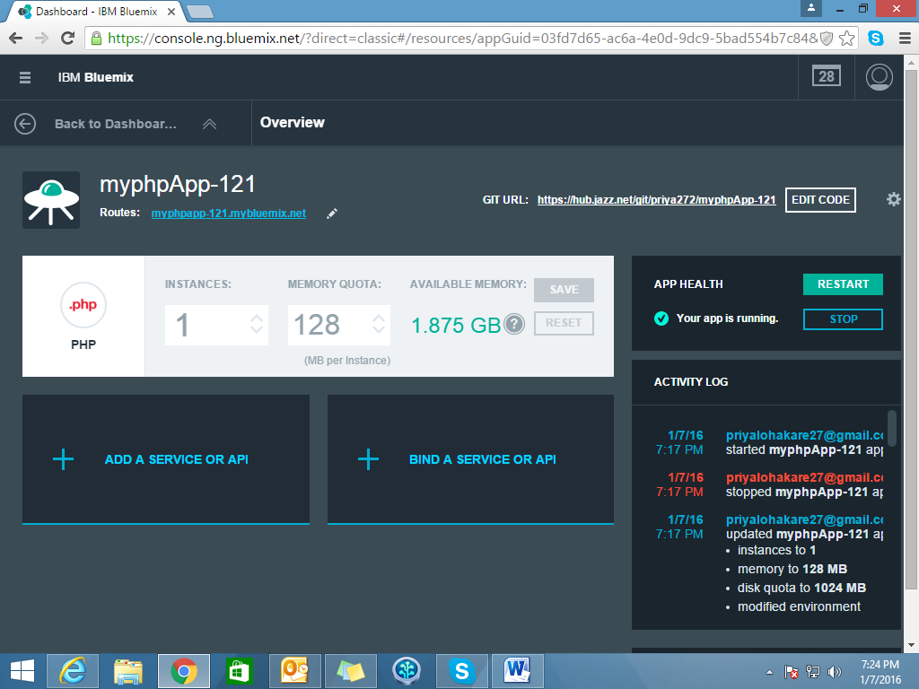

**Manage SQL Database from the CLI**

Use the following command to log in to IBM Bluemix from the command line:

$ cf login https:*//api.*ng.bluemix.net

To see which runtimes and services are available, use the following command:

$ cf marketplace

Create a SQL Database instance with the cf create-servicecommand:

$ cf create-service sqldb *sqldb_small* *mySQLDB*

Refer https://developer.ibm.com/bluemix/2015/04/06/from-workshop-to-production-in-under-a-day-migrating-a-php-app-to-bluemix/