***Fish-Eye Crucible***

# Fish-Eye: Search, track, and visualize code changes

* **FishEye** is a [revision-control](https://en.wikipedia.org/wiki/Revision_control) browser[[1]](https://en.wikipedia.org/wiki/FishEye_(software)#cite_note-1) and search engine owned by[Atlassian](https://en.wikipedia.org/wiki/Atlassian), Inc.
* Use in open source projects
* Atlassian approves free licenses for community and open-source installations[[2]](https://en.wikipedia.org/wiki/FishEye_(software)" \l "cite_note-nonprofit-2) under certain conditions. Many major open source projects use FishEye to provide a front-end for the source code repository:[[9]](https://en.wikipedia.org/wiki/FishEye_(software)#cite_note-9)

|  |  |
| --- | --- |
| **Project** | **FishEye** |
| [JBoss](https://en.wikipedia.org/wiki/JBoss) | <http://fisheye.jboss.com/> |
| [LimeWire](https://en.wikipedia.org/wiki/LimeWire) | <https://www.limewire.org/fisheye/> |
| [MySQL](https://en.wikipedia.org/wiki/MySQL) | <http://svn.mysql.com/fisheye/> |
| [OpenSymphony](https://en.wikipedia.org/wiki/OpenSymphony) | <http://svn.opensymphony.com/fisheye/> |
| [OsCommerce](https://en.wikipedia.org/wiki/OsCommerce) | <http://svn.oscommerce.com/fisheye/> |
| [Spring Framework](https://en.wikipedia.org/wiki/Spring_Framework)[[10]](https://en.wikipedia.org/wiki/FishEye_(software)#cite_note-10) | <https://fisheye.springframework.org/> |

* FishEye provides a read-only window into your Subversion, Perforce, CVS, Git, and Mercurial repositories, all in one place. Keep a pulse on everything about your code: Visualize and report on activity, integrate source with JIRA issues, and search for commits, files, revisions, or people.

### *Add a repository*

* Click the 'cog' menu in the FishEye header, and choose **Administration** (you'll need to be logged in as an [administrator](https://confluence.atlassian.com/display/FISHEYE/Administering+FishEye) to see this link).
* Click **Repositories** (under 'Repository Settings').
* Click  **Add repository**.
* Complete the wizard. See the following topics for more information:
  + 1. [CVS](https://confluence.atlassian.com/display/FISHEYE/CVS)
    2. [Git](https://confluence.atlassian.com/display/FISHEYE/Git)
    3. [Mercurial](https://confluence.atlassian.com/display/FISHEYE/Mercurial)
    4. [Perforce](https://confluence.atlassian.com/display/FISHEYE/Perforce)
    5. [Subversion](https://confluence.atlassian.com/display/FISHEYE/Subversion)
* Click **Add** to finish.

## Hide empty directories and deleted files

You can hide deleted files and empty directories in the left navigation tree:

* Click **Repositories** in the header and browse to a repository.
* In the left hand navigation panel, click the 'Actions' menu and choose either:
  + **Hide empty directories** – hide all empty (greyed out) directories and their contents (i.e. deleted files and empty sub-directories).
  + **Hide deleted files** – hide all deleted (i.e. greyed out) files. This does not affect directories.

## Watch a repository

You can "watch" a repository in FishEye/Crucible. Watching the repository allows you to receive email notifications when changes are made to the repository.

1. Navigate to the repository that you want to watch.
2. Choose **Tools** > **Watch**.

# [Using favourites in FishEye](https://confluence.atlassian.com/display/FISHEYE035/Using+favourites+in+FishEye)

FishEye allows you to add changesets, files, people and repositories as favourites. You can view your favourites, or see a stream of all activity relating to your favourites

# [Viewing people's statistics](https://confluence.atlassian.com/display/FISHEYE035/Viewing+people%27s+statistics)

To see charts and activity of everyone who commits code to your FishEye repositories, click the **People** tab at the top of the screen.

# [Using smart commits](https://confluence.atlassian.com/display/FISHEYE035/Using+smart+commits)

Smart commits allow repository committers to perform actions such as transitioning JIRA issues or creating Crucible code reviews by embedding specific commands into their commit messages.

### Requirements:

Smart commits that transition JIRA issues require the following:

* An Application Link must be configured between FishEye/Crucible and JIRA. See[Adding an Application Link](http://confluence.atlassian.com/display/FISHEYE/Adding+an+Application+Link).
* The [JIRA FishEye Plugin](https://plugins.atlassian.com/plugin/details/290) **version 3.4.5,** or later, must be installed on your JIRA instance. The plugin can be downloaded using the [Atlassian plugin manager](http://confluence.atlassian.com/display/JIRA/Managing+JIRA%27s+Plugins)from within JIRA, or manually downloaded from the [Atlassian plugin exchange](https://plugins.atlassian.com/plugin/details/290).

Note that:

* Multiple smart commits can be used in one commit message (and these can be on the same line).
* Smart commits only support the default JIRA issue key format (that is, two or more uppercase letters, followed by a hyphen and the issue number, for example BAM-123).
* Smart commits don't provide for field-level updates in JIRA issues.

#### Basic command line syntax

The command line syntax for a commit comment is:

<ISSUE\_KEY> #<COMMAND> <optional COMMAND\_PARAMETERS>

* Eg. <DEMO-22>#comment commit1
* FishEye contains a powerful query language called **EyeQL**. EyeQL is an intuitive SQL-like language that allows you to write your own specific queries

## Examples

The following examples demonstrate using EyeQL to extract information from your repository.

**Find files removed on the Ant 1.5 branch**:  
select revisions where modified on branch ANT\_15\_BRANCH and is dead group by changeset

**As above, but just return the person and time the files were deleted**:  
select revisions where modified on branch ANT\_15\_BRANCH and is dead return path, author, date

**As Sub-totals for each distinct changeset, Return csid, the author, date, comment, number of matched revisions, the number of files modified, the lines added/removed**:

select revisions

where date in [ 2003-10-10, 2004-12-12 ]

group by changeset

return csid, author, date, comment, count(revisions), count(distinct path), sum(linesAdded), sum(linesRemoved)

# [*Integrating FishEye with Atlassian applications*](https://confluence.atlassian.com/display/FISHEYE/Integrating+FishEye+with+Atlassian+applications)

# *JIRA:*

## Initial configuration in JIRA:

* You should check that the instances of JIRA that you wish to link to FishEye are configured to accept remote API calls; in each JIRA instance, go to **Administration** > **System** > **General Configuration** and turn on **Accept remote API calls** (under 'Options').
* When you are installing FishEye, the setup wizard allows you to configure the JIRA connection automatically. This is a quick way of setting up integration with JIRA for user management.

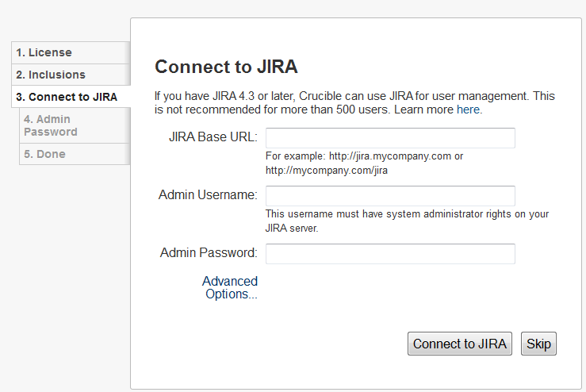

* When FishEye is [integrated with JIRA](https://confluence.atlassian.com/display/FISHEYE/JIRA+Integration+in+FishEye)you can:

1. [Use smart commits to transition JIRA issues](https://confluence.atlassian.com/display/FISHEYE/Using+smart+commits#Usingsmartcommits-TransitionyourJIRAissues)
2. [Delegate user and group management](https://confluence.atlassian.com/display/FISHEYE/Linking+FishEye+to+JIRA) to JIRA

# [Linking FishEye to JIRA](https://confluence.atlassian.com/display/FISHEYE/Linking+FishEye+to+JIRA):

# Follow steps given in <https://confluence.atlassian.com/display/FISHEYE/Linking+FishEye+to+JIRA>

* When Crucible is [integrated with JIRA](https://confluence.atlassian.com/display/CRUCIBLE/JIRA+integration+in+Crucible), you can:

1. [Transition JIRA issues](https://confluence.atlassian.com/display/CRUCIBLE/Transitioning+JIRA+issues)

* When JIRA is [integrated with FishEye](https://confluence.atlassian.com/display/JIRA/Integrating+JIRA+with+FishEye), you can:

1. [View an issue's FishEye changesets](https://confluence.atlassian.com/display/JIRA/Viewing+an+Issue%27s+FishEye+Changesets)

## Viewing an Issue's Changesets

1. Open the relevant issue in JIRA.
2. Click the **Source** tab in the **Activity** section.
3. The list of changesets related to the issue will display.

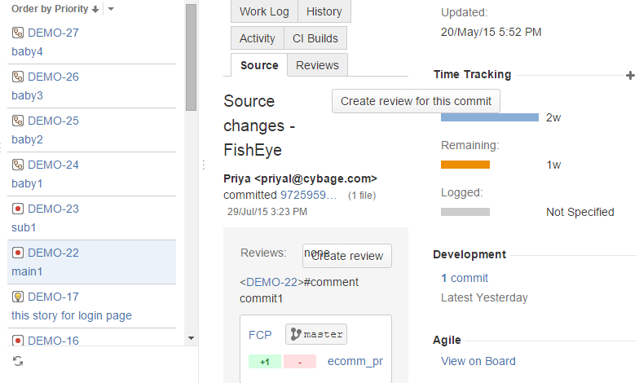

1. [Add the FishEye Charts Gadget to your JIRA dashboard](https://confluence.atlassian.com/display/JIRA/Adding+the+FishEye+Charts+Gadget)

## Adding the 'FishEye Charts' gadget to your Dashboard

* Go to your JIRA [dashboard](https://confluence.atlassian.com/display/JIRA/Customizing+the+Dashboard) and click '**Add Gadget**'.
* The '**Gadget Directory**' will appear. Locate the '**FishEye Charts**' gadget and click the '**Add it Now**' button. Then click the '**Finished**' button at the bottom of the Gadget Directory.
* The '**FishEye Charts**' gadget will appear on your dashboard as follows, ready for you to configure:

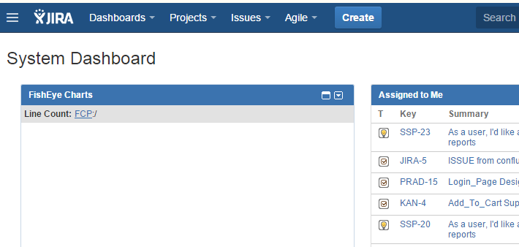

1. [Add the FishEye Recent Changesets Gadget to your JIRA dashboard](https://confluence.atlassian.com/display/JIRA/Adding+the+FishEye+Recent+Changesets+Gadget)

## Adding the 'FishEye Recent Changesets' gadget to your Dashboard

* Go to your JIRA [dashboard](https://confluence.atlassian.com/display/JIRA/Customizing+the+Dashboard) and click '**Add Gadget**'.
* The '**Gadget Directory**' will appear. Locate the '**FishEye Recent Changesets**' gadget and click the '**Add it Now**' button. Then click the '**Finished**' button at the bottom of the Gadget Directory.
* The '**FishEye Recent Changesets**' gadget will appear on your dashboard as follows, ready for you to configure:

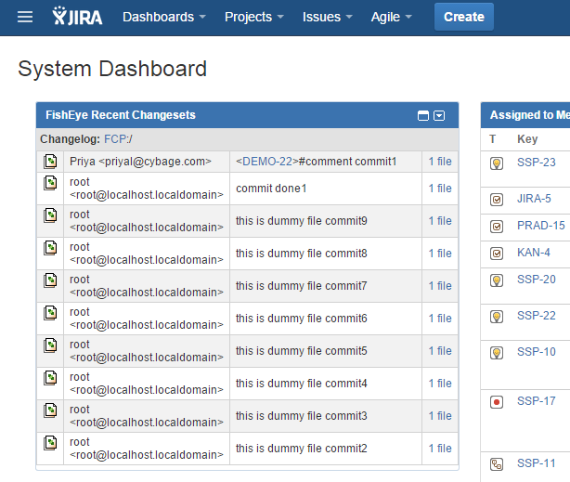

1. [View an issue's Crucible reviews](https://confluence.atlassian.com/display/JIRA/Viewing+an+Issue%27s+Crucible+Reviews)
2. [Add the Crucible Charts Gadget](https://confluence.atlassian.com/display/JIRA/Adding+the+Crucible+Charts+Gadget)

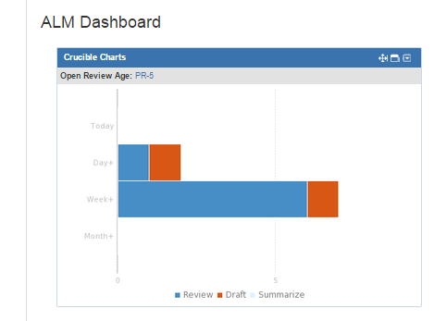

* When FishEye is integrated with Crucible, you can:
* In FishEye:

1. [Use smart commits](https://confluence.atlassian.com/display/FISHEYE/Using+smart+commits#Usingsmartcommits-IntegrationwithCrucible) to create Crucible reviews, add reviews to new reviews and update an existing review.

* In Crucible:

1. When using [Iterative reviews](https://confluence.atlassian.com/display/CRUCIBLE/Iterative+reviews) in Crucible, you will be prompted when a new version of a file is available.
2. Files and changesets displayed in activity streams (e.g. the dashboard activity stream) render as links to the relevant files/changesets.
3. See your content roots and repositories associated with projects.
4. See [repository lists and browse repositories](https://confluence.atlassian.com/display/FISHEYE/Browsing+through+a+repository) using the **Files** tab.
5. [View charts or code metrics](https://confluence.atlassian.com/display/FISHEYE/FishEye+charts).

*CRUCIBLE*

When FishEye is integrated with Crucible, you can:

* In FishEye:

1. [Use smart commits](https://confluence.atlassian.com/display/FISHEYE/Using+smart+commits#Usingsmartcommits-IntegrationwithCrucible) to create Crucible reviews, add reviews to new reviews and update an existing review.

* In Crucible:

1. When using [Iterative reviews](https://confluence.atlassian.com/display/CRUCIBLE/Iterative+reviews) in Crucible, you will be prompted when a new version of a file is available.
2. Files and changesets displayed in activity streams (e.g. the dashboard activity stream) render as links to the relevant files/changesets.
3. See your content roots and repositories associated with projects.
4. See [repository lists and browse repositories](https://confluence.atlassian.com/display/FISHEYE/Browsing+through+a+repository) using the **Files** tab.
5. [View charts or code metrics](https://confluence.atlassian.com/display/FISHEYE/FishEye+charts).

*STASH*

When FishEye is [integrated with Stash](https://confluence.atlassian.com/display/FISHEYE/Integrating+FishEye+with+Stash):

1. You can easily add Stash repositories to FishEye with a single click. Once added, the repository behaves just like a native repository in FishEye, so your team gets all the benefits of FishEye indexing, browsing and searching. Furthermore, the repository becomes available to Crucible, so you can perform in-depth code reviews for changes in the repository.
2. A push to a Stash repository that has been added to FishEye automatically triggers FishEye to run an incremental index. You don't have to configure polling for new commits, or set up dedicated FishEye web hooks in your Stash instance.

Bamboo:

https://confluence.atlassian.com/bamboo/integrating-bamboo-with-fisheye-289276943.html

# Crucible: Collaborative peer code review

* **Crucible** is a collaborative [code review](https://en.wikipedia.org/wiki/Code_review) application.
* Crucible is a [Web](https://en.wikipedia.org/wiki/World_Wide_Web)-based application primarily aimed at the [enterprise](https://en.wikipedia.org/wiki/Business), and certain features that enable peer review of a codebase may be considered [enterprise social software](https://en.wikipedia.org/wiki/Enterprise_social_software).
* Crucible also integrates with popular [source control](https://en.wikipedia.org/wiki/Source_control) tools,[[4]](https://en.wikipedia.org/wiki/Crucible_(software)" \l "cite_note-4) such as [Git](https://en.wikipedia.org/wiki/Git_(software)" \o "Git (software)) and [Subversion](https://en.wikipedia.org/wiki/Subversion_(software)).
* Crucible is not[open source](https://en.wikipedia.org/wiki/Open_source), but customers are allowed to view and modify the code for their own use.[[5]](https://en.wikipedia.org/wiki/Crucible_(software)#cite_note-5)
* It allows your development teams to catch major defects, improve code architecture, and discuss desired improvements, without the need for meetings.

# [Starting to use Crucible](https://confluence.atlassian.com/display/CRUCIBLE/Starting+to+use+Crucible)

Creating a review:

Just follow this link <https://confluence.atlassian.com/display/CRUCIBLE/Starting+to+use+Crucible>

# [The Crucible workflow](https://confluence.atlassian.com/display/CRUCIBLE/The+Crucible+workflow)

**Roles**  
Crucible is a flexible application that caters for a wide range of team sizes and work styles. You will need to know about the basic roles used in Crucible:

* [authors](https://confluence.atlassian.com/display/CRUCIBLE/authors+in+Crucible): Usually the creator of the code; the person who will act on the review's outcome.
* [reviewer](https://confluence.atlassian.com/display/CRUCIBLE/reviewer): A participant that will comment on the source files in the review, raising points and discussion on the work that was done.
* [moderator](https://confluence.atlassian.com/display/CRUCIBLE/moderator): Usually the person who starts the review and is responsible for deciding the outcomes and closing it.

# 

### Crucible performance

The performance of a Crucible instance can be seriously degraded if very large reviews are created.

To prevent a user from accidentally causing this, Crucible has a limit on the review content size when creating reviews. The limit is 800 file revisions.

Author

creates

the review

Reviewer(s)

co

# [Configuring SMTP](https://confluence.atlassian.com/display/FISHEYE/Configuring+SMTP)

To configure SMTP settings in FishEye:

1. Go to the Admin screen, click **Server** (under 'Global Settings') and look for the 'Mail Server' section.
2. Click **Edit config**.
3. You can edit the following settings:

|  |  |
| --- | --- |
| **Send emails from** | **Server address**: Fisheye and Crucible will use the **From Address** set below.  **User address**: Fisheye and Crucible will use the email address in the user's profile. |
| **From Address** | The sender address used when FishEye or Crucible sends an email, e.g. ['fisheye-noreply@example.com](https://confluence.atlassian.com/mailto:)' |
| **SMTP Host name** | The host name of the SMTP server. |
| **Enable debug** | Optional. Turn this on to enable debug logging from the mail server. Useful in tracking down mail server connectivity problems. |
| **SMTP Port** | Optional. The port to connect to on the SMTP host. FishEye needs to use port 25 or port 587, because unlike JIRA its initial connection doesn't use SSL. Port 25 will be used if no port is specified. |
| **Use SSL/TLS** | Optional, defaults to 'False'. This turns on [Secure Sockets Layer/Transport Layer Security](http://en.wikipedia.org/wiki/Transport_layer_security) security for mail servers that require it, or use it by default. |
| **Username & Password** | Optional. Username and password for authenticated SMTP access. |
| **Connection timeout** | The time in seconds to wait for a connection to the SMTP server (leave blank for infinite timeout). |
| **Timeout** | The time in seconds to wait for a response from the SMTP server (leave blank for infinite timeout). |

1. Click **Save**.

Error occurred:

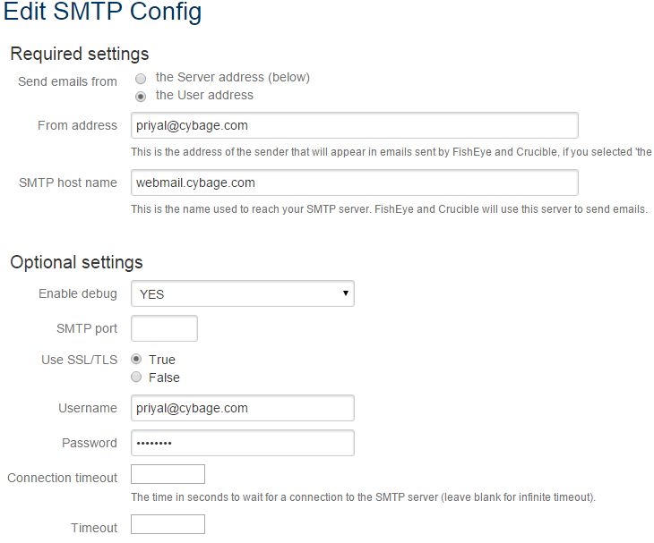

When you test mail

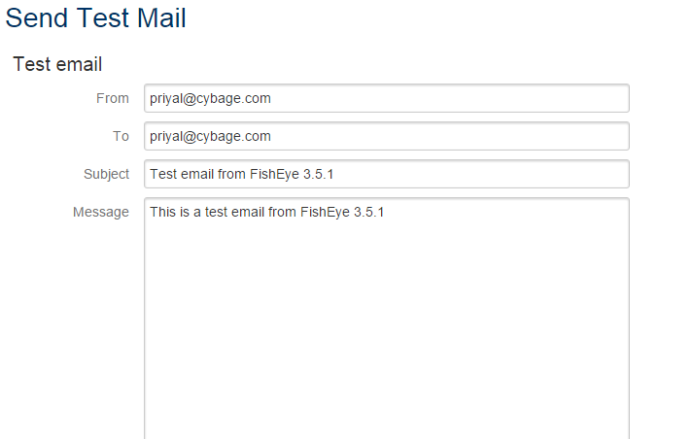

# [Review Reminders](https://confluence.atlassian.com/display/CRUCIBLE/Using+Review+Reminders)

### Preset Reminders

When a review has a deadline (due date), you can have Crucible send a preset reminder to all of the pending reviewers, some number of working days before the deadline.

To add a reminder, firstly edit the review, then click **Add a reminder**. You can edit the reminder period.

(info) The **Send Reminder** setting is only available if the review has a due date set.

### Manual Reminders

You can send a reminder to all the reviewers that have not yet completed their review:

Before the review is due, click **Share** and add recipients and a message. Besides sending reminders to participants, the **Share** option can also be used to share the review with people external to it:

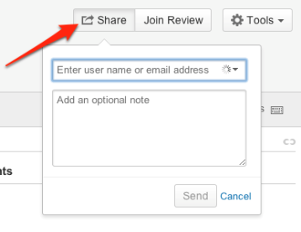

# A mail will come as a reminder.

# [Progress Tracking](https://confluence.atlassian.com/display/CRUCIBLE/Using+Progress+Tracking)

As you work your way through the files in a review, Crucible tracks the ones you have viewed. Whenever you open a file for review, Crucible will automatically mark it as read.

When participating in [iterative reviews](https://confluence.atlassian.com/display/CRUCIBLE/Iterative+reviews), progress tracking also takes lines of code and revisions into account.

The 'Details' section shows a summary of the progress of each participant through the files in the review.

* If there is only one file in the review, then the progress tracked will either show 0% or 100%.

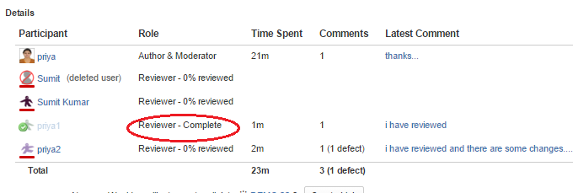

# [Time Tracking](https://confluence.atlassian.com/display/CRUCIBLE/Using+Time+Tracking)

# Crucible will automatically track the time you spend in a Crucible review. When you open a file for review, a counter in the Review Details panel starts. The time is added to your total when you leave the review screen.

# [Viewing people's statistics in Crucible](https://confluence.atlassian.com/display/CRUCIBLE/Viewing+people%27s+statistics+in+Crucible)

# The **People** tab in Crucible to see charts and activity from people with accounts on the system.